Collision and Interference Detection using

Dynamic Hierarchical Bounding Volumes

- Sept 2001

Overview:

The definitive factor in making a great hardware-accelerated 3D interactive game is fast collision detection (CD). With the industry gearing towards removing the bottleneck of the 3D pipeline, CD has now become the main factor that can make or break a game. With more realism and a huge number of polygons, gamers want the most immersing and surreal experience possible. This means thousands of possible collisions hundreds of times every second that must be checked and dealt with.
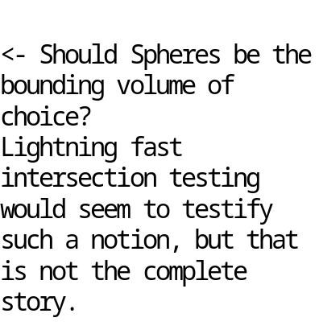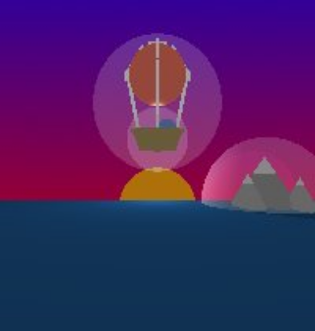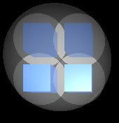

Objects are represented as triangles for purposes of pipelining to the graphics card. As such there is a natural inclination to do collision detection on those polygons. An optimal algorithm will not perform all pair-wise triangle intersection tests, instead organizing the triangles representing the geometry into groups based on a function of the topology.
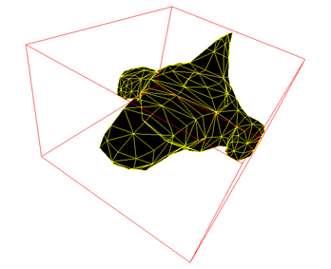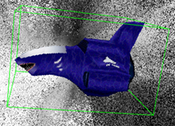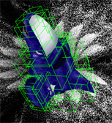

Starting from a list of possible collides we perform CD on them in an organized manner. Each CD routine call is fully customizable, allowing as much accuracy as needed by the client. Possible objects for interference detection (ID) include players, projectiles, terrain chunks, lights, the frustum, stray rays, forces, and sounds modeled as rays. Simple geometric shapes are used to represent all entities, turning the CD routine into a trivial task.

The Dynamic Hierarchical Bounding Volume Algorithm-

The Basics:
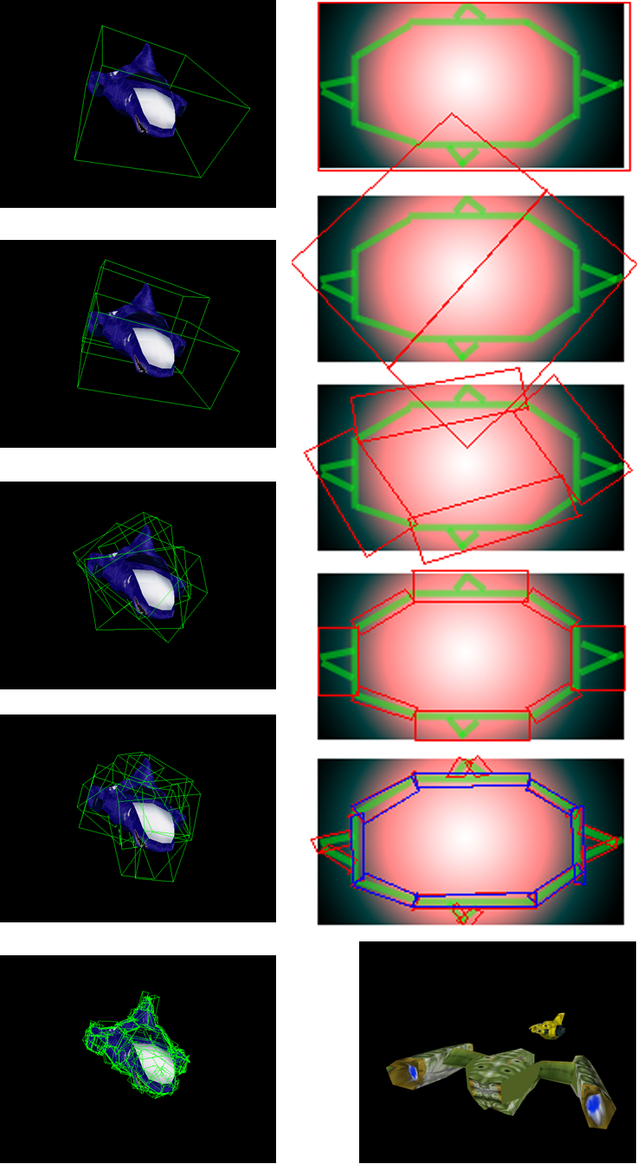

The cornerstone of the collision detection for CAS is being able to represent the subs and terrain patches using bounding box (BB) trees. Pictured to the far left here is a geometric description of the hierarchy construction for a sub. Just to the right of it is a similar yet more intuitive BB creation process (hand-drawn). Notice how each iteration brings the BBs closer to the actual shape of the geometry. The trees are dynamic sphere/box trees, allowing various levels of accuracy for CD.
Not only that, but CAS boasts the most accurate CD possible-at the polygon level. At the leaves of each bounding hierarchy, the bounding volumes (BVs) contain polygons, exploiting the input model for astonishing resolution.
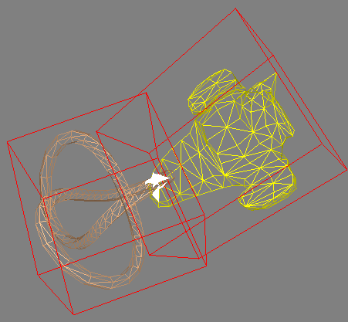

Collision Level of Detail allows for optimum performance. Ranging from trivial acceptance/rejection spheres, all the way down to per-polygon ID, the programmer is given full freedom.
Conventional Collision Detection methods may have a variable number of BVs at each level. However, our method uses a binary tree structure, which always has two BVs at most per level. This gives our CD routines O (lg (n)), while the other guys have O (m^2*lg (n)). Our collision routines are asymptotically better than traditional methods, with actual worst case run time performance of lg (n) (times a small constant), with n being the total # of BVs in both objects that CD is being performed on. A formal proof is within the scope of this document, but is trivial enough that it will not be derived in lieu of more important topics to cover.
The Meat and Potatoes of the BV Algorithm:
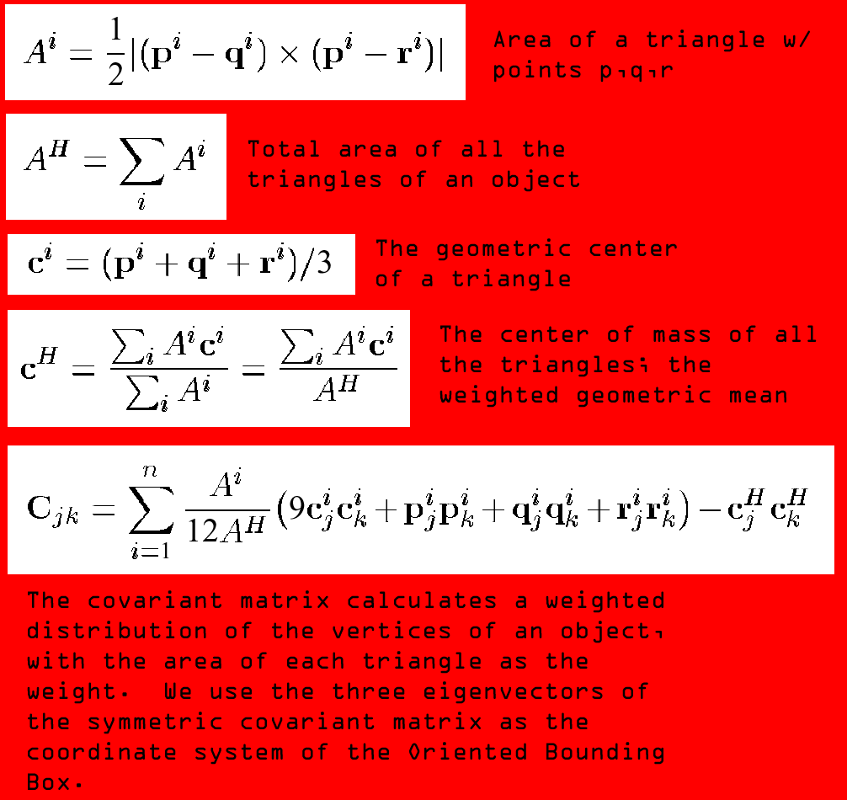
The algorithm was pioneered by academics in the Siggraph paper [OBBTree]. With a new CD routine for Oriented Bounding Boxes (OBBs) that is an order of magnitude faster than any previous, it is now a viable option to use OBBs in a real-time game environment. Unlike Axis Aligned Bounding Boxes (AABBs), which need sides parallel to the coordinate system of the world, OBBs can have any arbitrary orientation, allowing objects to have a much better fit.
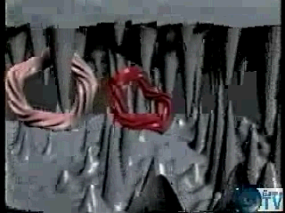
Shown above is the bulk of the algorithm. Once the covariant matrix is obtained and you have the three normalized eigenvectors (EV), another matrix is created which is used as the basis for the OBB, with the columns of this matrix being the three normalized EVs. For a recap, an eigenvector U of a matrix M is a vector which when multiplied by M will return a scalar multiple of U (M*U=k*U with k the constant scalar also known as the eigenvalue). The new basis vectors of the OBB are scaled until they encapsulate all of the geometry.
In order to split the OBB to calculate its children, we take the center of mass of the triangles, and slice the OBB at that point along whichever axis of the OBB is longest. Other axes are chosen if the first axis chosen cannot subdivide the geometry. The OBB has no children if it is not divisible.
Pictured to the right is M.C. Lin, one of the creators of the BV algorithm. At the forefront of collision technology, she gave an invited lecture at the Game Developers’ Conference in 2000. S. Gottschalk, now working at NVIDIA, also co founded the BV algorithm. The point is that this is a solid algorithm with years of research, proven to work in theory and in implementation (OBB trees for CAS are created offline-using [RAPID], and stored into files).

// Pseudo code for OBB tree creation:
OBB Build_OBB_Hierarchy( TRIANGLE_LIST Triangles )
{
MATRIX Covariant = calculate_covariant_matrix( Triangles );
MATRIX Basis = calculate_eigenvector_matrix( Covariant );
OBB BestFittingBox = refit_OBB( Basis, Triangles );
TRIANGLE_LIST splitTLeft = SplitOBB_Left( BestFittingBox, Triangles );
TRIANGLE_LIST splitTRight = SplitOBB_Right( BestFittingBox, Triangles );
BestFittingBox.LeftChild = Build_OBB_Hierarchy( splitTLeft );
BestFittingBox.RightChild = Build_OBB_Hierarchy( splitTRight );
Return BestFittingBox;
}

The structures of the Post BV Algorithm-
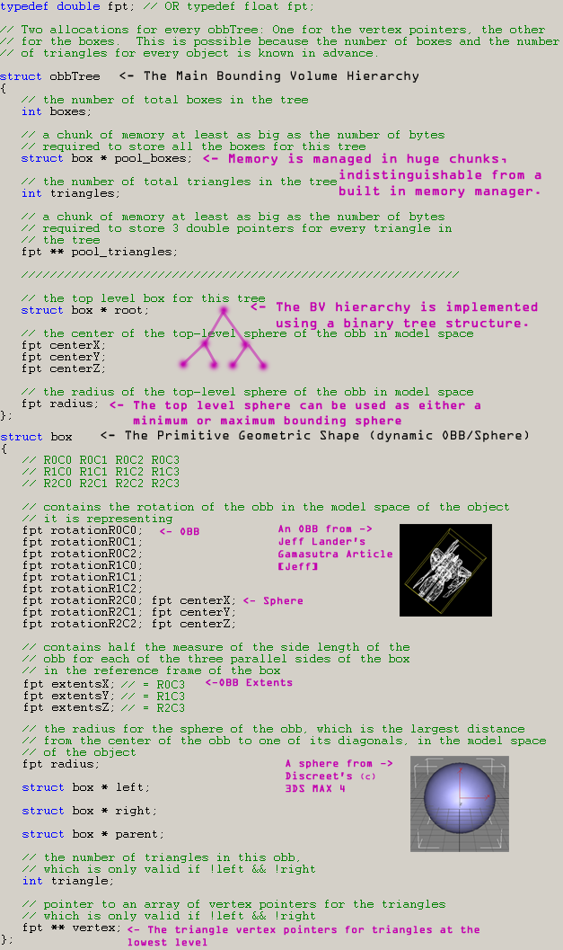
Wrapping things up with the OBB/Sphere Tree:
The BV structure could in theory take a variable number of different primitives. In our case, the sphere/OBB paradigm will dominate, and so the internal makeup of a BV is as such. Internal nodes contain an individual sphere/OBB, and the internal nodes together form the BSP tree hierarchy.
Notice the vertex component in the box structure. An array of vertex pointers is associated with every leaf node. The box will maintain a handle to the model’s triangle vertices, saving memory and allowing a relationship to exist between the model and the BV. This may break normal modular software engineering practices, but provides the extra functionality to the collision module required to let the client know the id of colliding triangles, which is more important than just knowing their vertices.

The Last BV Section; the In-Game BV Pipeline-
Collision Detection,

Traversal Design, and the

BV File Format:
There are three categories of CD, namely:
Bullet CD | Sub and Projectile CD | Secondary CD
Bullet-Sub | Sub-Sub | Sphere-Sphere
Bullet-Terrain | Sub-Terrain | Sphere-OBB
Bullet-Projectile | Sub-Projectile | Sphere-Frustum
Since bullets will be the default weapon, as well as being the fastest rapid-fire weapon, custom CD routines will be developed to check collision between bullets and other pieces of geometry. Moving bullets will be modeled as directed ray line segments. It will be assumed that bullet collisions may occur thousands of times a second. | Projectile-Terrain | Sphere-Ray
 | Projectile-Projectile | Ray-Triangle
 | The most versatile CD routines in CAS, the Sub/Projectile CD use the generality of the BV hierarchy, allowing all the above pair-wise checks to use the same code. Robustness surely follows this centralized coding scheme, allowing enough time for full debugging and in-code documentation. | Ray-OBB
 |  | Point-Rounded_Cone
 |  | Triangle-Triangle
 |  | OBB-OBB
 |  | OBB-Frustum
 |  | OBB-Rounded_Cone
 |  | Frustum-Rounded_Cone

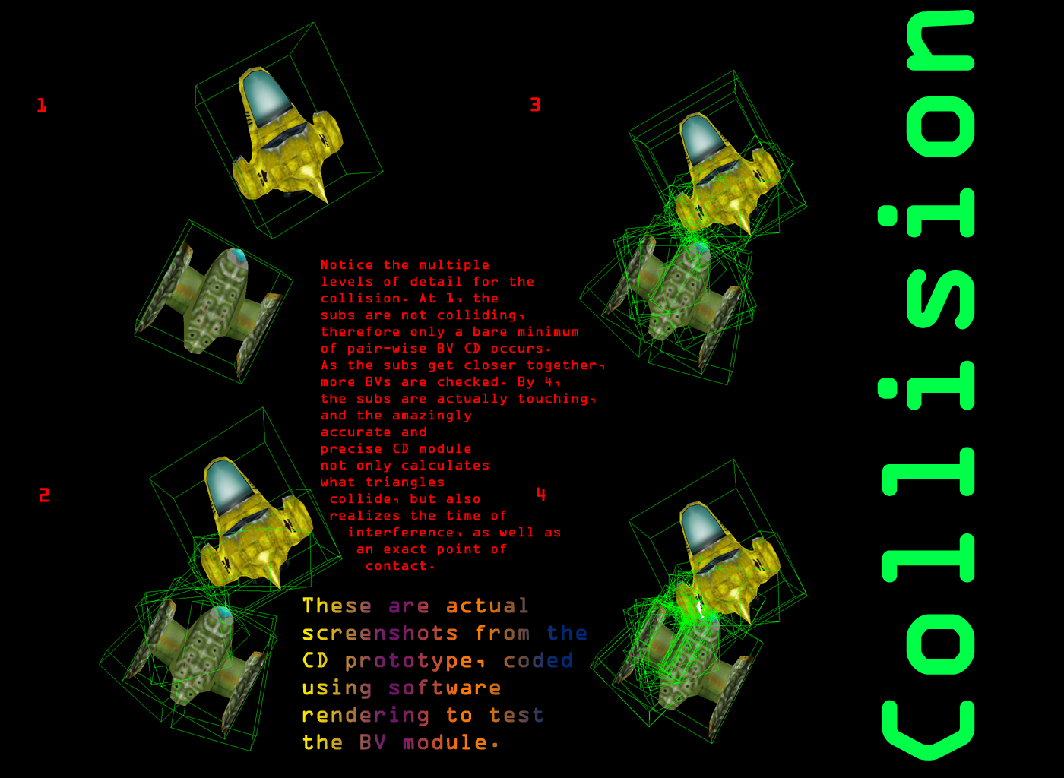

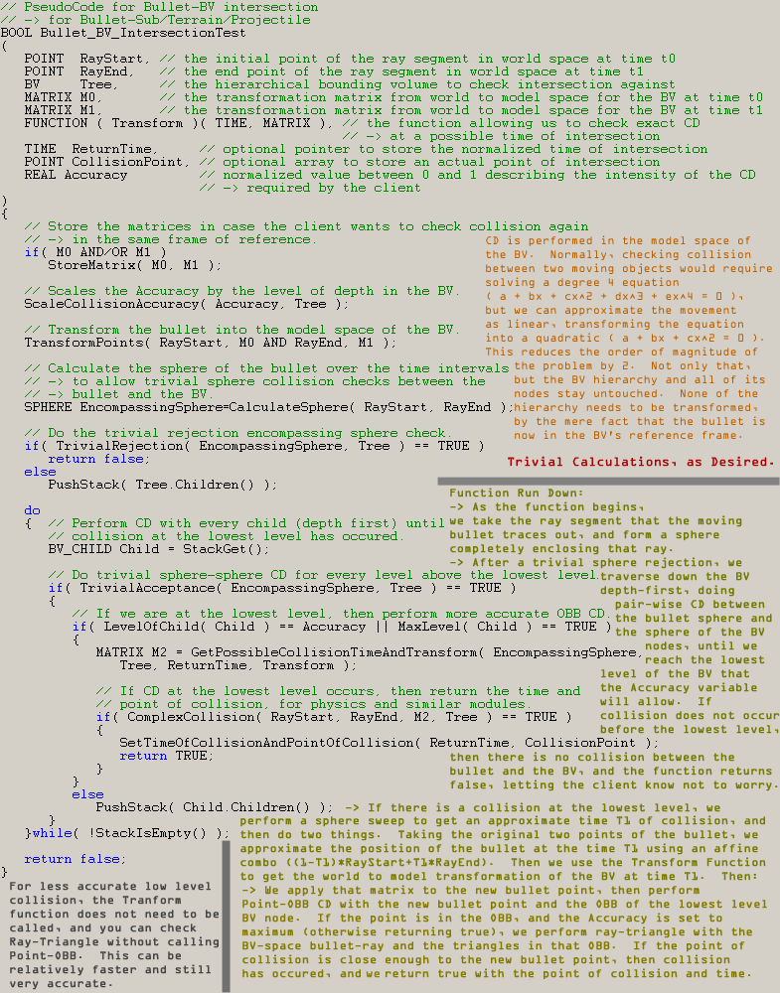
This pseudo code outlines the basic structure of all the main CD routines, so this pseudo code should be all that is required to understand how all of the other CD functions work.
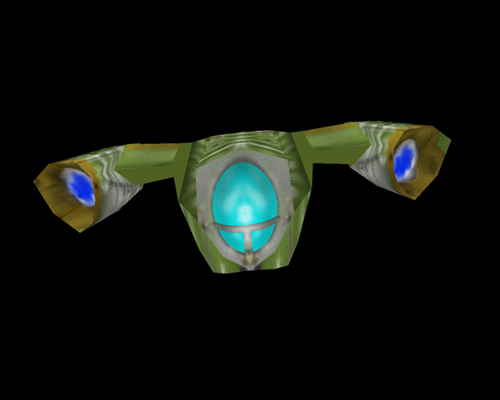
// Pseudo header for BV-BV intersection:
// -> for Sub-Sub/Terrain/Projectile
// -> also for Projectile-Terrain/Projectile
// Checks collision between two objects
// moving simultaneously
// during a time interval.

BOOL BV_BV_IntersectionTest
(
BV TreeA,
MATRIX MatrixTreeATimeStart,
MATRIX MatrixTreeATimeEnd,
FUNCTION ( TransformTreeA )
( TIME, MATRIX ),
BV TreeB,
MATRIX MatrixTreeBTimeStart,
MATRIX MatrixTreeBTimeEnd,
FUNCTION ( TransformTreeB )
( TIME, MATRIX ),
TIME ReturnTime,
POINT CollisionPoint,
REAL Accuracy
);
The secondary CD is used for the graphics engine and for the photo realistic preprocessed vertex color calculations. The specific things they are used for are explained in their respective TDD sections. The actual functions are trivial enough to not have to explain them in pseudo code. The secondary CD headers are not important enough to go over in any detail.
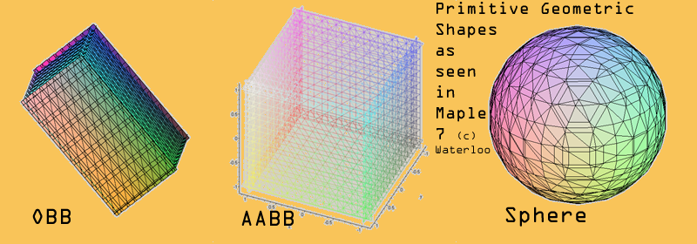
There is an intimate relationship between the sphere, AABB, and OBB. If we compare the relationship of the volume of the primitives with the speed of their respective CD routines, we find that there is a symbiotic relationship between the three.

# Of operations | Sphere | AABB | OBB
Compare | 1 | 6 | 15
Add/Sub | 6 | 12 | 60
Multiply | 4 | 0 | 4
Abs | 0 | 0 | 24

This table shows that sphere CD is nearly an un-asymptotic order of magnitude faster that AABB CD, and two orders of magnitude faster that OBB CD. Therefore, it would be optimal to rely on spheres for most of the geometry CD, and as we traverse down the BV hierarchies looking for more accurate (but fewer) collision checks, to morph from sphere CD to OBB CD. We already know that OBBs and AABBs are tighter around the representative geometry, but let us compare the representative worst-case volumes from the reference of the OBB extents (l=length, w=width, h=height).

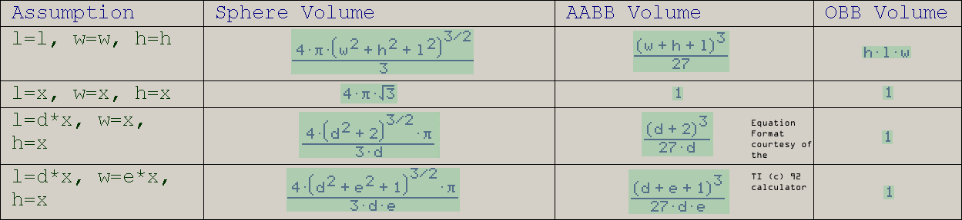

Based off of deductive research, we will assume that near the top of the hierarchy, objects will be much more cubical. This would mean that as the object is subdivided, the shape tends to morph towards skewed axes, in which the length, width, and height vary greatly from one another. Using this model, we maximize efficiency by initially doing sphere collision, since sphere volumes for cubical geometry is only a factor of about 4 less efficient than for BBs (seen in the above table), but uses CD which is at least an order of magnitude faster (more than 4 times faster). For the complicated BV CD down the hierarchy, the limit of the ratio of sphere volume inefficiency to the speed of OBB CD reaches one, and since we are trying to do as few CD tests as possible at this level, we cast the BV nodes to OBBs and use OBB CD, getting the most out of the dynamic sphere/OBB BV tree.
/ / / / / / / / / / / / / / / / / / / / / / / / / / / / / / / / / Foot Notes / / / / / / / / / / / / / / / / / / / / / / / / / / / / / / / / /
The traverse down the BV hierarchy uses a global stack big enough for the worst-case collision numbers (~n^2, about 250,000 node pointers in implementation). Since the traverse is depth first, the stack is the optimal choice. The traverse is iterative, completely bypassing the need for compiler optimization. Traversing with CD should take no more than O (n*lg (n)) time for an entire hierarchy. When minimum accuracy is required, but a point of collision has to be returned, that point will be approximated either as the point of collision between moving spheres/boxes, or between a ray and sphere/box.
/ / / / / / / / / / / / / / / / / / / / / / / / / / / / / / / / / / / / / / / / / / / / / / / / / / / / / / / / / / / / / / / / / / / / / / / /
The memory for each hierarchy ranges from 50kb to 300kb, with 100kb on the average. The memory layout for one example hierarchy is presented below, while the memory map for all the hierarchies typically encountered during a game is presented in the main TDD memory map. The file format for the BV hierarchy tree immediately follows. Closing remarks and a short bibliography conclude this TDD section.

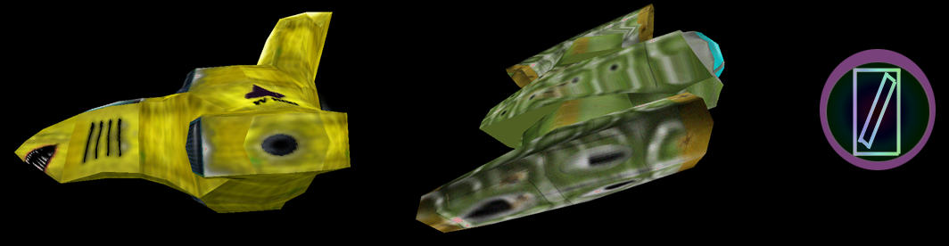
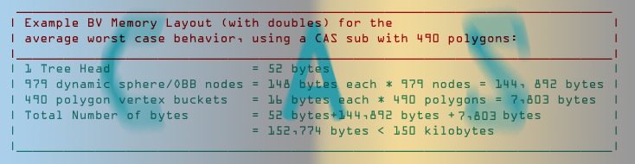

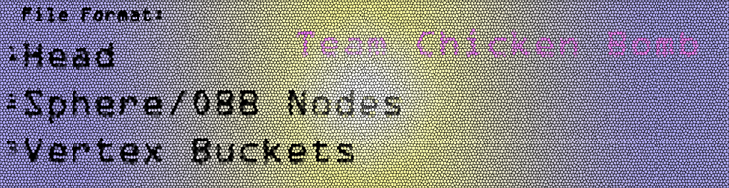

After such a strenuous and detailed breakdown of the method of CD used in CAS, it should be clear that our method is superior to all others. Paling in comparison, all academic scholars and game companies could learn a thing or two from this revolutionary new technology. Being faster and more accurate than any current ID or BV representation in the world, we will continue to break barriers and shred the competing 3D community.

We are Team Chicken Bomb.

Bibliography:

[OBBTree] S. Gottschalk, M. Lin, and D. Manocha. “OBBTree: A hierarchical Structure for rapid interference detection,” Proc. Siggraph 96. ACM Press, 1996. has contributed a great deal to the discussion of OBBs in terms of accuracy and speed of execution.

[Jeff] When Two Hearts Collide: Axis-Aligned Bounding Boxes by Jeff Lander [02.03.00] at www.gamasutra.com Most discussions of collision detection for real-time game applications begin with bounding spheres and bounding boxes. While fast, bounding spheres don't generally give the best approximation of an object's extent. Jeff Lander demonstrates the use of axis-aligned bounding boxes for 3D collision detection.

