Homework 3. Due Tuesday, January 29

1. Show that complex numbers w and z are linearly dependent (as vectors) if and only if 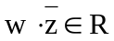 (Note: the linear dependence statement uses only the vector space properties of C, but the criterion in this case uses the multiplication of C).

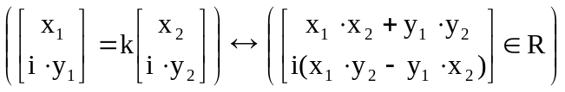

It can be shown that if 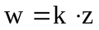then 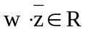:

And by the contrapositive it can be shown that if 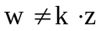then 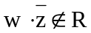:
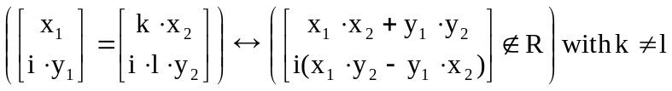

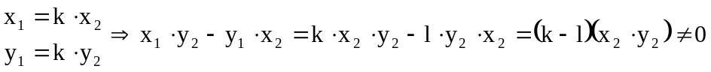
AS DESIRED!
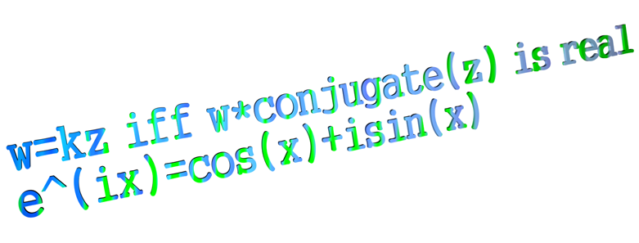
2. Prove the “Three Party Theorem:”

Theorem 4. Let 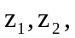 and 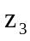 be three distinct complex numbers such that 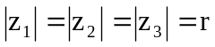. Then the following statements are equivalent:

a) and are the vertices of an equilateral triangle.
b) 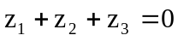.
c) and are the roots of an equation 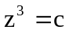 for some complex number c.

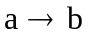
The given of the theorem 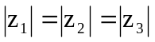 can be rewritten as 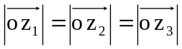 with o being the origin. Then the relationship can be stated as the three vectors having the same magnitude. If the three points were to lie on a circle, you could say that each of the distances from the points to the center of this circle would be the same, since that is what the definition of a circle is. Indeed, since the distance from the origin to each of these points is the same, such a statement can be made, that these three unique points go through a circle with radius r, its center being at the origin. We know this is the only circle since three distinct points can only define one unique circle. Knowing this, we can rewrite each of the points:
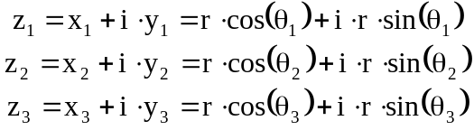
with each theta being an angle of the point on the circle. Now we also know that the three points define an equilateral triangle, with each point being a vertex of the equilateral triangle.
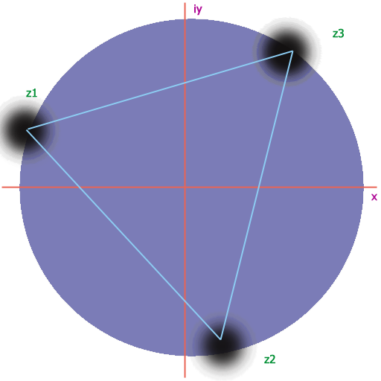
Now we have a relationship between our angles, as one of the properties of an equilateral triangle, each subsequent point can be gotten by rotating the previous point by 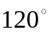 around the circumscribed circle containing the triangle. Therefore:
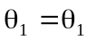, 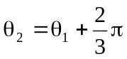, 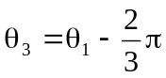
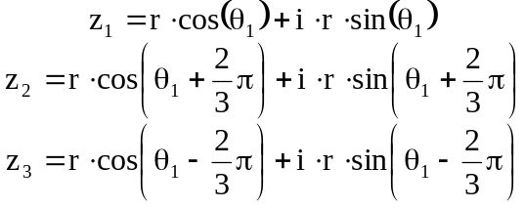
and 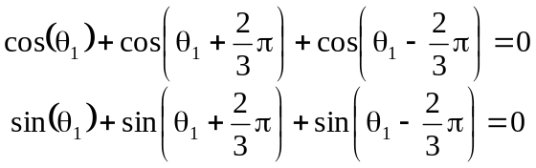, which is shown using the basic trig identity
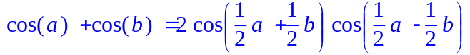
.

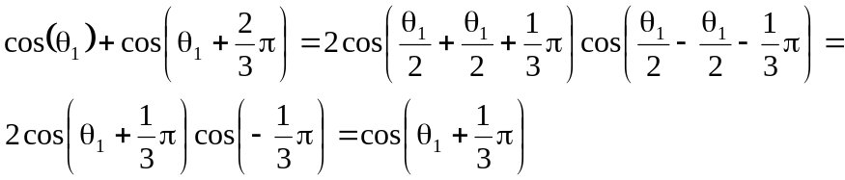
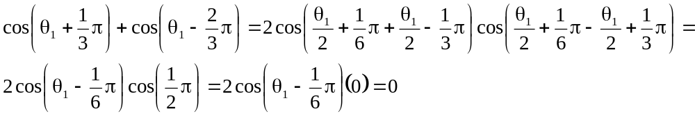

Similarly, it can be shown for sin (we won’t do it here since the process would be so similar to the cos reduction). The facts have been clearly stated:

Given
and
a) and are the vertices of an equilateral triangle,
we have shown
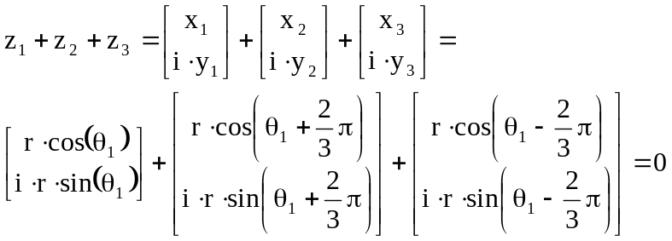,
which is exactly what we were trying to show ( AS DESIRED).

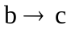
We are given and . Need to show that and are the roots of an equation for some complex number c.

Again we can think of points on a circle, and rewrite one of our equations:
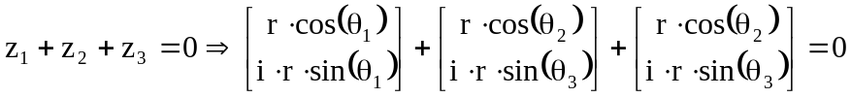.
We have two equations with three unknowns, but we can transform our coordinate system so that one of the angles is 0, such that :
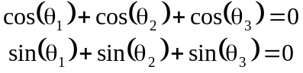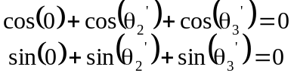.
Solving for the two angles we get (we won’t crank through the algebra and trig here for the simultaneous equation solving, use Maple if you don’t believe me):
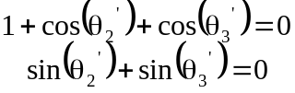 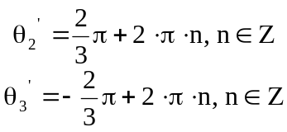.

Now that we have our angles we will write our points in exponential form in our original untransformed coordinate system:
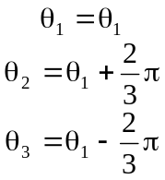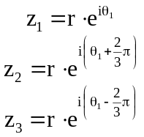
and now we can show that our three zs are the roots of a cubic equation , in our case 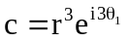:
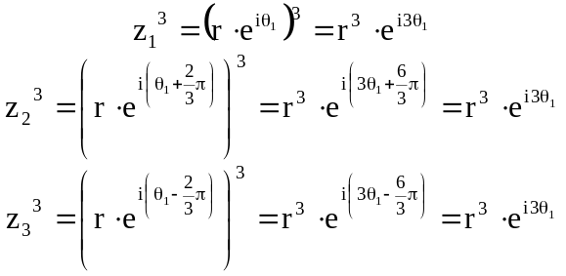AS DESIRED.

As an extra bonus, if we transform our coordinate system so that r=1 and theta=0, then 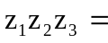 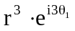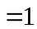, since 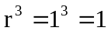 and 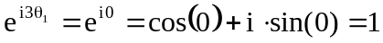. Then we can say that the three zs are the roots of the equation 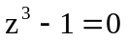. And it is true, look at the roots:
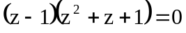 with roots z=1 and
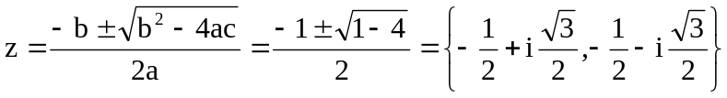.
These are the same values for the roots that we got earlier:
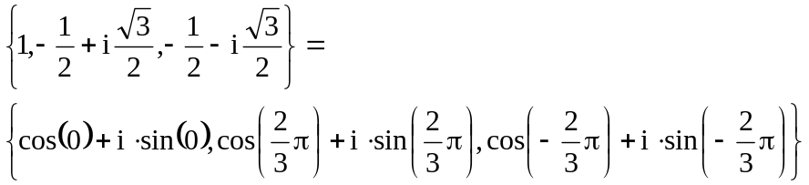,
which yet again verifies .

We are given . We also know that that and are the roots of an equation for some complex number c.

Well, using the extra bonus from the end of the previous problem, if we assume that our c is 1, and use our transformation simplification, then from the roots of , we can retrieve the values for each of the zs:
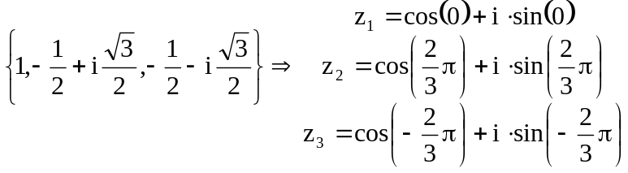from the bonus above.
We know from that each of the points lies on a circle centered about the origin, and from the roots of , we know that each of the three points are equiangular in measure, and therefore equidistant. This satisfies a, and we can know state that the three points form the vertices of an equilateral triangle, AS DESIRED.


3. Prove this equation: Three numbers a, b, and c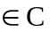 are collinear if and only if 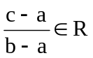, that is, if and only if 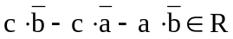.
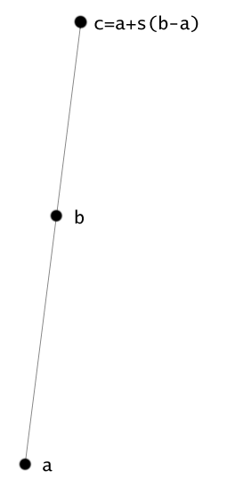

If then the equation 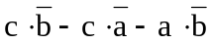 can be rewritten replacing c with 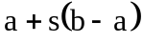:

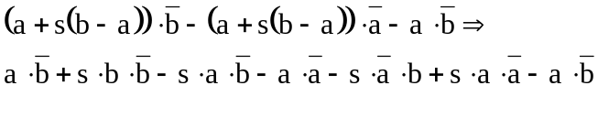
substitute the real components
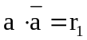, 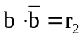, and 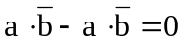:

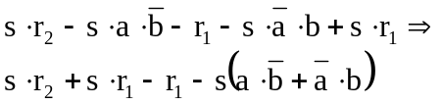

and by working out the math we see that 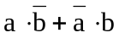 is always a real value:
.

Therefore,
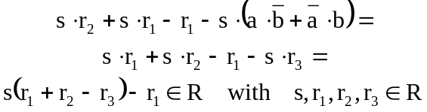.

We know that we can’t have one without the other, since if the three points are collinear and 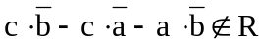, by the definition of collinear, the three points are linearly dependent, and so I can replace always replace c with , and I get the same reduction as above, , which is a contradiction. Going the other way will similarly result in a contradiction.

Therefore, we have shown that three numbers a, b, and c are collinear if and only if , AS DESIRED.

