 |  | Delamine B.V.
 |  | Oosterhorn 8
 |  | P.O. Box 87
 |  | 9930 AB DELFZIJL
 |  | The Netherlands
 |  | Telephone + 31 596 647800
 |  | Telefax + 31 596 610324
 |  | Bank ABN AMRO 428157270
 |  | KvK Groningen 02321186
 |  | BTW nr. NL003661386 B01

Date | Your reference | Our reference
Nov 29, 2010 |  | REACH/JBos

Subject : | REACH Registration/e-SDS

Dear Customer,

We are happy to inform you about Delamine’s progress towards REACH Registration. We hope and expect that the efforts will result in a better protection of people and environment. We timely submitted the dossiers of our substances to the European Chemicals Agency (ECHA) and the dossiers have been accepted. As a final step in the process we need to inform our customers about the result by sending the Electronic Safety Data Sheet (e-SDS). Please be aware that the e-SDS’s exist of 40 – 185 pages. For that reason we will only send the e-SDS’s by email.

We identified uses as indicated by customers as of December 1, 2009, and supplemented this information with data received later. In most of the cases we could determine a safe use situation exists. Please review the e-SDS to determine if your use has been identified.

At this point we can only provide an English version of the e-SDS. We are working to translate the e-SDS’s and will send them in your language in January 2011. E-SDS’s for custom made mixtures will be available in January 2011.

If you have any questions, please feel free to contact me.

Kind regards,
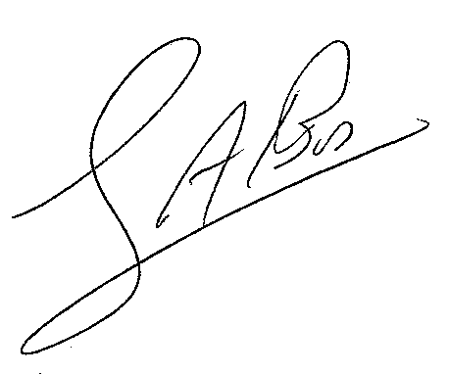

J.A. Bos
Manager Technology and Quality

