Tle

Table of Contents
1. Introduction 2
2. Prerequisites 2
3. Terminology 2
4. Understanding the TLE DLL 2
5. Working with Propagators 2
6. Two-Line Element Set (TLE) Data Description 3
5. TLE comma-separated-value (csv) Field Order/Description 13

1. Introduction
Two Line Elements (TLE) Version 8.0
Software developed and maintained by Air Force Space Command (AFSPC). Assistance can be requested at afspc.astrostandards@us.af.mil
Tle.dll provides many library functions to load and manage satellite element sets in two line element set format. The element sets are defined as Keplerian (North Aerospace Defense (NORAD) 2-Line MU-15) Two-Line Elements (TLE) including mean motion instead of the semi-major axis that is typical to a standard Keplerian element set. The two satellite element set formats that work with this Dynamic Link Library (DLL) are the mean NORAD Keplerian element set and the osculating NORAD Keplerian element set (see TLE Data Description section). Both types are referred to as a Two-Line Element set or a TLE in the Standardized Astrodynamic Algorithm (SAA) Library documentation.
The TLE DLL allows users to load/delete/update/parse two-line element sets.
The TLE Dynamic Link Library (DLL) is publically releasable and can be distributed/redistributed without the any license agreement.

2. Prerequisites
The following DLLs MUST be loaded and initialized before using the TLE DLL: DllMain, EnvConst, TimeFunc, and AstroFunc.

3. Terminology
Mean Keplerian element sets are referred as General Perturbations (GP) TLEs. GP TLEs include Simplified General Perturbations (SGP) TLEs (ephemeris type 0), and Simplified General Perturbations #4 (SGP4) TLEs (ephemeris type 2). Osculating Keplerian element sets are referred as Special Perturbations (SP) TLEs (ephemeris type 6).
In the SAA documentation, the terms "GP TLE", "SGP4 TLE", and "SGP4 satellite" are used interchangeably. Moreover, the terms "SP TLE" and "SP satellite" are used interchangeably. The term "satellite" is used to refer to satellites in general, and sometimes context is needed to know which type is being referred to.

4. Understanding the TLE DLL
The DLL stores each loaded TLE internally. Each TLE, when loaded successfully, will receive a unique key. This unique key is commonly called 'satKey' in the SAA documentation since TLE's represent satellites. The satKey is used to retrieve the TLE data.
Any SAA DLLs which work with TLEs, such as SGP4PROP.dll and SPPROP.dll, have access to the loaded data. Therefore, the associated TLE data can be retrieved throughout the SAA Library code via its satKey.

5. Working with Propagators
SGP and SGP4 TLEs only work with SGP4 propagator (SGP4PROP.dll).
SP TLEs only work with SP propagator (SPPROP.dll).

6. Two-Line Element Set (TLE) Data Description
1. NORAD 2-Line (MU-15) Element Set Format – SGP/SGP4
This section presents the format of the Two-line (also known as 2-Card) element set format as contained in CMOC MU15 messages. It is important to note that there are SP element sets which have superficially similar formats, but some of whose data fields (the drag terms, in particular) have different meanings than the MU15 case.
This MU15 format for an element set is widely used to contain SGP and SGP4 element sets. Only ephemeris types 0 (SGP) and 2 (SGP4) are allowed; this is the differentiation from the otherwise indistinguishable osculating Keplerian elements format described in the next section (for which ephemeris type is 6).
Element Set Line 1:
Column | Range | Format | Description
1 | 1 | I1 | element set line number 1
2 |  | 1X | blank column
3-7 | 1-99999 | I5 | satellite number
8 | U, C, S | 1X | security classification where:  U = unclassified  C = confidential  S = secret
9 |  | 1X | blank column
10-17 |  | A8 | internal designator
18 |  | 1X | blank column
19-20 |  | I2 | year of epoch, where;  50-99 = years 1950-1999  00-49 = years 2000-2049
21-32 |  | D12.0 | decimal day and time of epoch
33 |  | 1X | blank column
34-43 |  | D10.0 | n-dot/2 (for SGP, eph-type = 0)
44 |  | 1X | blank column
45-52 |  | D8.0 | n-double-dot/6 (for SGP, eph-type = 0)
53 |  | 1X | blank column
54-59 |  | F6.5 | B* drag component (to right of decimal)
60-61 | (-)1-9 | I2 | B* exponent
62 |  | 1X | blank column
63 | 0, 2 | I1 | ephemeris type  0 = SGP  2 = SGP4
64 |  | 1X | blank column
65-68 |  | I4 | element set number
69 |  | 1X | checksum (not used)
70 |  | I1 | FK4/FK5 flag; where 4=FK4; else = FK5
71-79 |  | 9X | not read (can be used to identify elset)
80 |  | A1 | blank (mandatory)
Key elements of this card are the B* drag term and the ephemeris type. The B* drag term is input in abbreviated notation in columns 54 through 61. This is short-hand notation for 0.nnnnnn x 10se, where nnnnnn is the data in columns 54 through 59, s is the exponent sign in column 60, and e is the exponent digit in column 61. Column 63 specifies the ephemeris type; the element set must have ephemeris type "0" (for SGP theory) or "2" (for SGP4 theory) in column 63. NORAD element sets are compatible with both SGP and SGP4. All element sets are transmitted by NORAD with "0" in column 63, but also include the SGP4 drag term (B*) in columns 54-59. The SGP4 program will automatically transform the SGP elements to SGP4 elements as follows:
(1) n-dot/2 and n-double-dot/6 are discarded;
(2) no is de-Kozai'd to compute a Brouwer mean motion.
All other orbital elements are used directly. Because column 80 is not used, but is an identifier, it must be blank, or SGP4 may mistakenly identify the line of data as another type of data card.
Element Set Line 2:
Column | Range | Format | Description
1 | 2 | I1 | line number (must be "2")
2 |  | 1X | blank column
3-7 | 1-99999 | 5X | satellite number (not used) (See Note 1.)
8 |  | 1X | blank column
9-16 | 0.0-180.0 | D8.0 | orbit inclination (degrees)
17 |  | 1X | blank column
18-25 | 0.0-360.0 | D8.0 | right ascension of ascending node (degrees)
26 |  | 1X | blank column
27-33 | 0-0.9999999 | F7.7 | eccentricity (leading decimal assumed)
34 |  | 1X | blank column
35-42 | 0.0–360.0 | D8.0 | argument of perigee (degrees)
43 |  | 1X | blank column
44-51 | 0.0-360.0 | D8.0 | mean anomaly (degrees)
52 |  | 1X | blank column
53-63 |  | D11.0 | mean motion no (revs/day)
64-68 |  | I5 | epoch rev (not used)
69 |  | 1X | checksum (not used)
70-79 |  | 10X | not read
80 |  | A1 | blank (mandatory)
As in the format for line 1, column 80 must be blank to keep SGP4 from incorrectly identifying this line as another type of input card.
Note 1: The satellite number in lines 1 and 2 are not required to match. In the past, these were used to keep pairs of physical punch cards together. Once this became obsolete, this field and the adjacent blank columns in line 2 began to be used by other applications for other purposes. For this reason, the satellite number field in line 2 is simply not looked at by SAAs input routines. The output routines will populate the line 2 field to match that in line 1.
Example of a TLE (SGP):
Copy
1 90021U RELEAS14 00 51.47568104 .00000184 0 0 -1234-4 814
2 90021 0.0222 182.4923 0000720 45.6036 131.8822 1.00271328 1199

Example of a TLE (SGP4):
Copy
1 5U 58002B 00081.96390402 +.00000364 +00000-0 +43727-3 2 0460
2 5 034.2549 288.8006 1858938 253.4906 085.4246 10.8236544440306

2. NORAD 2-Line (MU-15) Element Set Format – SGP4-XP
Element Set Line 1:
Column | Range | Format | Description
1 | 1 | I1 | element set line number 1
2 |  | 1X | blank column
3-7 | 1-99999 | I5 | satellite number
8 | U, C, S | 1X | security classification where:  U = unclassified  C = confidential  S = secret
9 |  | 1X | blank column
10-17 |  | A8 | internal designator
18 |  | 1X | blank column
19-20 |  | I2 | year of epoch, where;  50-99 = years 1950-1999  00-49 = years 2000-2049
21-32 |  | D12.0 | decimal day and time of epoch
33 |  | 1X | blank column
34-43 |  | D10.0 | N/A
44 |  | 1X | blank column
45-52 |  | D8.0 | agom (m2/kg)
53 |  | 1X | blank column
54-59 |  | F6.5 | ballistic coefficient (m2/kg) (B term)
60-61 | (-)1-9 | I2 | B term exponent
62 |  | 1X | blank column
63 | 0, 2 | I1 | ephemeris type (must be 4)  4 = SGP4-XP
64 |  | 1X | blank column
65-68 |  | I4 | element set number
69 |  | 1X | checksum (not used)
70 |  | I1 | FK4/FK5 flag; where 4=FK4; else = FK5
71-79 |  | 9X | not read (can be used to identify elset)
80 |  | A1 | blank (mandatory)

Element Set Line 2:
Column | Range | Format | Description
1 | 2 | I1 | line number (must be "2")
2 |  | 1X | blank column
3-7 | 1-99999 | 5X | satellite number (not used) (See Note 1.)
8 |  | 1X | blank column
9-16 | 0.0-180.0 | D8.0 | orbit inclination (degrees)
17 |  | 1X | blank column
18-25 | 0.0-360.0 | D8.0 | right ascension of ascending node (degrees)
26 |  | 1X | blank column
27-33 | 0-0.9999999 | F7.7 | eccentricity (leading decimal assumed)
34 |  | 1X | blank column
35-42 | 0.0–360.0 | D8.0 | argument of perigee (degrees)
43 |  | 1X | blank column
44-51 | 0.0-360.0 | D8.0 | mean anomaly (degrees)
52 |  | 1X | blank column
53-63 |  | D11.0 | mean motion no (revs/day) (Brouwer)
64-68 |  | I5 | epoch rev (not used)
69 |  | 1X | checksum (not used)
70-79 |  | 10X | not read
80 |  | A1 | blank (mandatory)

Example of a TLE (SGP4-XP):
Copy
1 41085U GPDC 19001.16111410 +.00000000 64817-1 25579 0 4 0001
2 41085 98.8405 84.6159 0030231 128.2631 288.8143 14.1732257715999

2. Osculating Keplerian Elements
This section presents the format of the osculating Keplerian elements. The format to input osculating Keplerian elements is nearly identical to the two-line element set format used for SGP and SGP4. The primary differences are:
- the osculating Keplerian element format is ephemeris type 6
- a true ballistic coefficient is used and is read from the SGP n-dot/2 location.
The following text elaborates on the format where necessary to explain the corresponding osculating Keplerian element format.
Osculating Element Set Line 1:
Column | Range | Format | Description
1 | 1 | I1 | element set line number 1
2 |  | 1X | blank column
3-7 | 1-99999 | I5 | satellite number
8 | U, C, S | 1X | security classification where:  U = unclassified  C = confidential  S = secret
9 |  | 1X | blank column
10-17 |  | A8 | internal designator
18 |  | 1X | blank column
19-20 |  | I2 | year of epoch, where;  50-99 = years 1950-1999  00-49 = years 2000-2049
21-32 |  | D12.0 | decimal day and time of epoch
33 |  | 1X | blank column
34-43 |  | D10.0 | ballistic coefficient (m2/kg) (BTerm)
44 |  | 1X | blank column
45-52 |  | D8.0 | outgassing parameter/Thrust Acceleration (m/s2)
53 |  | 1X | blank column
54-59 |  | F6.5 | agom (m2/kg)
60-61 |  | I2 | agom exponent
62 |  | 1X | blank column
63 | 6 | I1 | ephemeris type (must be 6)
64 |  | 1X | blank column
65-68 |  | I4 | element set number
69 |  | 1X | checksum (not used)
70 |  | I1 | FK4/FK5 flag; where 4=FK4; else = FK5
71-79 |  | 9X | not read (can be used to identify elset)
80 |  | A1 | blank (mandatory)
Key elements of this card are the ephemeris type and the ballistic coefficient. The ballistic coefficient (BTerm) used by SP is not the SGP4 B-star. The true ballistic coefficient in columns 34-43 is CDA/m where CD is the coefficient of drag, and A and m are the average cross-sectional area (m2) and the mass (kg) of the satellite, respectively. Column 63 specifies the ephemeris type; osculating Keplerian element sets must have ephemeris type “6” in column 63 to be compatible with SP format. The solar radiation pressure coefficient in m2/kg (agom) can be input via columns 54-61. Because column 80 is not used, but is an identifier, it must be blank, or SP may mistakenly identify the line of data as another type of data card.
Osculating Element Set Line 2:
Column | Range | Format | Description
1 | 2 | I1 | line number (must be "2")
2 |  | 1X | blank column
3-7 | 1-99999 | I5 | satellite number (not used)
8 |  | 1X | blank column
9-16 | 0.0-180.0 | D8.0 | orbit inclination (degrees)
17 |  | 1X | blank column
18-25 | 0.0-360.0 | D8.0 | right ascension of ascending node (degrees)
26 |  | 1X | blank column
27-33 | 0-0.9999999 | F7.7 | eccentricity (leading decimal assumed)
34 |  | 1X | blank column
35-42 | 0.0–360.0 | D8.0 | argument of perigee (degrees)
43 |  | 1X | blank column
44-51 | 0.0-360.0 | D8.0 | mean anomaly (degrees)
52 |  | 1X | blank column
53-63 |  | D11.0 | mean motion (revs/day)
64-68 |  | I5 | epoch rev (not used)
69 |  | 1X | checksum (not used)
70-79 |  | 10X | not read
80 |  | A1 | blank (mandatory)
Unlike the averaged orbital elements of SGP and SGP4, the elements listed above are osculating elements; they describe the true state of the satellite at epoch. As in the format for line 1, column 80 must be blank to keep SP from incorrectly identifying this line as another type of input card.
Example of a TLE (SP):
Copy
1 17302U 90 85.76554416 0.00000000 00000 0 00000 0 6 486
2 17302 6.3392 234.9188 3057446 205.3727 135.9681 9.52061962 4853

5. TLE comma-separated-value (csv) Field Order/Description
The Version 8 Astro Standards have been updated to accept various fundamental data types in comma-separated value format. This includes Observations and Element Sets for Release 8.0. For the next Release 8.1, external ephemeris files will also be accepted in csv format. Figure 1 provides the listed data order and data descriptions for csv Element Sets.

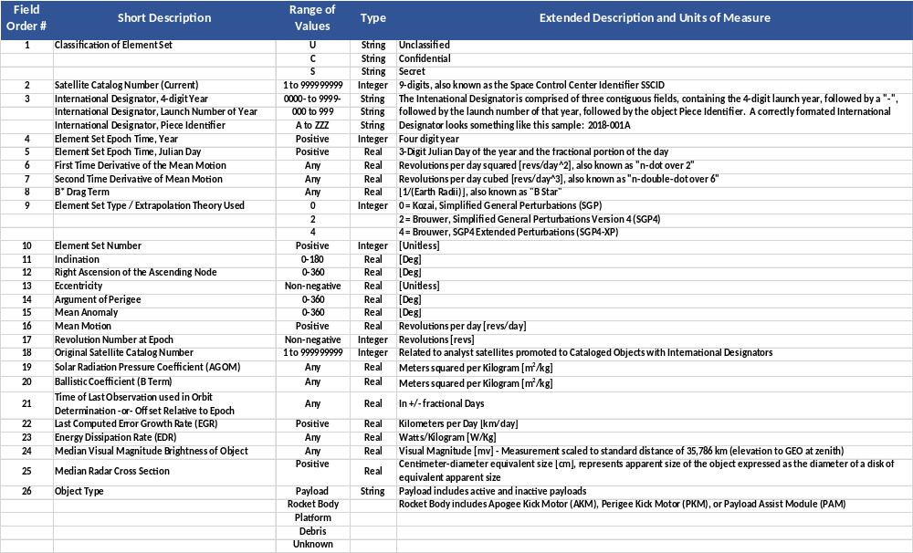
Figure 1. TLE comma-separated-value (csv) Field Order/Description

