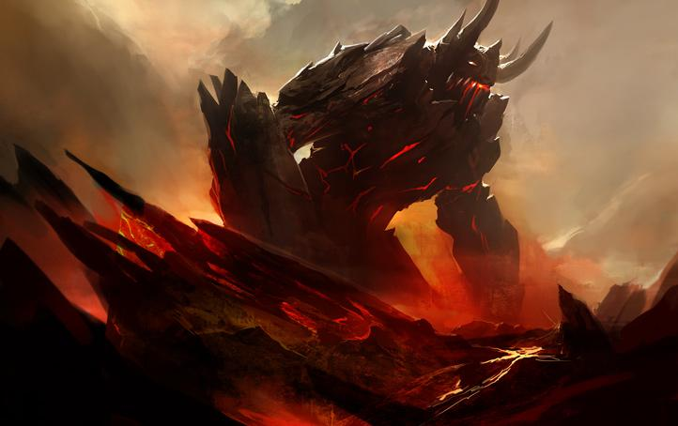**Game Overview**

You are a colossal monster who recently awoken from it’s millenia rest. The world is ravaged by other creatures and the civilizations of man have barely been able to survive by training heroic monster hunters or making alliances with the beasts themselves for protection. This is the beginning of your reign, it’s your choice how to take over the lands!

**Game Basics**:

The player picks one of the core races available in the game; a gigantic creature of improbable power. The player takes control of this being and from there works to increase their hoard and their domain, gaining followers and power as their influence goes. The game is split into three primary parts: an economic manager game where the player manages their cities and their people, combat where the player makes war with other civilizations or monsters, and an rpg where they can use their tribute and hoard to augment their own power. There is also a moral system in the game, where by being good aligned the player can gain tribute and worship by lesser races, as well as being able to make allies with other cities. By being evil and destructive, the player could just simply take what they want, but this will earn them quite a few foes, but the fear instilled could be a powerful weapon, increasing the chance the enemy may just surrender.

(more to come as more ideas come)

**Core Races**

Dragon - The rarest of all colossal creatures, the dragons gain power from their age and their horde. It’s magical abilities come into fruition upon the turn of their first century. They can cross land at great speeds and consume entire towns with their breath.

Giant - Gigantic humanoids of impressive intellect and martial skill, giants gain power from their equipment and their followers. Giants are schooled in the skill of smithing, and with time and training their fortress and their civilization can reach great technological heights.

Behemoths (or Colossi) - Primal being from another time, the behemoths are creatures composed almost entirely of non-living matter; stone, ice, magma, a few other types have been known. They are slow and deliberate, but their advance is inexhorable. They also have an uncanny power for manipulating the land itself, and gain power the larger their domain. Lesser beings typically worship these creatures as gods, which in turn can cause their power to increase dramatically.

**Follower Types**

* Dragon
  + Kobolds - Weak little creatures, they nonetheless possess an uncanny knack for the arcane, as well as for building and maintaining a lair
* Giant
  + Man - A lost tribe of men who dedicated their life to the giant. They are fierce and willful, and will be of great use to the venerable giant.
* Behemoth
  + Lesser elementals - Beings that spawned from the behemoth’s own magical energy, lesser elementals are exceptionally tough, but alas are not much good for growing and developing their master’s domain.

**Stats Breakdown**

*Strength*

* Strength governs physical might. While being a giant creature means your strength is well and beyond the realm of the mortals, against the other titanic creatures your strength may not match up well. Strength can also possibly determine the amount of treasure you could carry at a time, as well as opening up various ways to manipulate the land in a more mundane way.

*Magic*

* Magic encompasses how strong your spells are, what spells you are able to acquire, and the duration they last. It also governs your Intelligence. The higher you magic, the more new inventions your followers can create.

*Defense*

* Defense simply determines how much of a beating you can take before falling. While gigantic creatures like yourself are nigh impervious to the little arrows and swords of men, catapults, ballistae and other heavier weaponry still can puncture your thick hide. More defense, the harder it is for you to meet an early end.

*Speed*

* Speed determines your ability to move through your domain, as well as outside of your domain. It also affects how fast you are to deliver multiple blows.

*Size*

* Size is a measure of your titanic form. Size determines your reach, your majesty, and can even influence your dealing with the lessers. Your size also can determine your maximum area of influence (bigger creatures command bigger land, after all)

|  |  |
| --- | --- |
| Stat | Height (ft) |
| 0 | 40 |
| 1 | 50 |
| 2 | 70 |
| 3 | 100 |
| 4 | 140 |
| 5 | 190 |
| 6 | 250 |

*Hoard*

* Wealth - This is the primary currency you use to upgrade yourself. With wealth you can buy increases in your base stats, as well as purchase other armies, conduct treaties.
* Followers - Your followers need paid, and so the larger your hoard, the larger the forces you can yield. Beware, losing hoard can cause your army forces to dwindle as the money dries up.

*Domain*

* Your domain stat determines the power and influence you have within your domain. The higher this stat, the more power you command within the realm. (not sure)

Base Stats before subtype modifiers are applied

|  |  |  |  |
| --- | --- | --- | --- |
|  | Dragon | Giant | Behemoth |
| Strength | 2 | 3 | 2 |
| Magic | 3 | 1 | 2 |
| Defense | 1 | 2 | 3 |
| Speed | 3 | 2 | 1 |
| Size | 1 | 2 | 2 |
| Hoard | 3 | 2 | 1 |
| Domain | 1 | 2 | 3 |

Sub-Class

* Dragon
  + Gold
    - Elementally attuned to flame.
    - +1 hoard follower, domain
    - -1 Magic, Defense
  + Silver
    - Elementally attuned to cold
    - +1 to magic, speed
    - -1 Strength
  + Onyx
    - Elementally attuned to electricity
    - +1 to strength, defense
    - -1 Speed
* Giant
  + Storm
    - Attuned to electricity
    - +1 hoard, magic
    - -1 Strength
  + Mountain
    - Attuned to flame
    - +1 Strength, Speed
    - -1 Magic
  + Frost
    - Attuned to cold
    - +1 Magic, Defense
    - -1 Speed
* Colossus (non-bipedal creature possibly)
  + Magma
    - Elementally attuned to flame
    - +1 Speed, Magic
    - -1 Defense
  + Stone
    - Elementally attuned to electricity
    - +1 Size
    - -1 Speed
  + Ice
    - Elementally attuned to cold
    - +1 Magic, Defense
    - -1 Strength

Elemental Attunement

Elemental attunement determines the type of spells the creature can bring to bear against his foes. Flame attuned creatures have more aggressively oriented spells, ice spells are more defensive and supportive, and electricity is a balance between the two.

**Spells and Magic**

Gigantic creatures from time immemorial have an innate source of magic that can manifest in multiple ways. A creature’s magic score indicates which spells a creature can use, as well as determines the potency of their effects. I.E Fireball is a Magic 1 Spell. A creature has to have at least magic 1 to cast the spell.

**Flame Magic**

Magic 1 Spells

* Fireball - Deals Flame damage in an area (25 ft * magic level radius)
* Immolate - Causes damage over time in an area
* Flaming Blows - Augments physical attacks with fire damage

Magic 2 Spells

* Flame Strike - Deals Flame damage in a large area, ignites the ground for a time (50 ft * magic level radius)
* Detonate - Causes the target to explode in fiery energy
* Heart of Flame - Increases morale, defense, and magic for allied troops for a time

Magic 3 Spells

* Conflagration - The skies burn with fire, dealing constant fire damage around the caster for a short amount of time (25 ft * magic level radius)
* Magma burst - The ground erupts in molten magma, dealing damage for a time and slowing targets down. Deals bonus damage to buildings
* Sirocco - Flaming winds buffet the targets, reducing damage dealt and dealing fire damage.

Magic 4 Spells

* Summon Fire Elemental - Summons a squad of flame elementals for a short amount of time
* Sirocco - Flaming winds buffet the targets, reducing damage dealt and dealing fire damage.

**World**

The world of Behemoth Lords is a world at war. Towns and cities pit themselves against one another in fleeting displays of conflict, while the great beasts that preside over the lands vie for domain and tribute over the mortal races.

* Civilizations
  + Nations
    - Nations are the larger domains owned by the great beasts. Everything within the boundaries of a nation are in turn owned by that nation (i.e. a city within your realm of influence is considered owned by you)
    - Cities (and to a lesser extent, towns) can extend your nation’s boundaries and so can allow you to increase your domain.
    - Great beasts each have their own domain, and are treated as their own nation
  + Cities
    - Cities are governed by their lords and ladies, who dictate policies for the surrounding towns and area around a given city’s realm. A great beast, through intimidation or diplomacy, can force the rulers of these cities to bend to their will, and so can influence the city’s direction
      * Ex. A dragon wants more military production from a city, and so demands a city to focus on military production
    - Cities supply the largest amount of tribute to the great beast that rules over them
  + Towns
    - Towns are miniature cities. Small pockets of population, towns can gather resources and grow in population, and can eventually grow into a city when the population hits a critical mass
  + Monster Tribes
    - Monster tribes are special areas found in the game that allow a titanic creature to recruit special forces, from Ogres to Griffons to dryads. Each of these monster troops provides a special benefit to the overall forces of whoever owns their allegiance
* Resources - These are the naturally occurring trade goods that exist throughout the world. Any such good within your domain are at your disposal.
  + Gold
    - This is strictly tied to your wealth and as such, the wealth of your nation. The more gold you have the more powerful you are.
    - Gold can be found within mountains, in trade, and in raids.
    - Gold is the primary resource, as the player can determine whether the gold they earn will go into the coffers of the nation itself, or into their hoard
  + Lumber
    - Lumber is used to construct towns for your followers to live in
    - Lumber is gained through owning forests, trade, and in destroying other towns.
  + Food
    - Your people need to eat so they must have a food supply. If you want more followers than you have to be able to feed them.
    - Food can be gained by allied nations giving tribute, trade, farm land, plains, water sources.
  + Ore
    - To turn a town into a city, you must have ore. To craft better weapons you must have ore. Creating siege weapons also requires ore, as well as various city upgrades (?)

**Game Modes**

* Domain Management
  + City management
    - Determine policies for a given city
      * Tribute of the City (pick two)
        + Gold
        + Lumber
        + Food
        + Ore
      * General stances (aggressive, defensive)
  + Nearby nations
    - Diplomacy or Intimidation
      * Can demand tribute, make trade agreements (think Civ ‘cause that’s a good system)
      * Declare war
    - Treaties
      * You can
* Combat