R. Nate Crummett

rncrummett5@gmail.com

Processing Resistivity and IP Data  
ABEM TERRAMETER

Applied Geophysics, University of Nevada Reno

**Table of Contents**

**Table of Figures** 2

**Terameter** 4

Terameter Settings Adjustment 4

***Speeding Up Surveys*** 4

***Increasing Data Quality*** 4

***Setting amount of IP Collection Windows*** 4

Transferring Data to from ABEM to USB Stick 6

**Processing Data in LS Toolbox** 7

Download Hyperlink for LS Toolbox 7

***Opening Project*** 7

Contact Resistance Plots 8

Processing Resistivity Data 9

***Check column ‘Pext(V)’*** 9

***Filter column ‘Var(%)’*** 9

***Filter column ‘Rho-a(Ohm-m)’*** 10

***Filter ‘U(V)’*** 10

Why Didn’t We Filter Any IP Data in LS Toolbox? 11

Exporting Filtered Data 11

**Inverting Data in RES2DINV** 13

Reading in Data 13

Finding the Help Manual 15

Inverting Pseudo Section 16

Evaluating IP Data 17

**Displaying and Exporting Data in RES2DINV** 19

Displaying Model Cross Sections 19

Normalizing Color Ramps 20

Exporting Cross Sections 24

**Acknowledgements** 26

# **Table of Figures**

Figure 1: Three IP decay curves for the first data point in the pseudosection. The blue boxes underneath the blue curve approximate the area under the curve. The width of these boxes are all equal. 4

Figure 2: File tab -> New Project Group 6

Figure 3: Project Group -> Add Project... 7

Figure 4: Viewing electrode contact test 8

Figure 5: Opening table in LS Toolbox 9

Figure 6: View of table in LS Toolbox. Column 'Rho-a(Ohm-m)' is sorted decreasing. There are no outliers. 10

Figure 7: Full waveform of output voltage visualized. This orange line is the Tx Voltage, transmitted voltage. The jaggedness represents the noise, and amplitude might be though of as maximum vertical distance from the average value. 11

Figure 8: Exporting visible data. 'Filetype' in the upper right-hand corner is where to select Res2Dinv (.dat) format 12

Figure 9: Read in .DAT file to RES2DINV 13

Figure 10: Examine .DAT file information for accuracy 14

Figure 11: Location o help manual. Help -> Help 15

Figure 12: Run inversion. Inversion -> Carry out inversion 16

Figure 13: Displaying the inversion results. Display -> Show inversion results 17

Figure 14: In display window, display the RMS error statistics. Edit data -> RMS error statistics 18

Figure 15: RMS error statistics 19

Figure 16: Display inversion results. Display -> Show inversion results 20

Figure 17: Display the inversion results. Display sections -> Model display -> Include topography in model display 21

Figure 18: User defined logarithmic contour intervals. For resistivity model 22

Figure 19: Manually adjust the minimum contour value and contour increase factor 23

Figure 20: Export contour values as file, to be used with other models. Display sections -> Model display -> Save contour values 24

Figure 21: Now users can access the predefined contour values for other inversion results 25

Figure 22: Select file type for export. Print -> Select type of bitmap graphics format 26

Figure 23: Export the file in bitmapped format. Print -> Save screen as bitmapped graphics file 27

# **Terameter**

## Terameter Settings Adjustment

Settings should be adjusted before the survey.

This section is general advice, and should not be taken as gospel – the geologic setting and survey goals always determine what settings should be applied, and to what degree they should be applied.

### ***Speeding Up Surveys***

100% IP Duty Cycle should be used for resistivity and IP surveys. This significantly reduces the acquisition time, while retaining data quality. This [link](https://www.youtube.com/watch?v=CeHSZonegxM&t=2404s) will take you to an explanation of the 100% Duty Cycle by Jimmy Adcock, an ERT expert.

### ***Increasing Data Quality***

For both resistivity and IP data collection, increasing the acquisition time allows for better repeatability. This gives the stacking a better chance to average noise out.

Increasing the delay time between acquisition periods also improves data quality. This gives the ground a longer time to charge up and reach the steady state voltage we would like to measure.

For more, I refer you to [another](https://www.youtube.com/watch?v=TYWKs7iLXKY&t=3929s) Jimmy Adcock explanation.

### ***Setting amount of IP Collection Windows***

To measure the IP effect (chargeability, the ability of certain materials to let go of charge slowly) the ABEM measures the area under an IP decay curve. To do this, we measure certain windows – they approximate the area under the curve.

The boxes, which ABEM calls windows, might look something like this for the blue curve (ignore the other channels for the time being).

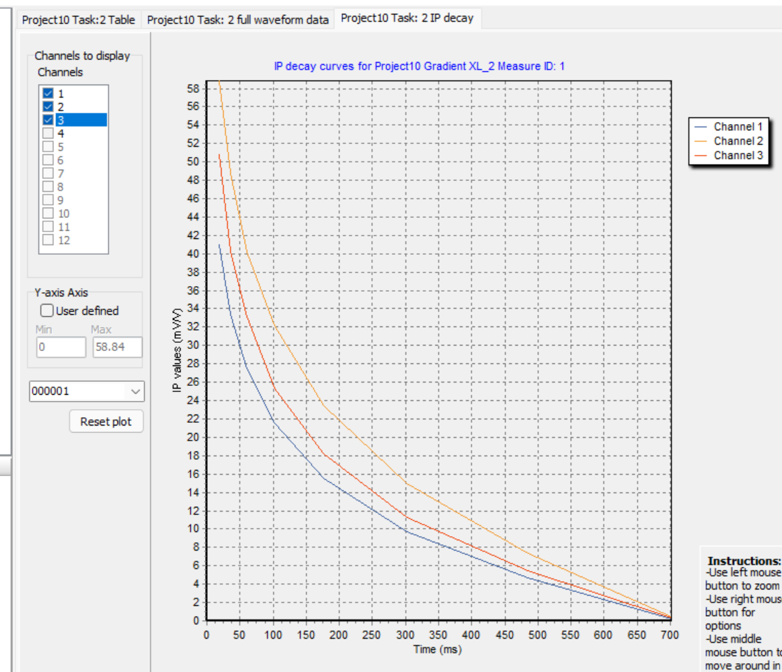

Figure 1: Three IP decay curves for the first data point in the pseudosection. The blue boxes underneath the blue curve approximate the area under the curve. The width of these boxes are all equal (150 ms)

Increasing the number of windows makes the estimation better. However, the more windows we have the narrower they become, and the accuracy of measurements is lowered. So, there is a balancing act that needs to be conducted between resolving the curve (decreasing window width) and retaining confidence in ability to measure (increasing window width).

*Notice that an infinite number of windows, all infinitely thin, would give the exact area under the curve – this is the classic definition of an integral.*

Additionally, IP quickly falls off with time - notice the horizontal axis is not even a whole second long, and the IP decay curve approaches zero. Measurement windows that are closer to the level of noise become less reliable. As a result of the decaying nature of IP, the quality of the final windows will be the poorest. It is a common to get negatives/unreliable data in the final windows.

## Transferring Data to from ABEM to USB Stick

Data can be pulled directly from the Terameter LS Toolbox with a USB Stick.

Insert the USB Stick directly into the Terameter LS Toolbox. Make sure the data you would like to access is not in the ‘active’ or ‘current’ project. The in the projects tab, select the project you would like to export.

This should export all of the tasks in the selected project out in a data base file (.db) format. This type of file can be processed in Terameter LS Toolbox.

**Common Issue:** You cannot directly export the Task – the entire Project must be exported. This is the only way to get the proper file type onto a USB-stick

# **Processing Data in LS Toolbox**

## Download Hyperlink for LS Toolbox

This [link](https://www.guidelinegeo.com/support-service-advice-training/resource-center/) should take you to the download of the latest software, if you do not already have it installed. There is also plenty of useful reference guides there.

### ***Opening Project***

Select the **‘File’** tab. Then select **‘New Project Group’** to prepare a project group for the project.

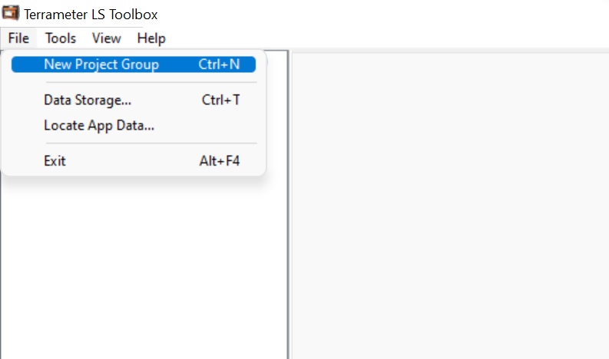

Figure 2: File tab -> New Project Group

Left click on the new project group and add a new project.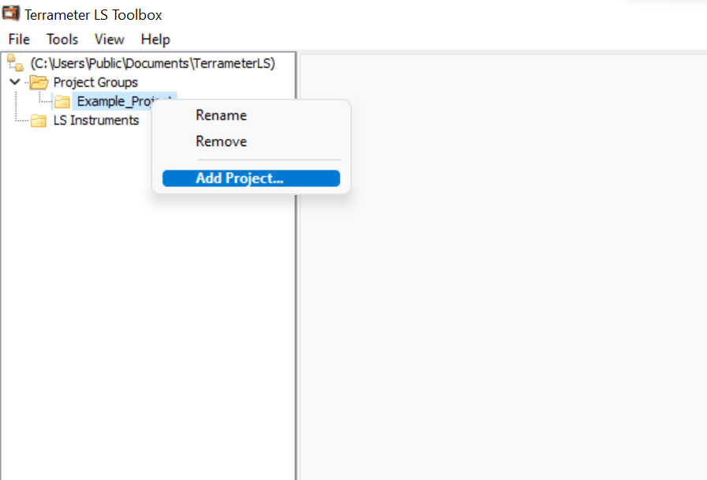

Figure 3: Project Group -> Add Project...

Now add the data base file (.db) that is on the USB device. Now the project should be in LS Toolbox.

## Contact Resistance Plots

Right click the line of choice. Select **‘Electrode Contact Test’**.

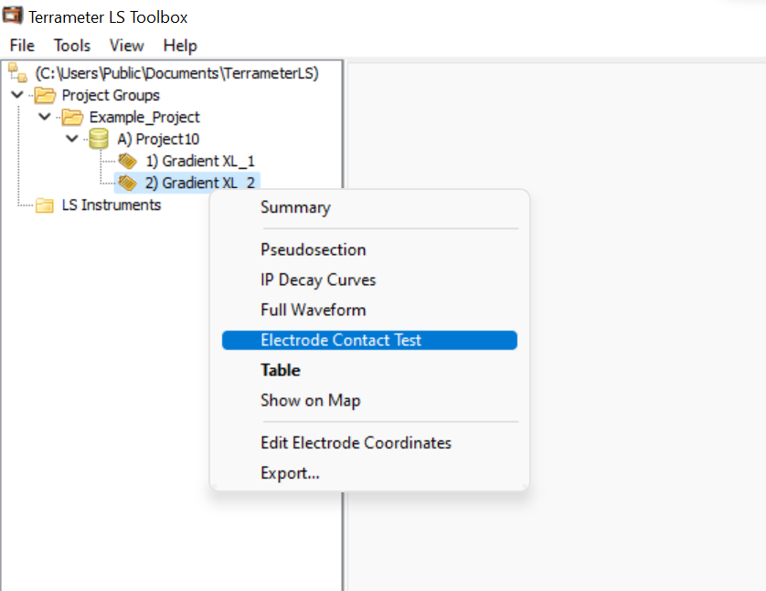

Figure 4: Viewing electrode contact test

To export the figure as a .PNG, simply right click on the resulting figure and select the export option.

## Processing Resistivity Data

Right click the line of choice. Select **‘Table’**. This is where the data is processed.

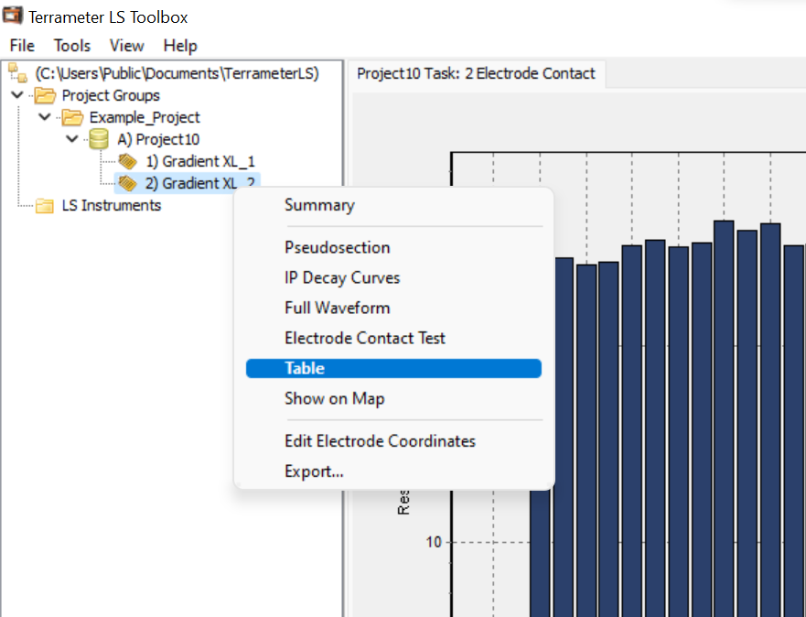

Figure 5: Opening table in LS Toolbox

What follows are the basic steps to terameter data processing:

### ***Check column ‘Pext(V)’***

Terameter LS sorts the data according to the column header last clicked. It will first sort the data increasing, then decreasing, then increasing, etc. This is pretty standard. Make sure the highest and lowest values are not far from 12V, if you are using a 12V battery.

*This is the external voltage column. It reports what the car battery is at. Make sure it is not wildly different. Jimmy Adcock from ABEM says that most failed surveys are the result of old or unreliable external voltage sources.*

### ***Filter column ‘Var(%)’***

A good rule of thumb is to throw out anything with a variance higher than 1%, unless the survey is in a relatively noisy environment.

To filter data, first sort it in descending order by clicking on the column name. Then select the columns to filter. Right click the selection, and click **‘Filter data point(s)’**

*Variance is a measure of the confidence in each individual data point. High variance is usually a sign of poor quality, while low variance is a sign of good quality. Low variance implies the measurements being stacked are repeatable – not necessarily reasonable. A poorly designed survey can have repeatable resistivity measurements.*

### ***Filter column ‘Rho-a(Ohm-m)’***

Check the apparent resistivity column for outliers, and filter them. Also check for negatives, and filter them as well. In the example photo, nothing needs to be filtered.

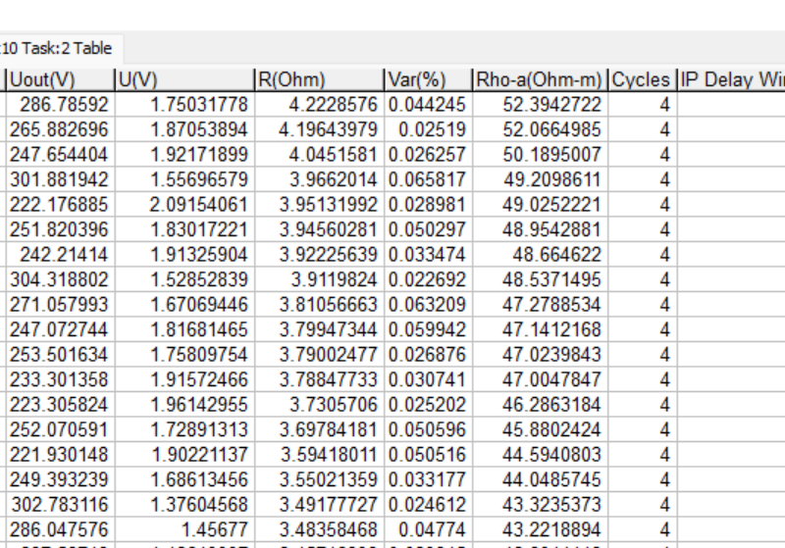

Figure 6: View of table in LS Toolbox. Column 'Rho-a(Ohm-m)' is sorted decreasing. There are no outliers.

*Outliers probably represent poor data. The cutoff for outliers is up to the data processor – culture and geology should be considered.*

*In a geologic setting, negative apparent resistivities are usually impossible – theoretically, crazy subsurface geometries can cause negatives in certain array types.*

### ***Filter ‘U(V)’***

This is the most advanced step I will include – do not worry if you do not get it. It normally does not matter too much.

To estimate the noise level, open up the **‘Full Waveform’** tab of your data. The zoom in to the **‘Tx Voltage’** line, in the **‘Output Voltage’** view. The amplitude of the squiggles is the noise level to remember. Here it is approximately 0.25 V.

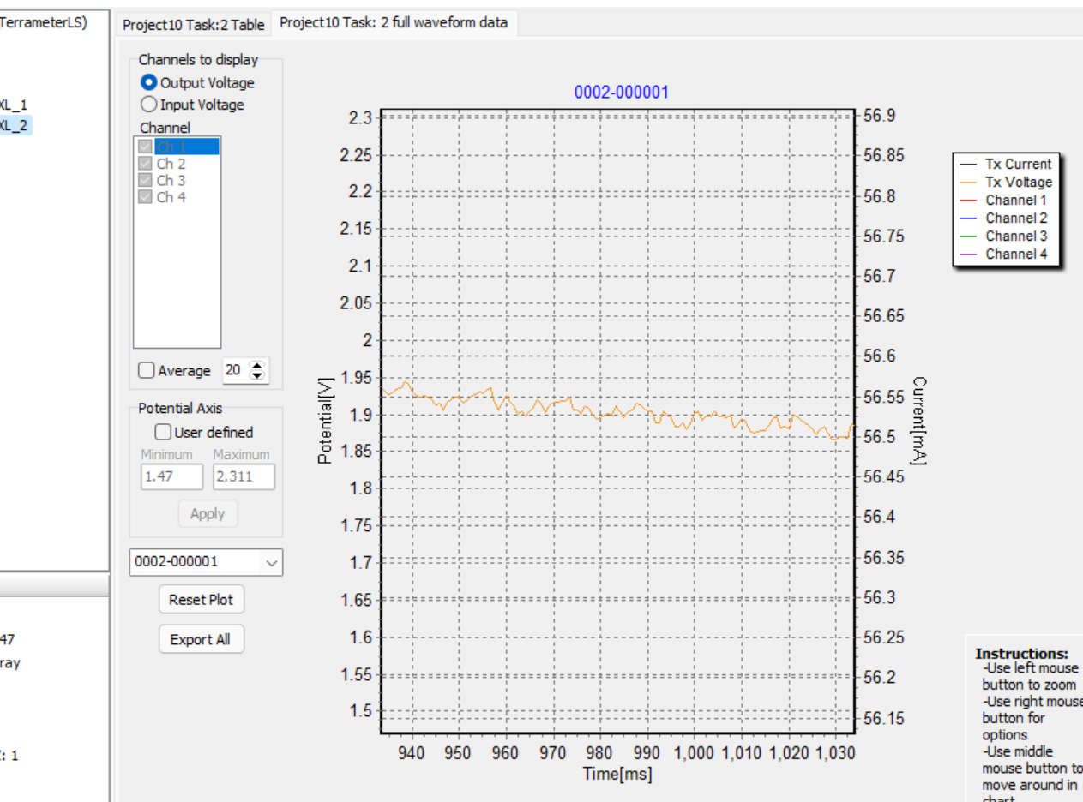

Figure 7: Full waveform of output voltage visualized. This orange line is the Tx Voltage, transmitted voltage. The jaggedness represents the noise. The amplitude here is approximately 0.025 V

With this value in mind, go back to the table and sort the **‘U(V)’** column to find the minimum voltage measured. If there are any below the minimum noise level, they can be filtered.

*When the voltage measured is below the noise value for a given sight, we cannot trust the data. It might be white noise, or signal from the band pass filters leaking through.*

## Why Didn’t We Filter Any IP Data in LS Toolbox?

Bad resistivity data always leads to bad IP data. But bad IP data does not necessarily mean that the resistivity data is bad.

Since LS Toolbox does not allow separate filtering of resistivity and IP, take as much good resistivity data as we can, and bite the bullet with IP. This process minimizes the amount of good data that might be wasted, while removing the data we are most confident is incorrect.

Unreliable/impossible IP data can be filtered later in RES2DINV.

## Exporting Filtered Data

In the **‘Table’** tab, right click the table of filtered values. Click the option **‘Export Visible’** option to export data.

Make sure the **‘Filetype’** is in RES2DINV (.dat) format. This allows the RES2DINV software to access the data easily. Unless you prefer to change other settings, usually exporting with default settings is fine.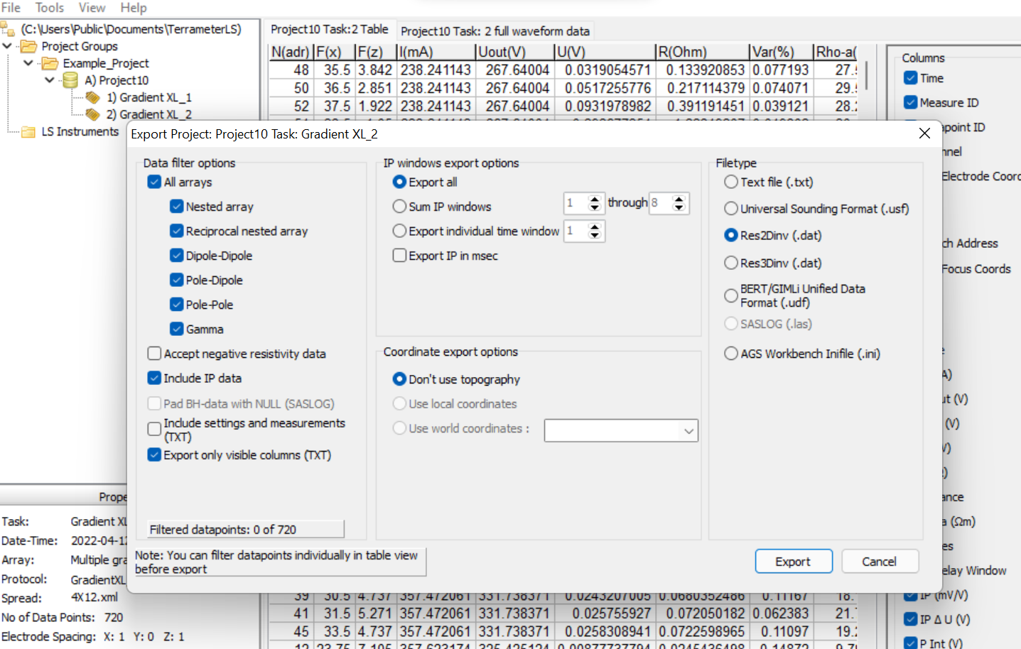

Figure 8: Exporting visible data. 'Filetype' in the upper right-hand corner is where to select Res2Dinv (.dat) format

# **Inverting Data in RES2DINV**

## Reading in Data

In RES2DINV, find the **‘File’** tab in the upper left-hand corner. Select **‘Read data file’** to read the .DAT file into RES2DINV

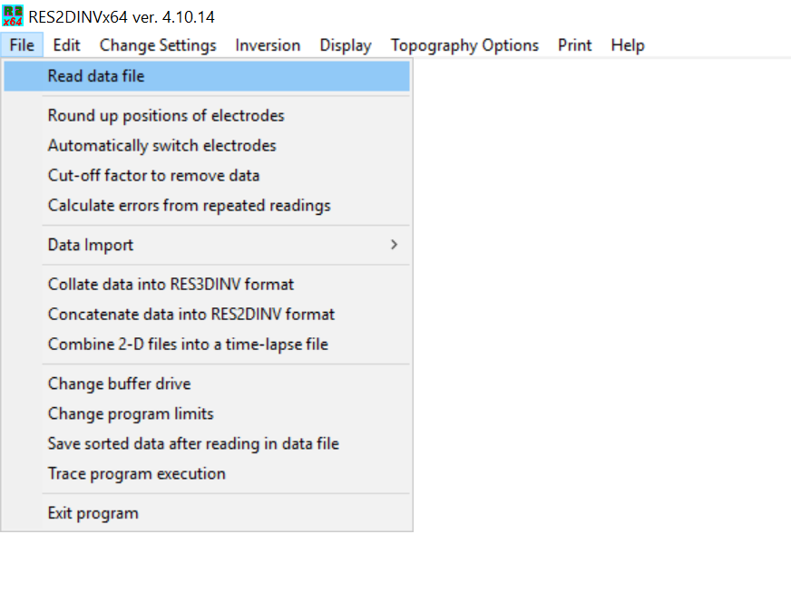

Figure 9: Read in .DAT file to RES2DINV

Once the .DAT file is in, a confirmation window will appear. Before clicking **‘OK’**, scan the information displayed – make sure the number of electrodes, electrode spacing, and survey type are what you expect them to be.

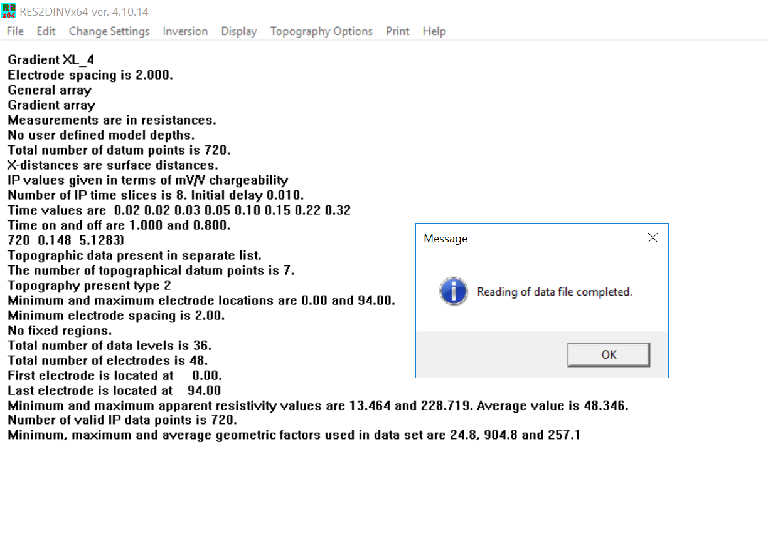

Figure 10: Examine .DAT file information for accuracy

## Finding the Help Manual

One of the best things about RES2DINV is how the program explains things. Often, the program will justify its recommendations by referring users to the help manual.

On the upper bar, find the **‘Help’** tab. Within the drop down, the **‘Help’** option will take you to the user manual. This explains everything you could ever want to do.

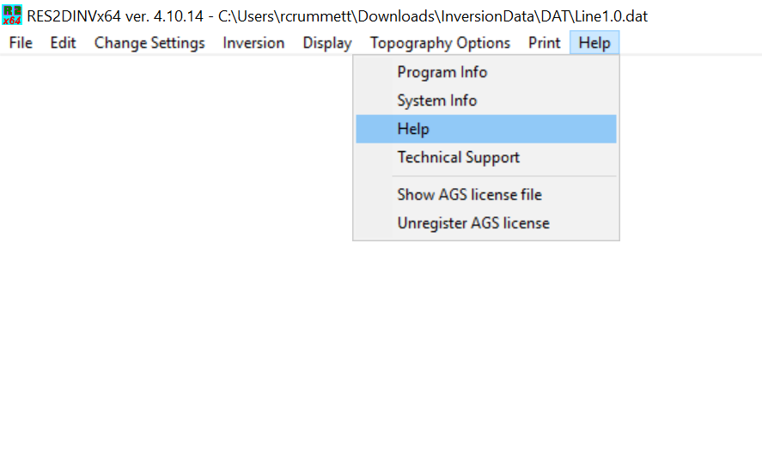

Figure 11: Location o help manual. Help -> Help

*This help manual will answer any question that ever comes up, if you care to read it.*

## Inverting Pseudo Section

Once you have set parameters for the inversion – half-width spacing, topography dampening, robust inversion (see the help manual for details) it is time to invert the pseudo sections.

In the upper tab, find **‘Inversion’**. To run the inversions, click **‘Carry out inversions’**. This will invert both the resistivity and IP data until a suitable RMS error difference is achieved, or the maximum number of inversions is completed (or the model diverges ☹).

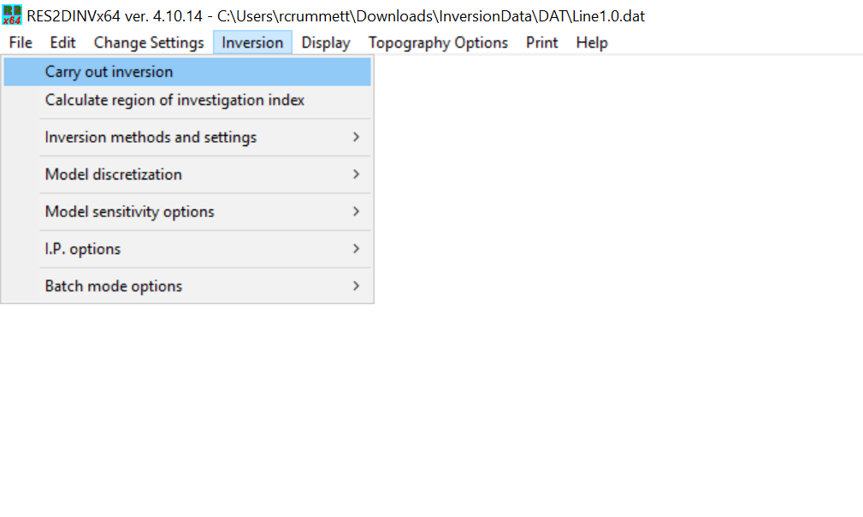

Figure 12: Run inversion. Inversion -> Carry out inversion

## Evaluating IP Data

IP data can be filtered in the display window.

Select **‘Display’** then **‘Show inversion results’**.

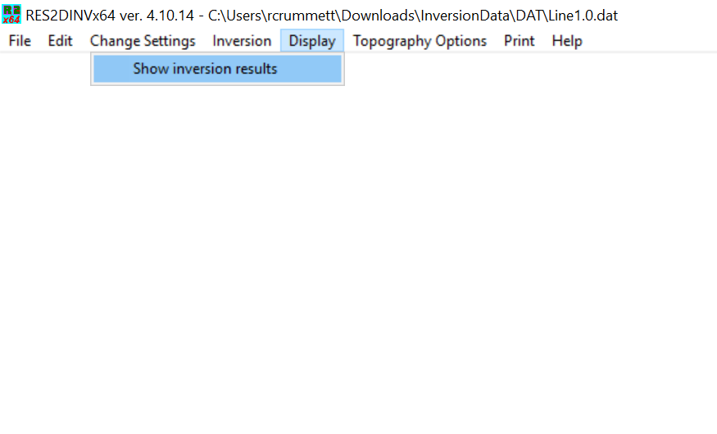

Figure 13: Displaying the inversion results. Display -> Show inversion results

Once in the display window, find the **‘Edit Data Tab’** then click **‘RMS statistics’**.

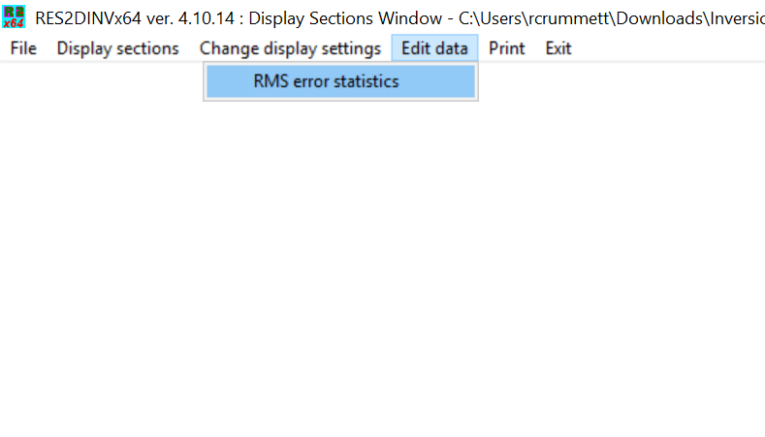

Figure 14: In display window, display the RMS error statistics. Edit data -> RMS error statistics

The left and right arrow keys can now be used to adjust the data cut off (the green line).

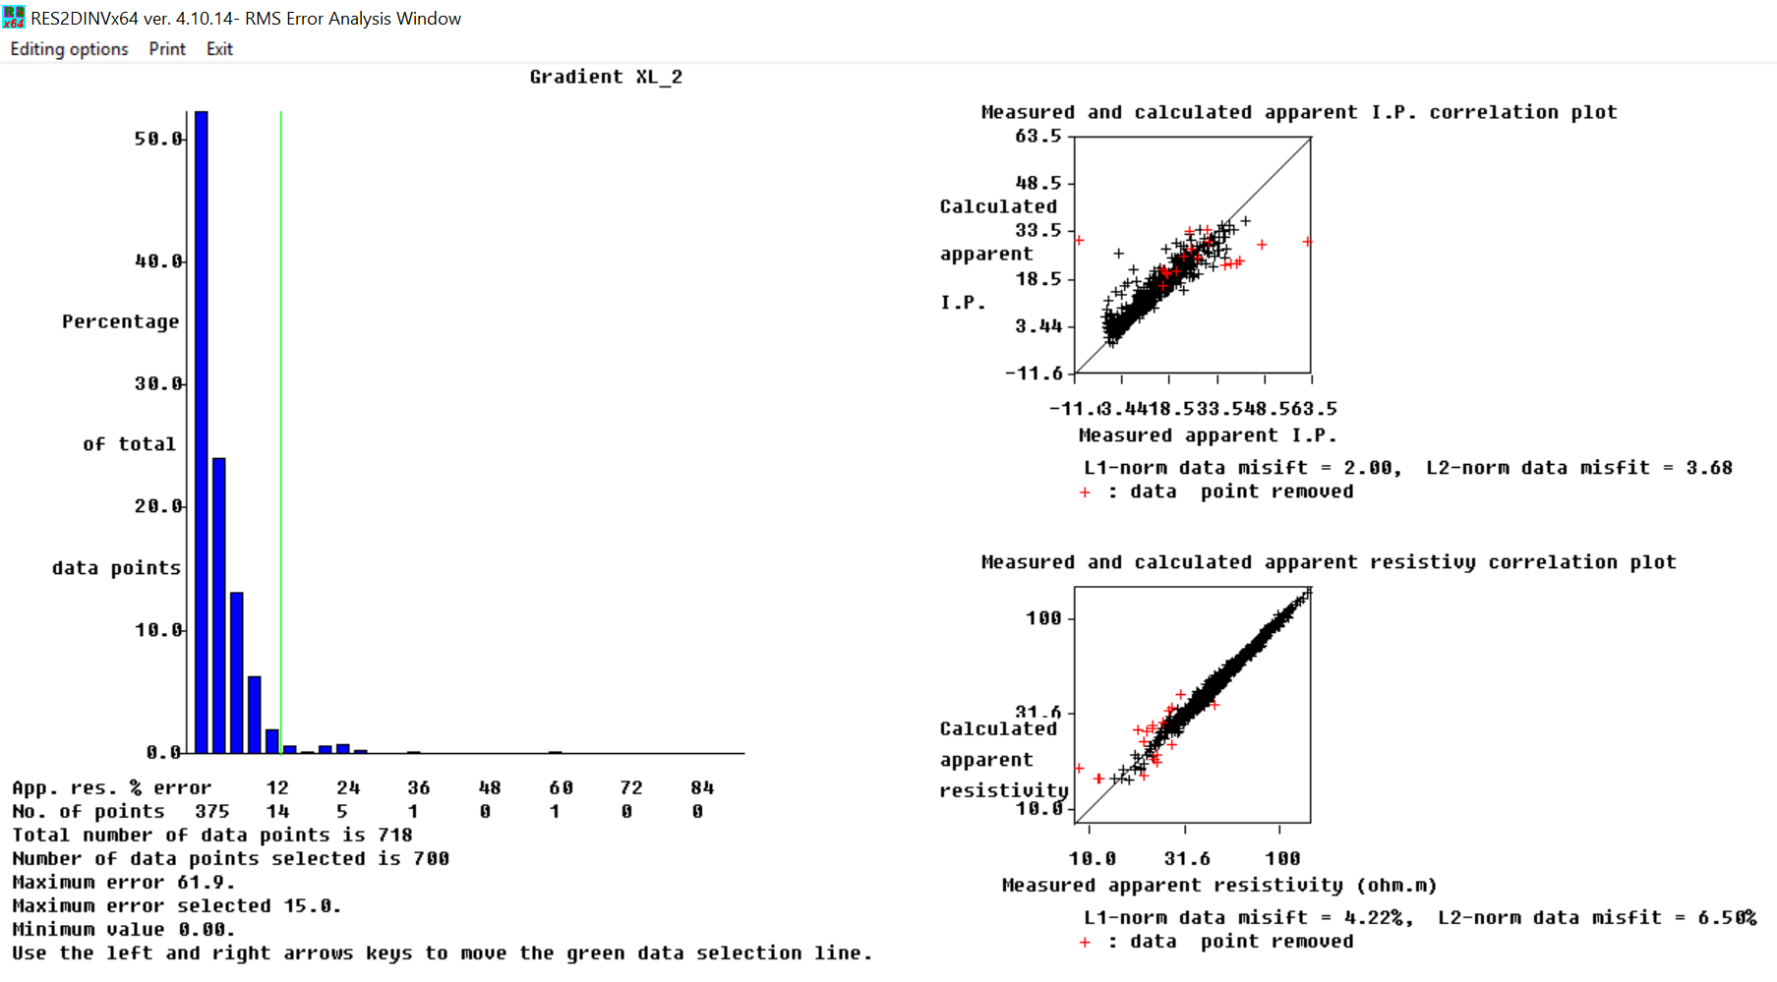

Figure 15: RMS error statistics

The further the data cut off moves to the left, the more data it will remove. The user has to be careful not to remove too much, if any at all. The correlation plots and statistics should all be referenced in order to select the ‘optimum’ cut off.

*Resources for understanding the L1 and L2 norm can be found* [*here*](https://towardsdatascience.com/visualizing-regularization-and-the-l1-and-l2-norms-d962aa769932)*.*

Once the cutoff is selected, the data can be saved simply by exiting this window.

# **Displaying and Exporting Data in RES2DINV**

## Displaying Model Cross Sections

After inversion has been completed, find the **‘Display tab’**. To display the model, click **‘Show inversion results’**. This will open the display window.



Figure 16: Display inversion results. Display -> Show inversion results

To display the model with topography, click **‘Display sections’** then **‘Model display’** then ‘**Include topography in model display’**. Explore this menu for more display options.

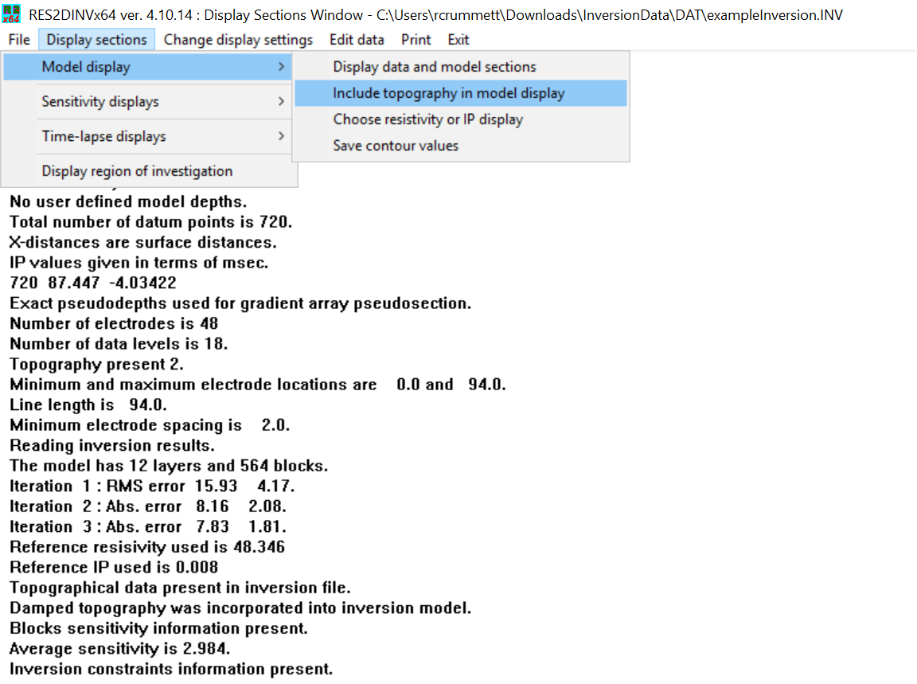

Figure 17: Display the inversion results. Display sections -> Model display -> Include topography in model display

By default, this will display the resistivity cross section. To display the IP, select the **‘Choose resistivity or IP display’** option.

Fonts, color ramps, and symbology can be adjusted in the tab **‘Change display settings’**.

## Normalizing Color Ramps

To normalize the color ramps, we need to first adjust the current color ramp.

Display the model, but this time click **‘User defined logarithmic contour intervals’**. This will open an interactive window where the user can adjust the color ramp values.

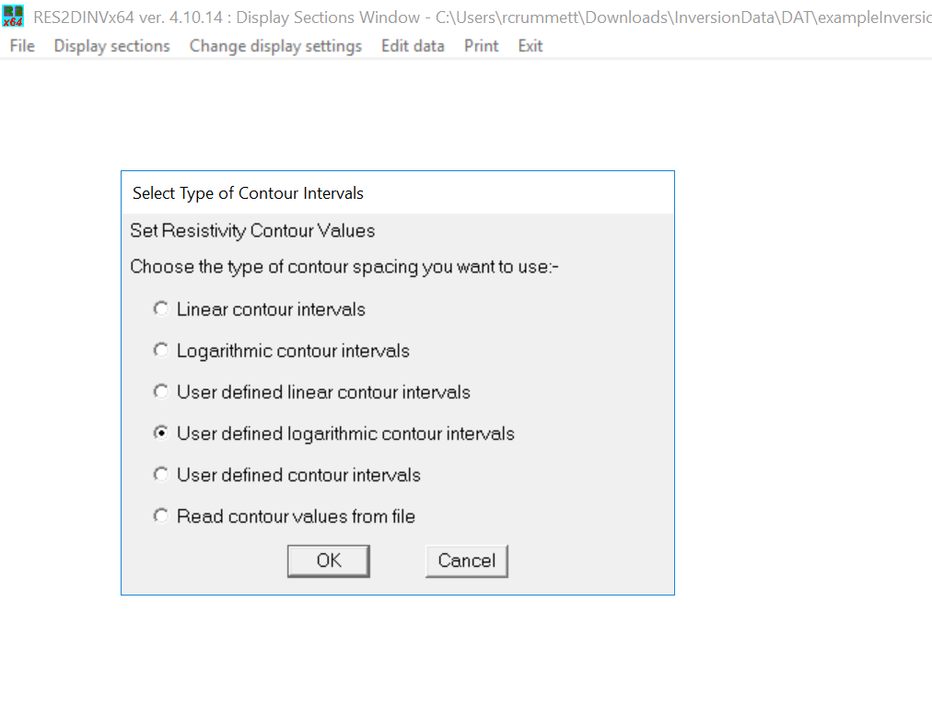

Figure 18: User defined logarithmic contour intervals. For resistivity model

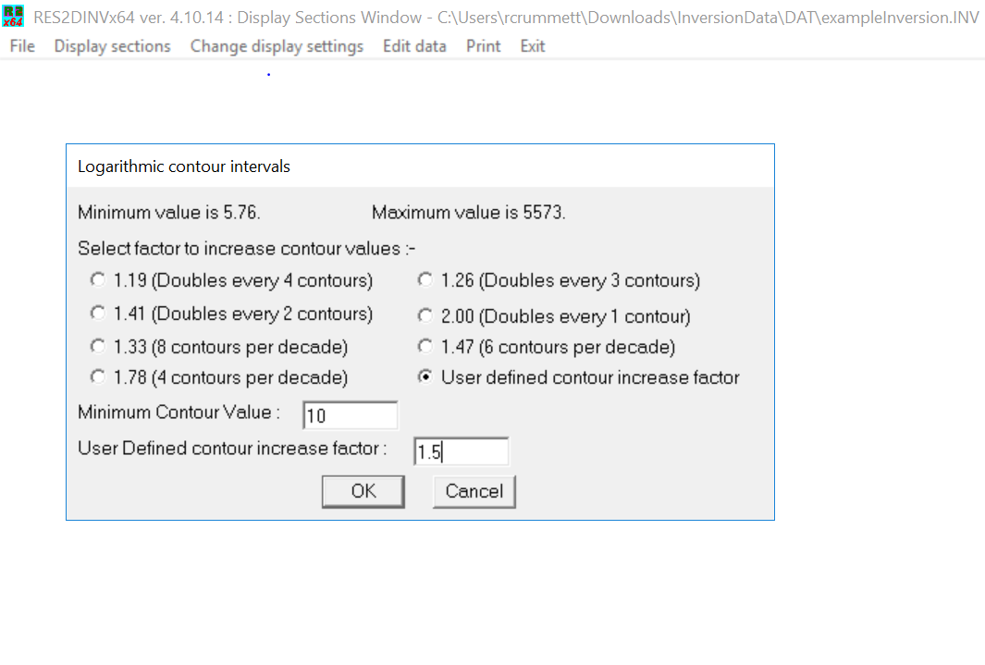

Figure 19: Manually adjust the minimum contour value and contour increase factor

The range of values selected is up to the user.

Values above/below the maximum/minimum contour values will saturate.

Note: Since the goal is to normalize the color ramp for multiple inversions, consider the minimum and maximum across the entire survey, not just the current inversion.

Once the contour values are set, save the values. Select **‘Display sections’** then ‘**Model display’** then **‘Save contour values’**

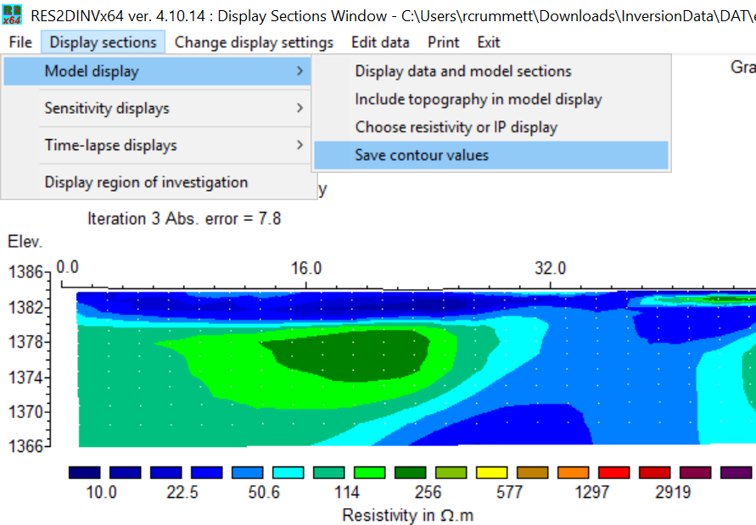

Figure 20: Export contour values as file, to be used with other models. Display sections -> Model display -> Save contour values

This will save the contours in a .VAL file format. Now the next inversion display can access the same color ramp scale by selecting **‘Read contour values from file’**

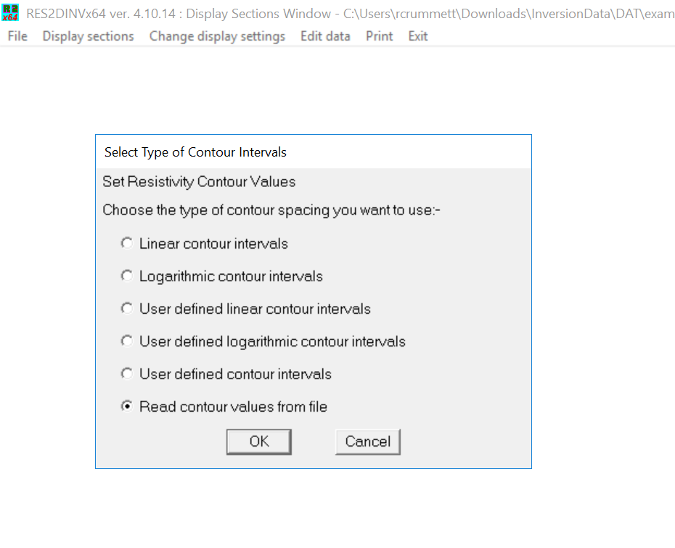

Figure 21: Now users can access the predefined contour values for other inversion results

This process should be done separately for resistivity and IP. They should each have their own separate .VAL files.

*Resistivity is usually plotted on a logarithmic scale, while IP is plotted on a linear scale. This is because resistivity can change several orders of magnitude realistically, while IP cannot.*

## Exporting Cross Sections

Cross sections can be exported in a number of file formats. Oasis Montaj prefers .PNG as of Spring 2022.

To select file type for export, select **‘Print’** then **‘Select type of bitmap graphics format’**

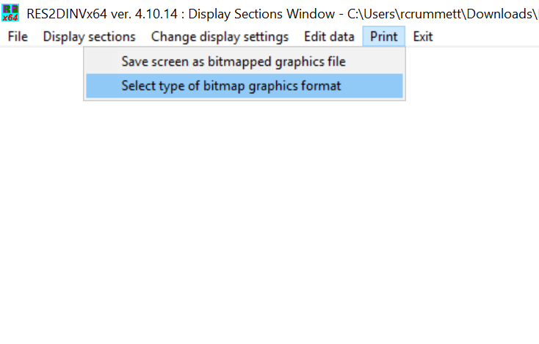

Figure 22: Select file type for export. Print -> Select type of bitmap graphics format

Once the correct format is chosen, select ‘Save screen as bitmapped graphics file’ to export.

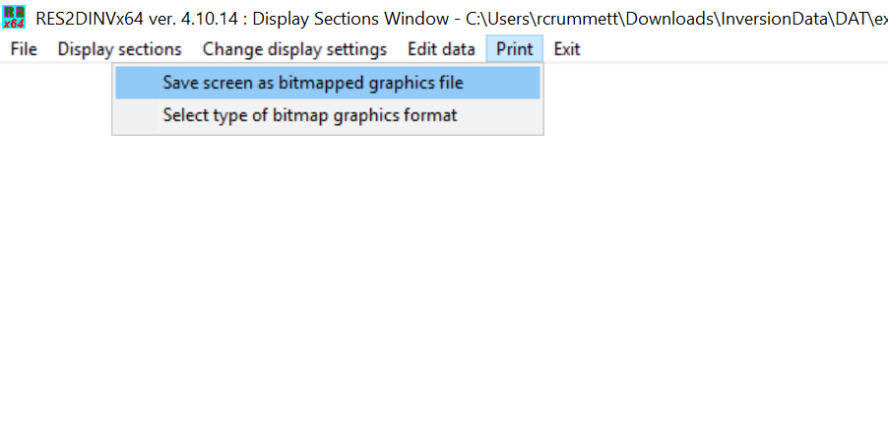

Figure 23: Export the file in bitmapped format. Print -> Save screen as bitmapped graphics file

Now the cross sections can be viewed as .PNG, .JPEG, etc.

# **Acknowledgements**

Thank you to Mr. Chris Kratt for spending a ridiculous amount of time in the field with me the last two semesters. Without him teaching me how to operate the ABEM Terameter this guide would never have been written.

Thanks to Mr. Hugh Roy Marshall for donating the ABEM Terameter to the University of Nevada Reno.

Thank you to Jimmy Adcock and the entire Guideline Geo team for posting excellent video lectures on everything from data processing to resistivity survey theory. They were invaluable to many explanations in this guide.

Thanks to the Applied Geophysics class of 2022 for collecting data sets for us to experiment with.