Group 1 (Hunter Dale, Seth Glover, Vanessa Espino, Robert Bean)

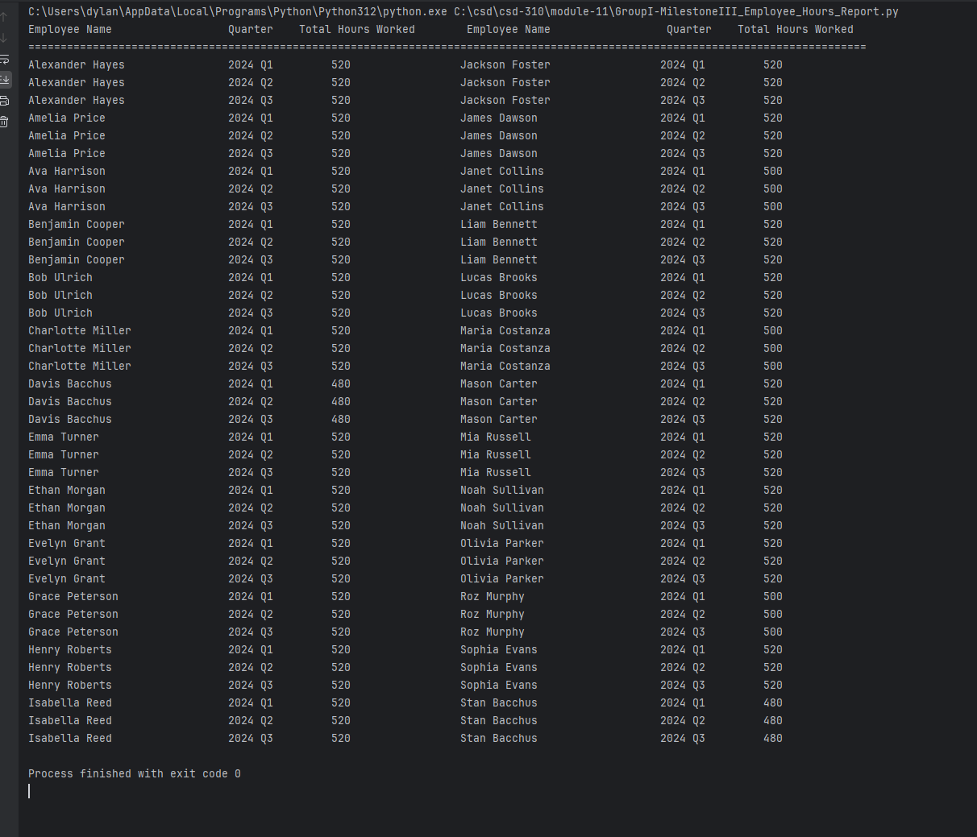Employee Hours by Quarters, and a Display of Total Hours Worked in all 4 Quarters

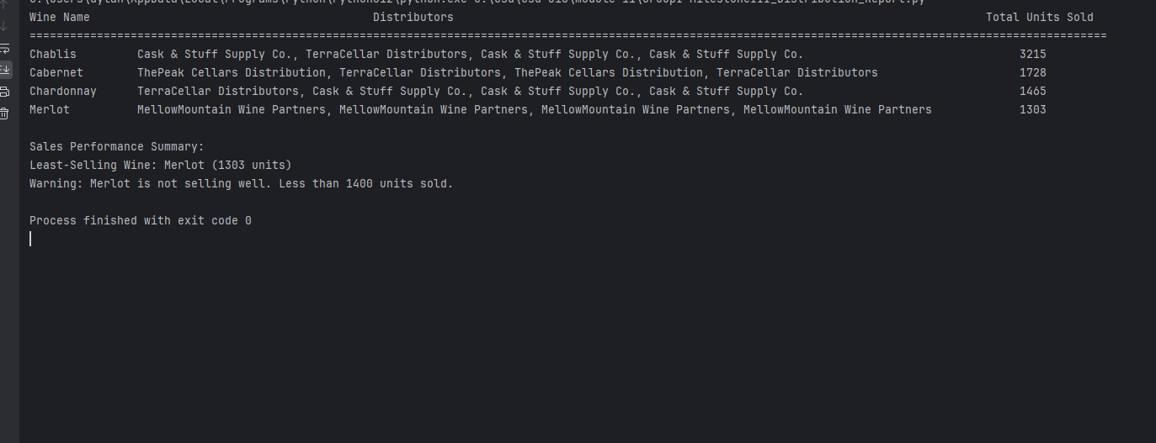The distribution report with the wine name, suppliers and total units sold. Also includes the least-selling wine and a warning label.

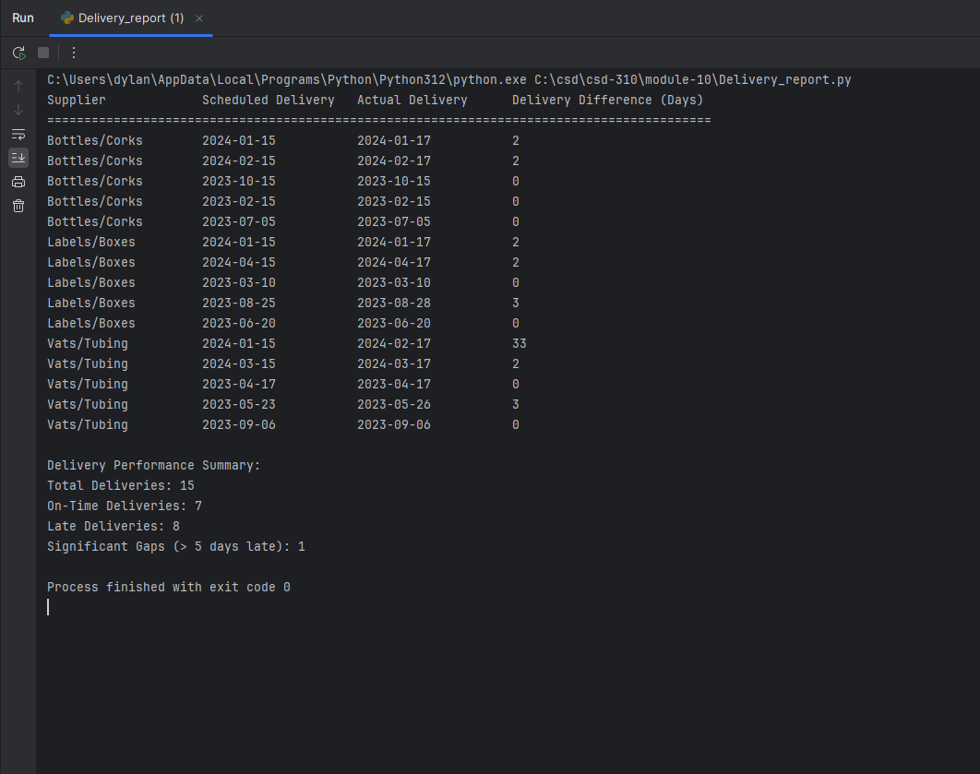Delivery report that includes when scheduled delivery was due versus when the delivery actually got to the warehouse. Include significant gaps, and the number of on time delivery and late ones.