**Project Outline/Responsibilities**

1. **Group Introduction/Tasks**: Begin by introducing each group member and their roles:
   * Monica and Robert: Handling backend database work, with Robert focusing on deadlines.
   * Bao and Celeste: Working on front-end development, with Bao focusing on GitHub uploads.
2. **Project Overview**: Describe "Paradise Pet," focusing on its goals to facilitate pet adoption and donations through a user-friendly website.
3. **Project Tools**:
   * **MS Project**: For project management and tracking.
   * **Hostinger**: For hosting the website.
   * **GitHub**: For version control and documentation of tasks.
   * **MS Teams**: For team communication
4. **Role Assignment for Next Milestone**:
   * Monica and Robert will continue their work on the backend database. Their tasks will involve further developing, refining, and testing the MySQL database to ensure its functionality and security align with the project's needs.
   * Bao and Celeste will maintain their focus on front-end development. They will progress with the design and implementation of the website's user interface, utilizing HTML, CSS, and JavaScript. Bao and Robert will also continue to manage GitHub uploads, ensuring that all code and documentation are up-to-date and version-controlled.
5. **Database Presentation**:
   * Explain the choice of MySQL for database development.
   * Show the database structure, including tables and data.(Insert UML)
6. **Web Design Progress**:
   * Discuss the current stage of web design, including any sketches, or HTML/CSS/Javascript development.
7. **Gantt Chart**:
   * Present a Gantt chart to illustrate the project timeline and progress.

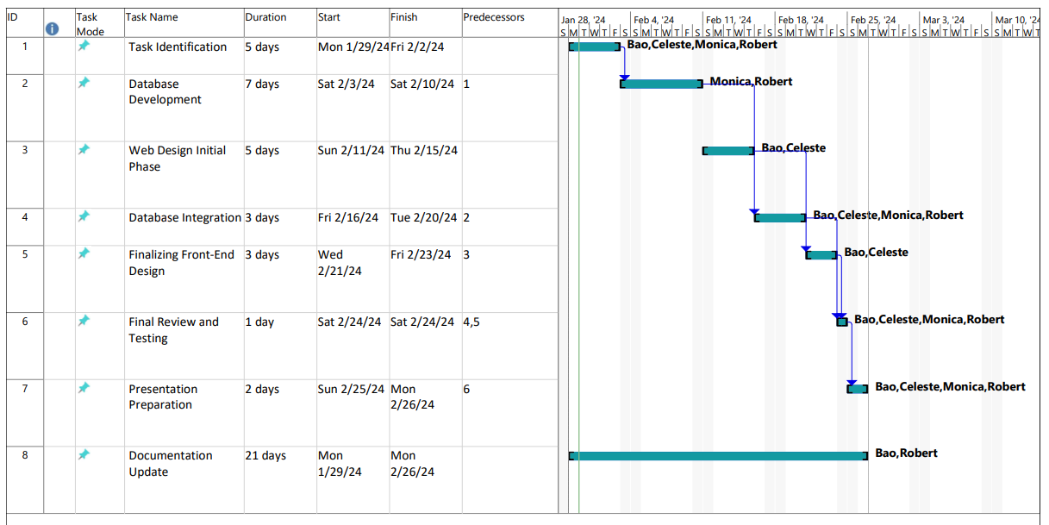

1. **GitHub Documentation**:
   * Include a link to the GitHub repository where each member's tasks for the next milestone are documented.
   * <https://github.com/RobertDevaney/ParadisePetRescue>