# Commands Implemented:

* MSGGET
* MSGSTORE
* SHUTDOWN
* LOGIN
* LOGOUT
* QUIT

# Compiling and Running the Server:

1. Go into the server directory, where the makefile is
2. Type: make
3. Type: make run
4. Now it should say that the server is running

# Compiling and Running the Client:

1. Go into the client directory, where the makefile for the client is
2. Type: make
3. Type: make run ADDRESS=“<ip_address>”
4. <ip_address> if running on mud servers is “127.0.0.1”
5. Now type a number to execute a command
6. If number 3 “Login” is chosen:
   1. Type your username <space> password
7. If number 2 “MSGSTORE” is chosen and the server responds with 200 OK
   1. Type your message that you would like to store.
8. For all other options simply typing the number will execute a command like:
   1. 1 ”MSGGET” will return the message of the day
   2. 4 “LOGOUT” will log you out if you are logged in. Other wise a 401 will be returned.
   3. 5 ”SHUTDOWN” will shutdown the server and close the connection if you are logged in as a root. Otherwise a 402 will be returned.
9. 6 “QUIT” will simply close connection with server and end the client program.

# Client Output:

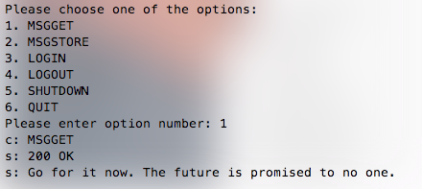

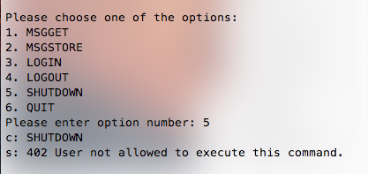

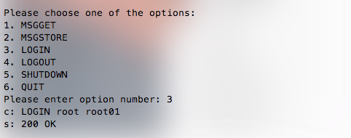

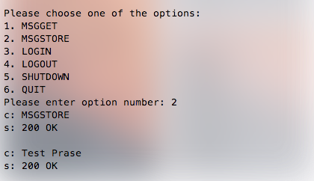

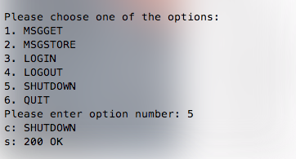

# Server Output:/Users/Nazariy/Desktop/Screen Shot 2016-02-05 at 3.49.22 PM.png