figure_word

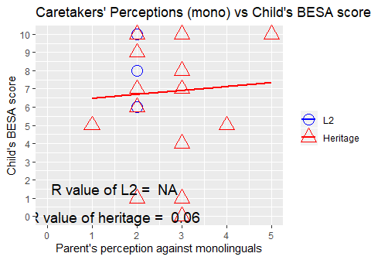

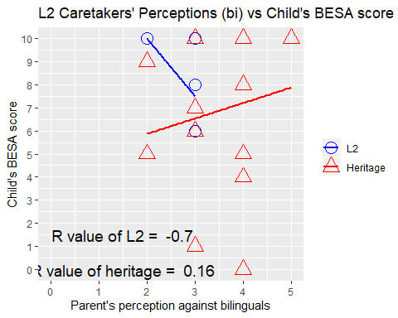

##   
## Welch Two Sample t-test  
##   
## data: H_undup$mono and L2_undup$mono  
## t = 3.1168, df = 17, p-value = 0.006275  
## alternative hypothesis: true difference in means is not equal to 0  
## 95 percent confidence interval:  
## 0.2153849 1.1179484  
## sample estimates:  
## mean of x mean of y   
## 2.666667 2.000000

##   
## Welch Two Sample t-test  
##   
## data: H_undup$bi and L2_undup$bi  
## t = 3.0583, df = 17.708, p-value = 0.006864  
## alternative hypothesis: true difference in means is not equal to 0  
## 95 percent confidence interval:  
## 0.2725886 1.4734432  
## sample estimates:  
## mean of x mean of y   
## 3.444444 2.571429

## `stat_bin()` using `bins = 30`. Pick better value with `binwidth`.

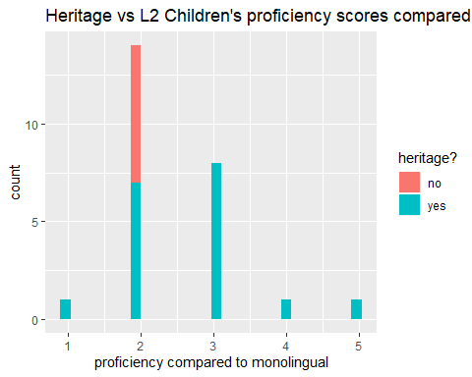

## `stat_bin()` using `bins = 30`. Pick better value with `binwidth`.

