The Effect of Language Dominance on Anticipatory Nasalization

Robert Esposito
Department of Spanish and Portuguese, Rutgers University

Author Note
The authors have no conflicts of interest to disclose.
Correspondence concerning this article should be addressed to Robert Esposito, Department of Spanish and Portuguese, Rutgers University, 15 Seminary Pl., New Brunswick, NJ 8901, USA, Email: rme70@rutgers.edu

Abstract
Languages differ in their inventory of nasal segments, with only about a quarter of the world’s languages having contrastive nasal vowels in their phonological inventory. However, all languages, to some degree, include phonetically-motivated nasalized vowels due to coarticulation in (NASAL-)VOWEL(-NASAL) ((N)V(N)) sequences, where at least one nasal consonant precedes or procedes the vowel. Languages differ in the degree of coarticulatory nasalization. For example, Mexican Spanish has been described as having fairly little nasal coarticulation, whereas American English has a relatively high degree of nasal coarticulation to the point that vowel nasalization has been said to be phonologized. It has been proposed that bilinguals must acquire these language-specific timings to sound native-like. The Complex Adaptive System Principles (CASP) model suggests that the bilingual brain pushes for convergence, especially in cases where the bilingual is not balanced, such that English-like timing patterns will occur in Spanish or vice-versa. To put this theory to the test, the present study used the The Multilingual Hispanic Speech in California (MuHSiC) corpus to investigate coarticulatory nasalization. The metric A1-P0 was used to measure nasalization in all tokens of English and Spanish /a/. It was found that language dominance, as measured by the Bilingual Language Profile, predicted different timing patterns for A1-P0.
Keywords: bilingualism, coarticulation, nasal

The Effect of Language Dominance on Anticipatory Nasalization
INTRODUCTION GOES HERE.

Nasal Segments
98% of the world’s languages have a nasal consonant (Maddieson, 2013), while about 26% percent of languages have contrastive nasal vowels (Hajek, 2013), such as Brazilian Portuguese or French. Spanish and English are among the languages that do not have contrastive nasal vowels, but vowels still become nasalized in vowel-nasal (VN) syllables due to timing gestures and biomechanical production of segments (Sampson, 1999). ‘Nasalization’ occurs when the velum lowers and velopharyngeal (VP) coupling occurs, such that the airstream flows through both the oro-pharyngeal and nasal tracts (Barlaz et al., 2018; Chafcouloff et al., 1999). When a vowel segment is followed by a nasal consonant, the velum anticipatorily lowers resulting in VP coupling and partial or full nasalization of the vowel (Zellou, 2022). Figure 1 represents such a process in English (upper) and Spanish (lower).

Figure 1
A representation of English (upper) and Spanish (lower) gestural timings of the word ‘pan’ (in Spanish, bread). Note that the nasal gesture overlaps the vowel gesture much more in English than in Spanish. Reproduced without permission from Goodin-Mayeda (2016).
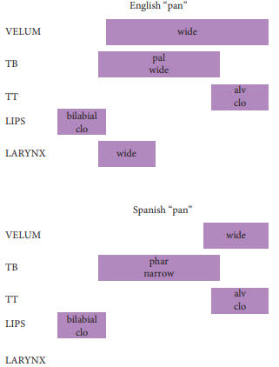
Coarticulatory vowel nasalization varies cross-linguistically (Clumeck, 1976). Solé and Ohala (1991) found that Peninsular Spanish and American English differ in degree of nasalization based on speaking rate, concluding that nasalization in the former is phonetic and in the latter, phonological. These findings align with more recent observations of English monolingual populations that nasalization is extensive in American English (Krämer, 2019), whereas many varieties of Spanish show a much shorter gestural overlap (Bongiovanni, 2021).

Heritage Speakers
Heritage speaker populations have received comparatively little attention with regards to coarticulatory phenomena. It has been established that heritage speakers tend to maintain phonemic robustness (Kissling, 2018), but investigation of fine-grained coarticulatory phenomena will provide richer detail to the monolingual and bilingual grammars. In the current case, whether or not gestural timing is encoded in the grammar, in the form of coarticulatory vowel nasalization, can be determined. Beristain (2023) investigated 16 heritage Mexican Spanish L2 English second generation speakers of varying dominance from the Chicagoland area using a nasometer to determine if they present distinct time setting patterns for nasality in English and Spanish /VN/ structures. An effect for language was found, but not for language dominance, which was measured with the Bilingual Language Profile [BLP; Birdsong et al. (2012)]. On the other hand, Amengual (2018) found an effect for dominance, again measured with the BLP, on the acoustic realization of laterals in 40 Spanish-English heritage speakers.

CASP Model
The Complex Adaptive System Principles (CASP) model (Filipović & Hawkins, 2019; Hawkins & Filipović, 2024) proposes five principles that underlie language behavior in bilinguals:
- minimize learning effort
- minimize processing effort
- maximize expressive power
- maximize efficiency in communication
- maximize common ground
Coarticulatory vowel nasalization, although allophonic in English, does not contrast in meaning with oral vowels in English or Spanish. As such, bilinguals may (a) minimize learning effort by not encoding language-specific gestural timing information for nasals or (e) maximize common ground by sharing a single gestural timing representation for both languages. Given that previous research has demonstrated that bilinguals do maintain language-specific timing information (Beristain, 2023), it is relevant that CASP also takes into account individual factors, such as language dominance, as it has also been found that gestural timing encoding varies with language dominance (Amengual, 2018). However, such dominance effects have yet to be seen for coarticulatory vowel nasalization in English-Spanish bilinguals, most likely due to low sample size and little dominance variation in the sample (Beristain, 2023).
The CASP model has little to say about phonological or phonetic interactions in the bilingual grammar, but the principles may be applied to such a situation as this. For example, at the level of form Filipović and Hawkins (2019) claim that high-proficiency bilingual speakers better control their output than low-proficiency bilinguals and “know” when they can maximize common ground, such that they will not produce “ungrammatical” structures in either language. In this case, high degree of vowel nasalization in Spanish will be seen as divergent behavior, while low degree of vowel nasalization in English will be equally seen as divergent.

Measures of Nasalization
Degree of nasalization may be measured using a nasometer (Bressmann, 2021), but in its absence, a number of acoustic features have been proposed to correlate with nasalization such as reduction of formant amplitudes, widening of formant bandwidths, modulation of formant frequencies, shifting of spectral energy toward lower frequencies, and addition of poles (i.e., formants) and zeros (i.e., anti-formants) to the acoustic spectrum (Carignan (2018); M. Y. Chen (1997); Feng and Castelli (1996); Styler (2017), inter alia).
In the current study, nasalization will be measured using A1-P0 (M. Y. Chen, 1997). This measure is the difference between the amplitude A1 of the first formant and the amplitude P0 of the nasal peak at low frequencies, and it works particularly well for mid and low vowels. Carignan (2021) compared various metrics with nasometer data across various English vowels and found that A1-P0 had an overall correlation with the nasometer “ground-truth” data of 0.66, respectively. However, looking at individual vowels demonstrates that A1-P0 has a 0.76 correlation with the nasometer data for the vowel /a/. As such, in the absence of a nasometer, A1-P0 provides an approximate metric to determine nasalization for specific vowels. Tamminga and Zellou (2015), for example, used A1-P0 to examine dialect differences in coarticulatory nasalization.

History of Spanish-English Contact in California
Today, California has the largest Hispanic population in the United States (Hugo Lopez & Manuel Krogstad, 2015), characterized by long-standing Latino communities and newly arrived Latinos (Zentella, 1997). While Spanish is being maintained at the societal level because of the influx of new immigrants, at the individual and family level, there is a clear shift to English (Silva-Corvalán, 1994). Residents of long-standing Latino communities include both newly arrived Latinos who are monolingual in Spanish, bilingual Latinos who have acquired English and retain Spanish, young bilingual Latinos who have acquired both languages in their communities, and monolingual English-speaking Latinos. In these communities, individuals interact with one another using Spanish, English, or both. Choice of language depends on language proficiency, topic of interaction, setting, and relationship between speakers. Children born and raised in such communities acquire language ability to interact with newly arrived individuals and monolingual members of the majority Anglophone community (Zentella, 1997). Spanish is primarily restricted to low-level functions and private sphere interactions (Valdés, 2004).

The Present Study
The present investigation presents an opportunity to relate articulatory phonology, sociolinguistics, and bilingualism. Sequences of vowel-nasal (VN) in American English and Mexican Spanish, specifically /an/ and /am/, are examined. Both Spanish and English possess /a/ in their phonological inventories, and A1-P0, as explained above, is an adequate measure of nasalization for this vowel, which will be used to identify degree of nasalization within the vowel. Spanish and English also differ in nasal consonant inventories, so the present investigation is limited to only those nasal consonants that are shared between the two phonological inventories. The variation investigated is degree of vowel nasalization, as measured with A1-P0. As such, the collected data was selected to answer the following research questions:
- Do bilinguals produce language-specific timing patterns of nasal gestures in English and Spanish?
Previous research has demonstrated that bilinguals do store language-specific timing information of gestures for nasals (Beristain, 2023), which would be reflected in differing patterns of A1-P0 across the vowel in VN sequences. Specifically, more negative values of A1-P0, indicating greater degree of nasality, are expected in English, whereas more positive values are expected in Spanish.
- Does language dominance predict degree of nasalization in each language in /aN/ sequences?
The CASP model (Filipović & Hawkins, 2019; Hawkins & Filipović, 2024) predicts that language dominance interacts with the maximize common ground and maximize expressive power principles, such that balanced bilinguals will show greater maintenance of language-specific patterns. English-dominant bilinguals will show greater nasalization in Spanish compared to the average, whereas Spanish-dominant bilinguals will show less nasalization in English compared to the average.
- How do values for A1-P0 differ for different sequences of /(N)a(N)/?
Mexican Spanish and American English differ in their nasal consonant inventory. While they both share /m/ and /n/, Spanish additionally has /ɲ/ and English has /ŋ/. As such, different sequences will be examined, keeping the vowel constant as /a/, to determine how A1-P0 values may differ depending on the adjacent nasal consonant(s).

The MuHSiC Corpus
The Multilingual Hispanic Speech in California [MuHSiC; Amengual et al. (2026)] corpus is an open-access collection of sociolinguistic interviews with bilinguals speakers of diverse social backgrounds and regional origins across California. It is comprised of 600 interviews, approximately 70 minutes per speaker, divided evenly between English and Spanish. It has over 42,000 minutes of transcribed and phonologically segmented speech, 4,698,607 time-aligned word tokens, and 16,277,689 time-aligned phonological segments. Included participants, who were primarily university-aged, had a minimum residency of five consecutive years in California and at least conversational proficiency in both English and Spanish. Each participant completed a socio-demographic questionnaire and the Bilingual Language Profile (BLP) questionnaire (Birdsong et al., 2012).

Figure 2
Violin plot of Bilingual Language Profile (BLP) scores in the sample. The individual boxplots represent the three dominance groups. Dominance was determined by standardizing BLP scores and using a threshold-based metric, such that English-dominance was > -0.5, Spanish dominance was < 0.5, and balanced bilinguals were between -0.5 and 0.5.
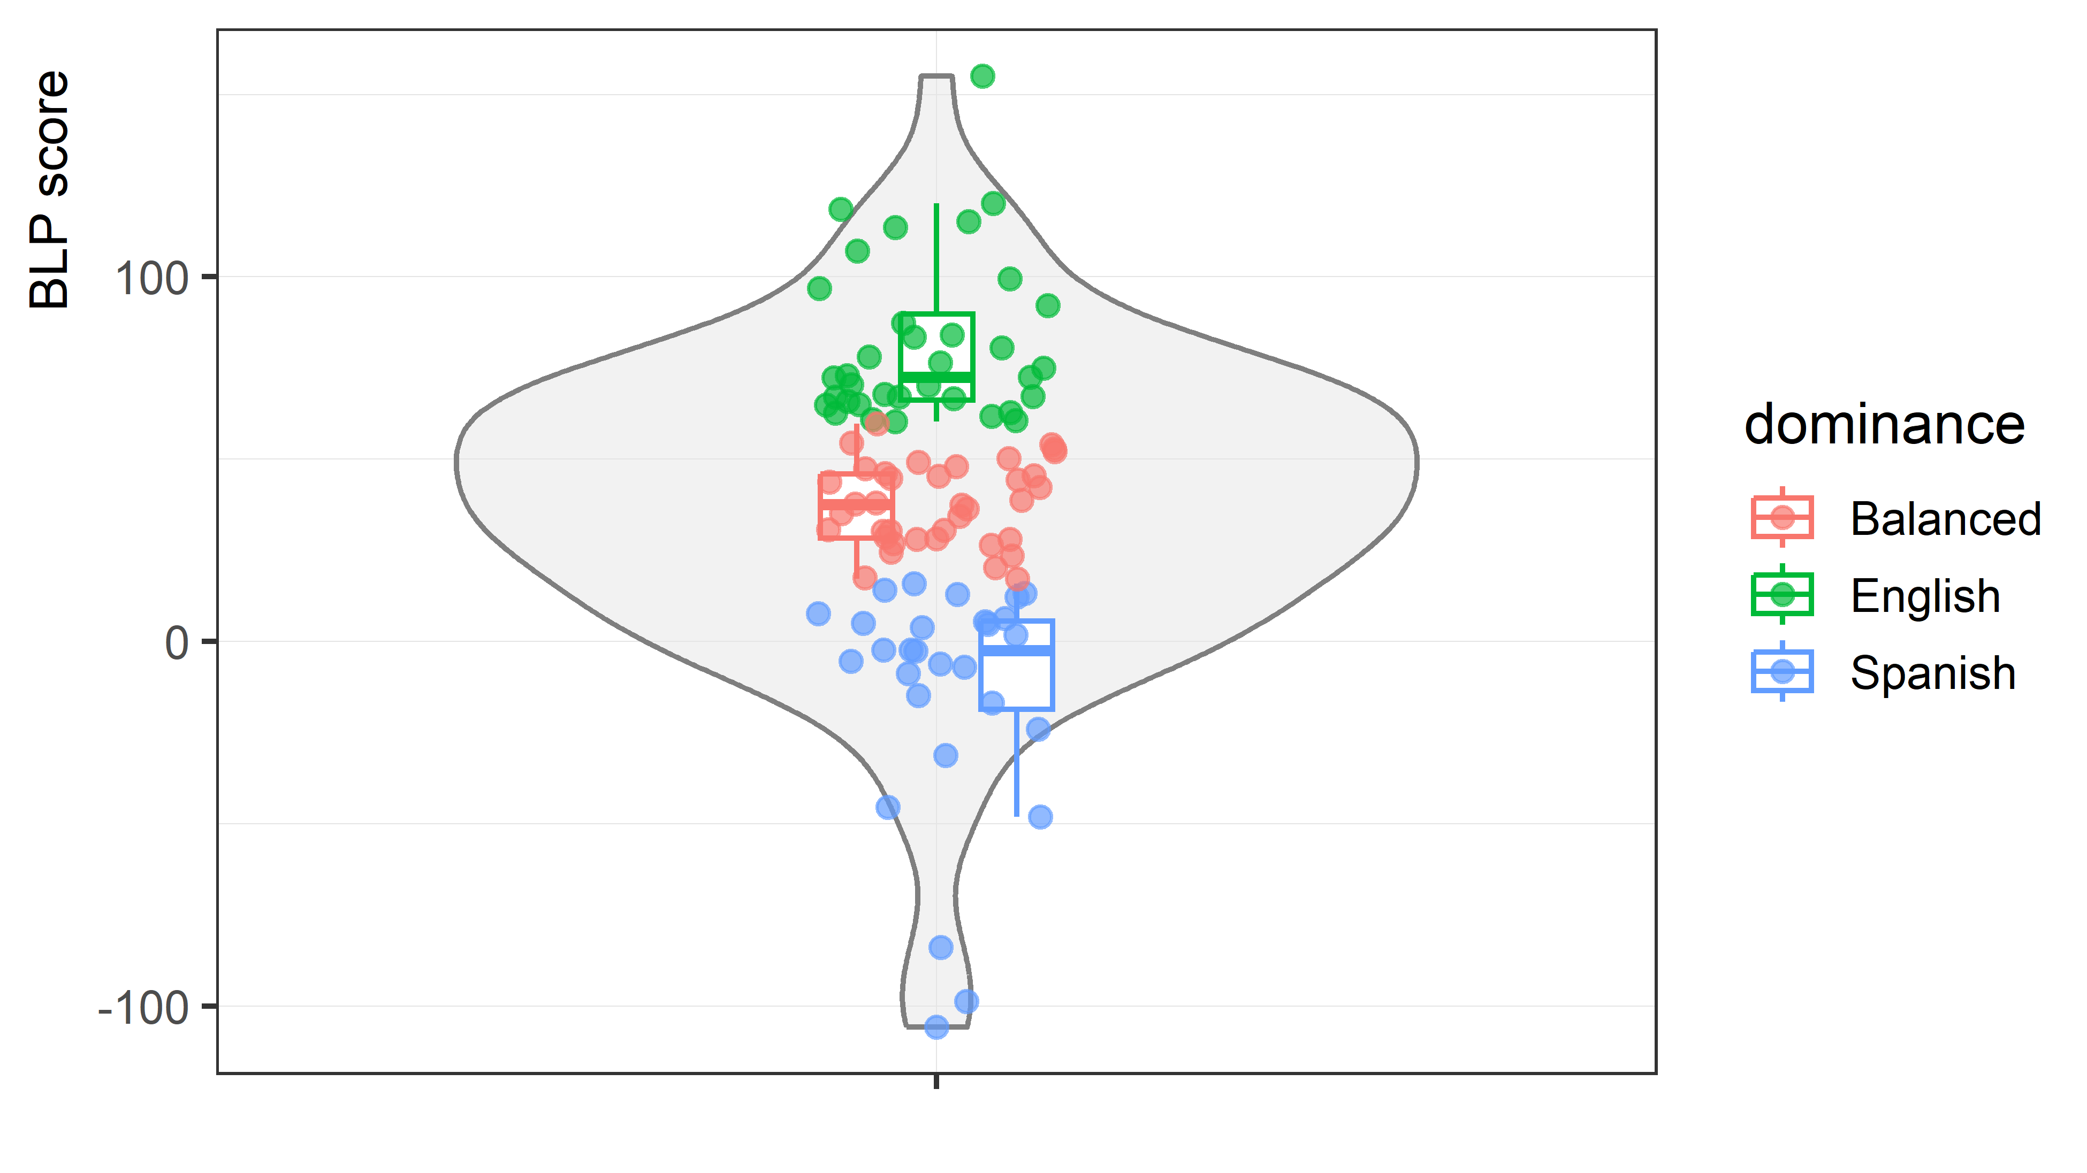
This corpus provides high-quality audio that is ideal for acoustic analysis for the bilingual community under investigation. The interviewees in the corpus are primarily of Mexican origin, and in the current sample, 0.8733333% are of Mexican origin (meaning that the interviewee, the interviewee’s father, mother, or at least one of four grandparents was born in Mexico). This is important because the majority of Mexican varieties are non-nasalizing (Bongiovanni, 2021).
Participants from the corpus were filtered based on socio-demographic information provided: 1) the interviewee’s age of US arrival was less than 13 years old (an arbitrary cut-off point based on early versus late L2 acquisition); 2) the interviewee’s parents both spoke English and/or Spanish and they did not speak another language to prevent any substantial input from another language; 3) the interviewee did not speak an additional language to English and Spanish to prevent any possible influence from another language system; 4) the interviewee identified their ‘sex’ as female, which was selected to limit anatomical differences, to prevent gender-related patterns of A1-P0 (Tamminga & Zellou, 2015), and because there were more female interviews than male; and 5) the interviewee immigrant generation was identified as 1.5, 2, 2.5, or 3.
Generation 1.5 are foreign-born individuals who arrived in the United States between the ages of 6 and 11. Generation 2 are individuals born in the US with both foreign-born parents. Generation 2.5 are individuals born in the US with one foreign-born parent. Generation 3 are individuals who, like their parents, were born in the US, and have foreign-born grandparents.
Using these filters, 300 interviews (150 in Spanish and 150 in English from the same 150 participants) were identified.

Token Identification and Extraction
Tokens for analysis were identified as contiguous segments /an/ and /am/ using the time-aligned TextGrids in the MuHSiC corpus (Amengual et al., 2026). English transcriptions use ARPABET (Klautau, 2001), so tokens were extracted using the ARPABET symbol “AAN” and “AAM”, which correspond to the IPA sequences /an/ and /am/.
Sequences of /NaN/, where /N/ represents any nasal, were excluded due to concerns of complete gestural overlap from the previous nasal segment. In the case of low audio quality or mistranscription, the token will be removed from the sample. Aside from these considerations, all sequences of /an/ and /am/ will be included in the analysis.
NasalityAutomeasure.praat (Styler, 2015) was used to extract A1-P0, as well as a number of other acoustic features associated with nasality at 10 equidistant points within each vowel. This procedure resulted in 149504 tokens extracted with 10 time points each, so 1495040 tokens in total.

Statistical Analysis
A Bayesian multilevel hierarchical linear regression model will be fit. Standardized A1-P0 will be the dependent variable, and the predictors will be dominance (standardized BLP score, continuous), previous nasal (a binary variable, whether or not the previous segment is a nasal consonant or not), following nasal (a binary variable, whether or not the following segment is a nasal consonant or not). Random intercepts will be included for participant and item, and random slopes will be included for previous segment and following segment.

Results
Thus far, only preliminary, descriptive data is available for the Spanish tokens. Extracted Spanish tokens were identified as either VC or VN sequences. A1P0 and BLP score were both standardized. BLP was then divided into three groups: values less than -0.5 were treated as Spanish-dominant, values greater than 0.5 were treated as English-dominant, and values in between were treated as balanced. Figure 3 plots the standardized A1P0 in the three dominance groups in the vowel /a/ for all /aC/ versus /aN/ sequences, where C represents any non-nasal consonant and N represents any nasal consonant. It is important to remember for this preliminary data that sequences of /Na/ are present in both cases, which means that A1P0 values early in the vowel are currently uninformative.

Figure 3
Standardized A1-P0 values for VC (left) and VN (right) syllables for standardized Bilingual Language Profile scores.
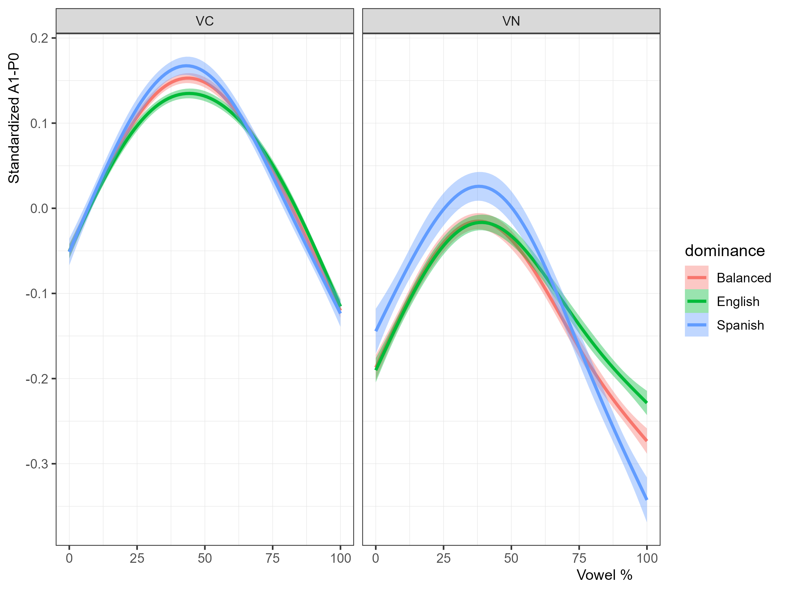
Looking first at the VC sequences, at approximately the midpoint of the vowel, A1-P0 values are more positive, indicating lesser degree of nasalization, for Spanish-dominant than for English-dominant or balanced bilinguals.
VN sequences show a similar pattern: Spanish-dominant bilinguals have more positive A1-P0 values compared to English-dominant and balanced bilinguals, indicating a lesser degree of nasalization, from the beginning of the vowel until approximately 75% of the vowel. From 75% of the vowel onward, Spanish-dominant speakers actually show a greater degree of nasalization.
Figure 4 plots standardized A1-P0 for /a/ followed by each of the four nasal consonants present in the data. Distinct patterns are present for each of the four nasal consonants, suggesting that velum lowering does not occur to equal degrees for the four consonants. Specifically, /a/ tokens followed by the velar nasal, which occurs only as an allophone due to assimilation of place of articulation and the only nasal consonant in this dataset without phonemic status, is the least nasalized across the entire vowel. When /a/ tokens are followed by the palatal nasal, on the other hand, A1-P0 has the lowest negative values. The labial and alveolar nasals pattern relatively similarly.

Figure 4
Standardized A1-P0 values for VN sequences, differentiated by following nasal consonant.
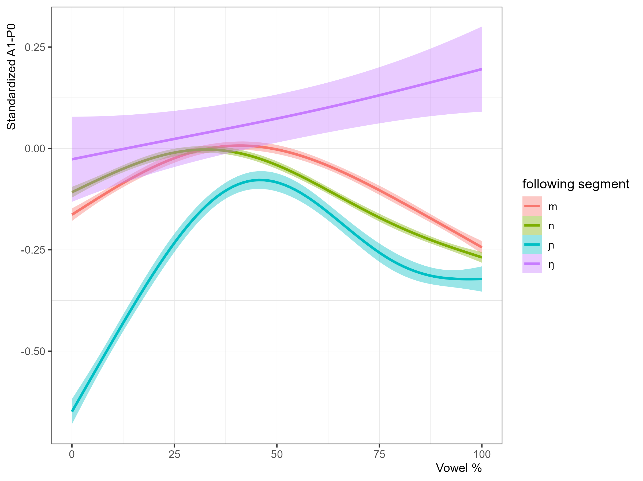

Discussion
The present study combines articulatory phonology, sociolinguistics, and bilingualism to better understand whether or not language-specific gestural timing is stored in the bilingual brain, and if so, if language dominance impacts that storage. Specifically, coarticulatory vowel nasalization of /a/ was examined using the acoustic measure A1-P0.
With the current dataset, the first research question cannot be answered. The latter two research questions, on the other hand, can be examined in light of the findings.
Regarding language dominance, the CASP model predicts that the maximize common ground and maximize expressive power principles are modulated by language dominance, such that balanced bilinguals will show greater maintenance of language-specific patterns. Beristain (2023) did not find strong evidence that language dominance strongly predicted degree of nasalization in each language. However, the author’s study included only 16 participants, as opposed to the current study which includes 150. Preliminary analysis suggests that, contrary to Beristain’s (2023) main findings, language dominance does impact coarticulatory vowel nasalization, such that Spanish-dominant bilinguals pattern distinctly from English-dominant and balanced bilinguals at the midpoint of the vowel, and all three groups are distinguished beyond the 75% point of the vowel. Specifically, Spanish-dominant bilinguals show less nasalization than English-dominant and balanced bilinguals until the 75% point, at which point Spanish-dominant bilinguals show the most nasalization, followed by balanced bilinguals, and finally English-dominant bilinguals. A possible explanation for this patterning is that English-dominant bilinguals are more likely to maintain oral airflow leading into the nasal consonant due to the phonological nature of vowel nasalization in English.
Moving onto the individual effect patterns of each nasal consonant on the preceding vowel, it is seen that /m/ and /n/ pattern similarly to one another, but the palatal and velar nasal consonants diverge. The palatal nasal in particular starkly contrasts with the other three segments in the first 50% of the vowel. Currently, it is unable to be determined if nasal consonants possibly are overrepresented as the previous segment, which would cause the sharp dip in A1-P0 at the beginning of the vowel.

Limitations and Future Directions
The present study has a number of limitations. BLP metric is skewed towards English-dominance. Using standardized values means that we are looking at language dominance within the sample, not in general. To look outside the sample, we would need to look at the raw scores or get a more balanced sample. Perhaps such can be obtained by looking at the entire corpus.
Currently, the present study limits itself to /a/ productions of female-identifying bilinguals. The corpus includes male-identifying individuals, and of course the whole gamut of vowels in both English and Spanish. As such, future work should move to include the rest of the corpus.
Regarding the vowel choice, /a/ was chosen because it had the best performance for A1-P0. A1-P0, unfortunately, performs very poorly for high vowels. Given such, it would be best to find another method, such as machine training through xgboost (T. Chen & Guestrin, 2016), to incorporate a number of acoustic measures that correlate with nasality (Carignan, 2021).
Finally, there are quite a number of transcription errors that must be corrected, as well as English words in the Spanish interviews that must be reviewed (and most likely excluded). In terms of long-term health of the corpus, it would be best to make the corrections in the .TextGrid files themselves. However, these corrected files would not be reuploaded to the corpus, but only kept locally, making the reach of the corrections not extend much beyond the present researcher. A possibly faster solution would be to extract words that include the token, plus the words before and after the word to which the token belongs, and then correct the alignment in that smaller file.

Conclusion

References
Amengual, M. (2018). Asymmetrical interlingual influence in the production of spanish and english laterals as a result of competing activation in bilingual language processing. Journal of Phonetics, 69, 12–28.
Amengual, M., Davidson, J., Kim, J. Y., & Vargo, J. (2026). The multilingual hispanic speech in california (MuHSiC) corpus: A large-scale open-access spanish–english bilingual corpus. University of California, Santa Cruz; University of California, Berkeley; University of California, Los Angeles. https://orcid.org/0000-0003-2007-9687
Barlaz, M., Shosted, R., Fu, M., & Sutton, B. (2018). Oropharygneal articulation of phonemic and phonetic nasalization in brazilian portuguese. Journal of Phonetics, 71, 81–97.
Beristain, A. (2023). An airflow analysis of spanish and english anticipatory vowel nasalization among heritage bilinguals. Languages, 8(3), 205.
Birdsong, D., Gertken, L. M., & Amengual, M. (2012). Bilingual language profile: An easy-to-use instrument to assess bilingualism. COERLL, University of Texas at Austin.
Bongiovanni, S. (2021). Acoustic investigation of anticipatory vowel nasalization in a caribbean and a non-caribbean dialect of spanish. Linguistics Vanguard, 7(1), 20200008.
Bressmann, T. (2021). Nasometry. In Manual of clinical phonetics (pp. 322–338). Routledge.
Carignan, C. (2018). Using ultrasound and nasalance to separate oral and nasal contributions to formant frequencies of nasalized vowels. The Journal of the Acoustical Society of America, 143(5), 2588–2601.
Carignan, C. (2021). A practical method of estimating the time-varying degree of vowel nasalization from acoustic features. The Journal of the Acoustical Society of America, 149(2), 911–922.
Chafcouloff, M., Marchal, A., Hardcastle, W. J., & Hewlett, N. (1999). Velopharyngeal coarticulation. Coarticulation: Theory, Data and Techniques, 69–79.
Chen, M. Y. (1997). Acoustic correlates of english and french nasalized vowels. The Journal of the Acoustical Society of America, 102(4), 2360–2370.
Chen, T., & Guestrin, C. (2016). Xgboost: A scalable tree boosting system. Proceedings of the 22nd Acm Sigkdd International Conference on Knowledge Discovery and Data Mining, 785–794.
Clumeck, H. (1976). Patterns of soft palate movements in six languages. Journal of Phonetics, 4(4), 337–351.
Feng, G., & Castelli, E. (1996). Some acoustic features of nasal and nasalized vowels: A target for vowel nasalization. The Journal of the Acoustical Society of America, 99(6), 3694–3706.
Filipović, L., & Hawkins, J. A. (2019). The complex adaptive system principles model for bilingualism: Language interactions within and across bilingual minds. International Journal of Bilingualism, 23(6), 1223–1248.
Goodin-Mayeda, C. E. (2016). Nasals and nasalization in spanish and portuguese.
Hajek, J. (2013). Vowel nasalization (v2020.4) [Data set]. In M. S. Dryer & M. Haspelmath (Eds.), The world atlas of language structures online. Zenodo. https://doi.org/10.5281/zenodo.13950591
Hawkins, J. A., & Filipović, L. (2024). Bilingualism-induced language change: What can change, when, and why? Linguistics Vanguard, 10(s2), 115–124.
Hugo Lopez, M., & Manuel Krogstad, J. (2015). Will california ever become a majority-latino state? Maybe not. Pew Research Center. https://www.pewresearch.org/short-reads/2015/06/04/will-california-ever-become-a-majority-latino-state-maybe-not/
Kissling, E. M. (2018). An exploratory study of heritage spanish rhotics: Addressing methodological challenges of heritage language phonetics research. Heritage Language Journal, 15(1), 25–70.
Klautau, A. (2001). ARPABET and the TIMIT alphabet. URL: Https://Web. Archive. Org/Web/20160603180727/Http://Www. Laps. Ufpa. Br/Aldebaro/Papers/Ak_arpabet01. Pdf.
Krämer, M. (2019). Is vowel nasalisation phonological in english? A systematic review. English Language & Linguistics, 23(2), 405–437.
Maddieson, I. (2013). Absence of common consonants (v2020.4) [Data set]. In M. S. Dryer & M. Haspelmath (Eds.), The world atlas of language structures online. Zenodo. https://doi.org/10.5281/zenodo.13950591
Sampson, R. (1999). Nasal vowel evolution in romance. Oxford University Press.
Silva-Corvalán, C. (1994). Language contact and change: Spanish in los angeles. Oxford University Press.
Solé, M., & Ohala, J. (1991). DIFFERENTIATING BETWEEN PHONETIC AND PHONOLOGICAL PROCESSES: THE CASE 0F NASALIZATION.
Styler, W. (2015). On the acoustical and perceptual features of vowel nasality [PhD thesis]. University of Colorado at Boulder.
Styler, W. (2017). On the acoustical features of vowel nasality in english and french. The Journal of the Acoustical Society of America, 142(4), 2469–2482.
Tamminga, M., & Zellou, G. (2015). Cross-dialectal differences in nasal coarticulation in american english. ICPhS.
Valdés, G. (2004). Learning and not learning english: Latino students in american schools. Teachers College Press.
Zellou, G. (2022). Coarticulation in phonology. Cambridge University Press.
Zentella, A. C. (1997). Growing up bilingual. Blackwell.

https://github.com/stylerw/styler_praat_scripts/tree/master/nasality_automeasure.

