Do Latin American Subtitles Sanitize Swearwords More Often Than Iberian Spanish Subtitles?

Robert Esposito  
Language Variation in the Spanish-speaking World  
Doctor Kendra Dickenson

# Introduction

With the globalization of English-language media, audiovisual translation (AVT) into Spanish, a language spoken by 485 million native speakers (Lewis, 2009) and 21 countries in which it is an official language, is a common occurrence. Sound films spread fully among cinemas in Spain and Argentina around 1931 (Fuentes 2019), which led to dubbing and subtitling of said films from countries like the United States and the United Kingdom. Cultural shifts in the 1960s led to swearwords becoming more acceptable in US and UK media (Hughes 2006), which thus had to be translated to different locales. This posed, and still poses, an interesting issue because “there exist intercultural differences on how, when, why, and even to whom swear-words are used (Scheu 1998: 390).

Although Spain can be argued to have a fairly homogenous culture when one considers the tolerance of swearwords, Latin America is typically treated as a single locale despite it comprising 19 culturally homogenous Spanish-speaking countries. Torey (2012) purports that sanitization (e.g., omission or toning down) of swearwords is the preferred translation method in general, there is a growing body of work indicating that ATV is not as clearcut as this. For example, Valdeón (2015) found that professional translators working from English into Iberian Spanish not only maintained the intensity of swearwords in the source text, but even vulgarized the text (i.e., adding swearwords in the target text where none appeared in the source text).

Unfortunately, there is a gap in the literature for sanitization in localizations aimed at Latin America. This paper aims to help fill that gap by investigating if swearwords in the movie *The Wolf of Wall Street* (2013, Martin Scorsese) are sanitized more often in Latin American subtitles than Iberian subtitles.

# Background Literature

## Swearwords and Tolerance

Although all languages have swearwords, the aforementioned intercultural differences (Scheu 1998) contribute to the difficulty of defining what a swearword is, or when it is deemed offensive. What can be said is that there is a difference between “slang” and “swearwords”, because swearwords are intended to “violate the properties of common decency” (Landau 1984: 38). However, “there are no criteria to establish what can be offensive” (Landau 1984: 233) due to the reliance on context and culture. For example, it is “not very uncommon to hear swearwords amongst members of the Spanish Parliament in any of the sessions of the Congress” (Scheu 1998: 391). Contrastively, BBC had to offer a formal apology for not beeping out an expletive on the ITV1 show, X-factor (Fernández-Gavela 2015: 135-136). This is further reflected in law, where the US and UK have “have strict television regulations” that are not present in Spain” (Valdeón 2015). Spain’s tolerance is further elaborated on by Pavesi, who found that Spanish-speaking audiences were more tolerant of swearwords in dubbed and original fictional media clips than Italian participants (2022).

Unfortunately, it is difficult to evaluate the “culture” of the audience that Latin American AVT is aimed at due to the great size and homogeneity of the audience. Furthermore, AVT research has focused “almost exclusively on Europe, with hardly any research on Latin-American countries” (Fuentes 2019: 1). However, in the future, a start to this investigation could begin with the countries in which AVT is typically carried out (i.e., Puerto Rico, Mexico, Argentina, Venezuela and Colombia [Fuentes 2019: 1]). The cultural norms regarding swearwords could be investigated and compared to the translations produced. However, since the translators know, and are typically instructed to appease, a larger, culturally homogenous audience, the cultural norms of these countries may not have great impact on the translations produced.

## AVT in Latin America

Hollywood, the leading producer of movies in the United States, expanded their market into Latin America as early as the 1930s. Due to the size of Latin America, it was and is easy to “treat the whole of Spanish-speaking Latin America as a single market”, which saved “time, work and, above all, money” (Fuentes 2019: 10). In line with treating all of Latin America as one unit, in 1931, seventeen Latin American countries gathered in San Franscisco to attempt negotiation of a “neutral Spanish” that would be used for AVT (6). “Neutral” Spanish varieties are further ratified in laws, such as the 1988 Argentine Decreto Nacional 1.091/1988:

se entenderá por ‘idioma castellano neutro’, al hablar puro, fonética, semántica y sintácticamente, conocido y aceptado por todo el público hispano parlante, libre de modismos y expresiones idiomáticas regionals de sectores. Su utilización no deberá desnaturalizar las obras, particularmente en lo que se refiere a la composición de personajes que requieran de lenguaje típico.

However, such a goal by this Argentine law is not so easily fulfilled. Like Hollywood’s ignorance towards the vast variety of Spanish across Latin America, Argentina’s law fails to account for such things as identical words have distinct meanings across varieties, or nuances being completely lost between two varieties. The concept of a “neutral” or “standard” Spanish is further complicated by researchers like Moreno-Fernández, who propose that Spanish is polycentric, and that “existen diversos modelos de referencia para el uso culto de la lengua, según el área dialectal de que se trate” (27). To align with Moreno-Fernández’s proposition, Hollywood and other major media producers would have to identify dialect groups and localize their AVT to each group.

Disney, for example, has a varied history when it comes to producing subtitles for Latin America. For some films like *Bueaty and the Beast* (Gary Trousdale & Kirk Wise, 1991), produced only two Spanish versions: European Peninsular Spanish and a “neutral Spanish” (made in Mexico). Other films had versions for European, Mexican, Argentinian, and “neutral Spanish”. Although there are attempts to localize subtitles to specific countries, these varieties still do not encompass the entirety of Latin America accurately, and “neutral Spanish” remains as an attempt to blur together the rest of the countries into a monolithic entity.

# The Present Study

## Rationale

This research attempts to fill in the gap in AVT research by investigating the degree to which swearwords are maintained in Latin American subtitle translations from English. It has been found that European Spanish tends towards vulgarization, but given the greater audience that Latin American subtitles are subjected to, translators may sanitize texts as to accommodate the larger, heterogenous cultural norms across various audiences.

## Research Hypothesis

The research hypothesis for the current study is the following: Latin American subtitles will sanitize swearwords more frequently than their European Spanish counterparts in the translation of *The Wolf of Wall Street*.

## Methodology

The research hypothesis was evaluated by reviewing four Spanish subtitles of *The Wolf of Wall Street*, two localized to Latin America and two to Spain, and determining to what degree sanitization of swearwords has occurred. 100 swearwords in English were identified starting at the beginning of the script, and their segments’ translations in the four Spanish subtitles were identified and recorded. This makes a total of 400 tokens, 200 for each locale.

Sanitization was classified as the omission or the “toning down” of swearwords. An example of an omission is the English segment “until one of us passes the fuck out” translated as “hasta que uno de los dos se desmaye”, where “fuck” has not been translated. The translation method of “toning down” maintains a swearword, but the intensity is reduced; for example, “Pick up the cocksucking phone!” being translated as “¡Levanta el maldito teléfono!”, since “maldito” is much less intense than “cocksucking”. If either of these two cases did not occur, then the data was coded as non-sanitized.

A logistic regression was then used to analyze the data, where sanitization (coded binary, where 1 means the translation has sanitization and 0 means the translation is not sanitized) acted as the dependent variable and locale (whether the translation was made for Latin America or Spain) as the predictor.

## Descriptive Results

Figures 1 and 2 display raw count and percentage of sanitization by locale respectively.

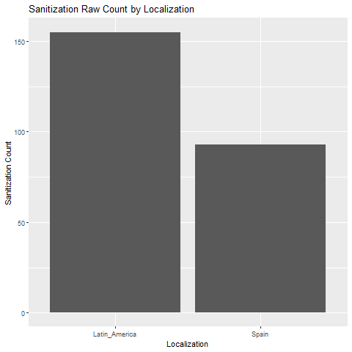

Figure 1Raw count of sanitization by locale. Figure 2Percentage of sanitization by locale.

Descriptively, both localizations sanitize more than 50% of the time, but Latin American subtitles sanitize about 30% more often.

## Analytic Results

The translation data was analyzed using a logistic regression with the glm() function in R. Sanitization rate was the criterion with locale (Latin America or Spain) as predictors. The locale was dummy coded with Latin America as the reference group. Experiment-wise alpha was set at 0.05. The model predictions are displayed in Figure 3.

The results suggested that localization significantly predicted whether a translation would be sanitized or not. Latin American translations showed a positive association with sanitization, displaying a coefficient of 1.2368 (95% CI: [0.914, 1.580]), indicating that compared to Spain, the log odds of an item being sanitized increased by approximately 1.2368.

Conversely, Spain exhibited a negative association with sanitization, displaying a coefficient of -1.3770 (95% CI: [-1.817, -0.950]). This suggests that compared to 'Latin_America,' the log odds of an item being sanitized decreased by approximately 1.3770 in the 'Spain' category.

The odds ratios further support these findings, with Latin America having an odds ratio of 3.44 and Spain having an odds ratio of 0.25. These odds ratios indicate that items from Latin_America are approximately 3.44 times more likely to be sanitized compared to Spain, while items from Spain are approximately 0.25 times less likely to be sanitized compared to Latin_America.

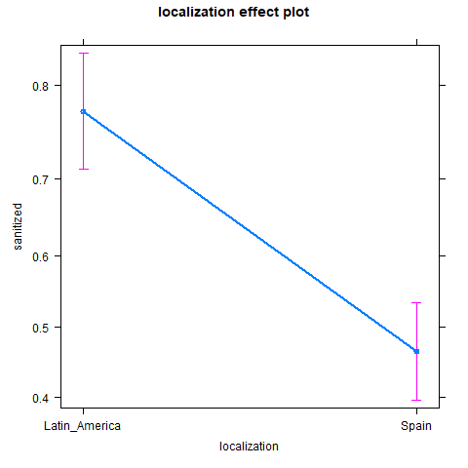

Figure 3Predicted values of sanitization from the logistic regression model.

# Discussion

The descriptive results show that sanitization occurs often in both Latin American and Spain translations, which is in line with research from scholars like Torey (2012), who indicates that sanitization is the preferred translation method for swearwords in AVT. These descriptive findings go against researchers like Valdeón (2015), who has been finding a growing body of translations that indicate vulgarization is actually more common in AVT from English to Peninsular Spanish.

The model supports the research hypothesis of this study, indicating that sanitization does occur more often in translations from English to Latin American Spanish than Peninsular Spanish. This falls in line with researchers like Valdeón, who have found that sanitization occurs less frequently in Peninsular Spanish AVT. This study contributes to the growing body of work by providing supporting evidence that Peninsular Spanish AVT does indeed sanitize less frequently than its Latin American counterpart of this movie.

# Future Research

This study is one of few that investigates swearwords, sanitization, and AVT in general for Latin America. Much more research is needed in various directions to give a better picture of the peculiarities of these topics in Latin American AVT.

In terms of swearwords, more research is needed to understand who are writing translations localized to Latin America, as well as what education they are given when it comes to translation specifically swearwords for translations aimed at such a large audience. For example, might it be expected that sanitization occurs more commonly in subtitles aimed at Latin America due to the homogenous cultures, which will decrease the likelihood of offending anyone? Is sanitization less likely to occur when localizations are written for specific countries in Latin America, such as ones aimed specifically at Argentina or Mexico?

Furthermore, there is a lot more data that should be collected to fully investigate the current model. This model unfortunately only utilized 100 tokens from one movie. The entire movie can be parsed for tokens, as well as other movies or television shows. Furthermore, the current data can be more finely parsed for specific sanitization method, whether the text was vulgarized, and if there are specific patterns regarding sanitization when it comes to specific curses. For example, if one locale is more sensitize to swearwords associated with sex than the other.

Overall, this study provides a first look at how Latin America translators handle swearwords from English to Spanish, but there is much more research to be done to better understand the situation.

References

Fuentes-Luque, A. (2019). An approach to audio-visual translation and the film industry in spain and latin america. *Bulletin of Spanish Studies*, *96*(5), 815–834.

Gavela, M. D. F. (2015). *The grammar and lexis of conversational informal english in advanced textbooks*. Cambridge scholars publishing.

Hughes, G. (2015). *An encyclopedia of swearing: The social history of oaths, profanity, foul language, and ethnic slurs in the english-speaking world*. Routledge.

Landau, S. I. (1984). Dictionaries: The art and craft of lexicography. *(No Title)*.

Lewis, M. P. (Ed.). (2009). *Ethnologue: Languages of the world* (Sixteenth). SIL International.

Moreno-Fernández, F. (2019). *Variedades de la lengua española*. Routledge.

Pavesi, M., & Zamora, P. (2022). The reception of swearing in film dubbing: A cross-cultural case study. *Perspectives*, *30*(3), 382–398.

Scheu-Lottgen, U. D., & Hernández-Campoy, J. M. (1998). An analysis of sociocultural miscommunication: English, spanish and german. *International Journal of Intercultural Relations*, *22*(4), 375–394.

Toury, G. (2012). Descriptive translation studies: And beyond. *Descriptive Translation Studies*, 1–366.

Valdeón, R. A. (2015). The (ab) use of taboo lexis in audiovisual translation: Raising awareness of pragmatic variation in english-spanish. *Intercultural Pragmatics*, *12*(3), 363–385.

Valdeón, R. A. (2020). Swearing and the vulgarization hypothesis in spanish audiovisual translation. *Journal of Pragmatics*, *155*, 261–272.