Rapid Acquisition of a Novel Intonation Contour by High-Empathy Individuals

Robert Esposito
Department of Spanish and Portuguese, Rutgers University

Author Note
Preregisteration, research materials, data, and analysis code are freely available at https://osf.io/vpseq. The author has no conflicts of interest to disclose. This research received no external funding. The study was conducted according to the guidelines of the Declaration of Helsinki and approved by the Institutional Review Board of Rutgers University. All participants gave their informed consent for inclusion before participating in this study. The author is grateful to Yhosep Barba, Joseph Casillas and two anonymous reviewers for comments that improved the quality of this work. All errors are mine alone.
Correspondence concerning this article should be addressed to Robert Esposito, Department of Spanish and Portuguese, Rutgers University, 15 Seminary Pl., New Brunswick, NJ 8901, USA, Email: rme70@rutgers.edu

Abstract
Intonation, pitch modulation across an utterance, plays a critical role in communication, signaling sentence type, speaker intent, and pragmatic nuances. Second language (L2) learners often struggle to accurately interpret intonational patterns, particularly in unfamiliar varieties, which impacts comprehension and communicative success. Emerging evidence suggests that individual differences in empathy, the ability to infer another’s intentions and emotions, influences L2 intonation acquisition. The present cross-sectional study investigated whether first language (L1) English L2 Spanish learners with higher empathy more rapidly acquire a novel intonation contour from Caribbean Spanish: information-seeking absolute interrogatives with low boundary tones. 200 learners of varying proficiency completed a two-alternative forced choice task judging whether utterances were questions or statements. Half of the participants received a brief incidental-learning exposure session (<5 minutes) consisting of naturalistic conversations with a content-based question after each. Bayesian multilevel regression found that higher-empathy learners with above-average proficiency showed higher accuracy than their lower-empathy peers. These results suggest that empathy facilitates L2 intonation acquisition by helping learners store more socially and linguistically relevant information, supporting faster establishment of novel sound-to-meaning associations.
Keywords: empathy, intonation, second language acquisition, speech perception, incidental learning

Rapid Acquisition of a Novel Intonation Contour by High-Empathy Individuals
Currently, most second language acquisition (SLA) phonological models focus primarily on segmental features, while suprasegmental features receive comparatively little theoretical or pedagogical attention. Intonation, the modulation of pitch across an utterance, is one such understudied feature (Jenkins, 2004; Rao, 2019), despite its critical role in communication. It can signal sentence type (Prieto & Roseano, 2010), speaker commitment (Orrico et al., 2020), or politeness (Devı́s Herraiz & Cantero Serena, 2014), among many other diverse functions. Given the many-to-many mappings between sound and meaning, second language (L2) learners often struggle with intonation, in part due to transfer effects from their first language (Mennen, 2015; Trofimovich & Baker, 2006). Emerging evidence indicates that target-like perception of intonation is influenced by pragmatic skills, particularly empathy (Joseph V. Casillas et al., 2023). This aligns with findings in monolingual (L1) populations, where higher empathy is associated with increased sensitivity to intonational contours (Esteve-Gibert et al., 2016, 2020; Orrico et al., 2025; Orrico & D’imperio, 2020).
The present study contributes to these lines of research by investigating the associative link between empathy and L2 intonation acquisition. A situation common to L2 learners was examined: exposure to an unfamiliar variety and the task of accurately interpreting its intonational patterns. Specifically, participants judged whether an utterance was a question or a statement. Based on prior findings that higher-empathy learners encode more information during communicative interactions (Melchers et al., 2017), it was hypothesized that they would more rapidly acquire the novel sound-to-meaning mapping and outperform their lower-empathy peers in a two-alternative forced choice task after a brief incidental-learning (Hulstijn, 2003) exposure session.

1. Background and Motivation

1.1 L2 Intonation Acquisition
Research on first language (L1) intonational phonology has exploded (Ladd, 2008; Pierrehumbert, 1980), but research on intonation SLA has lagged behind. L2 learners face challenges acquiring the target language’s intonation system (Trofimovich & Baker, 2006), and these difficulties may result in comprehension issues and communication breakdowns. Intonation serves to signal various and distinct communicative functions across syntax, pragmatics, and semantics, such as constituent focusing (Büring, 2016), affective meaning (Rodero, 2011), and politeness (Herrero et al., 2020). In Spanish, one such function is sentence modality (Navarro Tomás, 1974). For example, the spoken utterance ‘Mariano habla del tiempo’ Mariano talks about the weather may variably be a declarative or interrogative depending on the intonational contour. Given the many challenges posed to an L2 learner, a central question that remains is how SLA models can be used to account for the acquisition of intonation.
Few models of L2 learning provide a framework for intonation acquisition. One such model is the L2 Inotnation Learning Theory [LILt; Mennen (2015)], which predicts L2 learner outcomes by comparing the intonational systems of the two languages across four dimensions, based on L1-L2 transfer: (1) the inventory and distribution of categorical phonological elements; (2) the phonetic implementation of those elements; (3) the functionality of the elements; and (4) the frequency of use of each element. There is only one cue that would traditionally be considered categorical in Spanish for sentence modality, and thus relevant to the model, that being the boundary tone (Prieto & Roseano, 2010). Canonical yes-no questions in English are typically thought of as cued by a high boundary tone, but Geluykens (1988) reports that they are actually cued more frequently by low boundary tones. Based on that information, LILt predicts difficulty in acquiring a high boundary tone for Spanish yes-no questions that end in a rise, as they do in the majority of Spanish varieties, by L1 English L2 Spanish learners and more ease for those ending in a fall. Contrarily, what little data is available has demonstrated that L1 English L2 Spanish speakers face difficulty interpreting yes-no questions with low boundary tones accurately as interrogatives (Brandl et al., 2020; Joseph V. Casillas et al., 2023; George, 2024; Trimble, 2013a; for contrary results, see Bedialauneta Txurruka, 2023).
Beyond the boundary tone, Face (2007) found that L1 Castilian Spanish speakers use the first pitch accent’s scaling and the presence or absence of a medial pitch accent to distinguish broad focus declaratives from yes-no questions. English canonical yes-no questions, on the other hand, are signaled primarily by syntactic (word-order) and lexical (e.g., do-support) elements, so intonational cues do not carry a high functional load. L1 English speakers can use the first pitch accent type to disambiguate sentence type, but they use categorical differences rather than scaling (Patience et al., 2018). Although L1 English speakers may be tuned into the first pitch peak in Spanish, they may associate height differences as signalling emphasis (Chen, 2003; Ladd & Morton, 1997), not sentence type.
A ripe area for investigating L1-L2 intonation transfer is L1 English L2 Spanish perception of Spanish yes-no questions cued by a low boundary tone, such as those found in Caribbean (Armstrong, 2010; Bailey, 2014; Willis, 2010) and Galician Spanish (Pérez Castillejo & Fuente Iglesias, 2024), as well as some other varieties (Astruc et al., 2010; Gabriel et al., 2010). Given that L2 learners struggle with identification of sentence type for yes-no questions with low boundary tones, the results will provide important implications for LILt and L2 pedagogy.

1.2 L2 Intonation in the Language Classroom
Despite the various systematic functions of intonation, it remains sidelined in the L2 classroom (Jenkins, 2004; Rao, 2019). As with other linguistic areas, intonation transfer effects, as predicted by the LILt model (Mennen, 2015) may impose meaningful communication issues for L2 learners, motivating its inclusion in pedagogical material. For example, L1 Mandarin L2 Spanish speakers’ request productions were primarily judged as “impolite”, even when lexical-grammatical aggression mitigtors (e.g., ‘gracias’ please) were included due to the non-target-like intonation (Herrero & Devı́s, 2020). Similarly, English and Spanish differ in the intonational contour for “polite” responses to wh- questions, which may result in L1 English L2 Spanish speakers appearing “over-excited” and L1 Spanish L2 English speakers seeming “rude” (Estebas-Vilaplana, 2014). These studies work to highlight the importance of intonation in the L2 classroom, but it remains unclear how it should be included.
Research evaluating intonation-teaching methodologies remains limited. Recent research has demonstrated that intentional (Hulstijn, 2003) training methodologies (e.g., instructional sound-to-meaning mapping, shadowing exercises) resulted in meaningful improvement in L2 perception and production (Olea, 2019). L1 Turkish L2 English learners, after a three-week training involving explicit sound-to-meaning instruction and shadowing exercises on final intonation contours, showed meaningful improvement in production and perception for contours that previously showed negative cross-linguistic influence (Sonsaat-Hegelheimer & Levis, 2025). On the other hand, a 30-minute intentional training session with intermediate-to-advanced L1 English L2 Spanish speakers involving audio from eight dialects (Prieto & Roseano, 2009--2013), where the instructor highlighted differences in the overall contour, pitch accents, and boundary tones of utterance types in the varieties, was not enough to show noticeable differences between pre- and post- perception tests (George, 2019).
The above studies used training methodologies that relied on intentional learning paradigms. However, these studies represent a very small minority of what most L2 learners experience when acquiring intonation. As intonation is not typically explicitly or intentionally taught in textbooks or the classroom (Lord & Fionda, 2013), learners most likely rely on L1-L2 transfer (Ortega-Llebaria & Colantoni, 2014) or incidental learning through input from the instructor or other sources (e.g., audios and audio-videos from the course). Input from instructors have been found to not be representative of typical intonational contours produced during natural speech (Rao, 2011), and many students in Spanish departments are exposed to L1 and L2 Spanish instructors from varying regions. As such, the majority of learners are only exposed to many varieties through short-form audio(visual) content.
Incidental learning in the current investigation is based on a definition provided by Hulstijn (2003): “the ‘picking up’ of words and structures, simply by engaging in a variety of communicative activities… during which the learner’s attention is focused on the meaning rather than on the form of language” (p. 1). The majority of research on intentional and incidental learning has focused primarily on vocabulary, spelling, morphology, and syntax; phonetics and phonology have received little attention. As such, an important theoretical consideration is how L2 learners acquire intonation in their target language without explicit instruction and what factors there are to consider in their development. One way to address this gap is by considering learner-internal variables that may shape how intonation is acquired under these circumstances.

1.3 Individual Differences in Empathy
Individual pragmatic differences in learners in regards to L2 intonational phonology acquisition has garnered greater attention in recent years (J. Bishop, 2016; J. B. Bishop et al., 2015; Diehl et al., 2008; Ward & Hirschberg, 1988). The construct empathy has specifically received greater attention. Empathy, one’s ability to infer others’ intentions (Baron-Cohen & Wheelwright, 2004), has been associated with theory of mind, mindreading, mentalizing, and perspective-taking (Baron-Cohen, 2011; Carruthers, 2009; Frith & Frith, 2003). Typically, empathy is categorized by affective empathy, or emotional alignment with the interlocutor, and cognitive empathy, recognizing and understanding what an interlocutor feels or thinks. The latter categorization has clear ties to the linguistic domain: cognitive empathy is necessary to comprehend an interlocutor’s motives in verbal interactions, especially for the interpretation of non-literal meaning.
A growing body of research has provided evidence that the empathy explains variability in L1 intonation perception (Esteve-Gibert et al., 2016, 2020; Orrico et al., 2025; Orrico & D’imperio, 2020), and preliminary evidence in the L2. For example, Joseph V. Casillas et al. (2023) found an interaction between proficiency and empathy score in L1 English L2 Spanish learners, such that lower-proficiency learners with higher empathy scores, measured with the Empathy Quotient (Baron-Cohen & Wheelwright, 2004), performed more accurately when identifying an utterance as a question or not. Apart from this one example, the author knows of no other modern SLA research relating empathy to L2 perceptual development.
Although the link between empathy and intonation processing has been established in L1 research, the relationship has not been thoroughly or explicitly investigated in L2 research. Melchers et al. (2017), in a study involving L1 German speakers watching videos in their L1, found that higher-empathy participants more accurately responded to content-based questions about brief videos than their lower-empathy peers. Based on these findings, one possibility is that L2 learners with higher empathy store more information about the linguistic structure, content, and situation (Gradoville, 2023; Schweitzer, 2012), even if it is not the focus of a given communicative activity. Learners with higher empathy may encode more information during communicative activities and draw on that experience more readily than low-empathy individuals, even when attention is focused on meaning rather than form. Higher empathy, then, may manifest overtly as “better memory”, but is resultant from the higher-empathy individual making greater use of previous experiences and having more flexibility in sound-meaning correspondences (Orrico & D’imperio, 2020).

2. Present Study
The present study investigates whether L1 English learners of L2 Spanish can rapidly acquire accurate perception of Spanish absolute interrogatives with low boundary tones. Specifically, the relationship between acquisition of the target sound-meaning relationship and the construct empathy (Baron-Cohen & Wheelwright, 2004) is investigated. Although previous research has established a relationship between empathy and intonation in L1 speakers (Esteve-Gibert et al., 2016, 2020; Orrico et al., 2025; Orrico & D’imperio, 2020) and L2 learners (Joseph V. Casillas et al., 2023), it is remains unclear why individuals with differing empathy perform differently. The study was designed to address the following research questions:
- Do higher-empathy, compared to lower-empathy, L1 English L2 Spanish learners display higher accuracy when identifying a Spanish utterance as a declarative versus interrogative?
- Do higher-empathy, compared to lower-empathy, L1 English L2 Spanish learners display higher accuracy when identifying a Spanish utterance, from a variety to which they have little or no previous exposure, as an interrogative if they are briefly exposed to conversations from that variety?
With respect to RQ1, it is expected that higher-empathy learners, compared to lower-empathy learners, will more accurately identify sentence type (Joseph V. Casillas et al., 2023). Replication is an important aspect of research that is oftentimes sidelined (Joseph V. Casillas et al., 2025), and the current data allows for a more nuanced understanding of previous findings due to a slightly different design (i.e., within the two-alternative forced choice task: fewer Spanish varieties, fewer sentence types, and more trials).
As for RQ2, it is predicted that higher-empathy individuals will benefit greater from a brief incidental-learning training session, and thus perform more accurately than their lower-empathy peers when categorizing absolute interrogative utterances with low boundary tones.

3. Methodology

3.1 Participants
Two studies were launched on the online experimental platform Prolific.ac, which were different in only if it included the exposure task (“exposure group”) or not (“control group”). At the beginning of each study, all participants were asked whether they were familiar with Caribbean (e.g., Puerto Rican) or Galician Spanish. This question served as a proxy for familiarity with a variety that signals absolute interrogatives with a final fall. Participants responded by selecting either “yes” or “no” from a drop-down menu. Participants were recruited until both groups had 100 participants each that responded “no”.
Participants self-reported as being adult L1 English speakers born, raised, and currently living in the Northeastern US, growing up monolingual in English. They reported no hearing difficulties and were required to use headphones on a personal computer.
To address RQ1, all recruited participants in the control group were included in the analysis (n = 145) Table 1. For RQ2, only the first 100 participants from each group who responded that they were unfamiliar with the above-specified varieties were included Table 2.

Table 1
Sociolinguistic information of participants included in RQ1 dataset, who were exclusively in the control group (i.e., they did not complete the “exposure” task).
Age (years) |  | Reported gender |  | # of languages reported
Mean | SD | Female | Male | 2 | >2 | Not reported
38.1 | 12.8 | 80 | 65 | 128 | 8 | 9

Table 2
Sociolinguistic information of participants included in RQ2 dataset. The first 100 participants in each the control (those who did not complete the “exposure” task) and exposure (those who did complete the “exposure”) groups who responded that they were unfamiliar with Caribbean or Galician varieties of Spanish were included.
 | Age (years) |  | Reported gender |  |  | Number of languages reported
 | Mean | SD | Female | Male | Not reported | 2 | >2 | Not reported
control | 37.2 | 12.0 | 53 | 47 | 0 | 90 | 6 | 4
exposure | 38.2 | 12.5 | 57 | 42 | 1 | 92 | 5 | 3
Both groups were compensated at a rate of $12.00 per hour. Upon completing all tasks, control group participants were paid $3.00, and exposure group participants $4.00.

3.2 Tasks
Participants completed the following tasks: exposure (only for exposure group); a 2AFC task; a lexical decision vocabulary assessment; and a Likert-type questionnaire to assess empathy Table 3. The tasks were programmed in Python using PsychoPy3 (Peirce et al., 2019) and hosted on Pavlovia.

Table 3
Completion times for tasks in order of completion.
group | task | mean (mins) | sd (mins)
Exposure | Exposure | 2.92 | 0.90
Control | 2AFC | 3.89 | 1.33
Exposure |  | 4.15 | 2.09
Control | EQ | 4.30 | 1.80
Exposure |  | 4.69 | 3.79
Control | LexTALE | 3.10 | 2.16
Exposure |  | 3.14 | 2.55

3.2.1 Exposure Stimuli
Participants in the exposure group were first exposed to three naturalistic phone conversations between two speakers of either Dominican, Puerto Rican, or Galician Spanish talking about everyday topics Table 4.

Table 4
Stimuli for exposure trials in exposure group.
dialect | time (seconds) | # of absolute interrogatives | # of final fall absolute interrogatives
Dominican | 60 | 10 | 7
Galician | 47 | 5 | 3
Puerto Rican | 36 | 6 | 6
TOTAL | 143 | 21 | 16

3.2.2 2AFC
The auditory stimuli for the two-alternative forced choice task (2AFC) consisted of 88 items total from Cuban, Puerto Rican, Mexican, and Castilian speakers. Each speaker produced the same 22 utterances, evenly split between broad focus and absolute interrogative utterances. The sentences were made up of three function words following a subject-verb-object word order, the default in Spanish. The object was a noun with penultimate stress. Detailed analysis of auditory stimuli is available here: https://osf.io/zxkdt.

3.2.3 LexTALE
Spanish proficiency was assssed with the Lexical Test for Advanced Learners of Spanish (LexTALE-ESP, henceforth LexTALE, Izura et al., 2014; Lemhöfer & Broersma, 2012), a lexical decision experiment that provides a standardized assessment of vocabulary size. Participants are exposed to a series of real and pseudo words, and they must decide if the word is real or fake. LexTALE scores range from -20 to 60. Adult learners with low to medium proficiency range from 0 to 25, and advanced learners generally score above 25; monolingual Spanish speakers generally score above 50. For example, Izura et al. (2014) reports that L2 speakers taking a Spanish course for 2.5 months (N = 100) with varying L1s (although a majority L1 Dutch) scored a mean of 7.2 (SD = 8.9).
To assess how participants performed on this measure, descriptive statistics and a regression model were computed. Table 5 shows the descriptive statistics of LexTALE scores from the participant samples used to address RQ1 and RQ2. A Bayesian regression model was fit to LexTALE score as a function of group (baseline condition = control group). The intercept estimate was β = 0.94 (HDI = [-0.60, 2.52]). Relative to the baseline, the exposure group was estimated to score slightly lower (β = -0.57, HDI = [-2.79, 1.64]), but the wide HDI indicates no meaningful difference between the two groups.
Figure 1 plots the LexTALE score distributions for individual datasets used for RQ1 and RQ2. Note that few participants reach the threshold for what is considered an “advanced” learner (i.e., >25 points); the majority of participants would be classified as having “low to medium” proficiency (Izura et al., 2014).

Table 5
Descriptive statistics of LexTALE scores.
Dataset | Mean | SD | Min | Max
RQ1 | 0.62 | 9.09 | -20.00 | 41.00
RQ2 (control) | 0.98 | 8.10 | -20.00 | 31.00
RQ2 (exposure) | 0.35 | 8.34 | -12.00 | 38.00

Figure 1
Boxplot and violin plots with empirical data (dots) representing LexTALE scores. RQ1 includes all participants in the control group; RQ2 includes only participants who have reported not being exposed to varieties of Spanish that encode yes-no questions with a final fall.
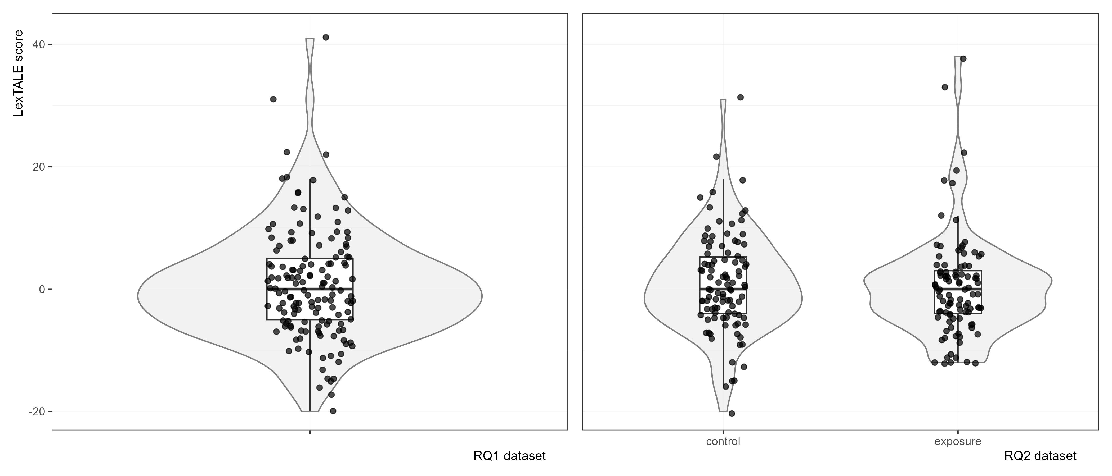

3.2.4 Empathy Questionnaire
Empathy was assessed using the Empathy Quotient (EQ, Baron-Cohen & Wheelwright, 2004). The EQ consists of 60 items, 40 critical items and 20 distractors, which participants rate on a four-point Likert scale ranging from “strongly agree” to “strongly disagree”. To avoid response bias, half of the target items are coded to elicit “agree” and the other half “disagree”. Target items are scored with 2 or 1 points based on if the participant responds “strongly” or “slightly” to the “empathic” response, and 0 otherwise, which are summed to a single-point value. Scores range from 0 (low empathy) to 80 (high empathy).
To assess how participants performed on this measure, descriptive statistics and a regression model were computed. Table 6 shows the descriptive statistics of EQ scores from the participant samples used to address RQ1 and RQ2. A Bayesian regression model was fit to EQ score as a function of group (baseline condition = control group). The intercept estimate was β = 40.19 (HDI = [37.80, 42.47]). Relative to the baseline, the exposure group was estimated to score slightly higher (β = 1.22, HDI = [-1.99, 4.48]), but the wide HDI indicates no meaningful difference between the two groups.

Table 6
Descriptive statistics of EQ scores.
Dataset | Mean | SD | Min | Max
RQ1 | 42.61 | 11.71 | 15.00 | 74.00
RQ2 (control) | 42.57 | 12.12 | 15.00 | 74.00
RQ2 (exposure) | 41.47 | 12.52 | 12.00 | 67.00

3.3 Procedure
Participants were recruited on Prolific.ac and completed all tasks in a single session. Upon beginning the experiment, participants answered four questions:
What variety of Spanish are you most familiar with? (free response); At what age did you begin learning Spanish? (dropdown: younger than 13; 13 or older); Are you proficient in any languages other than English/Spanish? (dropdown: yes; no); Are you familiar with Caribbean (e.g., Caribbean, Puerto Rican) or Galician Spanish? (dropdown: yes; no).
The exposure group first completed the “exposure” task. After listening to each conversation, participants responded to a true-or-false question regarding the contents of the conversation, for which they did not receive feedback. Both groups then began the 2AFC task. All participants completed 8 practice trials, for which they received feedback, and then completed the 88 experimental trials. Participants were instructed to determine as quickly and accurately as possible if the utterance they heard was a question or not. At the start of each audio, they were prompted on-screen with the question, “Is this a question?” and they responded with their keyboard by typing either “1” for “yes” or “0” for “no”. Participants then began the LexTALE. They completed 12 practice trials with feedback, followed by the 90 experimental trials. Finally, participants completed the Empathy Quotient and ended the experiment.

3.4 Statistical Analysis
Two statistical analyses are reported. Both model response accuracy using Bayesian multilevel logistic regression. Both models’ likelihoods were Bernoulli distributed with logit link functions. All continuous variables were standardized. The criterion, response, was coded as “1” for correct responses and “0” for incorrect responses. That is, the models represented the probability of accurately responding to the prompt, “Is this a question?”. Both models included group-level effects for participant and item.
The first analysis addressing RQ1 considered response accuracy for the population effects variety (rising-question varieties [RQV]; falling-question varieties [FQV]), utterance type (broad focus declarative; absolute interrogative), LexTALE score, EQ, and the higher order interactions. The intercept represented the log-odds response accuracy of a declarative produced by a RQV speaker at the average proficiency and EQ levels. For this model, all participants from the control group (n = 145) and all stimuli were included for analysis.
The second analysis addressing RQ2 considered response accuracy of only falling-variety (Puerto Rican and Cuban) yes-no questions for the population effects LexTALE score, EQ, and group (exposure, control), as well as the higher order interactions. The intercept represented the control group’s log-odds response accuracy of an absolute interrogative produced by a FQV Spanish speaker at the average proficiency and EQ levels.
For all models, regularizing, weakly informative priors were included (Gelman et al., 2017). The posterior distribution of a given model was sampled for statistical inferences. To assess the hypotheses, a region of practical equivalence (ROPE) was established around a point null value (see Kruschke, 2018) using the following formula:
$$ROPE=\frac{μ_{1}−μ_{2}}{\sqrt{\frac{σ_{1}^{2}+σ_{2}^{2}}{2}}}$$
For all models, median posterior point estimates are reported for each parameter of interest, along with the 95% highest density interval (HDI), the percent of the region of the HDI contained within the ROPE, and the maximum probability of effect (MPE). For statistical inferences, the focus is on estimation rather than decision-making rules, though, generally, a posterior distribution for a parameter in which 95% of the HDI falls outside the ROPE and MPE values close to 0 or 1 are taken as compelling evidence for a given effect. All analyses were conducted using R and fit all models using the probabilistic programming language stan via the R package brms (Bürkner, 2017b, 2017a).

4. Results

4.1 RQ1
The first analysis addressed RQ1, which aimed to replicate findings from Joseph V. Casillas et al. (2023). They found response accuracy to broad focus declaratives varied as a function of proficiency and empathy, such that low-proficiency participants with higher empathy performed more accurately than their proficiency-matched lower-empathy peers.

Figure 2
Forest plot of model output for RQ1. White points represent posterior medians; the thick black lines and thin black lines represent 66% and 95% highest density credible intervals, respectively.
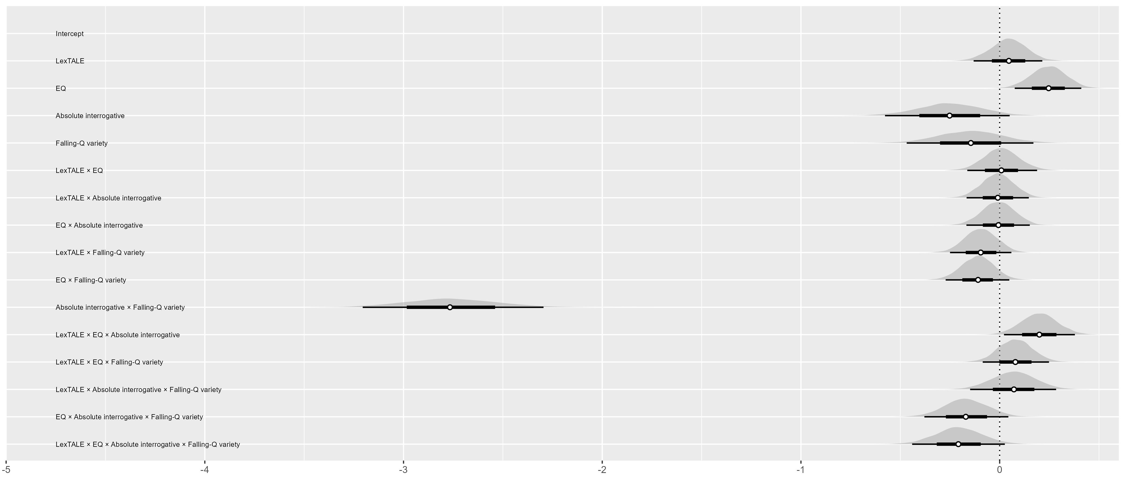
Figure 2 is a forest plot of the model output. Overall, participants responded more accurately to rising-question varieties (RQVs) than falling-question varieties (FQVs). The log-odds of a correct response for a RQV declarative at the average proficiency and EQ levels was 2.28 (β = 2.28, HDI = [2.02, 2.54], ROPE = 0, MPE = 1), or approximately 91.01%. This performance was on par with RQV absolute interrogatives (β = 2.03, HDI = [1.73, 2.32], ROPE = 0.00, MPE = 1.00) and FQV declaratives (β = 2.14, HDI = [1.84, 2.42], ROPE = 0.00, MPE = 1.00), with no meaningful differences.
In the case of FQV absolute interrogatives, participants correctly identified sentence type drastically less often (β = −0.88, HDI = [−1.16, −0.57], ROPE = 0.00, MPE = 1.00), approximately 29.51%; (HDI = [23.84%, 36.02%]).
Figure 3 plots response accuracy as a function of variety, sentence type and variably LexTALE (left panel) or EQ (right panel). Proficiency alone did not have a strong relationship with accuracy. Empathy, on the other hand, is positively associated with accuracy. A 1-SD change in empathy is associated with a 14% [-4% , 36%] increase for FQV declaratives, and stronger positive associations for RQV declaratives (27% [6% , 51%]) and RQV absolute interrogatives (28% [8% , 51%]).

Figure 3
Effect of LexTALE (A) and EQ (B) by variety and utterance type.
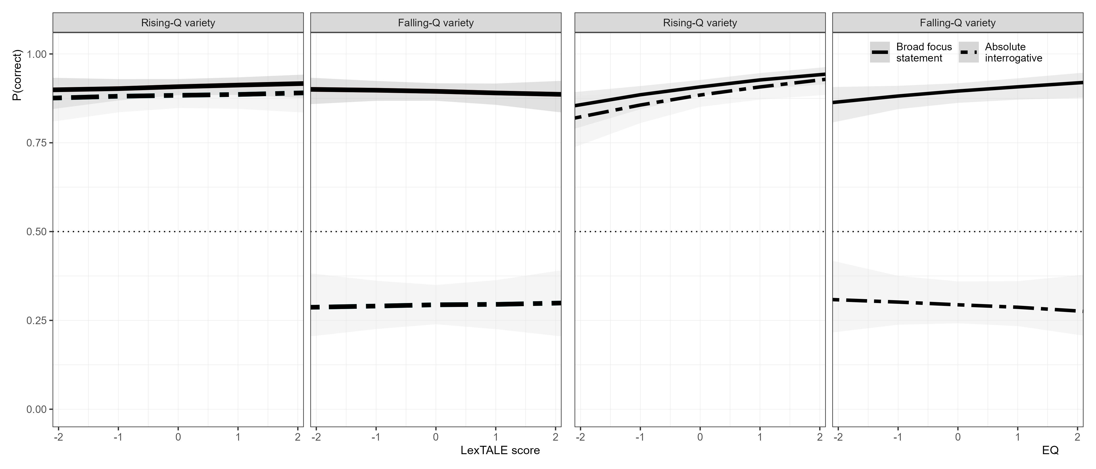
Lastly, the model estimated the proficiency by EQ interaction (Figure 4). There was strong evidence that the proficiency effect was modulated by EQ only for RQV absolute interrogatives. As an individual increases in proficiency, EQ becomes more influential as a predictor. The relationship is exemplified by holding proficiency at 2 SD above the mean (or a LexTALE score of 33.42) and varying EQ between -2 (EQ = 18.68) and +2 (EQ = 65.36). At -2, response accuracy is at 67.70% [43.22%, 86.24%], meaningfully lower than at +1 96.50% [92.50%, 98.78%].

Figure 4
Probability correct predicted by proficiency, faceted by sentence type and Spanish variety. The three lines are representative of EQ at -1, 0, and 1 standard deviation.
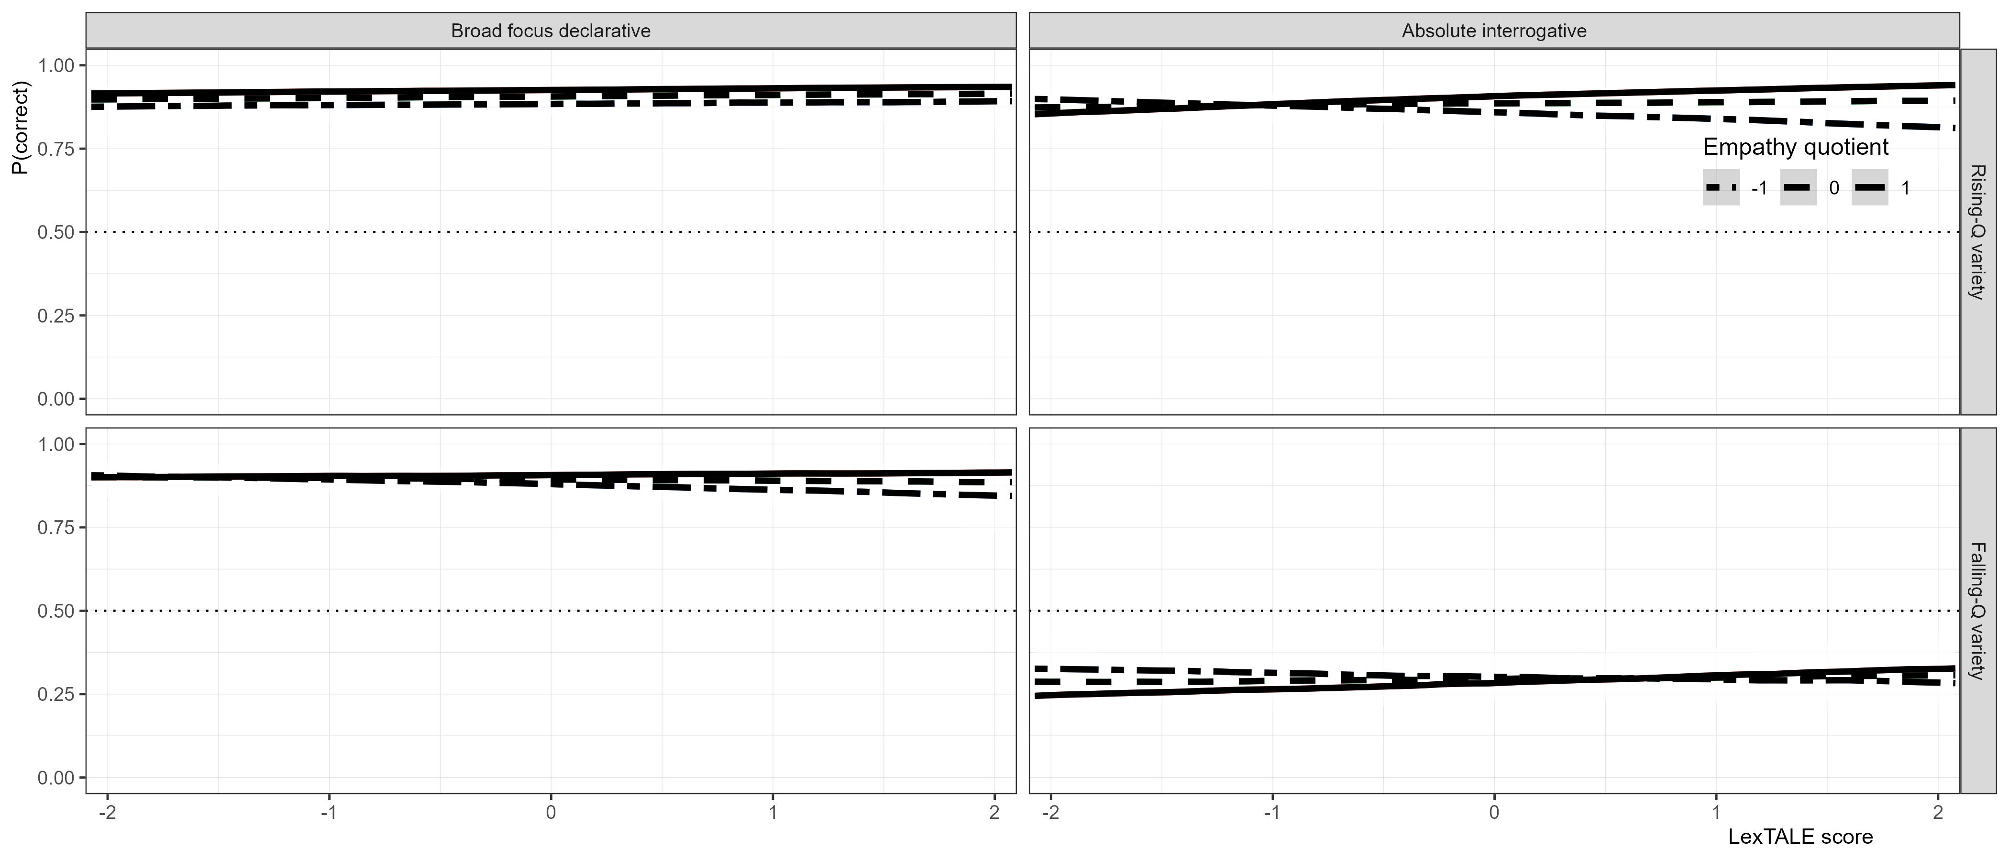
In sum, empathy had a weak influence on accuracy for all conditions except for falling-question variety absolute interrogatives. There was an interaction between empathy and proficiency only for rising-question variety absolute interrogatives, such that higher-proficiency individuals with higher empathy identified this sentence type more accurately than their proficiency-matched lower-empathy peers.

4.2 RQ2
The second analysis addressed RQ2, which examined whether L2 Spanish learners with higher empathy make greater use of brief exposure when exposed to an unfamiliar variety of Spanish compared to lower empathy individuals. This analysis included only falling-question varieties’ (Puerto Rican and Cuban) absolute interrogatives and participants who self-reported not being exposed to Caribbean or Galician varieties of Spanish (i.e., varieties with final falls for absolute interrogatives).

Figure 5
Forest plot of model output for RQ2. White points represent posterior medians; the thick black lines and thin black lines represent 66% and 95% highest density credible intervals, respectively.
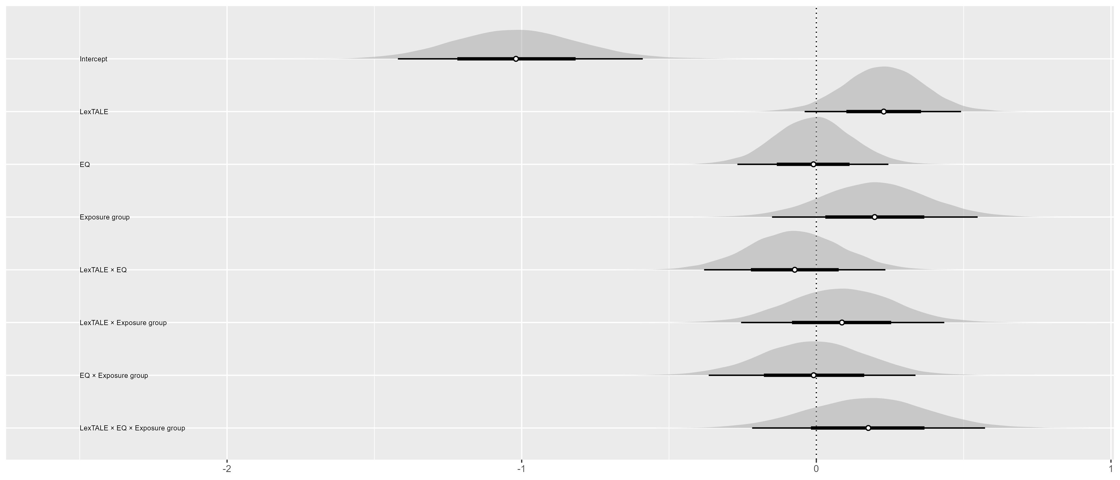
Figure 5 summarizes the posterior distribution of the response accuracy model, illustrating point estimates ±66% and 95% HDIs in graphical form. The log-odds of a correct response at the average proficiency and EQ levels in the control group was -1.02 (β = -1.02, HDI = [-1.42, -0.59], ROPE = 0, MPE = 1), or approximately 26.77% [19.46%, 35.69%]. The exposure group did not meaningfully differ from the control group (30.82% [22.27%, 41.14%]).

Figure 6
Effect of LexTALE (A) and EQ (B) by group.
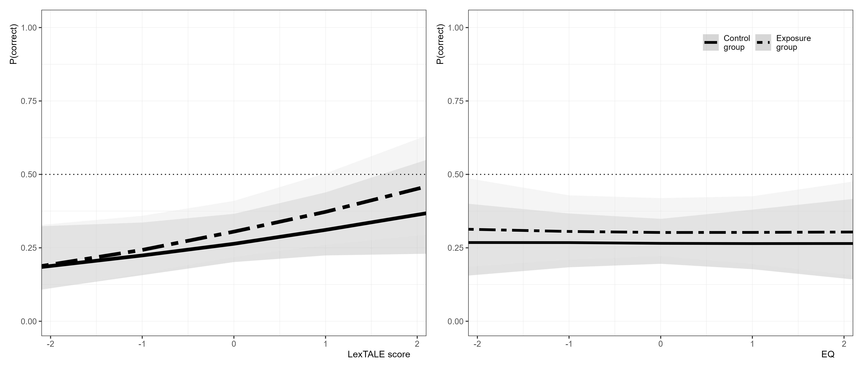
Figure 6 illustrates the relationship between LexTALE (left panel) and EQ (right panel) with response accuracy. The effect of proficiency was similarly positive between the control (β = 0.23, HDI = [−0.04, 0.49], ROPE = 0.15, MPE = 0.96) and exposure (β = 0.31, HDI = [0.05, 0.57], ROPE = 0.02, MPE = 0.99) groups, and the effect was practically equivalent between the two groups (β = 0.09, HDI = [-0.26, 0.43], ROPE = 0.41, MPE = 0.68). There was no evidence that empathy alone had an effect on response accuracy in either group (control: β = −0.01, HDI = [−0.27, 0.24], ROPE = 0.59, MPE = 0.53; exposure: β = −0.02, HDI = [−0.29, 0.25], ROPE = 0.55, MPE = 0.56).
Although no effect was found for empathy alone, a weak interaction between empathy and proficiency was found in only the exposure group (0.10 [-0.20, 0.40], plotted in Figure 7.

Figure 7
Probability correct predicted by proficiency in the control and exposure groups. The three lines are representative of EQ at -1, 0, and 1 standard deviation.
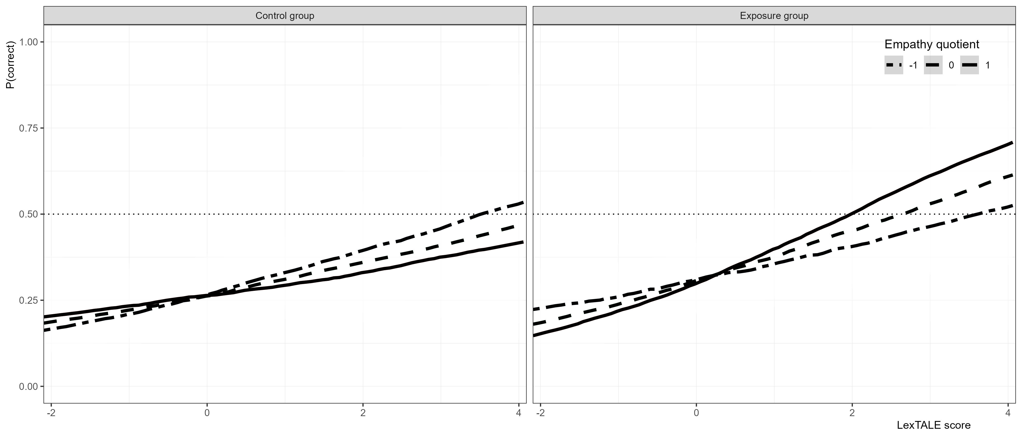
To illustrate the interaction effect, probability estimates were computed holding LexTALE constant at +4 SD above the average, equivalent to a LexTALE score of 33.42 and thus representing an intermediate-to-advanced learner, and varying EQ. At -2 SD below the mean EQ (or a score of 18.68), the estimated probability was 43.87% [4.04%, 92.64%], compared to +2 SD above the mean EQ (or a score of 65.36) estimated at 70.95% [17.42%, 98.24%].

5. Discussion

5.1 RQ1
The first research question, Do higher-empathy, compared to lower-empathy, L1 English L2 Spanish learners display higher accuracy when identifying a Spanish utterance as a declarative versus interrogative?, was a partial replication of Joseph V. Casillas et al. (2023). In the present study, it was found that empathy modulated accuracy for rising-question variety (RQV) utterances, as well as falling-question variety (FQV) declaratives, but not FQV absolute interrogatives. Furthermore, an interaction between empathy and proficiency was found for RQV absolute interrogatives, such that higher-proficiency, higher-empathy individuals outperformed their proficiency-matched, lower-empathy peers.
Proficiency, as measured by the LexTALE-ESP (Izura et al., 2014; Lemhöfer & Broersma, 2012), was not found to have a clear relationship with accuracy. The LexTALE (Izura et al., 2014; Lemhöfer & Broersma, 2012) has been criticized for not being representative of global proficiency (Puig-Mayenco et al., 2023). Although previous evidence indicates that LexTALE score is positively correlated with sentence-type identification (Brandl et al., 2020; Joseph V. Casillas et al., 2023; Nibert, 2006; Trimble, 2013b), more evidence is required to determine if a vocabulary measure is positively correlated with sentence-type identification and other aspects of intonation. Other measures, such as exposure (Sagarra et al., 2024) or learning environment (Trimble, 2013a), may prove better predictors of L2 intonation acquisition. Furthermore, the current dataset was primarily made up of learners with “low to medium” proficiency. Given that other effects were found at higher proficiency levels, rapid acquisition of sound-to-meaning associations should be investigated with a dataset of higher-proficiency participants.
The empathy-by-proficiency interaction found only for RQV interrogatives runs counter to results from Joseph V. Casillas et al. (2023) in two ways: first, they originally found no main or interaction effect for empathy in absolute interrogatives; second, they found an interaction between proficiency and empathy for lower-proficiency participants, not higher-participants ones. As previously noted, the present study included only 2 of the 4 sentence types included in Joseph V. Casillas et al. (2023), so it is possible that learners capitalized on the dichotomy to better identify sentence type, especially higher-proficiency, higher-empathy participants.

5.2 RQ2
With regards to LILt (Mennen, 2015), it was predicted that L1 English L2 Spanish learners would more easily identify yes-no questions with a low boundary tone (Geluykens, 1988). In line with previous studies, participants found extreme difficulty in correctly identifying this sentence type (Brandl et al., 2020; Joseph V. Casillas et al., 2023). Neither proficiency nor empathy modulated response accuracy. This leads into the second research question regarding exposure: Do higher-empathy, compared to lower-empathy, L1 English L2 Spanish learners display higher accuracy when identifying a Spanish utterance, from a variety to which they have little or no previous exposure, as an interrogative if they are briefly exposed to conversations from that variety?
Previous work shows that higher-empathy individuals retain more detail from social interactions (Melchers et al., 2017), and that both empathy and dialect exposure can shape phonological processing in L1 populations (Orrico & D’imperio, 2020). Building on this, the current study aimed to determine if higher-empathy L1 English L2 Spanish learners benefited greater from exposure to a novel intonation-meaning mapping, specifically Spanish absolute interrogatives with a final fall, when later determining if an utterance is an interrogative or not. Higher-empathy listeners were predicted to encode richer detail of the input than their lower-empathy peers, even during a short period of exposure, which they would draw on when listening to future speakers (Gradoville, 2023; Schweitzer, 2012).
No effect was found for empathy alone, but there was evidence for a weak interaction between empathy and proficiency only for individuals exposed to the naturalistic conversations. Specifically, individuals at the average proficiency level did not benefit from higher empathy, but individuals with higher empathy and above-average proficiency outperformed on average their peers. These results corroborate the idea that higher empathy individuals retain more detail from social interactions (Melchers et al., 2017), but in L2 processing, empathy specifically works to modulate a proficiency effect. Participants must have a certain proficiency in a language, as well as higher empathy, to benefit from rapid, incidental exposure to an unfamiliar intonation-to-meaning mapping.
Within the language classroom, these findings suggest that only a small set of students (those with both higher empathy and higher proficiency) will benefit from brief incidental intonation exposure. It is clear that exposure alone is not sufficient for all individuals to acquire target intonation in production (Herrero et al., 2020) or perception (Herrero & Devı́s, 2020), and it is also clear that intentional learning (Olea, 2019; Sonsaat-Hegelheimer & Levis, 2025) reaps wider benefits than those found in the present study. As such, the results of this study point towards a greater need of more intentional-learning training for intonation.

5.3 Limitations and Future Directions
Moving forward, more research should be conducted to determine how much exposure an individual needs to acquire sound-to-meaning associations for intonation, and how much this is modulated by empathy. Clearly, approximately 5 minutes of naturalistic conversation (or approximately 16 tokens) is not enough to see strong effects of empathy. Attempting to map out the time-span in which a higher-empathy L2 learner acquires a new sound-to-meaning association, in a longitudinal or study abroad study for example, would provide useful information for pedagogical and theoretical purposes.
No feedback was given during the two-alternative forced task, and there was little evidence for participants that there were exactly four different varieties presented in the stimuli. However, learners in real-life situations find themselves in situations where they cannot identify a regional variety and must comprehend the Spanish speaker. Even if a participant did interpret the stimuli as coming from the one variety, variable realization is fairly common. Even in Puerto Rican Spanish, for example, a final fall is common for yes-no questions, but a final rise is not categorically impossible (Armstrong, 2010).
Most importantly, the current study did not control for other intonational features present in the stimuli aside from the boundary tone. Castilian Spanish speakers can distinguish a broad focus declarative from an interrogative by the first pitch peak (Face, 2007), and L2 Spanish speakers also seem to accomplish this to a lesser degree (Bedialauneta Txurruka, 2024). These results indicate that L2 speakers do not solely pay attention to the final F0 movement, but instead use other F0 cues throughout the sentence for sentence type identification, like L1 Spanish speakers. Given that the early intonational cues for sentence type varies across dialects, more research is needed to determine what early features L2 speakers may pay attention to.

6. Conclusion
The current study investigated the impact that incidental learning and empathy has on the acquisition of a novel intonation-meaning mapping. It was found that individuals with above-average empathy and proficiency were more sensitive to the novel mapping after brief exposure to naturalistic conversation compared to their lower-empathy peers, and more importantly, compared to those who did not have the exposure. This study contributes to our understanding of how individual differences impact L2 learner intonation outcomes, as well as providing evidence that incidental learning of intonation may only be beneficial for a small subset of L2 learners. These results encourage more research in pragmatic skill as it relates to L2 learner outcomes, and how these findings relate to findings from L1 research on empathy and language processing.

7. References
Armstrong, M. E. (2010). Puerto rican spanish intonation. Transcription of Intonation of the Spanish Language, 155–189. https://doi.org/10.21437/speechprosody.2010-145
Astruc, L., Mora, E., & Rew, S. (2010). Venezuelan andean spanish intonation. Transcription of Intonation of the Spanish Language, 191–226. https://doi.org/10.3765/exabs.v0i0.582
Bailey, A. A. (2014). Intonational phonology of cuban spanish: A preliminary model. Proc. SpeechProsody 2014, 809–813. https://doi.org/10.21437/speechprosody.2014-151
Baron-Cohen, S. (2011). Zero degrees of empathy: A new theory of human cruelty (Vol. 30). Penguin uk. https://doi.org/10.1192/bjp.bp.111.098434
Baron-Cohen, S., & Wheelwright, S. (2004). The empathy quotient: An investigation of adults with asperger syndrome or high functioning autism, and normal sex differences. Journal of Autism and Developmental Disorders, 34, 163–175. https://doi.org/10.1023/b:jadd.0000022607.19833.00
Bedialauneta Txurruka, I. (2023). Perception of spanish declarative questions and statements by L2 spanish speakers. In R. Skarnitzl & J. Vol’ın (Eds.), Proceedings of the 20th international congress of phonetic sciences (pp. 2591–2596). Guarant International. https://doi.org/10.1017/S0025100323000348
Bedialauneta Txurruka, I. (2024). Perception and processing of spanish questions and statements by L1 english/L2 spanish speakers.
Bishop, J. (2016). Individual differences in top-down and bottom-up prominence perception. Proceedings of Speech Prosody, 2016, 668–672. https://doi.org/10.21437/speechprosody.2016-137
Bishop, J. B., Chong, A. J., & Jun, S.-A. (2015). Individual differences in prosodic strategies to sentence parsing. ICPhS. https://doi.org/10.1177/0023830914563368
Brandl, A., González, C., & Bustin, A. (2020). The development of intonation in L2 spanish: A perceptual study. In Hispanic linguistics (pp. 11–32). John Benjamins Publishing Company. https://doi.org/10.1075/ihll.26.01bra
Büring, D. (2016). Intonation and meaning. Oxford University Press. https://doi.org/10.1093/acprof:oso/9780199226269.001.0001
Bürkner, P.-C. (2017a). Advanced bayesian multilevel modeling with the r package brms. arXiv Preprint arXiv:1705.11123. https://doi.org/10.32614/rj-2018-017
Bürkner, P.-C. (2017b). Brms: An r package for bayesian multilevel models using stan. Journal of Statistical Software, 80, 1–28. https://doi.org/10.18637/jss.v080.i01
Carruthers, P. (2009). Mindreading underlies metacognition. Behavioral and Brain Sciences, 32(2), 164–182. https://doi.org/10.1017/s0140525x09000831
Casillas, Joseph V., Constantin-Dureci, G., Andreu Rascón, I., Shao, J., Rodrı́guez, S. A., Gadamsetty, A., Minetti, A., Laungani, K., Thatcher, J., Gardere, R.-T., et al. (2025). Opening open science to all: Demystifying reproducibility and transparency practices in linguistic research. Linguistics, 0. https://doi.org/10.1515/ling-2023-0249
Casillas, Joseph V., Garrido-Pozú, J. J., Parrish, K., Arroyo, L. F., Rodrı́guez, N., Esposito, R., Chang, I., Gómez, K., Constantin-Dureci, G., & Shao, J. (2023). Using intonation to disambiguate meaning: The role of empathy and proficiency in L2 perceptual development. Applied Psycholinguistics, 44(5), 913–940. https://doi.org/10.1017/S0142716423000310
Chen, A. (2003). Reaction time as an indicator to discrete intonational contrasts in english. 8th European Conference on Speech Communication and Technology, 97–100. https://doi.org/11858/00-001M-0000-0013-2790-4
Devı́s Herraiz, E., & Cantero Serena, F. J. (2014). The intonation of mitigating politeness in catalan. Journal of Politeness Research, 10(1), 127–149. https://doi.org/10.1515/pr-2014-0006
Diehl, J. J., Bennetto, L., Watson, D., Gunlogson, C., & McDonough, J. (2008). Resolving ambiguity: A psycholinguistic approach to understanding prosody processing in high-functioning autism. Brain and Language, 106(2), 144–152. https://doi.org/10.1016/j.bandl.2008.04.002
Estebas-Vilaplana, E. (2014). The evaluation of intonation: Pitch range differences in english and in spanish. In Evaluation in context (pp. 179–194). John Benjamins Publishing Company. https://doi.org/10.1075/pbns.242.09est
Esteve-Gibert, N., Portes, C., Schafer, A., Hemforth, B., & D’Imperio, M. (2016). The role of individual empathic skills on the online processing of intonational meaning. Architectures and Mechanisms for Language Processing (AMLaP). https://doi.org/10.21437/speechprosody.2016-252
Esteve-Gibert, N., Schafer, A. J., Hemforth, B., Portes, C., Pozniak, C., & D’Imperio, M. (2020). Empathy influences how listeners interpret intonation and meaning when words are ambiguous. Memory & Cognition, 48, 566–580. https://doi.org/10.3758/s13421-019-00990-w
Face, T. L. (2007). The role of intonational cues in the perception of declaratives and absolute interrogatives in castilian spanish. Journal of Experimental Phonetics, 16, 185–225. https://doi.org/10.1515/shll-2012-1125
Frith, U., & Frith, C. D. (2003). Development and neurophysiology of mentalizing. Philosophical Transactions of the Royal Society of London. Series B: Biological Sciences, 358(1431), 459–473. https://doi.org/10.1098/rstb.2002.1218
Gabriel, C., Feldhausen, I., Pešková, A., Colantoni, L., Lee, S.-A., Arana, V., & Labastı́a, L. (2010). Argentinian spanish intonation. Transcription of Intonation of the Spanish Language, 285–317. https://doi.org/10.1353/hpn.2010.a382873
Gelman, A., Simpson, D., & Betancourt, M. (2017). The prior can often only be understood in the context of the likelihood. Entropy, 19(10), 555. https://doi.org/10.3390/e19100555
Geluykens, R. (1988). On the myth of rising intonation in polar questions. Journal of Pragmatics, 12(4), 467–485. https://doi.org/10.1016/0378-2166(88)90006-9
George, A. (2019). Teaching and learning L2 spanish intonation: Technology and classroom instruction. Conference Proceedings. Innovation in Language Learning 2019. https://doi.org/10.5070/l29335670
George, A. (2024). L2 intonation perception in learners of spanish. Perspectives on Input, Evidence, and Exposure in Language Acquisition: Studies in Honour of Susanne E. Carroll, 69, 144. https://doi.org/10.1075/lald.69.06geo
Gradoville, M. (2023). The future of exemplar theory. The Handbook of Usage-Based Linguistics, 527–544. https://doi.org/10.1002/9781119839859.ch29
Herrero, C., & Devı́s, E. (2020). Unintentional impolite intonation in L2 spanish requests produced by chinese workers living in madrid. Proceedings of the 10th International Conference on Speech Prosody, 848–852. https://doi.org/10.21437/speechprosody.2020-173
Herrero, C., Planelles, M., & Alhmoud, Z. (2020). Perception of L2 spanish polite requests and impolite commands by chinese migrant workers living in spain. Lengua y Migración, 12(2), 65–85. https://doi.org/10.37536/lym.12.2.2020.1026
Hulstijn, J. H. (2003). Incidental and intentional learning. The Handbook of Second Language Acquisition, 349–381. https://doi.org/10.1002/9780470756492.ch12
Izura, C., Cuetos, F., & Brysbaert, M. (2014). Lexical test for advanced learners of spanish. Psicológica. https://doi.org/10.1037/t47086-000
Jenkins, J. (2004). 5. Research in teaching pronunciation and intonation. Annual Review of Applied Linguistics, 24, 109–125. https://doi.org/10.1017/s0267190504000054
Kruschke, J. K. (2018). Rejecting or accepting parameter values in bayesian estimation. Advances in Methods and Practices in Psychological Science, 1(2), 270–280. https://doi.org/10.31219/osf.io/s5vdy
Ladd, D. R. (2008). Intonational phonology. Cambridge University Press. https://doi.org/10.1017/cbo9780511808814
Ladd, D. R., & Morton, R. (1997). The perception of intonational emphasis: Continuous or categorical? Journal of Phonetics, 25(3), 313–342. https://doi.org/10.1006/jpho.1997.0046
Lemhöfer, K., & Broersma, M. (2012). Introducing LexTALE: A quick and valid lexical test for advanced learners of english. Behavior Research Methods, 44(2), 325–343. https://doi.org/10.3758/s13428-011-0146-0
Lord, G., & Fionda, M. I. (2013). Teaching pronunciation in second language spanish. The Handbook of Spanish Second Language Acquisition, 514–529. https://doi.org/10.1002/9781118584347.ch29
Melchers, M., Montag, C., Markett, S., Niazy, N., Groß-Bölting, J., Zimmermann, J., & Reuter, M. (2017). The OXTR gene, implicit learning and social processing: Does empathy evolve from perceptual skills for details? Behavioural Brain Research, 329, 35–40. https://doi.org/10.1016/j.bbr.2017.04.036
Mennen, I. (2015). Beyond segments: Towards a L2 intonation learning theory. In Prosody and language in contact: L2 acquisition, attrition and languages in multilingual situations (pp. 171–188). Springer. https://doi.org/10.1007/978-3-662-45168-7
Navarro Tomás, T. (1974). Manual de entonación española. Biblioteca Hernán Malo González.
Nibert, H. J. (2006). The acquisition of the phrase accent by beginning adult learners of spanish as a second language. Selected Proceedings of the 2nd Conference on Laboratory Approaches to Spanish Phonetics and Phonology, 131–148. https://doi.org/10.1075/lald.4.09pla
Olea, M. S. A. U. (2019). The effectiveness of the instruction of the intonation of english implications to L1 spanish trainee teachers. Logos: Revista de Lingüı́stica, Filosofı́a y Literatura, 29(2), 399–414. https://doi.org/10.15443/rl2930
Orrico, R., D’Imperio, M., et al. (2020). Tonal specification of speaker commitment in salerno italian wh-questions. Speech Prosody, 361–365. https://doi.org/10.21437/SpeechProsody.2020-74
Orrico, R., & D’imperio, M. (2020). Individual empathy levels affect gradual intonation-meaning mapping: The case of biased questions in salerno italian. Laboratory Phonology: Journal of the Association for Laboratory Phonology, 11(1), 1–39. https://doi.org/10.5334/labphon.238
Orrico, R., Gryllia, S., Kim, J., & Arvaniti, A. (2025). Individual variability and the h*~ l+ h* contrast in english. Language and Cognition, 17, e9. https://doi.org/10.1017/langcog.2024.62
Ortega-Llebaria, M., & Colantoni, L. (2014). L2 english intonation: Relations between form-meaning associations, access to meaning, and L1 transfer. Studies in Second Language Acquisition, 36(2), 331–353. https://doi.org/10.1017/s0272263114000011
Patience, M., Marasco, O., Colanton, L., Klassen, G., Radu, M., & Tararova, O. (2018). Initial pitch cues in english sentence types. https://doi.org/10.21437/SpeechProsody.2018-94
Peirce, J., Gray, J. R., Simpson, S., MacAskill, M., Höchenberger, R., Sogo, H., Kastman, E., & Lindeløv, J. K. (2019). PsychoPy2: Experiments in behavior made easy. Behavior Research Methods, 51(1), 195–203. https://doi.org/10.3758/s13428-018-01193-y
Pérez Castillejo, S., & Fuente Iglesias, M. de la. (2024). Basic intonation patterns of galician spanish. Languages, 9(2), 57. https://doi.org/10.3390/languages9020057
Pierrehumbert, J. B. (1980). The phonology and phonetics of english intonation [PhD thesis, Massachusetts Institute of Technology]. https://doi.org/10.3726/978-3-653-04390-7/7
Prieto, P., & Roseano, P. (2009--2013). Atlas interactivo de la entonación del español. http://prosodia.upf.edu/atlasentonacion/. https://doi.org/10.31390/gradschool_theses.4679
Prieto, P., & Roseano, P. (2010). Transcription of intonation of the spanish language. Lincom Europa Munich. https://doi.org/10.1075/sic.10.2.08fac
Puig-Mayenco, E., Chaouch-Orozco, A., Liu, H., & Martı́n-Villena, F. (2023). The LexTALE as a measure of L2 global proficiency: A cautionary tale based on a partial replication of lemhöfer and broersma (2012). Linguistic Approaches to Bilingualism, 13(3), 299–314. https://doi.org/10.1075/lab.22048.pui
Rao, R. (2011). Intonation in spanish classroom-style didactic speech. Journal of Language Teaching and Research, 2(3), 493–507. https://doi.org/10.4304/jltr.2.3.493-507
Rao, R. (2019). Key issues in the teaching of spanish pronunciation. Routledge London, United Kingdom. https://doi.org/10.4324/9781315666839
Rodero, E. (2011). Intonation and emotion: Influence of pitch levels and contour type on creating emotions. Journal of Voice, 25(1), e25–e34. https://doi.org/10.1016/j.jvoice.2010.02.002
Sagarra, N., Fernández-Arroyo, L., Lozano-Argüelles, C., & Casillas, J. V. (2024). Unraveling the complexities of second language lexical stress processing: The impact of first language transfer, second language proficiency, and exposure. Language Learning, 74(3), 574–605. https://doi.org/10.1111/lang.12627
Schweitzer, K. (2012). Frequency effects on pitch accents: Towards an exemplar-theoretic approach to intonation. https://doi.org/10.18419/opus-2994
Sonsaat-Hegelheimer, S., & Levis, J. (2025). Is intonation learnable in the classroom? Evidence from turkish learners of english. Language Teaching Research, 13621688241312502. https://doi.org/10.2139/ssrn.4710794
Trimble, J. C. (2013a). Perceiving intonational cues in a foreign language: Perception of sentence type in two dialects of spanish. Selected Proceedings of the 15th Hispanic Linguistics Symposium, 78–92. https://doi.org/10.1016/s0095-4470(19)31304-x
Trimble, J. C. (2013b). Acquiring variable L2 spanish intonation in a study abroad context [PhD thesis, University of Minnesota]. https://doi.org/10.1075/ihll.37.04tri
Trofimovich, P., & Baker, W. (2006). Learning second language suprasegmentals: Effect of L2 experience on prosody and fluency characteristics of L2 speech. Studies in Second Language Acquisition, 28(1), 1–30. https://doi.org/10.1515/iral.2011.007
Ward, G., & Hirschberg, J. (1988). Intonation and propositional attitude: The pragmatics of l*+ HLH%. Proceedings of the Fifth Eastern States Conference on Linguistics, 512–522. https://doi.org/10.1163/9780585474472
Willis, E. (2010). Dominican spanish intonation. Transcription of Intonation of the Spanish Language, 123–153. https://doi.org/10.4324/9781003054979-4

