Robert Esposito  
Phonology I

Quechua Phonology

# Introduction

Quechua describes a dialect continuum that was once spoken across the Incan Empire in South America, and in the present day ranges geographically from southern Ecuador to northern Argentina. Due to colonialization by the Spanish, Quechua has had extensive contact with Spanish, resulting in extralinguistic and linguistic changes. Extralinguistically, Quechua monolingualism has fallen dramatically, whereas Quechua-Spanish bilingualism has risen. Linguistically, Spanish loanwords have been adopted across word categories, such as *fiesta* (“party, feast”, Sp: fiesta) or *faltay* (“to lack”, Sp: faltar). Non-native sounds have also been introduced to Quechua, typically restricted to loan words, such as the labiodental fricative /f/ or the mid vowels /e/ and /o/ (Torero, 1983).

Quechua is typically divided into two major dialect groups, Quechua I and Quechua II, both of which have further subdivisions. This works focuses on South Bolivian Quechua (henceforth, SBQ), a Quechua II dialect. This paper will investigate vowel lowering in SBQ, which occurs when a high vowel is adjacent to /q/.

# Phoneme Inventory

## Consonants

SBQ presents the typical inventory of phonemes for a Quechua language (Table 1), retaining the three-way series of simple, aspirated, and glottalized (AKA ejective) stops.

Table 1. South Bolivian Quechua consonant inventory (Bills et al., 1969).

|  |  |  |  |  |  |  |  |
| --- | --- | --- | --- | --- | --- | --- | --- |
|  |  | **bilabial** | **alveolar** | **palatal** | **velar** | **uvular** | **glottal** |
| **nasal** |  | m | n | ɲ |  |  |  |
| **stop** | *simple* | p | t |  | k | q |  |
| *aspirated* | pʰ | tʰ |  | kʰ | qʰ |  |
| *glottalized* | pʼ | tʼ |  | kʼ | qʼ |  |
| **affricate** | *simple* |  |  | tʃ |  |  |  |
| *aspirated* |  |  | tʃʰ |  |  |  |
| *glottalized* |  |  | tʃʼ |  |  |  |
| **fricative** |  |  | s |  |  |  | h |
| **flap** |  |  | ɾ |  |  |  |  |
| **lateral** |  |  | l | ʎ |  |  |  |
| **approximant** |  | w |  | j |  |  |  |

## Vowels

There is an active and historic debate about whether Quechua should be represented orthographically with a three-vowel or five-vowel system. While institutions like the Peruvian Academy of the Quechua Language established a five-vowel system in 1987 (Coronel-Molina, 1997), whereas other institutions and linguists prefer the three-vowel system. The three-vowel system (/i a u/) is motivated by the fact that the mid vowels /o/ and /e/ only surface in Spanish loanwords and as allophones when adjacent to the uvular stop. Although this essay will take for granted that Quechua has a three-vowel system, it will make use of a SBQ dictionary (Lott, 1978) that *does* use a five-vowel system. Henceforth, all instances of [e] and [o] are assumed to be underlying /i/ and /u/ respectively, unless otherwise stated.

## Mid Vowels

Lott’s dictionary (1978), although using a five-vowel system, actually makes a good case for a three-vowel system by thoroughly demonstrating the conditioning factor of the mid vowels. In fact, of the 359 words in which <e> or <o> occur in the dictionary, approximately 83% of the cases can be explained by its adjacency to <q> or it being a loanword from Spanish.

The remaining instances of <e> and <o> occur adjacent to syllable-final <j> (e.g. *sojta* “six”, *Diosman kutirej* “convert”). The phonetic status of <j> here is unclear. Molina-Vital (2020), a speaker of Southern Quechua, transcribes and pronounces *suqta* [soχta] “six”, indicating that the underlying phoneme here is /q/. What Lott transcribes as *wajtan* “rib” is recorded in other dictionaries as *waqta.* However, there is not a clear correspondence between <j> in this dictionary and <q> /q/. For example, *ujyay* “to drink” has correspondences with *upyay* in other dialects. The Spanish loanword *carajo* “damn it” corresponds to Spanish /x/, which most likely is realized as [h] in SBQ. *Uj* “one” corresponds to [(h)uk] in other dialects.

However, it seems that when <j> occurs with <e> or <o>, there are clear correspondences with /q/ in other varieties. For example, *mosoj* “new” is *musuq* in other dictionaries; *yachayniyoj* “teacher” is *yachachiq* in other dictionaries. Most notably, *wijsayoj* “pregnant” is *wiksayuq* in other dictionaries. This gives strong motivation that <j> is not a single phoneme, as the orthography might suggest. That is, if it were representing the same phoneme, we would expect \**wejsayoj*.

The present evidence suggests that <j> can represent the surface forms [h] and [χ]. Where other dialects have /q/, the surface form [χ] most likely surfaces; otherwise, [h] surfaces. Furthermore, there is evidence that the underlying phoneme is /q/ in such cases that vowel lowering occurs. With this in mind, I will investigate vowel lowering only in proximity to <q> /q/ (and its aspirated/glottalized counterparts) and <j> only when it clearly has correspondences to /q/ in other dialects.

# Vowel Lowering in South Bolivian Quechua

## Environments

As discussed, high vowels lower to mid vowels when adjacent to /q/. However, /q/ can also lower vowels across some consonants regressively. In this dictionary, /q/ can lower /i/ to [e] when there is an intervening /n/, /r/, or /l/; it can lower /u/ to [o] when there is an intervening /n/ (which is realized as the homorganic sequence [ɴq]), /r/, or /s/ (Table 2). There are no instances in this dictionary where /q/ can lower a vowel progressively across a consonant, and Steriade (1995) claims that this process cannot happen.

Table 2. Vowel lowering across a phoneme.

|  |  |  |  |
| --- | --- | --- | --- |
| **Vowel** | **Intervening phoneme** | **Quechua** | **English gloss** |
| e | n | enqhay | to add wood to the fire |
| r | erqhe | crybaby |
| l | qelqey | to write |
| o | n | ch'onqay | to suck |
| r | morq'o | ball, round object |
| s | mosqoy | dream, to dream |

This situation is similar to what Adeelar (1977) records for another Quechua variety, Tarma Quechua. However, he claims that vowel lowering can occur across /l/ for back vowels, but not front vowels (the opposite of what is found here). Furthermore, Steriade (1995) claims that in Cochabamba Quechua, a SBQ variety, /s/ blocks vowel lowering (/riku-sqa/ 🡪 [rikusqa], “he/she had seen it”), which contradicts the data here. It is possible that the one word encountered in the dictionary, *mosqoy* “dream, to dream” is a loanword, but this seems unlikely.

There is exactly one entry for the sequence /ulq/ *p’ulqo* “baby boots made from yarn”, which exhibits blocking of vowel lowering for /u/. The sequence /wq/ *does* appear, and thus legal, but not with /i/ and /u/. Adeelar (1977) notes that stop+/q/ sequences are phonotactically allowed in other dialects of Quechua, but such sequences are not found in this dictionary.

In summary, /q/ can lower a high vowel in SBQ, according to Lott (1978), when it occurs after a segment that is [-vocoid] and not a stop, with some distinctions made between the front and back high vowel. However, due to overwhelming evidence from other studies (e.g. Adeelar, 1997 and Steriade, 1995), the two vowels will be treated the same in this analysis, and differences between them found in this dictionary (e.g. the occurrence [osq], but not [esq]) will be assumed to be a data availability issue.

## Spreading of PHARYNGEAL

Within Clements & Hume’s feature tree (1995), it is difficult to represent vowel lowering triggered by a consonant. The feature [-high] could be said to spread from /q/ to the vowel’s DORSAL node. However, height features are typically grouped under the APERTURE node, and there is no transparent or motivated way for a feature [-high], which is held under the DORSAL node of the consonant, to spread to the APERTURE node of the vowel.

McCarthy’s feature tree (1988) provides a more transparent and succinct representation of vowel lowering in this case. According to Rose (1996), taking McCarthy’s tree as a base, /q/ has both ORAL and PHARYNGEAL nodes dominated by PLACE. The ORAL nodes dominate DORSAL, whereas the PHARYNGEAL node dominates the terminal feature node [RTR] (Figure 1). Within her analysis, vowel lowering and vowel retraction is explained by the independent spreading of PHARYNGEAL and [RTR], respectively.

Figure 1. Feature geometry of /q/ (Rose, 1995).

This provides a succinct way to explain vowel lowering in Quechua (Figure 2), and the flexibility of spreading the PHARYNGEAL node and the [RTR] node independently or jointly allows for generalizations to be made across Quechua dialects. That is, in SBQ, only vowel lowering is noted. However, Adeelar (1977) records that in Tarma Quechua, the high vowels can be lowered and/or retracted. Since these two phenomena are clearly related, occurring in the same environments, it makes sense for the spreading features to be related in the tree.

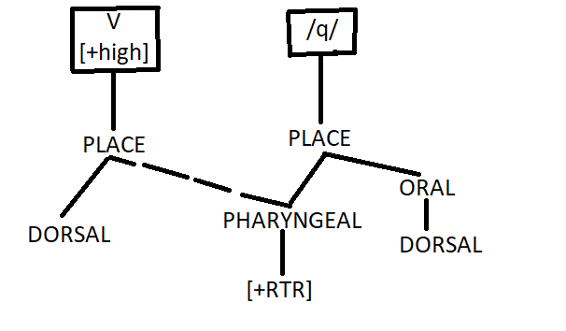

Figure 2. Spreading of PHARYNGEAL to account for vowel lowering in SBQ.

Clements & Hume (1995) would not have an easy way to represent these related phenomena. As written previously, the feature [-high] spreading from /q/ to the vowel could account for vowel lowering, but vowel retraction would be harder to explain. They do not use the feature [ATR] or [RTR] in their tree, and the feature [+back] does not make sense to account for vowel retraction since it would be difficult to justify describe [e] as [+back].

## Spreading Across Consonants

The spreading of PHARYNGEAL across consonants will now be treated. As explained previously, it will be assumed that vowel spreading can occur across the consonants /n r l s/. Although it is tempting to see the natural class [coronal] in this set, it seems unlikely that [coronal] itself would be relevant here, especially because it is missing /t/.

A more convincing explanation comes from an appeal to underspecification. I propose that coronal segments are placeless in Quechua and that PHARYNGEAL can only spread over a placeless segment. This leaves me with the task of justifying that the remaining non-coronal segments are specified for PLACE in the underlying representation. Avery & Rice (1989) claim that only contrasts are recorded in the underlying representation. For example, in Catalan, PLACE is only specified for the bilabial, palatal, and velar nasals, whereas the alveolar nasal is placeless. The same situation can be seen here. /s/ seems the most difficult to justify as placeless, but I claim that PLACE is not actually a distinctive feature for it underlyingly, as it can contrast with sonorants, using [-sonorant] and the stop obstruents by using [+continuant]. Therefore, /s/ in Quechua is placeless and later filled in with the default CORONAL.

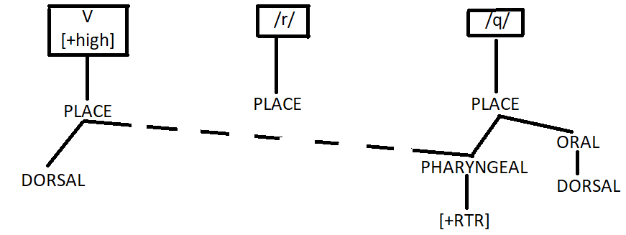

Figure 3. /q/ lowers a [+high] V over an underlyingly placeless consonant /r/.

The remaining issue is the treatment of /t/. According to Adeelar (1977), the sequence /tq/ is allowed in Tarma Quechua, but that sequence does not appear in the dictionary under analysis for SBQ. Under the current analysis, /t/ would also be treated as placeless. Just as is the case with the Catalan nasals, /t/’s PLACE node would be filled in with [CORONAL] by a default rule, whereas /p/ and /k/ would be specified for PLACE. Thus, it is predicted that /t/ would be transparent to the vowel lowering effects of /q/ in a sequence /itq/ or /utq/. In order to determine the legitimacy of this prediction, more data, especially sentence-level data, would be needed.

# Conclusion

Through the feature geometry presented by Rose (1996), I have justified the spreading of PHARYNGEAL as the source of /q/ lowering high vowels in South Bolivian Quechua. The node can spread over placeless segments /n r l s/, and it is predicted that it will also spread over /t/. Further data is needed to determine discrepancies between the current dataset (Lott, 1978) and others (Adeelar, 1977; Steriade, 1995), such as the possible segments that are transparent to vowel lowering and asymmetries between the distribution of those segments and /i/ or /u/.

References

Adelaar, W. F. (1977). *Tarma Quechua: Grammar, Texts, Dictionary*. The Peter de Ridder Press.

Avery, P., & Rice, K. (1989). Segment structure and coronal underspecification. *Phonology, 6*(2), 179–200. Cambridge University Press.

Bills, G. D., Vallejo, B. C., & Troike, R. C. (1969). *An introduction to spoken Bolivian Quechua*. Special publication of the Institute of Latin American Studies, the University of Texas at Austin. Published for the Institute of Latin American Studies by the University of Texas Press.

Clements, G. N. (1995). The internal organization of speech sounds. In *The Handbook of Phonological Theory*. Blackwell Publishers.

Coronel-Molina, S. M. (1997). Corpus planning for the Southern Peruvian Quechua language. *Working Papers in Educational Linguistics, 12*(2), 1–27. ERIC.

Lott, P. S. (1978). *Bolivian Quechua - English Dictionary*.

Molina-Vital, C. (2020, October 4). *Numbers in Southern Quechua* [Video]. YouTube. <https://www.youtube.com/watch?app=desktop&v=qJmjDzVrKYw&ab_channel=CarlosMolina-Vital>

Rose, S. (1996). Variable laryngeals and vowel lowering. *Phonology, 13*(1), 73–117. Cambridge University Press.

Steriade, D. (1995). Underspecification and markedness. In *The Handbook of Phonological Theory*. Blackwell.

Torero, A. (1983). La familia lingüística quechua. In *América Latina en sus lenguas indígenas* (pp. 61–92). Monte Ávila Editores Caracas.