Manual ImageRefiner 2021

# File and folder structure:

Place your image files in the following folder structure. It is important that your images and folders are named correctly.

data

|----191_19

| |----Cortex

| | |----191-19_GF01

| | | |-----<Name>_CH1.tif

| | | |-----<Name>_CH2.tif

| | | |-----<Name>_CH3.tif

| | | |-----<Name>_CH4.tif

| | |----191-19_GF02

| | | |-----<Name>_CH1.tif

| | | |-----<Name>_CH2.tif

| | | |-----<Name>_CH3.tif

| | | |-----<Name>_CH4.tif

| |----Medulla

| | |----191-19_GF01

| | | |-----<Name>_CH1.tif

| | | |-----<Name>_CH2.tif

| | | |-----<Name>_CH3.tif

| | | |-----<Name>_CH4.tif

Beside this structure you have to create a folder where MATLAB will insert your results.

# Download ImageRefiner from GitLab:

Click on the link below and sign in with your RWTH data.

<https://git.rwth-aachen.de/nephroimagerefiner>

Open the “ImageRefiner” chapter in GitLab

Ein Bild, das Text enthält.

Download ImageRefiner as Zip file

Ein Bild, das Text enthält.

Unzip the file

Place the “imagerefiner-master” folder where you can find it.

# Open ImageRefiner in MATLAB:

Open MATLAB an click on the small button “Browse for folder” on the left edge. It has a green arrow.

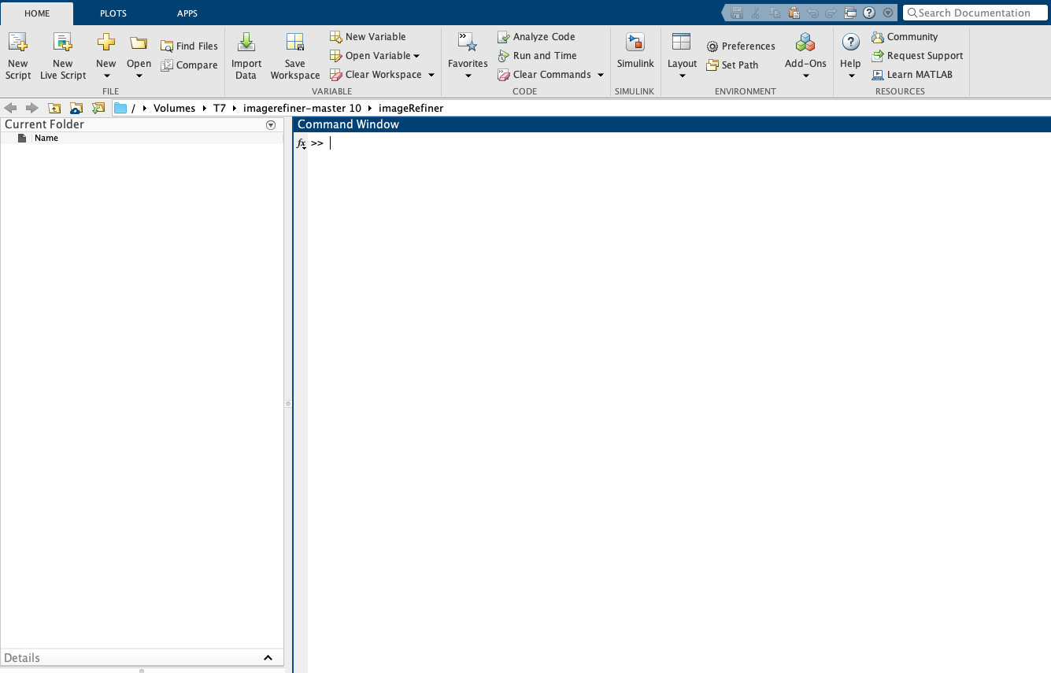

Select the folder „imageRefiner“ inside of the folder “imagerefiner-master”.

Ein Bild, das Text enthält.

Now you can see the content of the imageRefiner folder on the left edge in MATLAB.

# Change Settings:

Click on the “Settings.m” file. Now you see several variable and predefined values for each of them. Here are the most important variables for your analysis.

Line 28: Select the channel you want to analyse.

Line 29: define the size filter. If you don't need one, set the back value extremely high.

Line 30: This is the ratio of pixels in your image to distance in micrometer. You have to look for this value in the software or the manual of your microscope.

The other variable are less important. For further questions ask Robert Göllinger.

Ein Bild, das Text enthält.

# Create an instance:

Click on the command window: Type or copy the line for creating an instance out of the “README.md” file. It´s in the “imagerefiner-master” folder.

imageRefinerTask = Tasks.ImageRefinerTask('C:\\path\to\folder\with\data', 'ExportDirectory', 'C:\\path\to\export\folder', 'ExportFormat', 'excel', 'ColumnsToExport', {'Area', 'Perimeter', 'Centroid'}, 'VerificationMode', false)

Replace the section 'C:\\path\to\folder\with\data' with the file path of your images. Make sure you keep the quotes before and after the file path.

Replace the section 'C:\\path\to\export\folder' with the file path of your result folder. Make sure you keep the quotes before and after the file path.

You can both add and delete parameter in the curly brackets. Remind the quotes.

If you have changed all your variables, push enter. MATLAB will show you the properties of your analysis.

Type “imageRefinerTask.execute()” in the command window and push enter. The analysis starts. Now you can relax. The analysis will take a few minutes. The Analyse is finished, when the command window says “ans = 1”.

Ein Bild, das Text enthält.

Useful Notes:

If the requirements of your computer are low, the analysis will be slow. So if you think that the analysis will stop, look in the lower left corner. If it says "busy" the program is still working. It is useful to stop any other program except MATLAB while using the ImageRefiner.

# Results:

After the analysis you will find a lot of excel files in your result folder. There is one excel file for each single image. Thus you are able to see the raw data. Each excel file consists of two shields. The first one called “Data” contains your results. The second one is called “settings” and shows you all variables and the date of your analysis.

The last excel file is called “ImageRefiner_Summary”. There is one row for each image. You can see the count of analysed surfaces and both the mean and the median of each parameter your defined at the beginning of the analysis.

# Logger:

After the analysis you find a file called “logger.log” in your result folder. It is like a “blackbox”. So if you have trouble with the Refiner you can send this file to Robert Göllinger and he can find the problem easily.

# Verification Mode:

If you want to verify your analysis you can use the verification mode. You take a few (not all) of your images for this analysis. When you create your instance, you can replace the “false” at the end of the line with “true”. Now you start your analysis. When the analysis is finished, you can see two images for each analysed image in your result folder. The detected surfaces are in red frames. If you disagree with the result change the variables of your analysis.

# Notes:

Cite as: Robert Goellinger (2021), ImageRefiner - A Matlab Toolbox for refining nephrological images, RWTH Aachen University

In collaboration with AG Ostendorf, Division of Nephrology and Clinical Immunology, RWTH Aachen University Medical Faculty, RWTH

Aachen University, Aachen, Germany