Custom Data Access Templates
Custom data access templates allow for extensive customization of the display of information contained in data access tables. Each of the main modes (Add, Search, List, and Single) can have their own custom template; furthermore, custom templates are created on a section by section basis and not a database table by database table basis. An installation of GVC.SiteMaker comes with a set of default templates. The look and feel of which is potentially modified by the Style Template in use for the website.

How a Style Template interacts with the Data Access Templates
Every website must have a Style Template in GVC.SiteMaker, the construction of which can range from simple to elaborate and is detailed elsewhere. GVC.SiteMaker was designed to facilitate the styling of websites through the use of Cascading Style Sheets and to this end numerous hooks in the form of classes and ids are present in GVC.SiteMaker’s outputted HTML. The default data access templates contain numerous classes and ids, prefixed by “dataAccess” which may have been used by the Style Template author to improve and integrate the data access sections into the website.

How CSS Inheritance Works
CSS uses the principal of inheritance when the browser determines how to render a page. In CSS inheritance means that the closest or most specifically defined rule is the one that should be applied. A creator of a custom data access template thus can redefine a CSS rule, overriding the Style Template author if they write a more specific CSS rule. The easiest way to override a CSS rule in a custom data access template is just to remove the corresponding id or class and use standard HTML or a new inline CSS declaration.

WebObjects Tags
GVC.SiteMaker pages are rendered dynamically. The dynamic elements, including Data Access table data, are created through the use of the WebObject tag and the WebObjects adapter. The WebObjects tag is just like the regular HTML tags you are familiar with. It has a single attribute which must be provided. It always has a closing tag. In GVC.SiteMaker’s data access templates some WebObjects tags will have the name attribute on the opening and closing tag, the name attribute on the closing tag is optional. A WebObject opening tag looks like this:
<WebObject name=DataAccess_Form>
The corresponding closing tag would look like:
</WebObject name=DataAccess_Form>

Dynamic websites and web pages
The HTML seen by an end user in his or her browser is not contained in a simple text file in the case of dynamic websites instead it is created “on the fly” when the page is requested. GVC.SiteMaker as a dynamic page generation tool creates web pages “on the fly”. Pages in dynamic websites are created in numerous ways. GVC.SiteMaker uses a technology known as WebObjects.

How a template is used by GVC.SiteMaker
GVC.SiteMaker’s data access sections use the templates as a guide on how to produce the final pages seen by the end user. The WebObject tags are replaced “on the fly” with standard HTML as defined by the World Wide Web Consortium. Everything that is not a WebObject tag or in some cases is not contained inside a WebObject tag is left unchanged and is sent to a user’s browser as it was in the data access template. This allows for the creation of a custom look and feel using HTML tags in conjunction with the WebObject tags.

Initial Custom Data Access Templates
Each of the five modes provides an initial custom data access template which can be downloaded and used to base your own custom data access template off of. The initial custom data access templates are completely functional and almost identical to the default data access template of the same mode. Each one contains all the necessary WebObjects tags as well as standard HTML tags. The resulting file will be named [mode]_form.html where [mode] is replaced by the name of the relevant mode. A sample file name might be:
add_form.html

Creating your own Custom Data Access Templates
Although a custom data access template can be created completely from scratch it may prove simpler to modify the one initially downloaded. Regardless of how you choose to do it, the resulting custom template must be uploaded back into GVC.SiteMaker. It is likely that you will wish to use all the WebObjects tags present in the initial custom data access template and just reorder them and surround them with different HTML. The initial custom data access templates and the default templates are basic yet functional. They contain CSS classes and ids which you may wish to remove if you do not want your custom data access template to be potentially modified by the Style Template of the website.

Unique WebObjects Tags
Every table will have it’s own set of fields which will have corresponding WebObjects tags in the various template modes. For instance if you have a field in your data access table called “Salary” there is going to be a corresponding WebObjects tag to display that information onscreen named “Salary”. It would look like this:
<WebObject name=Salary></WebObject>

You could then position this where you wanted it to be displayed inside the HTML of your custom data access template. Fields with spaces in their name are concatenated, so if you have a field called “I have a space” the corresponding tag would be:
<WebObject name=Ihavaaspace></WebObject>

Adding or Removing Fields from a Data Access Table
When you add or remove fields from a data access table you must add or remove the fields from your custom data access template as well. Failure to do so will result in an error when GVC.SiteMaker attempts to render the page. One of the advantageous of using the default templates is that when you add or remove a field the standard template automatically reflects the change.

WebObjects Tags bound to an attribute of an HTML tag
This is permissible and is necessary in GVC.SiteMaker to provide the custom data access template feature. It is commonly used in the input HTML tag to allow for the correct interaction with other portions of the data access section. Take extra care when customizing the input tags.

Customizing Form Submission Buttons
A form submission button could be represented in data access template two ways. Initially they will produce identical results but the buttons are done this way to allow them to be replaced by images or to have alternative text.
Standard WebObject tag technique:
<WebObject name=DataAccess_SaveButton></WebObject>
WebObject tag embedded in input tag technique:
<input type="submit" value="Save Changes" name="<WebObject name=DataAccess_SaveName></WebObject>">

Standard Technique Vs Embedded Technique
The standard technique is just like any of the other WebObject tags in the template, at run time it is rendered as standard HTML that a browser will understand. However this standard technique does not allow for the modification of the text displayed in the button and replacement of a standard button with an image. If you want to change the text on a button you simply change the value of the input tag like so:
<input type="submit" value="Execute" name="<WebObject name=DataAccess_SaveName></WebObject>">

In order to use an image you would modify the tag like this:
<input type="image" src="media/submit.gif" height="20" width="60" border="0" alt="Submit your info" name="<WebObject name=DataAccess_SaveName></WebObject>">

You can also use CSS to alter the appearance of a button but this only works in modern browsers. For example, to make the text bigger and orange on a red background you could try this:
<input type="submit" value="Save" style="background: red; color: orange; font-size: 1.2em" name="<WebObject name=DataAccess_SaveName></WebObject>">>

Common WebObjects Tags
The following WebObjects tags are found in templates for multiple modes (but not necessarily all of them):

DataAccess_TableName
This tag is replaced by the name of the data access table when the page is generated.

DataAccess_CurrentUser
This tag is replaced by the userID of the currently logged in user when the page is generated.

DataAccess_SiteID
This tag is replaced by the ID of the site that contains the table.

DataAccess_SectionName
This tag is replaced by the name of the data access section being displayed.

DataAccess_OrgUnit
This tag is replaced by the name of the Org Unit that owns the site that contains the table.

DataAccess_TableHasData
This is a conditional WebObjects tag, it only shows the data (tags) onscreen if the page evaluates to the correct condition when it is displayed. In this case there must be records to display. All unique WebObject tags which correspond to a field of data in a data access table must be inside this tag.

DataAccess_TableIsEmpty
This is a conditional WebObjects tag, it only shows the data (tags) onscreen if the page evaluates to the correct condition when it is displayed. In this case there must not be any records to display.

DataAccess_CanEditRecords
This is an example of a conditional WebObjects tag. The Style Writers guide contains additional information concerning the various types of WebObject tags. Instead of being replaced by HTML tags itself when the page is rendered, a conditional WebObjects tag instead determines whether to display the contents between its opening and closing tags depending on predetermined criteria. In this case the criterion is whether the person viewing the webpage can edit records or not.

DataAccess_CanBrowseOrSearchRecords
This is another conditional WebObjects tag. In this case the user must have permission to browse or search records in this table for the data inside the tag to be displayed.

DataAccess_IsViewingData
This tag is a conditional tag. If the user is viewing data, all tags inside this one are displayed.

DataAccess_ToggleView
This is a link which changes the mode to Single mode.
DataAccess_SearchForRecords
This is a link which changes the mode to Search mode. This tag should be inside the DataAccess_CanBrowseOrSearchRecords tag.

DataAccess_ShowAllRecord
This is a link which shows all the records in the data access table. This tag should be inside the DataAccess_CanBrowseOrSearchRecords tag.

DataAccess_GoFirst
This is a link which goes to the first record in the data access table. This tag should be inside the DataAccess_CanBrowseOrSearchRecords tag.

DataAccess_GoPrevious
This is a link which goes to the previous record in the data access table.

DataAccess_GoNext
This is a link which goes to the next record in the data access table.

DataAccess_GoLast
This is a link which goes to the last record in the data access table.

DataAccess_TableIsEmpty
This is a conditional WebObjects tag, it only shows the data (tags) onscreen if the page evaluates to the correct condition when it is displayed. In this case there are no records to display. This tag is commonly used to display a message informing the user there is no data in the table.

DataAccess_CanDeleteRecords
This is a conditional WebObjects tag. It only shows the data (tags) onscreen if the person viewing the page has the correct permissions. In this case the user must have permission to delete records in this table. The DataAccess_DeleteRecord tag should be contained within this tag.

DataAccess_DeleteRecord
This is a link which deletes the currently displayed entry in a data access table.

DataAccess_CanAddRecords
This is a conditional WebObjects tag. It only shows the data (tags) onscreen if the person viewing the page has the correct permissions. In this case the user must have permission to add records in this table. The DataAccess_AddRecord tag should be contained within this tag.

DataAccess_AddRecord
This is a link which switches to Add mode allowing a new record to be entered into the data access table.

DataAccess_SaveButton
This is the input button used to save changes to a data access table. A data access section will typically only render one of DataAccess_SaveName and DataAccess_SaveButton.

DataAccess_SaveName
The name of the input button used to save changes to a data access table.

DataAccess_VisibleFields
This is WOReptition which displays all the field names in this table.

DataAccess_FieldName
This is the name of a specific field, usually contained inside a WOReptition.

DataAccess_FieldValue
This is the value of a specific field, must be inside a WOReptition.

DataAccess_IsConfirmingDeletion
This is a conditional tag, if the end user is confirming the deletion of a record then the contents of this tag will be displayed onscreen. This is used for confirmation messages.

DataAccess_AcceptDeletion
This is a button which when clicked accepts the deletion of records.

DataAccess_RejectDeletion
This is a button which when clicked declines the deletion of records.

DataAccess_ShowNotificationNotNeededCheckBox
This is a conditional tag: the contents of this tag will be shown if this user can be shown the “do not send notifications” checkbox.

DataAccess_ShouldNotSendNotification
Displays the “do not send notifications” checkbox.

DataAccess_CanImportRecords
This is a conditional tag: the contents of this tag will be shown if the user is allowed to import records.

DataAccess_ImportRecords
This displays the link to import records.

<FieldName> e.g. FirstName
This tag displays either the contents of, or an input for, the named field depending on mode and configuration.

<FieldName>_IsEmpty
This is a conditional tag: the contents of this tag will be shown if the field has no value.

<FieldName>_IsNotEmpty
This is a conditional tag: the contents of this tag will be shown if the field has a value.

Add Template Tags
These tags are only found in the Add mode template:

DataAccess_EditableFields
This is repetition style WebObjects tag it repeats once for every field in the table. It contains the WebObjects tags for field name and field value.

DataAccess_SaveAndAddName
The name of the input button used to save changes to a data access table and allow for the entry of another record.

DataAccess_SaveAndAddButton
This is the input button used to save changes and add a new entry into a data access table. A data access section will typically only render one of DataAccess_SaveAndAddName and DataAccess_SaveAndAddButton.

DataAccess_CancelName
The name of the input button used to cancel an action on a data access table.

DataAccess_CancelButton
This is the input button used to cancel changes made to an entry of a data access table. A data access section will typically only render one of DataAccess_CancelName and DataAccess_CancelButton.

List Template Tags
These tags are only found in the list mode template:

DataAccess_RecordsInGroup
This tag is from the family of tags known as WORepetitions. Everything contained inside this tag is repeated as often as necessary, in this case once for every record in the data access table.

DataAccess_ShowDetails
This is the link that switches to Single record mode.

DataAccess_DeleteRecordCheckBox
This tag is a checkbox which can be used to mark a table record for deletion.

DataAccess_DeletedRecordCount
This lists the number of records about to be deleted. This should be contained within the DataAccess_IsConfirmingDeletion tag.

Search Template Tags
DataAccess_SearchButton
This corresponds to the button that executes the search. This must be used when the search is written with just static HTML input tags (that is, none of the tags below are used).

DataAccess_SearchWithDefaultTemplateButton
This corresponds to the button that executes the search. This must be used when (most of) the tags below are used. It ensures that the contents of the special tags are properly processed to setup the search. If you use DataAccess_SearchButton and the tags below, the search may not execute properly.

DataAccess_InputDateHint
This tag is replaced by the InputDateFormatHint configuration item (e.g. YYYY\MM\DD).

DataAccess_SearchCriteria
This tag is from the family of tags known as WORepetitions. Everything contained inside this tag is repeated as often as necessary, in this case once for every visible field in the data access table. Some of the tags below must only be used inside of this tag

DataAccess_ShouldShowJoinConditionsPopup
For use only inside of DataAccess_SearchCriteria. This is a conditional tag: the contents of this tag will be shown if this is the first criterion.

DataAccess_JoinConditionsPopup
For use only inside of DataAccess_ShouldShowJoinConditionsPopup. This displays the popup of join conditions (and, or, and not, etc.).

DataAccess_CriterionColumnsPopup
For use only inside of DataAccess_SearchCriteria. This displays the popup list of field names.

DataAccess_CriterionColumnName
For use only inside of DataAccess_SearchCriteria. This displays the name of the field.

DataAccess_CriterionComparisonTypesPopup
For use only inside of DataAccess_SearchCriteria. This displays the popup list of comparisons (is equal to etc).

DataAccess_CriterionValueField
For use only inside of DataAccess_SearchCriteria. This displays the text input where the value to be searched for is input.

DataAccess_CriterionIsLookup
For use only inside of DataAccess_SearchCriteria. This is a conditional tag: the contents of this tag will be shown if the field is a Lookup field.

DataAccess_CriterionIsntLookup
For use only inside of DataAccess_SearchCriteria. This is a conditional tag: the contents of this tag will be shown if the field is not a Lookup field’

DataAccess_CriterionValuePopup
For use only inside of DataAccess_CriterionIsLookup. This displays the popup list of available values for a Lookup field.

DataAccess_CriterionHasError
For use only inside of DataAccess_SearchCriteria. This is a conditional tag: the contents of this tag will be shown if there is a validation failure in the criterion for this field.

DataAccess_CriterionErrorMessage
For use only inside of DataAccess_SearchCriteria. Displays the criterion validation failure, if any, for this field.

DataAccess_AddCriterionButton
This is only for use with the query builder form. This tag displays the ‘Use more criteria...’ button.

DataAccess_GroupSizePopup
This displays the popup used to select the group size for the search results listing.

DataAccess_SortOrderings
This tag is from the family of tags known as WORepetitions. Everything contained inside this tag is repeated as often as necessary, in this case once for every sort ordering added. Some of the tags below must only be used inside of this tag.

DataAccess_IsFirstSortColumnConditional
For use only inside of DataAccess_SortOrderings. This is a conditional tag: the contents of this tag will be shown if this is the first sort ordering.

DataAccess_IsNotFirstSortColumnConditional
For use only inside of DataAccess_SortOrderings. This is a conditional tag: the contents of this tag will be shown if this is not the first sort ordering.

DataAccess_SortByColumnsPopUp
For use only inside of DataAccess_SortOrderings. Displays the popup of list of field names that can be sorted on.

DataAccess_SortDirectionPopUp
For use only inside of DataAccess_SortOrderings. Displays the popup of sort order directions (ascending and descending).

DataAccess_SortOrderSameColumnTwiceInvalidConditional
This is a conditional tag: the contents of this tag will be shown if the same field has been selected for sorting on more than once.

DataAccess_AddSortOrderingButton
This tag displays the “Additional Sort” button.

<FieldName>_ComparisonPopup
Each searchable field has its own version of this tag (e.g. FirstName_ComparisonPopup, Address_ComparisonPopup etc). This displays the popup list of comparisons (is equal to etc) for this specific field.

<FieldName>_CriterionHasError
Each searchable field has its own version of this tag. This is a conditional tag: the contents of this tag will be shown if there is a validation failure in the criterion for this field.

<FieldName>_CriterionErrorMessage
Each searchable field has its own version of this tag. Displays the criterion validation failure, if any, for this field.

DataAccess_SearchAllTextInput
Displays the text input for the “search all text fields” search form.

DataAccess_SearchFindAll
Displays the radio button for “Find records that fit all of these criteria (AND)” radio button on the one term for each field search.

DataAccess_SearchFindAny: WORadioButton
Displays the radio button for “Find records that fit any of these criteria (OR)” radio button on the one term for each field search.

Single Template Tags

DataAccess_CanDuplicateRecord
This is a conditional WebObjects tag, it only shows the data (tags) onscreen if the person viewing the page has the correct permissions. In this case the user must have permission to duplicate records in this table. The DataAccess_DuplicateRecord tag should be contained within this tag.

Import Template Tags
DataAccess_IsImportingData
This is a conditional WebObjects tag, it only shows what is after this tag onscreen if an import is being started. These tags should be contained within this tag: DataAccess_ImportFileUplod, DataAccess_ImportDelimiterComma, DataAccess_ImportDelimiterTab, DataAccess_ImportRetainDataYes,
DataAccess_ImportRetainDataNo, and DataAccess_ImportButton. See the related tag, DataAccess_IsViewingResults.

DataAccess_ImportFileUplod
This is the widget that selects the file to upload; the file that the data to import comes from.

DataAccess_ImportDelimiterComma
DataAccess_ImportDelimiterTab
These are the radio buttons to select either tab or comma as the delimiter used in the import file. If you don’t want to leave this choice to the user, you can “hard code” it using a hidden input like this:
<input type="hidden" value="comma" name="DataAccess_ImportDelimiter">

DataAccess_ImportRetainDataYes
DataAccess_ImportRetainDataNo
These are the radio buttons to select whether to retain existing data in the table or not. If you don’t want to leave this choice to the user, you can “hard code” it using a hidden input like this:
<input type="hidden" value="true" name="DataAccess_ImportRetainData">

DataAccess_ImportButton
This is the input button used to start the import process.

DataAccess_IsViewingResults
This is a conditional WebObjects tag, it only shows what is after this tag onscreen if an import has finished (successful or not). These tags should be contained within this tag: DataAccess_ImportDidSucceed, DataAccess_ImportDidFail, DataAccess_ImportNumberOfRecords, DataAccess_ImportErrorMessages, DataAccess_ImportErrorMessage, and DataAccess_ImportDidFail. See the related tag, DataAccess_IsImportingData.

DataAccess_ImportDidSucceed
This is a conditional WebObjects tag, it only shows what is after this tag onscreen if an import has finished successfully. The contents will be hidden if the import failed, or has not been started yet.

DataAccess_ImportDidFail
This is a conditional WebObjects tag, it only shows what is after this tag onscreen if an import has finished unsuccessfully. The contents will be hidden if the import succeed, or has not been started yet. The DataAccess_ImportErrorMessages and DataAccess_ImportErrorMessage tags should be contained within this tag.

DataAccess_ImportNumberOfRecords
This tag is replaced by the number of records imported. If will be replaced with zero if the import has not yet started or has failed.

DataAccess_ImportErrorMessages
This tag is from the family of tags known as WORepetitions. Everything contained inside this tag is repeated as often as necessary, in this case once for every error message from a failed import.

DataAccess_ImportErrorMessage
This tag is replaced by one of the error messages from a failed import. It should only be used inside of the DataAccess_ImportErrorMessages tag.

DA Custom Template Tutorial
The following is an example of the step by step process to create a custom database template. It assumes that there exists a website called “demo”. The demo website contains a data access section called “example”. The example section uses the “sample” database table. The end user has permission to browse, add, and delete records in the “example” section. The “sample” database has two fields. The first field is called “field one” and is a text field. The second field is a date field and is called “field two”. The style template in use by the “demo” site also has an effect on the look of its custom data access templates. The style in use for the screen shots was called “Blue Menu Right” and is available at http://demo.gvcsitemaker.com

Here is how a token record in single view should look using the default template:
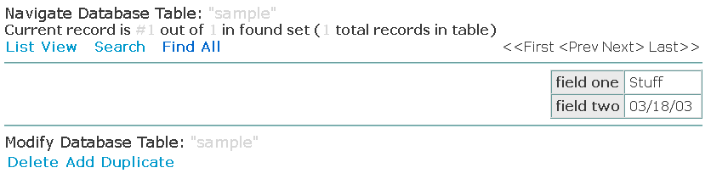

Download default single view template
The best first step to creating a custom data access template is to download the initial custom data access template. For the tutorial the downloaded file for the single view should be called: single_form.html. Open this in the text editor of your choice and you will find the following contents:

<!-- Start of Data Access Single Record Mode Custom Template -->
<WebObject name=DataAccess_IsViewingData>
<!-- Mode, Table Name -->
<WebObject name=DataAccess_CanBrowseOrSearchRecords>
<table width="100%" border="0" cellpadding="0" cellspacing="0">
<tr>
<td align="left" valign="middle" colspan="2">
<span class="dataAccessSubtitle">Navigate Database Table:</span> <span class="dataAccessColoredSubtitle">"<WebObject name=DataAccess_TableName></WebObject>"</span>
</td>
<tr>
<!-- Navigation Starts here -->
<WebObject name=DataAccess_TableHasData>
<tr>
<td align="left" valign="middle" style="font-weight: bold;" colspan="2">
Current record is <span class="dataAccessAlternateText">#<WebObject name=DataAccess_RecordOrRecordRangeBeingViewed></WebObject></span> out of <span class="dataAccessAlternateText"><WebObject name=DataAccess_NumberOfRecordsInFoundSet></WebObject></span> in found set (<span class="dataAccessAlternateText"><WebObject name=DataAccess_NumberOfRecordsInTable></WebObject></span> total records in table)
</td>
</tr>
</WebObject name=DataAccess_TableHasData>
<tr>
<td align="left" valign="middle">
<table border="0" cellpadding="2" cellspacing="0" class="dataAccessNavigation">
<tr>
<td align="center">
<WebObject name=DataAccess_ToggleView>List View</WebObject>
</td>
<td>&nbsp;&nbsp;</td>
<td align="center">
<WebObject name=DataAccess_SearchForRecords>Search</WebObject name=DataAccess_SearchForRecords>
</td>
<td>&nbsp;&nbsp;</td>
<td align="center">
<WebObject name=DataAccess_ShowAllRecords>Find All</WebObject>
</td>
</tr>
</table>
</td>
<td align="right" valign="middle">
<table border="0" cellpadding="2" cellspacing="0" class="dataAccessNavigation">
<tr>
<td align="center">
<WebObject name=DataAccess_GoFirst>&lt;&lt;First</WebObject>
</td>
<td align="center">
<WebObject name=DataAccess_GoPrevious>&lt;Prev</WebObject>
</td>
<td align="center">
<WebObject name=DataAccess_GoNext>Next&gt;</WebObject>
</td>
<td align="center">
<WebObject name=DataAccess_GoLast>Last&gt;&gt;</WebObject>
</td>
<tr>
</table>
</td>
</tr>
</table>
<!-- Navigation ends Here -->
</WebObject name=DataAccess_CanBrowseOrSearchRecords>
<WebObject name=DataAccess_TableHasData>
<hr>
<!-- Database Table fields -->
<table border="1" cellpadding="4" cellspacing="0" align="center" id="dataAccessTable">
<tr>
<th class="dataAccessTableHeading">
field one
</th>
<td class="dataAccessTableCell">
<WebObject name=fieldone></WebObject>&nbsp;
</td>
</tr>
<tr>
<th class="dataAccessTableHeading">
field two
</th>
<td class="dataAccessTableCell">
<WebObject name=fieldtwo></WebObject>&nbsp;
</td>
</tr>
</table>
<hr>
</WebObject name=DataAccess_TableHasData>
<WebObject name=DataAccess_TableIsEmpty>
<br><br><div align="center">There are no data to display.</div><br><br>
</WebObject name=DataAccess_TableIsEmpty>
<!-- Conditional on being able to Modify Records begins -->
<WebObject name=DataAccess_CanModifyRecords>
<table width="100%" border="0" cellpadding="0" cellspacing="0">
<tr>
<td align="left" valign="middle">
<span class="dataAccessSubtitle">Modify Database Table:</span> <span class="dataAccessColoredSubtitle">"<WebObject name=DataAccess_TableName></WebObject>"</span>
</td>
</tr>
<tr>
<table border="0" cellpadding="4" cellspacing="0" id="dataAccessActions">
<tr>
<WebObject name=DataAccess_CanDeleteRecords>
<td align="center" valign="middle">
<WebObject name=DataAccess_DeleteRecord>Delete</WebObject>
</td>
</WebObject name=DataAccess_CanDeleteRecords>
<WebObject name=DataAccess_CanAddRecords>
<td align="center" valign="middle">
<WebObject name=DataAccess_AddRecord>Add</WebObject>
</td>
</WebObject name=DataAccess_CanAddRecords>
<WebObject name=DataAccess_CanDuplicateRecord>
<td align="center" valign="middle">
<WebObject name=DataAccess_DuplicateRecord>Duplicate</WebObject>
</td>
</WebObject name=DataAccess_CanDuplicateRecord>
<WebObject name=DataAccess_CanEditRecords>
<td align="center" valign="middle">
<input type="submit" value="Save" name="<WebObject name=DataAccess_SaveName></WebObject>">
</td>
</WebObject name=DataAccess_CanEditRecords>
</tr>
</table>
</tr>
</table>
</WebObject name=DataAccess_CanModifyRecords>
<!-- Conditional on being able to Modify Records ends -->
</WebObject name=DataAccess_IsViewingData>
<!-- Confirmation of Delete Messages begins -->
<WebObject name=DataAccess_IsConfirmingDeletion>
<table align="center" border="0" cellpadding="4" cellspacing="0">
<tr>
<td align="center" valign="middle" colspan="3">
Proceed with deletion?
</td>
</tr>
<tr>
<td align="right" valign="middle">
<input type="submit" value="Yes" name="<WebObject name=DataAccess_AcceptDeletion></WebObject>">
</td>
<td align="center" valign="middle">&nbsp;</td>
<td align="left" valign="middle">
<input type="submit" value="No!" name="<WebObject name=DataAccess_RejectDeletion></WebObject>">
</td>
</tr>
<tr>
<td align="center" valign="middle" colspan="3">
If you do not proceed with the deletion, you will be returned to the previous page with your edits intact, but unsaved.
</td>
</tr>
</table>
</WebObject name=DataAccess_IsConfirmingDeletion>
<!-- Confirmation of Delete Messages begins -->
<!-- End of Data Access Single Record Mode Custom Template -->

What to Change
Although in Latin based languages text is read left to right, some languages are read right to left. So if your site is intended for one of these languages, it may be more sensible to have the headings on the right and content on the left. This is a relatively easy change. The part we want to change is between this comment:
<!-- Database Table fields -->
and this comment:
<!-- Conditional on being able to Modify Records begins -->
Since we have no plans on changing the no data available portion we can further narrow it down to the HTML between:
<table border="1" cellpadding="4" cellspacing="0" align="center" id="dataAccessTable">
and it’s corresponding closing tag.

Reversing the table headings
In each row of the table, of which there should be two, one for “field one” and one for “field two” we simply reverse the order of the <th> and <td> tags like so:
<tr>
<td class="dataAccessTableCell">
<WebObject name=fieldone></WebObject>
</td>
<th class="dataAccessTableHeading">
field one
</th>
</tr>
<tr>
<td class="dataAccessTableCell">
<WebObject name=fieldtwo></WebObject>
</td>
<th class="dataAccessTableHeading">
field two
</th>
</tr>

Now simply upload the saved file and submit and preview. You may need to add a record if you have none in the “sample” database currently to see the changes we’ve just made.

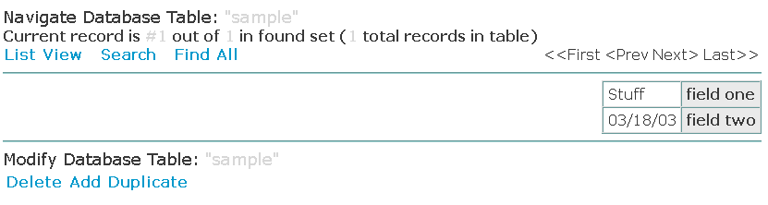

Putting Table Headings above the Contents
If you wish to have the table headings about the content you once again just rearrange the existing tags like so:
<tr>
<th class="dataAccessTableHeading">
field one
</th>
<th class="dataAccessTableHeading">
field two
</th>
</tr>
<tr>
<td class="dataAccessTableCell">
<WebObject name=fieldone></WebObject>
</td>
<td class="dataAccessTableCell">
<WebObject name=fieldtwo></WebObject>
</td>
</tr>

Then save the file upload the template, submit and preview to see the changes.

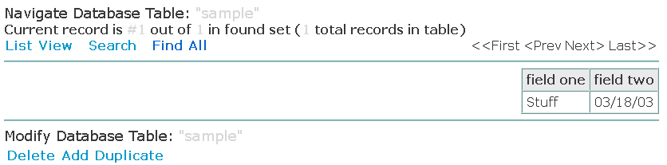

Altering Existing Tags
You can modify existing HTML tags such as removing the border on the “dataAccessTable”. Simply replace the existing HTML with the following:
<table border="0" cellpadding="4" cellspacing="0" align="center" id="dataAccessTable">

Then save the file, upload the template, submit and preview to see the changes.

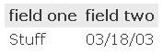

If you don’t like the horizontal rules you can simply remove all the <hr> tags you see in the template possibly replacing them with <br> tags. Then save the file, upload the template, submit and preview to see the changes.

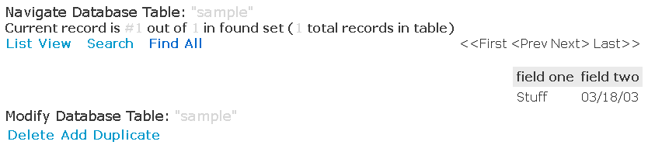

Adding New HTML attributes
Perhaps you would like a border around the whole “dataAccessTable” but not around individual cells. This can be accomplished in a number of ways. One is to simply add some more CSS styling to the corresponding table tag like so:
<table border="0" cellpadding="4" cellspacing="0" align="center" id="dataAccessTable"
style=”border: 1px dashed green;”>

This should create a dashed green border around the table, save the file, upload the template, submit and preview to see the changes.

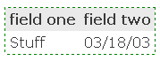

Adding New HTML tags
You can add almost any new HTML tags you want to your custom template. Perhaps you would like some more white space between the “dataAccessTable” and the upper navigation. Simply add in a few <br> tags, then save the file, upload the template, submit and preview to see the changes.

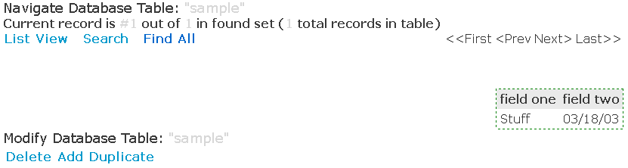

Removing WebObject Tags
Although it will cause less information to be displayed it is permissible to remove WebObjects tags completely. Some can not be removed however. If you remove a necessary tag GVC.SiteMaker’s parser will notify you about it when you attempt to upload the custom template. You could remove all the WebObjects tags that don’t directly deal with displaying or navigating records for instance. This includes the titles and the current record information. You should also remove the HTML that goes with the WebObjects tags such as <tr> and <td> tags. Once again you must save the file, upload the template, submit and preview to see how it looks. The following HTML was removed from the single_form.html file:

<tr>
<td align="left" valign="middle" colspan="2">
<span class="dataAccessSubtitle">Navigate Database Table:</span> <span class="dataAccessColoredSubtitle">"<WebObject name=DataAccess_TableName></WebObject>"</span>
</td>
<tr>
<!-- Navigation Starts here -->
<WebObject name=DataAccess_TableHasData>
<tr>
<td align="left" valign="middle" style="font-weight: bold;" colspan="2">
Current record is <span class="dataAccessAlternateText">#<WebObject name=DataAccess_RecordOrRecordRangeBeingViewed></WebObject></span> out of <span class="dataAccessAlternateText"><WebObject name=DataAccess_NumberOfRecordsInFoundSet></WebObject></span> in found set (<span class="dataAccessAlternateText"><WebObject name=DataAccess_NumberOfRecordsInTable></WebObject></span> total records in table)
</td>
</tr>
</WebObject name=DataAccess_TableHasData>

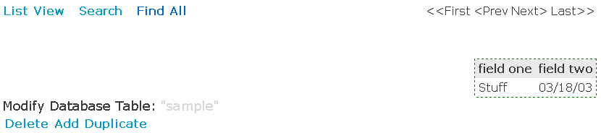

Moving WebObject Tags
Furthermore it might look better if all the navigation was below the “dataAccessTable”. So you can move the entire contents of the “DataAccess_CanBrowseOrSearchRecords” section below the content. I also once again adjusted the white space by removing some <br> tags. Once again you must save the file, upload the template, submit and preview to see how it looks.

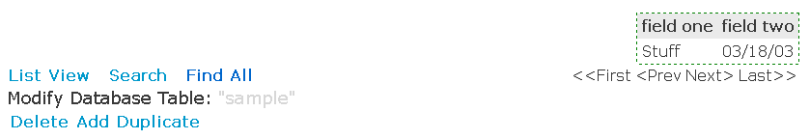

Final Touches
Now it looks like something needs to be above the “dataAccessTable” perhaps simply the title. To do this you could have a heading tag with the WebObjects tag representing the table name in it like so:
<h1><WebObject name=DataAccess_TableName></WebObject></h1>

Then perhaps adding in a horizontal rule between the two rows of links below the table to give them some separation. Also perhaps removing the following snippet of HTML as it is effectively replaced by the addition of the previous line:
<tr>
<td align="left" valign="middle">
<span class="dataAccessSubtitle">Modify Database Table:</span> <span class="dataAccessColoredSubtitle">"<WebObject name=DataAccess_TableName></WebObject>"</span>
</td>
</tr>

Finally save the file, upload the template, submit and preview to see the end result.

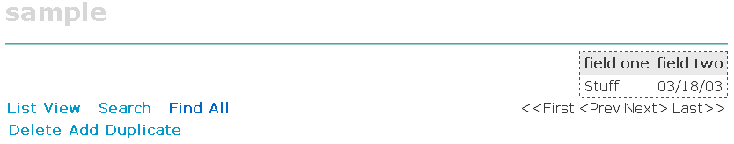

Final Custom Template
Below is the resulting custom template as created in the tutorial:

<!-- Start of Data Access Single Record Mode Custom Template -->
<WebObject name=DataAccess_IsViewingData>
<!-- Mode, Table Name -->
<h1><WebObject name=DataAccess_TableName></WebObject></h1>
<hr>
<WebObject name=DataAccess_TableHasData>
<!-- Database Table fields -->
<table border="0" cellpadding="4" cellspacing="0" align="center" id="dataAccessTable"
style="border: 1px dashed green;">
<tr>
<th class="dataAccessTableHeading">
field one
</th>
<th class="dataAccessTableHeading">
field two
</th>
</tr>
<tr>
<td class="dataAccessTableCell">
<WebObject name=fieldone></WebObject>
</td>
<td class="dataAccessTableCell">
<WebObject name=fieldtwo></WebObject>
</td>
</tr>
</table>
<br>
</WebObject name=DataAccess_TableHasData>
<WebObject name=DataAccess_TableIsEmpty>
<br><br><div align="center">There are no data to display.</div><br><br>
</WebObject name=DataAccess_TableIsEmpty>
<WebObject name=DataAccess_CanBrowseOrSearchRecords>
<table width="100%" border="0" cellpadding="0" cellspacing="0">
<tr>
<td align="left" valign="middle">
<table border="0" cellpadding="2" cellspacing="0" class="dataAccessNavigation">
<tr>
<td align="center">
<WebObject name=DataAccess_ToggleView>List View</WebObject>
</td>
<td>&nbsp;&nbsp;</td>
<td align="center">
<WebObject name=DataAccess_SearchForRecords>Search</WebObject name=DataAccess_SearchForRecords>
</td>
<td>&nbsp;&nbsp;</td>
<td align="center">
<WebObject name=DataAccess_ShowAllRecords>Find All</WebObject>
</td>
</tr>
</table>
</td>
<td align="right" valign="middle">
<table border="0" cellpadding="2" cellspacing="0" class="dataAccessNavigation">
<tr>
<td align="center">
<WebObject name=DataAccess_GoFirst>&lt;&lt;First</WebObject>
</td>
<td align="center">
<WebObject name=DataAccess_GoPrevious>&lt;Prev</WebObject>
</td>
<td align="center">
<WebObject name=DataAccess_GoNext>Next&gt;</WebObject>
</td>
<td align="center">
<WebObject name=DataAccess_GoLast>Last&gt;&gt;</WebObject>
</td>
<tr>
</table>
</td>
</tr>
</table>
<!-- Navigation ends Here -->
</WebObject name=DataAccess_CanBrowseOrSearchRecords>
<!-- Conditional on being able to Modify Records begins -->
<WebObject name=DataAccess_CanModifyRecords>
<table width="100%" border="0" cellpadding="0" cellspacing="0">
<tr>
<table border="0" cellpadding="4" cellspacing="0" id="dataAccessActions">
<tr>
<WebObject name=DataAccess_CanDeleteRecords>
<td align="center" valign="middle">
<WebObject name=DataAccess_DeleteRecord>Delete</WebObject>
</td>
</WebObject name=DataAccess_CanDeleteRecords>
<WebObject name=DataAccess_CanAddRecords>
<td align="center" valign="middle">
<WebObject name=DataAccess_AddRecord>Add</WebObject>
</td>
</WebObject name=DataAccess_CanAddRecords>
<WebObject name=DataAccess_CanDuplicateRecord>
<td align="center" valign="middle">
<WebObject name=DataAccess_DuplicateRecord>Duplicate</WebObject>
</td>
</WebObject name=DataAccess_CanDuplicateRecord>
<WebObject name=DataAccess_CanEditRecords>
<td align="center" valign="middle">
<input type="submit" value="Save" name="<WebObject name=DataAccess_SaveName></WebObject>">
</td>
</WebObject name=DataAccess_CanEditRecords>
</tr>
</table>
</tr>
</table>
</WebObject name=DataAccess_CanModifyRecords>
<!-- Conditional on being able to Modify Records ends -->
</WebObject name=DataAccess_IsViewingData>
<!-- Confirmation of Delete Messages begins -->
<WebObject name=DataAccess_IsConfirmingDeletion>
<table align="center" border="0" cellpadding="4" cellspacing="0">
<tr>
<td align="center" valign="middle" colspan="3">
Proceed with deletion?
</td>
</tr>
<tr>
<td align="right" valign="middle">
<input type="submit" value="Yes" name="<WebObject name=DataAccess_AcceptDeletion></WebObject>">
</td>
<td align="center" valign="middle">&nbsp;</td>
<td align="left" valign="middle">
<input type="submit" value="No!" name="<WebObject name=DataAccess_RejectDeletion></WebObject>">
</td>
</tr>
<tr>
<td align="center" valign="middle" colspan="3">
If you do not proceed with the deletion, you will be returned to the previous page with your edits intact, but unsaved.
</td>
</tr>
</table>
</WebObject name=DataAccess_IsConfirmingDeletion>
<!-- Confirmation of Delete Messages begins -->
<!-- End of Data Access Single Record Mode Custom Template -->

