Style Template Writer's Guide

This document gives pointers on how to write a template to be used in a Website (or Section) Style. It does not cover Style administration as this is described elsewhere. It assumes the reader has an excellent command of HTML but knows nothing about templates for GVC SiteMaker Site Styles.

About Templates
Templates control the layout and appearance of the pages that GVC SiteMaker generates. A template looks like a regular HTML file with some special WebObject tags embedded in it.

Limits on HTML Used in Templates
For the most part any HTML can be used in a template with your imagination being the only limit. The only restriction on this is for paths and links. In all but a few, rare cases, these must either start with a '/' or be a fully qualified URL (e.g. start with http://, ftp:// etc.). Links and image paths like 'images/mypic.gif' will not work. It is recommended that for links to sites and files on the GVC SiteMaker server that the domain (e.g. 'http://www.gvsitemaker.com' be omitted). This will prevent the links from breaking if the domain changes). The HTML below is not intended to exhibit good HTML coding practices. Things such as document types and comments have been sacrificed for the sake of brevity.

Images and Other Resources for Templates
A template can use images or any other resources that any HTML page would use. These can come from files uploaded to the webserver's document root (most efficient), files uploaded to a GVC SiteMaker website (most convenient), or from another server entirely. Files uploaded to the document root are, by convention, placed at /GVCSiteMaker/Styles/<style ID>/. CSS files are somewhat different and recommended strategies are discussed below.

World's Simplest Templates
Here is the simplest template possible:

<HTML>
<head></head>
<body>

Hello World.
</body>
</HTML>

It is not a very functional template. It just displays the words "Hello World." no matter what Section (page) is being displayed. Let's get a little more ambitious and actually display the contents of a section:

<HTML>
<head></head>
<body>
<webobject name="SectionContents"></webobject>

</body>
</HTML>

This is also not very functional, but it does display the contents of the Section. Most sites will be more functional if the user can move from page to page. To do this we will add in a navigation element:

<HTML>
<head></head>
<body>
<table>
<tr>
<td>
<webobject name="NavBar"></webobject>
</td>
<td>
<webobject name="SectionContents"></webobject>
</td>
</tr>
</table>

</body>
</HTML>

Now we are getting some place. We have a column of navigation links down the left side and the contents of a Section displayed to the right. The HTML table is used to lay out these two elements next to each other. Flushed with our success, we can add the Banner at the top and the Footer at the bottom:

<HTML>
<head></head>
<body>
<webobject name="Banner"></webobject>
<table>
<tr>
<td>
<webobject name="NavBar"></webobject>
</td>
<td>
<webobject name="SectionContents"></webobject>
</td>
</tr>
</table>
<webobject name="Footer"></webobject>

</body>
</HTML>

That looks sort of OK, but the Banner is shoved all the way off to the left. It will look better if we add the Banner like this:

<div align="center">

<webobject name="Banner"></webobject>
</div>

It will look better still if we add some embellishment too:

<div align="center">

<strong>Welcome to <webobject name="Banner"></webobject>!</strong>
</div>

Allowing Users to Control Templates
Styles are intended to be used on more than a single Website and not all site owners will want to show the Banner and Footer. Some may not even want the navigation bar (NavBar). GVC SiteMaker allows these to be turned on or off for a Website, but needs some co-operation within the template (in the form of WebObject tags) to make this work. Here is what our style looks like after this has been added:

<HTML>
<head></head>
<body>
<webobject name="ShowBanner">
<div align="center">
<strong>Welcome to <webobject name="Banner"></webobject>!</strong>
</div>
</webobject name="ShowBanner">
<table>
<tr>
<td>
<webobject name="ShowNavBar">
<webobject name="NavBar"></webobject>
</webobject name="ShowNavBar">
</td>
<td>
<webobject name="SectionContents"></webobject>
</td>
</tr>
</table>
<webobject name="ShowFooter">
<webobject name="Footer"></webobject>
</webobject name="ShowFooter">

</body>
</HTML>

Notice the name="Show…" in the closing </webobjects> tag. This is optional, but helps to make the HTML easier to read. Turn off display of the banner and view a site with this template. Notice also how the "Welcome to" in the HTML is not displayed. Anything between the <webobject "Show…"> and </webobject "Show…"> will not be displayed if that element is turned off for a site. This is why the Show… tags are not part of the element that they control - so that you the template author can control the HTML generated when one of the elements are included or excluded.

Getting a Bit Fancy
Good web pages have a title which helps the user see where they are. Let's add one to our template:

<head>
<title><webobject name="Banner"></webobject>:

<webobject name="SectionName"></webobject>
</title>
</head>

And what site would be stylin' without some CSS?

<head>
<title><webobject name="Banner"></webobject>:

<webobject name="SectionName"></webobject>
</title>

<style type="text/css">
.navbarText {font-family: Verdana, Arial, Helvetica, sans-serif;}
.navbarText {font-size: 9px;}
.navbarText {color: #FFFFFF;}
.navbarText a:link {color: #FFCC66;}
.navbarText a:active {color: #FFFF99;}
.navbarText a:visited {color: #FFCC66;}
.navbarText a:hover {color: #FFFF99;}
</style>
</head>

Our simple template in all of its glory:

<HTML>

<head>
<title><webobject name="Banner"></webobject>:

<webobject name="SectionName"></webobject>
</title>
<style type="text/css">
.navbarText {font-family: Verdana, Arial, Helvetica, sans-serif;}
.navbarText {font-size: 9px;}
.navbarText {color: #FFFFFF;}
.navbarText a:link {color: #FFCC66;}
.navbarText a:active {color: #FFFF99;}
.navbarText a:visited {color: #FFCC66;}
.navbarText a:hover {color: #FFFF99;}
</style>
</head>
<body>
<webobject name="ShowBanner">
<div align="center">
<strong>Welcome to <webobject name="Banner"></webobject>!</strong>
</div>
</webobject name="ShowBanner">
<table>
<tr>
<td>
<webobject name="ShowNavBar">
<webobject name="NavBar"></webobject>
</webobject name="ShowNavBar">
</td>
<td>
<webobject name="SectionContents"></webobject>
</td>
</tr>
</table>
<webobject name="ShowFooter">
<webobject name="Footer"></webobject>
</webobject name="ShowFooter">
</body>
</HTML>

The template can be found at http://www.global-village.net/clients/user_manual and selecting the Style Template Example item listed.

Towards A Compendium of WebObject Tags for Templates
Below is a description of the standard tags which are available for use when writing a template. These can be altered on an installation by installation basis. If this has been done the installation's documentation in GVCSMCustom should indicate this and define the additions and explain the removals. It is also possible to create different layouts for the Banner, Footer, and NavBar but this requires supporting code and manual changes to the Style in the database.

Substitution Tags VS Conditional Tags
The majority if not all WebObjects tags that can be included in a template fall into two categories. “Substitution Tags” and “Conditional Tags”. “Substitution Tags” are replaced when a page is displayed by the corresponding HTML tag. “Conditional Tags” are evaluated when the page is displayed. “Conditional Tags” use boolean logic i.e. they are either displayed or not displayed. If the tag evaluates to true the content between the open <webobject> tag and the close </webobject> tag is displayed. Examples of both categories of tags in use can be seen in the example template above.

Substitution Tags

Banner
Example: <webobject name="Banner"></webobject>

Displays the Banner Text for this website. The text is not enclosed in any HTML and there is no specific CSS style applied.

Footer
Example: <webobject name="Footer"></webobject>

Displays the contact information, Footer links from the Configure Appearance page and the system links GVC SiteMaker Home, Configure This Site, and Upload / Manage File for this Site. The Footer is displayed in a horizontal bar. The Footer is displayed in an HTML table for layout with the CSS styles detailed later.

NavBar
Example: <webobject name="NavBar"></webobject>

Displays the navigation bar in a vertical bar. The NavBar is displayed in an HTML table for layout with the navbarText CSS style.

OrgUnitName
Example: <webobject name="OrgUnitName"></webobject>

Displays the Org Unit Name for the unit that this website is in. The text is not enclosed in any HTML, there is no CSS style applied. This is primarily intended to help search engines.

OrgUnitPath
Example: <webobject name="OrgUnitPath"></webobject>

Displays the path (branch) of OrgUnits from the Root Unit down to the Org Unit this site is in. OrgUnits not in the System Wide List of OrgUnits are not included (they are "jumped over". The Org Unit names are separated by two colons, e.g. Root Unit::Child Unit::Grandchild Unit. The text is not enclosed in any HTML and there is no CSS style applied. This is primarily intended to help search engines.

SectionContents
Example: <webobject name="SectionContents"></webobject>

Displays the contents of one Section as appropriate for the type of Section. The Section contents are not enclosed in any HTML, the CSS styles applied are detailed later.

SectionName
Example: <webobject name="SectionName"></webobject>

Displays the name of this Section. The text is not enclosed in any HTML, there is no CSS style applied.

SiteID
Example: <webobject name="SiteID"></webobject>

Displays the Site ID for this website. The text is not enclosed in any HTML, there is no CSS style applied.

Conditional Tags

IsHomeSectionConditional
Example: <webobject name="IsHomeSectionConditional">
…
</webobject name="IsHomeSectionConditional">

Anything between the open and close tags is displayed only if the Section being displayed is the Home Section of the site. This can be used with some other tags to output special information only on the home page to aid search engine indexing. For example the Site ID and Org Unit Name:

<webobject name="IsHomeSectionConditional">

<!-- This is only for search engines, so hide it by making
it blend into the background and be really tiny -->

<div style="font-family: Arial; font-size: 1px; font-color: white">
<webobject name="SiteID"></webobject>
<webobject name="OrgUnitName"></webobject>
</div>
</webobject name="IsHomeSectionConditional">

IsNotHomeSectionConditional
Example: <webobject name="IsNotHomeSectionConditional">
…
</webobject name="IsNotHomeSectionConditional">

Anything between the open and close tags is displayed only if the Section being displayed is not the Home Section of the site.

ShowBanner
Example: <webobject name="ShowBanner">
…
</webobject name="ShowBanner">

Anything between the open and close tags is displayed if the display of the Banner is turned on for this site.

ShowFooter
Example: <webobject name="ShowFooter">
…
</webobject name="ShowFooter">

Anything between the open and close tags is displayed if the display of the Footer is turned on for this site.

ShowNavBar
Example: <webobject name="ShowNavBar">
…
</webobject name="ShowNarBar">

Anything between the open and close tags is displayed if the display of the NavBar is turned on for this site.

Using CSS in Templates
You can use any CSS rules that you want in a template. Although a file containing these rules can be uploaded to the webserver's document root this access is unlikely to be available to all template authors making CSS changes cumbersome. For this reason it is recommended that the CSS rules be defined in-line in the head section of the template (most efficient) or uploaded to a GVC SiteMaker website.

These styles have special uses in a template (the leading period denotes a class, the leading hash denotes an id):

.dataAccessAlternateText | Non heading text that is none the less set apart from standard text on data access table related pages.
.dataAccessColoredSubtitle | The subtitle on data access table pages consists of two portions, this style is applied to the second portion.
.dataAccessException | An error message, most likely invalid data has been entered into a field.
dataAccessCaution | Cautionary text advising on avoiding error situations, such as a required marker on a field.
.dataAccessInstruction | Additional text providing information on what data can be entered into a field.
#dataAccessActions | The group of links below the data access table.
.dataAccessSubtitle | This is the first portion of sub titles on data access table pages.
#dataAccessTable | This is applied to the entire table of information displayed from the data access.
.dataAccessTableCell | All non heading cells in a data access table.
.dataAccessTableHeading | All heading cells in a data access table.
. dataAccessNavigation | The group of links used to navigate within a data access section.
.footerContactInfoTitle | The Contact Information title.
.footerContactInfoText | All of the text below Contact Information title.
.footerUserLinks | The Footer links which is set on the Configure Appearance page and the horizontal rule (<hr>) separator.
.footerSystemLinks | The system links in the Footer: “GVC SiteMaker Home”, “Configure This Site”, and “Upload / Manage File” for this Site.
#gvcSiteMakerLink | The link in the Powered By text.
.listOfLinksTitle | The Section Name / Title at top of a List of Links section.
.listOfLinksText | The Section Description below the title at the top of a List of Links section.
.listLinkLink | The hyperlink part of one of the links in a List of Links section.
.listLinkInfo | The information (date, URL, etc.) that appears after the hyperlink in a List of Links section.
.listLinkDescription | The link description that appears below the hyperlink in a List of Links section.
.navbarText | This is used for all links in the NavBar.
#poweredByBar | The horizontal rule (<hr>) above the Powered By text at the bottom of every page.
#poweredByText | The Powered By text itself at the bottom of the page.
#systemMessageUnavailablePage | The text shown when an Embedded Section or Site is unavailable.
#systemMessageUnexpectedDeletion | The text shown when an Embedded Section or Site is deleted.
.textImageText | This overrides the font type and font size which can be set on a section by section basis while configuring a Text / Image Section. If no definition for this CSS rule is provided, the appearance of the text in a browser will be based on the font type and font size settings from the Text / Image configuration page. The Font Size on the Text / Image configuration page is changed into pixel sizes from 10 to 18 (Font Size x 2 + 8). This will not allow font sizes smaller than 10px, but larger sizes are possible if the Font Size list is expanded beyond 1 to 5.

Tricks and Tips for Better Templates

Case Sensitivity
WebObjects tag names are case sensitive as are CSS classes and ids. You will get unexpected behavior and outright errors if you do not use the correct case. The markup tags themselves are not case sensitive but as the latest W3C standards require lower case tags, it would be a good idea to start using all lower case tags now rather then have to change to using them at a later date.

Unclosed tags
Unclosed tags are the number one cause of templates that don't work as expected. Almost every tag requires both an open <tag> and a close </tag>. Some notable exceptions are <img />, <br />, and <hr />. Notice that although there is only one tag they still have a backslash. The backslash is optional, but to be forward thinking and XHTML compliant it is necessary to include it.

Doctypes
Every HTML document is supposed to have a doctype. A GVC.SiteMaker page is an HTML document although it is created on the fly by GVC.SiteMaker. The recommended doctype for styles in GVC.SiteMaker is HTML 4.01 Transitional. This is the most forgiving of all modern doctypes. It should be specified in the first line of your style as follows:

<!DOCTYPE HTML PUBLIC "-//W3C//DTD HTML 4.01 Transitional//EN"
"http://www.w3.org/TR/html4/loose.dtd">
Other doctypes can of course be used instead but an incorrect doctype can lead to unexpected rendering problems in many browsers.

Menu Placement
The menu in GVC.SiteMaker works best when placed on either the extreme right or left of the page. The default menu renders vertically, so unless you know exactly how many items will be in your menu, and are confident it will not change, avoid putting content directly below the menu. It is often best to have the menu in it’s own column as with the sample template.

Restricting Menu Size
The menu size is largely determined by the titles of the sections in the site. Long section names can lead to long menu item names and a wide menu. Besides carefully choosing your section names the best two ways to keep the menu small is to apply CSS rules to the table that the menu is contained in and the font size of the menu items themselves. The two CSS rules below are examples only and will not work unless your template closely matches the tutorial template given in the next section:

div#Menu table {
width: 300px; /* experiment with various sizes */
}
div#Menu table div div.navbarText {
font-size: small; /* experiment with various sizes */
}

Default CSS Rules
If you plan on using CSS in your template extensively, the file linked to below contains properly written blank rules covering the most commonly styled portions of a GVC.SiteMaker page. It can be downloaded from:
http://www.global-village.net/clients/user_manual and selecting the File to Download item listed.

Mouse Over Tricks
As GVC.SiteMaker uses textual links exclusively in the menu and elsewhere your pages will not be able to have fancy javascript rollovers easily. All is not lost as CSS provides many options for mouse over effects. Below is an example of CSS rules needed to do mouse overs. Experiment with these basic rules to achieve interesting results. See the GVC.SiteMaker gallery for additional examples.
a:link {
color: navy;
}
a:visited {
color: gray;
}
a:hover {
color: white;
background-color: navy;
}
a:active {
color: orange;
}

About Font Size
GVC.SiteMaker’s UI provides a means of controlling font size, however additional font size specifications can be included as part of a template. The preferred way of controlling font size is with a CSS rule. However there is a myriad of different options which generally confuse beginners. Until you get more familiar with CSS we recommend using font size keywords. The valid font size keywords are: xx-small, x-small, small, medium, large, x-large, and xx-large. A CSS rule to make the navbarText small would be:

.navbarText {
font-size: small;
}

If you define a rule for .textImageText in your style template which provides a definition for font-size and font-family (also refered to as the face or type) you will be overriding the choice made on the Configure a Section Text/Image page. This can lead to users erroneously believing the Configuration Page is not working when in fact it was the intent of the author of the Style Template to have a uniform look to the text for all sections.

Resources on the Web
The following web pages are useful in creating styles and web pages in general:

Master CSS Compatibility Chart:
http://www.webreview.com/style/css1/charts/mastergrid.shtml
A grid showing which browsers support which CSS features and how well.

Hype’s Color Chart:
http://users.rcn.com/giant.interport//COLOR/1ColorSpecifier.html
A page showing all colors supported by Netscape 3, and subsequent browsers. Hexadecimal values are provided which can be used in Cascading Style Sheets.

Common Fonts to use in CSS:
http://css.nu/examples/font-family.html
A page showing common fonts found on personal computers, these fonts can be used in Cascading Style Sheets.

GVC.SiteMaker Style Gallery:
http://www.global-village.net/Pages/Products/GVCSiteMaker/styleGallery.html
A gallery of alternate styles being used on the GVC.SiteMaker demo site.

Web Color Combination Gallery:
http://graphicdesign.about.com/library/color/blweb.htm
A gallery of suggested color combinations for use on web pages.

Eric Meyer on CSS:
http://www.ericmeyeroncss.com
Official website for the book “Eric Meyer on CSS”, which contains many examples of creative uses of Cascading Style Sheets.

Builder.com:
http://builder.com
A web portal for builders of websites. It contains information on a wide range of related topics.

Web Monkey:
http://www.webmonkey.com
Contains information on all aspects of website design. Has topics for both beginners and more advanced web designers/programmers/webmasters.

Powered By Text
The look and position of “Powered By GVC.SiteMaker” text can be adjusted by CSS if absolutely necessary. A common source of conflict in styles/templates is when absolute positioning CSS rules are used. The following CSS rule declarations may be useful in sorting out such problems:

div#poweredByText {

}
div#poweredByText a {

}
span#gvcSiteMakerLink {

}

Image Manipulation
A lot of the spiffier websites are made up of dozens of carefully crafted images that are assembled together using HTML. These types of pages are perfectly possible as templates in GVC.SiteMaker, the Metallic style (http://demo.gvcsitemaker.com/Marketing&style=metallic) is an example of such a technique in use.

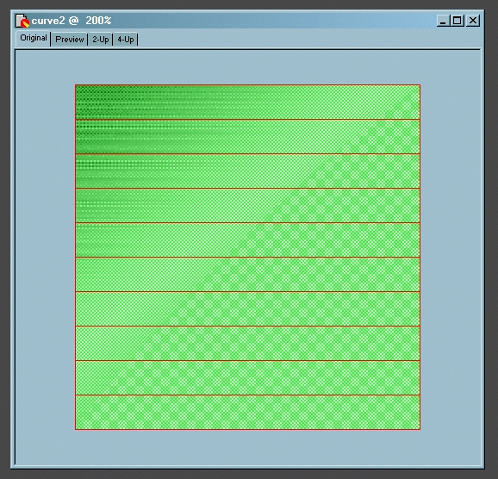

Image manipulation/slicing requires specialized software. Pictured above is the original unsliced curve, used in the Metallic style, as seen in Macromedia Fireworks. The green areas with the red outlines superimposed upon the original graphic each represent a single slice. Adobe Photoshop is another popular commercial image manipulation product. There are a number of shareware and freeware alternatives as well. As each program functions differently general advice is almost impossible to give, however these online resources may prove useful:

Macromedia Fireworks:
http://www.macromedia.com/software/fireworks/
Official website of Macromedia Fireworks.

One Day Fireworks Tutorial on Web Monkey:
http://hotwired.lycos.com/webmonkey/98/30/index2a.html
An introductory tutorial on using Macromedia Fireworks.

Adobe Photoshop:
http://www.adobe.com/products/photoshop/main.html
Official website of Adobe Photoshop.

Photoshop Users:
http://www.photoshopuser.com/
Website of the National Association of Photoshop Using Professionals.

Planet Photoshop:
http://www.planetphotoshop.com/
A website contain tutorials and numerous add-ons and plugins for Adobe Photoshop.

Google Web Directory on Image Manipulation Software:
http://directory.google.com/Top/Computers/Software/Graphics/Image_Manipulation/
Large listing in the Google Directory of Image Manipulation software packages.

Testing
After you’ve gotten the style to look acceptable on your computer it is vital to test it thoroughly under a wide variety of circumstances. Everyone has their preferred operating system, browser, and screen size/resolution and the number of actual combinations possible is a truly staggering. When most people think of browsers they think of Microsoft Internet Explorer or Netscape Navigator. These still remain the two most popular and you should try your style out in both of them. Almost as important as cross browser testing is testing on multiple operating systems.. Although most of the world uses various versions of Microsoft Windows literally millions of people do not. If possible test your style template in browsers running on Windows and other popular operating systems such as Mac OS and Linux. If your site is aimed at the scientific community it is doubly important to test with browsers running on a flavor of Unix such as Linux. A third consideration is screen resolution and monitor size. These can actually have a colossal effect on how a web page is rendered and often goes completely untested. To test screen resolutions it is not necessary to possess multiple monitors, simply adjust the screen resolution on your personal computer. Simply view your website in several common resolutions such as 640X480, 800X600, 1024X768 or 1280X1024 to make sure it is still useable. Here is a brief (two page) article on screen resolution issues: http://www.thedevweb.com/art_view.asp?aID=24 Remember to test your template using a variety of content as well. Examples to test include: pages with an image, pages without images, list of links pages, pages with a lot of text, and pages containing data in tabular form.

Niche/Alternative Browsers
Beyond the two most popular browsers is a surprising variety of niche browsers. These can range from specialized browsers for cell phones or PDAs to browsers for obscure operating systems such as QNX or BeOS. Opera, a popular alternative browser runs on cell phones, PDAs, QNX, and BeOS. Other popular alternate browsers include OmniWeb which runs on NeXT and Mac OS X. Lynx and dillo are popular under Linux, but perhaps the new king of niche browsers is Mozilla which is actually the foundation of modern versions of Netscape Navigator as well as a stand alone browser. Depending on how many visitors (to your site) you expect to be using non main stream combinations of browsers and OS’es it might be wise to try testing your style in one or more alternative browsers. Niche/Alternative browser users can be stubbornly loyal and are unlikely to return to your site if it does not display well in their browser of choice.

Legacy Browsers
In addition to modern alternative browsers many people still surf the web with old software. The most common and thus problematic of these older browsers is Netscape 4+ which is available on Windows, Mac OS, and UNIX/Linux. All the operating systems mentioned above will let you install multiple versions of Netscape on the same computer. Microsoft, maker of both Internet Explorer and the Windows operating system, makes it all but impossible to install multiple versions of IE, especially old obsolete ones on to a single copy of it’s operating system. It requires multiple partitions or hard drives each with their own installation of Windows and a single version of Internet Explorer. So testing older versions of IE such as versions 3 or 4 often requires an inordinate amount of work and is not worth the effort.

So what should I test with?
You should test with the browsers which frequent your site to ensure your audience gets a good web surfing experience. For new sites you will have to assume which browsers will be used most commonly to visit your web site. To paraphrase a near legendary quotation, “There are lies, damned lies, and browser usage statistics.” A reliable source for browser usage statistics is:
http://www.upsdell.com/BrowserNews/stat_trends.htm
The GVC.SiteMaker manual lists which browsers GVC.SiteMaker was tested under and that list could serve as a blue print for testing your style or site. A discussion of browser testing issues can be found here: http://www.webmasterworld.com/forum21/3148.htm

Font Testing Issues
CSS and HTML use a hierarchical system when selecting fonts. This is why a list of fonts is supplied. The user agent/browser will use the first font it recognizes on the list. An additional common misconception with fonts in GVC.SiteMaker is that font specifications on the Configuration Page will always be used. This is not the case, many Style Templates override the user font specifications with one of their own. A common example of this is providing a CSS definition for the textImageText class.

Style Template Tutorial
The following section describes the process by which the majority of the Style Templates in the GVC.SiteMaker style gallery were produced. In order to begin the tutorial, download the following file to your computer:

http://www.global-village.net/clients/user_manual , select the File to Download item listed.

The tutorial will take you on a step by step guide to creating a style template. When finished, the resulting template you make should look the same as the following:

http://www.global-village.net/clients/user_manual and select the Resulting HTML item listed.

The tutorial also makes use of an image which can be download from this URL:

http://www.global-village.net/clients/user_manual and select the Tutorial Logo item listed.

Creating the Style
The first step is to create the style by clicking the “Create New Style” button, after first logging into the style management portion of GVC.SiteMaker. Now you must provide a Style ID, Name, Org Unit, Upload Template (path), and Notes. These are the values that were used in the Tutorial Style:

Style ID: tutorialStyle
Name: Tutorial Style
Org Unit: GVC.SiteMaker Demo
Upload Template: (upload the detailedCSS.html file downloaded above)
Notes: This is a style that was built as a tutorial.

When constructing your own styles you should of course name them how you like and undoubtedly your path to the uploaded template will vary considerably.

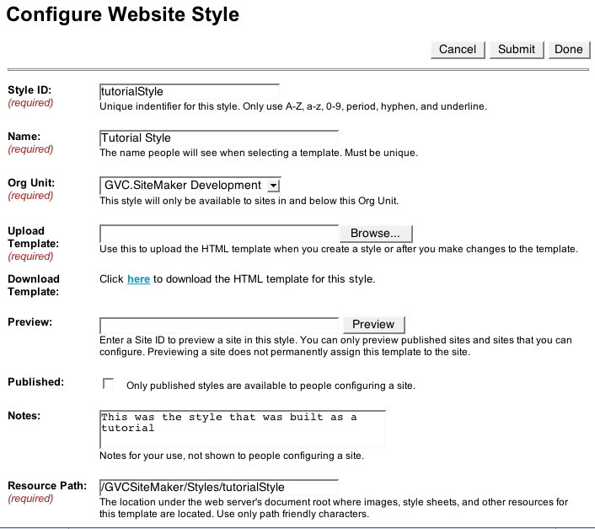

Configure Website Style
On the page pictured above are a lot of fields, most of which are already filled in for you. Having created a new style the first thing to do is to download the template. This will give you a correctly named template for editing purposes. You should edit the template in your favorite text editor. The second thing to do, if you plan on including images is to create the directory listed in the Resource Path. It is also possible to use images in other directories or on other servers entirely. For the tutorial we need to create a directory located at: /GVCSiteMaker/Styles/tutorialStyle on the webserver which is serving the pages from the GVC.SiteMaker application.
The third initial step, assuming you have already created a site, is to preview your style. In the demo site, this was accomplished by typing “screens” in the preview field and pressing the preview button. Below is a screenshot for Mozilla on Mac OSX.

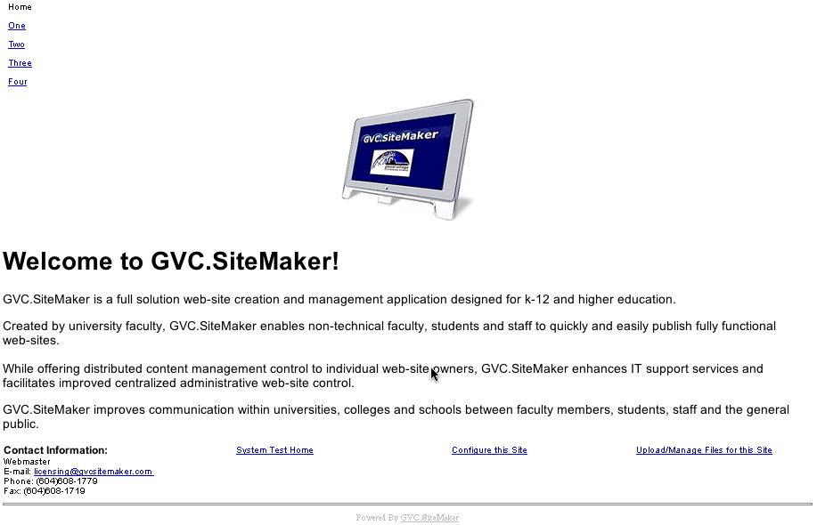

Overall Layout
The next big decision is to come up with the overall layout, some of which can be pretty complex, but most can be quickly sketched as a series of boxes on a scrap of paper. Most styles will either be a Menu Left style or a Menu Right style. Here is a sketch for both:

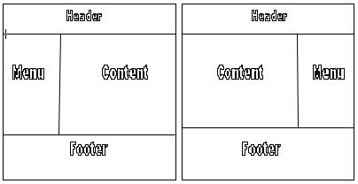

In order to get the Menu to be on the right or left we need a simple CSS Rule. You can simply cut ‘n’ paste the contents of this rule into the matching rule in your text editor.
div#Menu {
float: left;
}
Save the file. Browse to the file in the GVC.SiteMaker “Config Website Style” screen using the “Browse…” button. Then click save in GVC.SiteMaker. Now the file has been uploaded, preview the results. Here is how it looked in Mozilla on OSX:

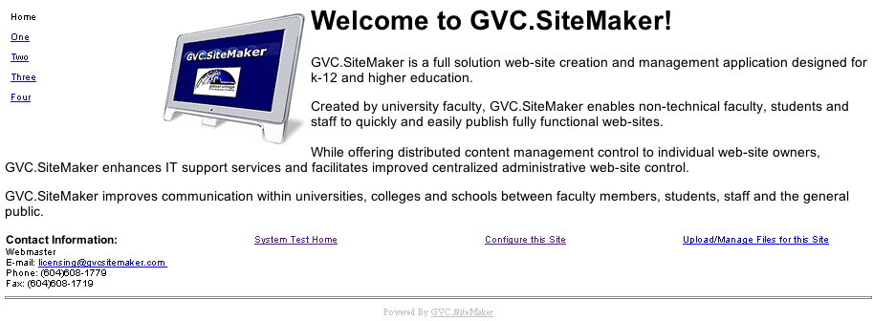

Notice the menu on the left, but it isn’t in its own column like in the drawing above. Although the style will work perfectly well as is, to get the menu to be in it’s own column we need to add another CSS rule.
div#Content {
float: right;
}

Repeating the save in text editor, upload to GVC.SiteMaker, save in GVC.SiteMaker and preview cycle yields the correct results in IE6+ for Windows. This super simple bit of CSS will work on most modern browser in most situations and gives you a nice two column layout. It is also easy enough to reverse which side the Menu and Content are on by reversing the floats. However if you are using a browser other then Internet Explore 6+ and do not see the menu in it’s own column on the left proceed to the Trouble Shooting section at the end. Using the so called "foolproof" HTML solution in Mozilla yields the following:

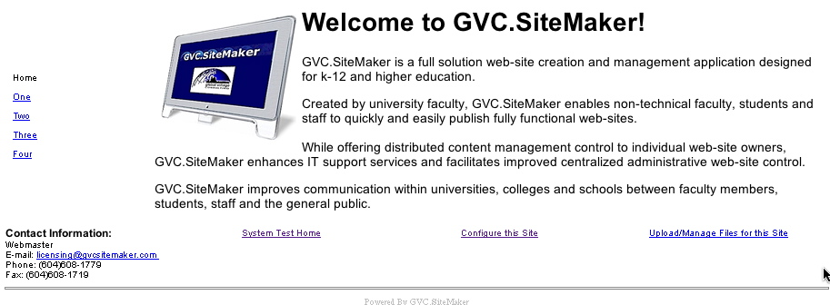

Beautification
With the basic layout achieved it is now time to beautify the various pieces of the page. It is common to start with the header, then the footer, then the menu, and leave the content to last as it has the most variables to consider. Sometimes it is wise to start with some basic document wide styling such as foreground and background colors and the default font. This can be accomplished with CSS rules either on div#Document or on the body tag itself. Since we thoughtfully put in a the div#Document tag we should make use of it as follows:
div#Document {
font-family: Helvetica, Arial, sans-serif;
color: black;
background-color: silver;
}
This rule sets a series of fonts to choose from for all text, as well as making the text black on a silver (light gray) background. Save, upload and preview these changes. Below is how it looked in Mozilla:

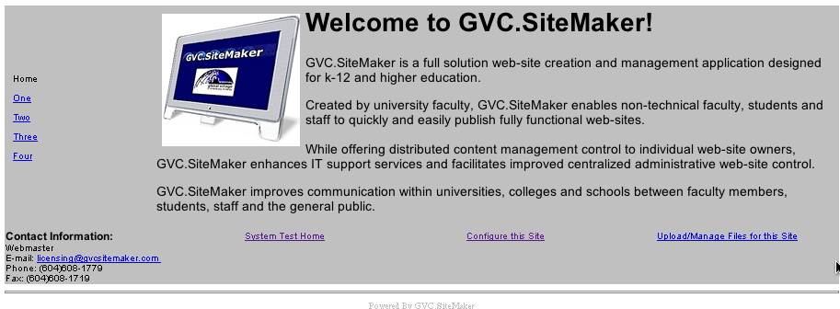

You’ll probably find this doesn’t look that great, the background color doesn’t go all the way to the edge of the screen (hard to see in the screenshot) and silver and black do not look that appealing. Replace the last CSS rule with these two:
body {
background-color: #FFEBCD;
}
div#Document {
font-family: Helvetica, Arial, sans-serif;
color: #A0522D;
}

The order of the CSS rules from the top to the bottom of the template style file is important, each CSS rule that is not present in detailedCSS.html should be added at the top of the file above div#Document but below the comment /* Document Wide Styles */. Each additional rule should work fine when placed below the previous one in this tutorial.

These rules set the background color to be on the body tag, which is often a better strategy. The color was changed to a light tan color which was specified using a hexadecimal code. There are a lot more shades available if you specify colors in hexadecimal codes rather than English words, it is also more cross-browser compliant. The foreground color was changed to better match the background color. After saving, uploading, and previewing this is how it looked in Mozilla in OS X:

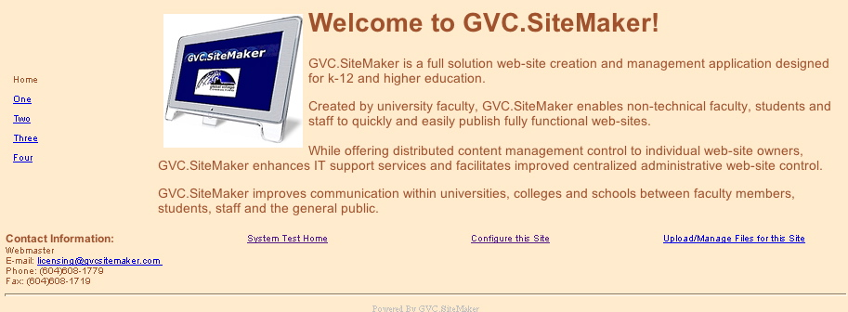

That should be better, remember when choosing colors it is best to have a light background color with a dark foreground color like in the example. The opposite does not work as well. You will notice text that is not brown in color, this is most likely a link, such as those in the menu. Since the browns look better lets make the horizontal rules brown as well with the following CSS rule:
hr {
color: #8B4513;
}
You’ll notice a different hexadecimal code was used, this is a slightly darker brown, this was chosen to help them stand out a bit more. If your content does not make use of horizontal rules then this will not yield any noticeable result. If you want to test this CSS rule use a List of Links section, as they always have horizontal rules in them. Now we’re ready to beautify individual portions of the page. The hexadecimal codes were determined by picking colors from Hype’s Color Chart, which is listed in the resource section.

Header
The header is the simplest part of the page to stylize. We’ll make the text bigger, in a different font, in the darker brown color and centered on the page, all with one CSS rule:
div#Header {
font-size: large;
font-family: cursive;
color: #8B4513;
text-align: center;
}
If you were not displaying the header for your website as in the previous screenshots, you must set Show Banner to yes on the Config Overall Appearance Page in order to see the effects of the most recent CSS rule onscreen.
After saving, uploading, and previewing the header now looks correct in Mozilla:

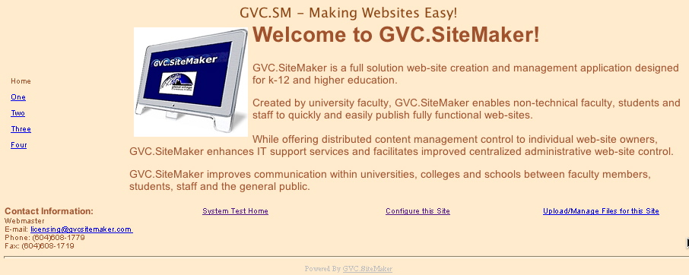

Perhaps our template would look better if the text was a bit bigger and back on the left, so replace the previous CSS Header rule with the following one, save, upload, and preview. The results are seen below.
div#Header {
font-size: x-large;
font-family: cursive;
color: #8B4513;
text-align: left;
}

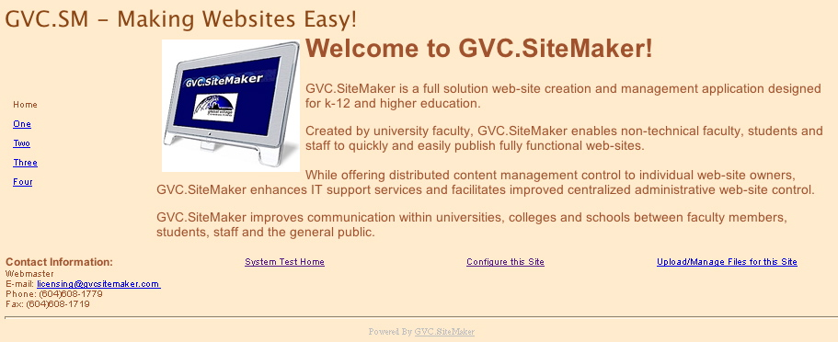

To really separate the Header from the rest of the page, perhaps a line under it would help, this can be achieved by adding another line to the Header CSS rule:
border-bottom: 3px solid #8B4513;

A final save, upload, and preview yields the finished Header:

Footer
The footer needs to be the opposite of the header, it needs a line at the top, to be in a smaller font, perhaps even italicized to differentiate it further from the actual content of the page. Also necessary is to ensure that it does not overlap any elements above it.
div#Footer {
clear: both;
font-size: small;
border-top: 3px solid #8B4513;
font-style: italic;
}

Adding the above rule to tutorialStyle.html then uploading and previewing in Mozilla yields:

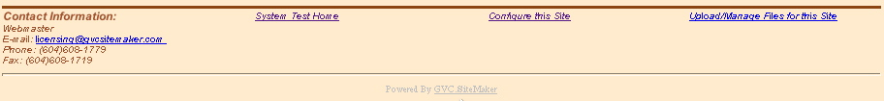

Link Text
Since the default link text colors just do not fit in well with the brown color scheme, a simple CSS rule is required to change all the links on the page to be orange.
a {
color: orange;
}

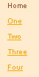

After saving, uploading, and previewing all the links should be orange. Now to really jazz up the links we need some sort of mouse over effect. This can be achieved with another CSS rule. Put this below the rule added above:
a:hover {
color: #8B4513;
background-color: orange;
}

The mouse overs of the menu are shown in the screenshot below:

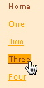

Menu
Having just styled the links, the menu is largely finished. One outstanding issue is how the menu doesn’t start at the top of its column, in some browsers. This is fixable by another CSS rule:
td, div {
vertical-align: top;
}
With that taken care off it is time to make the currently selected section stand out more. The CSS rule below makes the text bigger, bolder, and in different color:
div#Menu table div div.navbarText {
font-size: 1.25em;
font-weight: bold;
color: #8B4513;
}

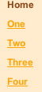

This rule however makes the menu links bigger and bolder too, which may not have been our intention. We can bring them back to normal size with the following rule. It should be placed following the original navBarText CSS rule.
div#Menu table div div.navbarText a {
font-size: 0.75em;
font-weight: normal;
}

If the links now seem a little too small now so try making them 0.8em or even 0.9em. Here is a screenshot in Mozilla with font-size set to 0.9em:

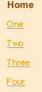

Content
The content is looking pretty good already, as a lot of the CSS rules we’ve written will trickle down to affect the content as well. Assuming your content makes use of the header tags like demo.gvcsitemaker.com does it is common to write a rule for the headings.
h1,h2,h3,h4,h5,h6 {
color: #8B4513;
}

Below is a screenshot of an H1 tag with some regular text below as rendered in Mozilla:

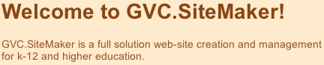

Final Touches
The “Powered By Text” at the bottom does not seem to fit in so, the following rules will allow it to blend in with the rest of the page better. They can be added below every other CSS rule. This will make it a closer match in color and give it an inverse mouse over effect which still sets it apart slightly from the rest of the links.
div#poweredByText {
color: #A0522D;
}
span#gvcSiteMakerLink {
color: orange;
text-decoration: underline;
}
div#poweredByText a:hover {
background-color: #8B4513;
}

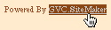

Currently the tutorial style template does not make use of any additional files such as images or scripts. However most web pages and GVC.SiteMaker pages are no exception, are made up of more then one file. A common addition to any website is a logo. To get a logo to appear on all the pages in your GVC.SiteMaker website you can make the logo part of the template. This is accomplished by uploading the image file to the resource path using the File Transfer Protocol (/GVCSiteMaker/Styles/tutorialStyle for the tutorial style). For the demo we uploaded a file called gvcLogoTransparentMedium.gif. In order for the image to appear on the page the following addition must be made to tutorialStyle.html:
<img src="/GVCSiteMaker/Styles/tutorialStyle/gvcLogoTransparentMedium.gif" alt="Global Village Consulting Logo">

It should go inside the body and the first div tag but above everything else. Once uploaded and previewed the positioning of the logo isn’t very aesthetic in Mozilla:

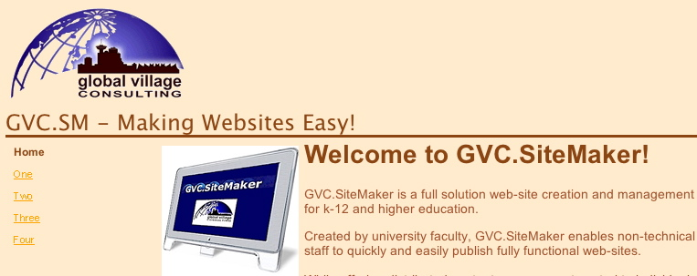

Moving the logo, is a simple matter of moving the corresponding <img> tag. In the tutorial we moved the logo into the same column as the menu. This is accomplished by putting the <img> tag just above the navBar <webobject> tag, just below the "Menu open" HTML comment. The results can be seen below:

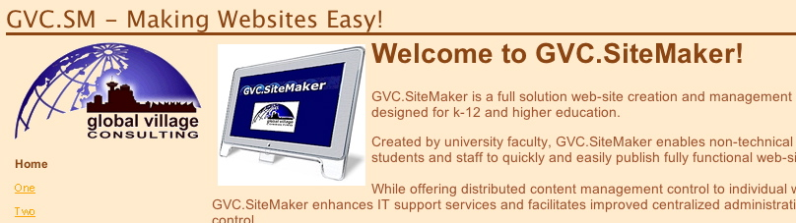

The final thing to do is remove all the empty CSS rules that we inherited from detailedCSS.html but did not use.

Testing
Now it is important to check all the sections of your site displayed with the style and to view them in several browsers to make sure nothing goes unexpectedly wrong. The style displayed in the following browsers (Opera 6+, Netscape 7, and Netscape 4.8) but not well enough. The solution is provided in the trouble shooting section, basically replace the CSS based layout with an HTML based one. Remember to keep the corporate logo in the same column as the menu. Also be sure to remove the unneeded CSS rules for div#Menu and div#Content. Below is a screenshot of the page rendering in IE 6+:

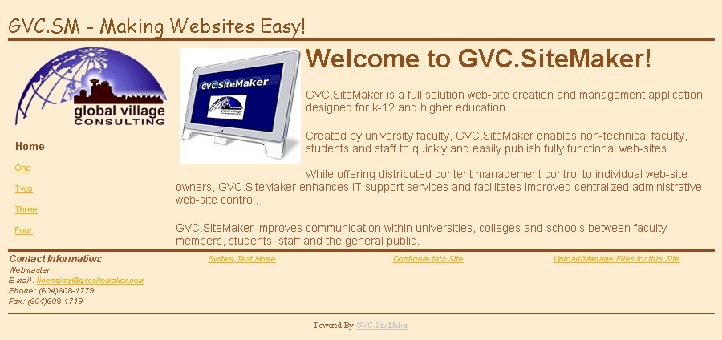

However if you try testing with Netscape 4.8 and wondered where all our hard work had gone, you need to change the first line of our <style> declaration from:

<style type="text/css" media=”all”>
to:
<style type="text/css">

Now it should look like this in Netscape 4.8:

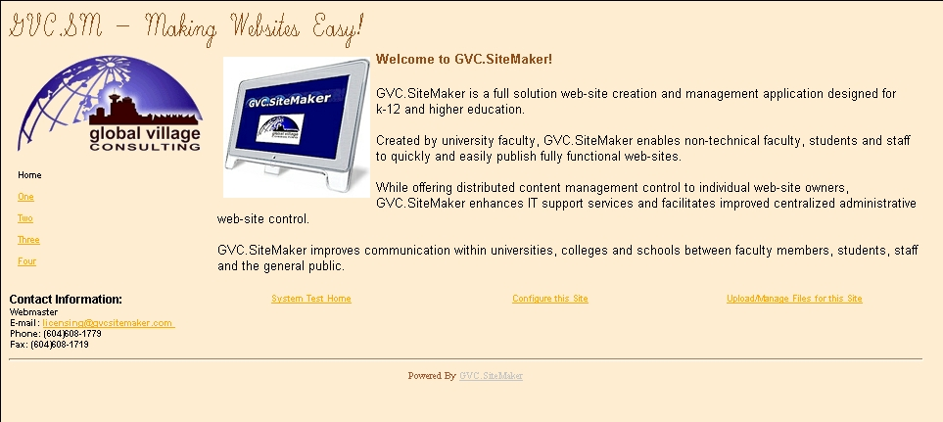

Sometimes it is best to protect Netscape from itself by not letting it attempt to parse more elaborate CSS rules. Even after this change Netscape 4+ still will not understand or correctly interpret some of our CSS rules. Do not worry if the font size or font family changes slightly from browser to browser, you’re mainly concerned that all the information is presented legibly and all pages are accessible. Netscape 4.8 does not understand mouse over effects either.

Once you are satisfied that it works acceptably you should publish the style (by marking the corresponding check box on the Config Website Style page and saving) and start using it on websites or sections.

Trouble Shooting
If you’re using a recently released browser but can not get the left menu/right content layout to work and find the footer is messing everything up add this rule:
div#Footer {
clear: both;
}
If things still don’t look basically like the drawing and screenshots you may want to try and reverse the order of the Content div and Menu div inside the body tag. Be sure and move all the webobject tags including the one named “ShowNavBar”. If things still aren’t working in your browser of choice, then perhaps a table layout is necessary. Table layouts are often necessary for older browsers such as Netscape 4.
First remove the three CSS rules we’ve added above. Then create a simple one row, two column table and put the menu in one cell and the content in the other like so:
<table border="0">
<tr>
<td>
<webobject name="ShowNavBar">
<div id="Menu">
<!-- Menu open -->
<webobject name="NavBar"></webobject>
<!-- Menu close -->
</div>
</webobject name="ShowNavBar">
</td>
<td>
<div id="Content">
<!-- Content open -->
<webobject name="SectionContents"></webobject>
<!-- Content close -->
</div>
</td>
</tr>
</table>
This should now have the menu on the left, in its own column, this should work in the vast majority of browsers and is as close as you can get to foolproof with HTML. This is almost identical to the method used in the introductory simple template.

