System Test Plan:
GVC.SM – Portable Data Tables
Version: 4.6

July 8, 2008
JOEE GARCIA
Project Sponsor: GVC Board of Directors

0000.doc

Revision Chart and Copyright Notice

Version | Primary Author(s) | Description of Version | Date Completed
Draft | Joee Garcia | Created initial document and tests | August 9, 2006
4.1.1 | Joee Garcia | Updated with latest UI changes | October 9, 2006
4.6 | Joee Garcia | Added tests with Calculated Fields | July 8, 2008

This document is Copyright © 2001 – 2006 by Global Village Consulting Inc. All rights reserved.
This document is published under the terms of the Educational Community License (ECL) version 1.0, a copy of which has been included with this distribution in the LICENSE.TXT file.

Table of Contents
Revision Chart and Copyright Notice 2
Table of Contents 3
SiteMaker Testing 4
Overview 4
Test Resources 4
Test Breakdown 4
GVC.SM – Portable Data Tables 5
Overview 5
Test Cases 5

SiteMaker Testing

Overview
This test plan contains the test cases that address both verification and testing of the Portable Data Table feature of GVC.SiteMaker application. Tests include normal and exceptional cases for the program to handle.
Each area will test expected and exceptional inputs for each field and also include tests for possible errors in functionality that may cause the system to behave in an unexpected manner.
The test plan is designed to test specific features of the application and can be run independently from other test plans. This test plan should be run from start to finish to ensure that the appropriate data is available for tests in the next section. Running the tests from the beginning of each section can be accomplished through the creation of database snapshots after each section, and then restoring the test database (and files) to that level.

Test Resources

Email Addresses
To facilitate testing, the system administrator should configure the following email aliases to the tester’s accounts:

SiteMaker1@global-village.net
<2,3,4,5,6,7,8,9>
SiteMaker10@global-village.net

Internal users should also be used for this feature, thus the server will need to have internal users=’true’. The following internal users and passwords may be used while testing this feature:
UserID Password

Test Breakdown
The Test Cases written to test GVC.SiteMaker have been broken into separate sections to correspond to the grouped areas of functionality. This has been done to facilitate testing of SiteMaker to be done by multiple testers via database snapshots, as well as to improve the manageability of the Test Plan.
The following is a brief description for the sections and the coverage they provide:

Sections | Coverage

GVC.SM – Portable Data Tables

Overview
This section of the test plan is designed to test exporting and installing a data table package. Tests in this section can be run independently from those of other sections, as the data produced in the area will not affect the results in another section. These tests assume that the tester knows how to setup and configure a website especially creating Data Access sections. The test preparations should be followed precisely for tests to be successful.

Test Cases

ID | Area – Test | Instructions | Expected Results | Comments
 | Test Preparation | In the Administration section, create a new site with the following values:  SiteID: schoolTestSite  OwnerID: <your user id>
 | Test Preparation | In the Configuration section, create Database Tables in this site with the following names and fields. For all descriptions, enter “<name of table or field> Description”:  - Country – Name (text)  - State – Name (text), Country (value list: Country – Name(Text))  - Division – Name (text)  - City – Name (text), State (value list: State – Name(Text)), Country (value list: Country- Name(Text))  - School – Name (text), Is New (Checkbox), Year Built (Number), Date Opened (Date/Time), Admin Files (File), City (value list: City – Name(Text)), Division (value list: Division – Name(Text)), Signature (Calculation/Formula: “Prof. “ + Name), Year Proclaimed (Calculation/Formula: YearBuilt + 4), Date Closed (Calculation/Formula: DateOpened.addYMDHMS(30, 0, 0, 0, 0, 0)), Date Closed (Calculation/Formula: DateOpened.addYMDHMS(30, 0, 0, 0, 0, 0)), NotIsNew (Calculation/Formula: not IsNew), City Name (Calculation/Formula: "City:" + City.max(20)), CityIdentifier (Calculation/Formula: "ID" + CityName)  Here’s a screenshot of the created fields for School as reference:  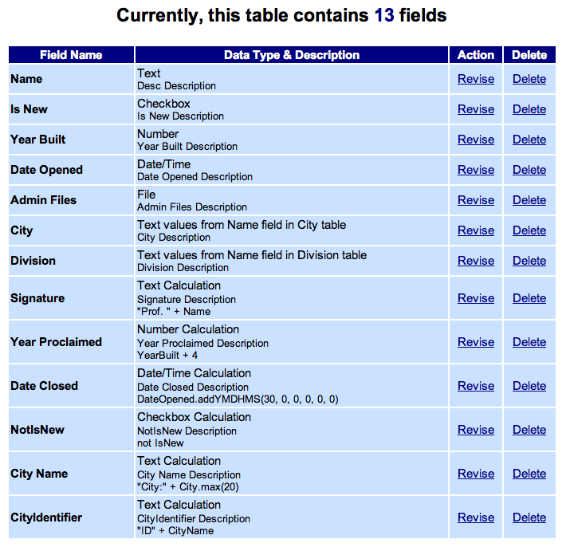
 | Test Preparation | Create Data Access Section for the Country table with the following values:  Type: Data Access, Name: Country_DA, Style: (choose any available style), Description: This is a DA section test that uses the Country Table, Section Access: Site Owner/Co-owners, Require HTTPS Access for Public Sections: No, MIME Type: text/html???  Do not change anything in the Contents configuration.  Add the following records:  - Name: Canada  - Name: US  In the Email Notification section of the DA section, specify the following:  - Create Records = Send Email: (check), Template in Use: Custom, Subject: Record is created Download File: createTemplateTest.html (found in /Tests/TestPlan/FilesForTesting/Portable Data Tables/).  - Modify Records = Send Email: (check), Template in Use: Custom, Subject: Record is modified Download File: modifiedTemplateTest.html (found in /Tests/TestPlan/FilesForTesting/Portable Data Tables/)..  From Address: sitemaker2@global-village.net  Send Email Notification To:  Site Owner/Co-owners: (check), Other recipients: sitemaker1@global-village.net, Addresses in these Data Access Fields: Name (check), Created By: (check), Modified By: (check)
 | Test Preparation | Create Data Access Section for the State table with the following values:  Type: Data Access, Name: State_DA, Style: (choose any available style), Description: This is a DA section test that uses the State Table, Section Access: Site Owner/Co-owners, Require HTTPS Access for Public Sections: Yes  Do not change anything in the Contents configuration.  Add the following records:  - Name: BC, Country: Canada  - Name: Alberta, Country: Canada  - Name: Washington, Country: US
 | Test Preparation | Create Data Access Section for the City table with the following values:  Type: Data Access, Name: City_DA, Style: (choose any available style), Description: This is a DA section test that uses the City Table, Section Access: Site Owner/Co-owners, Require HTTPS Access for Public Sections: No  Do not change anything in the Contents configuration.  Add the following records:  - Name: Vancouver, State: BC, Country: Canada  - Name: Richmond, State: BC, Country: Canada  - Name: Edmonton, State: Alberta, Country: Canada
 | Test Preparation | Create Data Access Section for the School table with the following values:  Type: Data Access, Name: School_DA, Style: (choose any available style), Description: This is a DA section test that uses the School Table, Section Access: Site Owner/Co-owners, Require HTTPS Access for Public Sections: No  In the Change Contents Page, specify the following for each tab:  Section Settings Tab  - Actions: check Browse/Search for Records, Add Records, Delete Records, Import Records  - Select Records found by the “Default Search”, defined below  - Enter 2 default search criteria:  - Field Name: City, Comparison: is equal to, Value: Vancouver  - Combined Criteria: OR, Field Name: Division, Comparison: contains (text only), Value: West  - Check Visitor will only be able to find record contained within the Default Search results set.  - For sorting, enter 2 sort criteria:  - Name in Ascending order  - City in Descending order  For the number of records to be shown in groups: enter 10  - For the type of page to display when visitors first enter this section: select “A Single Record”  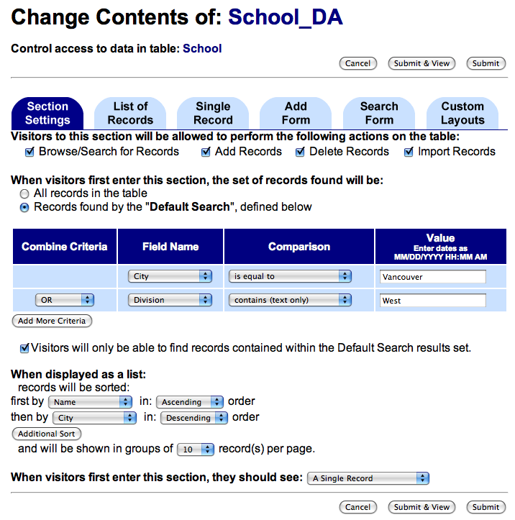
List of Records Tab for School_DA
For each field, change their options with the following values:
- Name = Show Field: √, Allow Edits: (unchecked), Width: 30, Height: 1, Display carriage returns: (unchecked), WYSIWYG Mode: Off
- Is New = Show Field: (unchecked), Allow Edits: (unchecked), Values for checked: True unchecked: False
- Year Built = Show Field: (unchecked), Allow Edits: (unchecked), Width: 30, Format: 987654321
- Date Opened = Show Field: (unchecked), Allow Edits: (unchecked), Width: 30, Format: mm/dd/yy format
- Admin Files = Show Field: (unchecked), Allow Edits: (unchecked), Show file contents: (unchecked), Scale to width: (blank)
- City = Show Field: √, Allow Edits: (unchecked), Display as: Pick List, If Grid, display with: blank
- Division = Show Field: (unchecked), Allow Edits: (unchecked), Display as: Pick List, If Grid, display with: blank
- Signature = Show Field: (unchecked)
- Year Proclaimed = Show Field: (unchecked), Format: 9876543221
- Date Closed = Show Field: (unchecked), Format: mm/dd/yy format
- NotIsNew = Show Field: (unchecked), Values for checked: True unchecked: False
- City Name = Show Field: (unchecked)
- CityIdentifier= Show Field: (unchecked)
- Date Modified = Show Field: (unchecked), Width: 30, Format: mm/dd/yy format
- Date Created = Show Field: (unchecked), Width: 30, Format: mm/dd/yy format
- RecordID = Show Field: (unchecked)
- Modified By = Show Field: (unchecked)
- Created By = Show Field: (unchecked)
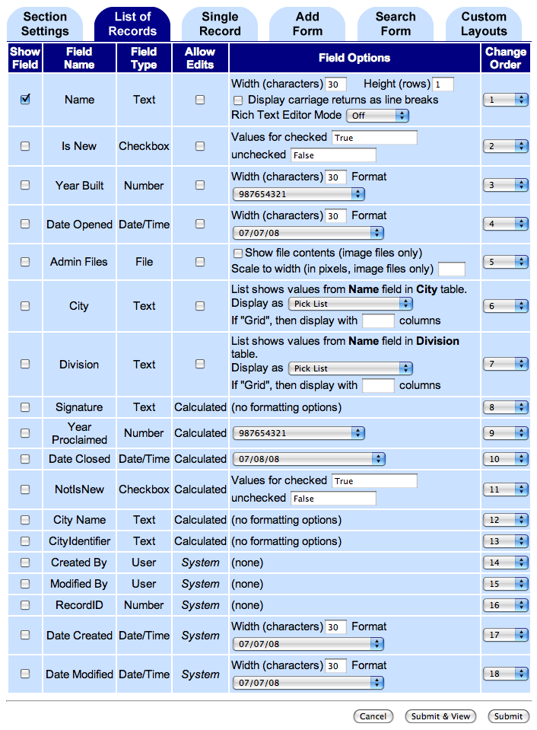

Single Record Tab for School_DA
For each field, change the ordering based on how they are listed here and change their options with the following values:
- Is New = Show Field: √, Allow Edits: √ Values for checked: Yes, unchecked: No
- Name = Show Field: √, Allow Edits: √, Width: 50, Height: 5, Display carriage returns: √, WYSIWYG Mode; Simple
- Signature = Show Field: √
- Year Built = Show Field: √, Allow Edits: √, Width: 4, Format: 987654321
- Date Opened = Show Field: √, Allow Edits: √, Width: 20, Format: 21 May 2006
- Admin Files = Show Field: √, Allow Edits: √, Show file contents: check, Scale to width: 100
- City = Show Field: √, Allow Edits: √, Display as: Vertical Radio Button, If Grid, display with: blank
- Division = Show Field: √, Allow Edits: √, Display as: Radio Button Grid, If Grid, display with: 2
- Year Proclaimed = Show Field: √, Format: 987,654,321
- Date Closed = Show Field: √, Format: mm/dd/yyyy format
- NotIsNew = Show Field: √, Values for checked: True unchecked: False
- City Name = Show Field: √
- CityIdentifier= Show Field: √
- Created By = Show Field: √
- Modified By = Show Field: √
- RecordID = Show Field: √
- Date Created = Show Field: √, Width: 10, Format: mm/dd/yy HH:MM PM format
- Date Modified = Show Field: √, Width: 10, Format: mm/dd/yy
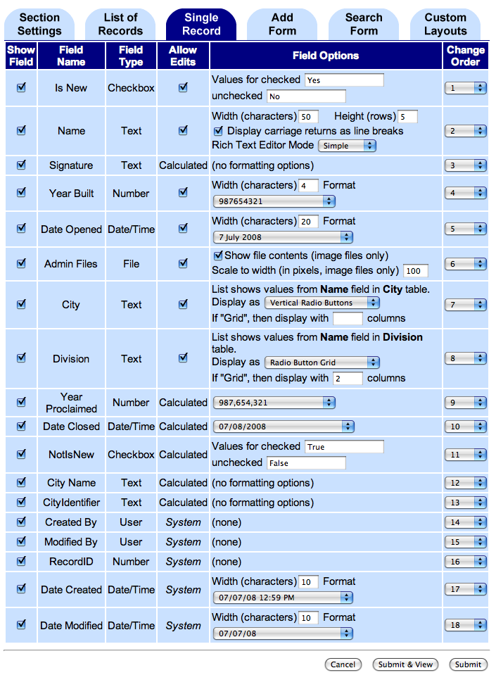

Add Form Tab for School_DA
For each field, change their options with the following values:
- Name = Show Field: √, Set default value: School, Width: 50, Height: 5, Display carriage returns: (checked), WYSIWYG Mode: Simple
- Is New = Show Field: √, Select default value: checked
- Year Built = Show Field: √, Default: 1990, Width: 4, Format: 987,654,321
- Date Opened = Show Field: √, Use current date and time as default: (checked), Width: 20
- Admin Files = Show Field: √
- City = Show Field: √, Display as: Radio Button Grid, If Grid, display with: 2, Select default value: Vancouver
- Division = Show Field: √, Display as: Horizontal Radio Buttons, If Grid, display with: (blank), Select default value: (blank)
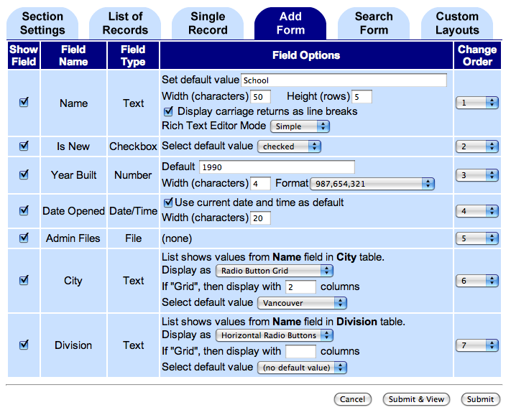
Search Form Tab for School_DA
Search Form Type: Accept one term, search all text fields
For each field, change their options with the following order and values:
- Name = Show Field: (unchecked), Default Comparison: is less than
- Year Built = Show Field: (unchecked), Default Comparison: is less or equal to
- Date Opened = Show Field: (unchecked), Default Comparison: is equal to
- Is New = Show Field: (unchecked), Default Comparison: is not equal to
- City = Show Field: (unchecked), Default Comparison: is greater than
- Division = Show Field: (unchecked), Default Comparison: is greater than or equal to
- Date Modified = Show Field: √, Default Comparison: contains (text only)
- Signature = Show Field: √, Default Comparison: is equal to
- Year Proclaimed = Show Field: √, Default Comparison: is equal to
- Date Closed = Show Field: √, Default Comparison: is equal to
- NotIsNew = Show Field: √, Default Comparison: is equal to
- City Name = Show Field: √, Default Comparison: is equal to
- CityIdentifier = Show Field: √, Default Comparison: is equal to
- Modified By = Show Field: √, Default Comparison: is equal to
- Created By = Show Field: √, Default Comparison: is equal to
- Record ID = Show Field: √, Default Comparison: is equal to
- Date Created = Show Field: √, Default Comparison: is equal to
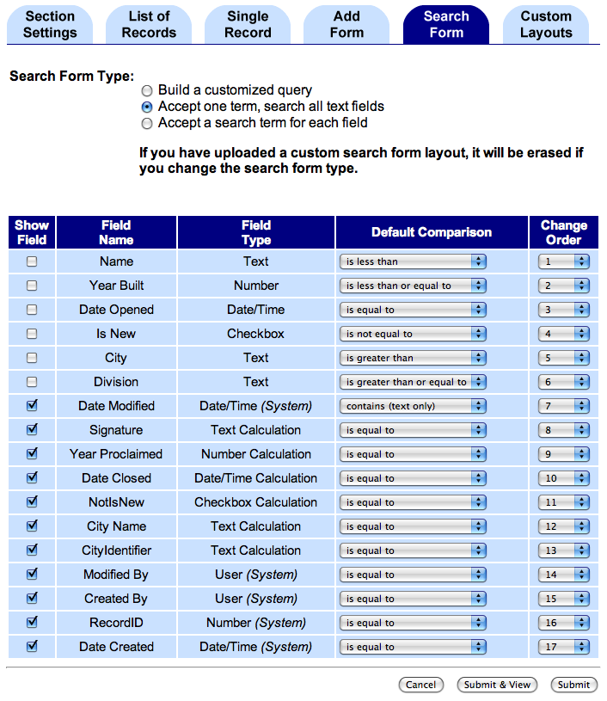

Custom Layout Tab for School_DA
For each display mode, create a custom template for each mode by downloading the standard template, modifying it and uploading the custom one.
 | Test Preparation | Create the following records to the School_DA section. Admin files can be found in /Tests/TestPlan/FilesForTesting/Portable Data Tables/  - Name: ABC School, Is New: (checked), Year Built: 1,990, Date Opened: <default>, Admin Files: SchoolFile1.doc, City: Vancouver, Division: (blank)  - Name: DEF School, Is New: (unchecked), Year Built: 1,995, Date Opened: <default>, Admin Files: SchoolFile2.gif, City: Richmond, Division: (blank)  - Name: GHI School, Is New: (unchecked), Year Built: 2,004, Date Opened: <default>, Admin Files: SchoolFile3.html, City: Edmonton, Division: (blank)
 | Test Preparation | Create 3 site folders: Packages, Images, Artworks
 | Test Preparation | Create another site simpleTestSite without a database table.
 | Create Package – link not available | In the admin section, go to the Website Management Page for the simpleTestSite. | The Website Management Page displays without the Create Data Table Package link.
 | Create Package – link available | Go to the Website Management Page for the schoolTestSite. | The page displays with the Create Data Table Package link.
 | Create Package – initial fields | Click on the link to Create Data Table Package. | Create Data Table Page displays with the following fields:  - SiteID – schoolTestSite (non-editable)  - Package Destination – pick list, no selection, displays all folders in site alphabetically with Main folder on top (Main, Artworks, Images, Packages)  - Select Main Data Table To Package– pick list, no selection, displays all database tables in site alphabetically (City, Country, Division, School, State)  Cancel and Create Package buttons are available on top of the page.
 | Create Package – create package button | Click on the Create Package button. | An error message displays stating that the Package Destination and Main Date Table need to be specified before an export can be created.
 | Create Package – create package button | Select Packages for Package Destination and click the Create Package button. | An error message displays stating that the Main Data Table needs to be selected before an export can be started.
 | Create Package – related sections and tables | Select Country database table as Main Data Table and verify the lists displayed. | The page redisplays with the tables and sections related to the selected Main Data Table.  In the Main and Related Table to Export table, verify that:  - The main table contains (Main) at the end of its name and always on top of the list.  - There are no related tables  - The checkbox to Include Data? for the main table is checked by default.  In the Related Sections To Export table, verify that:  - The related sections are only DA sections and are listed in alphabetical order.  (Country_DA)  - Each of the sections has a checkbox to Include in Package?, they are all checked by default. | Related tables are any tables that the Main table takes its lookup values from, and any tables those tables take lookup values from, and so on, and so forth.  Related sections are all Data Access sections that display the data from the Main or related tables.
 | Create Package – related sections and tables | Select State database table as Main Data Table and verify the lists displayed. | The page redisplays with the tables and sections related to the selected Main Data Table.  In the Main and Related Table to Export table, verify that:  - The main table contains (Main) at the end of its name and always on top of the list.  - The related tables are listed below the main table.  (Country)  - The checkbox to Include Data? for the main table is checked by default. The related tables also Include Data? by default but are non-editable.  In the Related Sections To Export table, verify that:  - The related sections are only DA sections and are listed in alphabetical order.  (Country_DA, State_DA)  - Each of the sections has a checkbox to Include in Package?, they are all checked by default.
 | Create Package – related sections and tables | Select Division database table as Main Data Table and verify the lists displayed. | The page redisplays with the tables and sections related to the selected Main Data Table.  In the Main and Related Table to Export table, verify that:  - The main table contains (Main) at the end of its name and always on top of the list.  - There are no related tables  - The checkbox to Include Data? for the main table is checked by default.  In the Related Sections To Export table, verify that:  - There are no related sections. The whole Related Sections table does not display.
 | Create Package – related sections and tables | Select City database table as Main Data Table and verify the lists displayed. | The page redisplays with the tables and sections related to the selected Main Data Table.  In the Main and Related Table to Export table, verify that:  - The main table contains (Main) at the end of its name and always on top of the list.  - The related tables are listed below the main table in alphabetical order. (Country, State)  - The checkbox to Include Data? for the main table is checked by default. The related tables also Include Data? by default but are non-editable.  In the Related Sections To Export table, verify that:  - The related sections are only DA sections and are listed in alphabetical order.  (City_DA, Country_DA, and State_DA)  - Each of the sections has a checkbox to Include in Package?, they are all checked by default. | Bug: Main and Related Tables not alphabetical  Bug: Related Sections not alphabetical
 | Create Package – related sections and tables | Select School database table as Main Data Table and verify the lists displayed. | The page redisplays with the tables and sections related to the selected Main Data Table.  In the Main and Related Tables to Export table, verify that:  - The main table contains (Main) at the end of its name and always on top of the list.  - The related tables are listed below the main table in alphabetical order. (Country, City, Division, State)  - The checkbox to Include Data? for the main table is checked by default. The related tables also Include Data? by default but are non-editable.  In the Related Sections To Export table, verify that:  - The related sections are only DA sections and are listed in alphabetical order.  (City_DA , School_DA, Country_DA and State_DA)  - Each of the sections has a checkbox to Include in Package?, they are all checked by default.
 | Create Package – uncheck include data | Select School as the Main Table to Export. Uncheck the Include Data? for the School. | The page redisplays and the Include Data? for all the tables become editable checkboxes
 | Create Package – check all button | Click Check All button under Main and Related Tables to Export. | The page redisplays with the School Table checked and the rest are uneditable with ‘YES’
 | Create Package – uncheck all button | Click Uncheck All button under Main and Related Tables to Export. | The page redisplays with all the checkboxes for all the tables unchecked.
 | Create Package – uncheck include data | Check the Include Data? for State table. | The page redisplays and the Include Data? for Country becomes required and non-editable. The other tables still display checkboxes. | If data is included for a certain table, the system will also require to include data for all its related tables.
 | Create Package – check all button | Click Check All button under Related Sections to Export. | The page redisplays with all the checkboxes for all the sections checked.
 | Create Package – uncheck all button | Click Uncheck All button under Related Sections to Export. | The page redisplays with all the checkboxes for all the sections unchecked.
 | Create Package – create package button | Click the Check All button for both Main and Related Tables to Export and Related Sections to Export.  Click the Create Package button. | The Queued Tasks Page displays with the new export task. | The system creates and queues the export task automatically.
 | Create Package – xml file | Wait for the export task to be completed by refreshing the page from time to time. When the task is completed, go to the Upload/Manage Files Page of the site in the configuration section. | Under the Packages folder, the file school_<current_date>.xml is created. | The format of the export file name is “<main_table_name>_mm-dd-yyyy.xml”.
 | Create Package – xml file | Download the xml file and review the contents. | The xml file should contain xml scripts and data regarding the tables and sections for all tables and sections
 | Create Package – valid xml file | Go back to the Create Data Table Page.  Select Packages as the Package Destination.  Select City as the Main Table to Export.  Do not include data for all tables.  Do not include any sections to export.  Click the Create Package button. | When export task is done, under the Packages folder, the file city_<current_date>.xml is created.  Download xml file and check if xml created does not include data and related sections.  Compare the output xml file with correct_city_output.xml. Both files should be the same.  Verify that output xml contains DTD.

ID | Area – Test | Instructions | Expected Results | Comments
 | Installing a Data Table Package into a new site
 | Test Preparation | In the Administration section, create a new site with the following values:  SiteID: newSchoolTestSite  OwnerID: <your user id>
 | Install Package – install page | Go to the Main Configuration Page for newSchoolTestSite.  In the Database Tables section below, click on Install Package button. | The Install Data Table Package Page displays with the Select Package File to Install pick list with no selections.  On top of the page are Cancel and Install Package buttons.  Below the pick list are instructions and a link to upload the package file.
 | Install Package – install package button | Click on the Install Package button. | The page redisplays with an error message stating that a package need to be selected before installing.
 | Install Package – cancel button | Click on the Cancel button. | The Main Configuration Page displays.
 | Install Package – package pick list | Go back to the Install Package Page. Click on the Select Package File to Install pick list. | There are no files in the pick list.
 | Install Package – upload link | Click on the here link to upload the package file. | The Upload/Manage Files Page displays.
 | Install Package – uploaded file | Upload the package school_<current_date>.xml in it.  Go back to the install page and click on the Select Package File to Install pick list again. | One item is displayed,  school_<current_date>.xml
 | Install Package – install options | Select school_<current_date>.xml from the pick list. | The page redisplays with the types of installations and contents of the selected package.  There are two types of install:  - Easy Install – radio button (default)  - Custom Install – radio button  In the Main and Related Table to Install table, verify that:  - The School table contains (Main) at the end of its name and on top of the list.  - The related tables are listed below the main table (City, State, Country and Division)  - The Install Option for all tables is Install table from package, including data except for Division, which will just be Install table from package.  In the Related Sections To Install table, verify that:  - The related sections are listed (State_DA , City_DA, Country_DA, School_DA)  In the Install? Column, all sections are going to be installed.
 | Install Package – install package button | Click the Install Package button. | The Main Configuration Page displays with the new sections and database tables being installed.  While the new sections and tables are being installed, they cannot be modified or deleted. Each contains notes below their names stating that they are being imported.
 | Install Package – finished installation | Wait for the install task to be completed.  When done, verify that the sections and database tables are installed properly. | In the Main Configuration Page, the new sections and tables can now be edited or deleted.  Verify installed values in the following tests.
 | Test Install Values | The following Database tables should be created with the same fields and all table descriptions contain “<name of table or field> Description”:  - Country – Name (text)  - State – Name (text), Country (value list: Country – Name(Text))  - Division – Name (text)  - City – Name (text), State (value list: State – Name(Text)), Country (value list: Country- Name(Text))  - School – Name (text), Is New (Checkbox), Year Built (Number), Date Opened (Date/Time), Admin Files (File), City (value list: City – Name(Text)), Division (value list: Division – Name(Text)), Signature (Calculation/Formula: “Prof. “ + Name), Year Proclaimed (Calculation/Formula: YearBuilt + 4), Date Closed (Calculation/Formula: DateOpened.addYMDHMS(30, 0, 0, 0, 0, 0)), Date Closed (Calculation/Formula: DateOpened.addYMDHMS(30, 0, 0, 0, 0, 0)), NotIsNew (Calculation/Formula: not IsNew), City Name (Calculation/Formula: "City:" + City.max(20)), CityIdentifier (Calculation/Formula: "ID" + CityName)
 | Check Install Values | A new Data Access Section for the School table with the following values:  Type: Data Access, Name: School_DA, Style: (choose any available style), Description: This is a DA section test that uses the School Table, Section Access: Site Owner/Co-owners, Require HTTPS Access for Public Sections: No  In the Change Contents Page, the following are set:  Section Settings Tab  - Actions: check Browse/Search for Records, Add Records, Delete Records, Import Records  - Select Records found by the “Default Search”, defined below  - Enter 2 default search criteria:  - Field Name: City, Comparison: is equal to, Value: Vancouver  - Combined Criteria: OR, Field Name: Division, Comparison: contains (text only), Value: West  - Check Visitor will only be able to find record contained within the Default Search results set.  - For sorting, enter 2 sort criteria:  - Name in Ascending order  - City in Descending order  For the number of records to be shown in groups: enter 10  - For the type of page to display when visitors first enter this section: select “A Single Record”
List of Records Tab for School_DA
For each field, the following are set:
- Name = Show Field: √, Allow Edits: (unchecked), Width: 30, Height: 1, Display carriage returns: (unchecked), WYSIWYG Mode: Off
- Is New = Show Field: (unchecked), Allow Edits: (unchecked), Values for checked: True unchecked: False
- Year Built = Show Field: (unchecked), Allow Edits: (unchecked), Width: 30, Format: 987654321
- Date Opened = Show Field: (unchecked), Allow Edits: (unchecked), Width: 30, Format: mm/dd/yy format
- Admin Files = Show Field: (unchecked), Allow Edits: (unchecked), Show file contents: (unchecked), Scale to width: (blank)
- City = Show Field: √, Allow Edits: (unchecked), Display as: Pick List, If Grid, display with: blank
- Division = Show Field: (unchecked), Allow Edits: (unchecked), Display as: Pick List, If Grid, display with: blank
- Signature = Show Field: (unchecked)
- Year Proclaimed = Show Field: (unchecked), Format: 9876543221
- Date Closed = Show Field: (unchecked), Format: mm/dd/yy format
- NotIsNew = Show Field: (unchecked), Values for checked: True unchecked: False
- City Name = Show Field: (unchecked)
- CityIdentifier= Show Field: (unchecked)
- Date Modified = Show Field: (unchecked), Width: 30, Format: mm/dd/yy format
- Date Created = Show Field: (unchecked), Width: 30, Format: mm/dd/yy format
- RecordID = Show Field: (unchecked)
- Modified By = Show Field: (unchecked)
- Created By = Show Field: (unchecked)

Single Record Tab for School_DA
For each field, the following are set, including the order:
- Is New = Show Field: √, Allow Edits: √ Values for checked: Yes, unchecked: No
- Name = Show Field: √, Allow Edits: √, Width: 50, Height: 5, Display carriage returns: √, WYSIWYG Mode; Simple
- Signature = Show Field: √
- Year Built = Show Field: √, Allow Edits: √, Width: 4, Format: 987654321
- Date Opened = Show Field: √, Allow Edits: √, Width: 20, Format: 21 May 2006
- Admin Files = Show Field: √, Allow Edits: √, Show file contents: check, Scale to width: 100
- City = Show Field: √, Allow Edits: √, Display as: Vertical Radio Button, If Grid, display with: blank
- Division = Show Field: √, Allow Edits: √, Display as: Radio Button Grid, If Grid, display with: 2
- Year Proclaimed = Show Field: √, Format: 987,654,321
- Date Closed = Show Field: √, Format: mm/dd/yyyy format
- NotIsNew = Show Field: √, Values for checked: True unchecked: False
- City Name = Show Field: √
- CityIdentifier= Show Field: √
- Created By = Show Field: √
- Modified By = Show Field: √
- RecordID = Show Field: √
- Date Created = Show Field: √, Width: 10, Format: mm/dd/yy HH:MM PM format
- Date Modified = Show Field: √, Width: 10, Format: mm/dd/yy

Add Form Tab for School_DA
For each field, the following are set:
- Name = Show Field: √, Set default value: School, Width: 50, Height: 5, Display carriage returns: (checked), WYSIWYG Mode: Simple
- Is New = Show Field: √, Select default value: checked
- Year Built = Show Field: √, Default: 1990, Width: 4, Format: 987,654,321
- Date Opened = Show Field: √, Use current date and time as default: (checked), Width: 20
- Admin Files = Show Field: √
- City = Show Field: √, Display as: Radio Button Grid, If Grid, display with: 2, Select default value: Vancouver
- Division = Show Field: √, Display as: Horizontal Radio Buttons, If Grid, display with: (blank), Select default value: (blank)
Search Form Tab for School_DA
Search Form Type: Accept one term, search all text fields
For each field, the following are set:
- Name = Show Field: (unchecked), Default Comparison: is less than
- Year Built = Show Field: (unchecked), Default Comparison: is less or equal to
- Date Opened = Show Field: (unchecked), Default Comparison: is equal to
- Is New = Show Field: (unchecked), Default Comparison: is not equal to
- City = Show Field: (unchecked), Default Comparison: is greater than
- Division = Show Field: (unchecked), Default Comparison: is greater than or equal to
- Date Modified = Show Field: √, Default Comparison: contains (text only)
- Signature = Show Field: √, Default Comparison: is equal to
- Year Proclaimed = Show Field: √, Default Comparison: is equal to
- Date Closed = Show Field: √, Default Comparison: is equal to
- NotIsNew = Show Field: √, Default Comparison: is equal to
- City Name = Show Field: √, Default Comparison: is equal to
- CityIdentifier = Show Field: √, Default Comparison: is equal to
- Modified By = Show Field: √, Default Comparison: is equal to
- Created By = Show Field: √, Default Comparison: is equal to
- Record ID = Show Field: √, Default Comparison: is equal to
- Date Created = Show Field: √, Default Comparison: is equal to

Custom Layout Tab for School_DA
For each display mode, create a custom template for each mode by downloading the standard template, modifying it and uploading the custom one.
 | Test Install Values | These records exist in the School_DA:  - Name: ABC School, Is New: (checked), Year Built: 1990, Date Opened: 05/22/1990 6:07 AM, Admin Files: SchoolFile1.doc, City: Vancouver, Division: (blank)  - Name: DEF School, Is New: (unchecked), Year Built: 1995, Date Opened: 05/22/1995 6:07 AM, Admin Files: SchoolFile2.jpg, City: Richmond, Division: (blank)  - Name: GHI School, Is New: (unchecked), Year Built: 2004, Date Opened: 05/22/2004 6:07 AM, Admin Files: SchoolFile3.html, City: Edmonton, Division: (blank)

ID | Area – Test | Instructions | Expected Results | Comments
 | Installing a Data Table Package in the same site
 | Install Package – same site | Go to the Main Configuration Page for schoolTestSite.  In the Database Tables section below, click on Install Package button. | The Install Data Table Package Page displays with the Select Package File to Install pick list with no selections.  On top of the page are Cancel and Install Package buttons.  Below the pick list are instructions and a link to upload the package file.
 | Install Package – package pick list | Click on the Select Package File to Install pick list. | There are two files in the pick list:  Packages: city_<current_date>.xml  Packages: school_<current_date>.xml
 | Install Package – install options | Select Package: school_<current_date>.xml from the pick list. | The page redisplays with the types of installations and contents of the selected package.  There are two types of install:  - Easy Install – radio button (default)  - Custom Install – radio button  In the Main and Related Table to Install table, verify that:  - The School table contains (Main) at the end of its name and on top of the list.  - The related tables are listed below the main table (City, State, Country and Division)  - The Install Option for all tables is Install table from package, including data except for Division, which will just be Install table from package.  In the Related Sections To Install table, verify that:  - The related sections are listed (State_DA , City_DA, Country_DA, School_DA)  In the Install? Column, all sections are going to be installed.
 | Install Package – custom install | Change option to Custom Install | The page redisplays with the same contents of the package except for the install options.  In the Main and Related Table to Install table, verify that:  - The School table install options become an editable pick list with the following items:  Install main table from package, including data  Install main table from package, excluding data  Use Existing table named School.  - City, State and Country has non-editable install option “Install Table from package, including data”  - Division has non-editable install option “Install table from package”  In the Related Sections to Install  All Sections Install? Option becomes editable checkboxes, defaulted to checked.
 | Install Package – custom install, excluding data | Change Install Option of School table to Install main table from package, excluding data | The page redisplays with the same contents of the package except for the install options.  In the Main and Related Table to Install table, verify the install options for the other related tables:  City – becomes picklist with two items:  - Install main table from package, including data  - Install main table from package, excluding data  State – non-editable “Install table from package, including data”  Country – non-editable “Install table from package, including data”  Division – editable pick-list with “Install table from package”
 | Install Package – use existing table | Change Install Option of School table to Use Existing table named School | The page redisplays with the same contents of the package except for the install options.  In the Main and Related Table to Install table, verify the install options for the other related tables:  City – non-editable “Use Existing table named City”  State – non-editable “Use Existing table named State”  Country – non-editable “Use Existing table named Country”  Division – non-editable “Use Existing table named Division”
 | Install Package – install package button | Click the Install Package button. | The Main Configuration Page displays with the new sections and database tables being installed.  While the new sections and tables are being installed, they cannot be modified or deleted. Each contains notes below their names stating that they are being imported.
 | Install Package – use existing results | Wait for the install task to be completed.  When done, verify that the sections and database tables are installed properly. | In the Main Configuration Page, the new sections and tables can now be edited or deleted.  Verify that the following new sections are installed:  - City_DA_1  - Country_DA_1  - Division_DA_1  - School_DA_1  - State_DA_1  No new database tables are created. There are still 5 database tables namely, City, Country Division, School, State | if a table to be installed has the same name as an existing table in the site, the name of the table being installed will be modified to make it unique by adding the next available number at the end of the table name. Same goes with tables.
 | Installing a Data Table Package without data and sections
 | Install Package – same site | Go to the Main Configuration Page for schoolTestSite.  In the Database Tables section below, click on Install Package button. | The Install Data Table Package Page displays with the Select Package File to Install pick list with no selections.
 | Install Package – install options | Select Package: school_<current_date>.xml from the pick list.  Change option to Custom Install | The page redisplays with the following options:  In the Main and Related Table to Install table, verify that:  - The School table install options become an editable pick list with the following items:  Install main table from package, including data  Install main table from package, excluding data  Use Existing table named School.  - City, State and Country has non-editable install option “Install Table from package, including data”  - Division has non-editable install option “Install table from package”  In the Related Sections to Install  All Sections Install? Option becomes editable checkboxes, defaulted to checked.
 | Install Package – excluding data option | Change Install Option of School table to Install main table from package, excluding data | The page redisplays with the same contents of the package except for the install options.  In the Main and Related Table to Install table, verify the install options for the other related tables:  City – becomes picklist with two items:  - Install main table from package, including data  - Install main table from package, excluding data  State – non-editable “Install table from package, including data”  Country – non-editable “Install table from package, including data”  Division – editable pick-list with “Install table from package”
 | Install Package – excluding data option | Change Install Option of City table to Install main table from package, excluding data | The page redisplays with the same contents of the package except for the install options.  In the Main and Related Table to Install table, verify the install options for the other related tables:  State – becomes picklist with two items:  - Install main table from package, including data  - Install main table from package, excluding data  Country – non-editable “Install table from package, including data”  Division – editable pick-list with “Install table from package”
 | Install Package – excluding data option | Change Install Option of State table to Install main table from package, excluding data | The page redisplays with the same contents of the package except for the install options.  In the Main and Related Table to Install table, verify the install options for the other related tables:  Country – becomes picklist with two items:  - Install main table from package, including data  - Install main table from package, excluding data  Division – editable pick-list with “Install table from package”
 | Install Package – excluding data option | Change Install Option of Country table to Install main table from package, excluding data | The page redisplays without any changes.
 | Install Package – uncheck all, related sections | Click Uncheck All for all Related Sections to Install | The page redisplays with all the Sections unchecked for the Install option
 | Install Package – install package | Click Install Package button | The Main Configuration Page displays with the new sections and database tables being installed.  While the new sections and tables are being installed, they cannot be modified or deleted. Each contains notes below their names stating that they are being imported.
 | Install Package – install results | Wait for the install task to be completed.  When done, verify that the sections and database tables are installed properly. | In the Main Configuration Page, the new sections and tables can now be edited or deleted.  Verify that the no new sections are installed. There are still 9 Sections including the Home section.  Verify that the following new database tables are installed:  - City_1  - Country_1  - Division_1  - School_1  - State_1  Create DA sections for these new database tables and verify that they do not have data installed.
 | Test XML File with DTD | Go to the Install Package Page for newSchoolTestSite.  Upload dtdTest.xml to this site.  Select this xml file as the package to install. | The page redisplays with an error message that XML file contains invalid data.  The file dtdtest.xml does not contain a valid package.  Error found on line 57: Attribute "name" is required and must be specified for element type "mainTable".

