|  |
| --- |
| MindStorm: Wire-Frame |
|  |
| Regis University |
| College of Professional Studies  MSSE650 – iOS Software Development |
|  |
| **Robert Holzhauser** |
| **9/14/2014** |

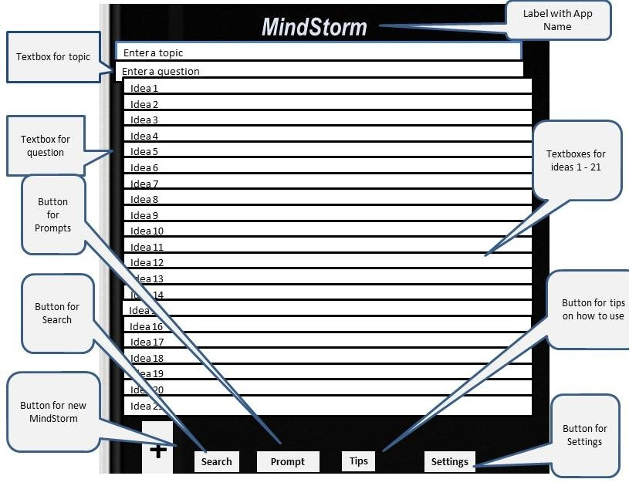

The MindStorm app opens to this screen, which is the main screen for the app. This screen is also accessed when the **+** button is touched.

**Search Screen – accessed from search button**.

Button: Back to navigate to main

+

Search Results

Tips

Prompt

Search Type List Box – Options: all, question, topic, idea.

Search Type

Enter search phrase

Textbox: word or phrase to search for

<MindStorm

**Prompt Screen – accessed from Prompt Button**

In keeping with the MindStorm concept, this screen is a gateway to 21 creativity enhancing strategies and techniques that can be useful in generating new ideas.

Prompt buttons open to a screen with a 1 – 2 paragraph description of the technique selected

<MindStorm

Evidence Frame

ACT As IF you are a genius

3 Mentors

How else could you … ?

Prompt

Tips

+

Backward planning

Let go of your assumptions

Metaphor & Analogy

Use your senses

Previous success

Rephrase the question

Consider the opposite

Chunk Up

Break it into small pieces

SCAMPER

**Prompt Screen part 2 – prompts 15 – 21 accessed by scrolling from Prompt Screen 1**

You

<MindStorm

Prompt buttons open to a screen with a 1 – 2 paragraph description of the technique selected

Difference Frame

What’s important about this?

Where would this be useful or valuable?

5 Why’s

What can you combine this with?

Hack Others Successes

How can you rearrange this?

Prompt

Tips

+

**Tips Screen – accessed from Tips Button at bottom of screen**

In keeping with the spirit of MindStorm tips are available for 21 topic areas.

You

<MindStorm

Achievement

Goals

Tip buttons open to a screen with examples of possible MindStorm questions for the topic area

Problem Solving

Time

Money

Productivity, Efficiency & Effectiveness

Health & Fitness

Tough Decisions

+

Tips

Prompt

Confidence

Learning & Teaching

Motivation

Managing Emotions

Relationships

**Tips Screen part 2**

**Tips 15 – 21 accessed by scrolling from Tips Screen 1**

Tip buttons open to a screen with examples of possible MindStorm questions for the topic area

Prompt

Tips

+

Enthusiasm

Self - Improvement

Changing Habits

Sales & Marketing

Having Fun

Humor

Writing

Deepening Faith

Creativity

<MindStorm

You