MindStorm: Use Cases

**Robert Holzhauser**

**Regis University**

**College of Professional Studies**

**MSSE 650 – iOS Development**

**Background**

Motivational speakers Earl Nightingale and Brian Tracy have advocated the use of a method that both have claimed a significant number of people have used to become millionaires. The method is rather simple, although not necessarily easy. One sits down with something to write with, and at the top of a blank piece of paper writes in question form a goal or problem that they wish to solve. Then one stretches one’s mind in whatever ways he or she can in order to generate a minimum of 21 answers to the question one wrote at the top of the page. Brian Tracy has dubbed this process, “MindStorming,”, and alternately, “The 21 Idea Method.”

The value of implementing the “MindStorm” process once for a single goal or problem is immediately obvious. One walks away from the completion of the exercise with 21 potential solutions. It may not be as obvious that a far greater set of benefits accrue when one makes this a regular practice. If a person were to practice this method every day for 30 days, at the end of the time they would have 630 ideas for how to achieve or solve 30 of their most important goals or problems.

Additionally, after doing this process a few dozen times, one begins to acquire a habit of generating a plethora of possible solutions at the first sign of a problem or opportunity. This is in stark contrast with how the majority of people seem to operate, which could be called having an “idea-deficit”.

**Vision**

The vision of the MindStorm app is twofold: The users will have a handy way of practicing this method. And, equally importantly, users will have a ready catalog of their ideas that they can then also apply to other topics, questions, goals, and problems.

**Use Case Diagram**

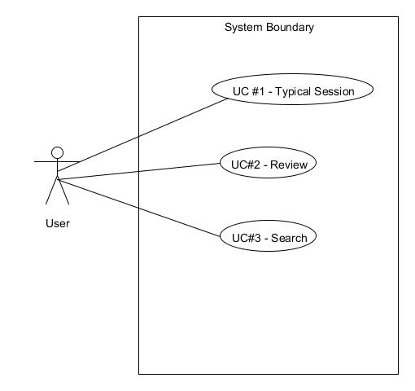

**Use Case List**

**Use Case #1 – Typical Session**

1. User clicks “New MindStorm.”
2. App prompts user for a topic area.
   1. Optionally, the user can click a drop down to see a list of past topic areas.
   2. The user can select a previously used topic area.
3. If the user doesn’t choose previously used topic area, they can free form enter one.
4. The topic area is displayed at the top of the screen.
5. App prompts the user for a goal or problem.
6. User enters a textual description of their goal or problem.
   1. Optionally, the user can click a drop down to see a list of goals and problems used for previous MindStorm sessions.
   2. The user can select a previously used topic or problem.
7. App prompts the user to create an open ended question for how to achieve their goal or solve their problem.
   1. If desired, the user can click on “tips” to get suggested ways of phrasing their question.
8. User enters a list of at least 21 ideas.
   1. As needed, or requested the App will prompt the user with motivational quotes, encouragement, questions, and suggestions to assist in the idea generation process.
   2. As desired, the user is able to click “view previous ideas”, to see lists of previous goals / problems, questions, and ideas, implementation plans, and summary statements that they have previously generated.
9. Once the user reaches 21 ideas they are rewarded with congratulations, audio congratulations, and music.
10. The App asks the user to evaluate the ideas to see if there is one or more the ideas that they would like to implement.
11. If so, the user selects the idea(s) for implementation.
12. For each idea selected to be implemented, the user is prompted for a time and place for implementation.
13. The user is prompted to enter a description of how, specifically they might implement the idea.
    1. The user is given the option of a new MindStorm session to explore how to implement.
14. User is prompted to enter a summary statement of what they learned or gained from the session.

**Use Case #2 – Review**

1. User clicks, “Review.”
2. Options are available to review any combination of topic areas, goals and problems, questions, ideas, implementation plans, summary learnings.
3. Content requested is retrieved from the database and displayed.

**Use Case #3 – Search**

1. User clicks, “Search.”
2. App opens a frame where the user can enter search string.
3. User enters text to be searched for.
4. App searches previous topics, problems & goals, questions, ideas, implementation plans, and summary learnings.
5. App returns and displays a list of all items that contain the search string.