Robert Bosch

CST356

Lab 2 Exercise 1

Step 1: Run Hello-World

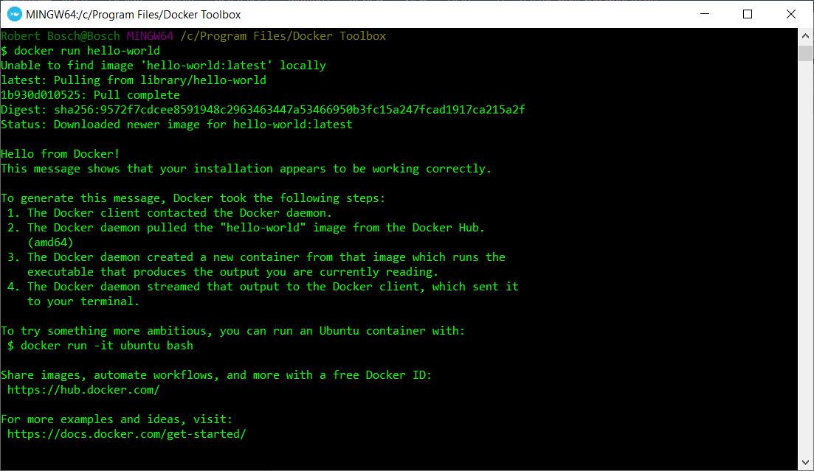

Step 2: Docker Images

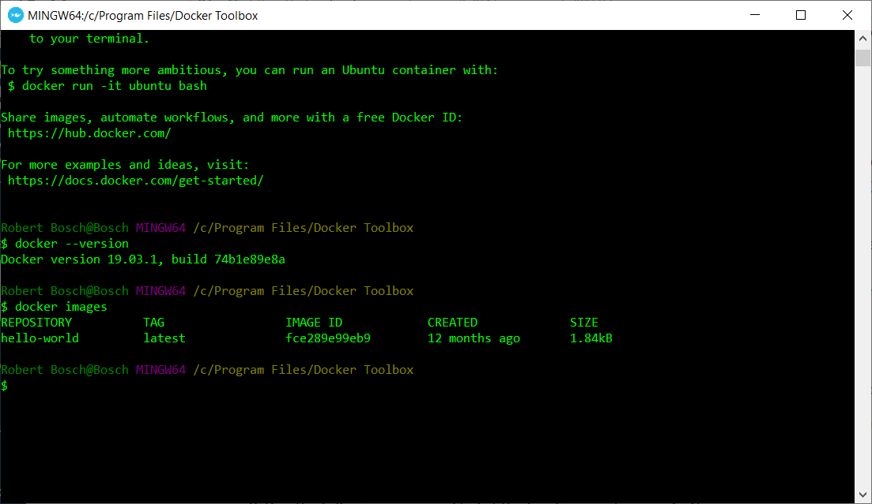

Step 3: docker pa -a

