Robert Bosch

CST356

Lab 2 Exercise 2

1.

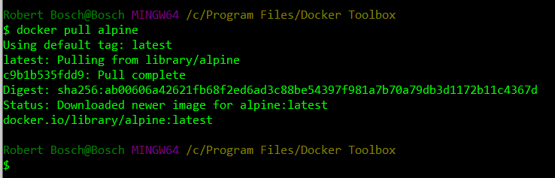

2.

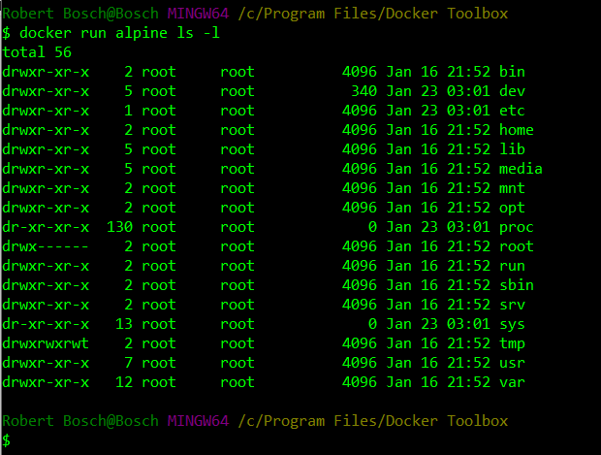

3.

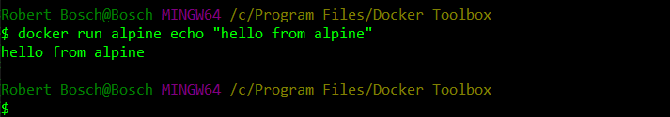

4.

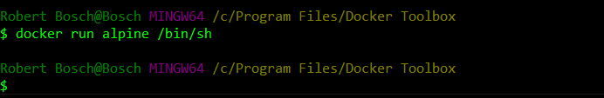

5 , 6, 7.

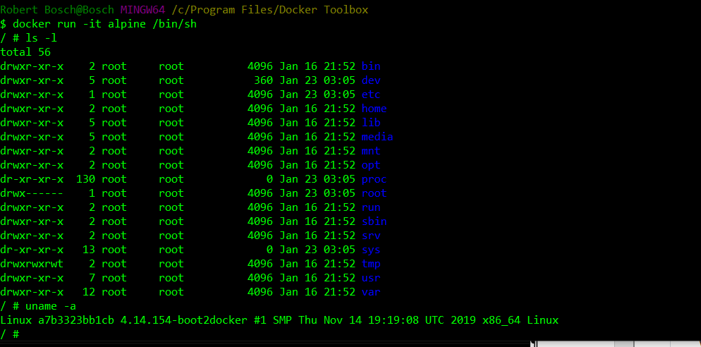

8.

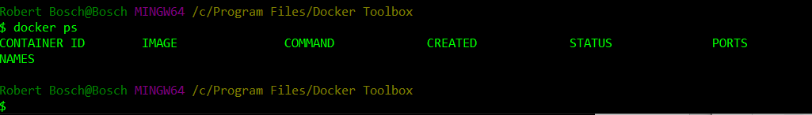

9.

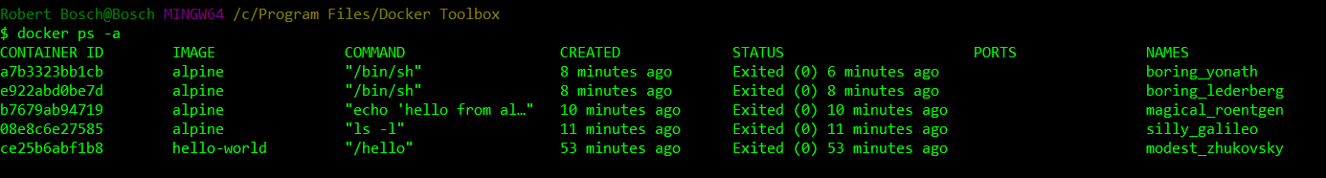

SEE 5, 6, AND 7 FOR OUTPUT OF “docker run -it alpine /bin/sh” WITH COMMANDS ENTERED