Robert Bosch

CST356

Lab 2 Exercise 3

1.

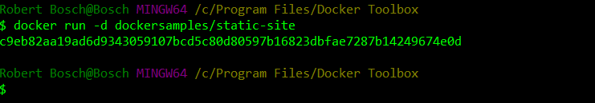

2.

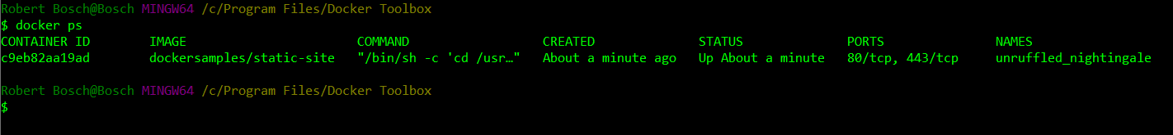

3.

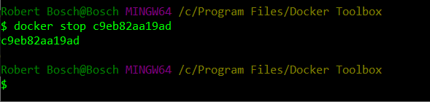

4.

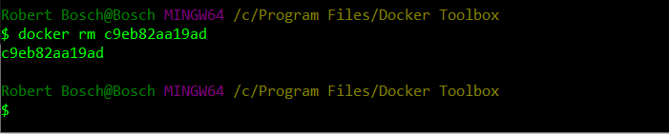

5.

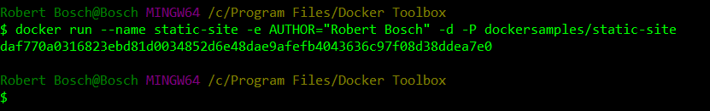

6.

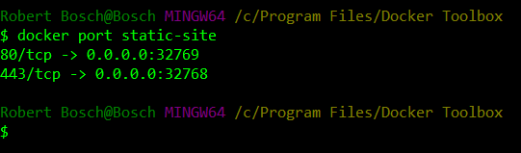

7.

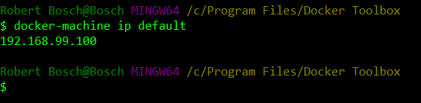

8.

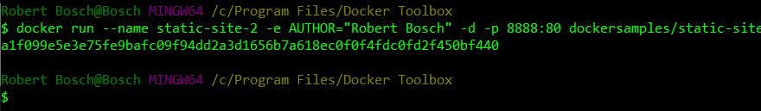

9.

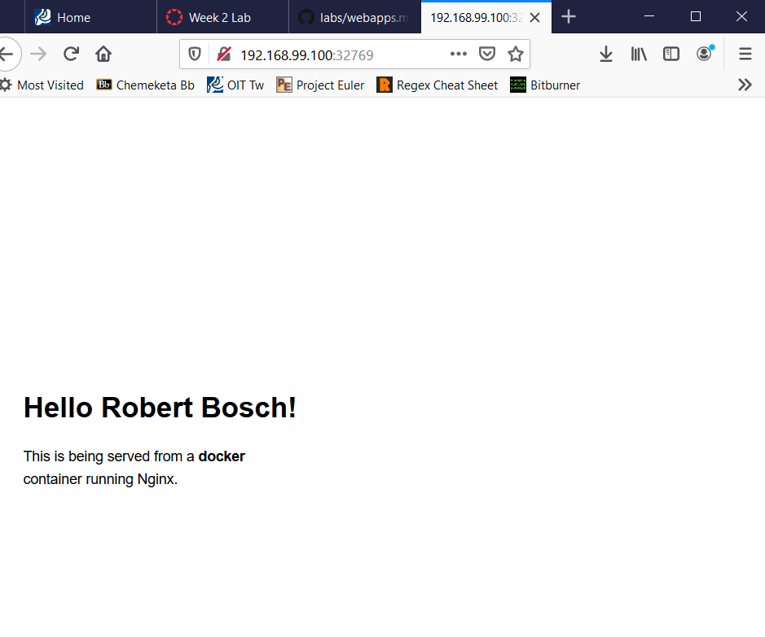

10.

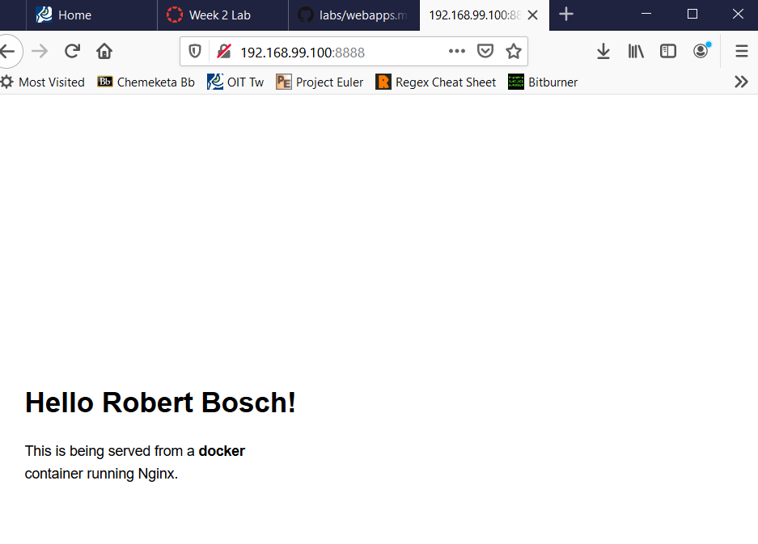

11.

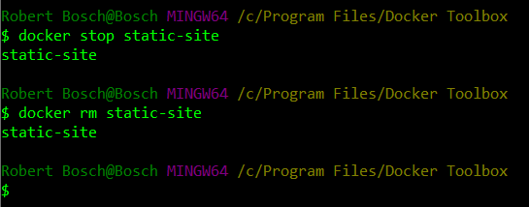

12.

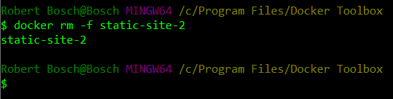

13.

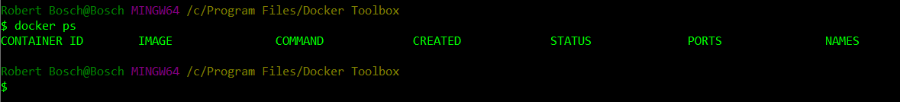

14.

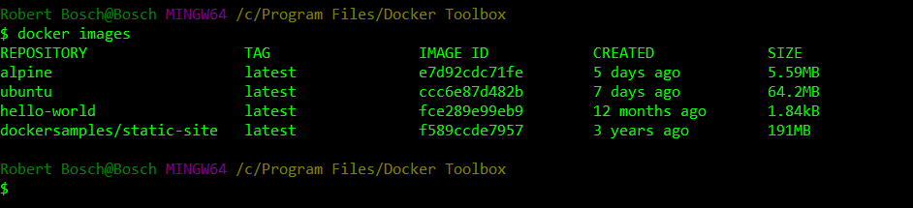

15.

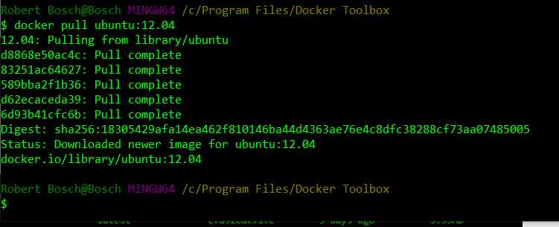

16.

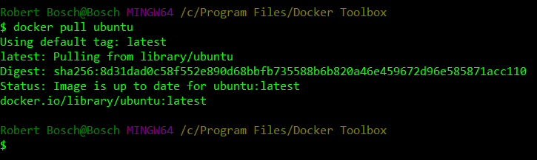

17.

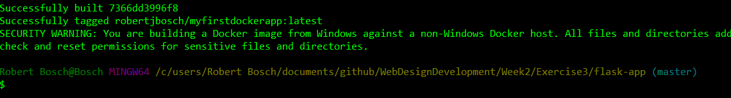

18.



19.

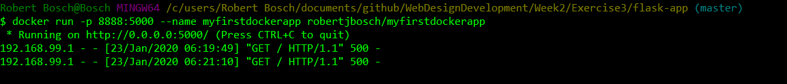

For some reason the webpage refused to load. I continuously got an “Internal Server Error” message even after completely re-making the flask-app. However, I do show that a connection attempt was made, showing that the container *was* running.

