Robert Bosch

Week 6 lab screenshots

C# local host Instructor:

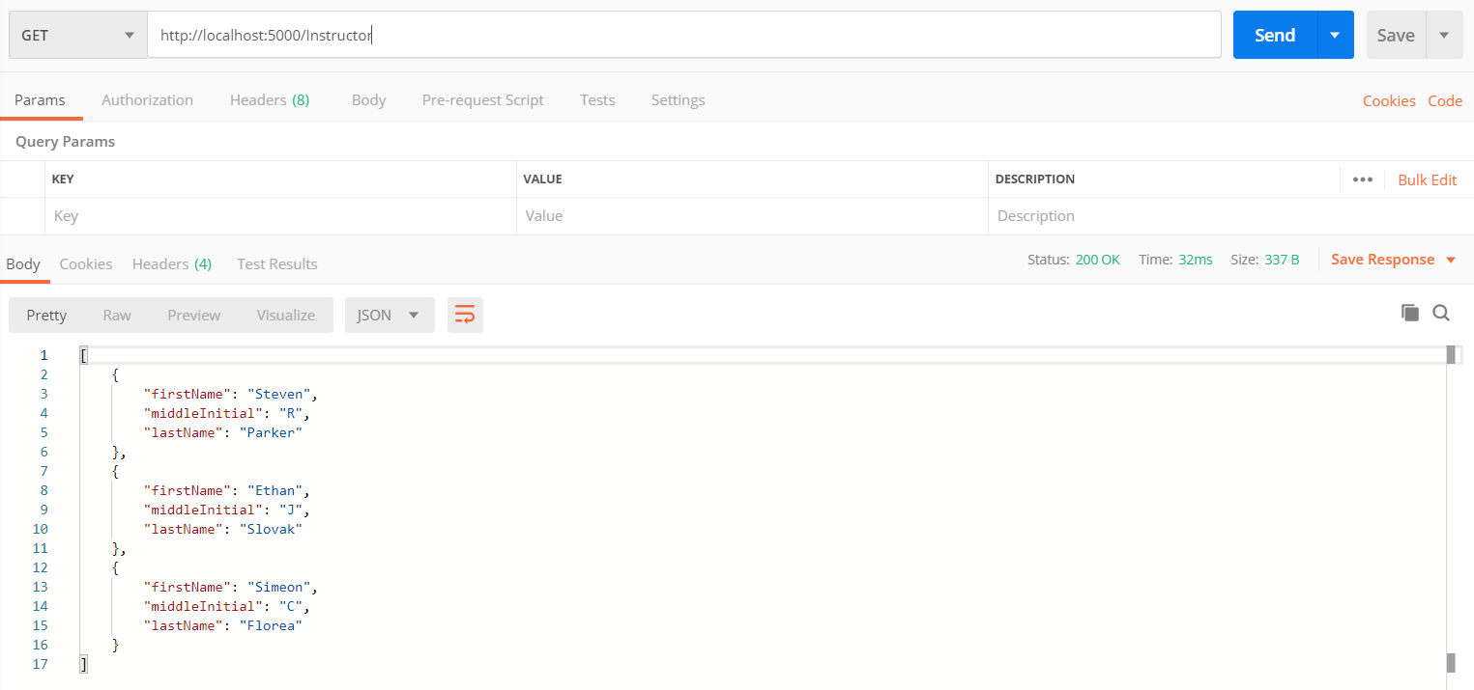

C# local host Student:

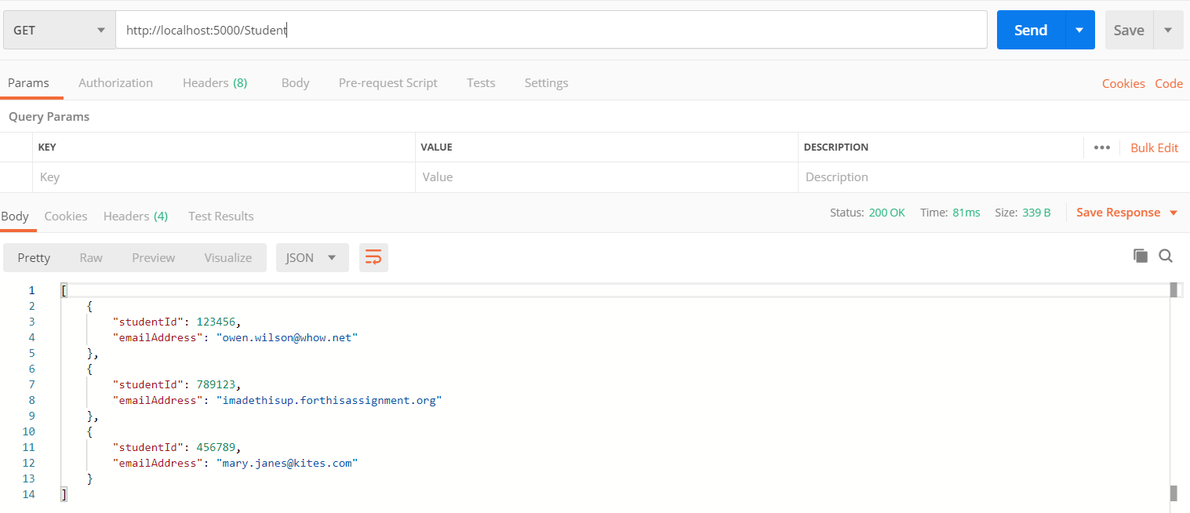

Sadly, Docker refused to run on my machine so I was unable to get those screenshots. It will probably work on your machine like the cat gifs assignment did

An attempt at using both listed ports to check if that was the problem

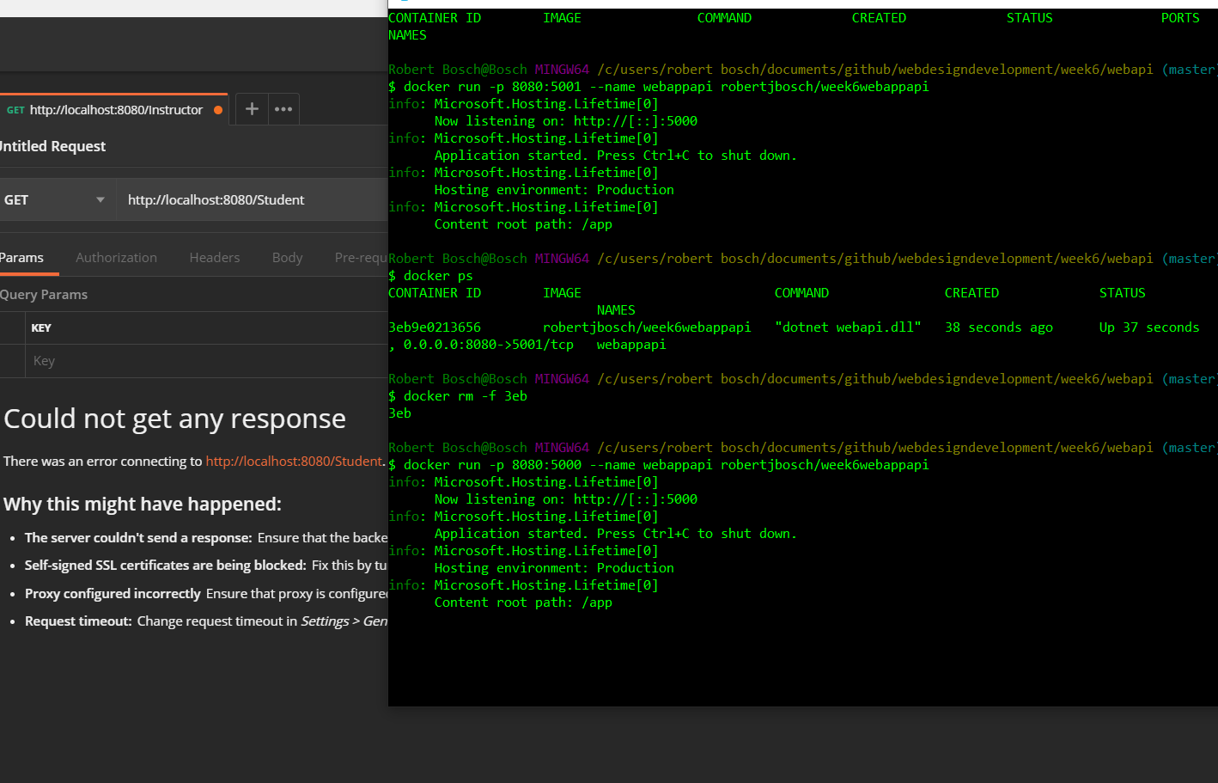

Verification that I do not have SSL verification turned on

