


Cork Institute of Technology

Prize for Innovation

Business Plan Template
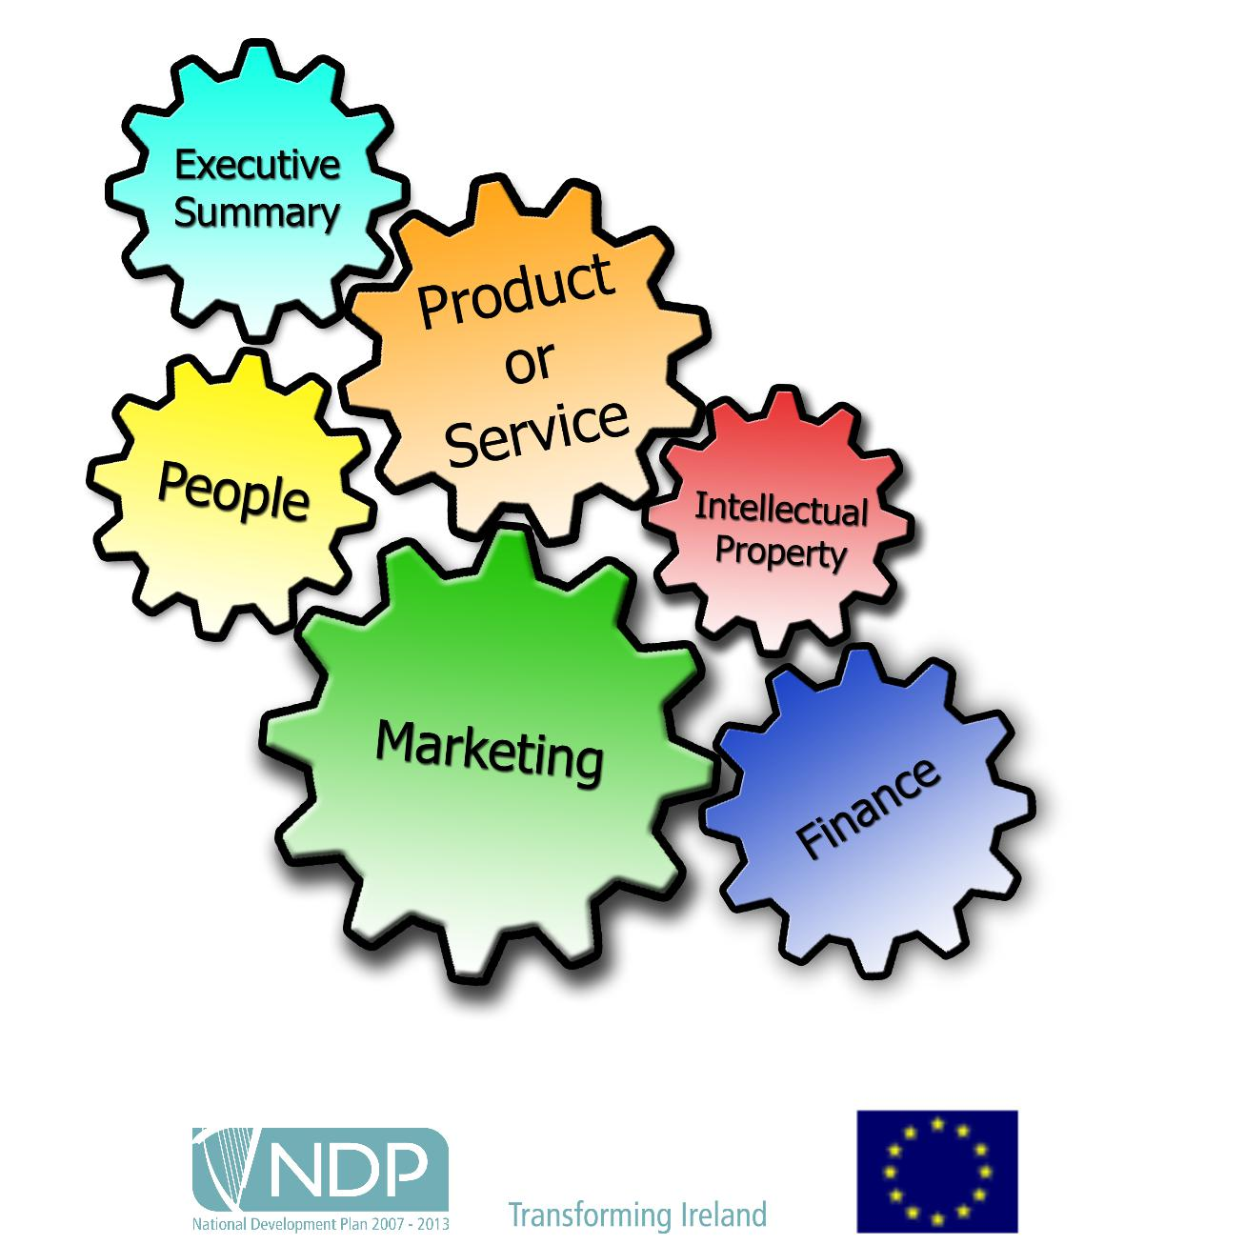

Funded by the Irish Government and part-financed by the European Union under the National Development Plan 2007-2013
(NOTE: Business plan maximum of 12 pages excluding Appendices)

Promoter Details

Name 1 & Team Lead:

Faculty & Year (please state if postgraduate student)

Please state if Part-time or Full-time student Telephone:

Email:

(Please continue for each member of the team)

1

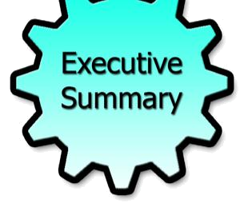
Section 1 - Executive Summary

(Maximum 1 Page)

(The objective of the executive summary is to summarise the main points of your business plan to potential investors to attract their attention and encourage them to read on. This section should aim to answer the potential investors’ basic questions.)

Main points to include:

- What does the company do?

- Describe your value creation pitch to potential investors in no more than 50 words

- Outline any progress made to date

- Brief outline of company structure

- Outline turnover and profit for the first year in business

- Outline the Investment required

2


Section 2 - Product or service

Clearly describe what your business does now and in the future.

Product or service

(What is the company proposing to do and what problem does it solve? Can you describe the products/services it will offer?)

Value Proposition

(How does your product/service give value to your customer or how does it help your customer make money or save money)

Unique Selling Point

(Describe the unique element of your business, how this is different to what is currently available on the market or how does it improve a current product)

Future plans

(Are there plans to develop the product(s) or service(s), or add new product(s) or service(s), in the future? How advanced is the project idea/business? How much work is required to take the project to the next stage?

3


Section 3 - Intellectual Property

Have you legally protected your Product/Service to date? Yes / No

If yes please describe:

Are you aware of any other Patents, trademarks or copyright issues with your product? If so describe

(Please note that this is not a requirement for rules of entry. The panel just need to ascertain that this is your team’s original idea)


Section 4 – People

Company Management Structure

What is the potential for employment in Ireland in this company?

4


Section 5 - Marketing

Market research

(Describe how the market research was carried out and give examples. Describe the market size and number of possible customers)

Market trends or issues

(Describe any trends or key issues or anticipated in the market that may affect the market place)

Customers (who are your customers?)

(How do you know they are interested in your products and their spending behaviours? What are the needs/wants of the customers? What is your unique selling point?

5

Competitors

(Who are the competitors and what are their strengths and weaknesses?)

 |  | Competitor |  |  | Strengths |  | Weaknesses
 |  | Competitor 1 |  |  | • |  | •
 |  | Competitor 2 |  |  | • |  | •
 |  | Competitor 3 |  |  | • |  | •

Promotion

(Use the table below to provide details of the promotional plan)

 | Promotional |  | How | When |  | Cost €
 | method
 |  |  |  |  |  | Total

6

Place/channels of distribution

(Describe how you are going to effectively sell product and your Routes to market for example Transportation & logistics, storage etc.)

Is there evidence of a real international business opportunity?

7

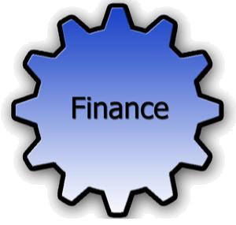
Section 6 - Finance

Pricing

(Detail price make up for product or service)

Sales

(Provide the monthly sales projections for the first 12 months of business trading.)

 | Month |  | 1 |  | 2 |  | 3 |  | 4 |  | 5 |  | 6
 | Sales €
 | Month |  | 7 |  | 8 |  | 9 |  | 10 |  | 11 |  | 12 |  |  | Total
 | Sales €

Sales assumptions

(Provide details of the sales assumptions)

Exports –

What is the potential for export sales?

Funding

(Provide details of how the business will be funded)
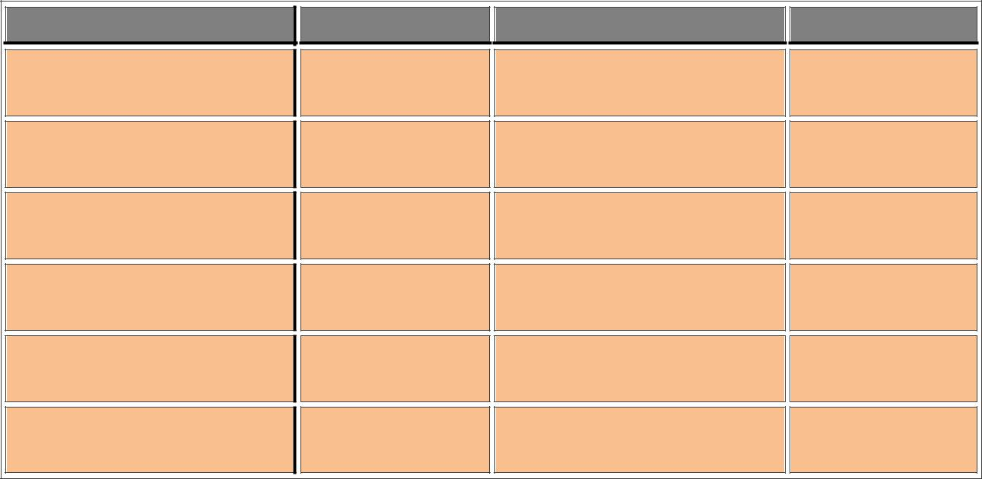
Project Costs | € | Sources of Funding | €

Promoter

Family/Friends

Banks

Venture Capitalists

Other:

8

Capital costs

 | Capital items |  | Value€ |  | Capital items |  | Value€
 | owned |  |  |  | required
 | Equipment/tools |  |  |  | Equipment/tools
 | Fixtures & fittings |  |  |  | Fixtures & fittings
 | Vehicle |  |  |  | Vehicle
 | Security & safety |  |  |  | Security & safety
 | ICT |  |  |  | ICT
 | Office Furniture |  |  |  | Office Furniture
 | Total |  |  |  | Total

Fixed costs
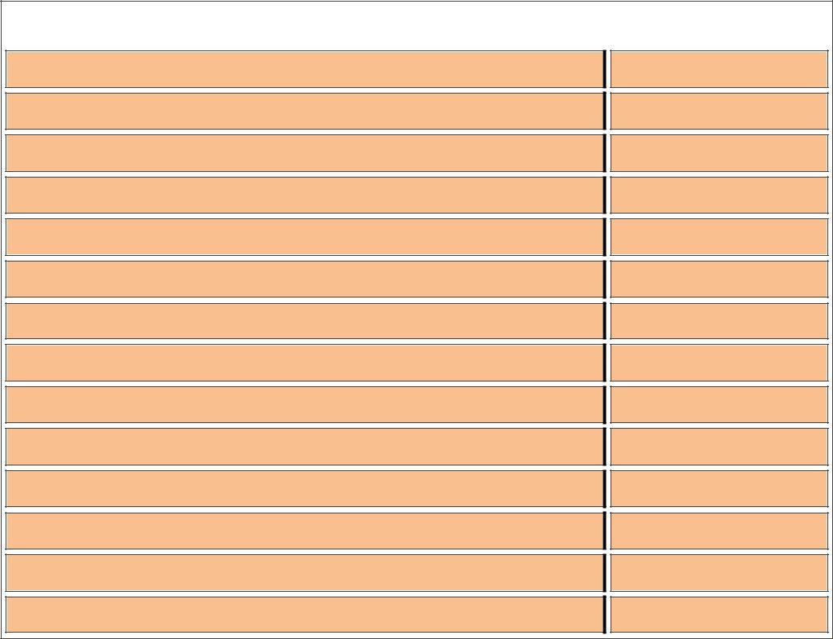
Fixed costs |  | €

Rent & rates

Heat & power

Tel & internet

Vehicle expenses

Advertising & promotion

Office supplies and postage

Sundries

Accountancy & legal

Insurance

Sundries

Staff costs

Finance charges

Other __________

Total

Variable costs
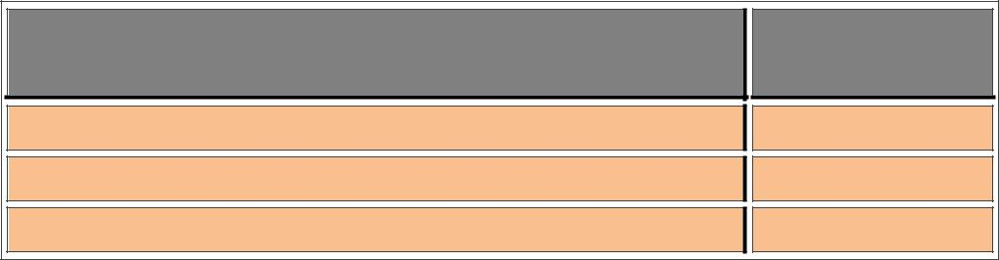

Variable costs e.g. stock, materials

Costs per annum €

Insert type of variable cost
Insert type of variable cost
Total variable costs | €

9

