Proiect Sisteme de Gestiune a Bazelor de Date

Roșianu Robert – Grupa 233

1. Proiectul prezinta o baza de date folosita pentru administrarea unei afaceri ce se ocupa cu vanzarea benzilor desenate. Avem mai multe magazine unde se vand diverse reviste (vandute de anumiti angajati avand diverse joburi). Aceste reviste fac parte dintr-un top (nu este obligatoriu), au cate un comparator si primesc sau nu un review in functie de cat de bun este continutul revistei respective. Baza noastra de date ofera operatii ce ajuta la mentinerea informatiilor cat si la mentenanta acesteia.
2. Diagrama Entitate-Relatie:

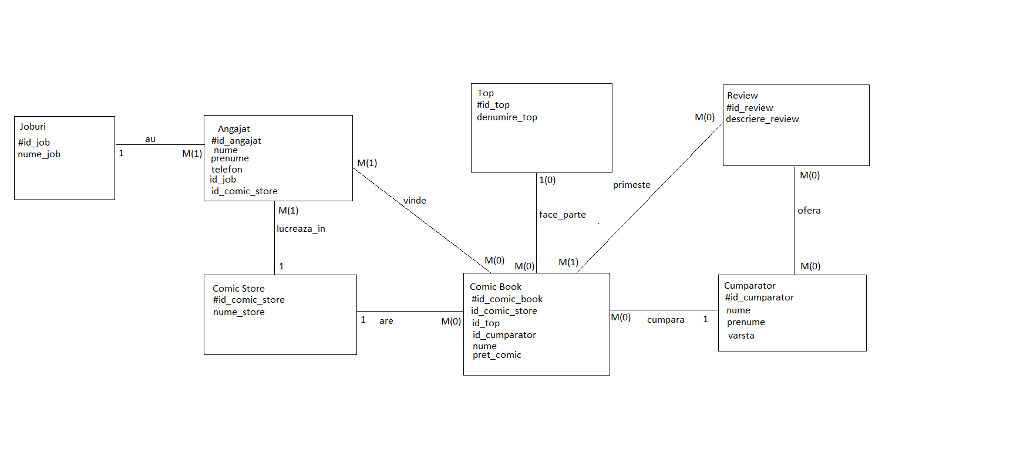

1. Diagrama Conceptuala:

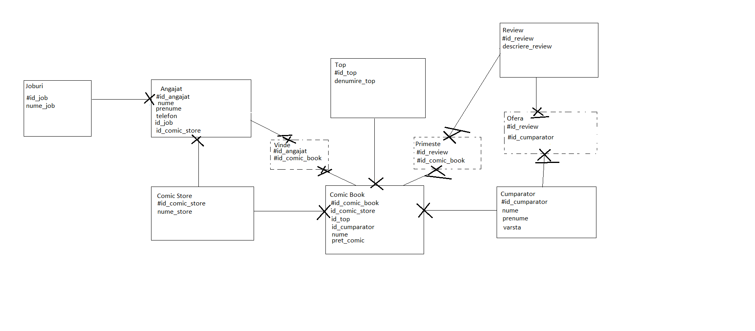

1. Tabele:

create table Joburi(

id_job number(4) primary key,

nume_job varchar2(10) not null

);

create table ComicStore(

id_comic_store number(4) primary key,

nume_store varchar2(15) not null

);

create table Top(

id_top number(4) primary key,

denumire_top varchar2(20) not null

);

create table Cumparator(

id_cumparator number(4) primary key,

nume varchar2(12) not null,

prenume varchar2(12) not null,

varsta number(4) not null

);

create table Review(

id_review number(4) primary key,

descriere_review varchar2(30) not null

);

create table ComicBook(

id_comic_book number(4) primary key,

id_comic_store number(4) references ComicStore(id_comic_store) on delete cascade,

id_top number(4) references Top(id_top) on delete cascade,

id_cumparator number(4) references Cumparator(id_cumparator) on delete cascade,

nume varchar2(20) not null,

pret number(4) not null

);

create table Angajat(

id_angajat number(4) primary key,

id_job number(4) references Joburi(id_job) on delete cascade,

id_comic_store number(4) references ComicStore(id_comic_store) on delete cascade,

nume varchar2(10) not null,

prenume varchar2(10) not null,

telefon number(11) not null unique

);

create table Vinde(

id_angajat number(4),

id_comic_book number(4),

primary key(id_angajat, id_comic_book),

foreign key(id_angajat) references Angajat(id_angajat) on delete cascade,

foreign key(id_comic_book) references ComicBook(id_comic_book) on delete cascade

);

create table Primeste(

id_review number(4),

id_comic_book number(4),

primary key(id_review, id_comic_book),

foreign key(id_review) references Review(id_review) on delete cascade,

foreign key(id_comic_book) references ComicBook(id_comic_book) on delete cascade

);

create table Ofera(

id_review number(4),

id_cumparator number(4),

primary key(id_review, id_cumparator),

foreign key(id_review) references Review(id_review) on delete cascade,

foreign key(id_cumparator) references Cumparator(id_cumparator) on delete cascade

);

1. Inserare in tabele:

create sequence angajati

start with 1

nocycle;

create sequence jobs

start with 1

nocycle;

create sequence comics

start with 1

nocycle;

create sequence comic_store

start with 1

nocycle;

create sequence tops

start with 1

nocycle;

create sequence cumparatori

start with 1

nocycle;

create sequence reviews

start with 1

nocycle;

insert into Joburi(id_job, nume_job)

values(jobs.nextval, 'Vanzator');

insert into Joburi(id_job, nume_job)

values(jobs.nextval, 'Manager');

insert into Joburi(id_job, nume_job)

values(jobs.nextval, 'Asistent');

insert into Joburi(id_job, nume_job)

values(jobs.nextval, 'Patron');

insert into Joburi(id_job, nume_job)

values(jobs.nextval, 'Curatator');

insert into Joburi(id_job, nume_job)

values(jobs.nextval, 'Investitor');

insert into Joburi(id_job, nume_job)

values(jobs.nextval, 'Asistent');

insert into ComicStore(id_comic_store, nume_store)

values (comic_store.nextval, 'Best Books');

insert into ComicStore(id_comic_store, nume_store)

values (comic_store.nextval, 'Hentai Heaven');

insert into ComicStore(id_comic_store, nume_store)

values (comic_store.nextval, 'Top Comics');

insert into ComicStore(id_comic_store, nume_store)

values (comic_store.nextval, 'Last Avengers');

insert into ComicStore(id_comic_store, nume_store)

values (comic_store.nextval, 'Downtown Comics');

insert into ComicStore(id_comic_store, nume_store)

values (comic_store.nextval, 'New Order Shop');

insert into ComicStore(id_comic_store, nume_store)

values (comic_store.nextval, 'Stranger Shop');

insert into ComicStore(id_comic_store, nume_store)

values (comic_store.nextval, 'Big Offer');

insert into ComicStore(id_comic_store, nume_store)

values (comic_store.nextval, 'New Nw');

insert into Angajat(id_angajat, id_job, id_comic_store, nume, prenume, telefon)

values (angajati.nextval,1,1, 'Ciocan', 'Madalin', 40763312934);

insert into Angajat(id_angajat, id_job, id_comic_store, nume, prenume, telefon)

values (angajati.nextval,2,1, 'Silviu', 'Lungu', 40763312314);

insert into Angajat(id_angajat, id_job, id_comic_store, nume, prenume, telefon)

values (angajati.nextval,3,1, 'Matea', 'Marian', 40762345674);

insert into Angajat(id_angajat, id_job, id_comic_store, nume, prenume, telefon)

values (angajati.nextval,4,2, 'Liviu', 'Sandu', 40743212934);

insert into Angajat(id_angajat, id_job, id_comic_store, nume, prenume, telefon)

values (angajati.nextval,5,2, 'Spataru', 'Sulean', 40743444934);

insert into Angajat(id_angajat, id_job, id_comic_store, nume, prenume, telefon)

values (angajati.nextval,1,2, 'Coltea', 'Spitalu', 40733312934);

insert into Angajat(id_angajat, id_job, id_comic_store, nume, prenume, telefon)

values (angajati.nextval,3,2, 'Cosmina', 'Ciortea', 40743299934);

insert into Angajat(id_angajat, id_job, id_comic_store, nume, prenume, telefon)

values (angajati.nextval,2,2, 'Sandu', 'Ciorba', 40712312734);

insert into Angajat(id_angajat, id_job, id_comic_store, nume, prenume, telefon)

values (angajati.nextval,5,1, 'Florin', 'Florin', 40743123454);

insert into Angajat(id_angajat, id_job, id_comic_store, nume, prenume, telefon)

values (angajati.nextval,4,1, 'Florin', 'Dinu', 40746754454);

insert into Angajat(id_angajat, id_job, id_comic_store, nume, prenume, telefon)

values (angajati.nextval,2,3, 'Martinel', 'Lungu', 40743555554);

insert into Angajat(id_angajat, id_job, id_comic_store, nume, prenume, telefon)

values (angajati.nextval,1,3, 'Guta', 'Nicolae', 40711123454);

insert into Angajat(id_angajat, id_job, id_comic_store, nume, prenume, telefon)

values (angajati.nextval,4,3, 'Trinu', 'Minu', 40743187874);

insert into Angajat(id_angajat, id_job, id_comic_store, nume, prenume, telefon)

values (angajati.nextval,5,4, 'Legion', 'Seven', 40741212654);

insert into Angajat(id_angajat, id_job, id_comic_store, nume, prenume, telefon)

values (angajati.nextval,2,4, 'Cultan', 'Oirr', 40755123552);

insert into Angajat(id_angajat, id_job, id_comic_store, nume, prenume, telefon)

values (angajati.nextval,1,4, 'Petrica', 'Simion', 40743666884);

insert into Angajat(id_angajat, id_job, id_comic_store, nume, prenume, telefon)

values (angajati.nextval,5,4, 'Minuc', 'Sad', 40724561834);

insert into Angajat(id_angajat, id_job, id_comic_store, nume, prenume, telefon)

values (angajati.nextval,1,5, 'Sidan', 'Pisan', 40215384912);

insert into Angajat(id_angajat, id_job, id_comic_store, nume, prenume, telefon)

values (angajati.nextval,2,5, 'Lionel', 'Messi', 40724444434);

insert into Angajat(id_angajat, id_job, id_comic_store, nume, prenume, telefon)

values (angajati.nextval,1,5, 'Cristiano', 'Ronaldo', 40724656224);

insert into Angajat(id_angajat, id_job, id_comic_store, nume, prenume, telefon)

values (angajati.nextval,5,5, 'Vecinu', 'Debloc', 40712361994);

insert into Angajat(id_angajat, id_job, id_comic_store, nume, prenume, telefon)

values (angajati.nextval,2,6, 'Ghioc', 'David', 40721122334);

insert into Angajat(id_angajat, id_job, id_comic_store, nume, prenume, telefon)

values (angajati.nextval,1,6, 'Flesa', 'Manar', 40754222811);

insert into Angajat(id_angajat, id_job, id_comic_store, nume, prenume, telefon)

values (angajati.nextval,3,6, 'Tarnaveanu', 'Sorin', 40724141794);

insert into Angajat(id_angajat, id_job, id_comic_store, nume, prenume, telefon)

values (angajati.nextval,4,6, 'Scovearca', 'Ramus', 40214563151);

insert into Angajat(id_angajat, id_job, id_comic_store, nume, prenume, telefon)

values (angajati.nextval,4,6, 'Sive', 'Relu', 40214999951);

insert into Angajat(id_angajat, id_job, id_comic_store, nume, prenume, telefon)

values (angajati.nextval,2,7, 'Svde', 'Rreu', 40223561711);

insert into Angajat(id_angajat, id_job, id_comic_store, nume, prenume, telefon)

values (angajati.nextval,1,1, 'SIle', 'Kamat', 40224441219);

insert into Angajat(id_angajat, id_job, id_comic_store, nume, prenume, telefon)

values (angajati.nextval,1,8, 'Ye', 'Kanye', 40234143297);

insert into Top(id_top, denumire_top)

values (tops.nextval,'Best Romance');

insert into Top(id_top, denumire_top)

values (tops.nextval,'Best Overall');

insert into Top(id_top, denumire_top)

values (tops.nextval,'Best Action');

insert into Top(id_top, denumire_top)

values (tops.nextval,'Most Recommended');

insert into Top(id_top, denumire_top)

values (tops.nextval,'Funniest');

insert into Review(id_review, descriere_review)

values (reviews.nextval, 'Foarte Faina');

insert into Review(id_review, descriere_review)

values (reviews.nextval, 'Buna');

insert into Review(id_review, descriere_review)

values (reviews.nextval, 'Mediocra');

insert into Review(id_review, descriere_review)

values (reviews.nextval, 'Slaba');

insert into Review(id_review, descriere_review)

values (reviews.nextval, 'Groaznica');

insert into Review(id_review, descriere_review)

values (reviews.nextval, 'Printre cele mai bune');

insert into Review(id_review, descriere_review)

values (reviews.nextval, 'Printre cele mai rele');

insert into Review(id_review, descriere_review)

values (reviews.nextval, 'Foarte Unica');

insert into Review(id_review, descriere_review)

values (reviews.nextval, 'Design Slab');

insert into Review(id_review, descriere_review)

values (reviews.nextval, 'Animatie buna');

insert into Cumparator(id_cumparator, nume, prenume, varsta)

values (cumparatori.nextval, 'Ghinea', 'Silviu', 23);

insert into Cumparator(id_cumparator, nume, prenume, varsta)

values (cumparatori.nextval, 'Florica', 'Nwo', 24);

insert into Cumparator(id_cumparator, nume, prenume, varsta)

values (cumparatori.nextval, 'Tataee', 'Bug', 43);

insert into Cumparator(id_cumparator, nume, prenume, varsta)

values (cumparatori.nextval, 'Maresalu', 'Antonio', 29);

insert into Cumparator(id_cumparator, nume, prenume, varsta)

values (cumparatori.nextval, 'Pican', 'Antonio', 31);

insert into Cumparator(id_cumparator, nume, prenume, varsta)

values (cumparatori.nextval, 'Goku', 'Saiyan', 42);

insert into ComicBook(id_comic_book, id_comic_store, id_top, id_cumparator, nume, pret)

values (comics.nextval, 1, 1, 2, 'Genshin Impact', 20);

insert into ComicBook(id_comic_book, id_comic_store, id_top, id_cumparator, nume, pret)

values (comics.nextval, 1, 3, 2, 'Big Adventure', 25);

insert into ComicBook(id_comic_book, id_comic_store, id_top, id_cumparator, nume, pret)

values (comics.nextval, 2, null, 3, 'Re:Zero', 18);

insert into ComicBook(id_comic_book, id_comic_store, id_top, id_cumparator, nume, pret)

values (comics.nextval, 2, null, 1, 'Horimiya', 22);

insert into ComicBook(id_comic_book, id_comic_store, id_top, id_cumparator, nume, pret)

values (comics.nextval, 3, 2, 3, 'Ian si Azteca', 29);

insert into ComicBook(id_comic_book, id_comic_store, id_top, id_cumparator, nume, pret)

values (comics.nextval, 5, null, 4, 'Dragon Ball Z', 26);

insert into ComicBook(id_comic_book, id_comic_store, id_top, id_cumparator, nume, pret)

values (comics.nextval, 2, 4, 5, 'Last Airbender', 21);

insert into ComicBook(id_comic_book, id_comic_store, id_top, id_cumparator, nume, pret)

values (comics.nextval, 5, 5, 6, 'Worst Date', 31);

insert into ComicBook(id_comic_book, id_comic_store, id_top, id_cumparator, nume, pret)

values (comics.nextval, 5, null, 4, 'Best Date', 31);

insert into ComicBook(id_comic_book, id_comic_store, id_top, id_cumparator, nume, pret)

values (comics.nextval, 4, null, 3, 'Worst Date', 37);

insert into ComicBook(id_comic_book, id_comic_store, id_top, id_cumparator, nume, pret)

values (comics.nextval, 7, null, 3, 'New Stuff', 33);

insert into ComicBook(id_comic_book, id_comic_store, id_top, id_cumparator, nume, pret)

values (comics.nextval, 8, null, null, 'AA problems', 42);

insert into Vinde(id_angajat, id_comic_book)

values(1,3);

insert into Vinde(id_angajat, id_comic_book)

values(2,4);

insert into Vinde(id_angajat, id_comic_book)

values(1,5);

insert into Vinde(id_angajat, id_comic_book)

values(1,1);

insert into Vinde(id_angajat, id_comic_book)

values(2,6);

insert into Vinde(id_angajat, id_comic_book)

values(3,3);

insert into Vinde(id_angajat, id_comic_book)

values(3,6);

insert into Vinde(id_angajat, id_comic_book)

values(4,1);

insert into Vinde(id_angajat, id_comic_book)

values(5,8);

insert into Vinde(id_angajat, id_comic_book)

values(22,5);

insert into Primeste(id_review,id_comic_book)

values(1,1);

insert into Primeste(id_review,id_comic_book)

values(2,2);

insert into Primeste(id_review,id_comic_book)

values(3,4);

insert into Primeste(id_review,id_comic_book)

values(4,6);

insert into Primeste(id_review,id_comic_book)

values(5,8);

insert into Primeste(id_review,id_comic_book)

values(6,9);

insert into Primeste(id_review,id_comic_book)

values(7,10);

insert into Primeste(id_review,id_comic_book)

values(8,3);

insert into Primeste(id_review,id_comic_book)

values(9,5);

insert into Primeste(id_review,id_comic_book)

values(10,7);

insert into Ofera(id_review, id_cumparator)

values(2,5);

insert into Ofera(id_review, id_cumparator)

values(1,4);

insert into Ofera(id_review, id_cumparator)

values(3,1);

insert into Ofera(id_review, id_cumparator)

values(4,2);

insert into Ofera(id_review, id_cumparator)

values(10,3);

insert into Ofera(id_review, id_cumparator)

values(9,6);

insert into Ofera(id_review, id_cumparator)

values(5,3);

insert into Ofera(id_review, id_cumparator)

values(6,3);

insert into Ofera(id_review, id_cumparator)

values(7,3);

insert into Ofera(id_review, id_cumparator)

values(9,4);

Tabelul Angajat:

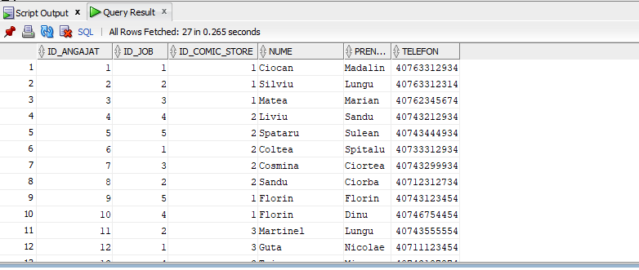

Tabelul Joburi:

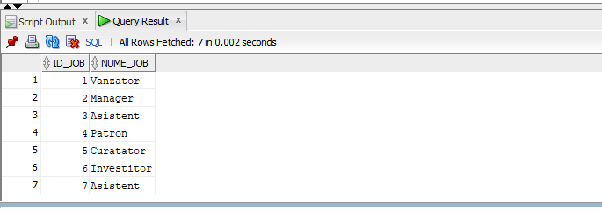

Tabelul ComicStore:

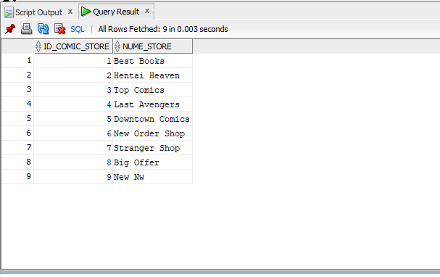

Tabelul ComicBook:

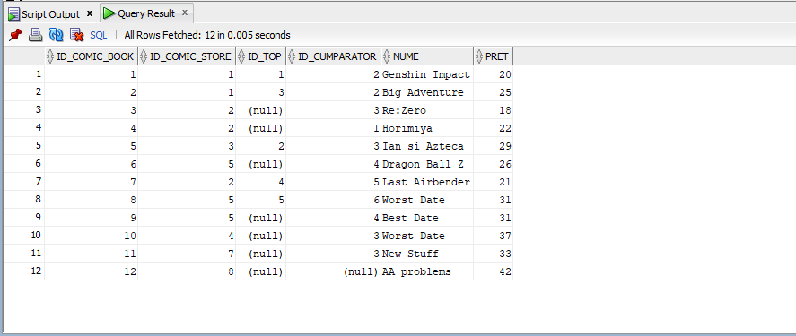

Tabelul Top:

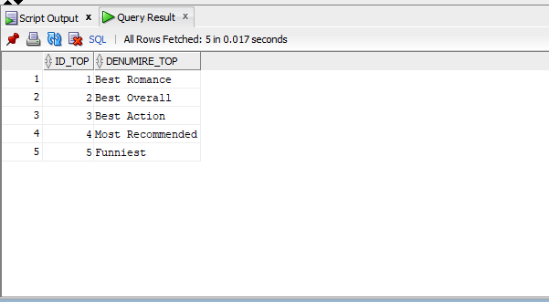

Tabelul Cumparator:

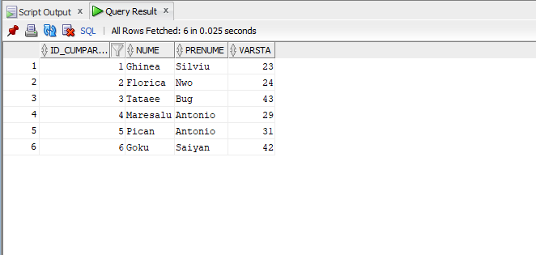

Tabelul Review:

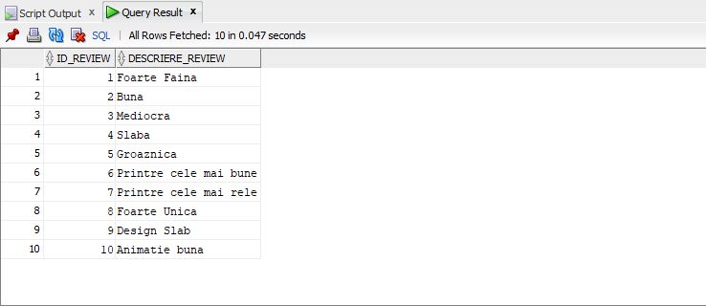

Tabelul Vinde:

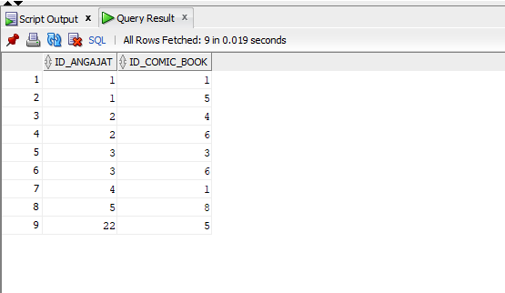

Tabelul Primeste:

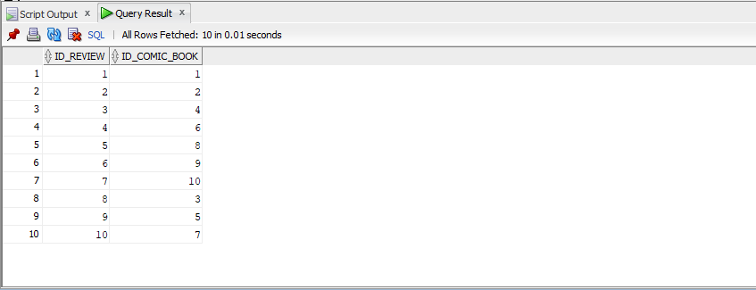

Tabelul Ofera:

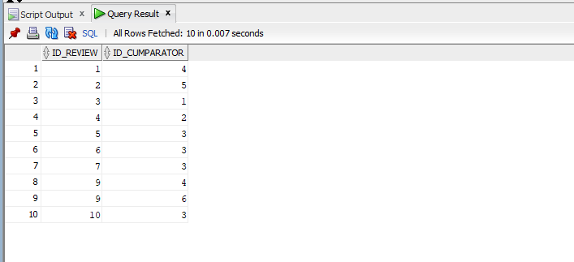

Exercitiul 6:

--6 Aflati toti angajatii din magazine si codul acestor magazine

create or replace procedure ang_si_magazine

as

type vector is varray(50) of ComicStore.id_comic_store%type;

type vector_2 is varray(50) of Angajat.nume%type;

type table_1 is table of vector_2 index by pls_integer;

cstore vector := vector();

cangajat table_1;

chk number(1) := 0;

begin

select id_comic_store

bulk collect into cstore

from ComicStore;

if cstore.count < 3 then

RAISE_APPLICATION_ERROR(-20099, 'Prea putine magazine!');

end if;

for i in 1..cstore.count loop

select nume

bulk collect into cangajat(i)

from Angajat

join ComicStore on Angajat.id_comic_store = ComicStore.id_comic_store

where ComicStore.id_comic_store = cstore(i);

dbms_output.put_line('Id-ul magazinului:' || cstore(i));

for j in 1..cangajat(i).count loop

dbms_output.put_line(cangajat(i)(j));

end loop;

end loop;

end ang_si_magazine;

/

--Test:

execute ang_si_magazine;

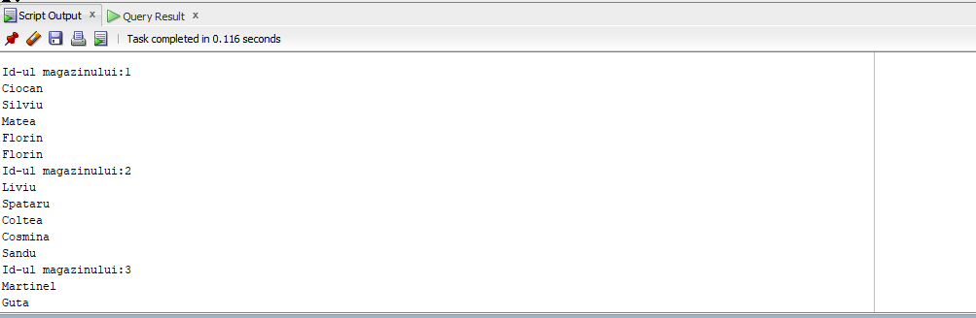

Eroare atunci cand nu avem suficiente magazine:

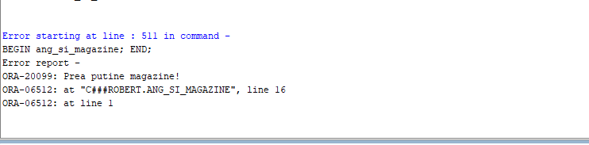

Exercitiul 7:

--7.Afisati numele tuturor revistelor avute cat si revistele ce contin in nume un anumit cuvant --dat si care au pretul mai mare decat un pret dat.

create or replace procedure comics_ex(p_cod comicbook.pret%type, p_cuvant in varchar2)

as

cursor cursor1 is

select * from ComicBook;

cursor cursor2 (v_pret comicbook.pret%type, v_cuvant_cheie varchar2) is

select * from comicbook

where pret > v_pret

and nume like '%' || v_cuvant_cheie || '%';

comic comicbook%rowtype;

begin

dbms_output.put_line('Toate revistele sunt: ');

open cursor1;

loop

fetch cursor1 into comic;

exit when cursor1%notfound;

dbms_output.put_line('Numele: ' || comic.nume);

end loop;

close cursor1;

dbms_output.put_line('Revistele cautate dupa nume si pret sunt: ');

open cursor2(p_cod,p_cuvant);

loop

fetch cursor2 into comic;

exit when cursor2%notfound;

dbms_output.put_line('Pretul este: ' || comic.pret || ' si numele este ' || comic.nume);

end loop;

close cursor2;

end comics_ex;

/

--Test:

begin

comics_ex(29,'Date');

end;

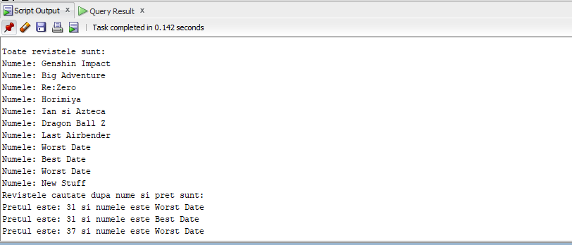

Exercitiul 8:

--8 Pentru un id dat al unei reviste afisati pretul acestei reviste, magazinul in care se afla cat ---si angajatul asociat acesteia

create or replace function reviste(p_id_comic comicbook.id_comic_book%type, lungime number) return number is

v_pret comicbook.pret%type;

v_comic_name comicbook.nume%type;

v_angajat_nume angajat.nume%type;

counter number;

pret_prea_mare exception;

nume_scurt exception;

begin

select cb.pret, cs.nume_store, a.nume

into v_pret, v_comic_name, v_angajat_nume

from comicbook cb

join comicstore cs on cb.id_comic_store=cs.id_comic_store

join angajat a on cs.id_comic_store=a.id_comic_store

where cb.id_comic_book=p_id_comic;

if length(v_angajat_nume) < lungime then

raise nume_scurt;

end if;

if v_pret > 40 then

raise pret_prea_mare;

end if;

dbms_output.put_line('Numele magazinului este: ' || v_comic_name);

dbms_output.put_line('Numele angajatului asociat este: ' || v_angajat_nume);

dbms_output.put_line('Pretul pentru comic bookul cu id ul: ' || p_id_comic || ' este: ');

return v_pret;

exception

when NO_DATA_FOUND then

RAISE_APPLICATION_ERROR(-20008, 'Nu exista comic-ul cu id ul dat');

when pret_prea_mare then

RAISE_APPLICATION_ERROR(-20007, 'Pretul dat este prea mare');

when nume_scurt then

RAISE_APPLICATION_ERROR(-20009, 'Numele este prea scurt!');

when TOO_MANY_ROWS then

RAISE_APPLICATION_ERROR(-20006, 'Mai multe reviste!');

end reviste;

/

--Test:

begin

dbms_output.put_line(reviste(9,2));

end;

/

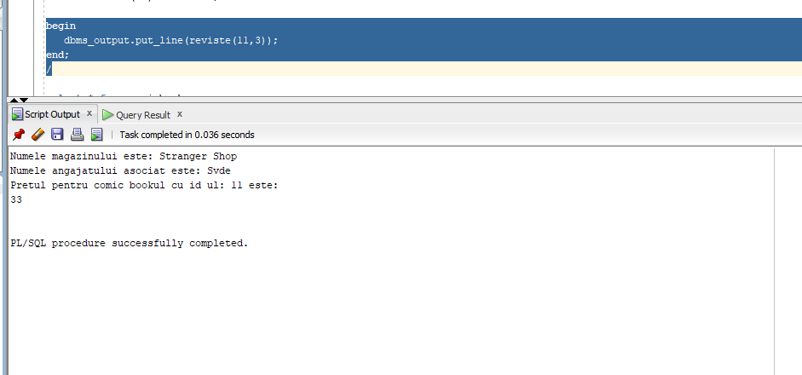

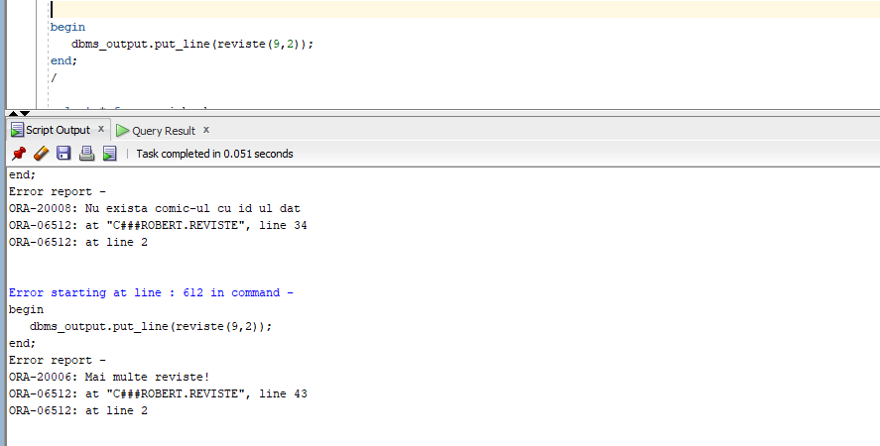

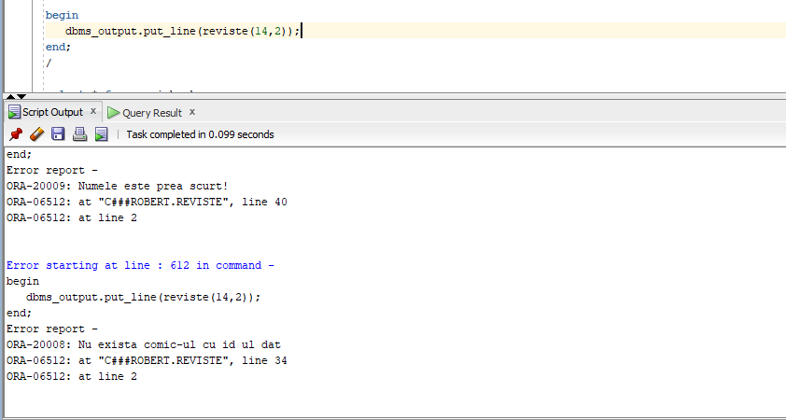

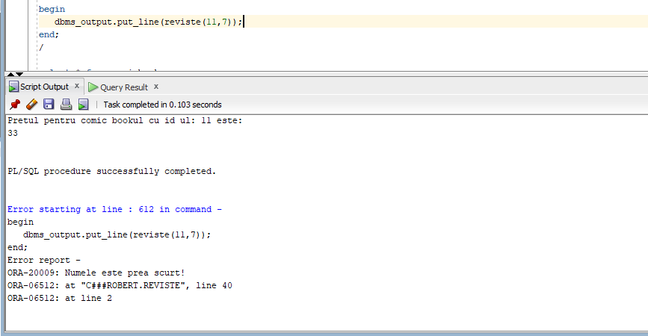

Exercitiul 9:

--9 Aflati jobul avut de un angajat care lucreaza la un comic store care are o anumita revista ---ce se afla intr-un top cu titlul ce contine "Romance"

create or replace procedure job_avut(id_angajat_dat angajat.id_angajat%type)

is

denumire_job joburi.nume_job%type;

begin

select jb.nume_job

into denumire_job

from joburi jb

join angajat a on a.id_job = jb.id_job

join comicstore cs on a.id_comic_store = cs.id_comic_store

join comicbook cb on cs.id_comic_store = cb.id_comic_store

join top tp on cb.id_top = tp.id_top

where tp.denumire_top like '%Romance%' and a.id_angajat = id_angajat_dat;

dbms_output.put_line('Jobul avut de angajatul cu id dat este: ' || denumire_job);

exception

when NO_DATA_FOUND then

RAISE_APPLICATION_ERROR(-20010, 'Nu s-au gasit joburi pe care lucreaza angajatul cu id-ul dat!');

end job_avut;

/

--Test:

begin

job_avut(9);

end;

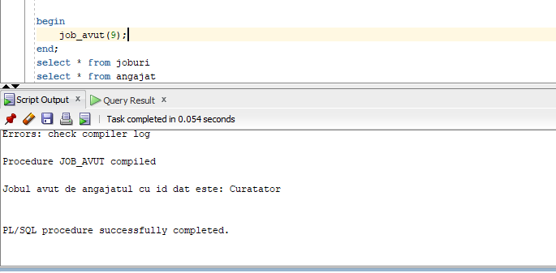

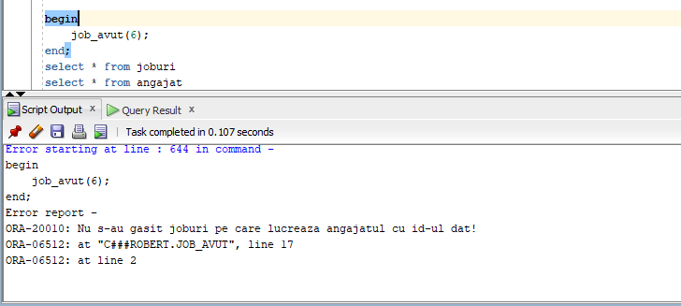

--10 Creati un trigger care nu ne permite modificarea tabelului angajat in ziua de luni si --duminica sau daca nu ne aflam in intervalul orar 8 -17

create or replace trigger actualizare_tabel

before insert or update or delete on angajat

begin

if (to_char(sysdate,'D') = 1) or (to_char(sysdate,'D') = 2) or (to_char(sysdate,'HH24') not between 8 and 17)

then

RAISE_APPLICATION_ERROR(-20010, 'Nu puteti actualiza tabelul!');

end if;

end;

/

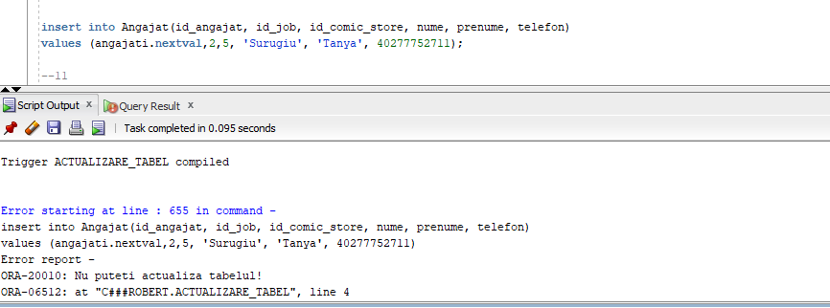

--11 Creati un trigger care nu ne lasa sa modificam pretul revistelor daca diferenta dintre -------pretul vechi si cel nou este mai mica de 15

create or replace trigger actualizare_pret

before update of pret on comicbook

for each row

declare

pret_obligatoriu exception;

begin

if :old.pret - :new.pret < 15 then

raise pret_obligatoriu;

end if;

exception

when pret_obligatoriu then

RAISE_APPLICATION_ERROR(-20010, 'Pretul este prea mic! - NU AM ACTUALIZAT PRETUL');

end;

/

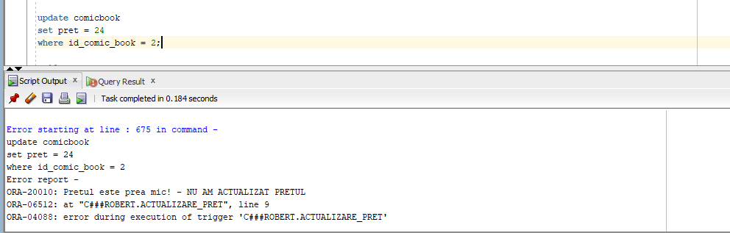

--12 Creati un trigger care nu ne permite crearea unor tabele noi in baza de date vinerea si -----sambata sau daca numele acestuia este fie prea mic < 2, fie prea mare > 10

create or replace trigger actualizare_database

before create on schema

declare

nume_gresit exception;

data_gresita exception;

begin

if (to_char(sysdate,'D') between 6 and 7)

then

raise data_gresita;

elsif length(ora_dict_obj_name) < 2 or length(ora_dict_obj_name) > 10

then

raise nume_gresit;

end if;

exception

when nume_gresit then

RAISE_APPLICATION_ERROR(-20010, 'Numele introdus este prea scurt sau prea lung - incorect!');

when data_gresita then

RAISE_APPLICATION_ERROR(-20009, 'Data cand s-a dorit introducere tabelului este invalida');

end;

/

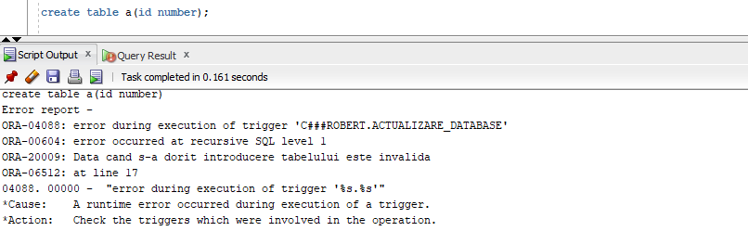

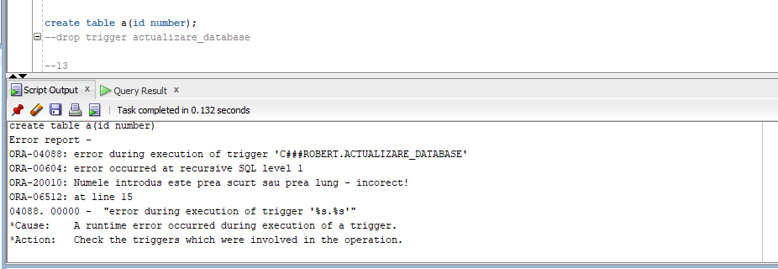

13. Pachetul cu obiectele:

create or replace package pachet_13 as

procedure ang_si_magazine;

procedure comics_ex(p_cod comicbook.pret%type, p_cuvant in varchar2);

function reviste(p_id_comic comicbook.id_comic_book%type, lungime number) return number;

procedure job_avut(id_angajat_dat angajat.id_angajat%type);

end pachet_13;

/

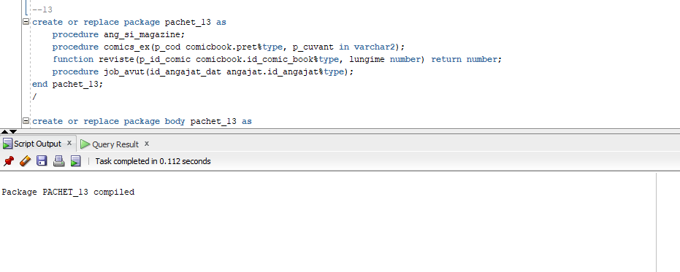

create or replace package body pachet_13 as

procedure ang_si_magazine

as

type vector is varray(50) of ComicStore.id_comic_store%type;

type vector_2 is varray(50) of Angajat.nume%type;

type table_1 is table of vector_2 index by pls_integer;

cstore vector := vector();

cangajat table_1;

chk number(1) := 0;

begin

select id_comic_store

bulk collect into cstore

from ComicStore;

if cstore.count < 3 then

RAISE_APPLICATION_ERROR(-20099, 'Prea putine magazine!');

end if;

for i in 1..cstore.count loop

select nume

bulk collect into cangajat(i)

from Angajat

join ComicStore on Angajat.id_comic_store = ComicStore.id_comic_store

where ComicStore.id_comic_store = cstore(i);

dbms_output.put_line('Id-ul magazinului:' || cstore(i));

for j in 1..cangajat(i).count loop

dbms_output.put_line(cangajat(i)(j));

end loop;

end loop;

end ang_si_magazine;

procedure comics_ex(p_cod comicbook.pret%type, p_cuvant in varchar2)

as

cursor cursor1 is

select * from ComicBook;

cursor cursor2 (v_pret comicbook.pret%type, v_cuvant_cheie varchar2) is

select * from comicbook

where pret > v_pret

and nume like '%' || v_cuvant_cheie || '%';

comic comicbook%rowtype;

begin

dbms_output.put_line('Toate revistele sunt: ');

open cursor1;

loop

fetch cursor1 into comic;

exit when cursor1%notfound;

dbms_output.put_line('Numele: ' || comic.nume);

end loop;

close cursor1;

dbms_output.put_line('Revistele cautate dupa nume si pret sunt: ');

open cursor2(p_cod,p_cuvant);

loop

fetch cursor2 into comic;

exit when cursor2%notfound;

dbms_output.put_line('Pretul este: ' || comic.pret || ' si numele este ' || comic.nume);

end loop;

close cursor2;

end comics_ex;

function reviste(p_id_comic comicbook.id_comic_book%type, lungime number) return number is

v_pret comicbook.pret%type;

v_comic_name comicbook.nume%type;

v_angajat_nume angajat.nume%type;

counter number;

pret_prea_mare exception;

nume_scurt exception;

begin

select cb.pret, cs.nume_store, a.nume

into v_pret, v_comic_name, v_angajat_nume

from comicbook cb

join comicstore cs on cb.id_comic_store=cs.id_comic_store

join angajat a on cs.id_comic_store=a.id_comic_store

where cb.id_comic_book=p_id_comic;

if length(v_angajat_nume) < lungime then

raise nume_scurt;

end if;

if v_pret > 40 then

raise pret_prea_mare;

end if;

dbms_output.put_line('Numele magazinului este: ' || v_comic_name);

dbms_output.put_line('Numele angajatului asociat este: ' || v_angajat_nume);

dbms_output.put_line('Pretul pentru comic bookul cu id ul: ' || p_id_comic || ' este: ');

return v_pret;

exception

when NO_DATA_FOUND then

RAISE_APPLICATION_ERROR(-20008, 'Nu exista comic-ul cu id ul dat');

when pret_prea_mare then

RAISE_APPLICATION_ERROR(-20007, 'Pretul dat este prea mare');

when nume_scurt then

RAISE_APPLICATION_ERROR(-20009, 'Numele este prea scurt!');

when TOO_MANY_ROWS then

RAISE_APPLICATION_ERROR(-20006, 'Mai multe reviste!');

end reviste;

procedure job_avut(id_angajat_dat angajat.id_angajat%type)

is

denumire_job joburi.nume_job%type;

begin

select jb.nume_job

into denumire_job

from joburi jb

join angajat a on a.id_job = jb.id_job

join comicstore cs on a.id_comic_store = cs.id_comic_store

join comicbook cb on cs.id_comic_store = cb.id_comic_store

join top tp on cb.id_top = tp.id_top

where tp.denumire_top like '%Romance%' and a.id_angajat = id_angajat_dat;

dbms_output.put_line('Jobul avut de angajatul cu id dat este: ' || denumire_job);

exception

when NO_DATA_FOUND then

RAISE_APPLICATION_ERROR(-20010, 'Nu s-au gasit joburi pe care lucreaza angajatii cu id-ul dat!');

end job_avut;

end pachet_13;

/

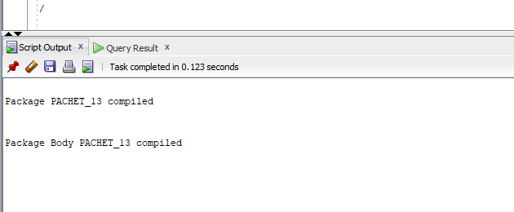

--Test pachet:

exec pachet_13.ang_si_magazine

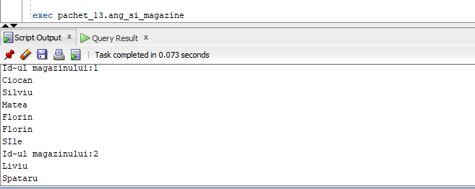

exec pachet_13.comics_ex(29,'Date');

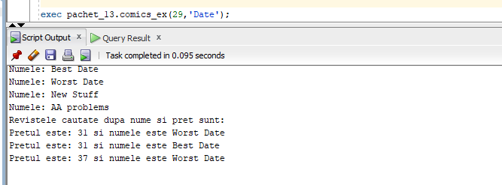

select pachet_13.reviste(9,2) from dual;

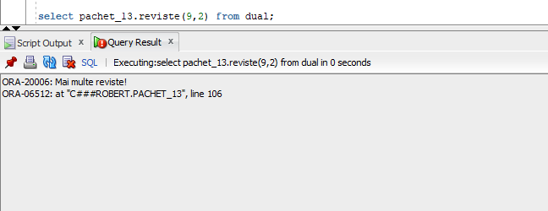

select pachet_13.reviste(11,2) from dual;

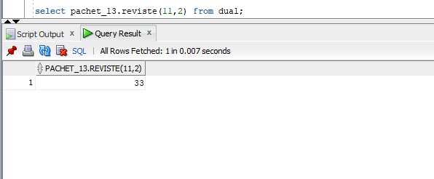

select pachet_13.reviste(16,8) from dual;

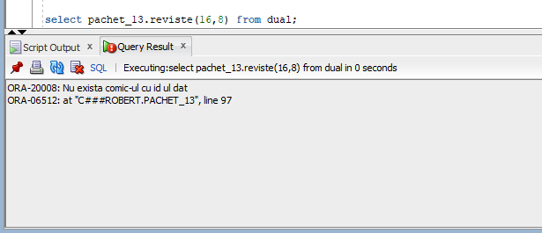

select pachet_13.reviste(12,8) from dual;

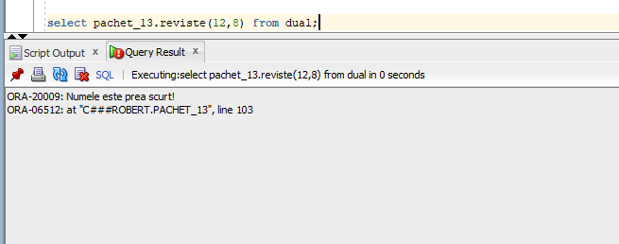

exec pachet_13.job_avut(1);

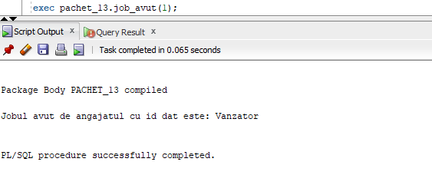

exec pachet_13.job_avut(242);

