MRSA Klassifizierung in Schweinemastherden mit *glm*

Dr. Robert Opitz

2021-08-26

Der MRSA-Datensatz in Schweinemastherden wurde von Fromm *et al.* in PVM, **117**, 2014 veröffentlicht. Es handelt sich dabei um eine Metastudie. Diese wurde mittels logistischer Regression und generalized estiamtion equations ausgewertet. Es wurde eine Variablenselektion durch geführt: (i) durch univariates filtern (mit logistischer Regression) wurden alle Variablen entfernt, die keinen direkten Einfluss auf die Zielvariable haben, (ii) von paarweise korrelierten Variablen wurde eine der korrelierten Variablen entfernt. Es wurde versucht auch Interaktionsterme zubreücksichtigen. Es wurde nur einer gefunden, auch aufgrund der Anzahl der Datenpunkte Datensatzes. Dieser wurde im finalen Modell nicht weiter berücksichtigt.

# Notwendige Pakte und eigene Funktionen

Hier verwendete Pakete.

library(magrittr)  
library(caret)

Einige Hilfsfunktionen zum Plotten usw..

plot_func <- function(model_fit_response, reference, title = "")   
{  
 lev <- levels(reference)  
 neg <- lev[1]; pos <- lev[2] # negative and positive class label  
   
 # compute accuracy, sensitivity, specificity, balancec accuracy   
 # for all thresholds  
 threshold <- seq(0, 1, 0.01)  
 n <- length(threshold)  
 acc <- rep(NA, n)  
 sen <- rep(NA, n)  
 spe <- rep(NA, n)  
 bacc <- rep(NA, n)  
 for (i in seq(n))   
 {  
 pred_class <- factor(ifelse(model_fit_response <= threshold[i],   
 neg, pos),  
 levels = lev)  
 acc[i] <- mean(reference == pred_class)  
 sen[i] <- mean(reference[reference == pos] == pred_class[reference == pos])  
 spe[i] <- mean(reference[reference != pos] == pred_class[reference != pos])  
 bacc[i] <- 0.5 * (sen[i] + spe[i])  
 }  
  
 # dependece of Acc, Sen, Spe, and bal. Acc of Threshold;  
 # Threshold dependence  
 plot(threshold, acc,   
 type = "l",  
 xlim = c(0,1),  
 ylim = c(0,1),  
 ylab = "Acc/Sen/Spe/bal. Acc",  
 main = title)  
 lines(threshold, sen, col = "red")  
 lines(threshold, spe, col = "blue")  
 lines(threshold, bacc, col = "green")  
 abline(v = 0.5, lty = 4)  
 cat("Max. Acc = ", max(acc),   
 " at Threshold = ", threshold[which.max(acc)], "\n")  
 abline(v = thres <- threshold[which.max(bacc)], lty = 2)  
 cat("Max. bal. Acc = ", max(bacc), " at Threshold = ", thres, "\n")  
 # no information criteria  
 tmp <- summary(reference)  
 no_info <- max(tmp) / sum(tmp)  
 abline(h = no_info, lty = 3)  
  
 # Receiver Operating Curve  
 plot(1 - spe, sen,   
 type = "l",   
 main = paste("ROC", title),   
 lwd = 5)  
 abline(a = 0, b = 1, lty = 2)  
 abline(a = 1, b = -1, lty = 3)  
  
 print(pROC::roc(reference, model_fit_response))  
  
 # Youden's J curve  
 plot(1 - spe, sen + spe - 1,  
 ylim = c(0,1),  
 type = "l",  
 ylab = "J = sen + spe - 1",  
 main = paste("Youden's J", title),   
 lwd = 5)  
 abline(a = 1, b = -1, lty = 2)  
 max_youden_j <- which.max(sen + spe - 1)  
 cat("max. Youden's J = ", sen[max_youden_j] + spe[max_youden_j] - 1, " ",  
 "Sen = ", sen[max_youden_j], ";",  
 "Spe = ", spe[max_youden_j], ";",  
 "threshold = ", threshold[max_youden_j], "\n")  
 abline(v = 1 - spe[max_youden_j], lty = 3)  
   
 return(thres)  
}  
  
get_and_plot_feature_frequencies <- function(feature_list,   
 my_formula,   
 input_data)   
{  
 term_list <- vector( mode = 'list', length = length(feature_list) )  
 all_term_names <- colnames( model.matrix( my_formula,   
 data = input_data ) )  
  
 for (i in seq_along(term_list))  
 term_list[[i]] <- which( all_term_names %in% feature_list[[i]] )  
  
 test <- rep( 0, length( all_term_names ) )  
 for (x in term_list)  
 test[ x ] <- test[ x ] + 1  
   
 plot( sort(test/length(term_list), decreasing = TRUE),  
 type = 'h',  
 xlab = 'term',   
 ylab = 'frequency')  
  
 abline( h = 0.9, lty = 2 )  
  
 df_result <- data.frame(term_counts = test,   
 frequency = test/length(term_list),   
 term_name = all_term_names)  
 df_result <- df_result[order(df_result$frequency,   
 decreasing = TRUE),]  
  
 return(df_result)  
}  
  
plot_weights_of_feature <- function(weights_list, feature_name){  
 weights <- sapply(weights_list,   
 function(x, feature_name) x[feature_name,], feature_name)  
 hist(weights,  
 main = paste("Weight distribution for", feature_name),  
 breaks = 100,  
 probability = TRUE)  
 invisible(NULL)  
}

# Datenvorbereitung

## Einlesen und Vorbereiten der Daten.

Einlesen und Bereinigung der Daten. Es wird sichergestellt, dass alle Daten einen R-konformen Namen haben und als Faktoren vorliegen. die Variablennamen erhalten die Namen aus dem Paper. Einige der Kategorien der Variablen werden besser lesbar gestaltet.

MRSA_schweineherden <- read.csv(file = file.choose(),  
 header = TRUE)  
  
# all categorigal variables needs to be checked if there name is valid in R  
# E. g.: TRUE and FALSE are not; TRUE. and FALSE. are  
# All categorical Variables need to be (at least) described as factors  
for (i in seq_len(ncol(MRSA_schweineherden)))   
{  
 MRSA_schweineherden[[i]] <- make.names(MRSA_schweineherden[[i]])  
 MRSA_schweineherden[[i]] <- factor(MRSA_schweineherden[[i]])  
}  
  
# the old names in the data set are renamed, so they match the names in the paper  
new_col_names <- list(HerdMRSA = 'HERD_MRSA',  
 HerdTypeNum = 'HERD_TYPE',  
 FeedingPlacesMinGrouped = 'HERD_SIZE',  
 PurchaseBin = 'PURCHASE',  
 AntibioticsFrom10W = 'AM_DRUG',  
 AllInAllOut = 'ALL_IN_or_OUT',  
 Cleanup = 'CLEAN_UP',  
 Disinfection = 'DISINFECTION',  
 SlattedFloor = 'SLATTED',  
 OrganicFarm = 'ORGANIC',  
 OtherLivestockAtFarmBin = 'OTHER_LIVESTOCK',  
 CompanionAnimalsBin = 'COMPANION',  
 IndoorHousing = 'INDOOR' )  
  
# rename the column names  
column_names <- colnames(MRSA_schweineherden)  
for (col_name in column_names)  
 colnames(MRSA_schweineherden)[column_names == col_name] <- new_col_names[[col_name]]  
  
# replace old variable types for variable HERD_SIZE  
levels(MRSA_schweineherden$HERD_SIZE)

## [1] "X..5000.pigs" "X0.499.pigs" "X1000.4999.pigs" "X500.999.pigs"

levels(MRSA_schweineherden$HERD_SIZE) <- c('huge', 'small', 'large', 'medium')  
# reorder factors  
MRSA_schweineherden$HERD_SIZE <- factor(MRSA_schweineherden$HERD_SIZE,   
 levels = c('small', 'medium',   
 'large', 'huge'),  
 ordered = TRUE)  
levels(MRSA_schweineherden$HERD_SIZE)

## [1] "small" "medium" "large" "huge"

levels(MRSA_schweineherden$HERD_TYPE)

## [1] "farrow.to.finisher" "grower.to.finisher" "weaner.to.finisher"

levels(MRSA_schweineherden$HERD_TYPE) <- c("farrow", "grower", "weaner")  
levels(MRSA_schweineherden$HERD_TYPE)

## [1] "farrow" "grower" "weaner"

# replace old variable types for variable SLATTED_AT_LEAST_PARTIALLY  
levels(MRSA_schweineherden$SLATTED)

## [1] "no..not.slatted." "yes..at.least.partially.slatted."

levels(MRSA_schweineherden$SLATTED) <- c('no', 'yes')  
levels(MRSA_schweineherden$SLATTED)

## [1] "no" "yes"

## Vorstellung des Datensatzes (EDA)

str(MRSA_schweineherden)

## 'data.frame': 400 obs. of 13 variables:  
## $ HERD_MRSA : Factor w/ 2 levels "negative","positive": 2 2 1 2 1 2 2 2 2 2 ...  
## $ HERD_TYPE : Factor w/ 3 levels "farrow","grower",..: 2 2 2 1 1 1 2 2 2 2 ...  
## $ HERD_SIZE : Ord.factor w/ 4 levels "small"<"medium"<..: 3 3 2 1 2 2 2 2 3 3 ...  
## $ AM_DRUG : Factor w/ 2 levels "no","yes": 2 2 1 1 1 1 2 1 2 1 ...  
## $ PURCHASE : Factor w/ 2 levels "no","yes": 2 2 2 1 1 1 2 2 2 2 ...  
## $ INDOOR : Factor w/ 2 levels "no","yes": 2 2 2 2 2 2 2 2 2 2 ...  
## $ OTHER_LIVESTOCK: Factor w/ 2 levels "no","yes": 1 2 1 1 1 1 2 2 1 1 ...  
## $ COMPANION : Factor w/ 2 levels "no","yes": 1 1 1 2 2 2 1 2 1 2 ...  
## $ ALL_IN_or_OUT : Factor w/ 2 levels "no","yes": 2 2 1 1 1 2 2 1 2 2 ...  
## $ CLEAN_UP : Factor w/ 2 levels "no","yes": 2 2 2 1 2 2 2 2 2 2 ...  
## $ DISINFECTION : Factor w/ 2 levels "no","yes": 2 2 2 1 2 2 2 2 2 2 ...  
## $ SLATTED : Factor w/ 2 levels "no","yes": 2 2 2 2 2 2 2 2 2 2 ...  
## $ ORGANIC : Factor w/ 2 levels "no","yes": 1 1 1 1 1 1 1 1 1 1 ...

Bestimmung der Anzahl der Datenpunkte, Anzahl Variablen und Verteilung der Response.

MRSA_schweineherden$HERD_MRSA %>% length -> number_of_datapoints  
MRSA_schweineherden[1,-1] %>% length -> number_of_variables  
MRSA_schweineherden$HERD_MRSA %>% summary

## negative positive   
## 186 214

MRSA_schweineherden$HERD_MRSA %>% summary %>% pie(.,main = 'HERD MRSA')

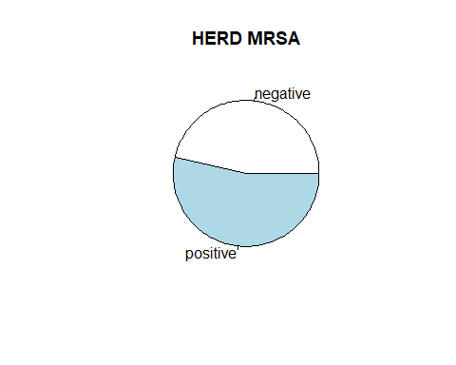

Datenpunkte=400, Variablen=12.

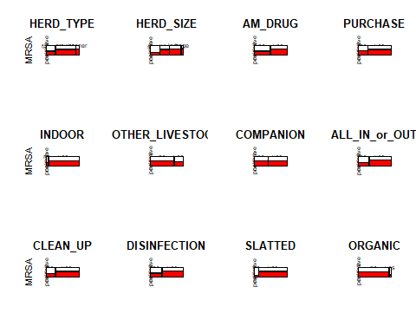

nearZeroVar(MRSA_schweineherden, saveMetrics = TRUE)

## freqRatio percentUnique zeroVar nzv  
## HERD_MRSA 1.150538 0.50 FALSE FALSE  
## HERD_TYPE 2.252252 0.75 FALSE FALSE  
## HERD_SIZE 1.247863 1.00 FALSE FALSE  
## AM_DRUG 1.105263 0.50 FALSE FALSE  
## PURCHASE 2.603604 0.50 FALSE FALSE  
## INDOOR 20.052632 0.50 FALSE TRUE  
## OTHER_LIVESTOCK 2.738318 0.50 FALSE FALSE  
## COMPANION 1.409639 0.50 FALSE FALSE  
## ALL_IN_or_OUT 2.149606 0.50 FALSE FALSE  
## CLEAN_UP 2.846154 0.50 FALSE FALSE  
## DISINFECTION 1.941176 0.50 FALSE FALSE  
## SLATTED 7.695652 0.50 FALSE FALSE  
## ORGANIC 16.391304 0.50 FALSE FALSE

Die Variable INDOOR besteht fast ausschließlich aus Herden, die indoor leben, fast keine die outdoor sind. Dadurch haben wir eine near-zero-variance (nzv) für diese Variable. Wir entfernen diese Variable daher.

MRSA_schweineherden_reduced <- MRSA_schweineherden  
MRSA_schweineherden_reduced$INDOOR <- NULL

# Erstes Modell

first_model <- glm(HERD_MRSA ~ .,  
 data = MRSA_schweineherden_reduced,  
 family = binomial(link = "logit"))  
  
pred_prob <- predict(first_model, type = "response")  
pred_class <- ifelse(pred_prob <= 0.54, "negative", "positive")  
table(pred_class)

## pred_class  
## negative positive   
## 167 233

table(MRSA_schweineherden_reduced$HERD_MRSA)

##   
## negative positive   
## 186 214

confusionMatrix(data = factor(pred_class),  
 reference = MRSA_schweineherden_reduced$HERD_MRSA,  
 positive = "positive")

## Confusion Matrix and Statistics  
##   
## Reference  
## Prediction negative positive  
## negative 117 50  
## positive 69 164  
##   
## Accuracy : 0.7025   
## 95% CI : (0.6551, 0.7469)  
## No Information Rate : 0.535   
## P-Value [Acc > NIR] : 5.827e-12   
##   
## Kappa : 0.398   
##   
## Mcnemar's Test P-Value : 0.09893   
##   
## Sensitivity : 0.7664   
## Specificity : 0.6290   
## Pos Pred Value : 0.7039   
## Neg Pred Value : 0.7006   
## Prevalence : 0.5350   
## Detection Rate : 0.4100   
## Detection Prevalence : 0.5825   
## Balanced Accuracy : 0.6977   
##   
## 'Positive' Class : positive   
##

plot_func(pred_prob, MRSA_schweineherden_reduced$HERD_MRSA)

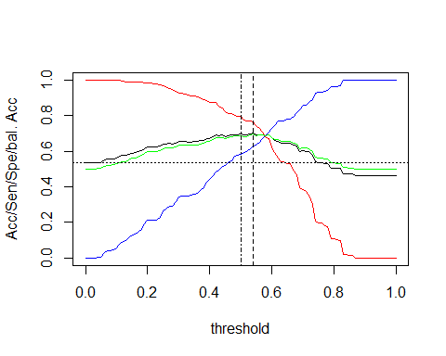

## Max. Acc = 0.7025 at Threshold = 0.54   
## Max. bal. Acc = 0.6976937 at Threshold = 0.54

## Setting levels: control = negative, case = positive

## Setting direction: controls < cases

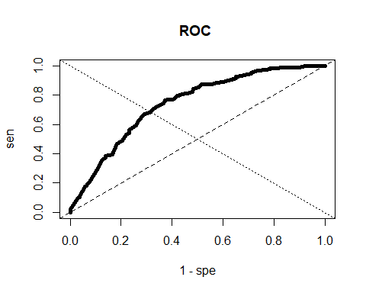

##   
## Call:  
## roc.default(response = reference, predictor = model_fit_response)  
##   
## Data: model_fit_response in 186 controls (reference negative) < 214 cases (reference positive).  
## Area under the curve: 0.7413

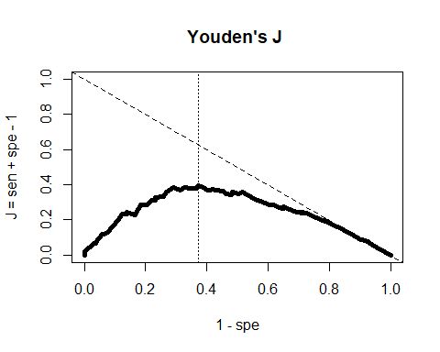

## max. Youden's J = 0.3953874 Sen = 0.7663551 ; Spe = 0.6290323 ; threshold = 0.54

## [1] 0.54

hist(pred_prob,   
 xlim = c(0,1),   
 breaks = 25,  
 main = "predicted MRA risk for training data",  
 xlab = "P(HERD_MRSA = positive)")

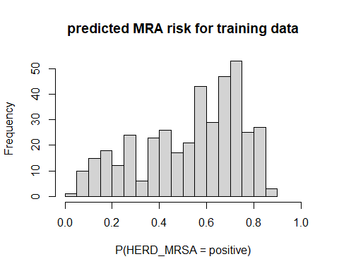

# Repeqted Crossvalidation

train_index <- createMultiFolds(MRSA_schweineherden_reduced$HERD_MRSA,  
 k = 10,  
 times = 100 )

trained_models <- lapply(train_index,  
 function(this_index)  
 {  
 df_train <- MRSA_schweineherden_reduced[this_index,]  
 trained_model <- glm(HERD_MRSA ~ .,  
 data = df_train,  
 family = binomial(link = "logit"))  
 trained_model  
 })  
# get predicted probabilities  
pred_prob <- mapply(function(trained_model, train_data)  
 {  
 df_test <- MRSA_schweineherden_reduced[-train_data,]  
 predict(trained_model,  
 newdata = df_test,  
 type = "response")  
 }, trained_models, train_index)  
pred_prob <- unlist(pred_prob)  
# get references classes of test data  
ref_class <- unlist(lapply(train_index,   
 function(x) MRSA_schweineherden_reduced$HERD_MRSA[-x]))  
# plot everything for test data  
plot_func(pred_prob, ref_class)

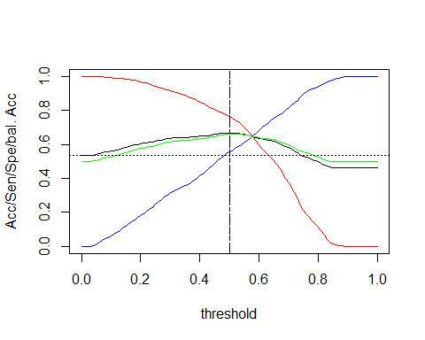

## Max. Acc = 0.668475 at Threshold = 0.5   
## Max. bal. Acc = 0.6610655 at Threshold = 0.5

## Setting levels: control = negative, case = positive

## Setting direction: controls < cases

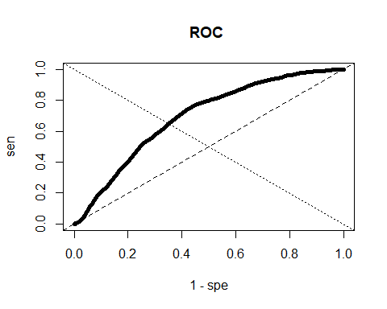

##   
## Call:  
## roc.default(response = reference, predictor = model_fit_response)  
##   
## Data: model_fit_response in 18600 controls (reference negative) < 21400 cases (reference positive).  
## Area under the curve: 0.6941

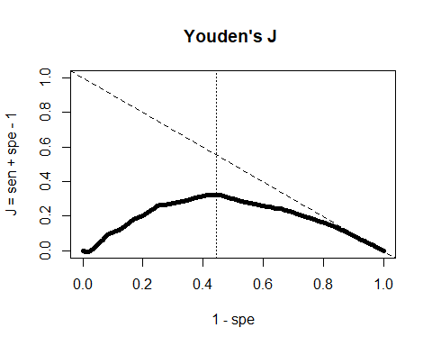

## max. Youden's J = 0.3221309 Sen = 0.7669159 ; Spe = 0.5552151 ; threshold = 0.5

## [1] 0.5

# Distribution of weights in all training models

df_weights <- NULL  
for (trained_model in trained_models)  
 df_weights <- rbind.data.frame(df_weights,  
 coef(trained_model))  
colnames(df_weights) <- names(coef(trained_models[[1]]))

Plot some weight distributions

hist(df_weights$HERD_SIZE.L, main = "Weight distribution HERD_SIZE.L")

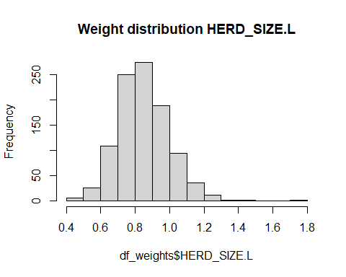

hist(df_weights$SLATTEDyes, main = "Weight distribution of SLATTEDyes")

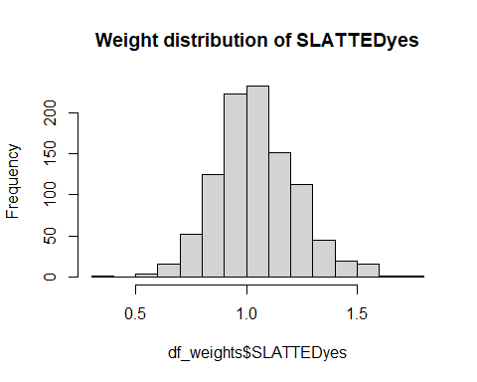

hist(df_weights$ORGANICyes, main = "Weight distribution of ORGANICyes")

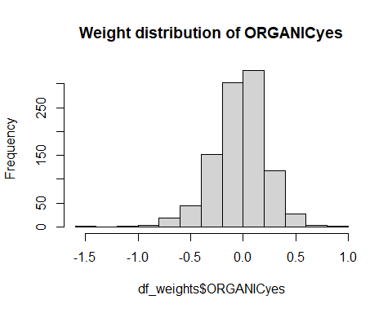

# Take a closer look – predicted distribution of risk, and its parts

Plot the probaility calibration curve

df_cal <- data.frame(Class = ref_class)  
df_cal$glm <- pred_prob  
cal_obj <- caret::calibration(Class ~ glm,  
 data = df_cal,  
 cuts = 50,  
 class = "positive")  
plot(cal_obj)

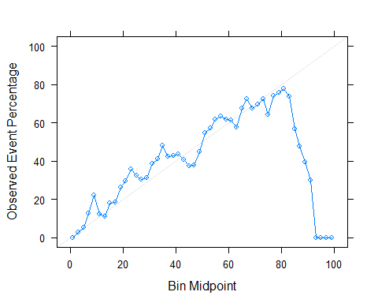

Some helper functions to startify the predicted risk.

my_subset <- function(df_input, selection_rule)  
{  
 selected_col <- selection_rule[1]  
 selected_value <- selection_rule[2]  
 df_output <- NULL  
 for (i in seq_len(nrow(df_input)))  
 {  
 if (df_input[i,selected_col] == selected_value)  
 df_output <- rbind.data.frame(df_output,  
 df_input[i,])  
 }  
 if (!is.null(df_output))  
 colnames(df_output) <- colnames(df_input)  
 df_output  
}  
  
get_risk_subset <- function(df_input, trained_models,   
 train_index, subset_list)  
{  
 result <- mapply(function(trained_model, train_data)  
 {  
 df_test <- df_input[-train_data,]  
 for (this_subset in subset_list)  
 {  
 df_test <- my_subset(df_test, this_subset)  
 if (is.null(df_test))  
 return(NULL)  
 }  
 predict(trained_model,  
 newdata = df_test,  
 type = "response")  
 }, trained_models, train_index)  
 # remove empty entries in result list  
 result <- Filter(Negate(is.null), result)  
 unname(unlist(result)) # simple vector with predicted risks  
}

# original distribution of predicted risk  
org_hist <- hist(pred_prob,  
 breaks = -1*Reduce("-", range(pred_prob))/0.01,  
 plot = FALSE)  
  
sub_dist_A <- get_risk_subset(MRSA_schweineherden_reduced,  
 trained_models, train_index,  
 list(c("HERD_SIZE", "small"),  
 c("SLATTED", "yes")))  
  
sub_dist_B <- get_risk_subset(MRSA_schweineherden_reduced,  
 trained_models, train_index,  
 list(c("HERD_SIZE", "small"),  
 c("SLATTED", "no")))  
  
# distribution of stratified sample  
sub_dist_A_hist <- hist(sub_dist_A,  
 breaks = -1*Reduce("-", range(sub_dist_A))/0.01,  
 plot = FALSE)  
sub_dist_B_hist <- hist(sub_dist_B,  
 breaks = -1*Reduce("-", range(sub_dist_B))/0.01,  
 plot = FALSE)  
# plot it all  
plot(org_hist,  
 freq = TRUE,  
 col = rgb(0,0,1,1/4),  
 xlim = c(0,1),  
 xlab = "P(Y=1)",  
 main = "GLM")  
plot(sub_dist_A_hist,  
 freq = TRUE,  
 add = TRUE,  
 col = rgb(1,0,0,1/4))  
plot(sub_dist_B_hist,  
 freq = TRUE,  
 add = TRUE,  
 col = rgb(0,1,0,1/4))  
legend("topleft",  
 legend = c("complete",  
 "small HERDs, SLATTED floor",#"sub_dist_A",  
 "small HERDs, no SLATTED floor"),#"sub_dist_B"),  
 col = c(rgb(0,0,1,1/4),  
 rgb(1,0,0,1/4),  
 rgb(0,1,0,1/4)),  
 lty = 1, lwd = 4)

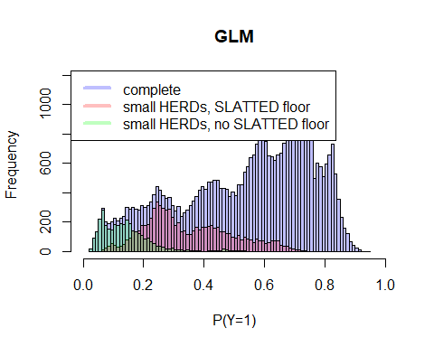

# Change in predicted risk distribution

get_mod_pred_risk <- function(df_input, trained_models,   
 train_index, subset_list)  
{  
 col_name <- subset_list[1]  
 new_value <- subset_list[2]  
 result <- mapply(function(trained_model, train_data)  
 {  
 df_test <- df_input[-train_data,]  
 lev <- levels(df_test[[col_name]])  
 df_test[,col_name] <- factor(rep(new_value,   
 nrow(df_test)),  
 levels = lev)  
 pred <- predict(trained_model,  
 newdata = df_test,  
 type = "response")  
 }, trained_models, train_index)  
 # remove empty entries in result list  
 result <- Filter(Negate(is.null), result)  
 unname(unlist(result)) # simple vector with predicted risks  
}

# original distribution of predicted risk  
org_hist <- hist(pred_prob,  
 breaks = -1*Reduce("-", range(pred_prob))/0.01,  
 plot = FALSE)  
  
sub_dist_A <- get_mod_pred_risk(MRSA_schweineherden_reduced,  
 trained_models, train_index,  
 c("SLATTED", "no"))  
  
# distribution of stratified sample  
sub_dist_A_hist <- hist(sub_dist_A,  
 breaks = -1*Reduce("-", range(sub_dist_A))/0.01,  
 plot = FALSE)  
  
# plot it all  
plot(org_hist,  
 freq = TRUE,  
 col = rgb(0,0,1,1/4),  
 xlim = c(0,1),  
 xlab = "P(Y=1)",  
 main = "predicted risk for GLM")  
plot(sub_dist_A_hist,  
 freq = TRUE,  
 add = TRUE,  
 col = rgb(1,0,0,1/4))  
legend("topleft",  
 legend = c("unchanged",  
 "no SLATTED floors"),#"sub_dist_A",  
 col = c(rgb(0,0,1,1/4),  
 rgb(1,0,0,1/4)),  
 lty = 1, lwd = 4)

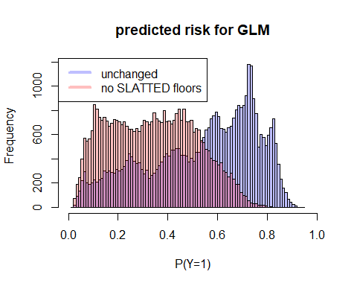

# Change in Predicted Prevalence

get_mod_pred_prev <- function(df_input, trained_models,   
 train_index, subset_list, threshold)  
{  
 col_name <- subset_list[1]  
 new_value <- subset_list[2]  
 result <- mapply(function(trained_model, train_data)  
 {  
 df_test <- df_input[-train_data,]  
 lev <- levels(df_test[[col_name]])  
 df_test[,col_name] <- factor(rep(new_value,   
 nrow(df_test)),  
 levels = lev)  
 pred <- predict(trained_model,  
 newdata = df_test,  
 type = "response")  
 ifelse(pred > threshold, 1, 0)  
 }, trained_models, train_index)  
 # remove empty entries in result list  
 result <- Filter(Negate(is.null), result)  
 unname(unlist(result)) # simple vector with predicted risks  
}

pred_prev <- mapply(function(trained_model, train_data)  
 {  
 df_test <- MRSA_schweineherden_reduced[-train_data,]  
 pred <- predict(trained_model,  
 newdata = df_test,  
 type = "response")  
 ifelse(pred > 0.51, 1, 0)  
 }, trained_models, train_index)  
pred_prev <- mean(unlist(pred_prev))  
  
mod_pred_prev <- get_mod_pred_prev(MRSA_schweineherden_reduced,   
 trained_models,  
 train_index,  
 c("SLATTED", "no"),  
 0.51)  
mod_pred_prev <- mean(mod_pred_prev)

obs_prev <- mean(MRSA_schweineherden_reduced$HERD_MRSA == "positive")  
pie(c(1 - obs_prev, obs_prev),  
 labels = c("negative", "positive"),  
 main = 'observed MRSA prevalence')

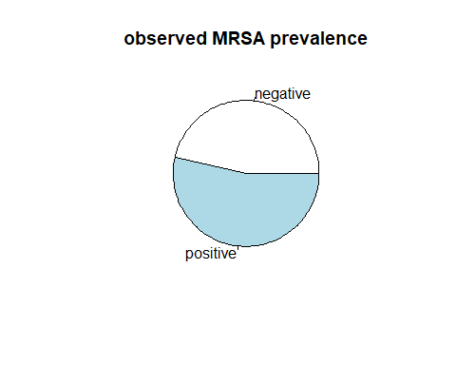

pie(c(1 - pred_prev, pred_prev),   
 labels = c("negative", "positive"),  
 main = 'predicted MRSA prevalence')

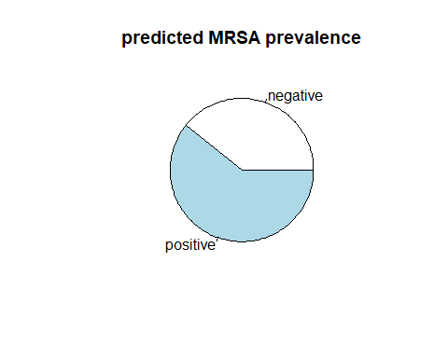

pie(c(1 - mod_pred_prev, mod_pred_prev),   
 labels = c("negative", "positive"),  
 main = 'pred. no SLATTED prevalence')

