Team WORK Milestone 5

CSCI 3308 Spring 2018

Who: Jacob Bloom, Tuqa Alaithan, Eliott Ishack, Robert Rosetti, Jun Sheng, Joy Mace

Title: Natural Neighbors Wildlife Journal

Automated Tests:

<https://travis-ci.org/mrjacobbloom/teamWORK>

1. Try Invalid login
2. Try valid login
3. Check login button gone after login
4. Try posting to journal
5. Try invalid journal posting
6. See if journal post shows up

Exits 1 for errors.

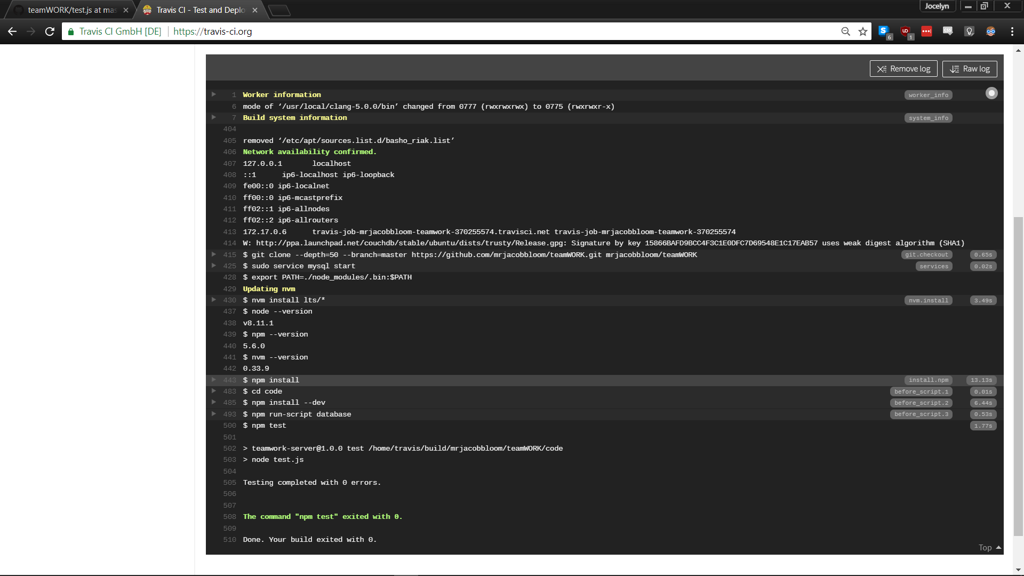

Because this website is a journal style site, the features that need to be tested are registration, login and posting of journal entries. These are tested using test cases that register a new user, login the new user and post an entry to the user’s journal page.

All tests pass.

# User Acceptance Test Plans:

A team member will attempt to register, login and post a journal entry to their page.

Registration: User will enter their name, and password (‘Robert’, ‘1234’)

Team member must check that the login button isn’t available if they haven’t registered yet.

Login: User enters name and password correctly and is taken to their personal journal page (‘Robert’, ‘1234’ and proceeds to Journal page)

Team member must check an incorrect password to make sure that only correct passwords work. They must also check that the login button goes away upon successful login.

Post: User enters a post that then shows up in the post list. (‘Post about animal….’etc)

Team member must check that the dropdown is available, and that there is a prompt for a new post on the page. Team member must also check that the journal only accepts proper posts, not empty posts.