Robert Szkutak

A -> var <- A | BN | D

BN -> !(B) | B

B -> R BO R | R

BO -> ^ | |

R -> D RO D | D

RO -> > | < | <= |>= | == | != | #

D -> D % E |D % (A) | E

E -> E+ T | E+(A) | E / T | E/(A) | T

T -> T\*F | T\*(A) | F

F -> F – G |F-(A) | G

G -> any number | any variable

Robert Szkutak

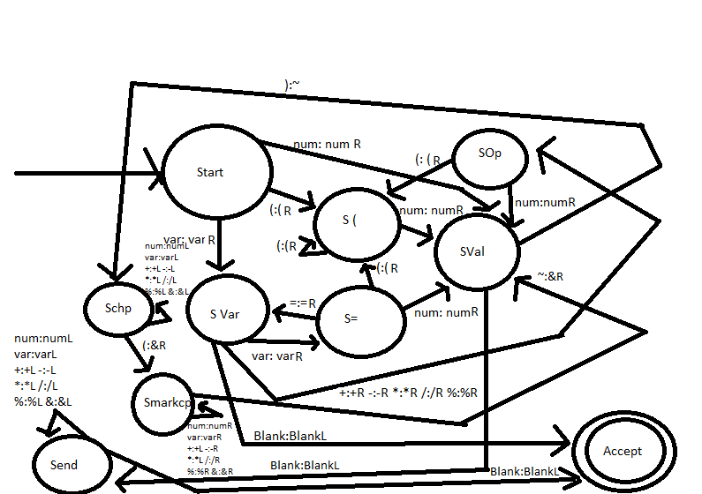

Robert Szkutak

CSIT 321 – Paradigms of Programming Languages

Assignment 1

//Written by Robert Szkutak

int index = 0;

string input;

main() {

input = getinput();

A();

}

A() {

If(index+1 == ‘=’) {

Index++;

Index++;

A();

}

If(index == ‘’ || index == ‘!’)

BN();

D();

}

BN(){

Index++;

B();

}

B(){

R();

If(index == ‘^’ || index == ‘|’){

BO();

R();

}

}

BO(){

Index++;

}

D(){

If(index+1 == ‘%’){

Index++;

If(index+1 == ‘(‘)

A();

D();

}

Else {

E();

}

}

E(){

If(index+1 == ‘+’ || index == ‘/’){

Index++;

If(index+1 == ‘(‘)

A();

E();

}

Else {

T();

}

}

T(){

If(index+1 == ‘\*’){

Index++;

If(index+1 == ‘(‘)

A();

T();

}

Else {

F();

}

}

F(){

If(index+1 == ‘-’){

Index++;

If(index+1 == ‘(‘)

A();

F();

}

Else {

G();

}

}

G(){

Index++;

}

R(){

D();

If(index == ‘<’ || index == ‘>’ || index == ‘!’ || index ==”#” || index == ‘>=’ || index == ‘<=’ || index == ‘==’) {

RO();

D();

}

}

RO(){

Index++;

}