PrePost_CBCL_6.0.R_README
Robert Toms, robert.toms@utdallas.edu

README SECTIONS:
- Purpose of Code
- Key Tips for Use
- Researcher-facing Explanation of Code
- Explanation of Variables
- Methods Section Summary
- References

PURPOSE OF CODE:
The purpose of this code is to calculate change scores in Internalizing and Externalizing symptoms on the Child Behavioral Checklist (CBCL) from pre to post menarche.

KEY TIPS FOR USE:
ChangeScore is the primary outcome variable of this code, made by subtracting Pre_CBCL_Score from Post_CBCL_Score. There are a few subjects who are missing CBCL scores for their exact premenarche and postmenarche report dates—these had “best-fit” scores assigned, and length of time in days between used PLE scores and pre/post menarche reports has been calculated and saved to “PreMenScore->PreMenReport” and “PostMenScore->PostMenReport”. For information on how menarche data were arrived at, consult PrePost_Menarche_6.0.R and its readme.

RESEARCHER-FACING EXPLANATION OF CODE:
- Counts of subjects are interspersed throughout the code. Flowcharts of these counts can be found in the Methods Section Summary below, and the Outputs folder.

- All columns of interest are enumerated below in the Explanation of Variables section, in order of appearance. Dataframes in this explanatory section with “Int/Ext” in the name refers to both Internalizing and Externalizing versions of the dataframe in question.
  - e.g. int/ext_youth = int_youth & ext_youth

- Derivative ABCD 6.0 menarche data were imported for youth (Youth_PrePost_Menarche_11_21_25.csv) and parent (Parent_PrePost_Menarche_11_21_25.csv) reports. These were used rather than raw data because they contain predetermined variables for when participants switched from premenarche to postmenarche (last_pre_session, first_post_session). Additionally, CBCL Internalizing and Externalizing data (mh_p_cbcl.tsv) and interview date data (ab_g_dyn.tsv) were imported.

- Clean and Prepare Data
  - Useful columns were kept and renamed for human readability, if necessary.
  - Timepoints with Data: Chronological list vectors of which sessions each subject had CBCL data for were constructed and saved to has_cbcl_data
    - e.g. c(“0”, “1”, “2”, “4”, “5”) = has CBCL data for sessions 00A, 01A, 02A, 04A, and 05A.
  - CBCL Scores in Chronological Order: Chronological list vectors of each subject’s CBCL scores were constructed and saved to cbcl_scores
    - e.g. c(“15”, “12”, “15”, “30”, “13”, “21”, “0”) = score of 15 for ses-00A, 12 for ses-01A, etc.
    - Raw Aggregated CBCL scores (mh_p_cbcl__synd__ext_sum, mh_p_cbcl__synd__int_sum) were used as CBCL scores because of they are most consistently used in extant ABCD literature
  - CBCL data and menarche data are merged into int/ext_parent and int/ext_youth, for parent and youth menarche reports, respectively

- Find Best-Fit PreMenarche and PostMenarche Sessions with CBCL data
  - Wrote 2 functions:
    - find_pre_cbcl_session: finds the location index of the value in the has_cbcl_data list vector (1-7) corresponding to the session (with score data) that matches or most closely precedes a participant’s last premenarche report, will get saved to CBCL_PreSession_index
      - Example
        - last_pre_session = 3
        - has_cbcl_data = c(“0”, “1”, “2”, “4”, “5” “6”)
        - finds “2” value, 3rd item in vector, PreScoreIndex = 3
    - find_post_cbcl_session: finds the location index of the value in the has_cbcl_data list vector (1-7) corresponding to the session (with score data) that matches or most closely follows a participant’s first postmenarche report, will get saved to CBCL_PostSession_index
      - Example
        - first_post_session = 4
        - has_cbcl_data = c(“0”, “1”, “2”, “4”, “5”, “6”)
        - finds “4” value, 4th item in vector, PostScanIndex = 4
  - Applied the find_premenarche_score & find_postmenarche_score functions to youth and parent reports
  - Used the indexes (CBCL_PreSession_index, CBCL_PostSession_index) to identify the timepoints with score data most closely associated with premenarche and postmenarche reports
    - Examcbcl
      - has_cbcl_data = c(“0”, “1”, “2”, “4”, “5” “6”)
      - CBCL_PreSession_index = 3, 3rd item is “2”, ses-02A has the best-fit premenarche scan, “0” is saved to CBCL_PreSession
      - CBCL_PostSession_index = 4, 4th item is “4”, ses-04A has the best-fit postmenarche scan, “4” is saved to CBCL_PostSession
  - Pulled the CBCL Scores associated with CBCL_PreSession (Premenarche score) and CBCL_PostSession (Postmenarche score), saved to Pre_CBCL_Score and Post_CBCL_Score, respectively

- Calculate Pre/Post Difference Scores
  - Sanity Check—check for subjects that have premenarche and/or postmenarche reports that don’t have corresponding best-fit CBCL scores
    - All without scores for menarche events did not have premenarche or postmenarche CBCL scores, as appropriate
  - Calculate Pre/Post Change Scores
    - Subtracted Premenarche score from Postmenarche score (Post_CBCL_Score - Pre_CBCL_Score), saved to ChangeScore

- Days between Data collection and/or days between menarche report and data collection
  - Interview dates were formatted so they could be systematically pulled and subtracted from each other, then merged in with CBCL/Menarche data
    - Saved as a chronological list vector “interview_dates”
  - Calculating Date Differences
    - Number of days between best-fit premenarche and postmenarche scores, saved to “between_scores”
    - Number of days between last premenarche and first postmenarche reports, saved to “PreMen->PostMen”
    - Number of days from best-fit premenarche Score to last premenarche report, saved to “PreMenScore->PreMenReport”
    - Number of days from first postmenarche report to best-fit postmenarche score, saved to “PostMenReport->PostMenScore”

- Clean and Reorder dataframes for CSV export
  - cbcl_scores was converted to a string to retain readability while affording the ability to be written into a csv
  - Necessary columns are kept and reordered
  - Itemized menarche reports were renamed and merged in for reference

- Write to CSV
  - int_youth -> Youth_PrePost_IntCBCL_12_1_25.csv
  - ext_parent -> Youth_PrePost_ExtCBCL_12_1_25.csv
  - int_parent -> Parent_PrePost_IntCBCL_12_1_25.csv
  - ext_parent -> Parent_PrePost_ExtCBCL_12_1_25.csv

- Get Counts
  - Made dataframes for counting exclusions
  - Determined why subjects with valid pre/post menarche scores were missing CBCL Change scores
    - Youth: 40 subjects missing, 39 no PostMenarche CBCL data, 1 no PreMenarche CBCL data
    - Parent: 2 subjects missing, both had no PostMenarche CBCL data

EXPLANATION OF VARIABLES

participant_id | ABCD Participant Identifier
session_id | ABCD Visit Identifier
last_pre_session | Numeric version of session with last premenarche report
first_post_session | Numeric version of session with first postmenarche report
PostMenarche_at_Baseline_Y1N0 | Flags everyone who was postmenarche at first visit, Yes = 1 and No = 0
PreMenarche_at_LastReport_Y1N0 | Flags everyone who was premenarche through 6.0, Yes = 1 and No = 0
Inconsistent_Reporting_Y1N0 | Flags everyone who reported being premenarche after reporting bein postmenarche  e.g. c(“0”, “0”, NA, “1”, “0”, “1”, “1”) = c(Pre, Pre, NA, Post, Pre, Post, Post)
mh_p_cbcl__synd__int_sum  mh_p_cbcl__synd__ext_sum | Aggregated Sum of Internalizing/Externalizing CBCL endorsements, raw score. Also referred to as CBCL Score.
sesnum | Numeric version of session_id; ses-00a = 0, ses-01A = 1, etc.
has_cbcl_data | Chronological list vector of sessions with CBCL data; c(“0”, “1”, “2”, “4”, “5”) = subject has CBCL data for sessions 00A, 01A, 02A, 04A, and 05A.
cbcl_scores | Chronological list vector of CBCL Score values;  c(“15”, “12”, “15”, “30”, “13”, “21”, “0”) = score of 15 for ses-00A, 12 for ses-01A, etc.
find_pre_cbcl_session | finds the location index of the value in the has_cbcl_data list vector (1-7) corresponding to the session (with score data) that matches or most closely precedes a participant’s last premenarche report, will get saved to CBCL_PreSession_index
find_post_cbcl_session | finds the location index of the value in the has_cbcl_data list vector (1-7) corresponding to the session (with score data) that matches or most closely follows a participant’s last postmenarche report, will get saved to CBCL_PostSession_index
CBCL_PreSession_Index | Location in has_cbcl_data list vector (1-7) of the value that matches or is the best-fit for last premenarche report
CBCL_PostSession_Index | Location in has_cbcl_data list vector (1-7) of the value that matches or is the best-fit for last postmenarche report
CBCL_PreSession | PreMenarche CBCL session: Numeric version of the session with score data best-fit matched to last premenarche report
CBCL_PostSession | PostMenarche CBCL session: Numeric version of the session with score data best-fit matched to first postmenarche report
Pre_CBCL_Score | PreMenarche Score: CBCL score from the session best-fit matched to last premenarche report
Post_CBCL_Score | PostMenarche Score: CBCL score from the session best-fit matched to first postmenarche report
PreFlag | Yes = 1 No = 0 Flag, signals if a subject has a last premenarche report and no corresponding CBCL score
PostFlag | Yes = 1 No = 0 Flag, signals if a subject has a first postmenarche report and no corresponding CBCL score
ChangeScore | Post_CBCL_Score – Pre_CBCL_Score; change in CBCL severity score from premenarche to postmenarche
ab_g_dyn__visit_dtt | Datetime of each subject’s interview
interview_date | Date of each subject’s interview, ab_g_dyn__visit_dtt without the time
interview_dates | Chronological list vector of interview_date ‘s
between_scores | Number of days between PreMenarche CBCL score date (PreScore_date) and PostMenarche CBCL Score date (PostScore_date)
PreMen->PostMen | Number of days between PreMenarche report and PostMenarche report
PreMenScore->PreMenReport | Number of days from PreMenarche CBCL score date (PreScore_date) to PreMenarche report
PostMenReport->PostMenScore | Number of days from PostMenarche report to PostMenarche CBCL score date (PostScore_date)
00A_menarche_report | ses-00A menarche report:  Premenarche = 0, Postmenarche = 1
01A_menarche_report | ses-01A menarche report:  Premenarche = 0, Postmenarche = 1
02A_menarche_report | ses-02A menarche report:  Premenarche = 0, Postmenarche = 1
03A_menarche_report | ses-03A menarche report:  Premenarche = 0, Postmenarche = 1
04A_menarche_report | ses-04A menarche report:  Premenarche = 0, Postmenarche = 1
05A_menarche_report | ses-05A menarche report:  Premenarche = 0, Postmenarche = 1
06A_menarche_report | ses-06A menarche report:  Premenarche = 0, Postmenarche = 1

Methods Section Summary:

To facilitate analysis of changes in Internalizing and Externalizing Child Behavior Checklist (CBCL) severity from premenarche to postmenarche, we compared raw CBCL Internalizing and Externalizing aggregate scores (mh_p_cbcl__synd__int_sum, mh_p_cbcl__synd__ext_sum; mh_p_cbcl.tsv) to predetermined last premenarche reports and first postmenarche reports to find matching sessions or sessions of best-fit, then calculated differences. To accomplish this for each participant, lists of sessions with CBCL score data were compiled. Sessions matching and/or preceding the participant’s last premenarche report were separated out, and the score associated with the latest of these sessions was deemed the “best-fit” premenarche score. Similarly, sessions matching and/or following the participant’s first postmenarche report were separated out, and the score associated with the first of these sessions was deemed the “best-fit” postmenarche score. The premenarche CBCL score was then subtracted from the postmenarche CBCL score to get a Change Score.

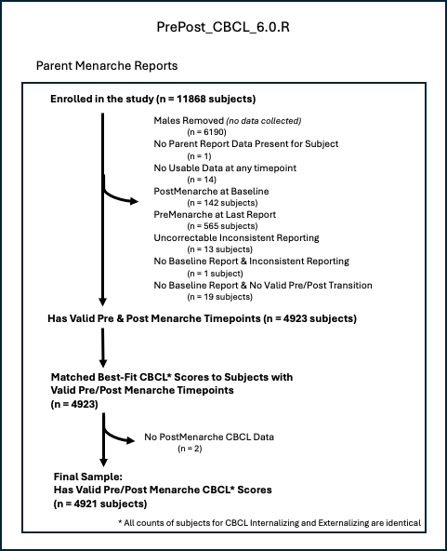

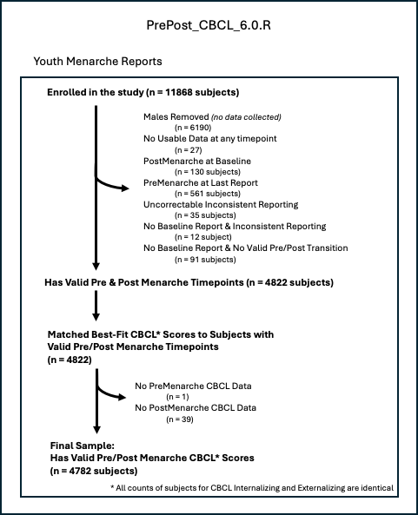

References:

