Required equipment
Indoor setup
- RPi x 3 with SD cards;
- 3 RPi Type C power supply adapters;
- 1 portable power bank and Type C power connector cable;
- 1 RPi camera;
- 1 RPi camera flex cable;
- 1 stepper motor;
- 1 small reduction stepper motor driver suitable for RPi;
- 5V passive buzzer;
- 6 female to female jumper cables;
- 2 female to male jumper cables;
- RPi Sense Hat;
- Wifi dongle with SIM card and internet connection;
- Laptop;
- SD flash drive;
- Television with HDMI connection;
- HDMI cable;
- Mouse;
- Keyboard.
Outdoor setup
If you want to set your Zonescanner in a remote location, you will need in addition to the above:
- Leisure battery;
- 12V/24V to 240V AC inverter; and
- Additional material to protect the Zonescanner from the elements.

Please note that I have omitted the manufacture of the rotating stand and weatherproofing the project for the purposes of this assignment.

How to set up the project from scratch
The completed project for indoors:
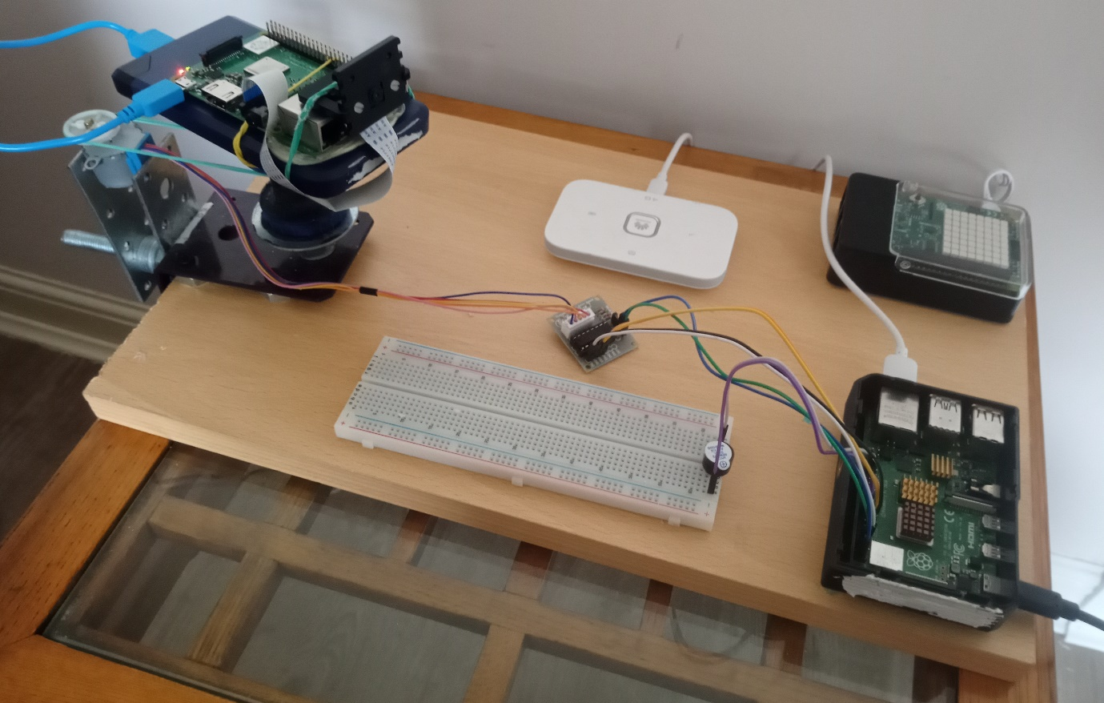

- Install VNC Viewer onto the laptop
The first step is to install VNC Viewer onto your laptop, instructions are available from the software manufacturer:
Download VNC Viewer for Windows | VNC® Connect (realvnc.com)
VNC Viewer on the laptop will not be used again until stage 7.

- Install Linux Raspian OS on all three RPis
Download an OS image and the RPi imager from Raspberry Pi OS – Raspberry Pi onto the laptop. Even though it is not the most up to date version, we chose bullseye OS for all three RPis because it ran the given Python code without errors.
Insert the flash drive with SD card into the laptop and run the RPi imager GUI. This process prepares the SD card as a hard drive containing the Raspian operating system for the RPi.
Repeat this process for the two remaining SD cards.
STAGES 3 TO 8 must be carried out on one RPi at a time.

- Start up RPIs one at a time
At this stage the RPi must be connected to the TV for the initial settings to be configured.
Insert the SD card into the RPi. Connect the RPi to the TV with the HDMI cable. Also connect the mouse and keyboard into USB ports on the RPi. Power up the RPi. Adjust the TV settings to the HDMI port that the RPi is connected to.
After some initial loading, the TV screen will show the RPi Desktop and you will be prompted to choose a user name and password. The standard “pi” user name is recommended at this stage. Go through all set up options and connect the wifi making sure to save the password. Make sure that you connect to the same wifi dongle as the laptop and that it has an internet connection.

- Update operating system
Even though the RPi is now running on a newly downloaded image, it may still require updating and upgrading. Open the Terminal and type the following commands:
$ sudo apt-get update
$ sudo apt-get upgrade
This may take some time but allow the RPi to finish and select “yes” when prompted for the upgrade command. Reboot RPi.

- Enable VNC on RPi
VNC should already be installed on your RPi as part of the Raspian OS. Navigate to Preferences -> Raspberry Pi Configuration on the start menu. Click on the Interfaces tab and enable VNC.

- Note log-in details and RPi IP address
Staying in Raspberry Pi Configuration, click on the System tab and check that Auto-Login is set to “Log in as user ‘pi’” and Network at Boot is set to “do not wait”. The username will later be changed for security purposes but it can be left as ‘pi’ at this stage. Change the hostnames to “sinkPi”, “cameraPi” and “senseHatPi”.
Exit the GUI and go back to the Terminal. Enter the “$ ifconfig” command and note the IP address of the RPi.

- Connect to VNC
Do not remove the RPi from the TV until stage 8 is complete. If the RPi and laptop are not connected to the same dongle the VNC connection will fail.
Open VNC Viewer in your laptop and choose File -> New Connection. Enter the details collected in stage 6 above and connect.
You should now be able to see the RPi Desktop from your laptop as well as the TV.
- Restart the RPi to check wifi auto login
Reboot the RPi. If it has automatically connected to the same wifi dongle as your laptop and your VNC connection continues to function you may now disconnect the RPi from the TV.
If this is not the case, persevere with previous steps until the RPi can automatically connect to wifi and connect to the laptop before disconnecting the RPi from the TV.
If the RPi Desktop is not showing properly on the laptop VNC Viewer, return to the RPi Terminal and enter the “$ sudo raspi-config” command which will take you to the RPi configuration tool. Select Display Options -> Resolution and then select a higher resolution that you are operating on at present. Exit the configuration tool and reboot the RPi.
The RPi can now be controlled entirely from the laptop and the TV should no longer be required for this RPi.
Repeat this procedure for the two remaining RPis.
Using the power bank for the cameraPi is not required until final assembly.
Note: Always shut down an RPi from the start menu, pulling out the power cable could lead to damage to the SD card and the operating system.

- Control all three RPis from the laptop
Now all three RPis should be connected to the laptop by VNC Viewer and the TV, HDMI cable, keyboard and the mouse can be set to one side bringing an end to a potentially frustrating stage of setting up the project.

- Install MQTT, paho client and test connection
MQTT software is used to send data between the RPis and this needs to be installed from the Terminal.
The sinkPi will receive and store the data gathered from the senseHatPi and cameraPi and MQTT broker software must be installed for this to be work. Here is a general video on how to do this:
Pi Guide - Raspberry Pi as a MQTT Broker | Install Mosquitto on Raspberry Pi - YouTube
You will need to set up clients and a broker with a channel called “Alarm”. Once you have set these up try it out in the terminal otherwise the MQTT sections of the provided Python code will not work.
You should also install paho client for MQTT.
Eclipse Paho | The Eclipse Foundation
At this stage you need to allow anonymous login to the MQTT broker:
MQTT Allow anonymous login - Configuration - Home Assistant Community (home-assistant.io)

- Connect hardware
Make sure that all three RPis are shut down and powered off before carrying out this stage.

senseHatPi
Plug the Sense Hat into the senseHatPi as shown here:
https://www.youtube.com/watch?v=lsBNtxpm_Rk

sinkPi
The dongle can be plugged into a USB port of the sinkPi as there will be enough power available for this purpose in addition to other demands that will be placed on the sinkPi. For other concerns regarding power usage, see the comments within the provided Python code.
Please note that the Python code used in this project uses the GPIO.BOARD set up meaning that the top left pin is referred to as “1” and not 3V3 power as shown on this diagram:

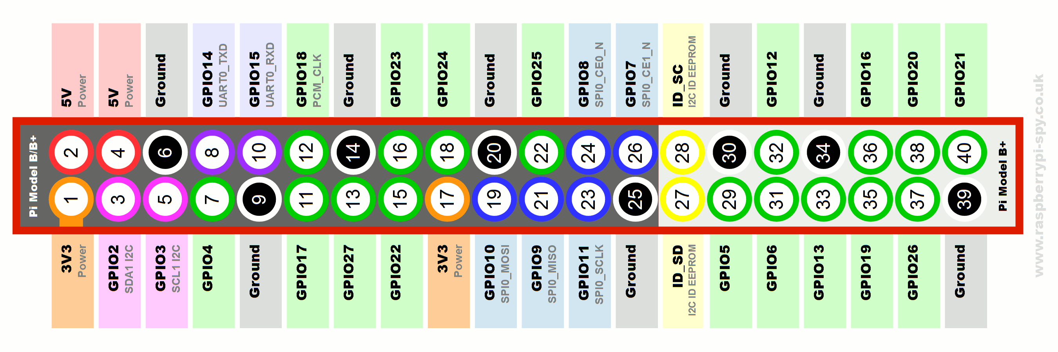

Connect female to male jumper cables to pins 18 and 34. Pin 34 is a ground pin and in the provided Python code, GPIO pin 18 will be turned on and off giving power to the buzzer when desired.
Place the male cable ends in the breadboard as shown and make sure that the longer of the two connectors for the buzzer matches to the pin 18 side of the breadboard. Fitting it the other way around will result in the buzzer not working:

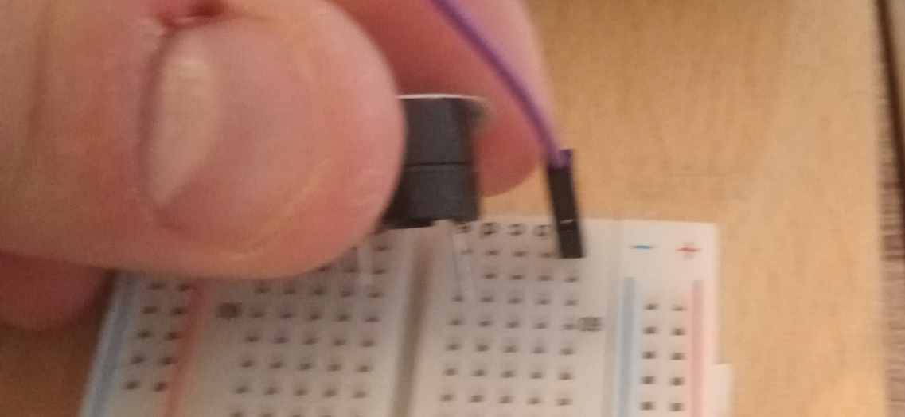

Four female to female jumper cables should be connected to GPIO pins 7, 11, 13, 15 and these connect directly to the stepper motor driver as shown. These cables provide power to the driver in a sequence which in turn powers magnets within the stepper motor so it is imperative that the correct pins are used otherwise the stepper motor magnets will activate in the wrong order. The Python code is written so that the 5V buzzer and the 5V stepper motor are never powered at the same time which would cause the RPi to crash. Also, two further female to female cables shown in the photo as blue and green should be connected to GPIO pins 2 and 6 providing 5V power and an earth respectively.

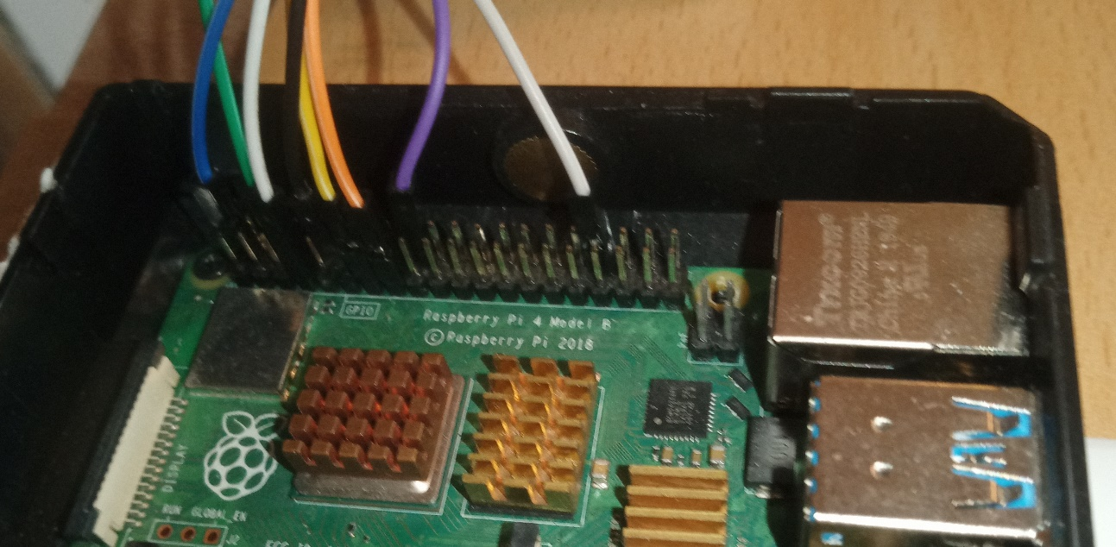

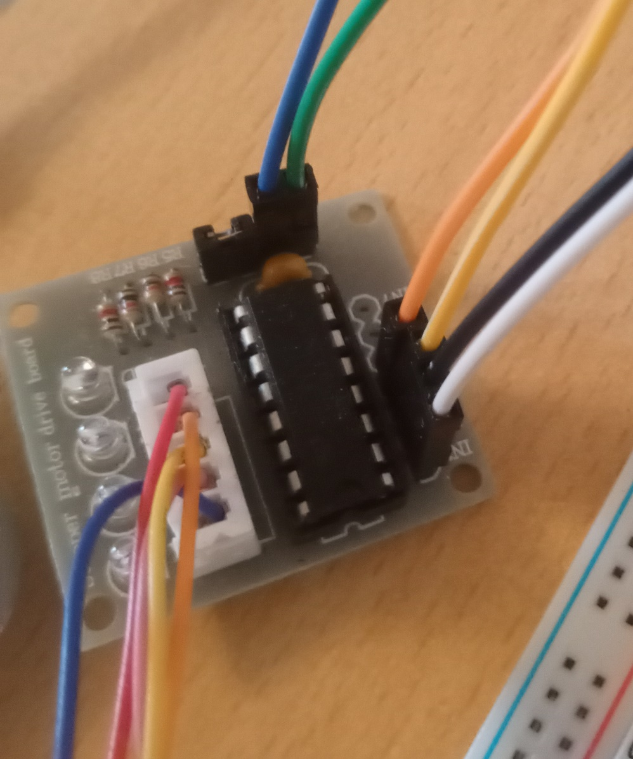

cameraPi
Connecting the camera to the RPi can be trickier than expected, please see a guide on how to do so here:
https://projects.raspberrypi.org/en/projects/getting-started-with-picamera
If the camera is correctly installed, open the Terminal and the following command should take and save a jpg photo with the name first_image.jpg in the specified directory:
$ raspistill -o ~/Pictures/first_image.jpg
If you manage to take an image with this command, your cameraPi should handle the image recognition code provided otherwise please refer to the Q&A section of the image detection software installation referred to in stage 13.

- Copy Python code to sinkPi and sensePi
The buzzer-motor-csv Python code should be copied to the Desktop of the sinkPi and the send_alarm Python code should be copied to the Desktop of the sensePi. Both of these scripts will be executed later from Thonny IDE which should already be installed as part of the bullseye operating system.

- Install image recognition software on cameraPi
The installation and amendment of image recognition code on the cameraPi is a lengthy process. The majority of the code is taken from an online project and excellent installation instructions and a Q&A forum are available here:
Object and Animal Recognition With Raspberry Pi and OpenCV - Tutorial Australia (core-electronics.com.au)
Once this process is complete you should be able to run all three RPis and achieve the same result as shown in demo film included with these instructions. However, in order to gather meaningful data the image recognition code needs to be altered and this is already provided as the run_object_recognition.py Python code.
Do not run the object-indent Python code that comes with the tutorial as this will output the image detection process in real time and this will place a greater load on the cameraPi than required and will not output the data as shown in the demo film.

- Consider making the device more secure
The software installation is now complete but it would be wise to take the following steps to ensure that the device is made safer from tampering and hacking:
- Hide device to deter theft and cloning attacks;
- Password protect your dongle;
- Password protect the VPN connection;
- Choose a different user name than “pi” for the RPis – it is far too common among RPi operators to leave this as standard; and
- Disable anonymous login for MQTT.

- Enable SSH and allow password free login
The run_object_recognition.py code requires SSH to transfer the accumulated image files to the sinkPi. Go to Preferences -> Raspberry Pi Configuration and enable SSH.
To allow log in without password, you will need to set up a key in the cameraPi and copy it to the sinkPi by following these steps:
3 Steps to Perform SSH Login Without Password Using ssh-keygen & ssh-copy-id (thegeekstuff.com)

- Build the Zonescanner project and take it to a suitable location
Now that the software and hardware are set up, you need to make the rotating stand as shown in the diagram and attach the various bits of hardware to a secure board. You now have a Zonescanner. If you wish to leave the Zonescanner at a location with no mains power we suggest that you take measures to protect it from the elements and that you take power from a 12V leisure battery attached to an AC inverter. This power supply set up requires no more maintenance than an electric fence powered by a leisure battery. Remember to bring your laptop and power off all RPi’s via VNC Viewer before changing the leisure battery.
A leisure battery will easily power the sinkRPi and the cameraRPi for a few days. If you want to use the spinning stand the cameraPi will need to take power from a power bank otherwise the cables powering the stepper motor will become entangled within a short period of time.

- Execute the three Python scripts and gather data
Once everything is set up and ready to go, simply power on the three RPis and connect by VNC to your laptop.
The three Python scripts will not automatically log on boot rather you will need to execute them from the Thonny IDE.

Otherwise, your device is now active and collecting data.

If you got this far, well done to you both.

