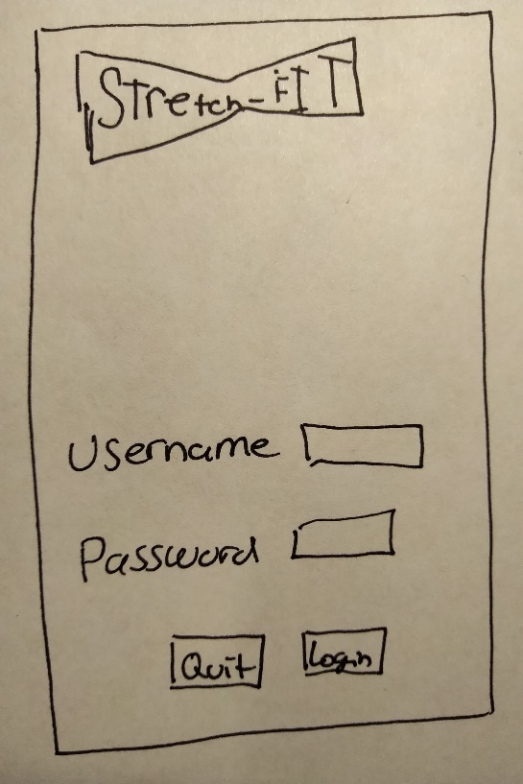

\Create account

Screen the user will first encounter when opening the Stretch Fit application.

Login

* Unique username – not used
* Unique password
* Unique email – never been used
* Login
* Correct username
* Correct password
* Incorrect username
* Incorrect password
* Ask for username sent to email
  + Provides link to username
* Ask for password sent to the email
  + Provides link to reset password

**Sync Cuff Button**

* Confirms Bluetooth is on
  + Verifies connection is made successfully
  + If fails, then verify user has cuff turned on
    - Verify Bluetooth is on
    - Ask to reconnect once Bluetooth and cuff are on
  + Lights upper banner green if connected
  + Lights upper banner red if not connected
* Requires Bluetooth type of phone
* Requires Bluetooth type on cuff
* Requires from database that the cuff and phone are on the same piconet (PAN) Radio frequency that only the device and phone share
* Requires battery charge from cuff device
* Requires signal strength of the piconet between the cuff and the phone
* If the device reports that it is connected
  + Send the data to the top ribbon
    - Display Connection strength
    - Display battery level of cuff.

Screen user will encounter when correctly logging in.

Homescreen

**Quick Start Button**

Screen user will encounter when correctly logging in.

Homescreen

* Verify user wants to start workout
* Verify that cuff is connected
* Ask what work-outs user wants to do
  + Upper, lower, full body, custom

Ask user to select from list the workouts he/she wants to do

* If selected make button to create workout visible
  + Ask user if they would like to add workouts from their analytics page that needs improvement.
    - Make a “Yes” or “No” button visible
      * If “Yes” then add selection process to pick the workouts that they we’re weak in.
        + Take selection and add to the custom selection screen
        + Make button “Start” and “Quit” visible

If “Start” take user to workout screen

If “Quit” take user back to home screen

* + - * If “No” then make button “Start” and “Quit” visible
        + If “Start” take user to workout screen
        + If “Quit” take user back to home screen

Screen user will encounter when correctly logging in.

Homescreen

**Training Program Button**

* Confirms if user wants to continue coaching plan
  + If “No” takes user to workout screen
  + If “No” close confirmation screen

Screen user will encounter when correctly logging in.

Homescreen

**Progress Button**

* Request user’s data from database
* Request’s user’s analytical data from database
  + Success
  + Fails
  + Last workout day
  + Time per workout
  + Time for week
  + Time for month
  + Last QuickStart info
  + Last upper success & failures
  + Last lower success & failures
  + Last full body success & failures
  + Success rate per specific exercise
  + Failure rate per exercise
  + (What can be imp0roved per workout, per upper, lower, full)
  + (What’s mastered per upper, lower, full)
* Requests user’s profile name, picture, cuff type, age, weight, height, sex(male/female)
* Packages it and sends the package to the progress screen

Screen user will encounter when correctly logging in.

Homescreen

**Social Button**

* Request’s user’s data from database
  + Request user’s profile name, real name, age, sex
  + Requests success & fails in an overall percentage for the day, week, month, with upper, lower, full body
* Packages it and sends it to social page.

**Account Button**

Screen user will encounter when correctly logging in.

homescreen

* Requests from database
  + Users
    - Name
    - Address
    - Phone number
    - Membership type
    - Preferred payment method
    - Sex
    - Age
    - Music credentials
    - Social media credentials
    - Email address

**Help Button**

Screen user will encounter when correctly logging in.

Homescreen

* Sends user to help page

**Logout Button**

Screen user will encounter when correctly logging in.

Homescreen

* End the connection to the cuff’s radio signal
* Send
  + QuickStart
  + Training program
  + Progress, social
  + Account
  + Sync data dumps to database (final)
* End connection with database
* Display to user they are now logged off.
* Remind user to turn off there cuff

**Music Footer**

Screen user will encounter when correctly logging in.

Homescreen

* Requests from database
  + Music service
    - Pandora
    - Spotify
    - Apple Music
    - IHeart Radio
    - YouTube Music
    - Amazon Music
    - Deezer
* Requests from data base users’ credentials relating to music service
  + Use API relating to music service from database

**Ribbon**

Screen user will encounter when correctly logging in.

Homescreen

* Request profile image from database relating to my account
* Request signal and battery cuff information from database, being relayed by the home screen sync button.

**Main Screen**

Screen user will encounter when correctly logging in.

Homescreen

* Requests date last worked out from database, being relayed by progress page
* Requests last workout type
  + Upper, lower, full body from database being relayed by progress page
* Requests top success specific workout from database being relayed by progress page
* Requests name from database being relayed from my account
* Request areas to focus on by the least successful workout from last session being relayed by progress page
* Request workout type from database relayed by training program
* Request GIF from database
* Clear Screen and Input workout from QuickStart or training program when user begins their workout

