Lay-laid-laid放置

Lie-lay-lain

fair颜色比较浅的

Rear children养育孩子

rear后面的

fair迷人的，公平的，头发颜色浅的

光泽luster

lust欲望

propeller螺旋桨

Tail尾翼

梅花club

方片diamond

红桃heart

黑桃spade

dye染色

tie系

deaf-mute聋哑人

Come to a halt停止，停顿

turf草皮;(铺草坪用的)草皮块;泥煤;泥炭;泥煤块;泥炭块;赛马;（自己的）地盘，势力范围、

So it is

By god= in God’s namea

Might as well也，做a的时候不妨把b也做了

You have no business doing sth

There is no sense in doing

It overpowered that other feeling of dread that had been with her during the morning.

Glow

Spark

Extinct

Volcano

a

A live volcano

A live show

A live video programme

A live performance一个现场

Tornado

Torpedo鱼雷

tuxedo燕尾服

As it were=as if it were so= so to speak

她闭上眼睛好像要重温往昔美好时光

She closed her eyes trying to relieve her past happy years as it were.

relieve重温

她好像生活在梦幻世界里

She was living in a dream world as it were.

Gerund动名词

Gerund phrase

Present participle分词短语

participle分词

Hateful

Detestable

Disgusting

Abhorrent

胡子

Beard

Moustache

Whisker

fair颜色浅的=blonde

Blonde金发女郎

Legally blonde律政俏佳人

She looked hardly more than a girl, red-checked and blue-eyed.

On fire with excitement热情澎湃的=full of ardor

ardor热情

ardent热情的，热忱的

He was on fire with excitement a this marvelous sight

Dejected=dishearten=in low spirits=dismayed=irritated

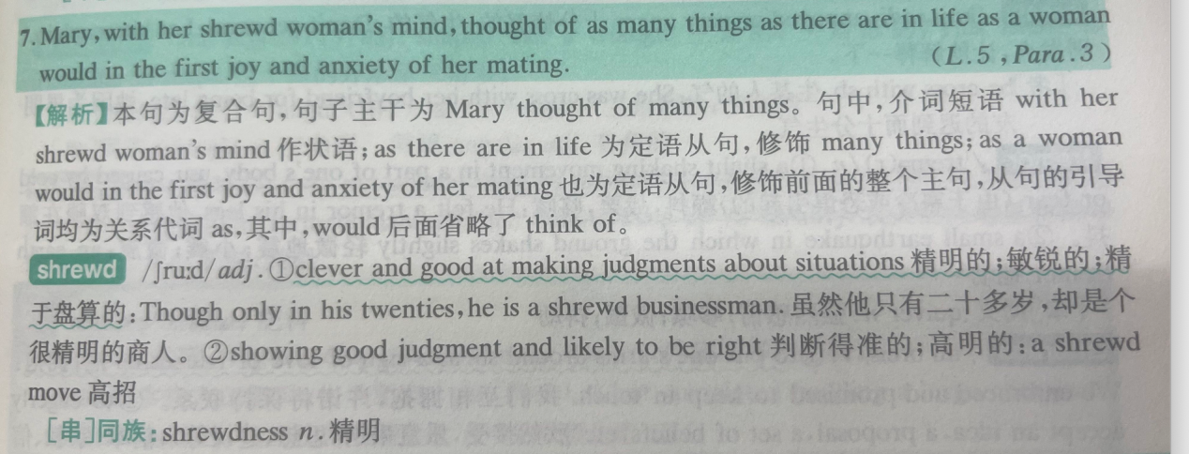

**Be better off=in more favorable position or financial circumstance**

**They would be better off flying than driving there.**

**They are not rich, but they are better off than most of their neighbors.**

**welfare福利**

**farewell告别**

**At all costs=by no means=at any rate**

**At this rate以这种速度**

**以这种速度我们永远不可能及时完成**

**超越surpass=overtake**

**Be overtaken by other countries**

**massacre大屠杀**

**acre英亩**

**Soul**

**Seoul**

**Heart and soul**

**在敌人的入侵之后，这个区域没有一个人幸存**

**There wasn’t a single soul left alive**

**他答应过不告诉任何人这件事情**

**He promised not to tell another living soul about this.**

**Rest sth on把，，，放在**

**Rest his crutch against the rail**

**willow柳树**

**pillow枕头**

**Sugarcane甘蔗**

**Rail**

**Widow寡妇**

**widower鳏夫**

**A cluster of cabins一堆小木屋**

**Luster有光泽的**

**lust**

**Take hold of=take control of**

**Take hold with sb在sb心中扎根，被sb接受，影响sb**

**He felt a strange excitement taking hold of him.**

**He made a decision that he won’t make the illness take hold again.**

**The idea will not take hold with these voters.**

**In the name of**

**Palm**

**Psalm赞美诗**

**Take xxx for xx=regard as**

**Take sb for**

**Take sth for granted认为，，，理所当然**

**Take us for fools把我们当成傻子**

**Nothing but仅仅是**

**Anything but绝不是**

**She speaks nothing but Greek.她只说希腊语**

**The ship’s crew gave him nothing but some bread.**

**Screw螺丝**

**screwdriver螺丝刀，鸡尾酒**

**Numb with cold**

**Draw back =withdraw=retreat退却**

**Must have done对过去事实的推测**

**Make a fire**

**Inch one’s way toward sb慢慢靠近某人**

**Get bold变得勇敢**

**bald秃顶的**

**Get bald在变的秃顶**

**Bold type加粗体字**

**I must have looked terrible for my mother drew back when she saw my face.**

**Turn up=Dig up and turn over翻起，铲起; 开大声，出现**

**Turn up at the meeting**

**Mislay -mislaid-mislaid错误放置**

**Mislead**

**Misunderstand**

**Bosom pocket**

**Bosom friend闺蜜，要好的朋友**

**Chain sth to=Be bound to束缚**

**binding force**

**Be bound for 地点 去往某地**

**The kitchen sink**

**Household chores**

**Attend to照顾，照料**

**Chain store连锁店**

**blossom开花**

**The man was lying there unconsciously, clenching his fists(his fists clenched)**

**疯狂地，猛烈地**

**Furiously**

**Fiercely**

**Ferociously**

**独立主格：**

**The young man thought about this for a moment, his head cocked to one side.**

**Secure=take hold of 努力保障，努力得到,With a tremendous effect**

**Manage to达到目的**

**Try doing试着做**

**Help do sth也行**

**Secure him the job双宾语：job和him没有主谓关系**

**Would no doubt help do sth**

**his head cocked to on side**

**The man was lying there unconsciously, clenching his fists.|**

**A cup of tea**

**A glass of water\bear**

**A tumbler of brandy**

**Goblet**

**A bowl of rice**

**Handful**

**A handful of crimes一小撮**

**Several mouthfuls of biscuits**

**Deprive sb of 剥夺某人的权利**

**Be deprived of = be robbed of被夺去，失去了**

**Distinctive**

**He has been deprived of the happiness which was his due**

**Be entitled to some right**

**Overpower**

**Dizzy**

**Dizziness**

**drizzle下蒙蒙细雨**

**I was overpowered by guilt and shame that I was unable to speak.**

**Shameless**

**shameful**

**Be shamed of对，，，感到羞愧**

**Robber**

**Robbery**

**Burglary入室盗窃**

**Revel in= take much pleasure**

**Level sth off夷为平地**

**Carry a long way声音传的很远**

**Drudgery苦工**

**宾语从句：形容词、动词后**

**Thick stick**

**拐棍：crutch**

**mutton羊肉**

**Lamb**

**Pork**

**Beef**

**address致辞**

**dress rehearsal带妆彩排**

**rehearse排练**

**他讲话经常带着一种突如其来的机智**

**A flash of 突如其来的，简短的，剧烈的**

**Make the utterance说话**

**Outweigh**

**outgrow比，，，长得大**

**Outwit**

**Wit**

**Shed**

**Hit upon**

**Cross one’s mind=Occur to sb\Strike to sb\dawn on sb**

**refuse加人=Turn sb down拒绝某人**

**Reject 具体的事**

**Decline+具体的事情**

**Might have done 对过去事实的推测**

**Antidote to corrupting influence**

**kidnap拐卖儿童**

**Sleeping car房车**

**The car is used for sleeping**

**Sleeping beauty睡美人**

**Onomatopia拟声词**

**He speaks with a bit of a lisp、**

**Have a sore eye**

**A sore loser**

**Integrity**

**Elixir万能药**

**contact lenses隐形眼镜**

**pedestrian行人**

**pavement人行道**

**pediatrician儿科医生**

**Dinosaur**

**jurisdiction司法权;审判权;管辖权;管辖区域;管辖范围**

**punctuality**