Thank you for participating in the Pocket Pollster Alpha Testing program. Your feedback is crucial to ensuring that when the product is sold that it will be as bug free and easy to use as possible.

This document consists of both a tutorial and a feedback form, in which you can incorporate your comments during testing. We hope you can devote as much time as possible to trying out every part of the software. Feel free to send one or more of these completed forms back to: info2@pocketpollster.com

Overview
Pocket Pollster is a mobile data collection application that allows you to quickly convert most any paper form into its digital equivalent. It's an easy-to-use tool that revolutionizes the way data is collected by an organization. Pocket Pollster can be used in one of two ways:
- In a traditional polling sense, with a pollster interviewing respondents.
- Gathering data when no respondents are involved.

Essentially, if a business process involves data being gathered on paper, then it can be done much faster and more accurately using Pocket Pollster.

Pocket PCs have long proven themselves as great extensions of the Microsoft Outlook information that many use on their desktop & laptop computers. Pocket Pollster extends this ability to most any kind of data that needs to be collected - by 1 person or by 1,000+.

The software works as follows:

- On a Windows computer, a person defines a series of questions and possible answers – on absolutely anything they want. All of this information is stored in a template. When they’re ready the template is "published", making it available to any number of Pocket PC users.
- From that point onward, every time a Pocket PC user synchronizes their device with this Windows computer, the template is copied over, if it isn’t already there.
- Away from their desk, they open the template and follow the instructions within, gathering information as they traditionally would with a pen and a paper form. They can repeat the series of questions over & over again until they’re done.
- When the mobile users next sync, the data they've collected is transferred back to the Windows computer, where it accumulates over time. This data and the corresponding statistics can then be analyzed at any point. Furthermore, automated export to a companion MS Access database file can be activated with just one-click.

Basic Info

Name: _____________________________

E-mail: _____________________________

Phone Number: ______________________

Pocket PC(s) you're using: _____________________________

Version of ActiveSync on your computer: _________________

Version of Windows you’re using: _________________

Approx. Test Period: _____________________ to _____________________

If you haven't already done so in previous correspondence, please briefly describe your profession and the industry you work in:

__________________________________________________________________________________

__________________________________________________________________________________

__________________________________________________________________________________

__________________________________________________________________________________

Marketing Question
As soon as you start using the product, you’ll quickly see that it has capabilities far beyond “polling”, in the traditional sense of the word. If you have any ideas about related products that could be sold & marketed separately, please feel free to describe them here, along with any catchy names you can think of.

Pocket Pollster – QuickStart
The remainder of this document will guide you through the basic operation of the application, as well as pose several questions to you. Feel free to add any & all other comments that are not adequately covered.

Assumptions
- Recommended minimum desktop/laptop resolution: 1024x768
- dotNet Framework 1.1 and/or 2.0 must be already installed.

- ActiveSync must be already installed and properly synching.
- To date, the software has been successfully installed & tested on a variety of different Pocket PCs using every version of ActiveSync between 3.8 and 4.5.

- In this document the term “desktop” is often used in a generic sense to refer to the Window-based PC that you’re using. But a laptop or Tablet PC will work equally well.

Initial Installation
To install the Pocket Pollster software, just double-click on the "Setup.msi" file that you’ve downloaded. The default location for the software installation is: C:\Program Files\Pocket Pollster

In this folder you will see one file called “PP.exe” and one folder called “MobileCabs”. There are also several hidden DLL files, which you’ll only see if your Windows Explorer is configured to show them.

“MobileCabs” contains several folders and files. These are the installation files that Pocket Pollster copies to a Pocket PC when one is synched with your computer.

After Pocket Pollster is run for the first time it adds a separate series of folders for holding the data files. The parent folder resides here:
C:\Documents and Settings\Your_UserName\Application Data\Pocket Pollster

It, and 3 folders inside it, hold your data files, also known as “PP files”. Here’s the overall structure:

Data | This is the main storage location for all data files. It’s where PP files are initially created. Later, they serve as containers to hold the data captured by the pollsters.
Templates | PP template files reside here, which will be uploaded to mobile device users when they next sync. They are only placed here when a poll creator decides to Publish them. Note: The original copies still remain in ‘Data’.
Incoming | This is where newly downloaded PP files, containing captured data, are stored. This is simply a temporary holding area, until these files are processed [automatically] by the software.
Archive | This is where populated PP files, after they’ve had their collected data retrieved, are placed. They’re renamed to reflect the username of the pollster and the date they were downloaded. At the moment this folder simply preserves these files for historical purposes.
Note: The sub-folders of “Data” are internal to the software and their contents should never need to be manipulated by the user. So they’re set to “Hidden”. They will only appear if your Windows settings allow hidden files & folders to be displayed.

Initial Installation Questions
Did the desktop installation work flawlessly? If not, please specify what problems or warnings occurred.

What version of the dotNet Framework is installed on your computer? (If you’re not sure, you can find out here: Start -> Control Panel -> Administrative Tools)

Desktop Usage
After the program is installed, you can start Pocket Pollster by either double-clicking on the “Pocket Pollster” icon on your Windows Desktop or by going to the Start menu and clicking:
Programs → Pocket Pollster → Pocket Pollster

There’ll be a delay of several seconds before the blue background screen appears. Over top of this a yellow dialog box will be shown. Since this is the very first time you’re running the software, you must enter your first name and last name, which will automatically create a username for you. Please enter your name and press “OK”.

To get things started, click File → New. This will create a new poll template entitled “Poll1”. You’ll see 3 large tabs near the top entitled “Questions & Answers”, “Instructions”, and “Settings”. You’ll be positioned on the first one, but take a quick look at the others and then return to “Questions & Answers”.

Questions & Answers
This is the primary page where a poll gets defined. Each poll is made up of a series of Questions, with one or more possible answers for each.

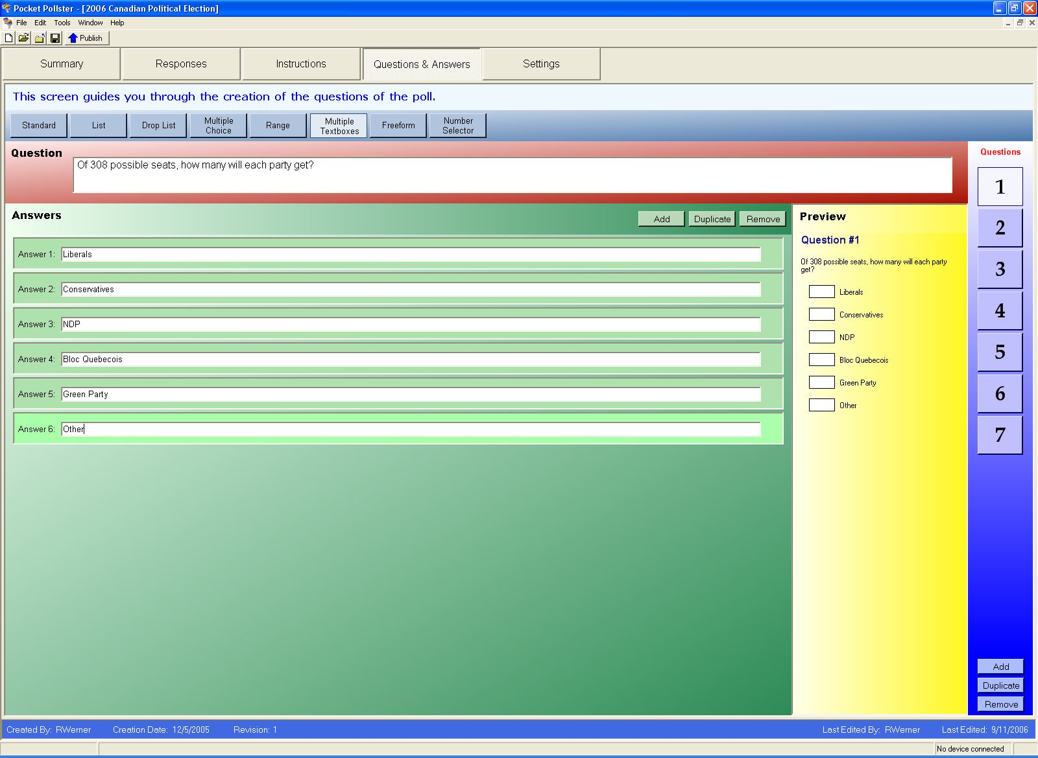

On the far right side you’ll see a large “1” inside a square button. This represents Question #1. Below this you’ll see “Add”, “Duplicate”, and “Remove” buttons.

Toward the top of the screen you’ll see a wide red panel entitled “Question”. Inside a textbox are the words “Enter your question here . . .” highlighted in blue. Start typing a question and what you type will replace this text. For purposes of this exercise, add this question: What is your favorite soft drink?

Press the “Tab” key or click in the textbox inside the green “Answer 1:” panel. When you do this you’re signifying to the software that you’ve completed entering the text of your question. Notice that in the yellow Preview panel, your question has appeared.

Every question can have one or more possible answers. On the upper-right side of the large green Answers panel you’ll see “Add”, “Duplicate”, and “Remove” buttons. Press the “Add” button several times and observe that additional answers are added. Nothing changes in the Preview panel though because the answers are still all blank. Let’s change that.

In the first 4 Answer textboxes, please add these answers: Coke Pepsi 7-Up Canada Dry
You can get to the next successive textbox by pressing Tab twice or by just clicking on it with your mouse. Notice that your answers start appearing in the yellow Preview panel.

Now look toward the top of the screen at the 8 blue rectangular buttons. The currently selected one is labeled “Standard”. These buttons represent the different kinds of Answer Formats available to you. Press the others and watch what happens in the Preview panel. In the cases of “Range” and “Number Selector” you will have to add additional info to complete the Answer definition.

The first four Answer Formats offer a feature called “Allow More Info”. Its purpose is similar to when you see “Other” on a paper questionnaire. The difference though is that this option can be added to any and all answers of a question, not just the last one.

The Preview pane is designed to be interactive, so feel free to try it out to get confirmation that your poll is coming together as you’re expecting. Though once you get the hang of designing a poll, it’ll probably suffice to just give this pane a quick glance periodically.

One of the subtler features on this page is how you change the order of Questions and Answers. For example, perhaps you decided later on that you want “Pepsi” before “Coke”. Changing the order is done through an intuitive drag & drop mechanism. Once you start dragging something, watch the thin black lines that help guide you to where the drop will occur.

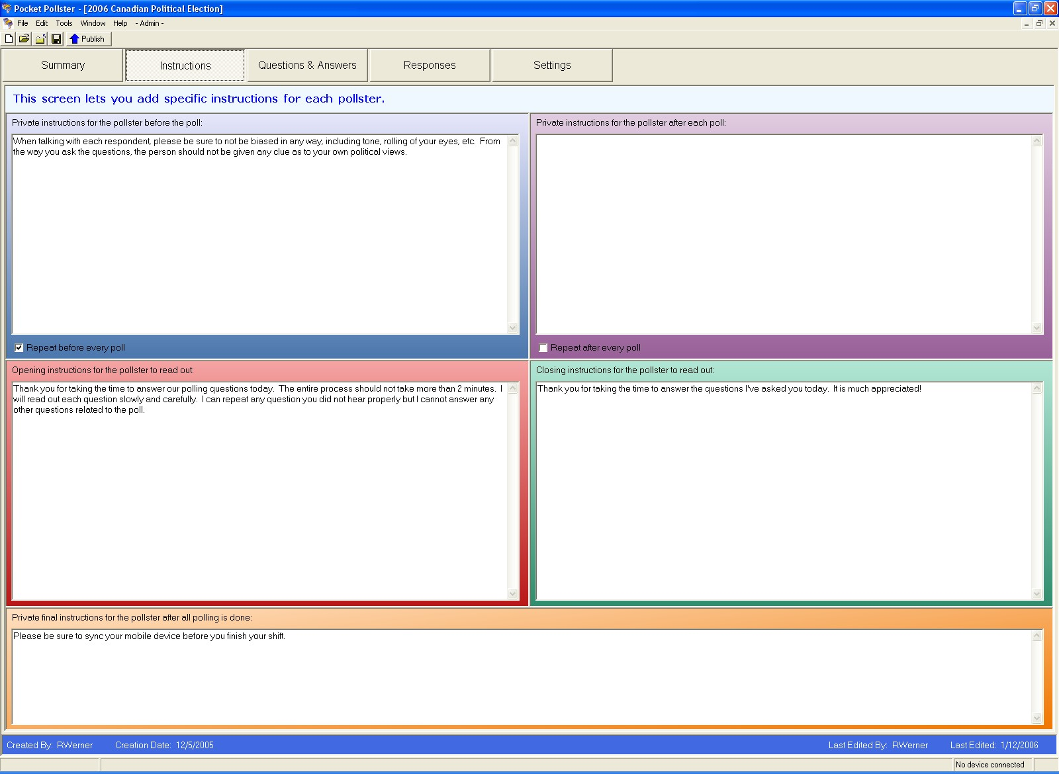
Instructions
It’s most often the case that the person creating the poll template is not the same one using it in the field. In fact, the poll creator may never even meet the pollsters face-to-face. Pocket Pollster provides an easy way to provide custom instructions to the pollsters. Click on the “Instructions” tab near the top of the screen. You’ll see four large equal-sized panels plus a fifth one at the bottom. These represent the 5 sets of instructions you can provide at different stages of the poll. Note: As mentioned earlier, a poll can be configured for those situations where data is not gathered from actual respondents. In this case, there will be only 3 sets of instructions available.

Settings
Click on the “Settings” tab near the top of the screen. Add one or two sentences to the summary – e.g. “Sample Survey for Testing”.

Only a few settings have been implemented on this page to date (many more are planned). Most should be fairly self explanatory but here’s a brief explanation of the less obvious ones:

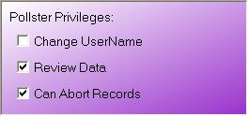
Pollster Privileges provide a finer degree of control over how a poll operates on a mobile device.
- Change UserName – Determines whether the pollster will be presented with a screen that allows them to change their username. If unchecked then this screen will not appear.

- Review Data – If unchecked then the pollster will not be able to review the data they’ve collected. This is useful in those circumstances when reducing the bias of the pollsters is of extreme importance.
- Can Abort Records – A pollster can press Finish to skip through a given set of questions. This is useful when the respondent leaves or for some other reason the questions can’t be answered. If this item is checked then the pollster will be asked whether they want to abort the record (not save it at all). If it’s unchecked then every record will be saved, even partially completed ones.

Export
Pocket Pollster has the ability to export the collected data to an MS Access Database. This can be done manually by selecting File → Export. But even more powerful is the auto-export feature. This can be activated with just one-click on the Settings page, though you can customize the location & name of the destination MDB file if you wish. This MDB file can exist anywhere on your network that you have access to.
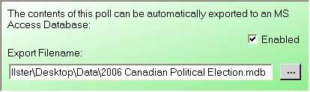

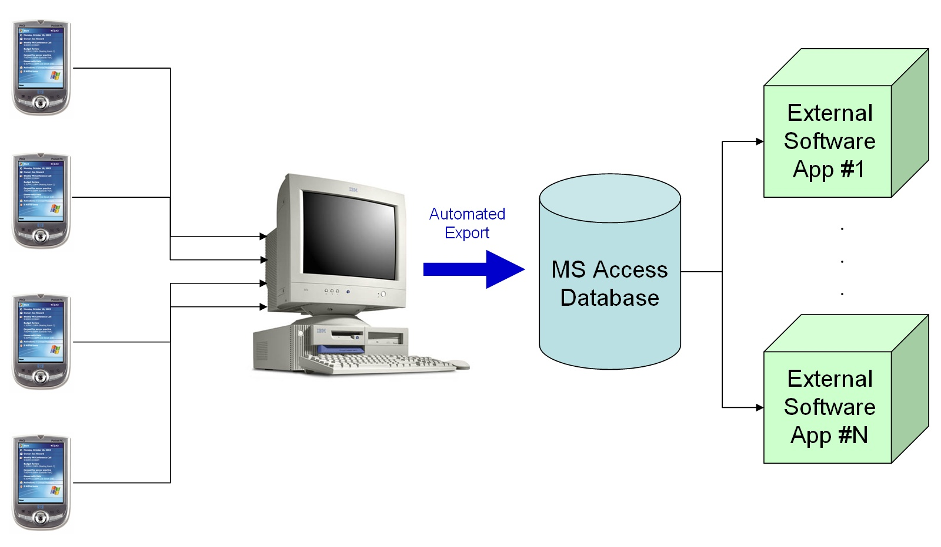
Once activated, all new data downloaded from the pollsters will automatically be sent to the MDB file. This effectively means that once you’ve created and published one or more templates, you may very well not find any need to go back into the Pocket Pollster software for some time because all of the data will be fully available in the external database file, which itself can be connected to your other software applications. Thus in some organizations Pocket Pollster will serve as a highly customizable front-end mobile data collection tool for one or more software packages.

Note: In Tools → Options you can change the version of the MDB file created. It’s generally advisable to try the “Newer” format first. If that doesn’t work with your existing software then try the “Older” format.

For purposes of this exercise, on the Settings page ensure that:
- “This poll involves interviewing respondents” is checked
- “Hide Question Numbers” is unchecked.
- Change UserName is checked
- Review Data is checked
- Can Abort Records is checked

Go back to the “Questions & Answers” page and add a few more questions and answers. Change the Answer Formats. Then add some sample instructions (even just copy & paste some random text). Save the file template and close it.

Now open this template again. This time you will see that two new tabs have appeared:

Summary
This page is designed to provide a quick overview of the poll design and any data that has been gathered for it. Here’s a sample Summary page:

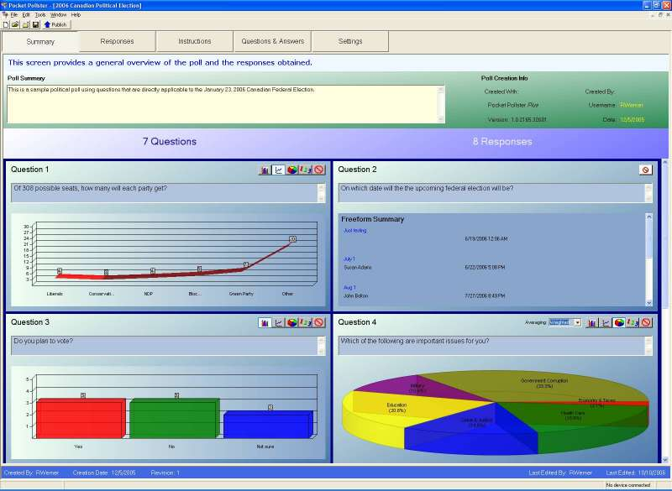

The top portion of the page displays assorted information about the poll. Below this there is one “Chart Panel” per question. The charts are stacked vertically in pairs. Each question can be shown with one of four different chart types:
- Bar Charts
- Line Charts
- Pie Charts
- Textual Summaries

The one exception to this is for the Freeform answer format, which has its own display format.

The Multiple Choice answer format offers two different ways to display its data: Simple and Weighted. With Simple, one vote is assigned to each item selected. So for example, if there are only two responses and with the first one Items A, B, & C were each selected and with the second one Items A & B were selected then A & B would each be assigned two votes and Item C would be assigned one vote. Thus percentage-wise A & B would each have 40% and C would have 20%.

Weighted looks at things somewhat differently. It assumes that if one person selects many choices in a multiple-choice answer then the value of each choice is less than that of someone who picks just a few choices. The weighting formula is simple:

1 Choice – 100% 2 Choices – 50% each 3 Choices – 33% each . . .

The chart type of each question can be changed but the poll must be saved to retain these settings.

Responses
This page lets you review the individual responses that have been collected by the pollsters. In the example you’re working with, nothing has been collected yet, so a message to this effect is displayed. But once you have data it will look something like this:

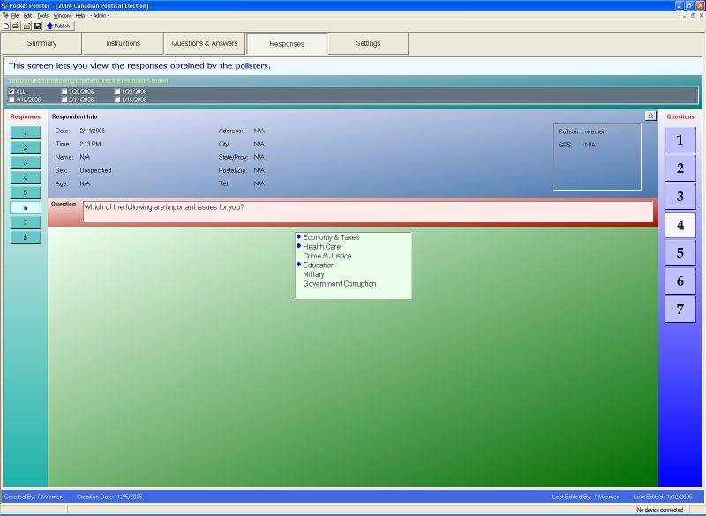

Once some data is available to review, you will notice some special filters near the top of the page:

Date Filter
Lets you screen out just those dates you want. The default is “ALL”. Note: This filter has no purpose if all the results are from the same day. In fact, it won’t even appear if this is the case.

Sequence Filter
Lets you specify ranges of data like “Last 10”, “First 50”, etc. This filter is applied after the Date filter is applied. The default is “ALL”. Note: This filter will only become visible once there are more than 10 responses. It’s most effective when there are hundreds or thousands of responses.

Publishing
Once you’ve added a few sample questions and answers, press the large “Publish” button on the toolbar. This will make a copy of the template and place it in the “Templates” folder. By doing this, you’re telling the software that you want this template to be made available to all mobile devices that sync with your computer in the future.

As soon as you publish your poll template, it will become “locked”. This is because subsequent changes to its structure or contents could cause data integrity problems. Envision the situation where a poll template is published, distributed to several Pocket PCs, and data is collected using that template. If the original template is then altered, the incoming data may no longer “fit” into the changed version.

If you’re doing scientific polling, then it’s advisable that no changes whatsoever be made and instead a new poll template is issued. If you’re collecting data for an internal business process then there’s likely no harm in correcting a spelling mistake or improving the Instructions of a poll.

In any case, once you’ve published your poll, if you then try to alter anything on the Instructions or Questions & Answers pages, a dialog box like this one will appear:

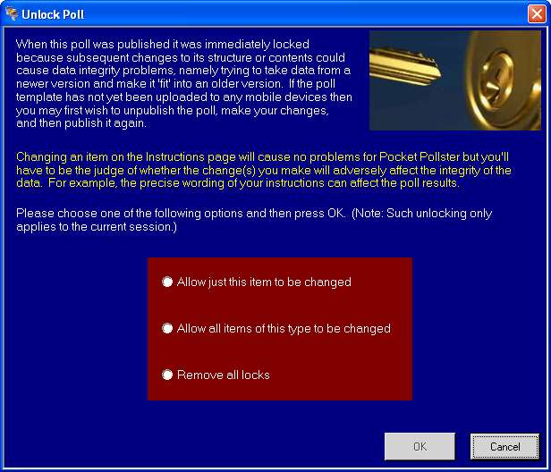

You are given several Unlock options or you can press Cancel to abort the change.

There’s also an “Unpublish” option in the File menu. Selecting it simply removes the associated file in the “Templates” folder.

Desktop Usage/Design Questions
Additional Answer Formats could be added in the future. Are there particular formats you’d like to see that would prove useful in your work? If so, please elaborate in as much detail as you can. Also feel free to e-mail or fax us any sample forms that your organization currently uses.

Some of the Answer Formats offer the “Allow More Info” option. Are there other kinds of options you’d like to see with some/all of the Answers?

Currently there are no specific options to customize each Question. Are there any you’d like to see?

What additional options on the Settings page would you like to see?

In the Options dialog box, are there additional options (program options) you’d like to see?

There is great room for expansion of the various charting options. What other sorts of charts and/or charting options would you like to see?

Does the way Export currently works suffice your purposes? If not, please elaborate.

To preserve the integrity of the poll data it was decided to not allow the user to be able to modify the collected data. Do you consider this to be a limitation if your organization were to adopt Pocket Pollster?

What other improvements or changes would you like to see?

Mobile Installation
The software can be installed on your mobile device(s) at any point. You can do this with the Desktop software running or not running. For purposes of this tutorial, please ensure that the Desktop app is not running before you sync your Pocket PC.

Sync your Pocket PC as you normally would. The ActiveSync window on your Windows desktop will appear as usual, but this time a special blue Pocket Pollster Data Transfer window will also appear, in the lower right corner of your screen. You should also see a little “P-P” icon spinning in your System Tray.

A few seconds later you will be presented with a dialog box, asking if you'd like to install Pocket Pollster onto your mobile device:

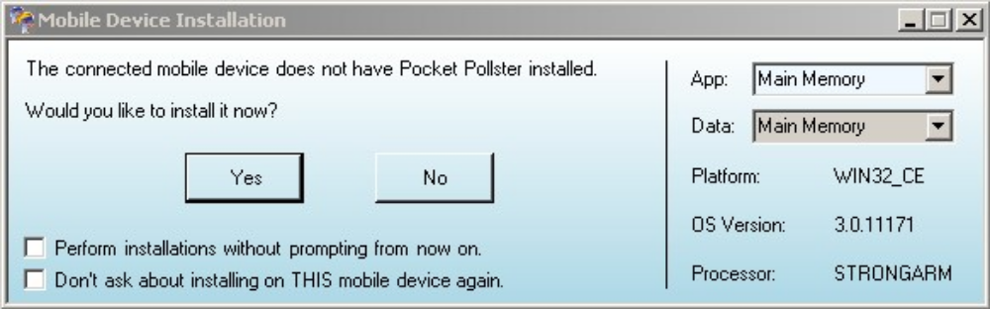

Before clicking "Yes", please note on the upper right section of the dialog box, you can change the location of where the application will be installed and where the [future] data files will be stored. These options are contingent on your Pocket PC having either a separate internal storage area and/or a memory card present. Many users prefer keeping as much stuff out of Main Memory, but the choice is yours. After you click “Yes”, the Data Transfer window will look something like this:

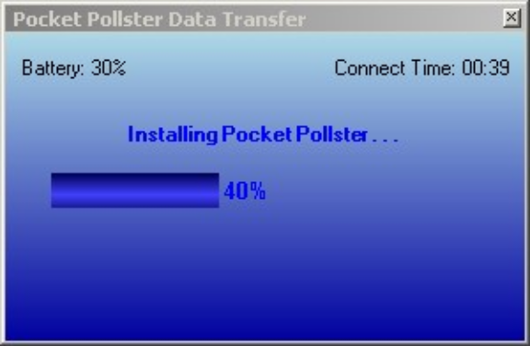
Note: The installation procedure for older Pocket PCs will take longer because the [large] Compact Framework has to be installed.

Because you earlier published the poll template you were working on, it will be copied to your mobile device once the Pocket Pollster software is installed on it.

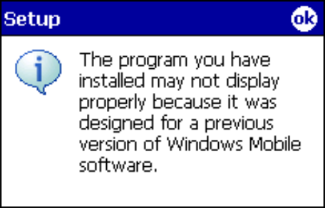

Depending on which device you have, you may see the little message box shown at the right. This is normal and should not provide any pause for concern. Similarly, if you’re installing a newer version of the software on the mobile device then you may see this message: "Pocket Pollster is already installed. Re-install?" Just press OK to complete the installation.

Extra Feature: The little spinning “P-P” icon in your system tray provides you with a visual cue that the Pocket Pollster Data Transfer module is doing its work. But you can also right-click on the icon to access a menu that will allow you to open up the full-screen Desktop application window.

Mobile Installation Troubleshooting
One of the key selling points of Pocket Pollster is intended to be Simplicity of Installation. Therefore a lot of effort has been put into making the setup of a new Pocket PC as simple & straightforward as possible. In fact, if everything is working as it should, then all the user has to do is sync the Pocket PC and press “Yes” on the dialog box shown earlier. In fact, if multiple mobile devices are being setup with Pocket Pollster then even that dialog box can be bypassed by checking the topmost checkbox.

Setup seems to be working properly on most computers but there are a few reports that it is not on some. If you are one of the latter then here’s how you can setup the mobile component of Pocket Pollster manually:

- Sync your mobile device with ActiveSync.
- On your desktop, click “Explore” on the ActiveSync window and examine the contents of your mobile device. Ensure that it has a “\Temp” folder. If not, create it.
- Open Windows Explorer and navigate to: C:\Program Files\Pocket Pollster\MobileCabs
- If you have a Pocket PC 2000 device then continue navigating to: wce300\sh3
If you have a Pocket PC 2002 device then continue navigating to: wce300\arm
If you have a newer device then continue navigating to: wce400\armv4
- Copy the 2 files you see there into “\Temp” on your mobile device.
- Disconnect your mobile device.
- On your device, start File Explorer and navigate to “\Temp”
- Click on each of the 2 CAB files in order:
  - netcf.all.wce4.ARMV4.cab - Compact Framework 1.0
  - PP_PPC.ARMV4.CAB - Pocket Pollster Mobile Component
Note: For Pocket PC 2002 (and older) devices, the filenames will be slightly different.

What you just did is exactly what Pocket Pollster does automatically during mobile installation. By the end of the process you should be able to run Pocket Pollster’s mobile software. If not, there are pertinent questions in the next section that we would appreciate you answering.

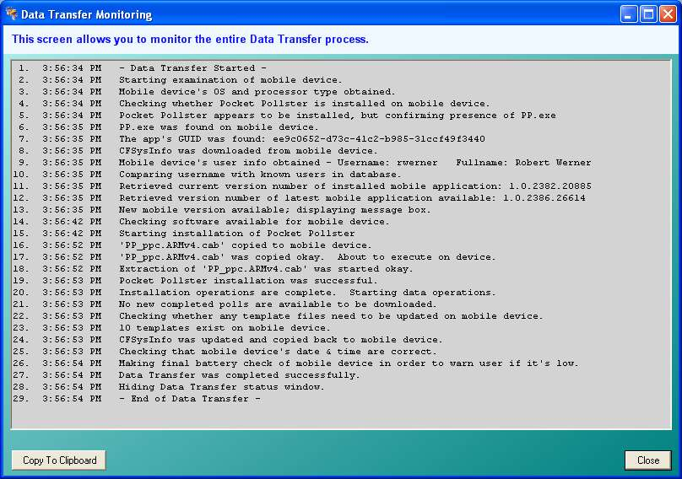
Another thing you can do is go to Tools → Monitor Data Xfer. This will bring up a special dialog box that will instruct you to synchronize your device. As soon as you do that it will start displaying the precise events of the Data Synchronization process. There’s also a button that lets you quickly copy all of the text into the Windows buffer. You can then easily paste it into an e-mail or other document.
Mobile Installation Questions
The spinning “P-P” icon in the System Tray should appear during synchronization whenever the Desktop app is not running or is minimized. Did it appear on your system?

Did everything go flawlessly with the mobile installation? If not, please elaborate.

If any error or warning messages or questions appeared on the Desktop during the mobile installation, please note what they said or include some screen captures using “PrntScrn”.

If any error or warning messages or questions appeared on the Pocket PC during the mobile installation, please note what they said.

Please sync your Pocket PC without the Desktop software running. Then when you disconnect your Pocket PC, did the Pocket Pollster software on the Desktop properly shut down? (You can test for this by trying to run the Desktop app anew. If it gives a warning about the Desktop app already running then it did not properly shut down. To close it, you can press Ctrl-Alt-Delete, select PP.exe underneath the Processes tab, and then click “End Process”.)

The Pocket Pollster Data Transfer module has the ability to explicitly sets the time on the Pocket PC to that of the Desktop. This seems to work on some mobile devices but not others. Did it work with your device? (You can set the time on your device 5 minutes earlier and see if it gets corrected.)

Mobile Device Usage
You can start the mobile component of Pocket Pollster by going to the Start menu and clicking:
Programs → Pocket Pollster

You may also find it advantageous to add the program directly to the Start menu by clicking:
Settings → Menus and then clicking the checkbox beside “Pocket Pollster”
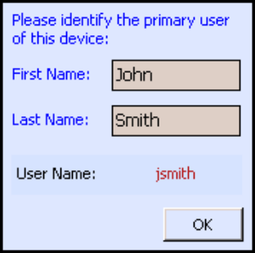
The first time you run Pocket Pollster on a mobile device you will need to identify who the primary user is. For purposes of this exercise, this is probably you, but you may want to enter a fictional name to differentiate from the name you entered when you initialized the Desktop application.

You’ll then be presented with the main screen. The center menu can be hidden but provides a quick way to access the major features of the mobile software. Along the bottom edge of the blue screen you’ll see the username you defined, along with the remaining battery power available, which is useful to give the user an indication of how much longer they’ll be able to conduct polling before requiring a recharge or battery swap.

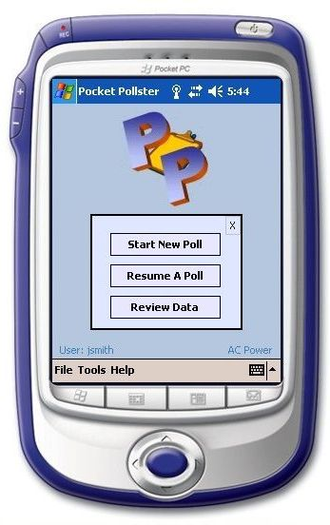
Running A Poll
To get started, click on “Start New Poll”. You will see the poll template you designed on your desktop computer. Note: If not, reset your device and sync again. Please also report this on this form.

Select your poll and then click on “Next >” at the bottom.

The mobile software works in a classic “Wizard” like fashion, using “< Back” and “Next >” buttons. You’ll also notice an extra Wizard button entitled “Finish”. This is for those situations when the questionnaire has to suddenly be aborted for some reason. Perhaps the respondent refused to answer any more questions or perhaps some other external factor forced the poll to be aborted, even just temporarily. “Finish” provides an instant way to get out of the current polling Wizard. If you press it then you’ll be asked whether “you want to throw away the responses for the current set of questions”. Choose ‘Yes’ if you don’t want any of the previous answers for that sequence to be stored.

The one exception is that on the very last question “Next >” will be disabled and “Finish” will be the only way to move forward. This is an intentional subtle reminder to the pollster that the series of questions is nearly complete.

Polling Screens
The exact sequence of screens that appears depends on a lot of factors. But here, in brief, are the types of screens you will see while polling:

Change UserName | If you checked the “Change UserName” checkbox on the poll’s Settings screen of the desktop software then this screen will appear. It allows the mobile user to change the username to their own, if it is not already set accordingly.
Instructions | If text was entered into an Instructions panel in the desktop software then that text will appear on the mobile device, at the specific point it was intended to.
Respondent Info | If the “This poll involves interviewing respondents” checkbox on the Settings page of the desktop software was left checked then this screen will appear, allowing you to gather personal info about the person you’re polling. You can access this screen both before and after the questions.
Questions/Answers  (Q&A) | This is where most of the time is spent with the mobile software. Each screen varies depending on how you configured it on the desktop.
Poll Completion | Upon completing one sequence of polling (e.g. a given set of Q&A screens), a group of 3 or 4 buttons will appear, letting the pollster proceed as required.

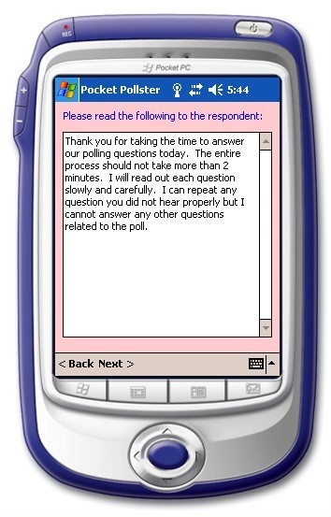 | 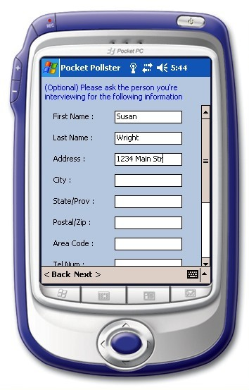
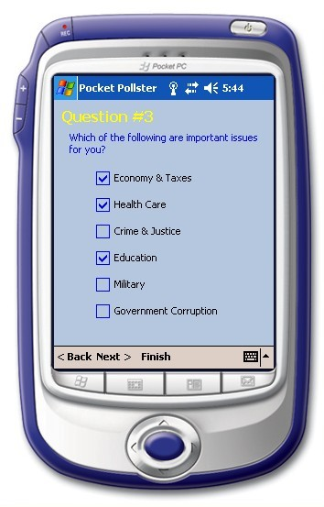 | 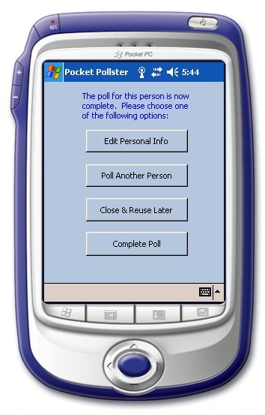
Mobile Design/Usage Questions
How responsive was the software? Did you notice any screens that were excessively slow? If you accumulated more than 25 responses, did you notice the responsiveness change at all?

If your work involves interviewing respondents, is the current Respondent Info screen sufficient? If you’d like to see other fields available then please list them.

Did the Questions & Answers screens you designed function as you expected they would on the mobile device? If not, please elaborate.

An option could be given to the poll creator to prevent the mobile users from reviewing the data they’ve captured. Would this be useful in your work? If so, what would be a scenario in which you’d use this feature?

The Options screen is currently disabled. What, if any, options do you think should be available to the pollster on the mobile software?

What other improvements or changes would you like to see?

Data Transfer
The last step in this exercise is to send the collected data back to the desktop computer. There’s no particular limit to the amount of data that can be collected in one session or the number of polls that can be carried out at one time (some organizations will want their mobile users to run several questionnaires every shift).

In order for Pocket Pollster to copy collected data from a mobile device to the desktop, a poll must be completed, so please ensure that at least one poll has been. To better understand the logic Pocket Pollster uses to manipulate data files on the mobile device, here’s an overview of the “Data” folder structure:

Data | This is the working folder where PP files are located during the data collection process.
Templates | PP template files, copied from the desktop, reside here. Once a device is synched, the contents of this folder are identical to the Templates folder on the desktop.
Completed | This is a temporary storage area where PP files are placed once the user declares them as being “completed”. They reside here only until the device is next synched. These files are then processed [automatically] by the Data Transfer component of Pocket Pollster.
Downloaded | When synching occurs, completed data files are copied to the desktop but a copy is also placed in this folder. The length of time it stays here is completely up to the poll creator and is set on the Settings page of the desktop software. This ranges from “immediately after download” to “never”, with several durations in between.

Data Transfer is almost always completely automatic. Just sync your mobile device as you normally would. The special blue Pocket Pollster Data Transfer window will appear in the lower right corner of your desktop screen, as you saw earlier.

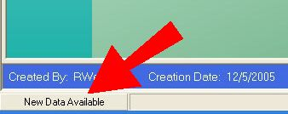
The data collected by the mobile device will be added to the poll of the same name that resides in the Pocket Pollster “Data” folder on the desktop. If the desktop computer you’re downloading to does not yet have the PP file in question, then one will be created. If you happen to be reviewing a poll that is receiving new data at the same time, then a message to this effect will appear on the status bar at the bottom of the desktop screen. If you click on this message you will be asked whether you want the new data imported immediately. If not, the new data file(s) will be placed in a queue and automatically imported the next time Pocket Pollster is started on the desktop.

Mobile Transfer Questions
When synching collected data, do try it both with the poll(s) in question open on the desktop and not open. Did the addition of the new data work perfectly in both cases? If not, please elaborate.

What other improvements or changes would you like to see?

