STAT 151 X01

Group #19

Lab 1

Kaitlin Paul

Robert Joseph

Zheng Liu

**Question #1.)**

The shape of this histogram is unimodal and skewed right (positively skewed). The histogram does not show a symmetric shape, hence the skew to the right of the histogram. The variable AGE is not distributed evenly throughout the histogram; based on the histogram we can see that there is substantially more people winning Oscars between the age of 30 and 50. There are 104 Oscar winners that fall into the age

Category of 30 to 50 years old.

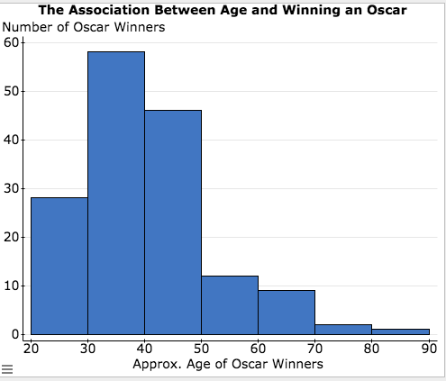

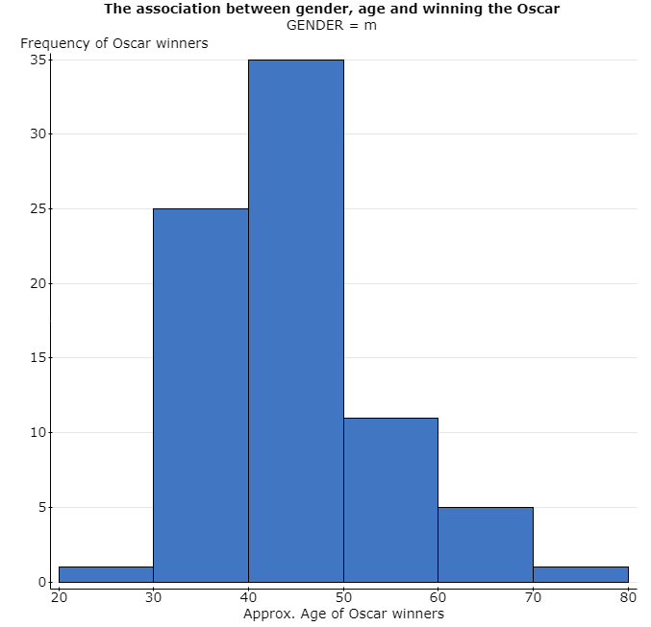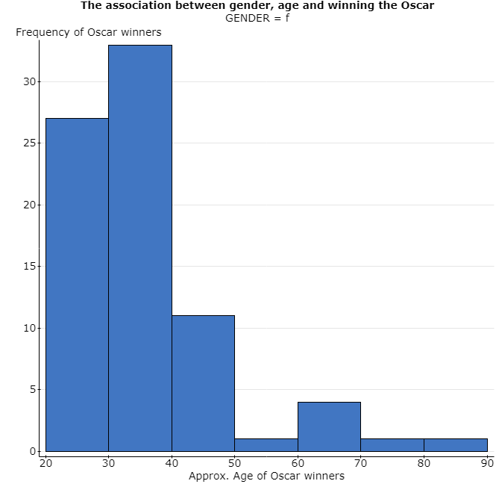**b)**

Both histograms depicting the age of female and male Oscar winners are positively skewed and unimodal. The histogram depicting the age of female Oscar winners is more positively skewed when compared to the histogram depicting the age of male Oscar winners. The most likely age range to receive an Oscar for females is between 30 and 40 years of age, while the most likely age range for a male to receive an Oscar is between 40 to 50 years of age. For both genders the most common age range to receive an Oscar is 30 to 40 years old. Based on the comparison between these two histograms it can be seen that females are more likely to receive an Oscar when they are younger compared to males.

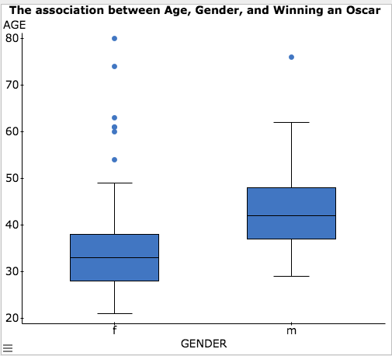**Question #2.)**

1. Based on these two box-plots we can see that they are both skewed right (positively skewed). The median age for female Oscar Winners is 33 years old. The median age for male Oscar winners is 42 years old. For females based on values that fall within the boxplot and are not considered outliers.The 1st quartile is 28 and the 3rd quartile is 38 therefore creating an interquartile range of 10. With minimum and maximum values equaling to 21 and 80, the range is 59. For males based on the values that fall within the boxplot, the 1st quartile is 37 and the 3rd quartile is 48 therefore creating an interquartile range of 11. With minimum and maximum values equaling to 29 and 76, the range is 47.  The median age of male Oscar winners is 42 years of age.
2. Yes there were outliers in both the female and male boxplots. The female boxplot had 6 outliers, while the male boxplot had 1 outlier.
3. Based on the plot I can conclude that Best Actress award winners do tend to be younger then Best Actor award winners. The median age for female award winners is 33 compared to 42 years of age for male winners.

**Question #3.)**

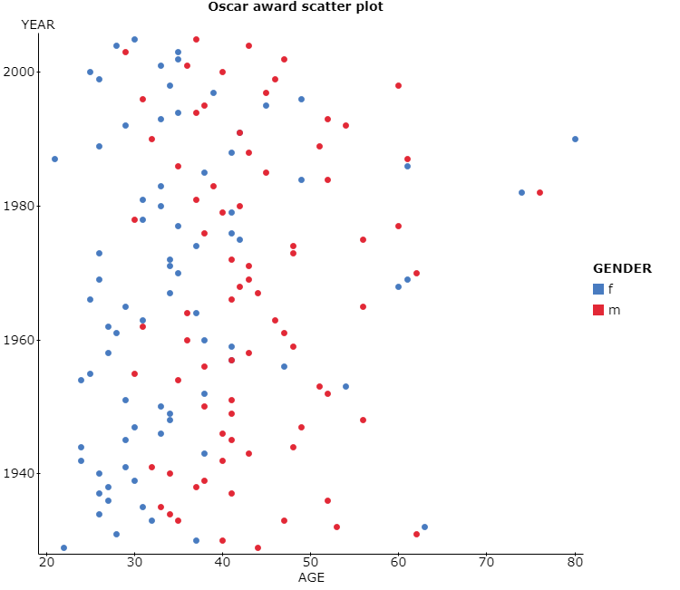

1. Based on the scatterplot it is visible that there is an increasing trend in age over time. In the earlier years of Oscar wins it is clear that females tended to be younger then male Oscar winners, however, as we move into the 1980s and later we see that consistent trend disappearing. In the later years it seems that both female and male Oscar winners are of similar age. The scatterplot does support our conclusion in the previous question as there is data to support that in the earlier years of Oscar wins females did tend to be younger then males.
2. Yes there are outliers within the scatterplot. The three most aged Oscar winners are 74, 76, and 80 years old with two of these aged Oscar winners being female. If these three people were removed from the data the trend would stay more consistent but however the median would not be affected but the mean would go down by (0.729 years) with conclusion that in general females do tend to be younger then males. However, this trend becomes less apparent after the year of 1980 even with the outliers removed.

**Question #4.)**

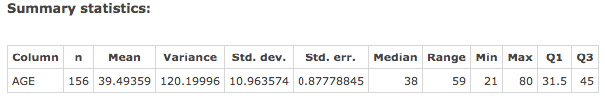

1. The center and spread should be reported as median and IQR, respectively, based on the histogram obtained in question 1 (Part a). Given that the histogram is not symmetric and positively skewed the values of median and IQR are more accurate. The median is 38 years old and the IQR is 13.5 years.
2. Yes there is an outlier based on the 1.5 x IQR criterion. The lower fence for this data set is 11.25 and the upper fence is 65.25. The minimum value for this data set is 21 meaning that there are no outliers below the lower fence, however, the maximum value for this data set is 80 years of age which falls outside the upper fence of 65.25 making it an outlier value.

**Question #5.)**

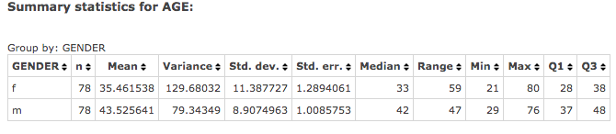

1. Based on the histogram in Question 1 (part b) the measures of center and spread should be reported as median and IQR, respectively. Median and IQR are better measures for the data that is skewed or has outliers. The median for female Oscar winners is 33 years of age, while the IQR is 10 years. The median for male Oscar winners is 42 years of age, with the IQR being 11 years.
2. Yes there are outlier values for both female and male Oscar winners. For females the lower fence is 13 years of age, while the upper fence is 53 years of age; the minimum age for female Oscar winners is 21 years old with the maximum age being 80 years old. The age of 80 is considered an outlier as it falls outside the upper fence. Their values are 54, 60, 61, 63, 74 and 80. For males the lower fence is 20.5 years of age, while the upper fence is 64.5 years of age; the minimum age for male Oscar winners is 29 years old and the maximum age is 76 years old. The age of 76 falls outside the upper fence based on 1.5*IQR criterion making it an outlier value.
3. Yes based on the summary statistics and our analysis of outliers it can be concluded that females that win Oscars do tend to be younger then males. This statement is consistent with the answer that we concluded in question 2 (part c).

**Question #6.)**

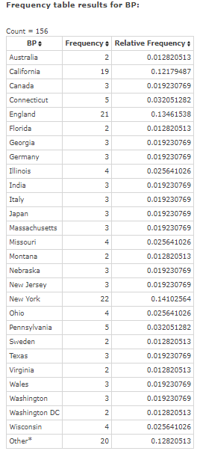

Yes there are certain places that seem to produce more Oscar Winners. USA; New York produced 22 Oscar winners. England produced 21 Oscar winners and USA; California produced 19 Oscar winners.

**Question #7.)**

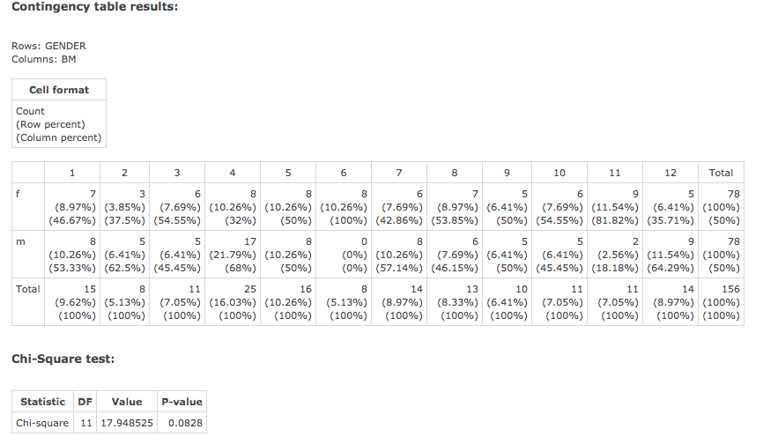

1. In month 4 (April) the most best actor award winners were born, which was 17 (21.79%) male winners. Month 6(June) seems to have zero(0%) best actor winners
2. For females the month of November (month 11) seems to produce the most best actress award winners (11.54%), while the month of February (month 2)(3.85%) seems to produce the smallest amount of best actress award winners.
3. The month that seems to produce the most Oscar award winners in total is month 4 (April) (16.03%); there are 25 people born in month 4 that are award winners. Month 5 (May) (10.25%) also produces a lot of Oscar award winner with a total of 16 people with Oscar wins.