Did we already cross Earth’s boundaries without realising it?
Robert de Ridder
2025-12-27

For years, we’ve been told that global warming must not exceed two degrees Celsius. The range between 1.5 °C and 2 °C is printed into our collective memory.
Whenever you watch the news, read articles, or consume any kind of climate-related information, you’re almost guaranteed to encounter those numbers 1.5 and 2 as if they are sacred thresholds. And of course, they must be meaningful; countless scientists have worked on them.
Yet I have my doubts. What I see happening in the world, wars, fires, droughts, you name it, it doesn’t seem to match those numbers.
Right now, I’m studying data science, and I want to use this opportunity to investigate these doubts. While exploring online datasets, I found two particularly interesting ones: the temperature anomaly dataset from Our World in Data, and the monthly_in_situ_co2_mlo dataset from Scripps CO₂. They are continuously updated and form a solid starting point for my investigation.
During this “journey,” I will estimate Earth’s ability to absorb carbon dioxide, take a closer look at the airborne fraction, and separate temperature change into a fast and a slow component.
This may sound abstract, so what does it actually mean?
The fast and slow components refer to how heat is distributed. As the planet warms, part of that heat is immediately noticeable at the surface, while another part is absorbed by the deep oceans. Without oceans, the world would be far hotter.
The airborne fraction is the percentage of human-emitted CO₂ that remains in the atmosphere. It’s useful when calculating gross and net emissions. Currently, this fraction is roughly 47%.
The next part of my work becomes quite technical and involves some mathematics, probably boring to write about and even more boring to read. So I used R Markdown to visualise what I’ve done.
In R-studio, I used the following library’s:
library(lubridate)
library(ggplot2)
library(ggthemes)
library(dplyr)
library(readr)
library(patchwork)
library(tidyr)
After loading the data, and running my script,
This summary was produced.
## Model: global_average = -22.993 + 4.023 * log(CO2)
## Temperature rise now : 1.55258 (°C)
## Net CO2 emission : 2.583939 (ppm)
## Gross CO2 emission : 5.497743 (ppm)
## Current CO2 absorption : 2.913804 (ppm)

After a lot of copying, tweaking values, deleting and rewriting code, I finally arrived at something that made sense to me. But the result was also quite shocking. I repeatedly encountered the value 1.2.
How could that be? The media told me under 1.5 °C, we should be in the safe zone.
I ran my code many times, checked it with AI tools, read numerous articles, and surprisingly, the value I found seemed quite realistic, and disturbingly consistent with what we’re seeing in the world today.
They say, pictures say more than a thousand words. To illustrate this, consider the following figure.
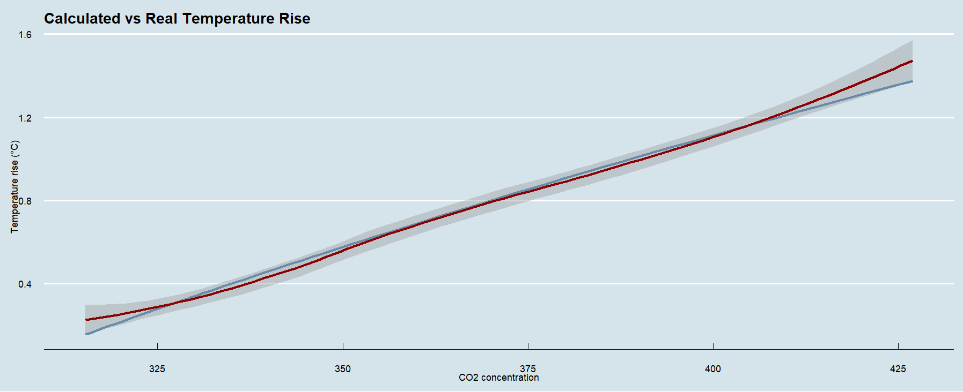
Lets have a look at the top graph, on the x-axis we have the CO₂ concentration and on the y-axis the temperature increase. The blue line represents the calculated temperature increase as CO₂ is rising. The red line is the real measured temperature. Surprisingly, both match pretty well, except in the last part, it looks like the real temperature is climbing while the calculated temperature steadily increases.
This raised an important question, I had to look further. I know that the earth has an ability to take up some of this CO₂. That’s why I made the second graph.
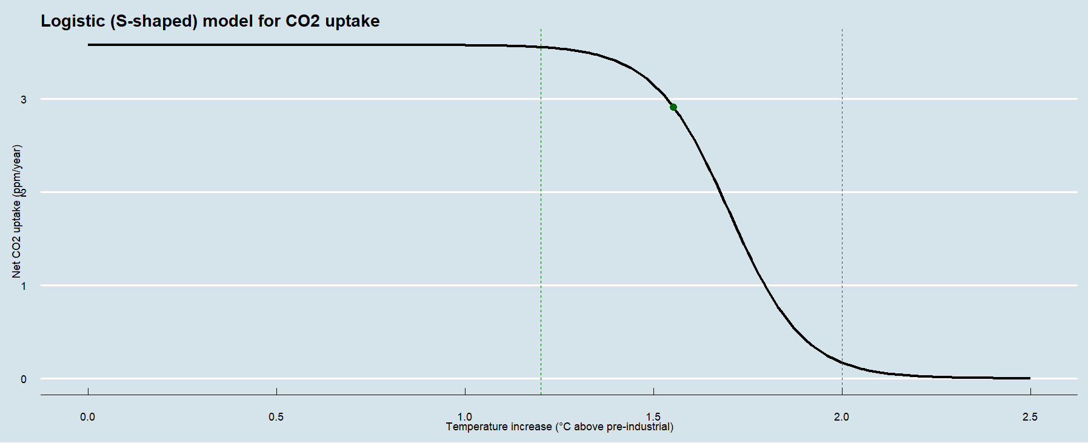
It shows how the uptake declines as temperatures rise. And again, 1.2 degrees. Around this temperature, we see that the earth’s ability to take up CO₂ goes down. The little green dot, is the last real measured global average temperature rise. It’s around 1.55 °C. The red dotted line, represents the 2 °C threshold, but around that temperature, the earth’s uptake is almost zero. So, we’ve been told that global warming must not exceed two degrees Celsius, but this seems a little bit too late. Not everything that seems, is always true. So I looked a little bit further.
In the last graph, I made a two-box simplification. I broke up the global temperature into two components. A fast and a slow component. It represents the land surface temperature (fast), and the deep ocean temperature (slow). For a long time these lines were nicely separated. Meaning that the oceans took up a reasonable portion of the total temperature. Shockingly, we see that around the 1.2 degrees all the lines merge. For me it’s clear that those numbers 1.5 and 2 as if they are sacred thresholds, don’t hold up any more. This does not mean that 1.2 °C is a precise physical tipping point, but the fact that multiple independent diagnostics converge around this value is noteworthy.

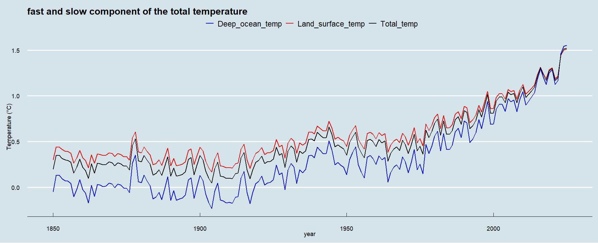
I know my model is very simplified, I looked around on the internet to check if my findings have any similarities with other studies.
For convenience, I made one extra graph that summarises all and indicates the 1.2 °C with a green dotted line.
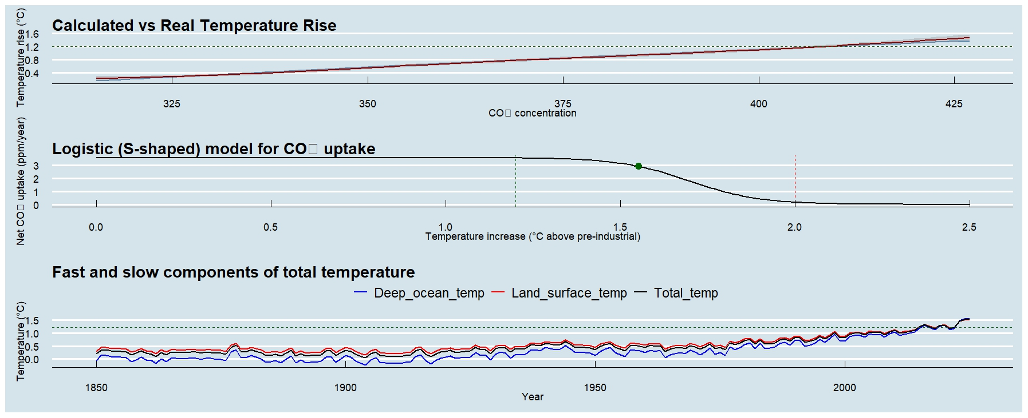

Conclusion:
The results of my model align remarkably well with recent climate reports. Both the WMO and Copernicus confirm that global temperatures in recent years have hovered around 1.2–1.3 °C above pre-industrial levels, with 2024 becoming the first calendar year to temporarily exceed 1.5 °C.
Studies show that both land-based carbon sinks and ocean CO₂ uptake weakened significantly in 2023–2024 due to extreme heat, drought, and record-warm oceans. At the same time, analyses from 2024/2025 point to a possible phase of accelerated warming, driven in part by declining aerosols and melting ice.
Reports from 2025 highlight that the first tipping points may already occur around 1.2 °C, such as the large-scale loss of warm-water coral reefs. The extreme weather events we are already experiencing heatwaves, floods, and crop failures were previously expected only at 1.5–2.0 °C.
In short: the danger zone is beginning earlier than expected. What was once considered “extreme” at 2 °C is now occurring at 1.2–1.5 °C.

The following formulas were used.

Where:
• R(T) = reduction (ppm)
• r_now = gross emissions – net emissions (ppm)
• k = slope
• h = inflection point of the curve
• T = temperature increase (°C)

Where:
• E_br = gross emissions (ppm)
• E_nt = net emissions (ppm)
• AF = airborne fraction ~ 0.47

Where:
• T(C) = temperature increase relative to pre-industrial
• b0 = intercept at T = 0 when C = 280 ppm (initial concentration)
• b1 = slope (sensitivity per log CO₂)
• C = E_nt

Where:
- tau = time factor
- alpha = weight factor (0.7)

Literature.

- State of the Global Climate2024
- Global Climate Highlights 2024
- 1.5°C: what it means and why it matters

Code and markdown can be found here.
- Github

