**Homework Submissions Documentation**

**STEP I: Setting up GitHub for HW Submissions**

Step 1: Login the GitHub account

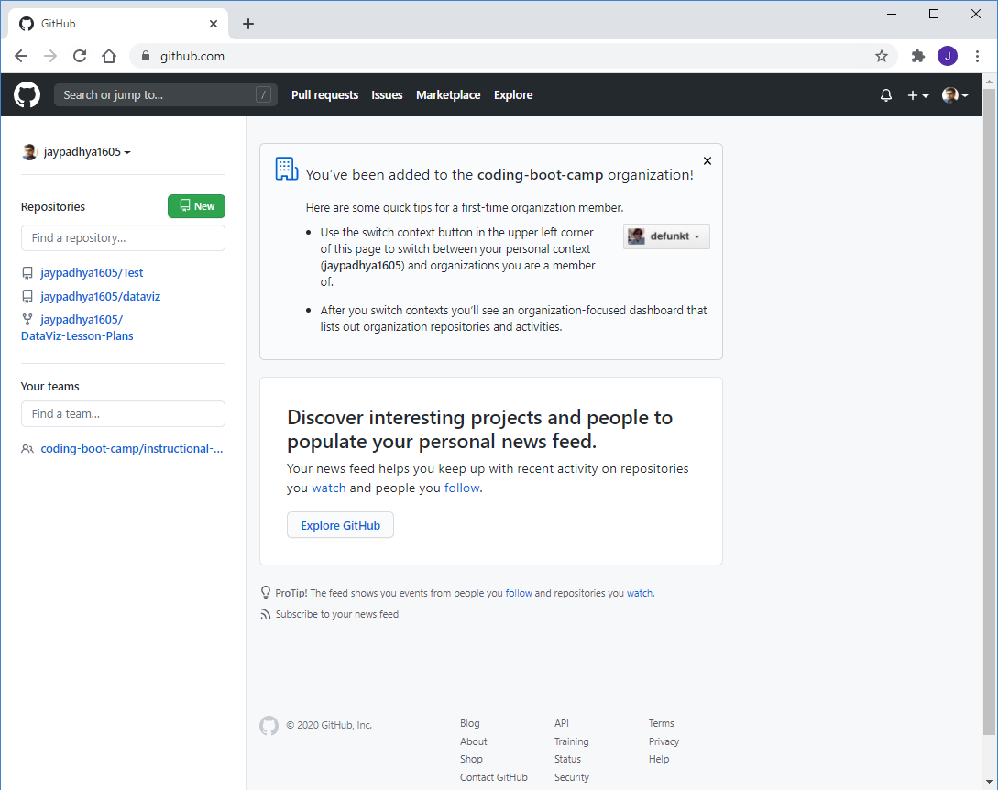

* Hit “New” button on top left to create a new repository

**Step 2: Create a repository for HW submissions**

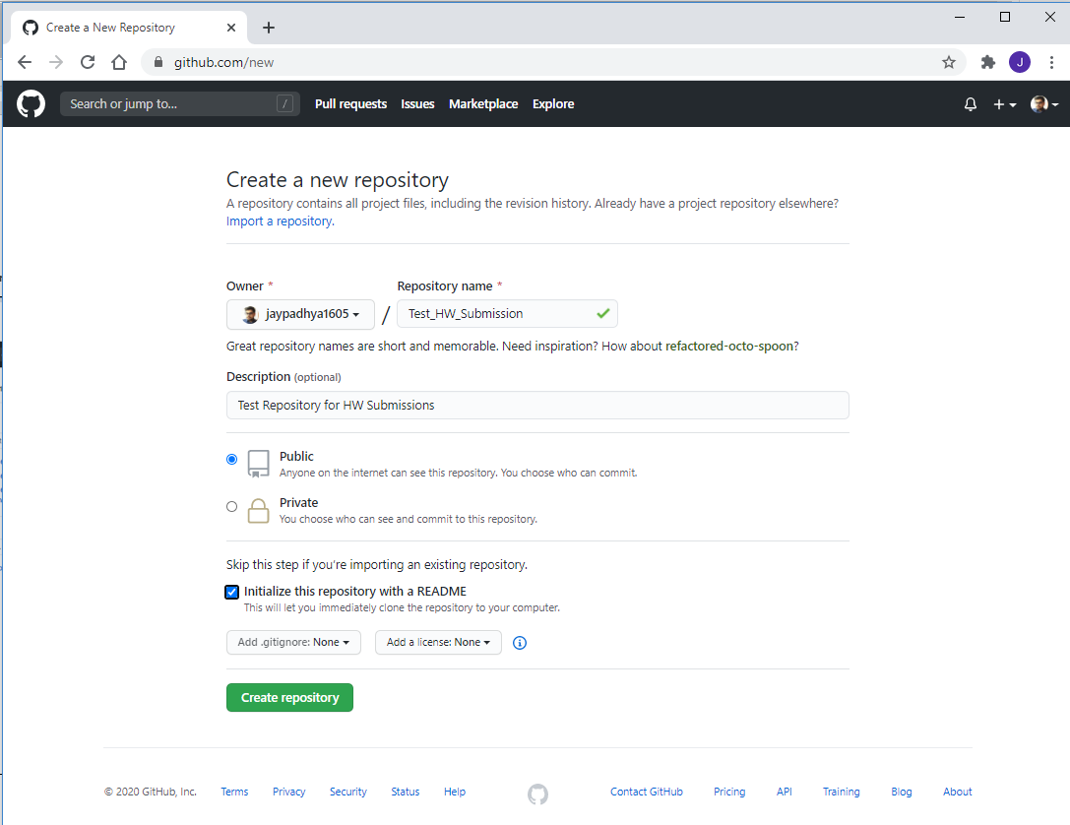

* Owner is your username / Repository Name (Example: MSU Homework Submissions)
* Keep “Public” as option so everyone can view it
* Initialize with README file (This will also let you clone repo to local)
* **Create repository**

You shall see screen as:

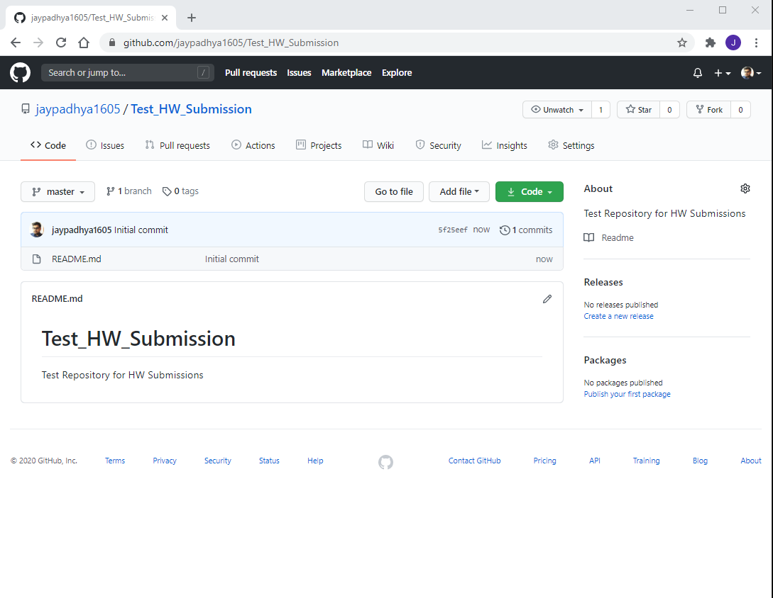

**Click the “Code” button to get a dropdown:**

Clone with ***HTTPS*** will have a URL link:

* In order to copy the link, click the icon next to URL

You should see something like below when you paste it:

https://github.com/jaypadhya1605/HW3_submission_python.git

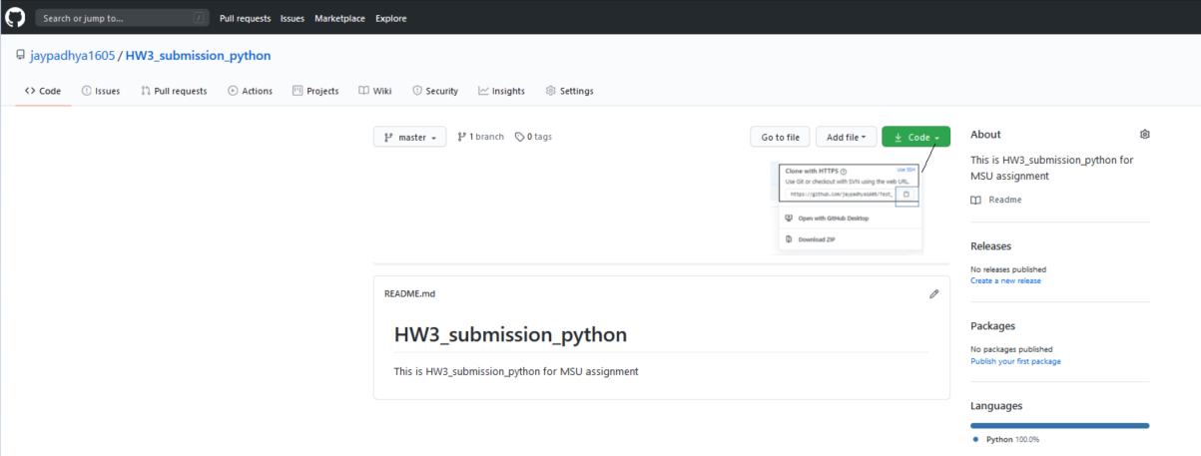

**PART II: Create HW folder on local**

You should first create a New Folder just for HW submissions. For demo I created a New folder called

“HW3_submission_Python” and created a subfolder for Python HW 3

I created a folder called **HW3_python_submission** for **python HW assignment**

Never use spaces for naming folder/files as good practice on directories – You can use underscores “_”

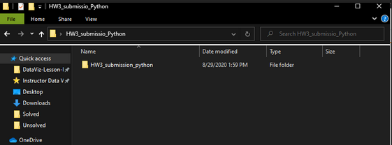

**I**nside this I have 2 folders

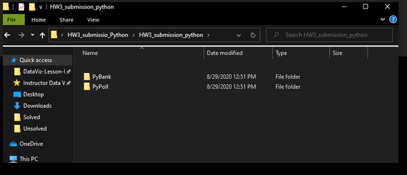

We will be pushing our folders as our HW submission 3.

**PART III: Pushing your HW to GitHub using GitBash**

* **Open GitBash as administrator** to dedicate to your HW folder directory. For demo, I had it on desktop so you can type   
    
  cd desktop

Use ls to see list of files in your folder

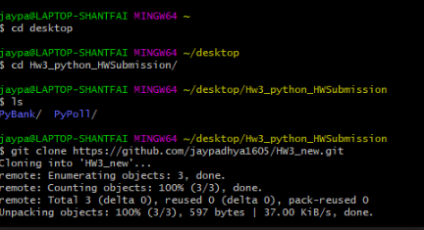

cd to your HW Folders until you see **PyBank** and **PyPoll**

Use git clone to clone the empty Git repository you just created on **github.com.**

git clone <**PASTE URL OF GITHUB**>

Make sure you can see .git on your folder and then move your folders in one folder that has .git and readME. **.git** is hiddenso you wantto go to VIEW-tick the HIDDEN file

In case you can’t see the folder – check **View** and see if you can tick the “**Hidden items**”

You have to make sure you can allow hidden folders

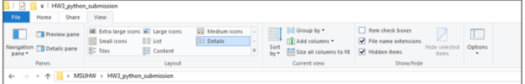

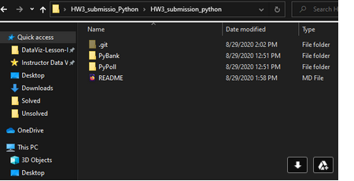

git add .

git commit –m “**Your first message**”

git push origin master

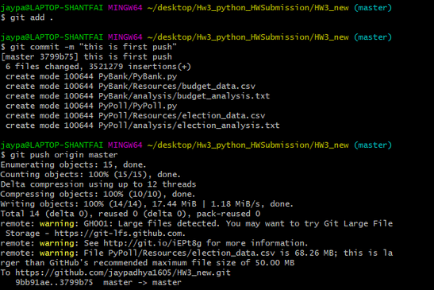

Check your GitHub account to see if the file is visible on your GitHub account

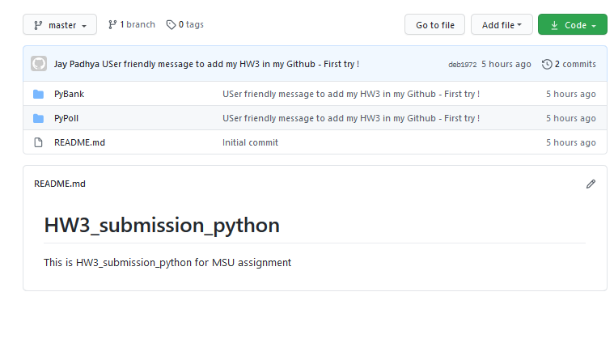

You can **Add a** **README** file as Markdown file to add some comments of what your repository is

**PART IV: Pushing your Changed HW to GitHub using GitBash**

Let’s say you do multiple code edits and add more content /files that you need to submit for evaluation

**Step 1:** Add the necessary changes in python file and add the files in same folder

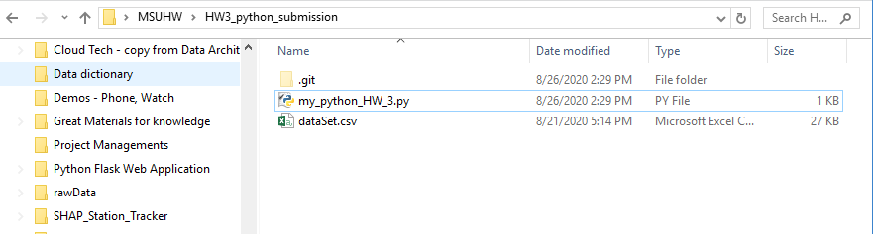

I changed some code in **python file HW** and want to add **dataset.csv** to GitHub repo. I would repeat the same steps what I did earlier.

git add .: “add .” means add all. **Don’t forget the space and then dot**

git commit –m “Your NEW message”: -m stands for message and 2nd commit message

git push -f origin master

