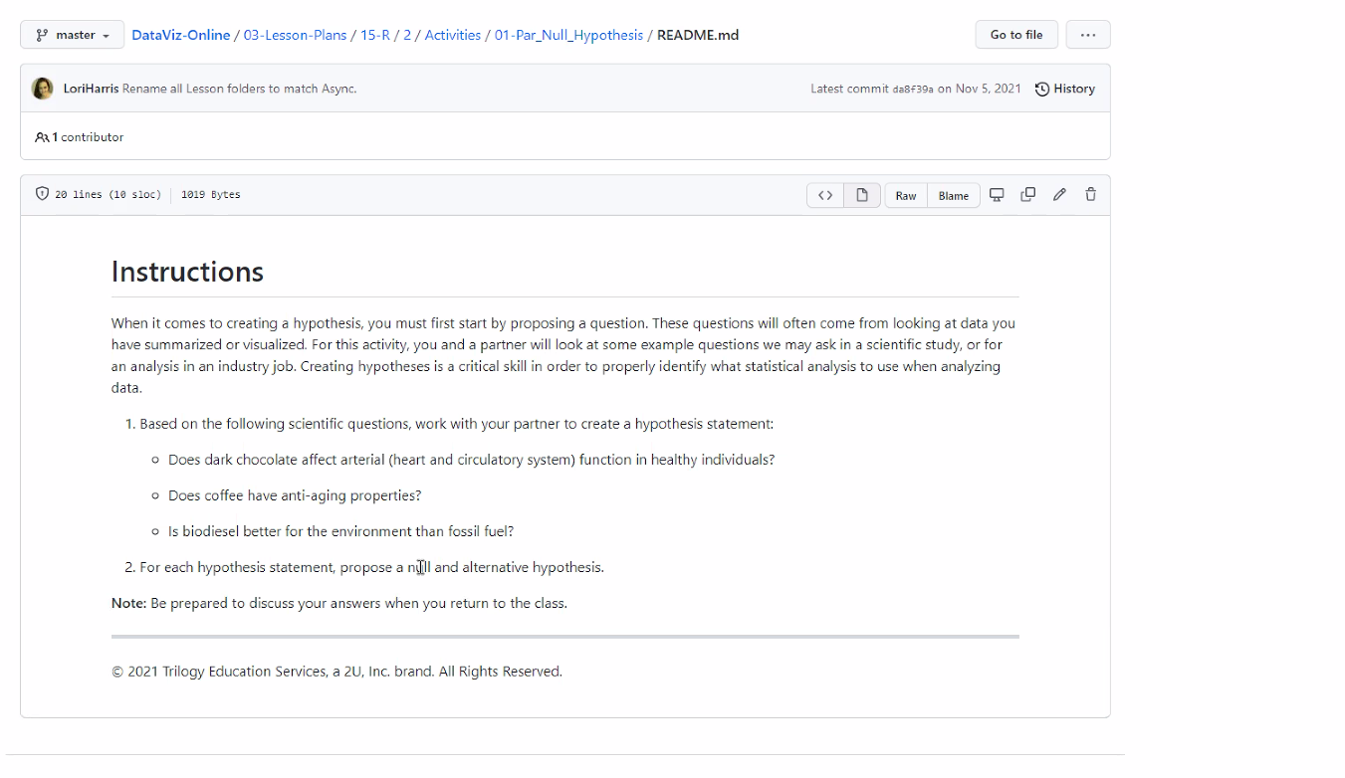

N- Dark chocolate does not affect arterial function in health individuals

H- Data supports that dC affect arterial function in health individuals

[add measure such as how much per day; then how long of a study; specific on dark chocolate such as greater than 60% cacao]

N - Coffee does not have anti-aging properties

H - Coffee does have anti-aging properties

[be specific on amount and time of study

N – Biodiesel is not better for the environment than fossil fuel, or there is no significant evidence that biodiesel is better for the environment than fossil fuel.

H – Data supports that biodiesel is better for the environment than fossil fuel