**Test 2**

**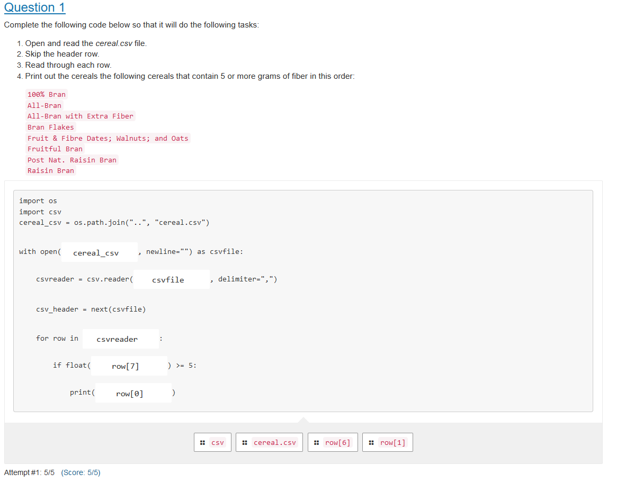**

**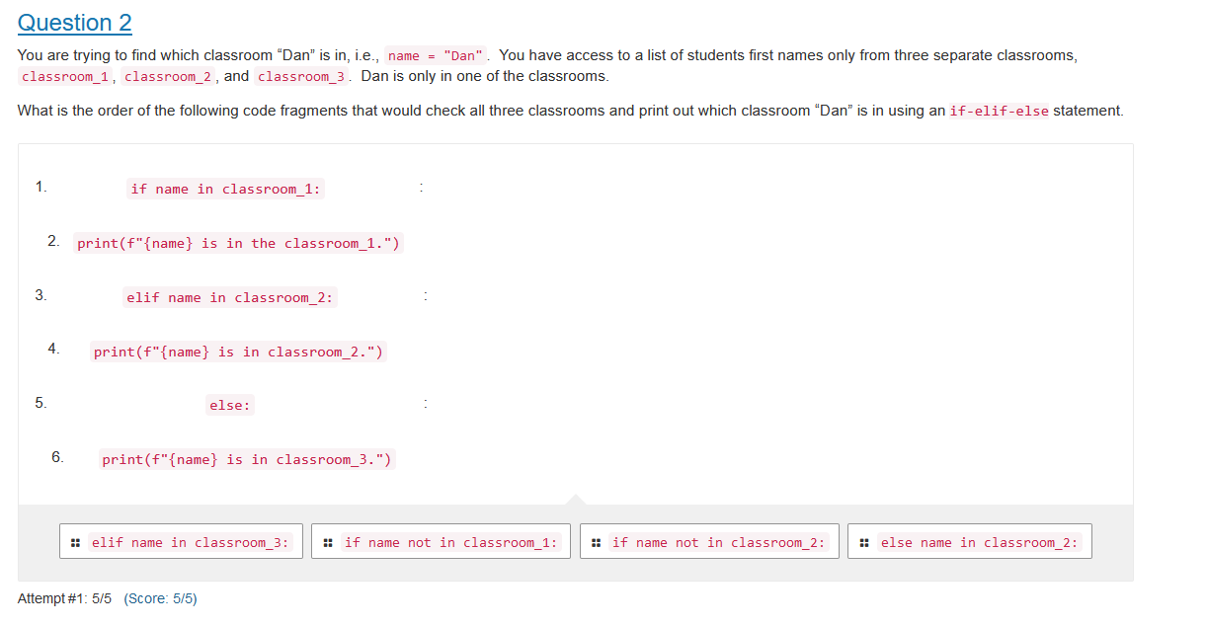**

**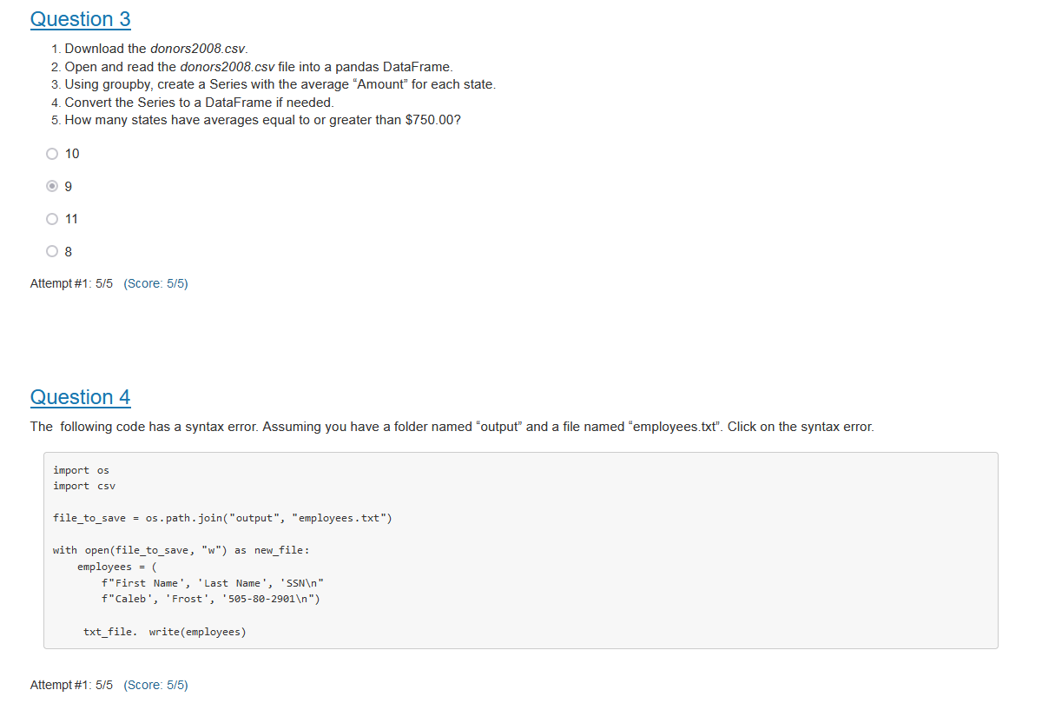**

**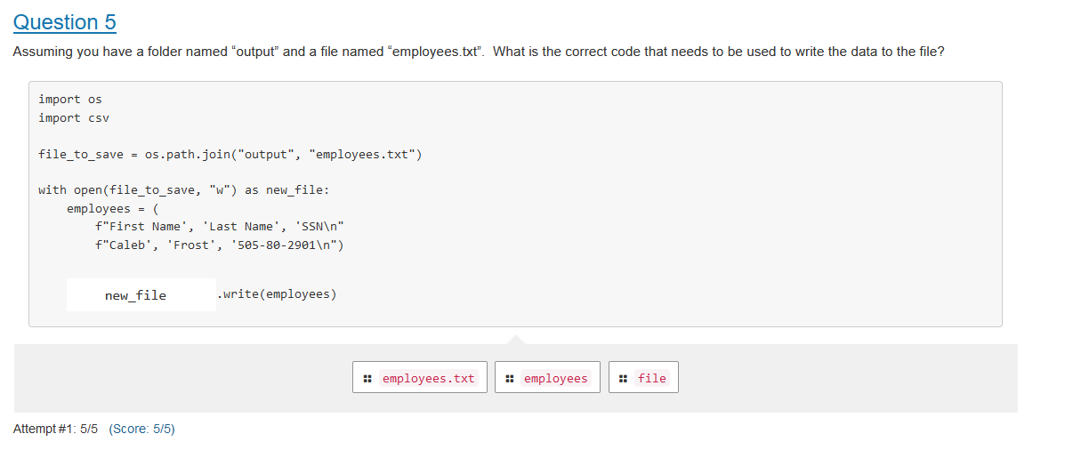**

**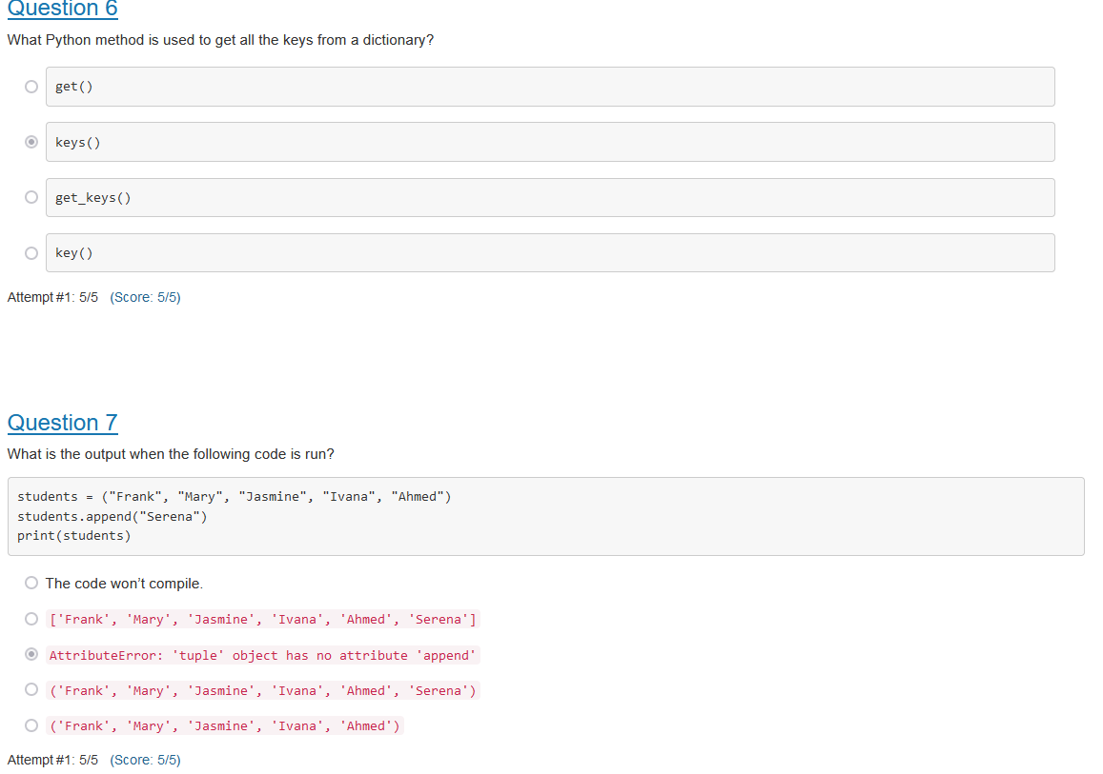**

**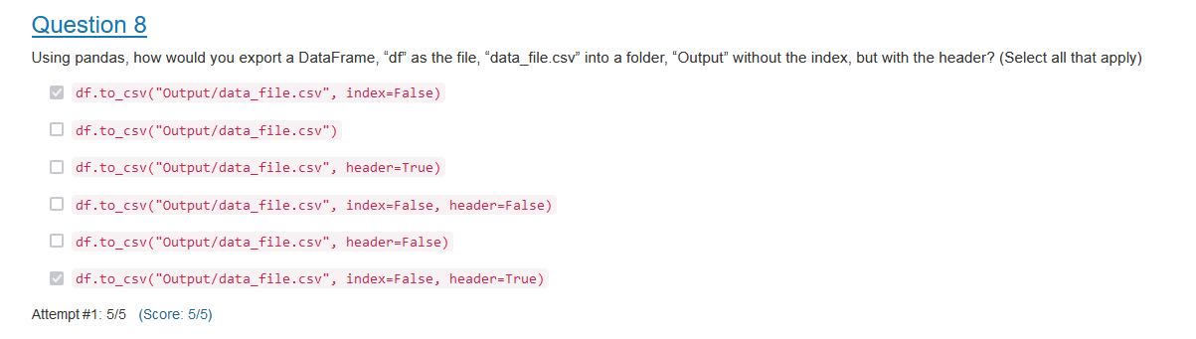**

**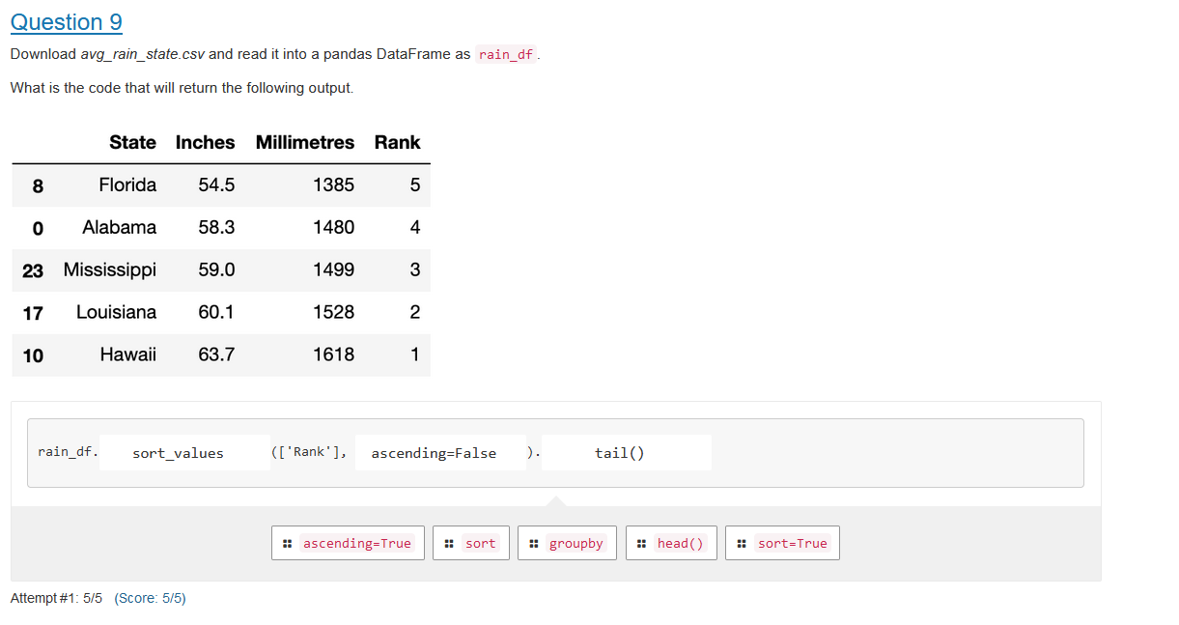**

**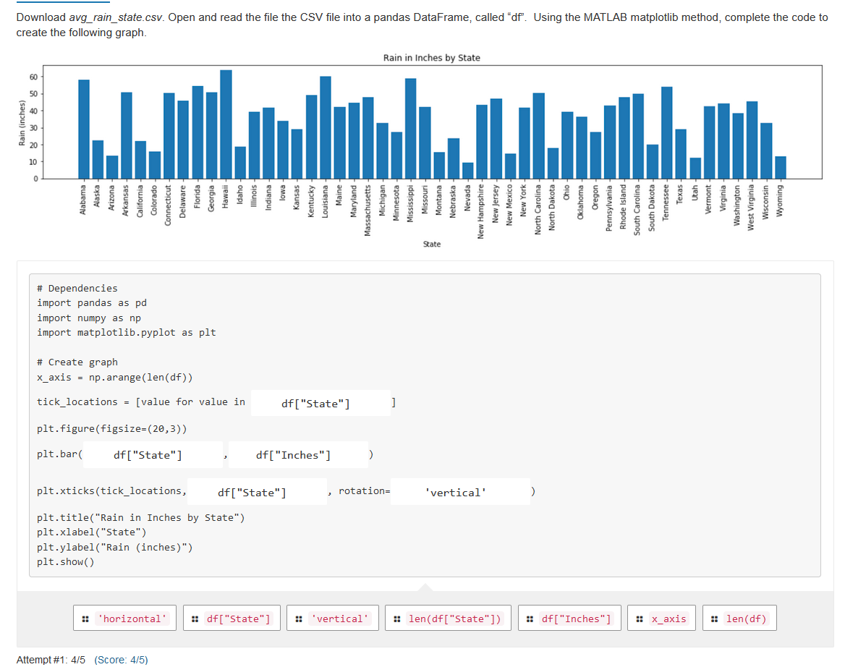**

**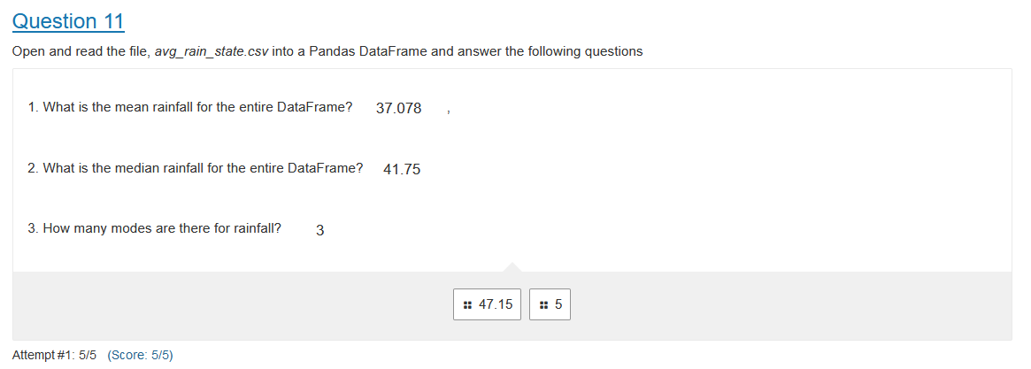**

**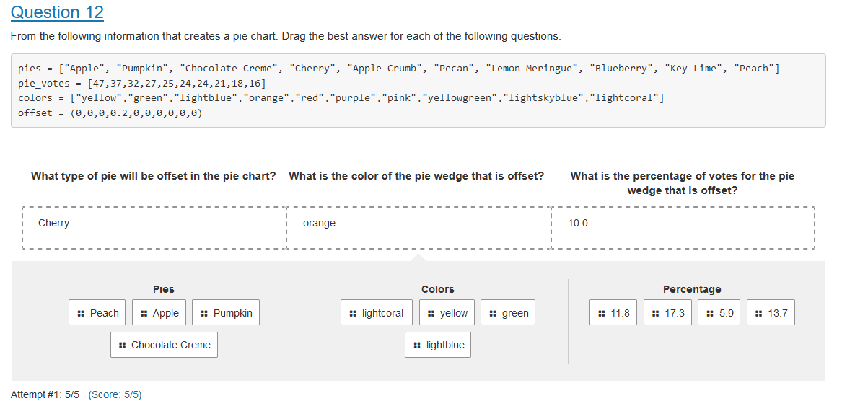**

**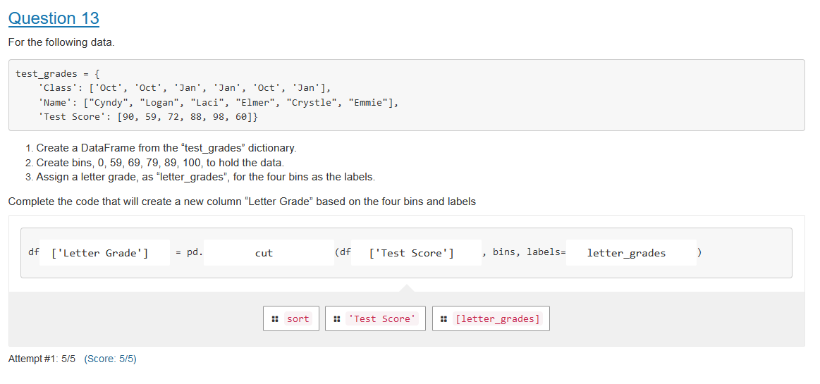**

**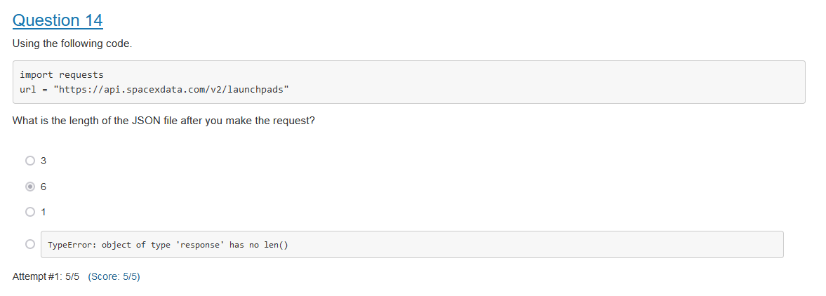**

**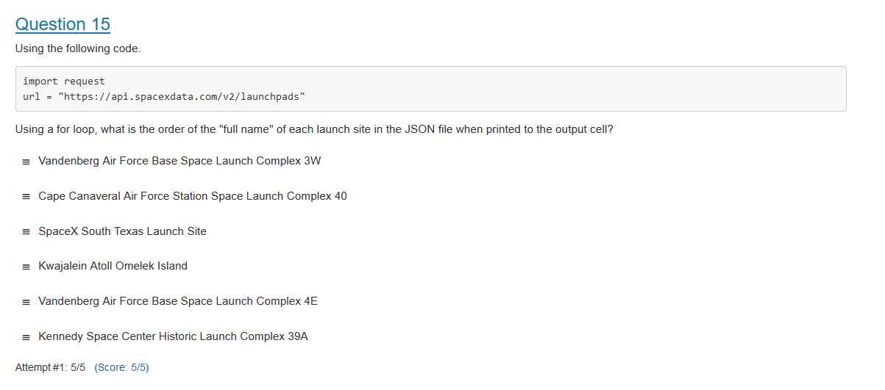**

**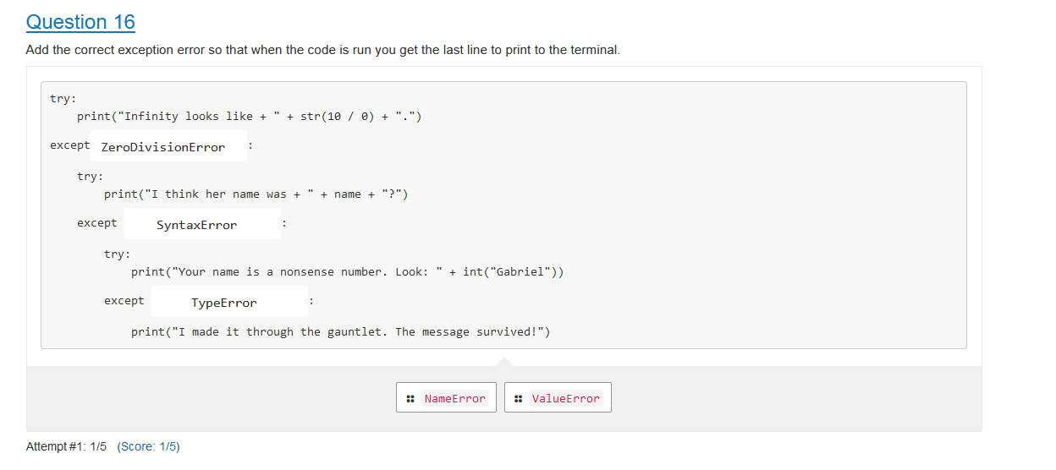**

**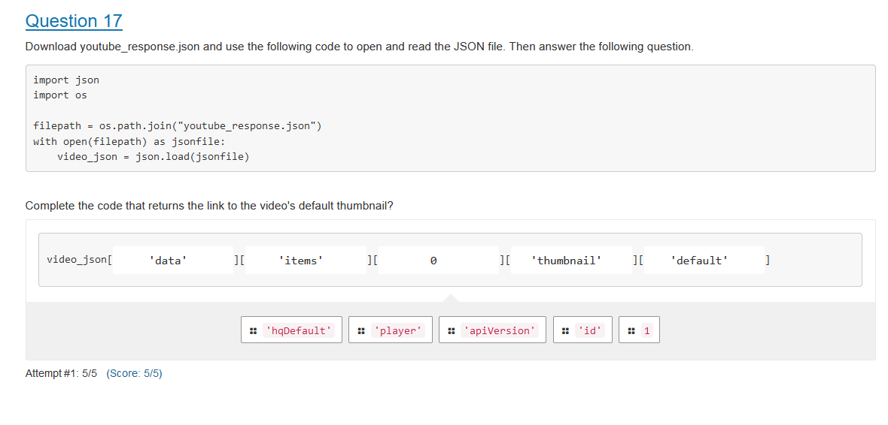**

**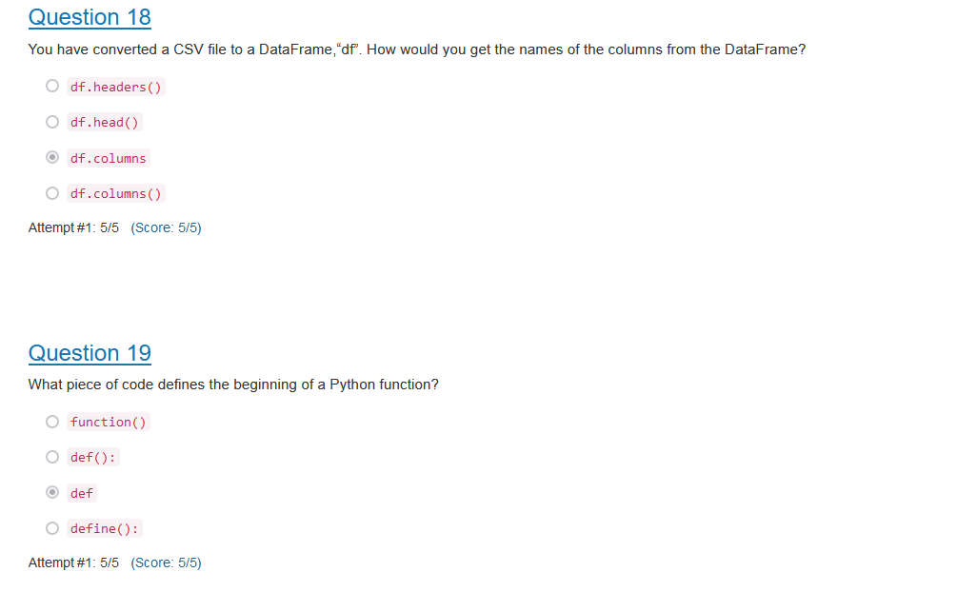**

**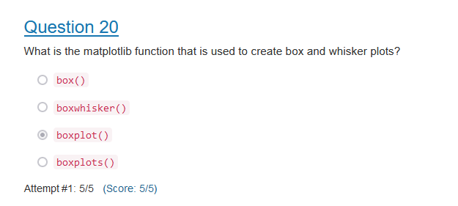**

**Test1**

**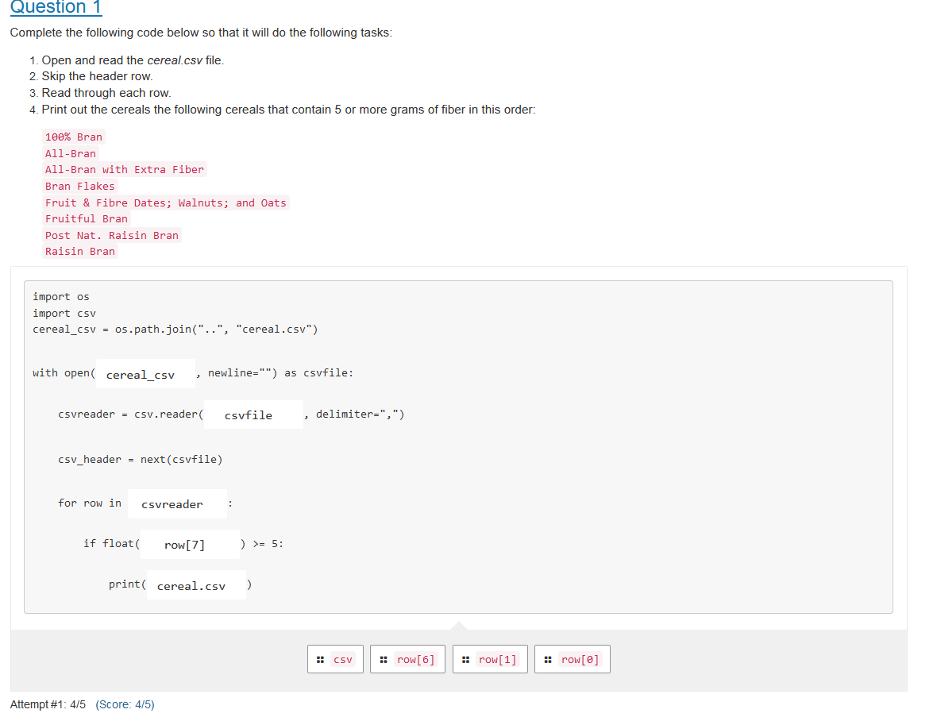**

**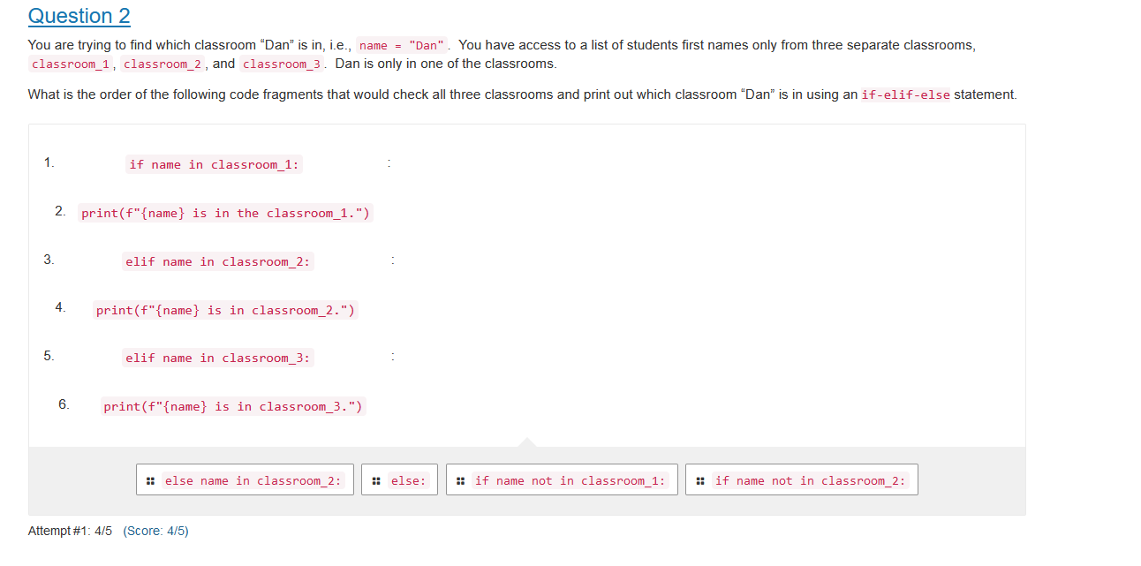**

**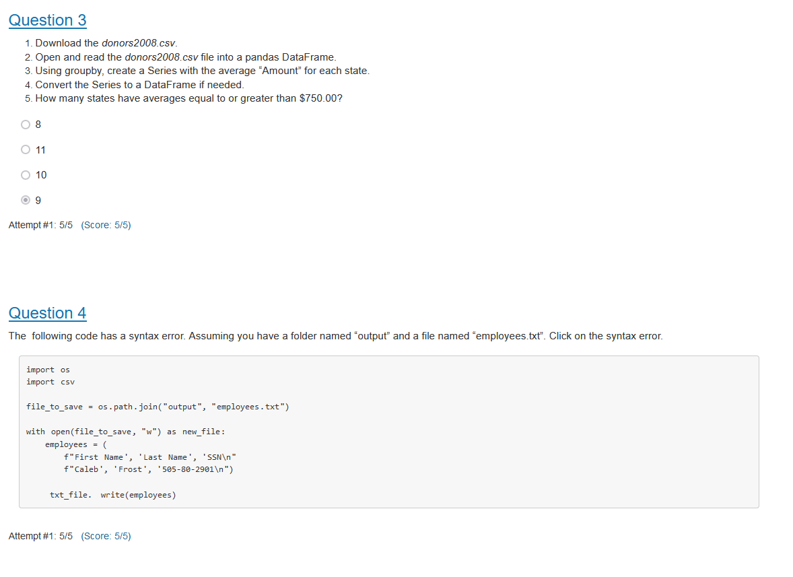**

**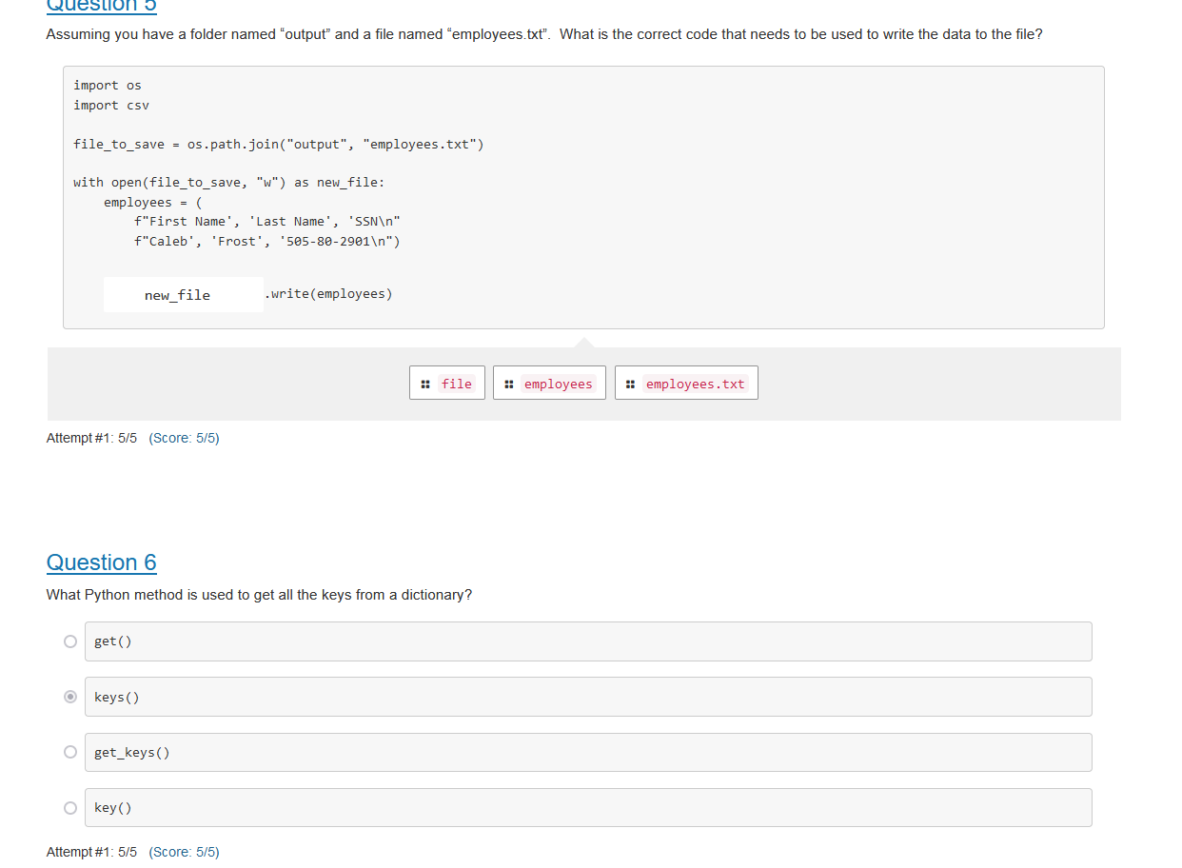**

**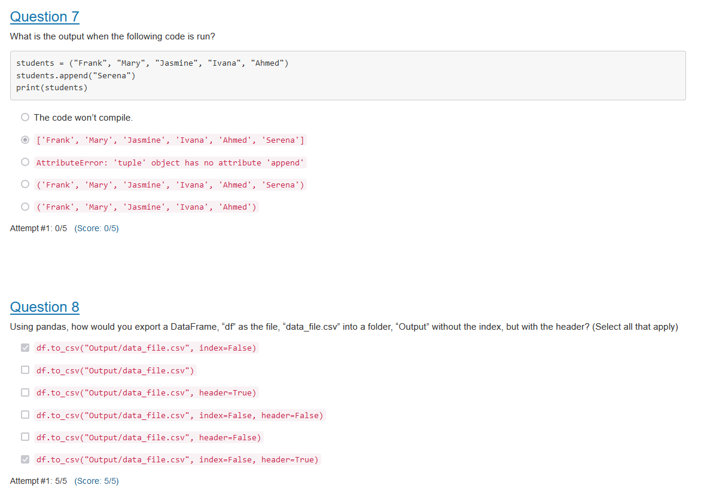**

**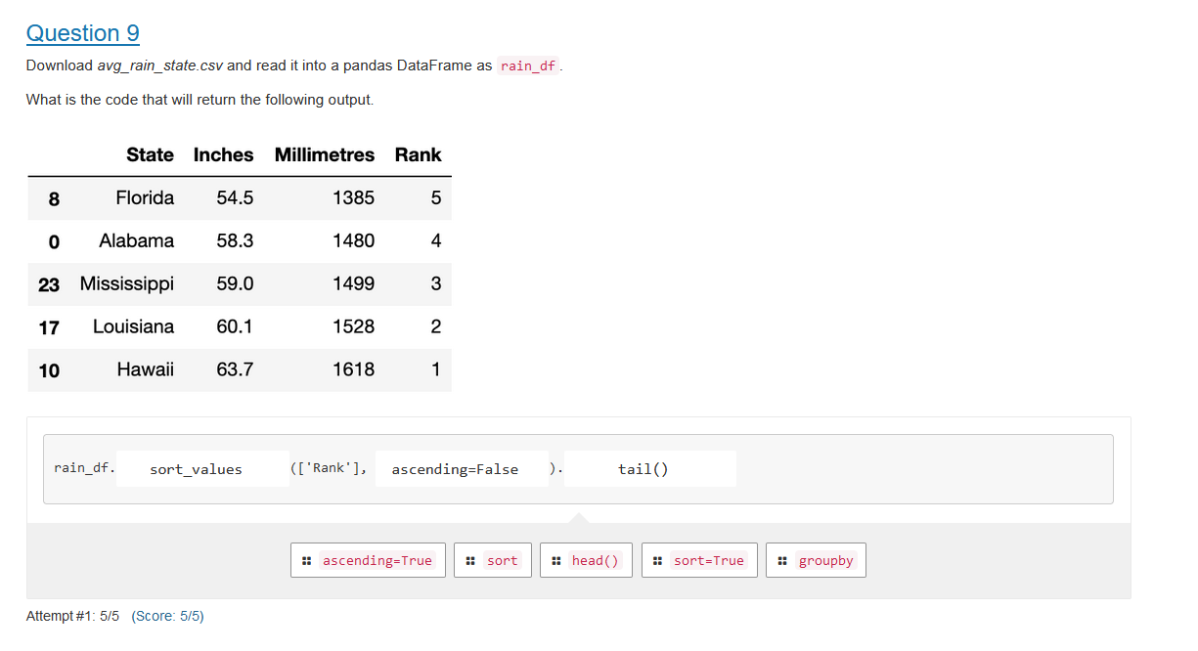**

**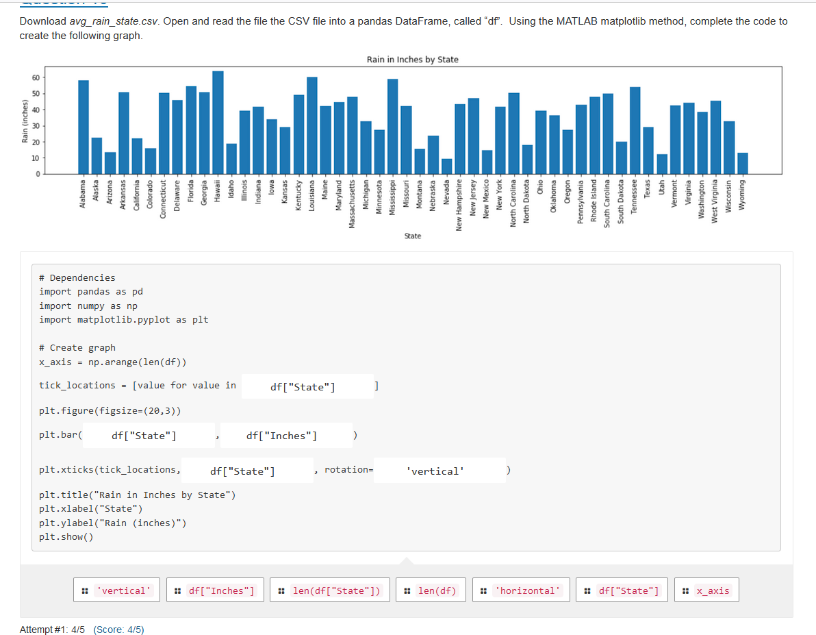**

**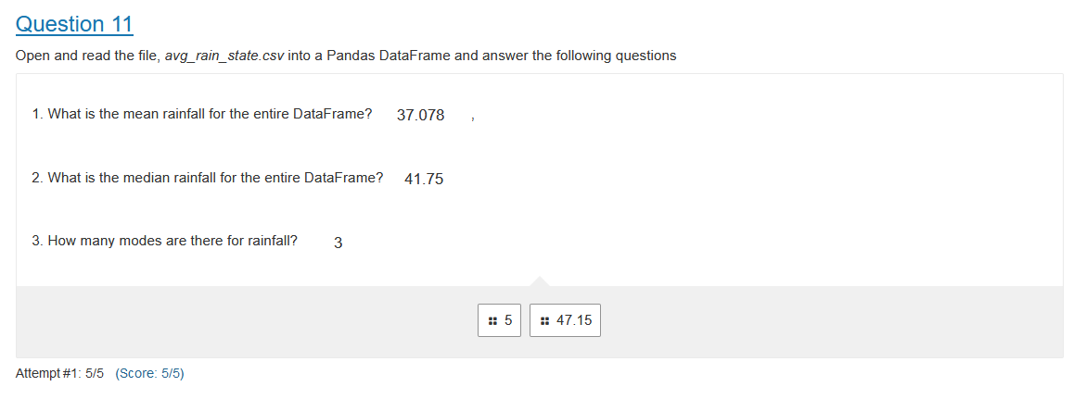**

**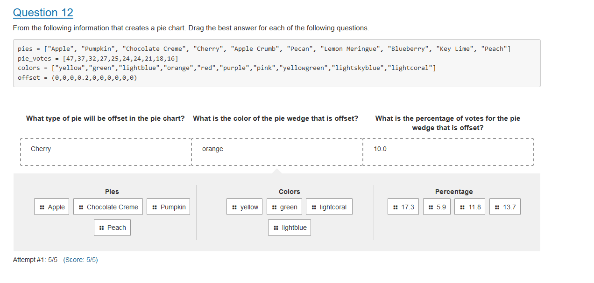**

**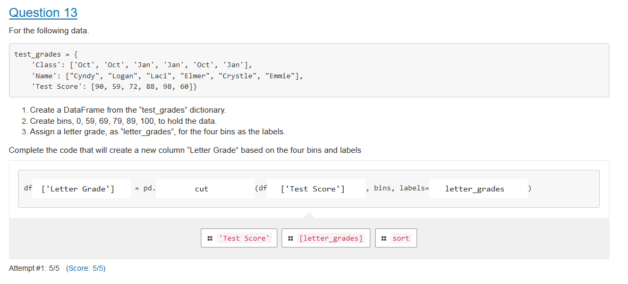**

**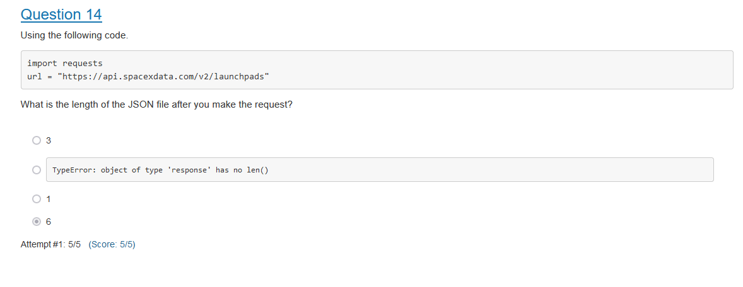**

**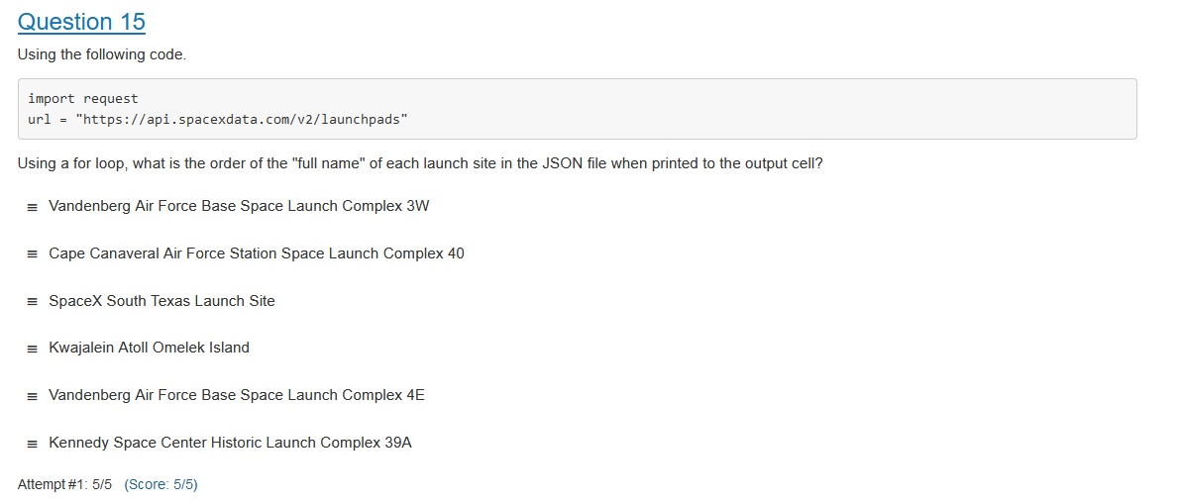**

**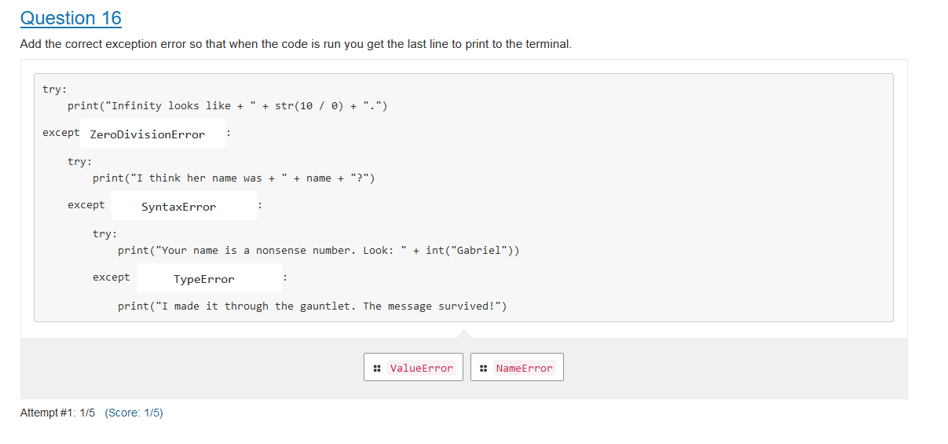**

**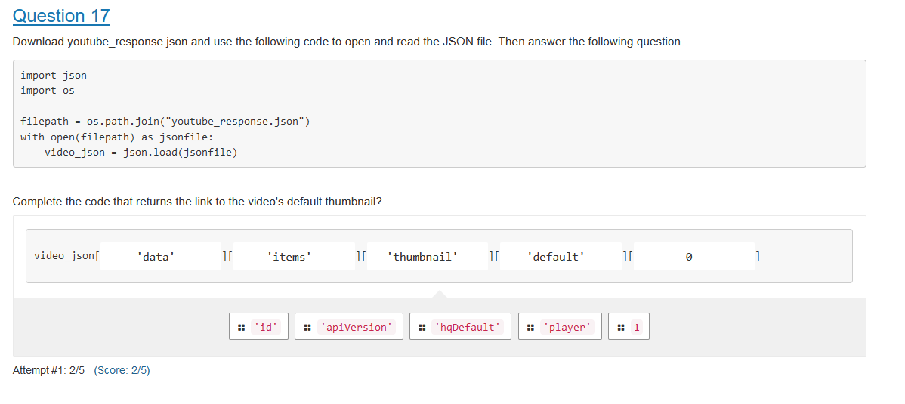**

**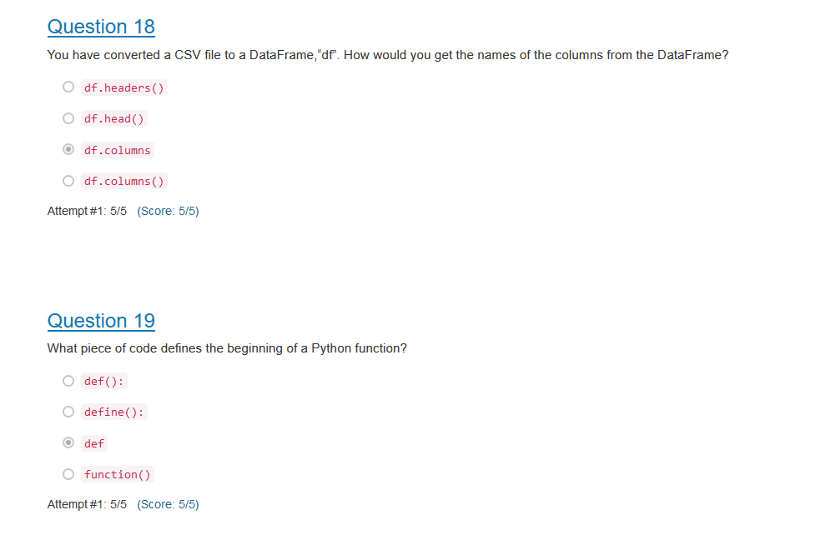**

**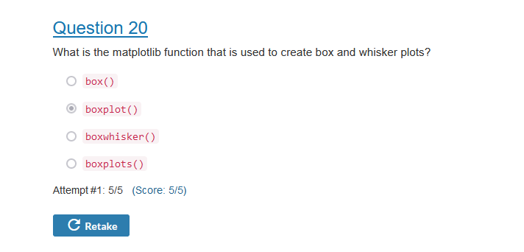**

[**Question 1**](https://learnosityplayer.atomicjoltapps.com/lti_launches/BnCxnazwQTAsy8d1iXPdbpVa#3430135d-bb65-44df-80c3-54d4c4dd8548_80ee4d811c069257497eb93a8b2aee9e)

Complete the following code below so that it will do the following tasks:

1. Open and read the *cereal.csv* file.
2. Skip the header row.
3. Read through each row.
4. Print out the cereals the following cereals that contain 5 or more grams of fiber in this order:

100% Bran  
All-Bran  
All-Bran with Extra Fiber  
Bran Flakes  
Fruit & Fibre Dates; Walnuts; and Oats  
Fruitful Bran  
Post Nat. Raisin Bran  
Raisin Bran

Put responses in the correct input to answer the question. Select a response, navigate to the desired input and insert the response. Responses can be selected and inserted using the space bar, enter key, left mouse button or touchpad. Responses can also be moved by dragging with a mouse.

import os

import csv

cereal\_csv = os.path.join("..", "cereal.csv")

with open(

, newline="") as csvfile:

csvreader = csv.reader(

, delimiter=",")

csv\_header = next(csvfile)

for row in

:

if float(

) >= 5:

print(

)

Attempt #1: 4/5

**[Question 2](https://learnosityplayer.atomicjoltapps.com/lti_launches/BnCxnazwQTAsy8d1iXPdbpVa" \l "3430135d-bb65-44df-80c3-54d4c4dd8548_2906159346143675295939c604d568e4)**

You are trying to find which classroom “Dan” is in, i.e., name = "Dan".  You have access to a list of students first names only from three separate classrooms, classroom\_1, classroom\_2, and classroom\_3.  Dan is only in one of the classrooms.

What is the order of the following code fragments that would check all three classrooms and print out which classroom “Dan” is in using an if-elif-else statement.

Put responses in the correct input to answer the question. Select a response, navigate to the desired input and insert the response. Responses can be selected and inserted using the space bar, enter key, left mouse button or touchpad. Responses can also be moved by dragging with a mouse.

1.

:  
   2.   
3. :  
   4.   
5. :  
    6.

Attempt #1: 4/5

**[Question 3](https://learnosityplayer.atomicjoltapps.com/lti_launches/BnCxnazwQTAsy8d1iXPdbpVa" \l "3430135d-bb65-44df-80c3-54d4c4dd8548_1cca91ab2ba5b19cc7b4a6fcf0deb5be)**

1. Download the *donors2008.csv*.
2. Open and read the *donors2008.csv* file into a pandas DataFrame.
3. Using groupby, create a Series with the average “Amount” for each state.
4. Convert the Series to a DataFrame if needed.
5. How many states have averages equal to or greater than $750.00?

* 8 - no response given

8

8

* 11 - no response given

11

11

* 10 - no response given

10

10

* 9 - correct

9

9

Attempt #1: 5/5

**[Question 4](https://learnosityplayer.atomicjoltapps.com/lti_launches/BnCxnazwQTAsy8d1iXPdbpVa" \l "3430135d-bb65-44df-80c3-54d4c4dd8548_2db560ef5edd4fea0c83520591550c9a)**

The  following code has a syntax error. Assuming you have a folder named “output” and a file named “employees.txt”. Click on the syntax error.

response - correct

To interact with this question use tab to move through the text tokens. Use space or enter to select or deselect the relevant tokens

Attempt #1: 5/5

**[Question 5](https://learnosityplayer.atomicjoltapps.com/lti_launches/BnCxnazwQTAsy8d1iXPdbpVa" \l "3430135d-bb65-44df-80c3-54d4c4dd8548_80dcd8632f849c03545853a493c01369)**

Assuming you have a folder named “output” and a file named “employees.txt”.  What is the correct code that needs to be used to write the data to the file?

response - correct

Put responses in the correct input to answer the question. Select a response, navigate to the desired input and insert the response. Responses can be selected and inserted using the space bar, enter key, left mouse button or touchpad. Responses can also be moved by dragging with a mouse.

import os

import csv

file\_to\_save = os.path.join("output", "employees.txt")

with open(file\_to\_save, "w") as new\_file:

employees = (

f"First Name', 'Last Name', 'SSN\n"

f"Caleb', 'Frost', '505-80-2901\n")

.write(employees)

response - correct

Attempt #1: 5/5

**[Question 6](https://learnosityplayer.atomicjoltapps.com/lti_launches/BnCxnazwQTAsy8d1iXPdbpVa" \l "3430135d-bb65-44df-80c3-54d4c4dd8548_f0ed5aa8851fdf0e4c631e2e6aa230a4)**

What Python method is used to get all the keys from a dictionary?

* get() - no response given

get()

get()

* keys() - correct

keys()

keys()

* get\_keys() - no response given

get\_keys()

get\_keys()

* key() - no response given

key()

key()

Attempt #1: 5/5

**[Question 7](https://learnosityplayer.atomicjoltapps.com/lti_launches/BnCxnazwQTAsy8d1iXPdbpVa" \l "3430135d-bb65-44df-80c3-54d4c4dd8548_2ea0e825e3668108b445899dc5f42b53)**

What is the output when the following code is run?

students = ("Frank", "Mary", "Jasmine", "Ivana", "Ahmed")

students.append("Serena")

print(students)

* The code won’t compile. - no response given

The code won’t compile.

The code won’t compile.

* ['Frank', 'Mary', 'Jasmine', 'Ivana', 'Ahmed', 'Serena'] - incorrect

['Frank', 'Mary', 'Jasmine', 'Ivana', 'Ahmed', 'Serena']

['Frank', 'Mary', 'Jasmine', 'Ivana', 'Ahmed', 'Serena']

* AttributeError: 'tuple' object has no attribute 'append' - no response given

AttributeError: 'tuple' object has no attribute 'append'

AttributeError: 'tuple' object has no attribute 'append'

* ('Frank', 'Mary', 'Jasmine', 'Ivana', 'Ahmed', 'Serena') - no response given

('Frank', 'Mary', 'Jasmine', 'Ivana', 'Ahmed', 'Serena')

('Frank', 'Mary', 'Jasmine', 'Ivana', 'Ahmed', 'Serena')

* ('Frank', 'Mary', 'Jasmine', 'Ivana', 'Ahmed') - no response given

('Frank', 'Mary', 'Jasmine', 'Ivana', 'Ahmed')

('Frank', 'Mary', 'Jasmine', 'Ivana', 'Ahmed')

Attempt #1: 0/5

**[Question 8](https://learnosityplayer.atomicjoltapps.com/lti_launches/BnCxnazwQTAsy8d1iXPdbpVa" \l "3430135d-bb65-44df-80c3-54d4c4dd8548_cc74d2ccb039694354dc3373b1fd84b5)**

Using pandas, how would you export a DataFrame, “df” as the file, “data\_file.csv” into a folder, “Output” without the index, but with the header? (Select all that apply)

response - correct

* df.to\_csv("Output/data\_file.csv", index=False) - correct

df.to\_csv("Output/data\_file.csv", index=False)

df.to\_csv("Output/data\_file.csv", index=False)

* df.to\_csv("Output/data\_file.csv") - no response given

df.to\_csv("Output/data\_file.csv")

df.to\_csv("Output/data\_file.csv")

* df.to\_csv("Output/data\_file.csv", header=True) - no response given

df.to\_csv("Output/data\_file.csv", header=True)

df.to\_csv("Output/data\_file.csv", header=True)

* df.to\_csv("Output/data\_file.csv", index=False, header=False) - no response given

df.to\_csv("Output/data\_file.csv", index=False, header=False)

df.to\_csv("Output/data\_file.csv", index=False, header=False)

* df.to\_csv("Output/data\_file.csv", header=False) - no response given

df.to\_csv("Output/data\_file.csv", header=False)

df.to\_csv("Output/data\_file.csv", header=False)

* df.to\_csv("Output/data\_file.csv", index=False, header=True) - correct

df.to\_csv("Output/data\_file.csv", index=False, header=True)

df.to\_csv("Output/data\_file.csv", index=False, header=True)

Attempt #1: 5/5

**[Question 9](https://learnosityplayer.atomicjoltapps.com/lti_launches/BnCxnazwQTAsy8d1iXPdbpVa" \l "3430135d-bb65-44df-80c3-54d4c4dd8548_90f401f34956e78165292f708cdb570b)**

Download *avg\_rain\_state.csv* and read it into a pandas DataFrame as rain\_df.

What is the code that will return the following output.

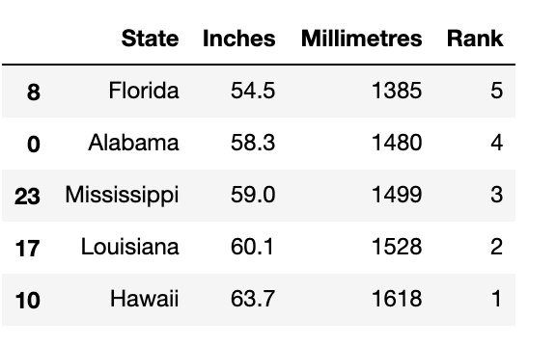

Put responses in the correct input to answer the question. Select a response, navigate to the desired input and insert the response. Responses can be selected and inserted using the space bar, enter key, left mouse button or touchpad. Responses can also be moved by dragging with a mouse.

rain\_df.

(['Rank'],

).

Attempt #1: 5/5

**[Question 10](https://learnosityplayer.atomicjoltapps.com/lti_launches/BnCxnazwQTAsy8d1iXPdbpVa" \l "3430135d-bb65-44df-80c3-54d4c4dd8548_c4bc9b76868cfb52ef2b79a76d968b14)**

Download *avg\_rain\_state.csv*. Open and read the file the CSV file into a pandas DataFrame, called “df”.  Using the MATLAB matplotlib method, complete the code to create the following graph.

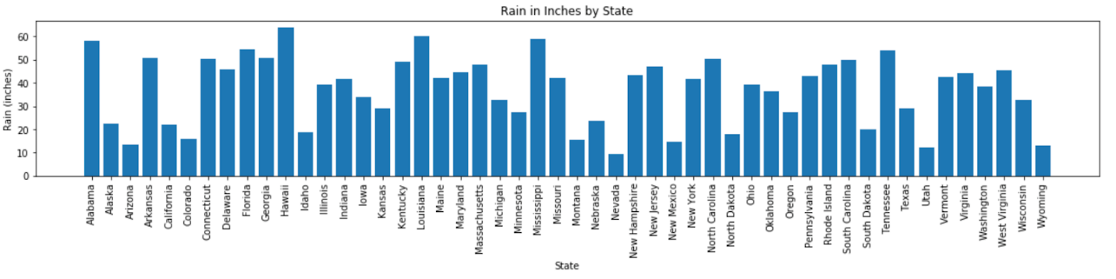

Put responses in the correct input to answer the question. Select a response, navigate to the desired input and insert the response. Responses can be selected and inserted using the space bar, enter key, left mouse button or touchpad. Responses can also be moved by dragging with a mouse.

# Dependencies

import pandas as pd

import numpy as np

import matplotlib.pyplot as plt

# Create graph

x\_axis = np.arange(len(df))

tick\_locations = [value for value in

]

plt.figure(figsize=(20,3))

plt.bar(

,

)

plt.xticks(tick\_locations,

, rotation=

)

plt.title("Rain in Inches by State")

plt.xlabel("State")

plt.ylabel("Rain (inches)")

plt.show()

Attempt #1: 4/5

**[Question 11](https://learnosityplayer.atomicjoltapps.com/lti_launches/BnCxnazwQTAsy8d1iXPdbpVa" \l "3430135d-bb65-44df-80c3-54d4c4dd8548_db24e38135f7f75ce977db145dc77c8c)**

Open and read the file, *avg\_rain\_state.csv* into a Pandas DataFrame and answer the following questions

Put responses in the correct input to answer the question. Select a response, navigate to the desired input and insert the response. Responses can be selected and inserted using the space bar, enter key, left mouse button or touchpad. Responses can also be moved by dragging with a mouse.

1. What is the mean rainfall for the entire DataFrame?

,

2. What is the median rainfall for the entire DataFrame?

3. How many modes are there for rainfall?

Attempt #1: 5/5

**[Question 12](https://learnosityplayer.atomicjoltapps.com/lti_launches/BnCxnazwQTAsy8d1iXPdbpVa" \l "3430135d-bb65-44df-80c3-54d4c4dd8548_baedbe76b49fa56e3d32d673399aae4e)**

From the following information that creates a pie chart. Drag the best answer for each of the following questions.

pies = ["Apple", "Pumpkin", "Chocolate Creme", "Cherry", "Apple Crumb", "Pecan", "Lemon Meringue", "Blueberry", "Key Lime", "Peach"]

pie\_votes = [47,37,32,27,25,24,24,21,18,16]

colors = ["yellow","green","lightblue","orange","red","purple","pink","yellowgreen","lightskyblue","lightcoral"]

offset = (0,0,0,0.2,0,0,0,0,0,0)

response - correct

Put responses in the correct input to answer the question. Select a response, navigate to the desired input and insert the response. Responses can be selected and inserted using the space bar, enter key, left mouse button or touchpad. Responses can also be moved by dragging with a mouse.

| **What type of pie will be offset in the pie chart?** | **What is the color of the pie wedge that is offset?** | **What is the percentage of votes for the pie wedge that is offset?** |
| --- | --- | --- |
|  |  |  |

Pies

Colors

Percentage

Attempt #1: 5/5

**[Question 13](https://learnosityplayer.atomicjoltapps.com/lti_launches/BnCxnazwQTAsy8d1iXPdbpVa" \l "3430135d-bb65-44df-80c3-54d4c4dd8548_6029b4fca6bf43522213d36162665e1a)**

For the following data.

test\_grades = {

'Class': ['Oct', 'Oct', 'Jan', 'Jan', 'Oct', 'Jan'],

'Name': ["Cyndy", "Logan", "Laci", "Elmer", "Crystle", "Emmie"],

'Test Score': [90, 59, 72, 88, 98, 60]}

1. Create a DataFrame from the “test\_grades” dictionary.
2. Create bins, 0, 59, 69, 79, 89, 100, to hold the data.
3. Assign a letter grade, as “letter\_grades”, for the four bins as the labels.

Complete the code that will create a new column “Letter Grade” based on the four bins and labels

Put responses in the correct input to answer the question. Select a response, navigate to the desired input and insert the response. Responses can be selected and inserted using the space bar, enter key, left mouse button or touchpad. Responses can also be moved by dragging with a mouse.

df

= pd.

(df

, bins, labels=

)

Attempt #1: 5/5

**[Question 14](https://learnosityplayer.atomicjoltapps.com/lti_launches/BnCxnazwQTAsy8d1iXPdbpVa" \l "3430135d-bb65-44df-80c3-54d4c4dd8548_2ca27d21a557fbc6cf7cdbd67750263c)**

Using the following code.

import requests

url = "https://api.spacexdata.com/v2/launchpads"

What is the length of the JSON file after you make the request?

* 3 - no response given

3

3

* TypeError: object of type 'response' has no len() - no response given

TypeError: object of type 'response' has no len()

TypeError: object of type 'response' has no len()

* 1 - no response given

1

1

* 6 - correct

6

6

Attempt #1: 5/5

**[Question 15](https://learnosityplayer.atomicjoltapps.com/lti_launches/BnCxnazwQTAsy8d1iXPdbpVa" \l "3430135d-bb65-44df-80c3-54d4c4dd8548_6450197c0011c3b9aac54b5cdc9329b9)**

Using the following code.

import request

url = "https://api.spacexdata.com/v2/launchpads"

Using a for loop, what is the order of the "full name" of each launch site in the JSON file when printed to the output cell?

Arrange responses in the correct order to answer the question. Select a response, navigate to the desired position and insert response at that position. Responses can be selected and inserted using the space bar, enter key, left mouse button or touchpad. Responses can be moved using the up and down arrow keys or by dragging with a mouse.

Attempt #1: 5/5

**[Question 16](https://learnosityplayer.atomicjoltapps.com/lti_launches/BnCxnazwQTAsy8d1iXPdbpVa" \l "3430135d-bb65-44df-80c3-54d4c4dd8548_8a245b4036511a6e7955af4ea71f037a)**

Add the correct exception error so that when the code is run you get the last line to print to the terminal.

Put responses in the correct input to answer the question. Select a response, navigate to the desired input and insert the response. Responses can be selected and inserted using the space bar, enter key, left mouse button or touchpad. Responses can also be moved by dragging with a mouse.

try:

print("Infinity looks like + " + str(10 / 0) + ".")

except

:

try:

print("I think her name was + " + name + "?")

except

:

try:

print("Your name is a nonsense number. Look: " + int("Gabriel"))

except

:

print("I made it through the gauntlet. The message survived!")

Attempt #1: 1/5

**[Question 17](https://learnosityplayer.atomicjoltapps.com/lti_launches/BnCxnazwQTAsy8d1iXPdbpVa" \l "3430135d-bb65-44df-80c3-54d4c4dd8548_9e24fe3cbdd4020b4795fdb8319ee0d0)**

Download youtube\_response.json and use the following code to open and read the JSON file. Then answer the following question.

import json

import os

filepath = os.path.join("youtube\_response.json")

with open(filepath) as jsonfile:

video\_json = json.load(jsonfile)

Complete the code that returns the link to the video's default thumbnail?

Put responses in the correct input to answer the question. Select a response, navigate to the desired input and insert the response. Responses can be selected and inserted using the space bar, enter key, left mouse button or touchpad. Responses can also be moved by dragging with a mouse.

video\_json[

][

][

][

][

]

Attempt #1: 2/5

**[Question 18](https://learnosityplayer.atomicjoltapps.com/lti_launches/BnCxnazwQTAsy8d1iXPdbpVa" \l "3430135d-bb65-44df-80c3-54d4c4dd8548_66c2300fab2af63c1bfc0278bd1e11fe)**

You have converted a CSV file to a DataFrame,“df”. How would you get the names of the columns from the DataFrame?

* df.headers() - no response given

df.headers()

df.headers()

* df.head() - no response given

df.head()

df.head()

* df.columns - correct

df.columns

df.columns

* df.columns() - no response given

df.columns()

df.columns()

Attempt #1: 5/5

**[Question 19](https://learnosityplayer.atomicjoltapps.com/lti_launches/BnCxnazwQTAsy8d1iXPdbpVa" \l "3430135d-bb65-44df-80c3-54d4c4dd8548_2a627d4832531d7d698d3712dbef6054)**

What piece of code defines the beginning of a Python function?

* def(): - no response given

def():

def():

* define(): - no response given

define():

define():

* def - correct

def

def

* function() - no response given

function()

function()

Attempt #1: 5/5

**[Question 20](https://learnosityplayer.atomicjoltapps.com/lti_launches/BnCxnazwQTAsy8d1iXPdbpVa" \l "3430135d-bb65-44df-80c3-54d4c4dd8548_31687a280acf7b52c9cffe8d08c499d1)**

What is the matplotlib function that is used to create box and whisker plots?

* box() - no response given

box()

box()

* boxplot() - correct

boxplot()

boxplot()

* boxwhisker() - no response given

boxwhisker()

boxwhisker()

* boxplots() - no response given

boxplots()

boxplots()

Attempt #1: 5/5