On the Ubuntu Server, we can check repositories with the command

grep ^ /etc/apt/sources.list

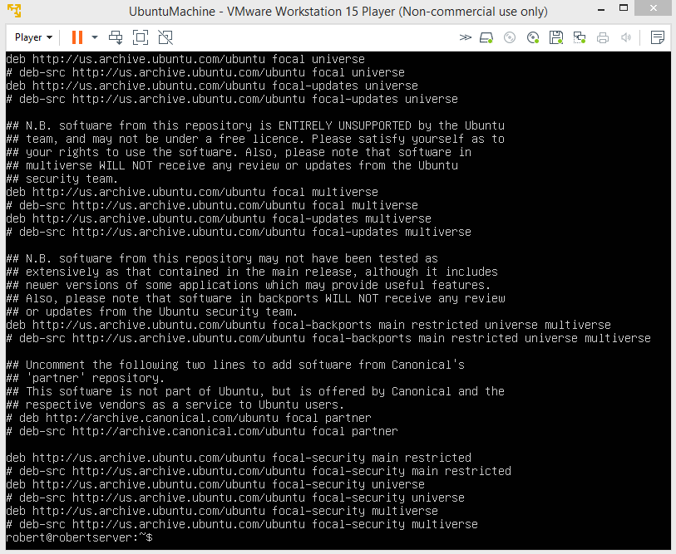

adding repository

We can check what programs we have installed with the command apt list --installed

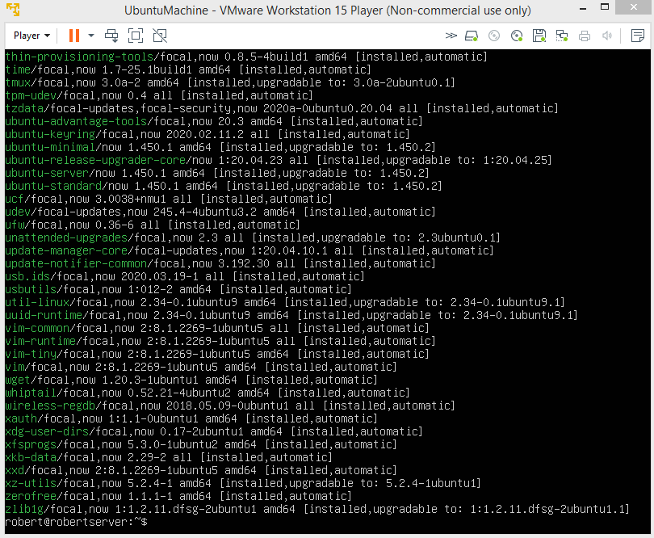

Not all that helpful really. However, we can check if a specific program is installed with the command apt list -a .

For example, apt list -a vim

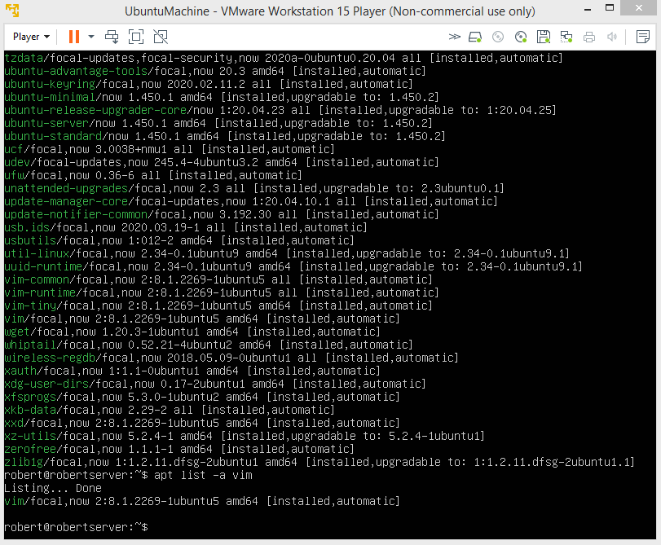

Now to install Tmux. The command is sudo apt-get install tmux

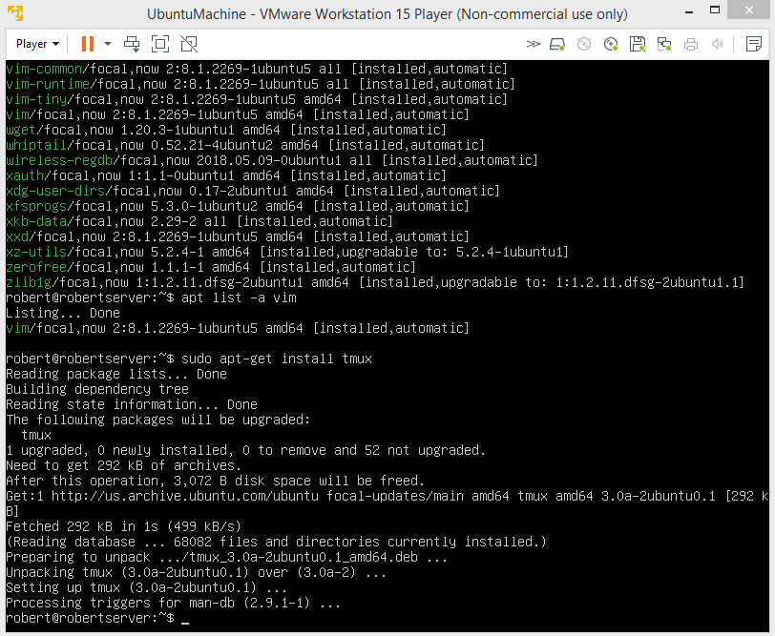

Installing emacs uses the same command, but you will given a prompt part way through.

Fail2ban is installed the same way.

Now, we will work on CentOS. To check repositories, we use the command "yum -v repolist".

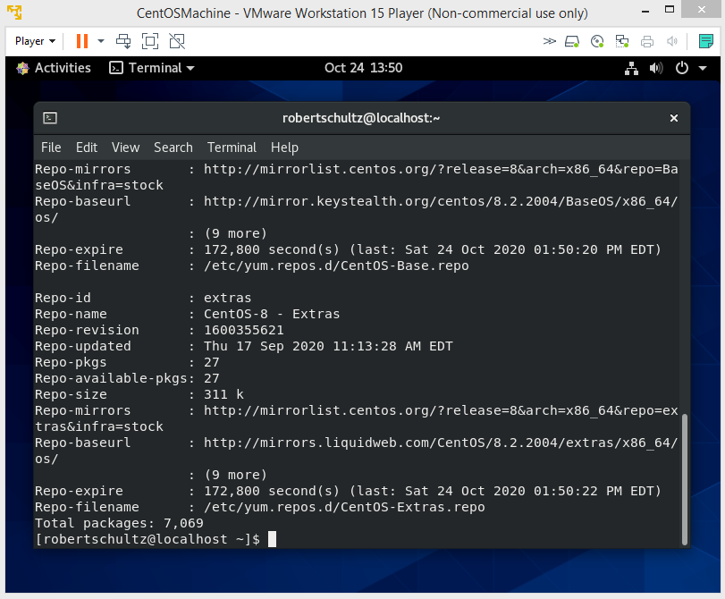

Now we check to see what programs are installed. To do this we use the command "sudo yum list installed". You will then need to enter your password.

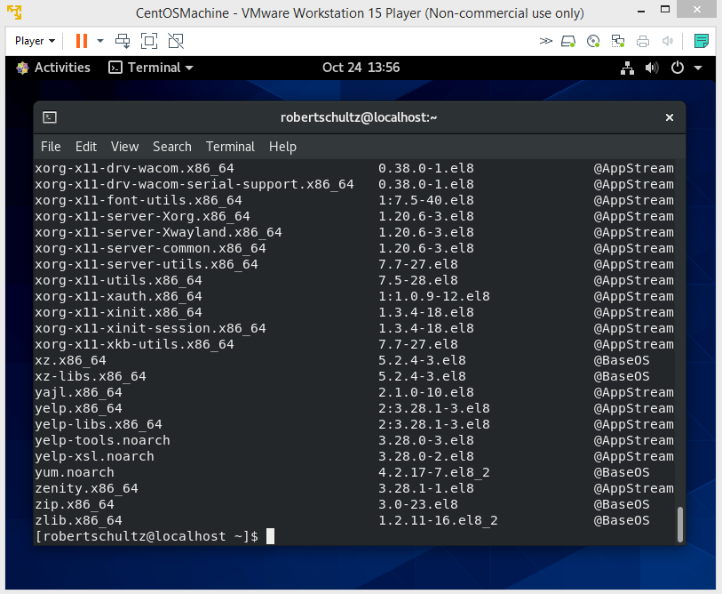

You might need to go through the data.

As you can see, we already have vim installed.

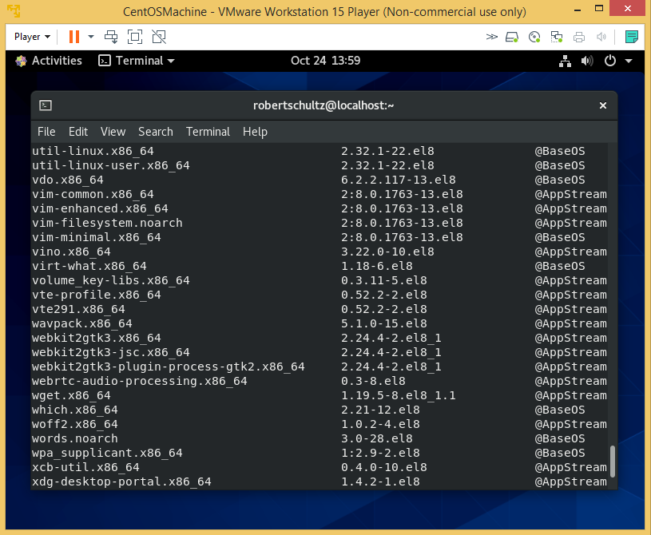

Emacs is also already installed.

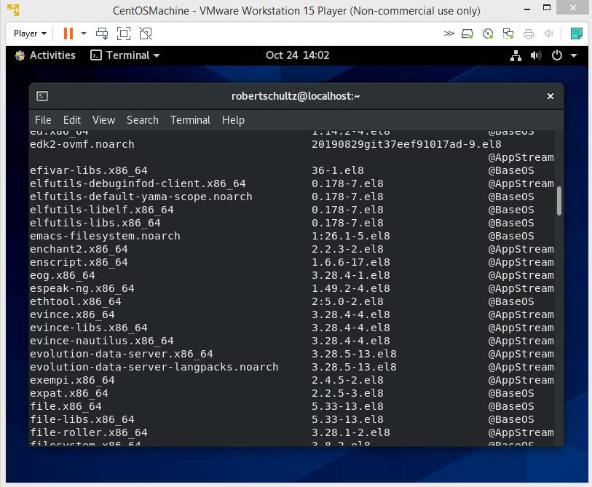

We still need to install Tmux and Fail2Ban.

Tmux is installed easily with "yum install tmux". Oh yeah you can only do this as root.

You will be prompted twice during the install. Just enter "y" both times and the install will be completed.

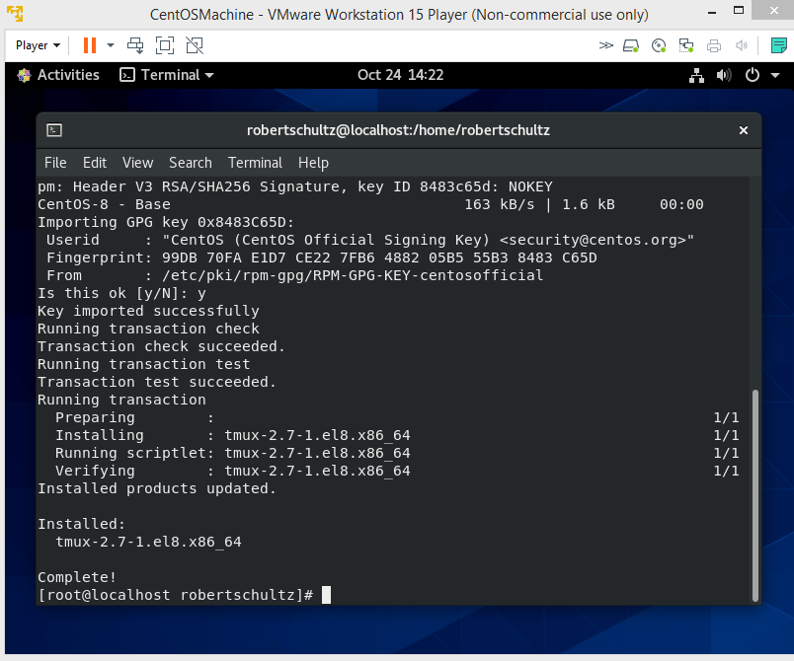

Before you can install Fail2Ban, you will need to enable the EPEL repository. You can do this with the command "yum install epel-release". This time you will only be prompted once.

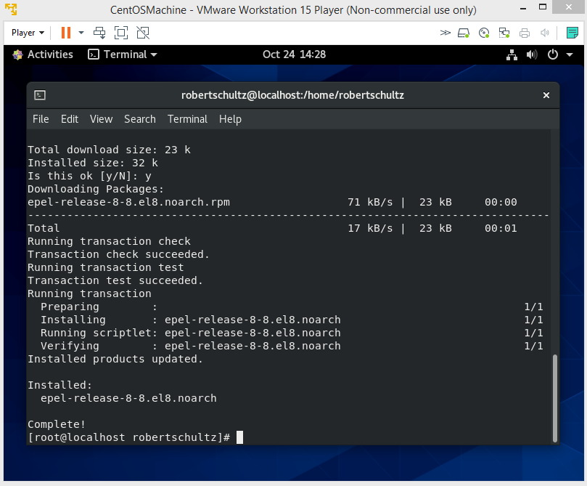

Now to install Fail2Ban, you just use the command "yum install fail2ban fail2ban-systemd". Once again, you will be prompted to confirm twice during the install.

