Installing docker on CentOS first requires the installation of yum-utils. First, enter the command 'sudo yum install -y yum-utils'.

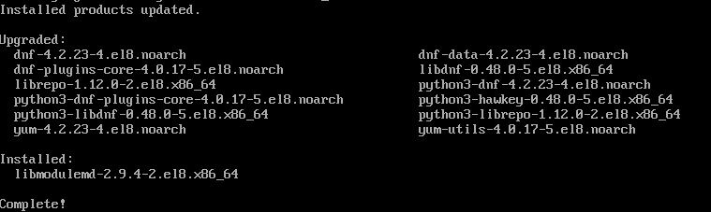

After that, enter the command 'sudo yum-config-manager \'. You will then continue on the next line '--add-repo \'. Finally, on the next line, enter 'https://download.docker.com/linux/centos/docker-ce.repo'.

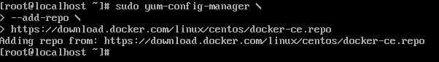

Not done yet. Use the command 'sudo yum install docker-ce docker-ce-cli containerd.io'.

You may need to add other options to the command such as '--allowerasing' or '--nobest'. Do not use the option '-y', you might be prompted to accept a key. If it is 060A 61C5 1B55 8A7F 742B 77AA C52F EB6B 621E 9F35, then you can accept.

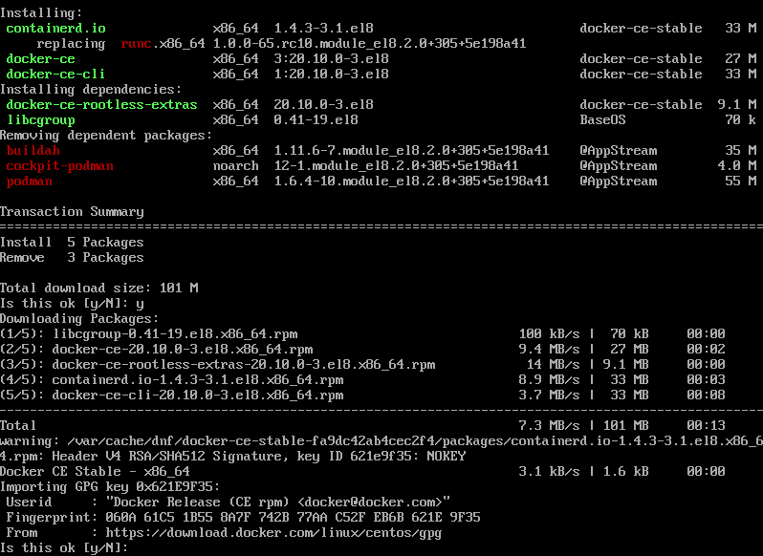

Once all that is done, it's time to start the new service. Use the command 'sudo systemctl start docker'. Then we should test it with the command 'sudo docker run hello-world'.

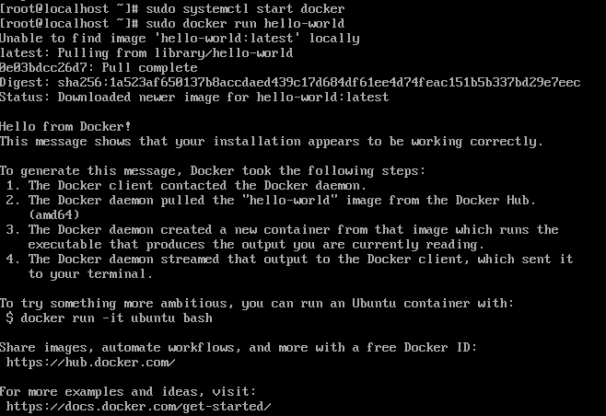

And it appears everything is working correctly

Now lets do it on Ubuntu.

First, use the command 'sudo apt-get update'.

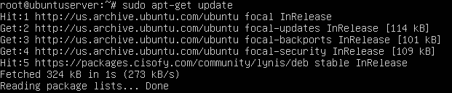

Then use 'sudo apt-get install \'. You will be moved to the next line. There, you should enter 'apt-transport-https \' and then 'ca-certificates \' after that 'curl \' next 'gnupg-agent \' and finally 'software-properties-common'. Wow, that was a long one.

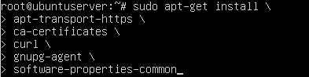

Next, use 'curl -fsSL https://download.docker.com/linux/ubuntu/gpg | apt-key add -'.

Untitled:ubuntucontainer_dockerkey.png

Now we should check that we have everything right. use the command 'sudo apt-key fingerprint 0EBFCD88'.

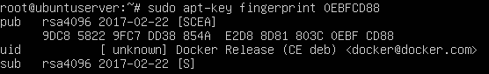

If the information matches, everything is correct so far.

Now use 'sudo add-apt-repository \' then '"deb [arch=amd64] https://download.docker.com/linux/ubuntu \' and '$(lsb\_release -cs) \' and finally 'stable'".

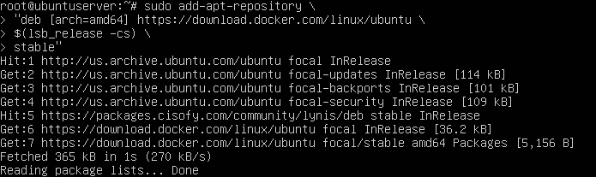

We're almost done. Use the commands 'sudo apt-get update' and then 'sudo apt-get install docker-ce docker-ce-cli containerd.io'. This will take a while.

Now time to start and test it. Enter the command 'sudo systemctl start docker'. and test it with 'sudo docker run hello-world'.

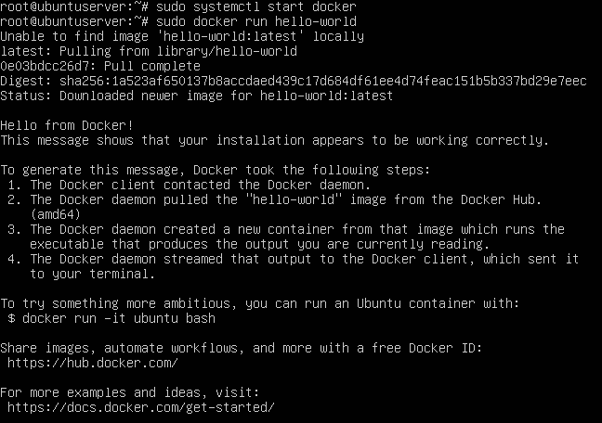

Everything seems to be working.

Now we'll try installing Kubernetes

The first command to use is 'curl -LO "https://storage.googleapis.com/kubernetes-release/release/$(curl -s https://storage.googleapis.com/kubernetes-release/release/stable.txt)/bin/linux/amd64/kubectl"'.

Here it is on CentOS

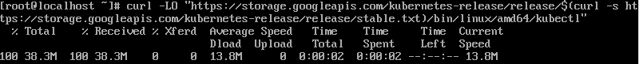

And here is Ubuntu

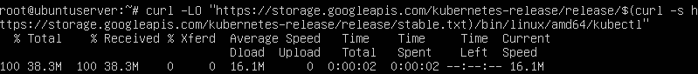

After that, we need to add permission to execute to our newest file. The command is 'chmod +x ./kubectl'.

Now we need to move the file to the right directory. We use the command 'sudo mv ./kubectl /usr/local/bin/kubectl'

Finally, we perform a test. This is just to make sure it is up to date. Use the command 'kubectl version --client'.

Here are the results for CentOS

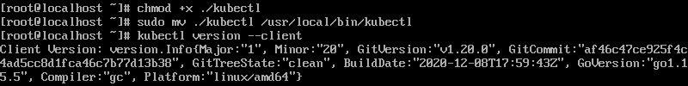

And here, we have Ubuntu

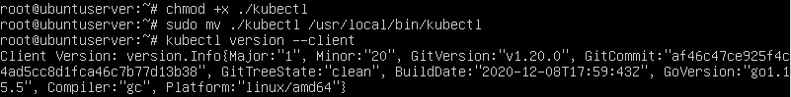

Looks like everything is working here.

I had some hardware trouble starting the tutorial for Minikube. I think it's just that my computer was exceptionally slow with this. However, once I gave my computer some time to get started, I was able to finish the tutorial with no further difficulties. It wasn't hard, just ended up being time consuming.

Sources

docs.docker.com/engine/install/centos/

docs.docker.com/engine/install/ubuntu/

kubernetes.io/docs/tasks/tools/install-kubectl/