1. Print all lines containing the string San .

The grep command prints all lines from a file or files that contain a specified pattern.

This command tells the computer to print all lines that contain "San".

grep 'San' datebook

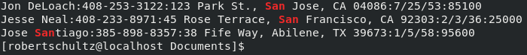

2. Print all lines where the person's first name starts with J .

This tells the computer to print all lines that begin with an upper case j.

The ^ tells the computer to only look for the pattern at the beginning of the line.

grep '^J' datebook

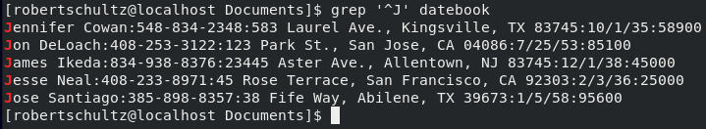

3. Print all lines ending in 700 .

The character "$" tells the computer that the pattern we're looking for is at the end of the line.

This one wasn't working. After doing some searching, I was recommended to run the command 'dos2unix datebook'. After that, it worked.

grep '700$' datebook

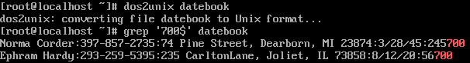

4. Print all lines that don't contain 834 .

The -v option tells the computer to print only lines where the pattern does not match.

grep -v -e '834' datebook

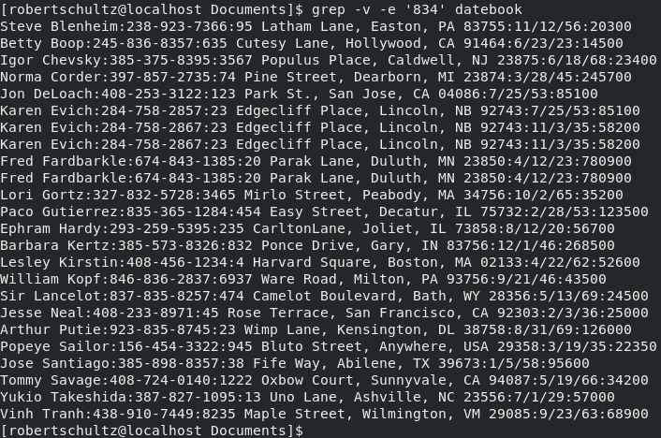

5. Print all lines where birthdays are in December .

The -E option tells the computer to use extended regular expressions.

The [0-9]+ tells the computer to look for numbers but for no given amount of characters.

The next thing it looks for /12.

Finally the computer looks for [0-9]+ again.

grep -E ':[0-9]+\/12\/[0-9]+' datebook

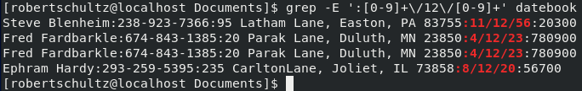

6. Print all lines where the phone number is in the 408 area code.

All phone numbers follow the same pattern. We can use this to tell the computer what pattern to look for. Using [0-9]{3} tells the computer to look for exactly three characters each falling in the range 0-9. After that, [0-9]{4} does the same thing, but for a string of four characters.

Since all phone numbers begin and end with :, we can tell the computer to look for a pattern that starts and ends with:.

grep -E ':408-[0-9]{3}-[0-9]{4}:' datebook

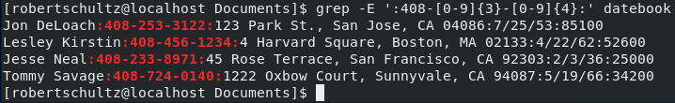

7. Print all lines containing an uppercase letter, followed by four lowercase letters , a comma, a space, and one uppercase letter.

The [A-Z] tells the computer to look for any uppercase letter

The [a-z]\{4\} tells the computer to look for a string of four lowercase letters.

grep '[A-Z][a-z]\{4\}, [A-Z]' datebook

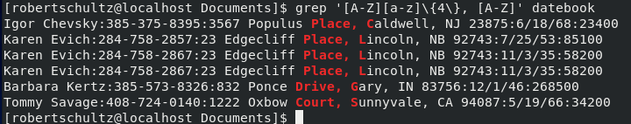

8. Print lines where the last name begins with K or k .

The \< indicates a word begins and then \> indicates the end of that word.

The . tells the computer that any character can be here and the \* states that it can be a string of any size.

The end of the second word does not matter, only the beginning. We use \< to tell the computer to look at the begin of the second word. (K|k) tells the computer it can be either an upper or lowercase k.

grep -E '\<.\*\>[\t ]\<(K|k)' datebook

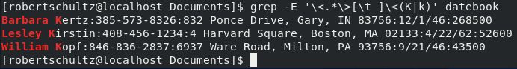

9. Print lines preceded by a line number where the salary is a six-figure number.

Same idea as number 6, but at the end of the line.

The -n option tells the computer to print the line number at the start.

grep -n '[0-9]\{6\}$' datebook

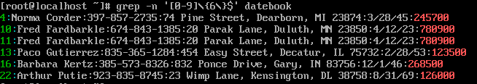

10. Print lines containing Lincoln or lincoln (remember that grep is insensitive to case).

The [Ll] tells the computer to look for either L or l. It will look for any one character between those brackets.

grep '[Ll]incoln' datebook

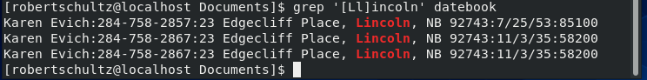

I found most of the answers in Linux Pocket Guide