First, once you have your two Linux Distros, you need to set up your two machines. Once you have all your files in place, you can start building the first machine.

We'll start with CentOS.

You will need to search your files for the image your going to use. Once you have it selected, hit next .

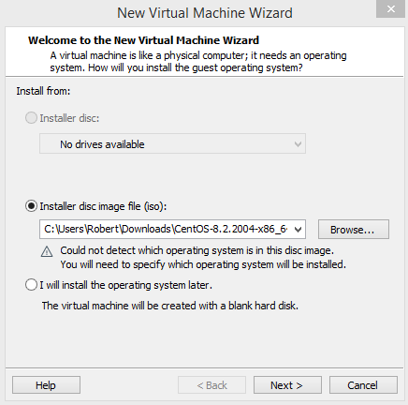

Select the correct OS and version, then hit next.

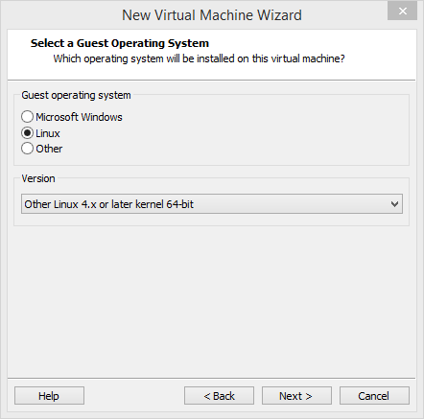

Give the machine an appropriate name and hit next.

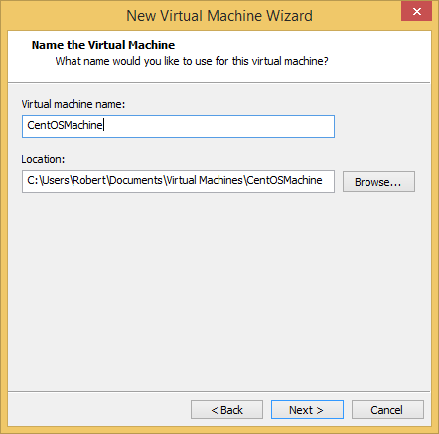

Define maximum disk size.

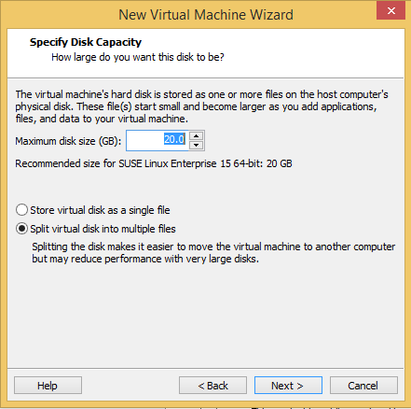

Okay, now you just hit finish.

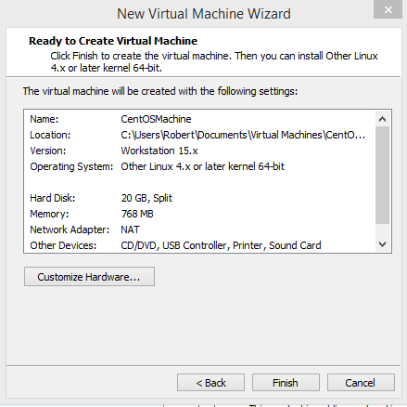After that, you can start up the new machine.

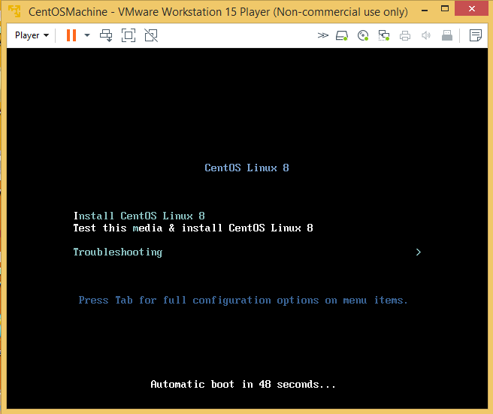

Hit enter to begin the install. You might need to wait a while.

Eventually you will see this screen.

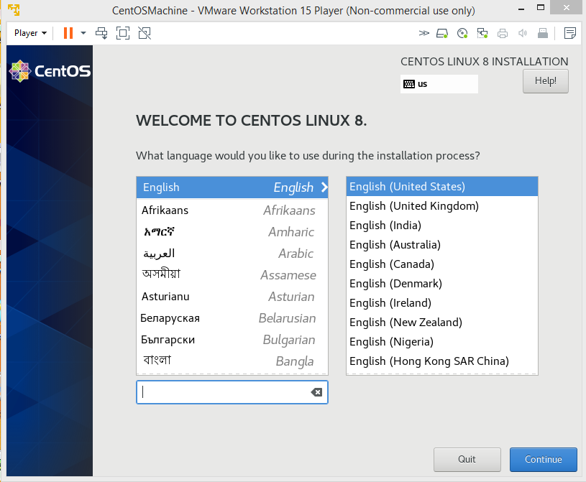

Pretty obvious, just choose the correct language and move on.

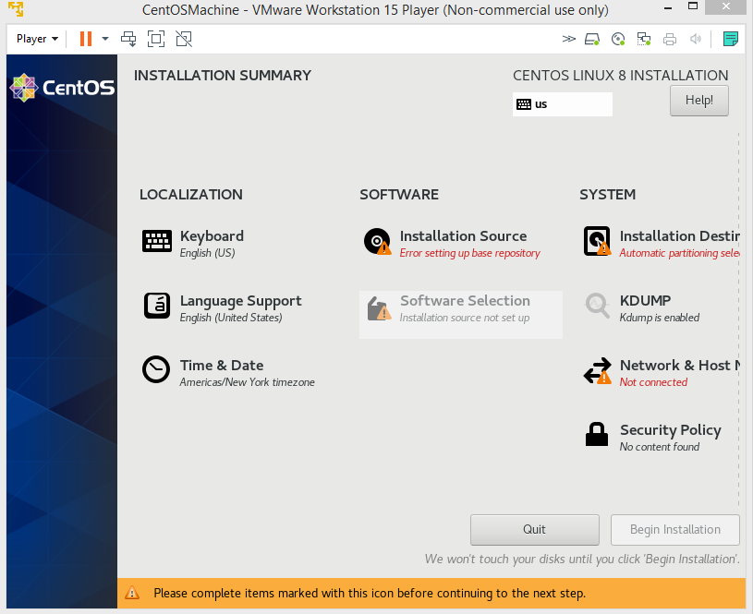

Select appropriate install destination and after that the network

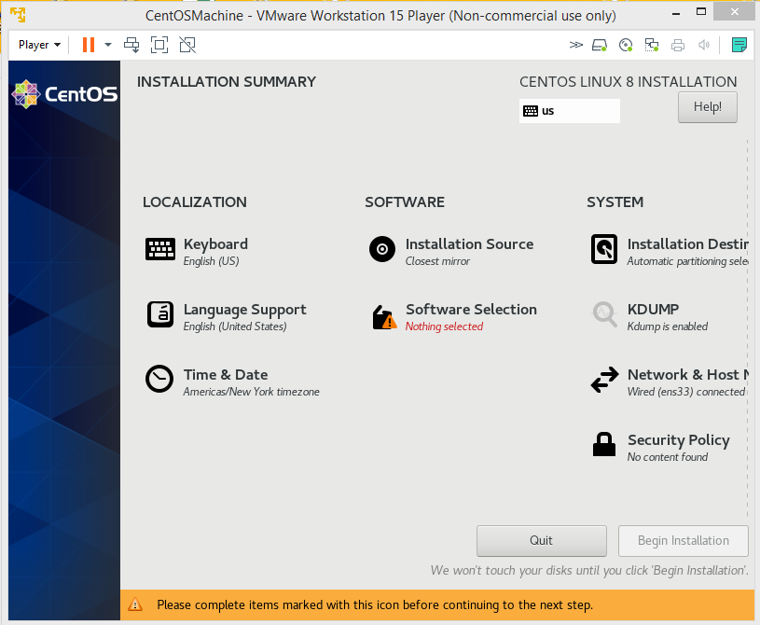

Go to software selection and choose the appropriate option.

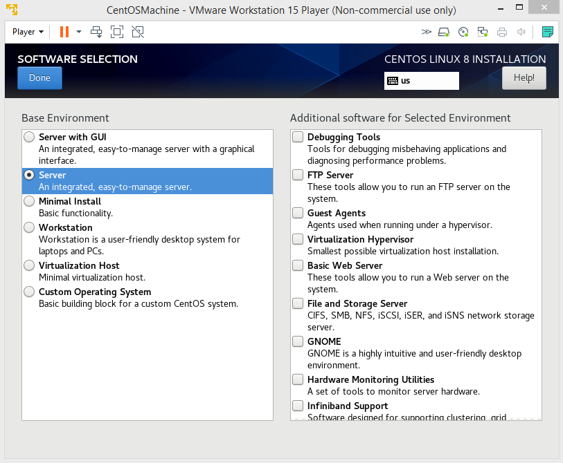Now begin installation.

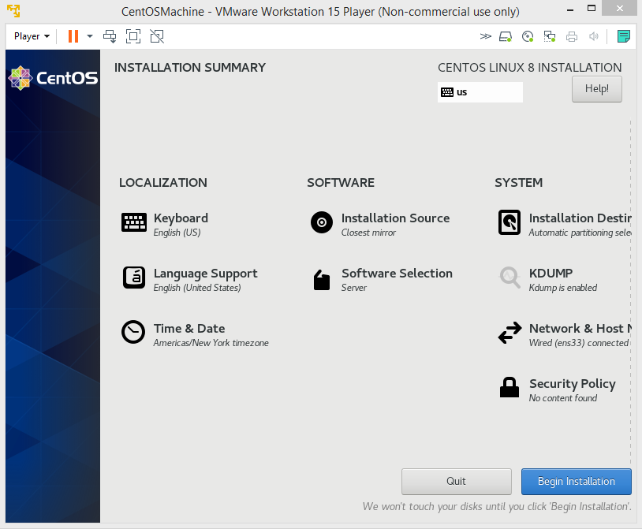You will need to create a root password. A longer password is always more secure

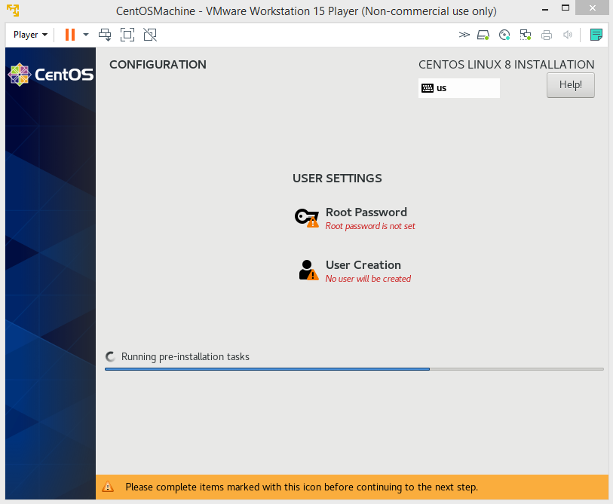

Once all this has been done, you will need to wait some time.

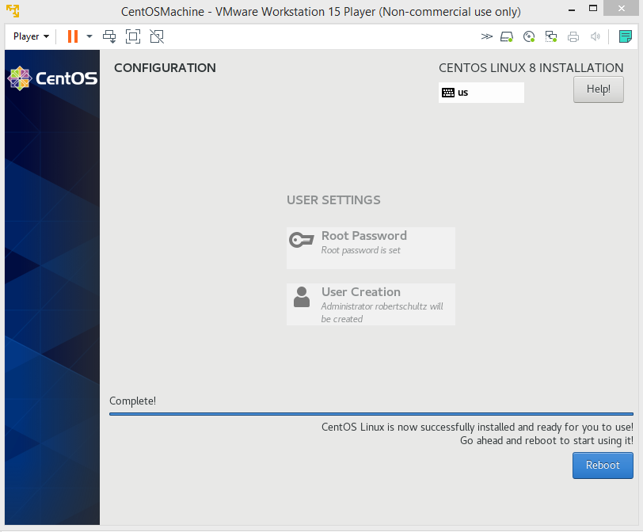

Now you're good to go.

Now, it's time to work on Ubuntu.

Like before, search your files for the correct image. and hit next

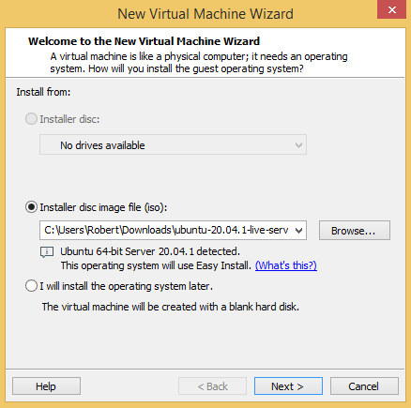

Already you will have to enter some information.

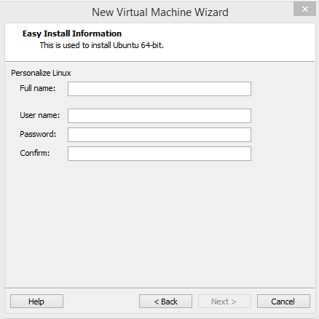

Like before, the machine needs to be given an appropriate name.

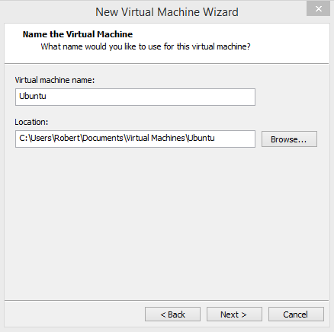

Define maximum disk space

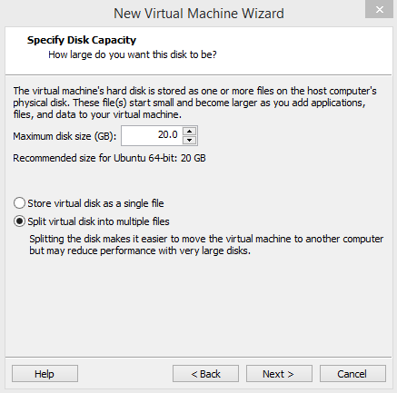

Again, we hit finish

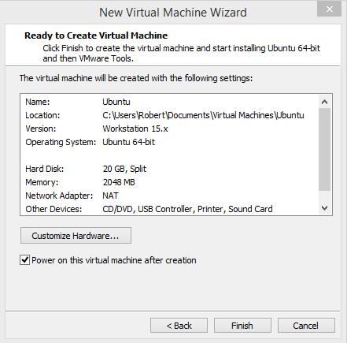

After some waiting, it's time to select language.

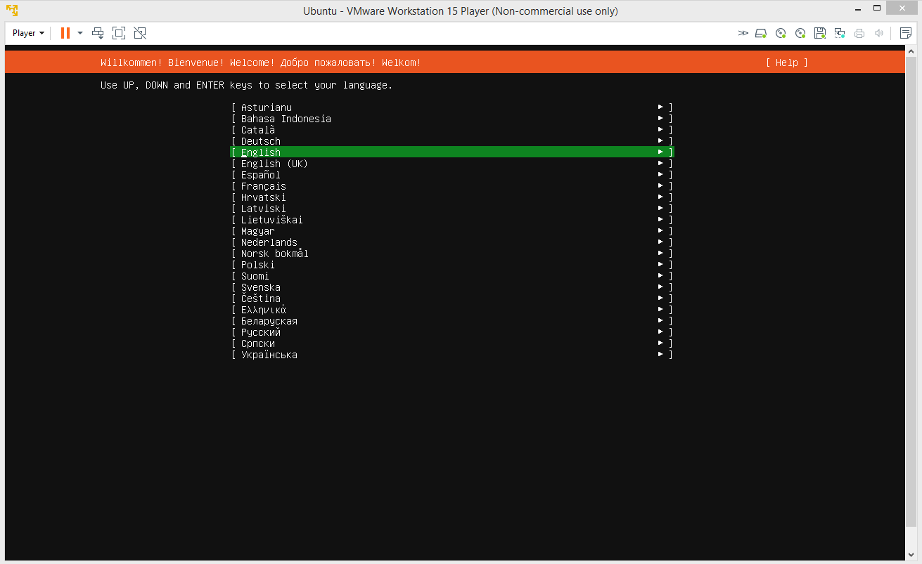

You now have the choice of updating to the new installer or to continue without updating. I'd recommend using the new installer.

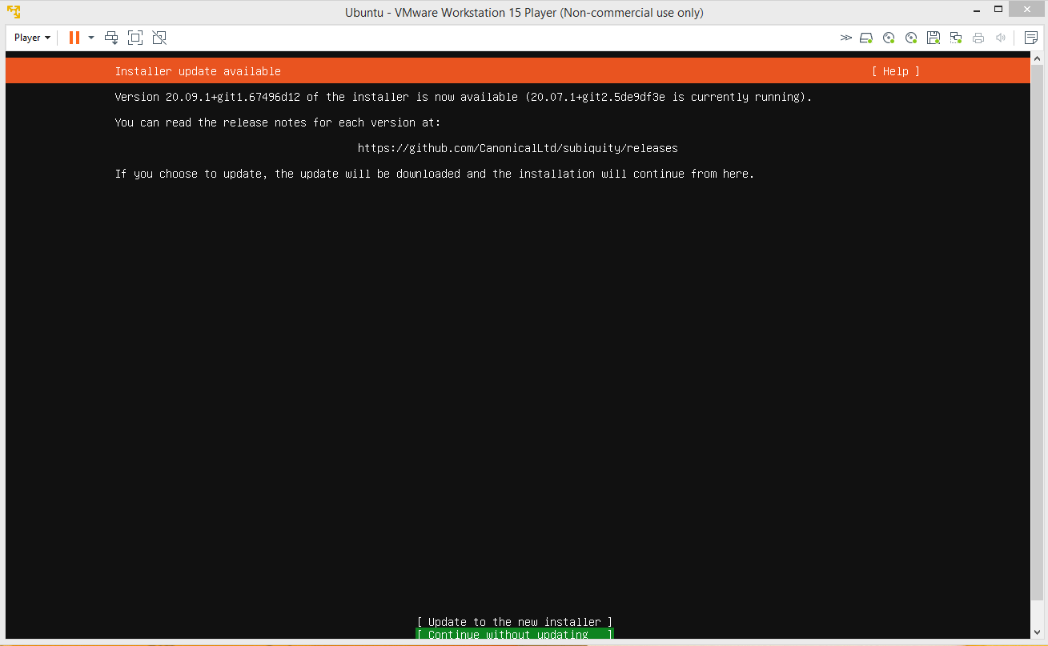

Just hit enter a few times here.

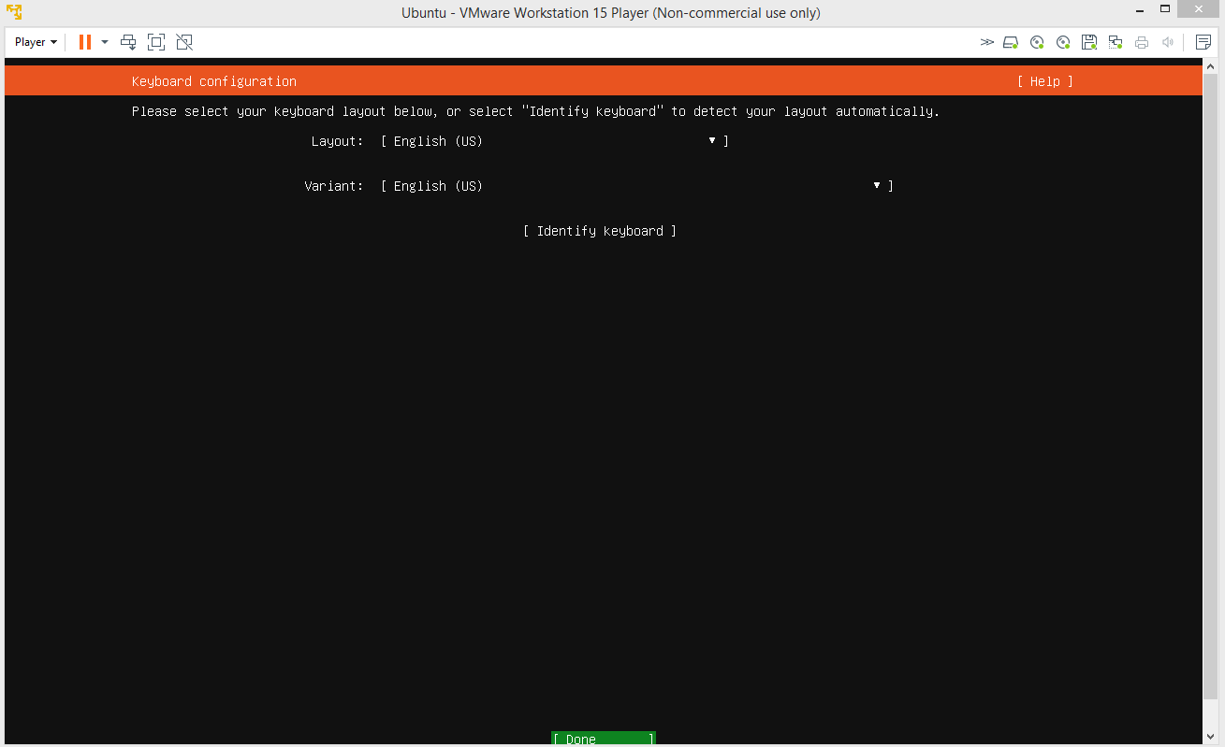

Now it's time for the install.

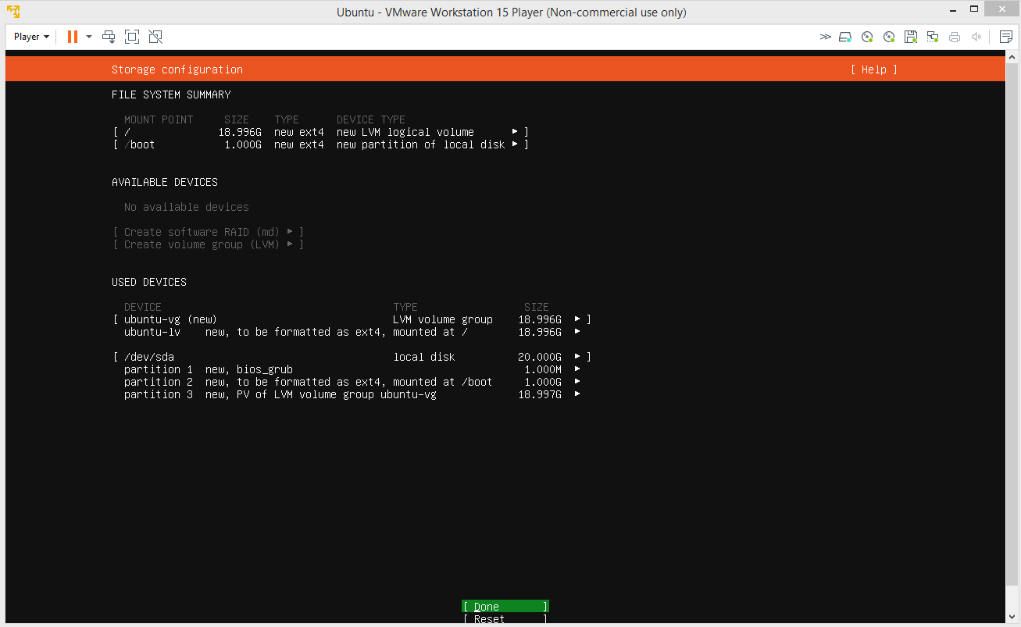

Now, we go through profile setup.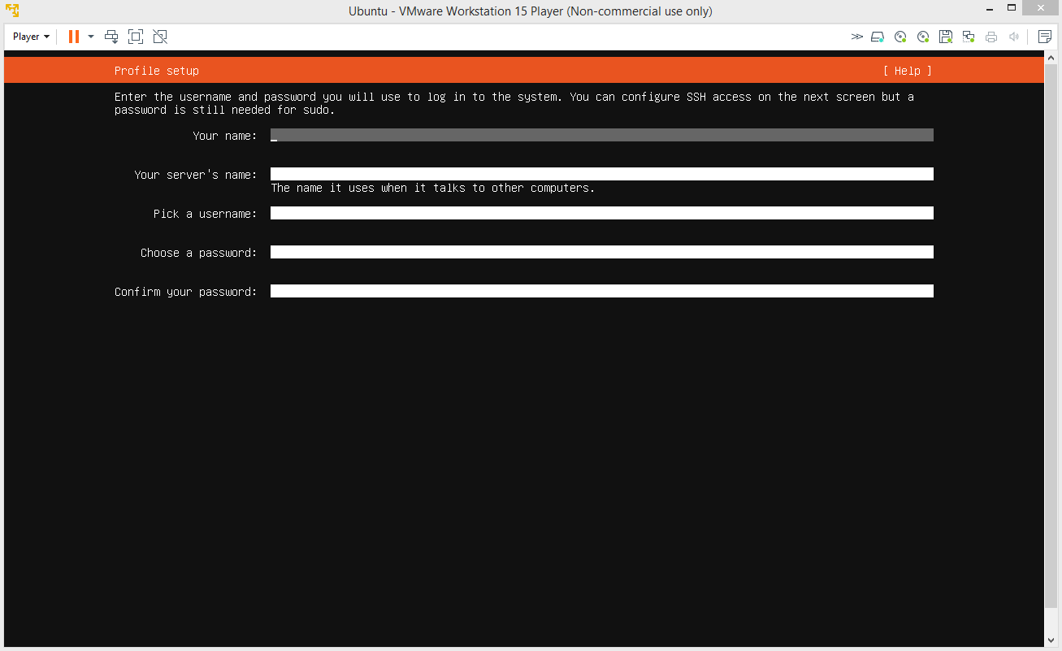

Now we have the choice to install OpenSSH package. I'd go ahead with this.

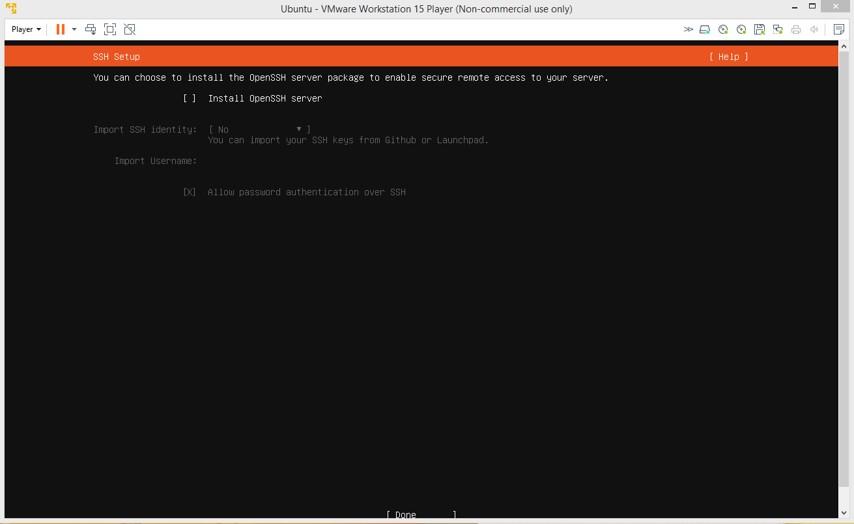

We now can make a choice of what package you might like to install. I would skip this part.

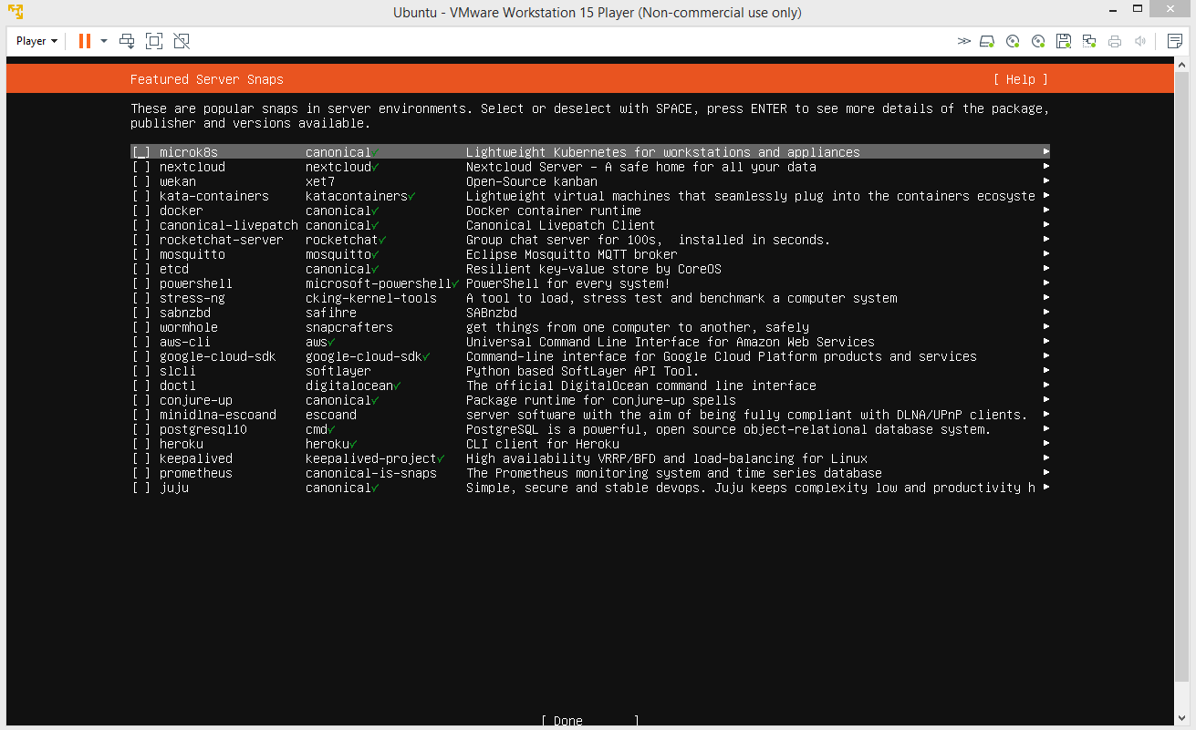

Then comes some waiting. After, that select reboot

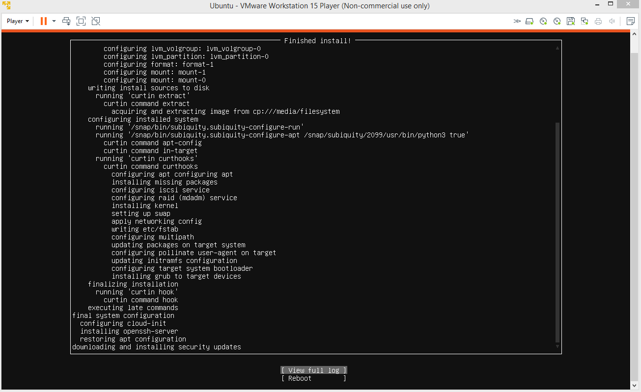

More waiting, then you will be prompted to log in. After that, you're good.

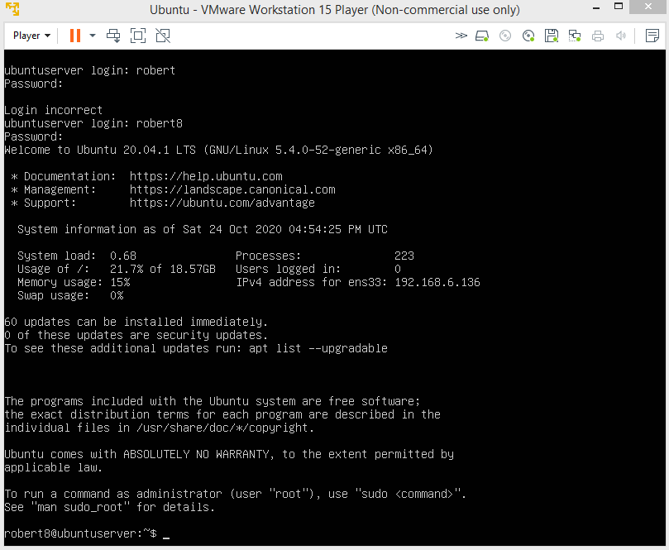

Now we just need to set up a way to share files. One I found that works on both CentOS and Ubuntu is Samba.

To install on CentOS, you need to be logged in as root. Once you are, use the command "yum install samba samba-client samba-common"

After that you need to ensure samba is not blocked by your firewall. The commands "firewall-cmd --permanent --zone=public --add-service=samba" and then

"firewall-cmd --reload" will allow this.

Now, we need to create a shared directory for files.

"mkdir -p /srv/samba/anonymous"

Then, we set up permissions.

"chmod -R 0775 /srv/samba/anonymous"

"chown -R nobody:nobody /srv/samba/anonymous"

Next we need to make a change to security for the directory.

"chcon -t samba_share_t /srv/samba/anonymous"

Now the configuration file.

Use "vi /etc/samba/smb.conf" to open the file.

Make additions like this.

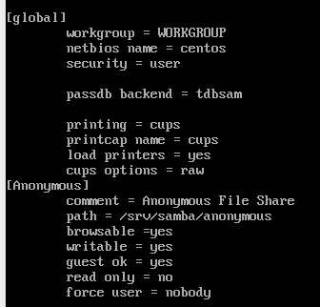

Now, test it with the command "testparm"

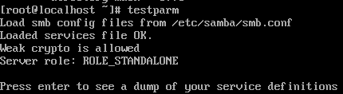

Now, we enable samba and make it start whenever we boot up.

"systemctl enable smb.service"

"systemctl enable nmb.service"

"systemctl start smb.service"

"systemctl start nmb.service"

And now, the centos machine is all set up.

Now on to ubuntu.

This time we use the command "sudo apt install samba"

There, it's installed. But now we need to make a directory .

"sudo mkdir -p /srv/samba/share" and then "sudo chown nobody:nogroup /srv/samba/share/"

Just need to configure it now. Open the configuration file, use your preferred text editor. The file is found at "/etc/samba/smb.conf".

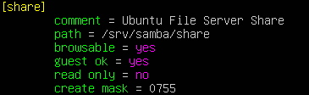

And with that, both machines are fully set up.