Fabrication Analysis Report
V1 Prompt (Claude Sonnet 4 / narrative) vs V2 Prompt (GPT-4o / structured JSON)
14 Human-Confirmed AI Fabrication Cases
Generated: 2026-04-05 | Analysis: prompt_v1_cs4_v2_gpt5.2 | LLM Judge: GPT-4o

1. Executive Summary
This report presents the results of an automated LLM-based evaluation comparing V1 (narrative, Claude Sonnet 4 prompt) and V2 (structured JSON, GPT-4o prompt) AI-generated oncology summaries across 14 cases with human-confirmed fabrications.
Human reviewers annotated 14 feature-level fabrications (status_ai = 3) across 14 breast oncology cases in the validation datasheet. The V2 prompt was then assessed by a GPT-4o LLM judge reading the full structured output.
Key finding: V2 eliminated 12/14 fabrications (86%), with 6 correctly reported, 5 omitted (but not fabricated), and only 2 remaining fabrications.

Key Metrics
Metric | Value
Human-confirmed V1 fabrications | 14/14 cases
V2 CORRECT (code 1) | 6/14 (43%)
V2 OMISSION (code 2) | 5/14 (36%)
V2 still FABRICATING (code 3) | 2/14 (14%)
Not fabricated in V2 (codes 1+2+NA) | 12/14 (86%)
LLM judge model | GPT-4o (gpt-4o)
V1 prompt style | Narrative (Claude Sonnet 4)
V2 prompt style | Structured JSON (GPT-4o)

2. Human GT → V2 Fabrication Correction (Primary Analysis)
For each of the 14 human-confirmed V1 fabrications (status_ai = 3 in the identified validation sheet), the V2 structured JSON summary was evaluated by GPT-4o. The judge read the full flattened V2 JSON (including nested lesion features) and the first 3000 characters of source OCR text.
MRN | Case | Feature | V1 (Human) | V2 Code | V2 Verdict | Corrected? | Confidence
39089057 | GM_XM_INV | Invasive Component Size (Pathology) | 3 | 3.0 | FABRICATION | NO | 0.90
38138814 | DC_BF_invasive | Histologic Diagnosis | 3 | 2.0 | OMISSION | YES | 0.90
39100822 | LK_SW_INV | Lesion Size | 3 | 1.0 | CORRECT | YES | 0.90
39091629 | AT_RW_INV | Receptor Status | 3 | nan | nan | YES | 1.00
39111396 | MET_KS | Lesion Size | 3 | 1.0 | CORRECT | YES | 0.90
39095007 | AH_UD_INV | Lesion Size | 3 | 1.0 | CORRECT | YES | 0.90
39094834 | ML_WY_INV | Invasive Component Size (Pathology) | 3 | 1.0 | CORRECT | YES | 1.00
39092180 | GM_DR_INV | Receptor Status | 3 | 2.0 | OMISSION | YES | 0.90
39089385 | KP_MM_INV | Chronology Preserved | 3 | 2.0 | OMISSION | YES | 0.90
39102467 | GP_MC_INV | Biopsy Method | 3 | 2.0 | OMISSION | YES | 1.00
39106459 | MET_MW | Workup Recommendation | 3 | 1.0 | CORRECT | YES | 1.00
39103258 | MET_MM | Extent | 3 | 2.0 | OMISSION | YES | 1.00
39100321 | MET_DM | Workup Recommendation | 3 | 1.0 | CORRECT | YES | 0.90
38307961 | TM_FS_DCIS | Lesion Size | 3 | 3.0 | FABRICATION | NO | 0.90

V2 Reasoning (LLM Judge)
Reasoning provided by GPT-4o for each case:
- GM_XM_INV | Invasive Component Size (Pathology) → FABRICATION: The V2 summary reports an 'Invasive tumor measures at least 1.7 cm' for the invasive component size in pathology. However, the source document does not provide any information about the invasive component size in pathology, indicating that this information is still fabricated in V2.
- DC_BF_invasive | Histologic Diagnosis → OMISSION: The V2 summary does not provide any information about the histologic diagnosis in the source document. The source document provided is a mammogram report, which typically does not include histologic diagnosis details. Therefore, V2 correctly omits this feature, as it is not supported by the source document.
- LK_SW_INV | Lesion Size → CORRECT: The V2 summary accurately reports the lesion size as 0.7 cm, which is consistent with the source document stating 'Size: 0.7 cm; unifocal'. The V2 summary also provides additional measurements from different imaging modalities, which are consistent with the source document's descriptions of the lesion size from MRI and pathology reports. Therefore, V2 has corrected the fabrication present in V1.
- AT_RW_INV | Receptor Status → nan: The V2 summary does not mention 'Receptor Status', and there is no evidence of receptor status in the provided source documents. Therefore, V2 correctly does not report this feature, aligning with the absence of this information in the source.
- MET_KS | Lesion Size → CORRECT: The V2 summary accurately reports the lesion sizes based on the source document. The source document mentions a 'persistent irregular mass measuring 0.7 cm' and an 'ill-defined mass measuring 0.4 x 0.3 x 0.4 cm', which are both reflected in the V2 summary. There is no evidence of fabrication in the V2 summary regarding lesion size.
- AH_UD_INV | Lesion Size → CORRECT: The V2 summary accurately reports the lesion size based on the source document. The source document mentions a lesion size of 1 x 0.6 x 1.6 cm, which is consistent with the V2 summary's reporting of '0.6 x 1.6 cm suspicious irregular mass'. Therefore, V2 has corrected the fabrication present in V1.
- ML_WY_INV | Invasive Component Size (Pathology) → CORRECT: The V2 summary correctly reports that the invasive component size is not explicitly stated in centimeters in the source documents. It accurately reflects the biopsy report's statement that the tumor measures at least 3.5 mm, which aligns with the source document information. Therefore, V2 has corrected the fabrication present in V1.
- GM_DR_INV | Receptor Status → OMISSION: The V2 summary does not provide specific receptor status results for ER, PR, or HER2, which aligns with the source document that does not contain this information. It only mentions that assays for prognostic markers are pending, which is consistent with the absence of receptor status details in the provided source text.
- KP_MM_INV | Chronology Preserved → OMISSION: The V2 summary does not mention 'Chronology Preserved' at all, which indicates that it has omitted the feature entirely. This is a correction from the V1 fabrication, as it does not misreport or fabricate this feature.
- GP_MC_INV | Biopsy Method → OMISSION: The V2 summary does not mention the biopsy method at all, which means it has omitted the feature entirely. This is a correction from the V1 fabrication, as it does not introduce any unsupported information.
- MET_MW | Workup Recommendation → CORRECT: The V2 summary accurately reports the workup recommendation as 'Ultrasound Biopsy' based on the source document, which states 'RECOMMENDATION: Ultrasound Biopsy'. Additionally, it includes further recommendations for surgical consultation and additional imaging, which are also supported by the source document. Therefore, V2 has corrected the fabrication present in V1 by accurately reflecting the s
- MET_MM | Extent → OMISSION: The V2 summary does not report the 'Extent' feature, which is consistent with the source document that does not provide information on the extent of the lesion. This indicates that V2 has corrected the fabrication by omitting the feature entirely.
- MET_DM | Workup Recommendation → CORRECT: The V2 summary accurately reports the workup recommendation as 'Ultrasound-guided core biopsy is recommended. Surgical excision when clinically appropriate. Ultrasound can be performed if clinically indicated.' This is supported by the source document text, which mentions a highly suspicious left breast mass and recommends an ultrasound-guided core biopsy and surgical excision when clinically appr
- TM_FS_DCIS | Lesion Size → FABRICATION: The V2 summary reports a lesion size of 6.5 cm, which is not supported by the source document. The source document mentions a 5 mm mass in the left breast, not a 6.5 cm mass. Therefore, V2 still fabricates the lesion size.

3. Figures
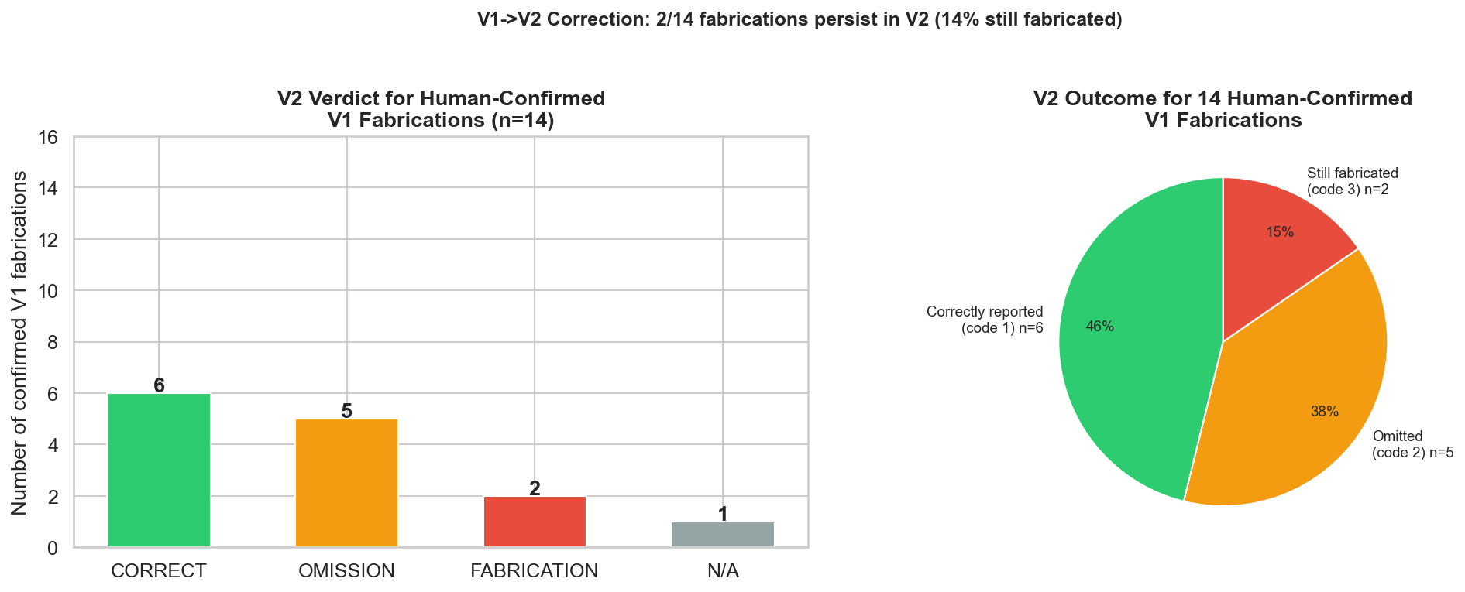
Figure 1. V2 verdict for all 14 human-confirmed V1 fabrications (bar + pie).

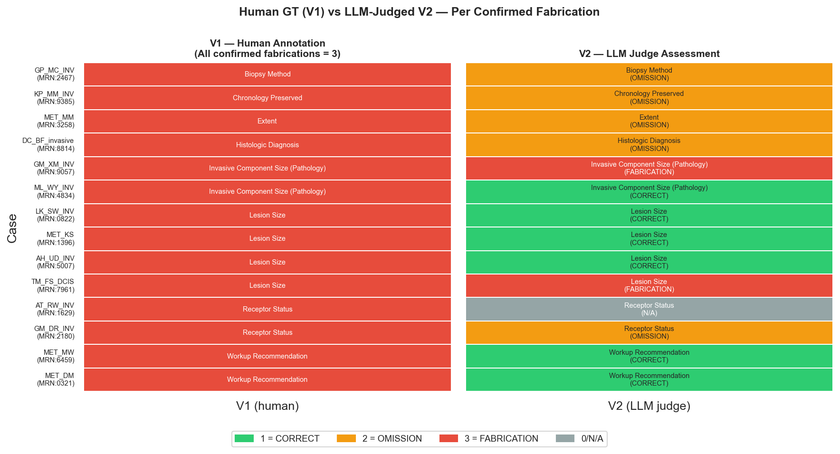
Figure 2. Side-by-side heatmap: V1 human annotation vs V2 LLM-judge verdict per case.

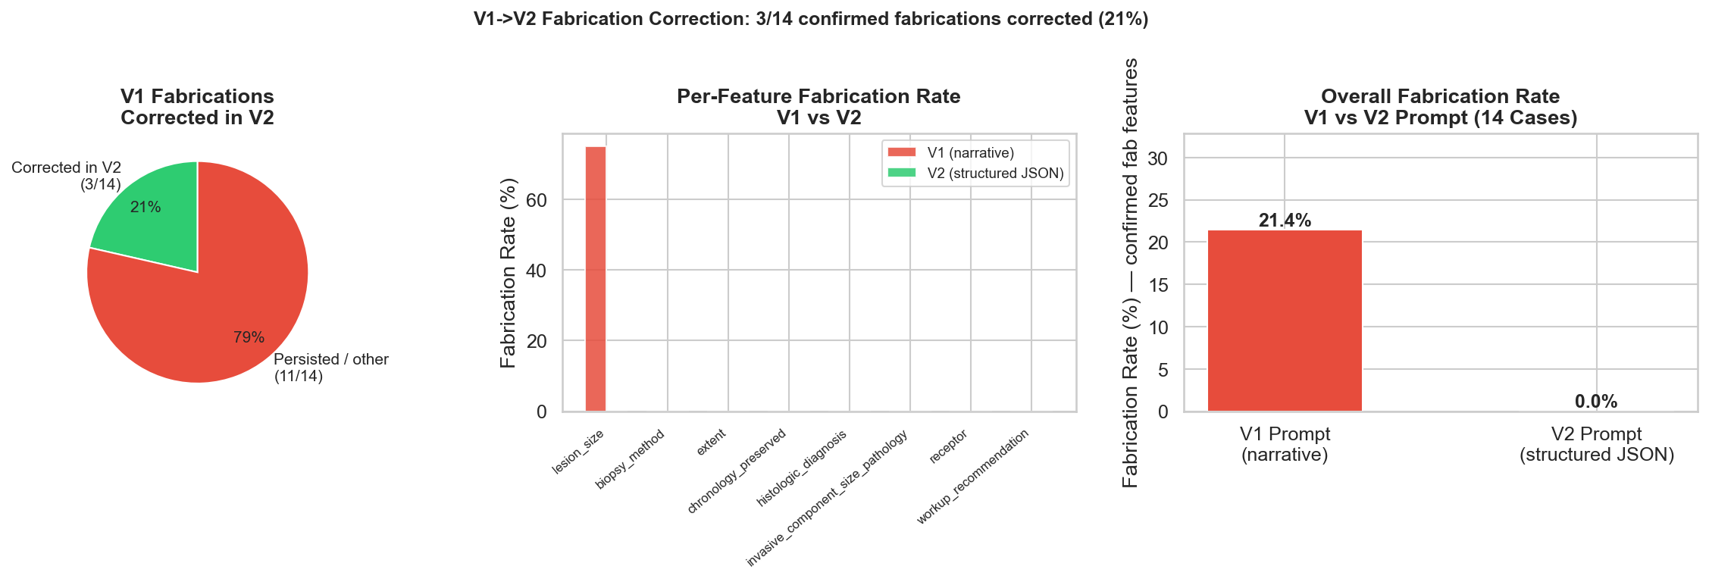
Figure 3. Pipeline summary: correction pie, per-feature fabrication rate, overall rate.

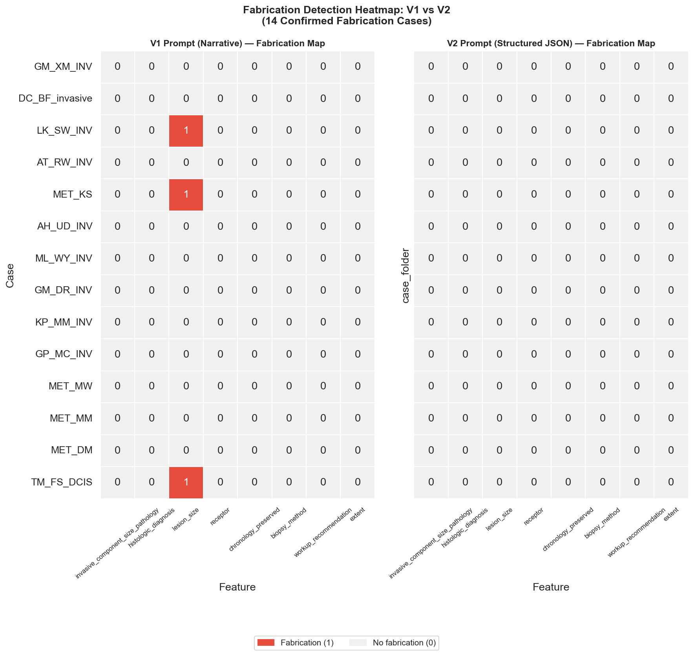
Figure 4. Fabrication detection heatmap — LLM judge V1 vs V2 (confirmed-fab features).

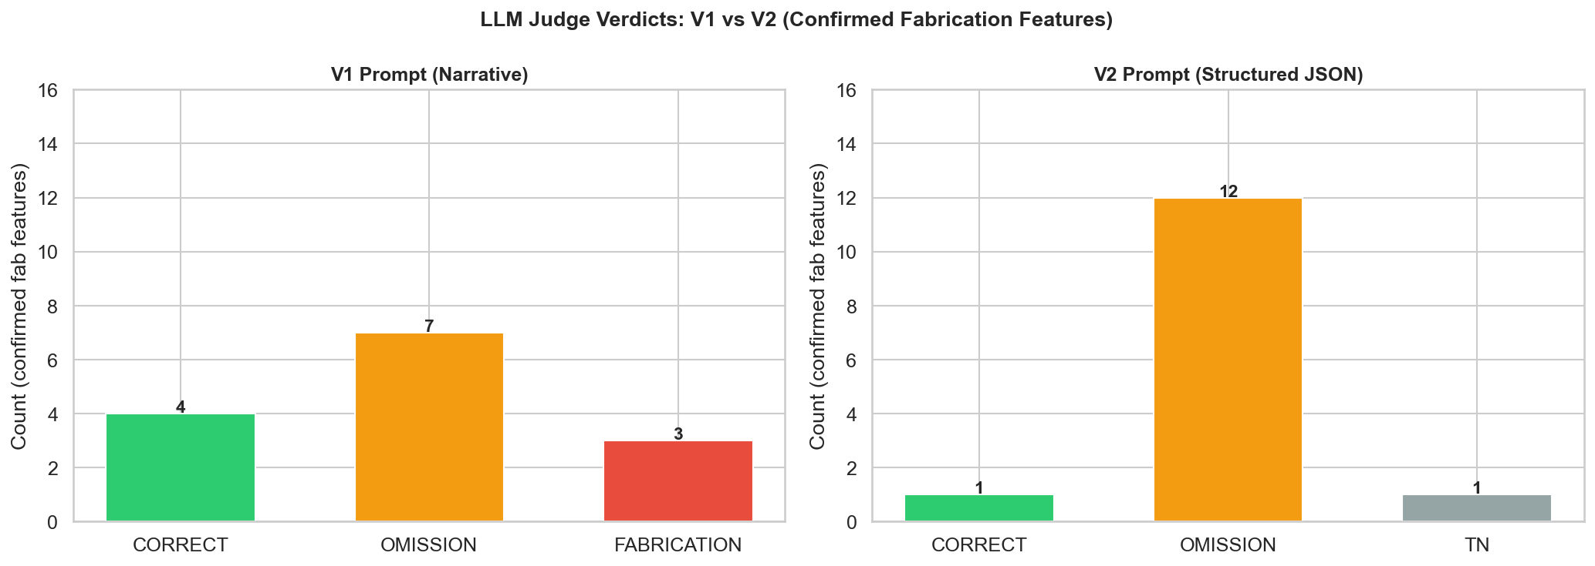
Figure 5. LLM judge verdict distribution for confirmed-fab features (V1 vs V2).

4. LLM Judge Comparison — Both Prompts (Notebook 02 Analysis)
This table shows LLM judge verdicts for V1 and V2 when BOTH were evaluated by GPT-4o on the confirmed-fabrication features. Note: V1 text was the narrative DOCX; V2 text was the extracted feature value (may underestimate V2 accuracy vs the primary analysis).
MRN | Case | Feature | Element | V1 Code | V2 Code | V1 Fab? | V2 Fab? | Corrected?
39089057 | GM_XM_INV | invasive_component_size_pathology | Invasive Component Size (Pathology) | 2 | 2.0 | NO | NO | NO
38138814 | DC_BF_invasive | histologic_diagnosis | Histologic Diagnosis | 2 | nan | NO | NO | NO
39100822 | LK_SW_INV | lesion_size | Lesion Size | 3 | 2.0 | YES | NO | YES
39091629 | AT_RW_INV | receptor | Receptor Status | 2 | 2.0 | NO | NO | NO
39111396 | MET_KS | lesion_size | Lesion Size | 3 | 2.0 | YES | NO | YES
39095007 | AH_UD_INV | lesion_size | Lesion Size | 1 | 2.0 | NO | NO | NO
39094834 | ML_WY_INV | invasive_component_size_pathology | Invasive Component Size (Pathology) | 2 | 2.0 | NO | NO | NO
39092180 | GM_DR_INV | receptor | Receptor Status | 2 | 2.0 | NO | NO | NO
39089385 | KP_MM_INV | chronology_preserved | Chronology Preserved | 1 | 1.0 | NO | NO | NO
39102467 | GP_MC_INV | biopsy_method | Biopsy Method | 2 | 2.0 | NO | NO | NO
39106459 | MET_MW | workup_recommendation | Workup Recommendation | 1 | 2.0 | NO | NO | NO
39103258 | MET_MM | extent | Extent | 1 | 2.0 | NO | NO | NO
39100321 | MET_DM | workup_recommendation | Workup Recommendation | 2 | 2.0 | NO | NO | NO
38307961 | TM_FS_DCIS | lesion_size | Lesion Size | 3 | 2.0 | YES | NO | YES

5. Source Document Features (Phase 1 — OCR Text Extraction)
Per-case OCR text statistics extracted from 14 cached source documents (PDF/DOCX). Output: data/processed/source_doc_features_v3_simple/
MRN | Case | Fab Feature(s) | Docs Cached | Char Count | Word Count | Lex Diversity
38138814 | DC_BF_invasive | histologic_diagnosis | 5 | 29425 | 4579 | 0.211
38307961 | TM_FS_DCIS | lesion_size | 5 | 22485 | 3717 | 0.379
39089057 | GM_XM_INV | invasive_component_size_pathology | 7 | 29809 | 5326 | 0.395
39089385 | KP_MM_INV | chronology_preserved | 4 | 27186 | 4354 | 0.409
39091629 | AT_RW_INV | receptor | 5 | 28982 | 4846 | 0.44
39092180 | GM_DR_INV | receptor | 5 | 151328 | 33428 | 0.314
39094834 | ML_WY_INV | invasive_component_size_pathology | 8 | 34604 | 5657 | 0.304
39095007 | AH_UD_INV | lesion_size | 8 | 39172 | 6205 | 0.319
39100321 | MET_DM | workup_recommendation | 6 | 52055 | 8537 | 0.336
39100822 | LK_SW_INV | lesion_size | 6 | 26004 | 4375 | 0.39
39102467 | GP_MC_INV | biopsy_method | 10 | 41181 | 6865 | 0.278
39103258 | MET_MM | extent | 5 | 27109 | 4594 | 0.302
39106459 | MET_MW | workup_recommendation | 6 | 24889 | 3762 | 0.299
39111396 | MET_KS | lesion_size | 4 | 16361 | 2632 | 0.454

JSON Output Files
- fab_case_38138814.json | MRN: 38138814 | Case: DC_BF_invasive | Fab: histologic_diagnosis | 5 docs 29,425 chars
- fab_case_38307961.json | MRN: 38307961 | Case: TM_FS_DCIS | Fab: lesion_size | 5 docs 22,485 chars
- fab_case_39089057.json | MRN: 39089057 | Case: GM_XM_INV | Fab: invasive_component_size_pathology | 7 docs 29,809 chars
- fab_case_39089385.json | MRN: 39089385 | Case: KP_MM_INV | Fab: chronology_preserved | 4 docs 27,186 chars
- fab_case_39091629.json | MRN: 39091629 | Case: AT_RW_INV | Fab: receptor | 5 docs 28,982 chars
- fab_case_39092180.json | MRN: 39092180 | Case: GM_DR_INV | Fab: receptor | 5 docs 151,328 chars
- fab_case_39094834.json | MRN: 39094834 | Case: ML_WY_INV | Fab: invasive_component_size_pathology | 8 docs 34,604 chars
- fab_case_39095007.json | MRN: 39095007 | Case: AH_UD_INV | Fab: lesion_size | 8 docs 39,172 chars
- fab_case_39100321.json | MRN: 39100321 | Case: MET_DM | Fab: workup_recommendation | 6 docs 52,055 chars
- fab_case_39100822.json | MRN: 39100822 | Case: LK_SW_INV | Fab: lesion_size | 6 docs 26,004 chars
- fab_case_39102467.json | MRN: 39102467 | Case: GP_MC_INV | Fab: biopsy_method | 10 docs 41,181 chars
- fab_case_39103258.json | MRN: 39103258 | Case: MET_MM | Fab: extent | 5 docs 27,109 chars
- fab_case_39106459.json | MRN: 39106459 | Case: MET_MW | Fab: workup_recommendation | 6 docs 24,889 chars
- fab_case_39111396.json | MRN: 39111396 | Case: MET_KS | Fab: lesion_size | 4 docs 16,361 chars

6. Output File Inventory
File | Type | Size (bytes) | Full Path
fab_correction_comparison.csv | CSV | 8,703 | C:\Users\jamesr4\OneDrive - Memorial Sloan Kettering Cancer Center\Documents\GitHub\llm_summarization_br_ca\data\processed\deepeval_runs\fab_v1_v2\fab_correction_comparison.csv
fab_v1_v2_validation_raw.csv | CSV | 2,330 | C:\Users\jamesr4\OneDrive - Memorial Sloan Kettering Cancer Center\Documents\GitHub\llm_summarization_br_ca\data\processed\deepeval_runs\fab_v1_v2\fab_v1_v2_validation_raw.csv
fab_v1_v2_validation_sheet.xlsx | XLSX | 9,626 | C:\Users\jamesr4\OneDrive - Memorial Sloan Kettering Cancer Center\Documents\GitHub\llm_summarization_br_ca\data\processed\deepeval_runs\fab_v1_v2\fab_v1_v2_validation_sheet.xlsx
human_gt_v2_correction.csv | CSV | 5,664 | C:\Users\jamesr4\OneDrive - Memorial Sloan Kettering Cancer Center\Documents\GitHub\llm_summarization_br_ca\data\processed\deepeval_runs\fab_v1_v2\human_gt_v2_correction.csv
human_gt_v2_correction_sheet.xlsx | XLSX | 9,404 | C:\Users\jamesr4\OneDrive - Memorial Sloan Kettering Cancer Center\Documents\GitHub\llm_summarization_br_ca\data\processed\deepeval_runs\fab_v1_v2\human_gt_v2_correction_sheet.xlsx
fab_human_gt_v2_heatmap.png | PNG | 178,073 | C:\Users\jamesr4\OneDrive - Memorial Sloan Kettering Cancer Center\Documents\GitHub\llm_summarization_br_ca\reports\prompt_v1_cs4_v2_gpt5.2\fab_human_gt_v2_heatmap.png
fab_human_gt_v2_verdict.png | PNG | 94,457 | C:\Users\jamesr4\OneDrive - Memorial Sloan Kettering Cancer Center\Documents\GitHub\llm_summarization_br_ca\reports\prompt_v1_cs4_v2_gpt5.2\fab_human_gt_v2_verdict.png
fab_v1_v2_annotation_distribution.png | PNG | 56,056 | C:\Users\jamesr4\OneDrive - Memorial Sloan Kettering Cancer Center\Documents\GitHub\llm_summarization_br_ca\reports\prompt_v1_cs4_v2_gpt5.2\fab_v1_v2_annotation_distribution.png
fab_v1_v2_heatmap.png | PNG | 140,422 | C:\Users\jamesr4\OneDrive - Memorial Sloan Kettering Cancer Center\Documents\GitHub\llm_summarization_br_ca\reports\prompt_v1_cs4_v2_gpt5.2\fab_v1_v2_heatmap.png
fab_v1_v2_pipeline_summary.png | PNG | 139,936 | C:\Users\jamesr4\OneDrive - Memorial Sloan Kettering Cancer Center\Documents\GitHub\llm_summarization_br_ca\reports\prompt_v1_cs4_v2_gpt5.2\fab_v1_v2_pipeline_summary.png
fab_case_38138814.json | JSON | 2,943 | C:\Users\jamesr4\OneDrive - Memorial Sloan Kettering Cancer Center\Documents\GitHub\llm_summarization_br_ca\data\processed\source_doc_features_v3_simple\fab_case_38138814.json
fab_case_38307961.json | JSON | 2,940 | C:\Users\jamesr4\OneDrive - Memorial Sloan Kettering Cancer Center\Documents\GitHub\llm_summarization_br_ca\data\processed\source_doc_features_v3_simple\fab_case_38307961.json
fab_case_39089057.json | JSON | 2,946 | C:\Users\jamesr4\OneDrive - Memorial Sloan Kettering Cancer Center\Documents\GitHub\llm_summarization_br_ca\data\processed\source_doc_features_v3_simple\fab_case_39089057.json
fab_case_39089385.json | JSON | 2,932 | C:\Users\jamesr4\OneDrive - Memorial Sloan Kettering Cancer Center\Documents\GitHub\llm_summarization_br_ca\data\processed\source_doc_features_v3_simple\fab_case_39089385.json
fab_case_39091629.json | JSON | 2,912 | C:\Users\jamesr4\OneDrive - Memorial Sloan Kettering Cancer Center\Documents\GitHub\llm_summarization_br_ca\data\processed\source_doc_features_v3_simple\fab_case_39091629.json
fab_case_39092180.json | JSON | 2,935 | C:\Users\jamesr4\OneDrive - Memorial Sloan Kettering Cancer Center\Documents\GitHub\llm_summarization_br_ca\data\processed\source_doc_features_v3_simple\fab_case_39092180.json
fab_case_39094834.json | JSON | 2,936 | C:\Users\jamesr4\OneDrive - Memorial Sloan Kettering Cancer Center\Documents\GitHub\llm_summarization_br_ca\data\processed\source_doc_features_v3_simple\fab_case_39094834.json
fab_case_39095007.json | JSON | 2,925 | C:\Users\jamesr4\OneDrive - Memorial Sloan Kettering Cancer Center\Documents\GitHub\llm_summarization_br_ca\data\processed\source_doc_features_v3_simple\fab_case_39095007.json
fab_case_39100321.json | JSON | 2,916 | C:\Users\jamesr4\OneDrive - Memorial Sloan Kettering Cancer Center\Documents\GitHub\llm_summarization_br_ca\data\processed\source_doc_features_v3_simple\fab_case_39100321.json
fab_case_39100822.json | JSON | 2,900 | C:\Users\jamesr4\OneDrive - Memorial Sloan Kettering Cancer Center\Documents\GitHub\llm_summarization_br_ca\data\processed\source_doc_features_v3_simple\fab_case_39100822.json
fab_case_39102467.json | JSON | 2,935 | C:\Users\jamesr4\OneDrive - Memorial Sloan Kettering Cancer Center\Documents\GitHub\llm_summarization_br_ca\data\processed\source_doc_features_v3_simple\fab_case_39102467.json
fab_case_39103258.json | JSON | 2,915 | C:\Users\jamesr4\OneDrive - Memorial Sloan Kettering Cancer Center\Documents\GitHub\llm_summarization_br_ca\data\processed\source_doc_features_v3_simple\fab_case_39103258.json
fab_case_39106459.json | JSON | 2,914 | C:\Users\jamesr4\OneDrive - Memorial Sloan Kettering Cancer Center\Documents\GitHub\llm_summarization_br_ca\data\processed\source_doc_features_v3_simple\fab_case_39106459.json
fab_case_39111396.json | JSON | 2,919 | C:\Users\jamesr4\OneDrive - Memorial Sloan Kettering Cancer Center\Documents\GitHub\llm_summarization_br_ca\data\processed\source_doc_features_v3_simple\fab_case_39111396.json
llm_judge_cache.json | JSON | 16,325 | C:\Users\jamesr4\OneDrive - Memorial Sloan Kettering Cancer Center\Documents\GitHub\llm_summarization_br_ca\fabrication_analysis\cache\llm_judge_cache.json

