Angela’s Assessment Reporting System

External Documentation

Robert Kelly

Contents

Toe Chart 1

Interface Design 1

IPO Chart 2

# Toe Chart



# Interface Design

The client has expressed a very specific design requirement. The client has provided us with an image of the desired layout.

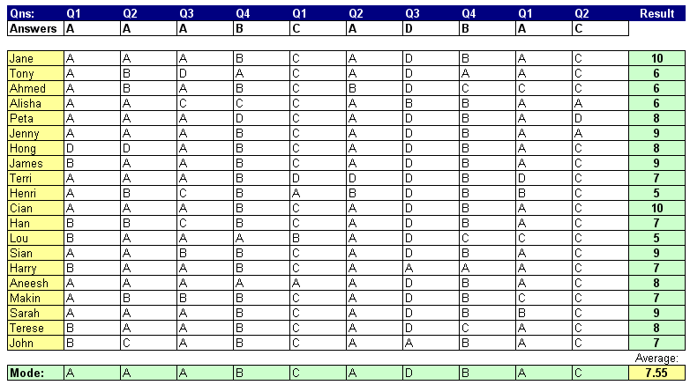

# IPO Chart

