Fault Condition Ten Report

Fault condition ten of ASHRAE Guideline 36 is an AHU economizer + mechanical cooling mode only with an attempt at flagging conditions where the outside air temperature and mixing air temperatures are not approximetely equal when the AHU is in a 100% outside air mode. Fault condition ten equation as defined by ASHRAE:

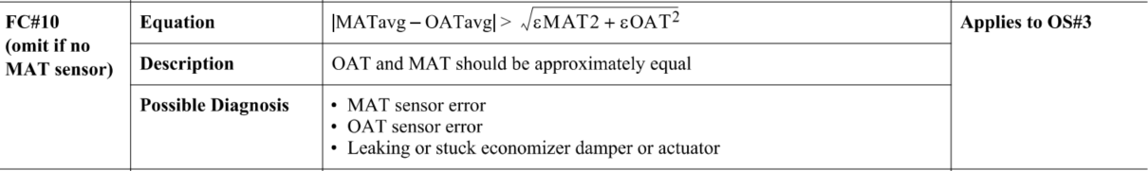

## Dataset Plot

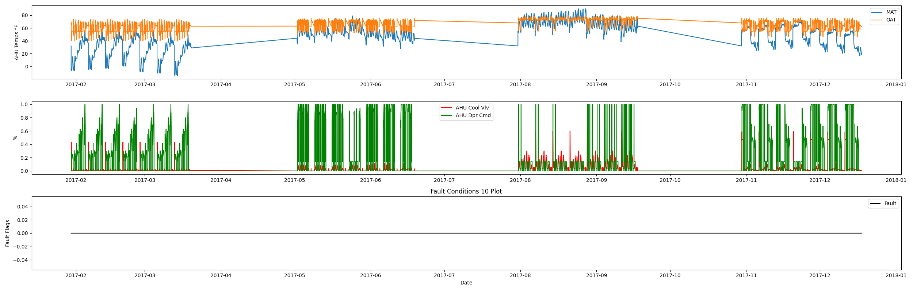

## Dataset Statistics

* Total time in days calculated in dataset: 322.0
* Total time in hours calculated in dataset: 7727.983333333334
* Total time in hours for when fault flag is True: 0.0
* Percent of time in the dataset when the fault flag is True: 0.0%
* Percent of time in the dataset when the fault flag is False: 100.0%
* Calculated motor runtime in hours based off of VFD signal > zero: 3061.08
* No faults were found in this given dataset for the equation defined by ASHRAE.

# Summary Statistics filtered for when the AHU is running

### Mixing Air Temp

* count 183665.000000  
  mean 47.087935  
  std 22.141181  
  min -14.236000  
  25% 32.720000  
  50% 51.700000  
  75% 63.536000  
  max 90.140000  
  Name: AHU: Outdoor Air Temperature, dtype: float64

### Outside Air Temp

* count 183665.000000  
  mean 64.303172  
  std 7.987304  
  min 40.262000  
  25% 55.090000  
  50% 64.300000  
  75% 72.220000  
  max 78.320000  
  Name: AHU: Mixed Air Temperature, dtype: float64

## Suggestions based on data analysis

* The percent True metric that represents the amount of time for when the fault flag is True is low inidicating the AHU components are within calibration for this fault equation Ok.

Report generated: Fri Mar 17 11:11:20 2023