Fault Condition Seven Report

Fault condition seven of ASHRAE Guideline 36 is an AHU heating mode only with an attempt at verifying an AHU heating or cooling valve is not stuck or leaking by verifying AHU supply temperature to supply temperature setpoint. Fault condition seven equation as defined by ASHRAE:

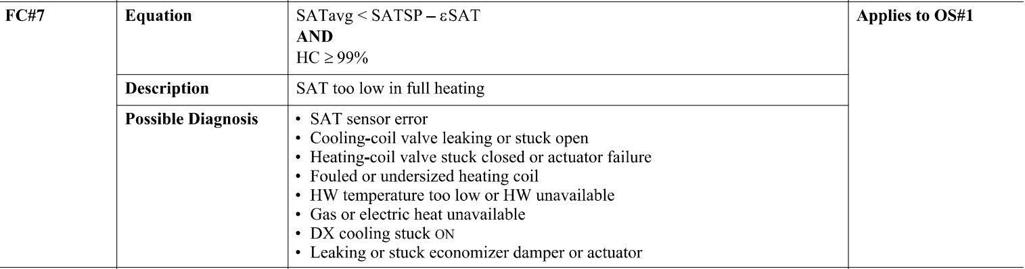

## Dataset Plot

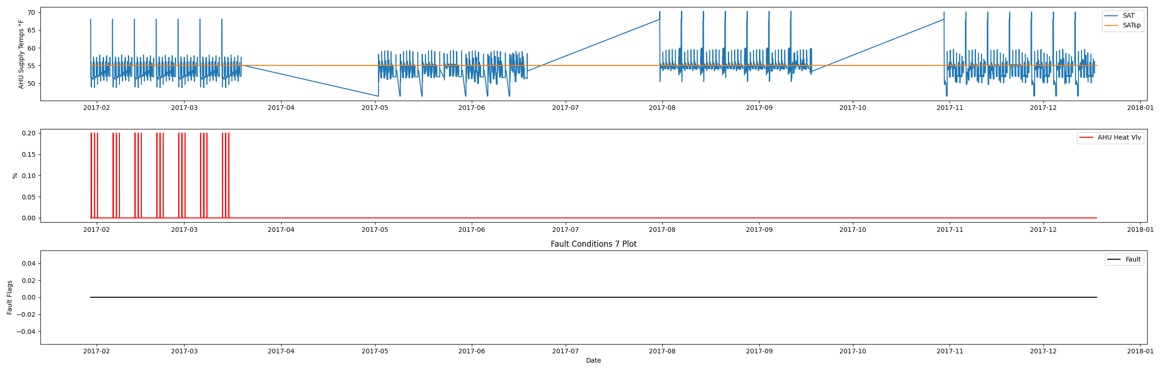

## Dataset Statistics

* Total time in days calculated in dataset: 322.0
* Total time in hours calculated in dataset: 7727.983333333334
* Total time in hours for when fault flag is True: 0.0
* Percent of time in the dataset when the fault flag is True: 0.0%
* Percent of time in the dataset when the fault flag is False: 100.0%
* Calculated motor runtime in hours based off of VFD signal > zero: 3061.08
* No faults were found in this given dataset for the equation defined by ASHRAE.

# Summary Statistics filtered for when the AHU is running

### Supply Air Temp

* count 183665.000000  
  mean 54.113744  
  std 1.730771  
  min 48.578000  
  25% 52.740000  
  50% 54.928000  
  75% 55.046000  
  max 70.310000  
  Name: AHU: Supply Air Temperature, dtype: float64

### Supply Air Temp Setpoint

* count 1.836650e+05  
  mean 5.504000e+01  
  std 2.131634e-14  
  min 5.504000e+01  
  25% 5.504000e+01  
  50% 5.504000e+01  
  75% 5.504000e+01  
  max 5.504000e+01  
  Name: AHU: Supply Air Temperature Set Point, dtype: float64

### Heating Coil Valve

* count 183665.000000  
  mean 0.000114  
  std 0.004781  
  min 0.000000  
  25% 0.000000  
  50% 0.000000  
  75% 0.000000  
  max 0.200000  
  Name: AHU: Heating Coil Valve Control Signal, dtype: float64

## Suggestions based on data analysis

* The percent True metric that represents the amount of time for when the fault flag is True is low inidicating the AHU heating valve operates Ok.

Report generated: Fri Mar 17 11:10:52 2023