Fault Condition Two Report

Fault condition two and three of ASHRAE Guideline 36 is related to flagging mixing air temperatures of the AHU that are out of acceptable ranges. Fault condition 2 flags mixing air temperatures that are too low and fault condition 3 flags mixing temperatures that are too high when in comparision to return and outside air data. The mixing air temperatures in theory should always be in between the return and outside air temperatures ranges. Fault condition two equation as defined by ASHRAE:

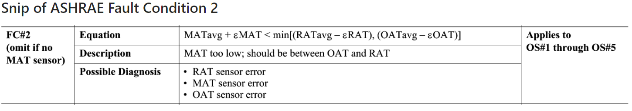

## Dataset Plot

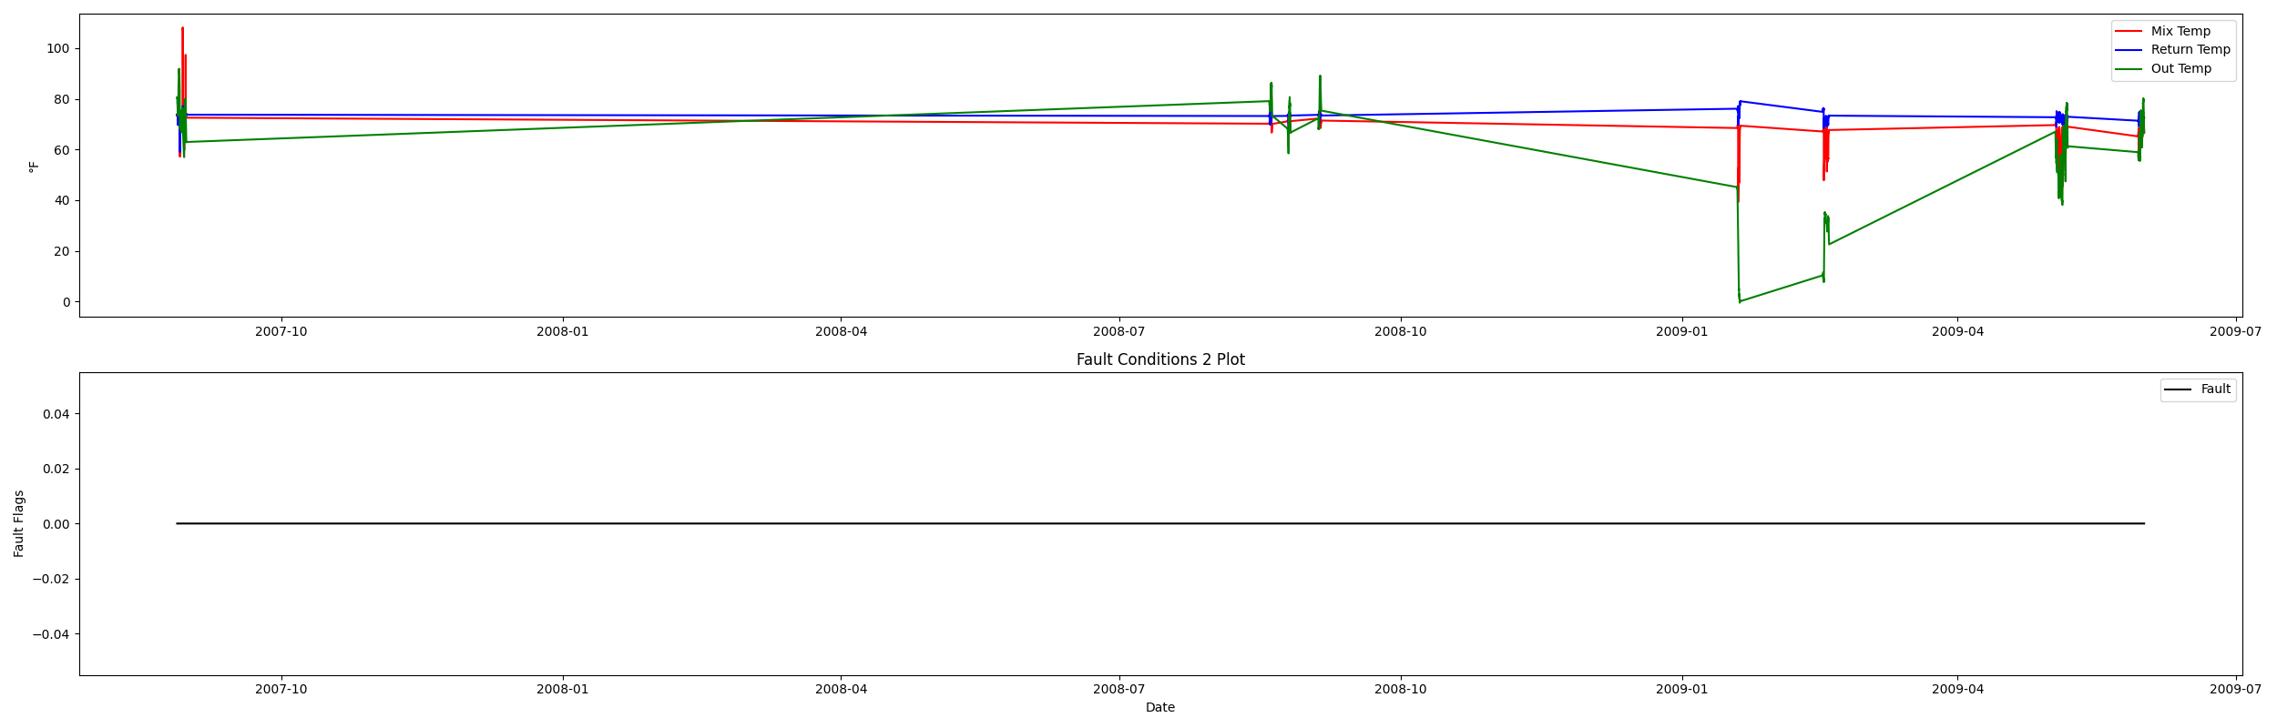

## Dataset Statistics

* Total time in days calculated in dataset: 643.0
* Total time in hours calculated in dataset: 15431.983333333334
* Total time in hours for when fault flag is True: 0.0
* Percent of time in the dataset when the fault flag is True: 0.0%
* Percent of time in the dataset when the fault flag is False: 100.0%
* Calculated motor runtime in hours based off of VFD signal > zero: 15431.98
* This fan system appears to run 24/7 consider implementing occupancy schedules to reduce building fuel use through HVAC
* No faults were found in this given dataset for the equation defined by ASHRAE.

# Summary Statistics filtered for when the AHU is running

### Mix Temp

* count 21600.000000  
  mean 67.488601  
  std 7.859105  
  min 39.212000  
  25% 64.080000  
  50% 68.684000  
  75% 72.590000  
  max 108.130000  
  Name: AHU: Mixed Air Temperature, dtype: float64

### Return Temp

* count 21600.000000  
  mean 72.611181  
  std 1.613407  
  min 58.984000  
  25% 71.384000  
  50% 72.770000  
  75% 73.504000  
  max 79.060000  
  Name: AHU: Return Air Temperature, dtype: float64

### Outside Temp

* count 21600.000000  
  mean 58.224958  
  std 21.454548  
  min -0.456000  
  25% 44.965500  
  50% 63.643000  
  75% 74.556500  
  max 91.776000  
  Name: AHU: Outdoor Air Temperature, dtype: float64

## Suggestions based on data analysis

* The percent True of time is low inidicating the AHU temperature sensors are within calibration

Report generated: Tue Mar 7 10:43:01 2023