Electricity Dataset Visualation

# City_Library_2019.csv

Entire_Dataset_Plot.png

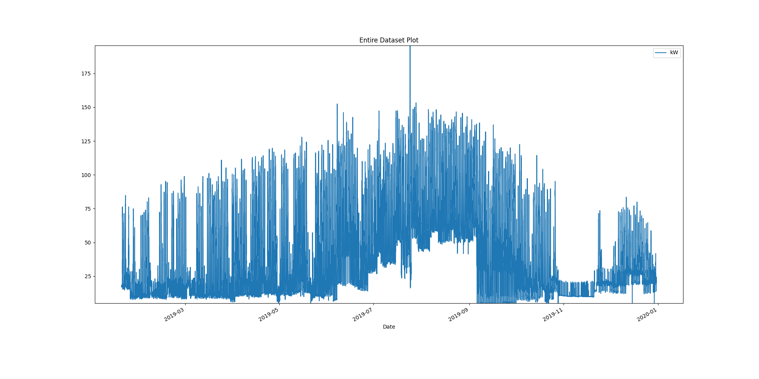

# Plot of month with max demand recorded

Month_maximum_recorded_demand.png

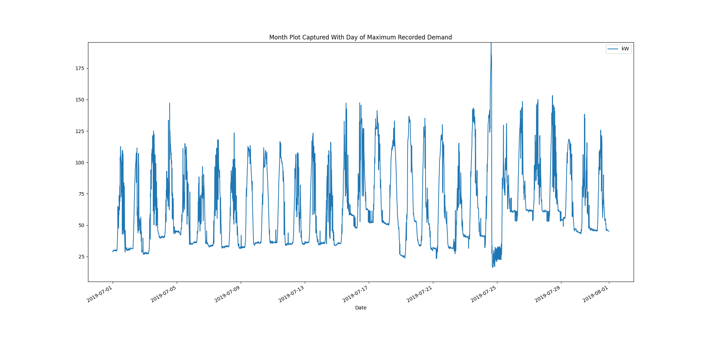

# Power box plots per month

AllDatakWboxPlots.png

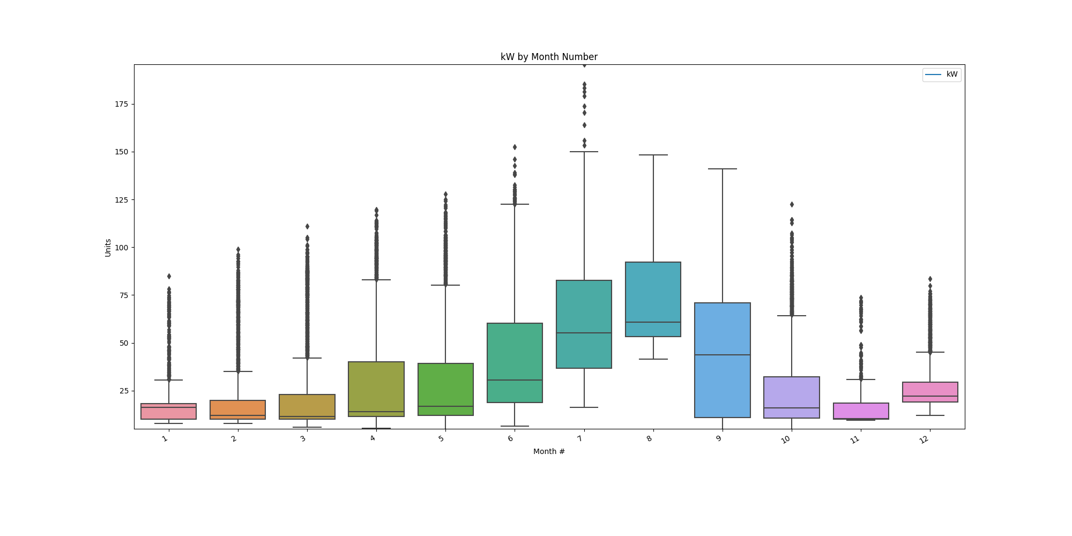

# Power consumption trends

kWtrendsPlot.png

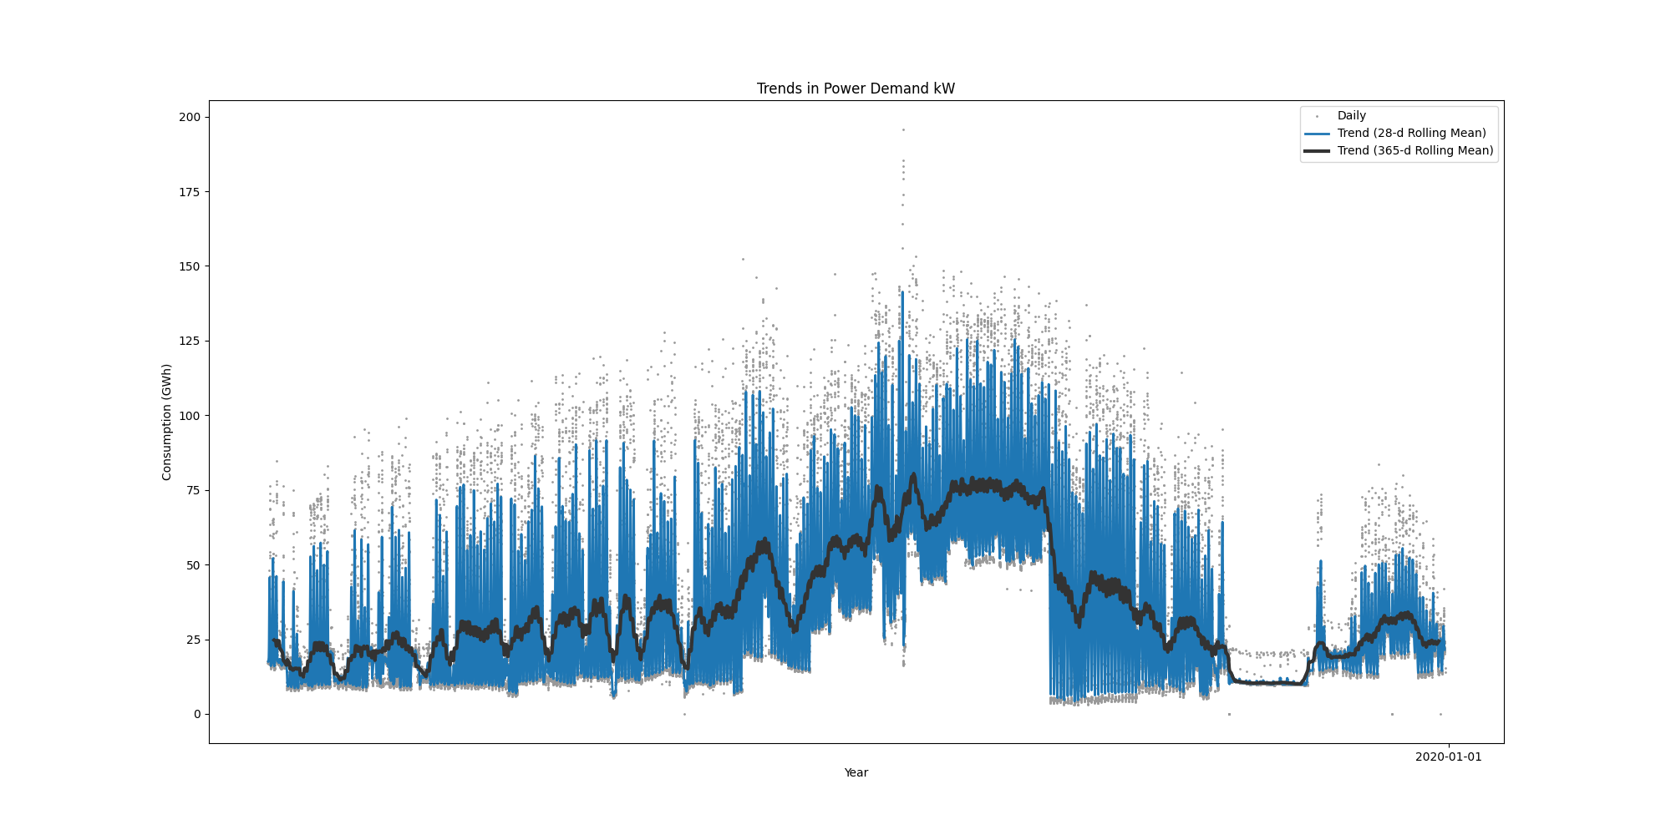

Data Analysis Report Winter

Winter Months Electrical Load Profiles

datasetPlot.png

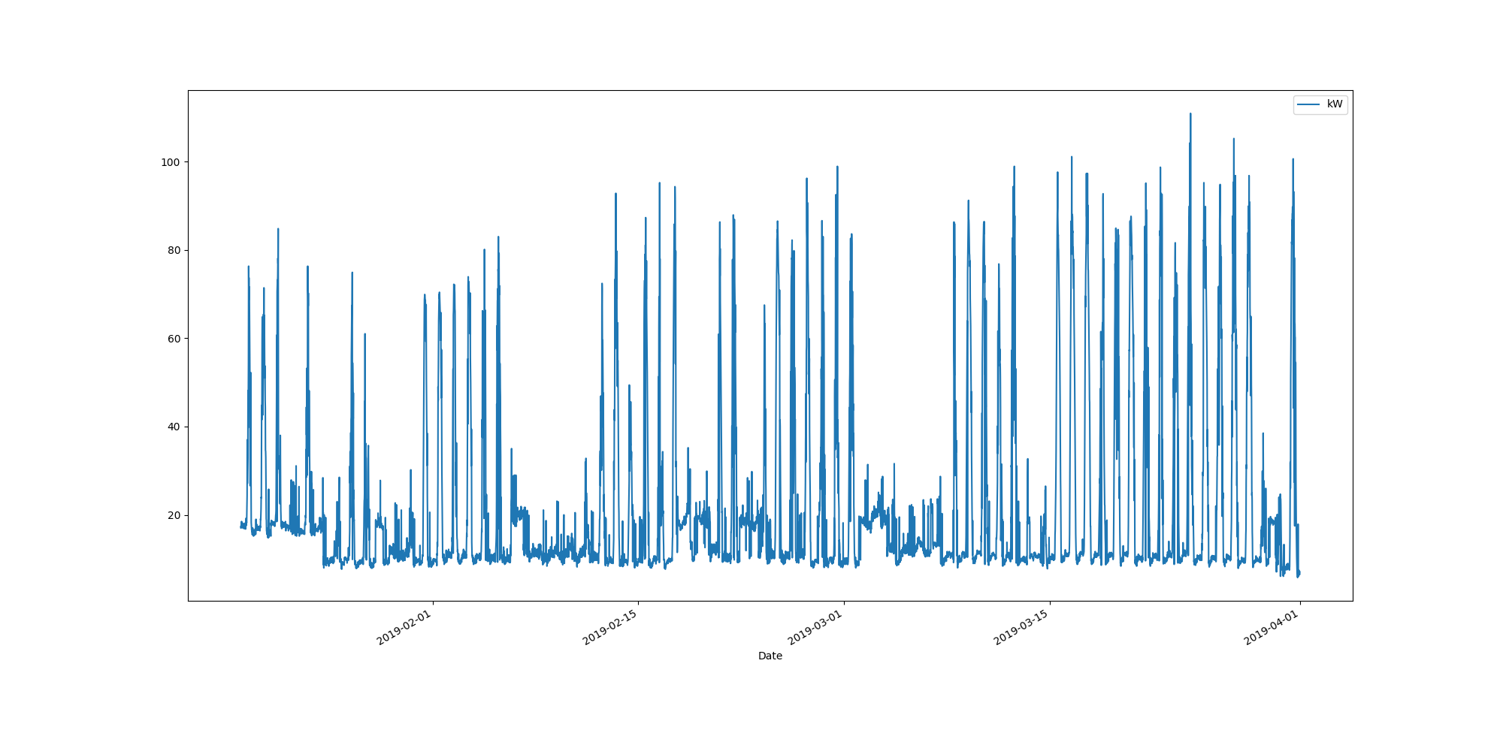

# Max Demand Found In Dataset

kW 110.9  
Name: 2019-03-24 13:30:00, dtype: float64

# Dataset Summary Statistics

kW  
count 6907.000000  
mean 21.605386  
std 19.963722  
min 5.800000  
25% 10.000000  
50% 12.200000  
75% 20.300000  
max 110.900000

# Highest Ranked Change Point Algorithm Detection

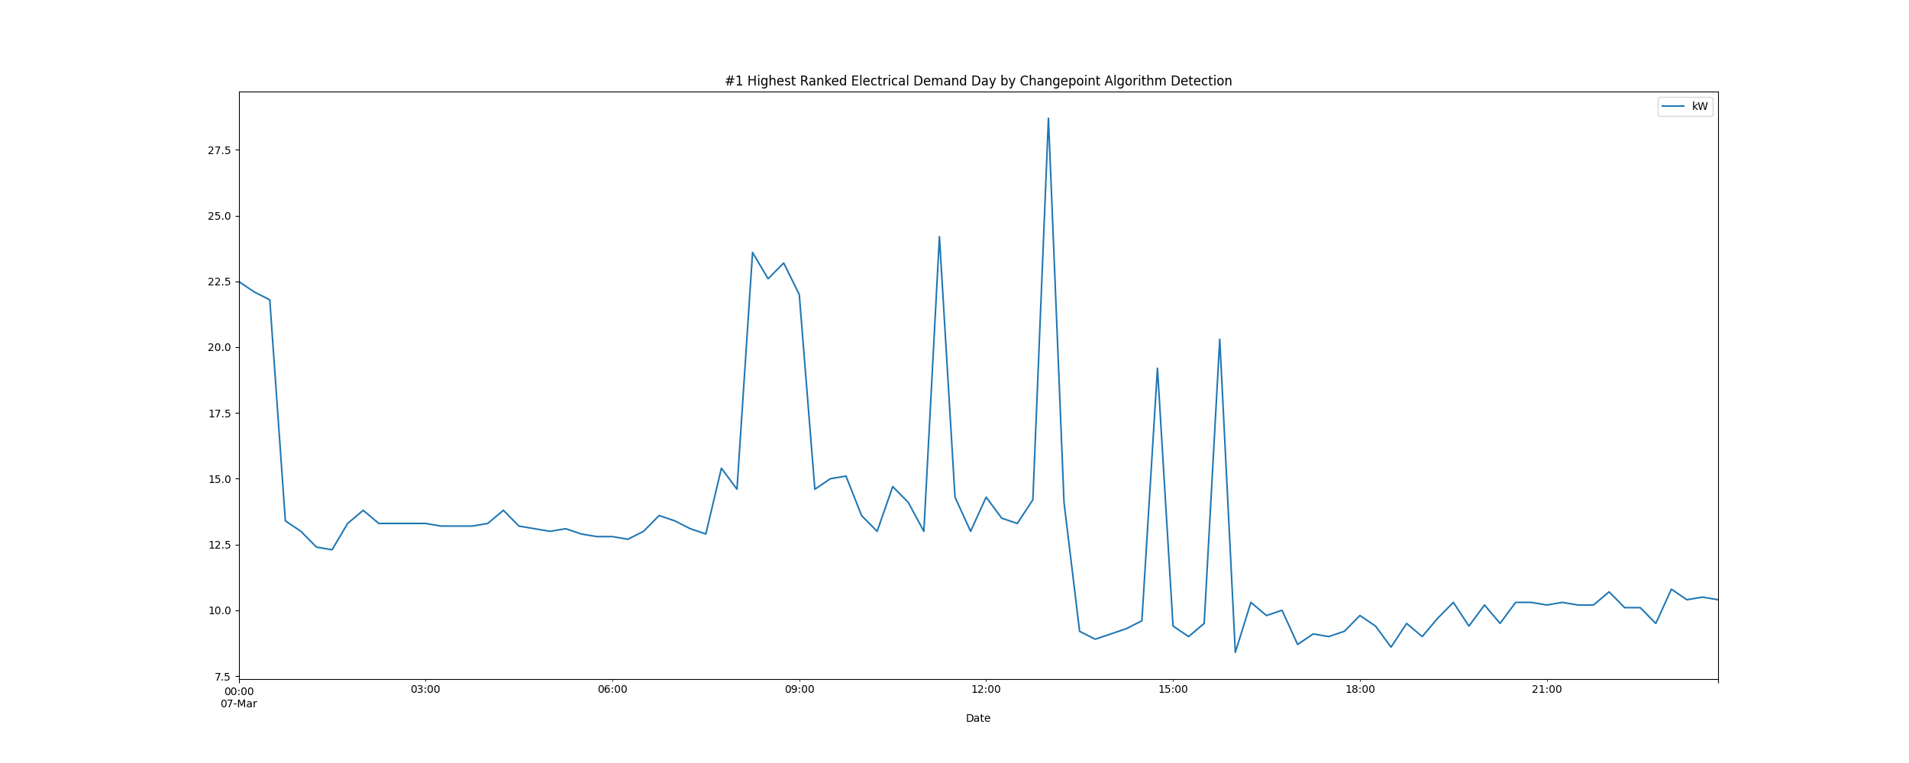

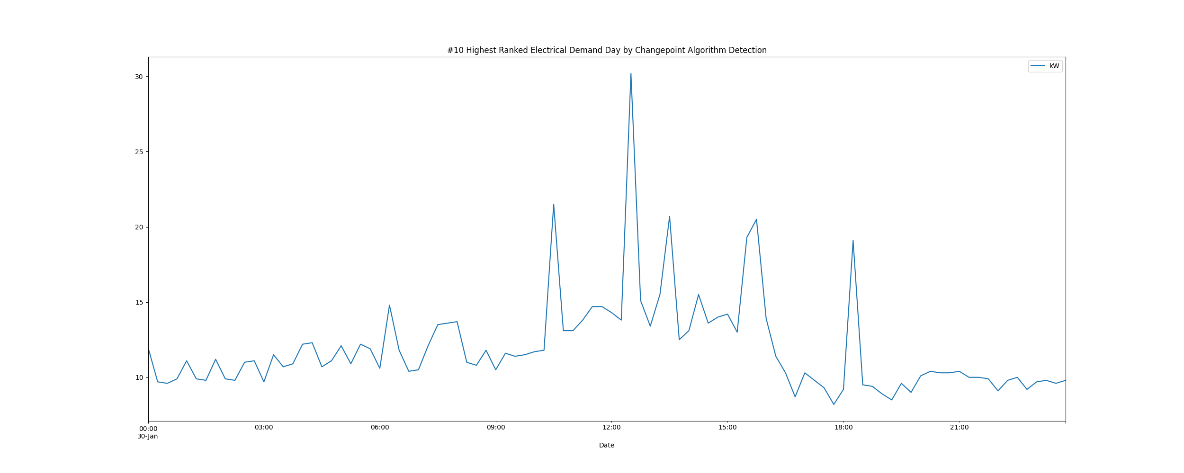

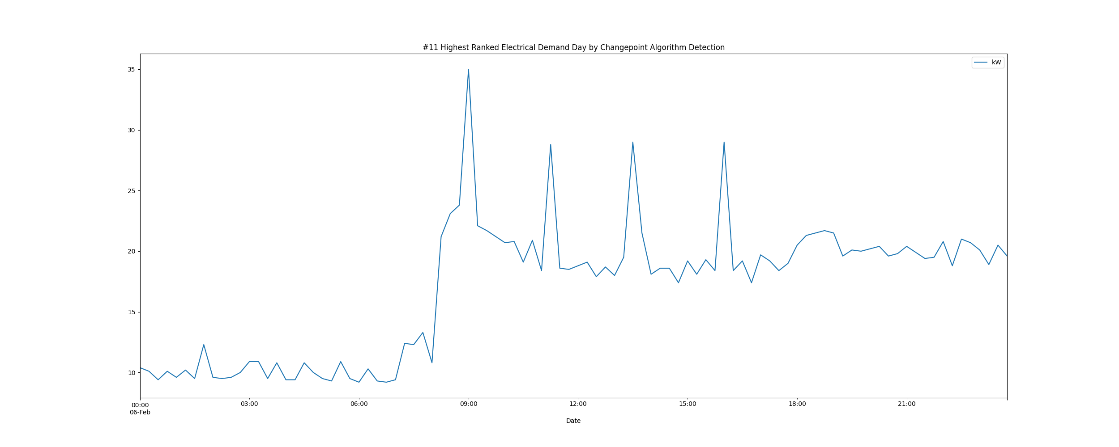

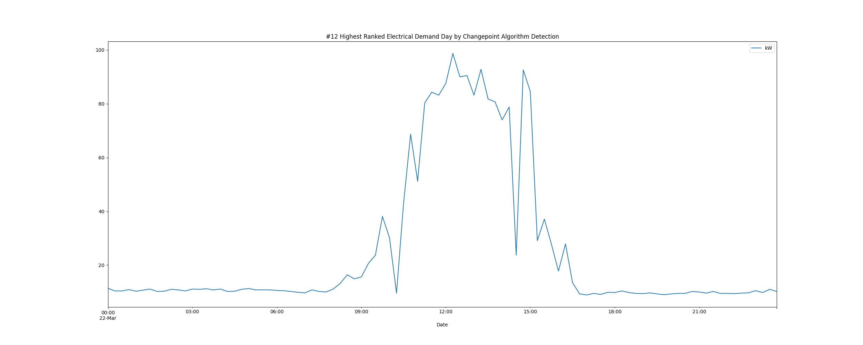

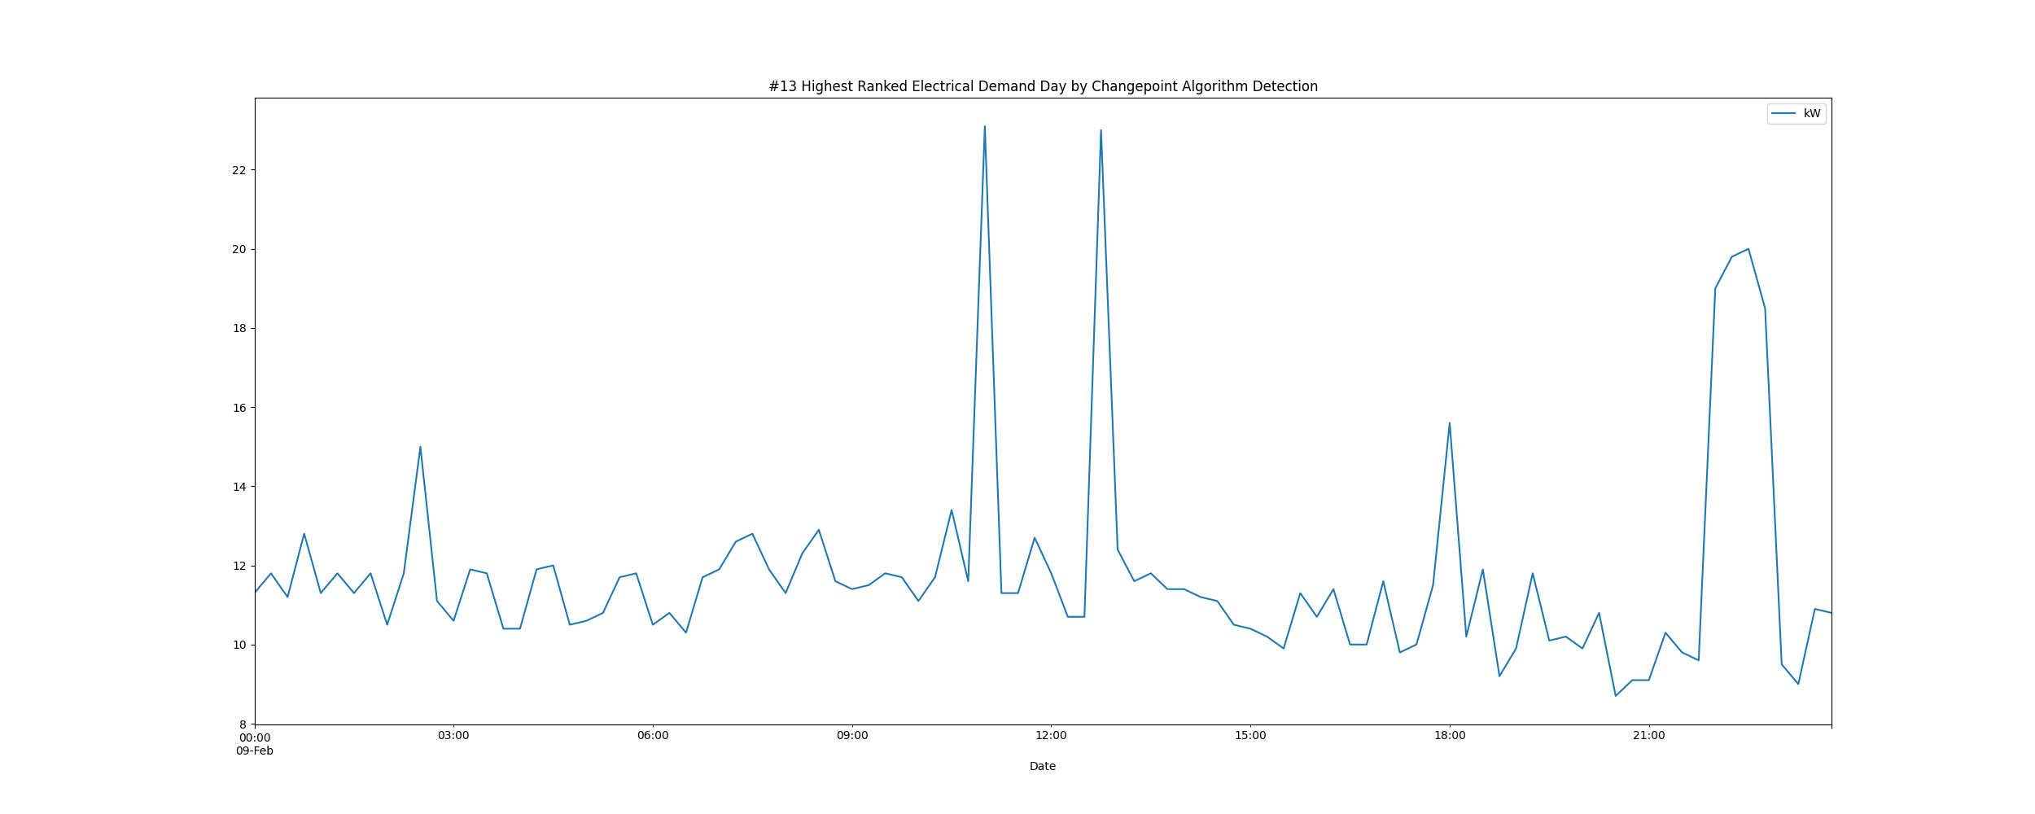

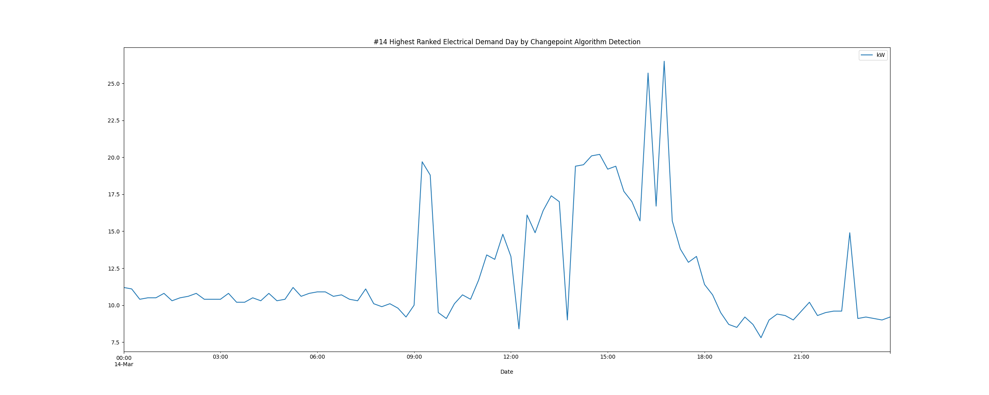

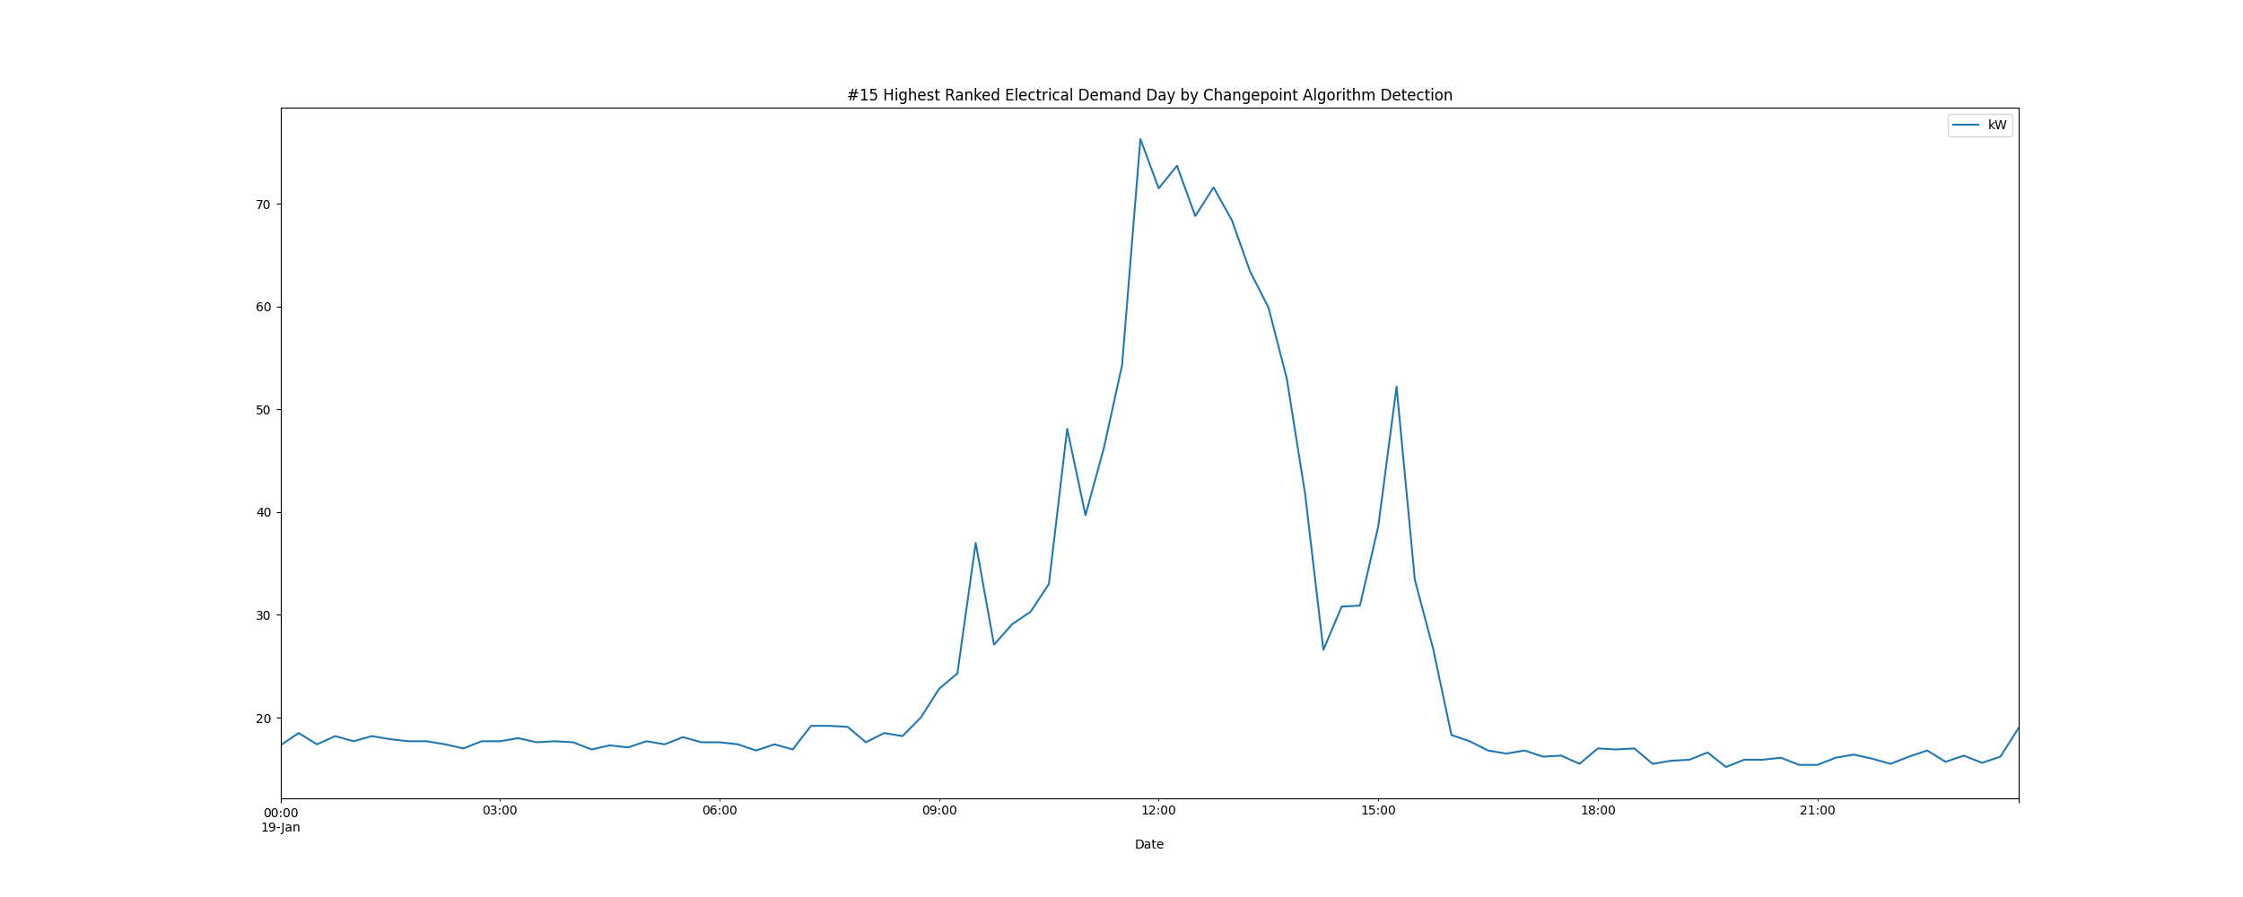

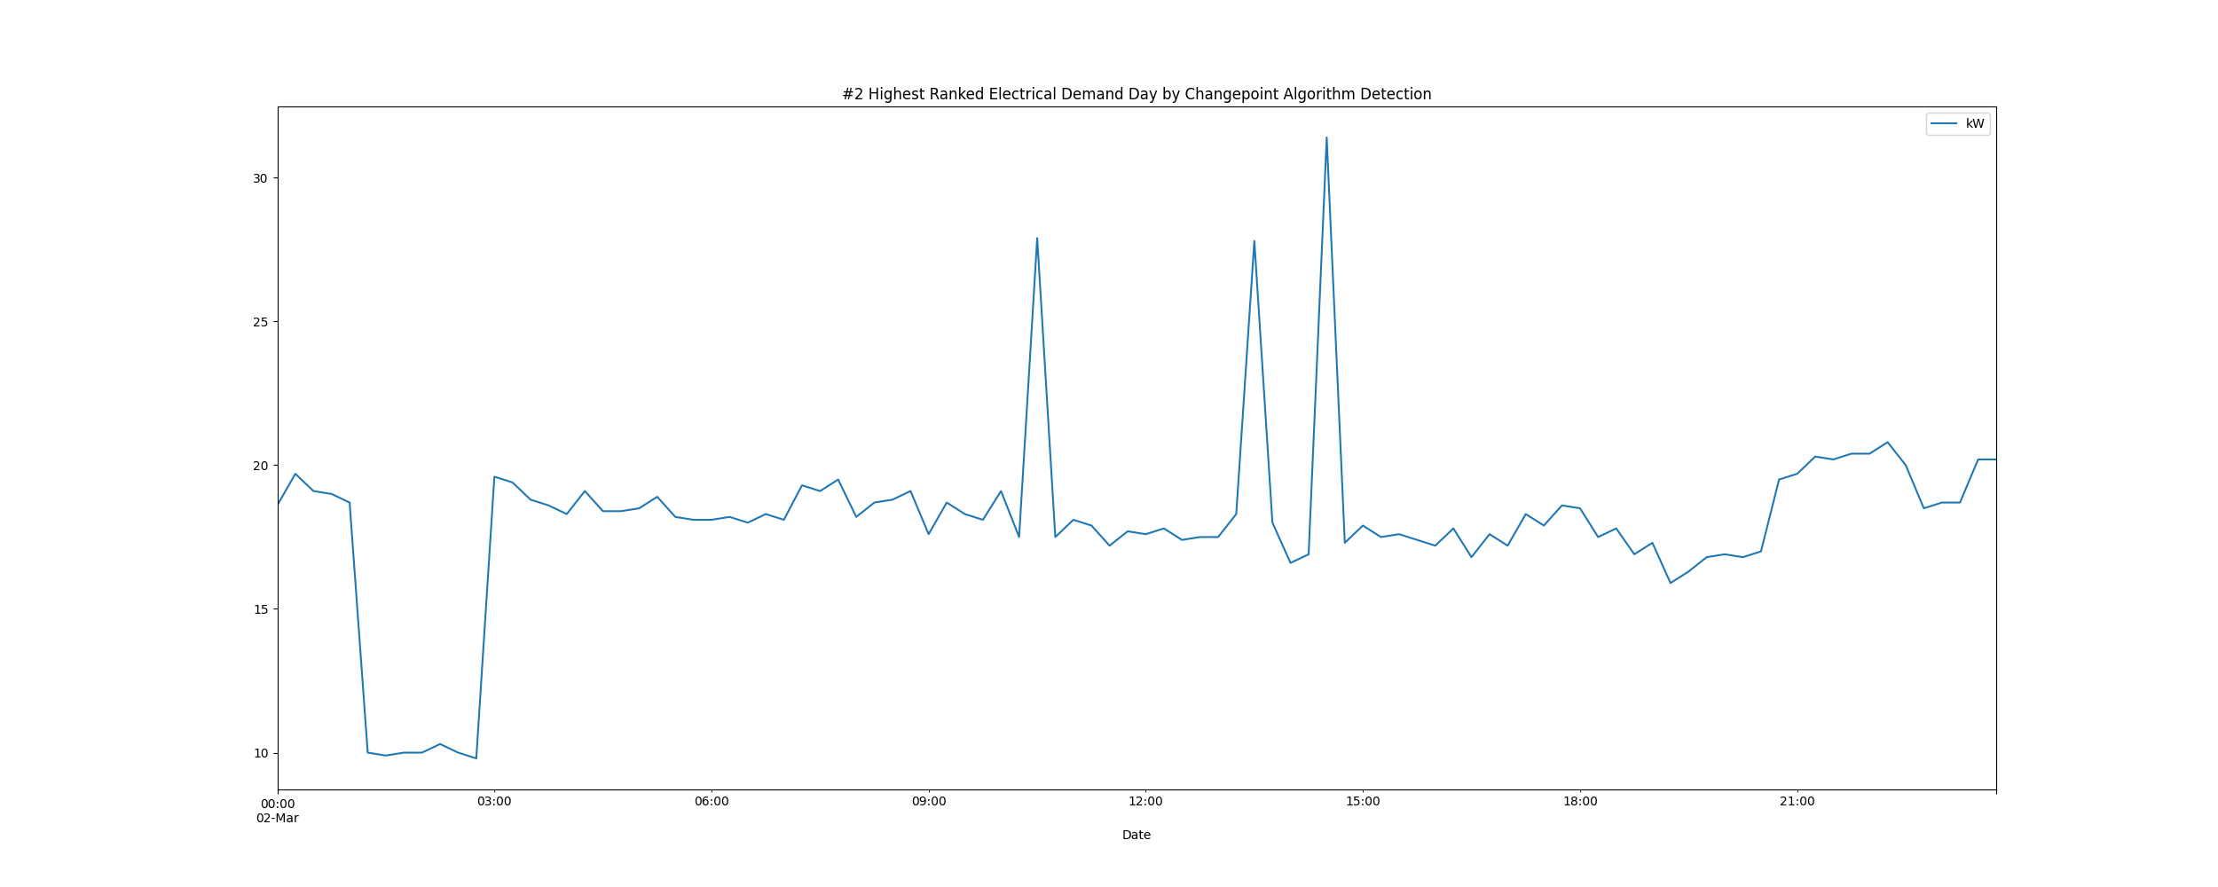

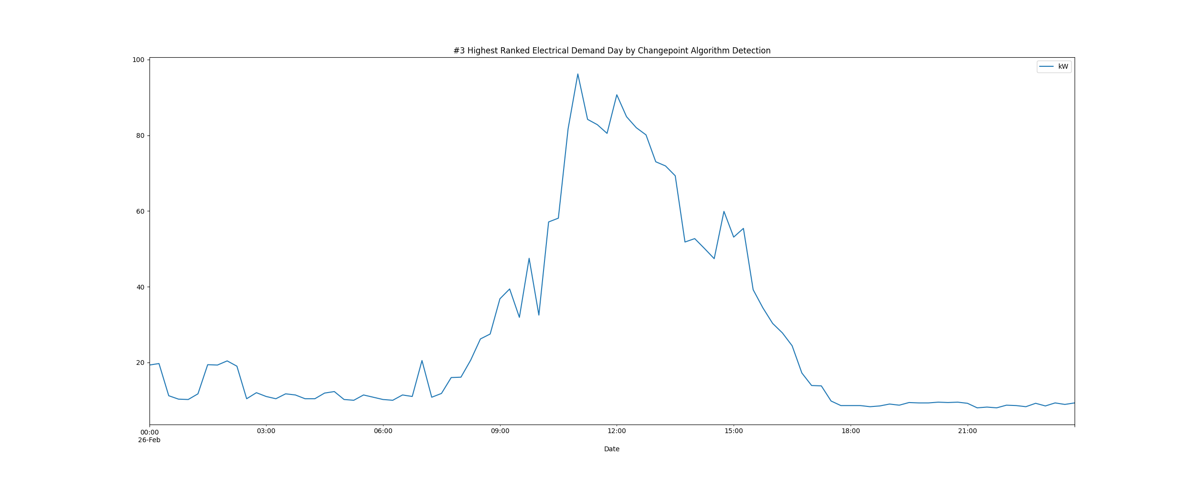

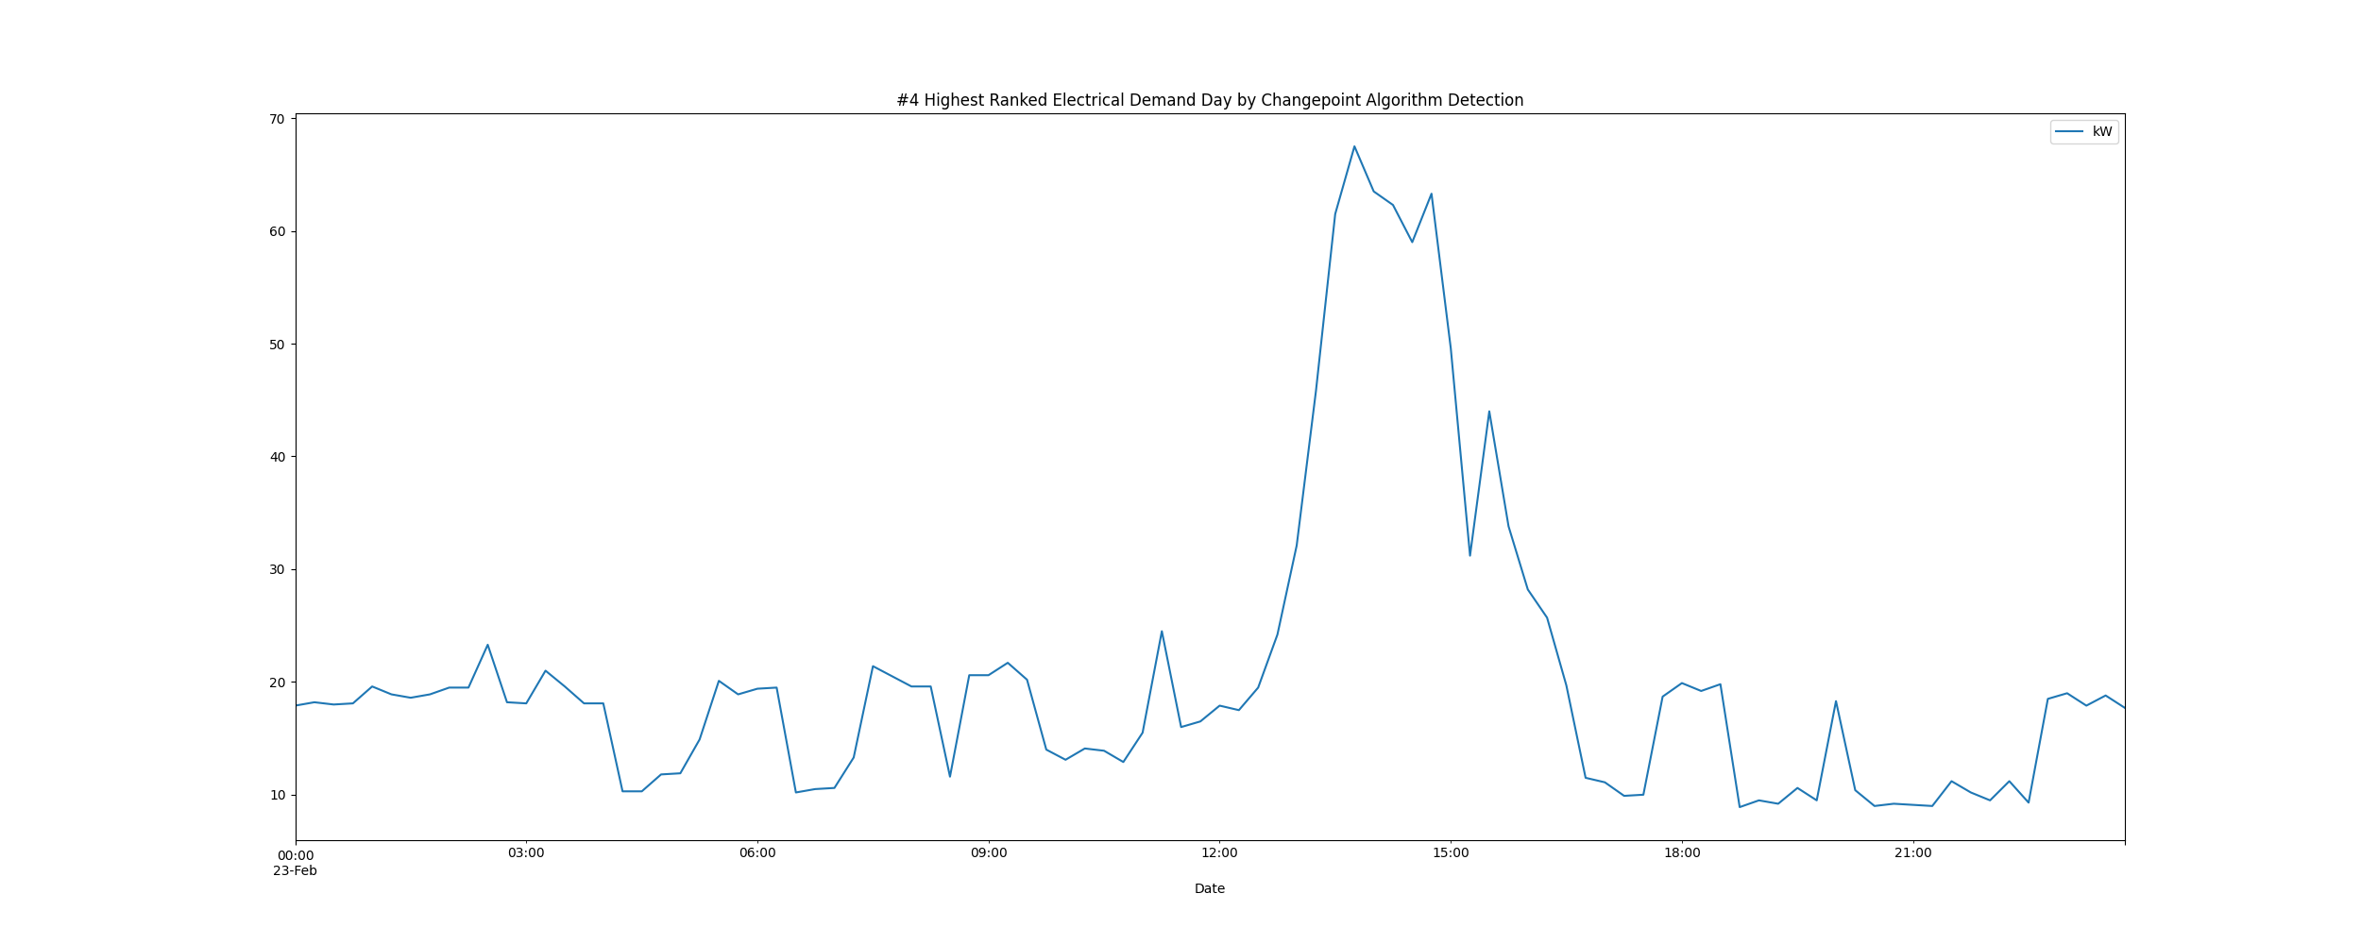

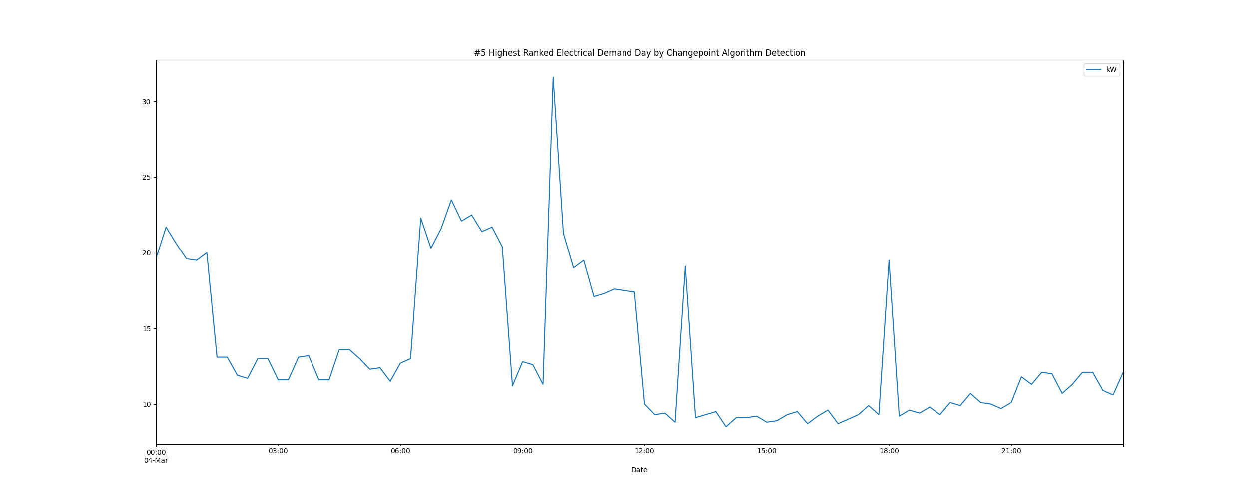

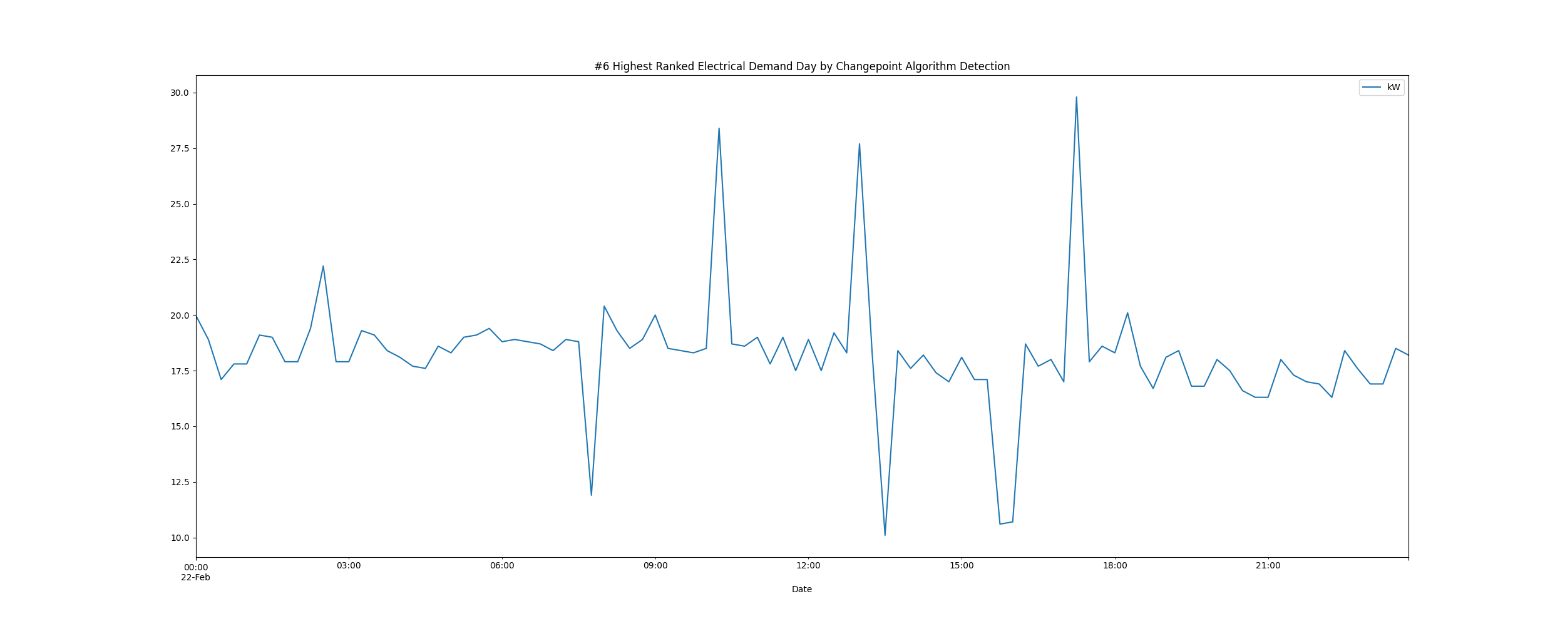

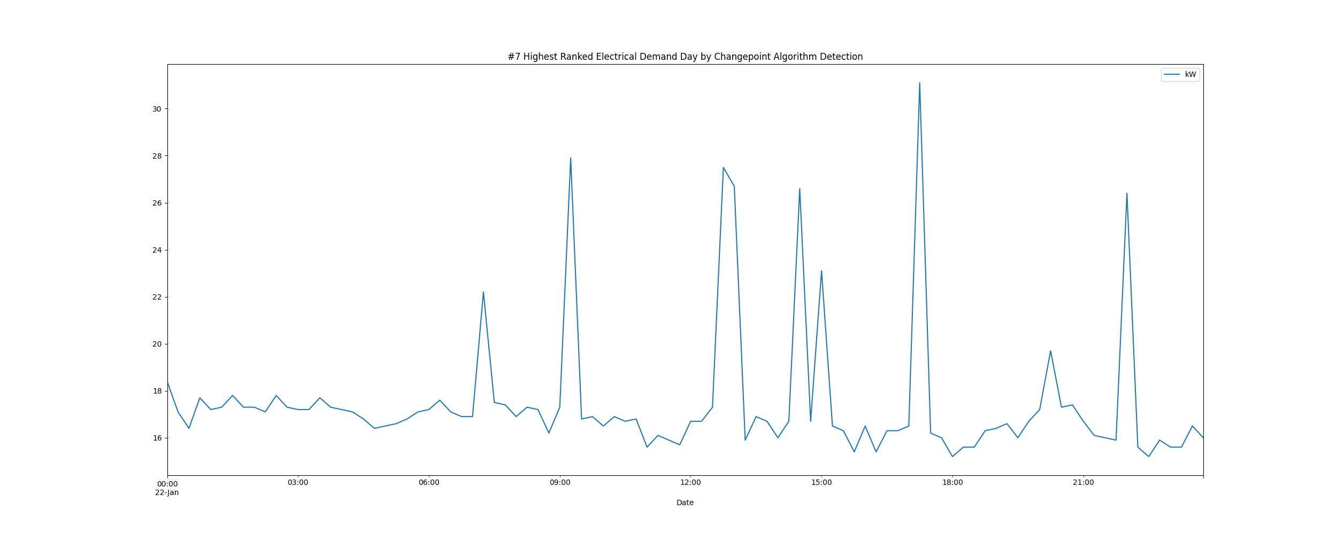

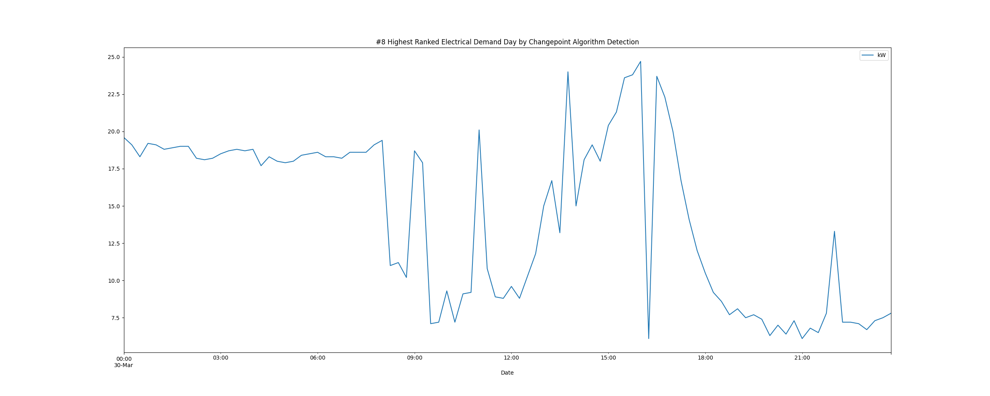

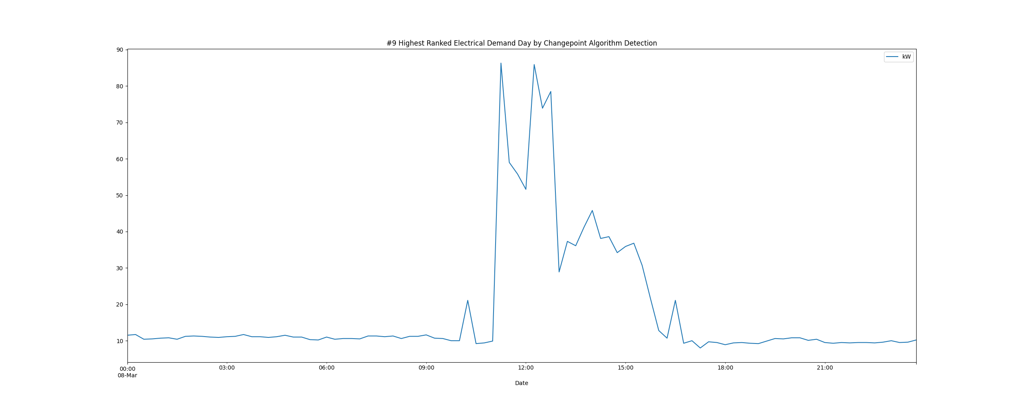

# Daily High and Low Load kW Values

highLowLoadsPlot.png

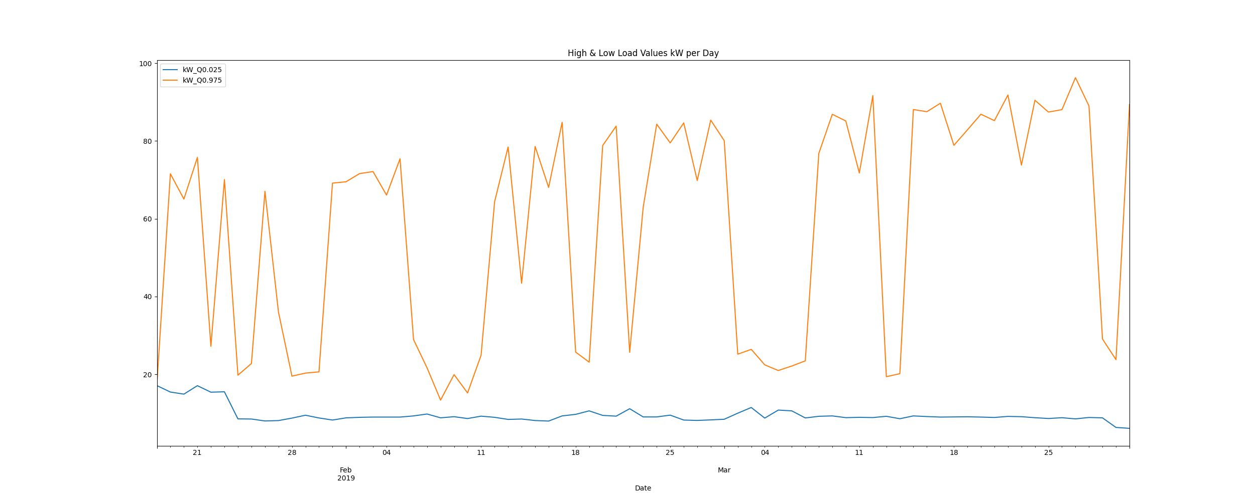

# Max Demand and Hour of Day Plot

Max_Demand_and_Max_Hour_of_Day.png

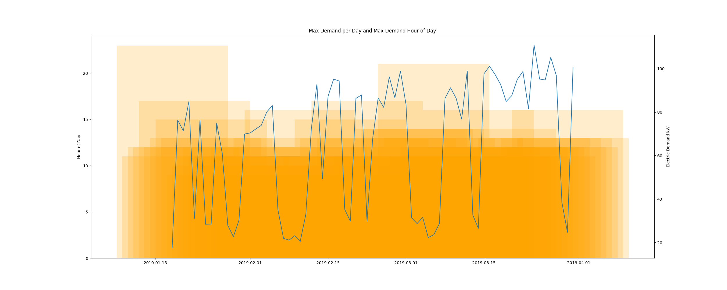

* Resampling the interval dataset to calculate units of energy KWh/day, the first day is 2019-01-18 and the last day is 2019-03-31
* Total days in dataset 72 days
* Total Sum of calculated electrical energy 37333.875 kWh

# kWh Rolling 7 Day Avg

kWhRollingAvg.png

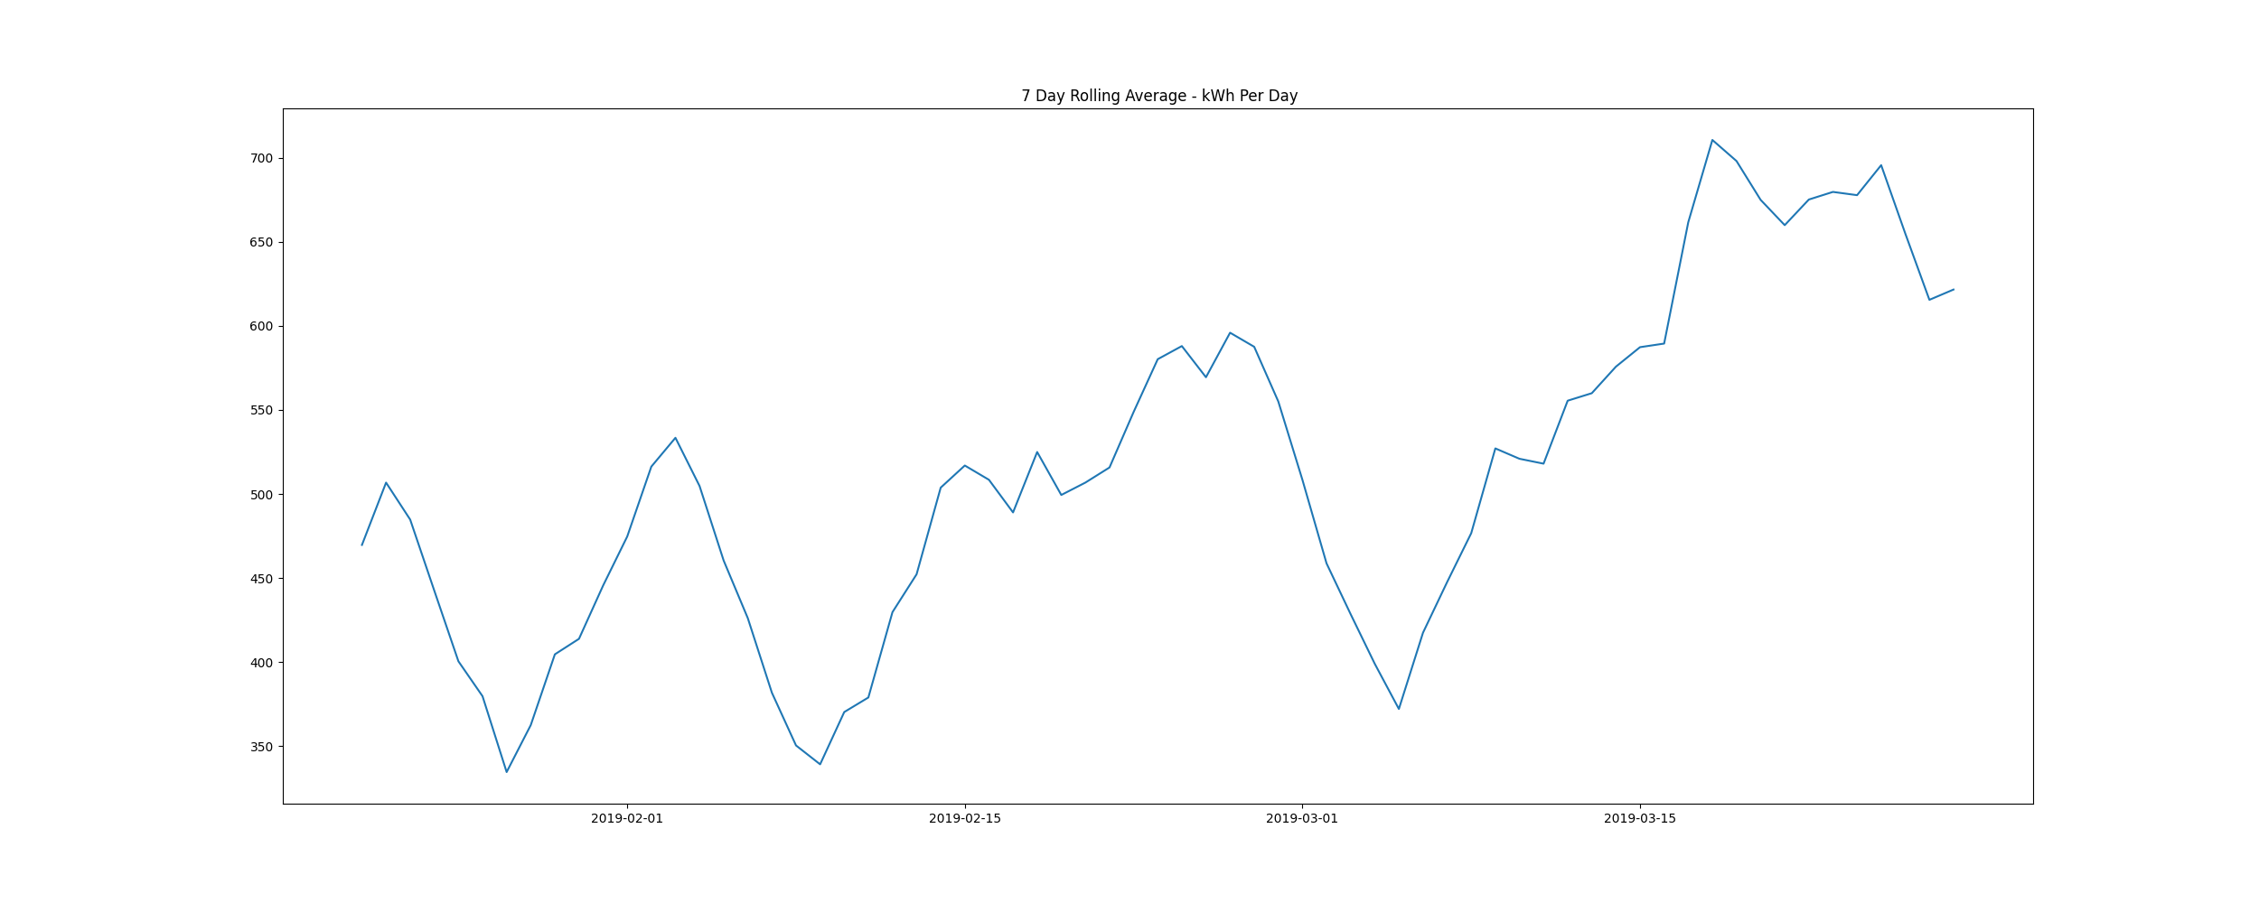

# Demand Plots By Month

Demands_for_Winter_Month_January.png

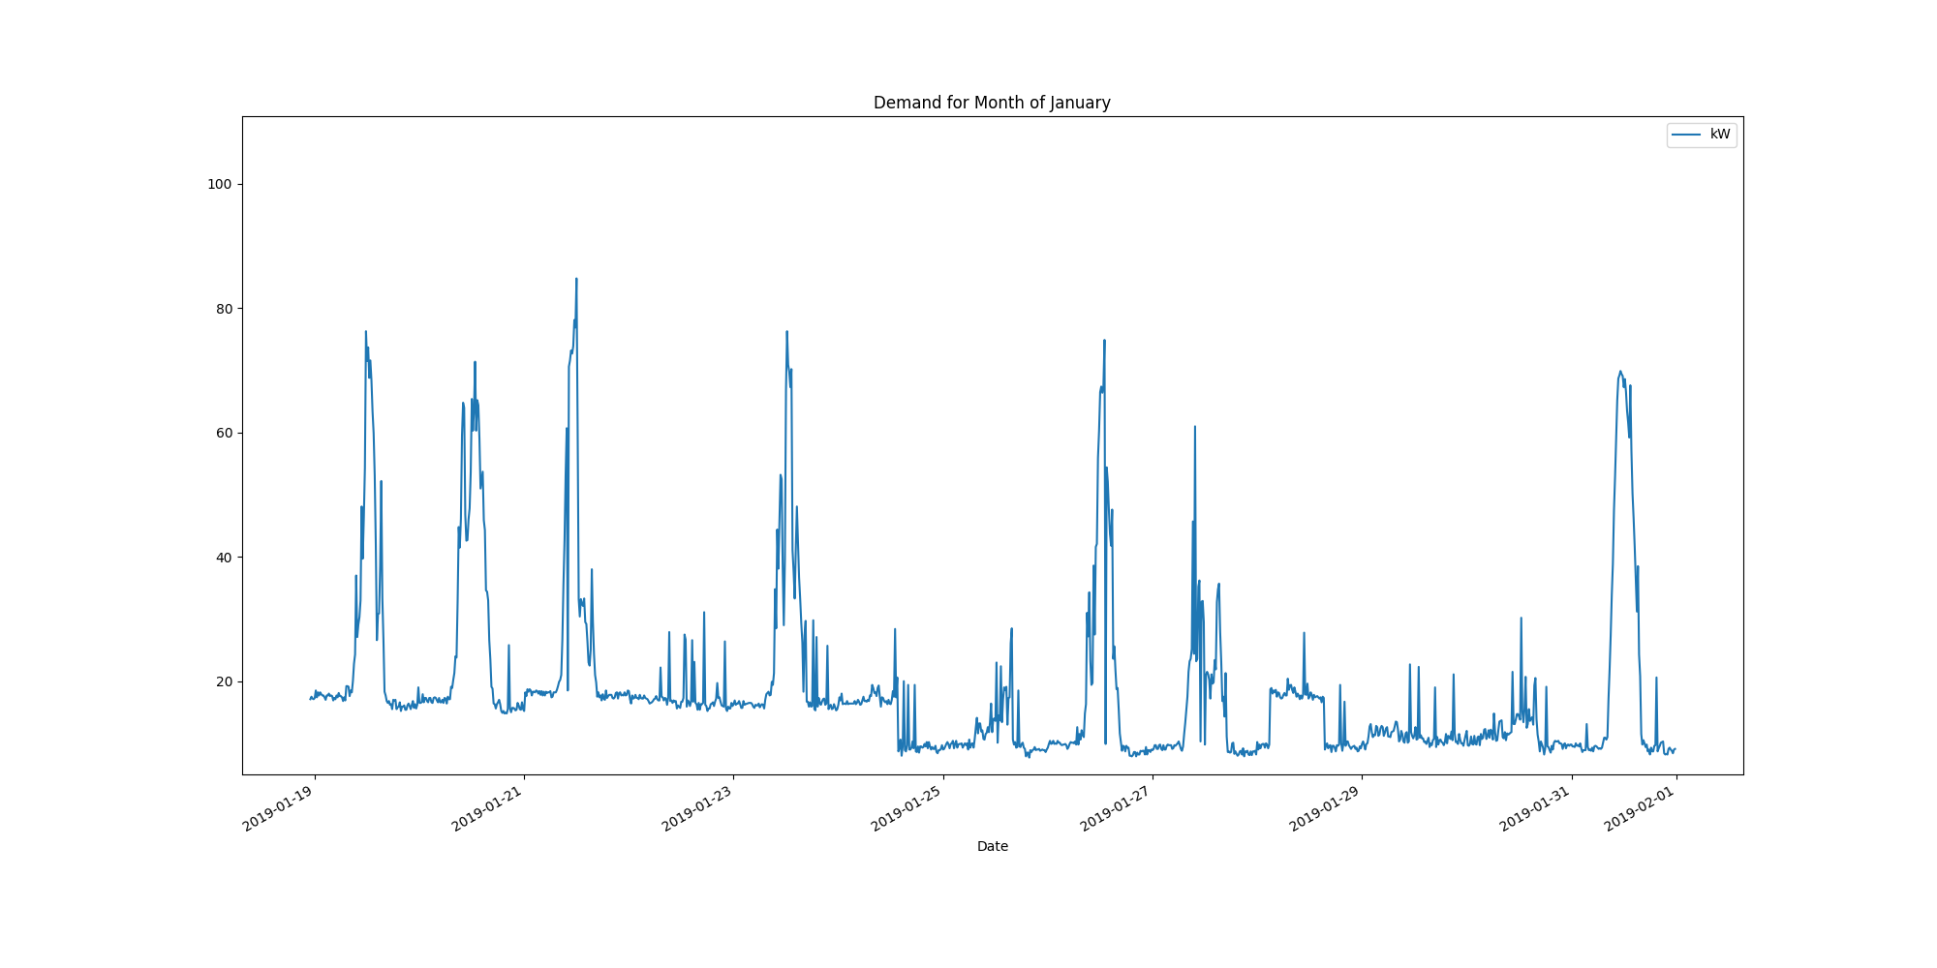

Data Analysis Report Summer

Summer Months Electrical Load Profiles

datasetPlot.png

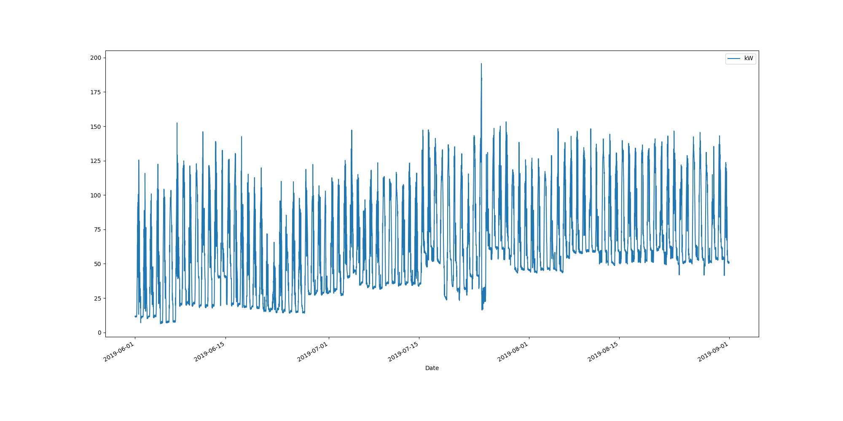

# Max Demand Found In Dataset

kW 195.7  
Name: 2019-07-24 15:15:00, dtype: float64

# Dataset Summary Statistics

kW  
count 8827.000000  
mean 60.264903  
std 32.357571  
min 6.300000  
25% 35.800000  
50% 54.600000  
75% 79.900000  
max 195.700000

# Highest Ranked Change Point Algorithm Detection

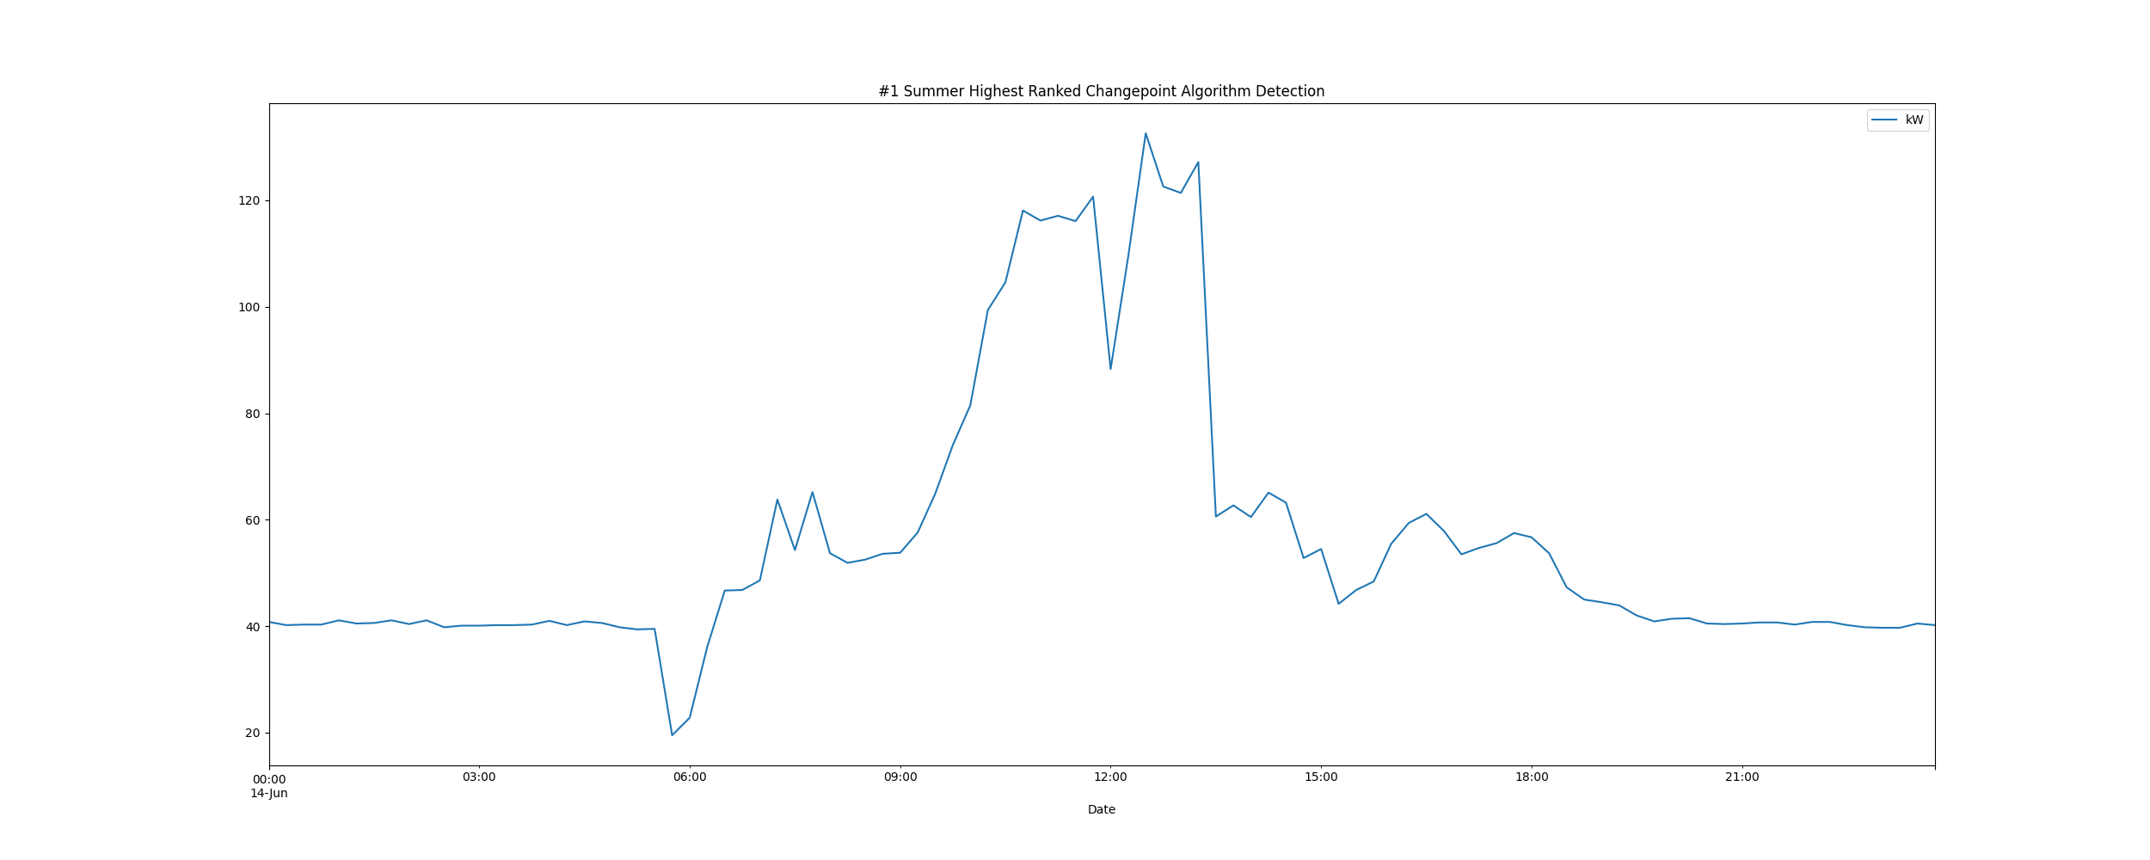

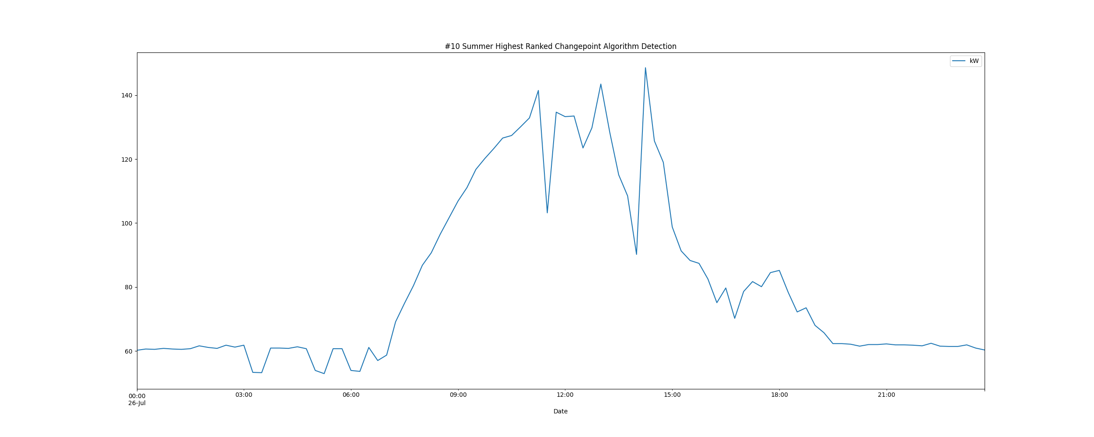

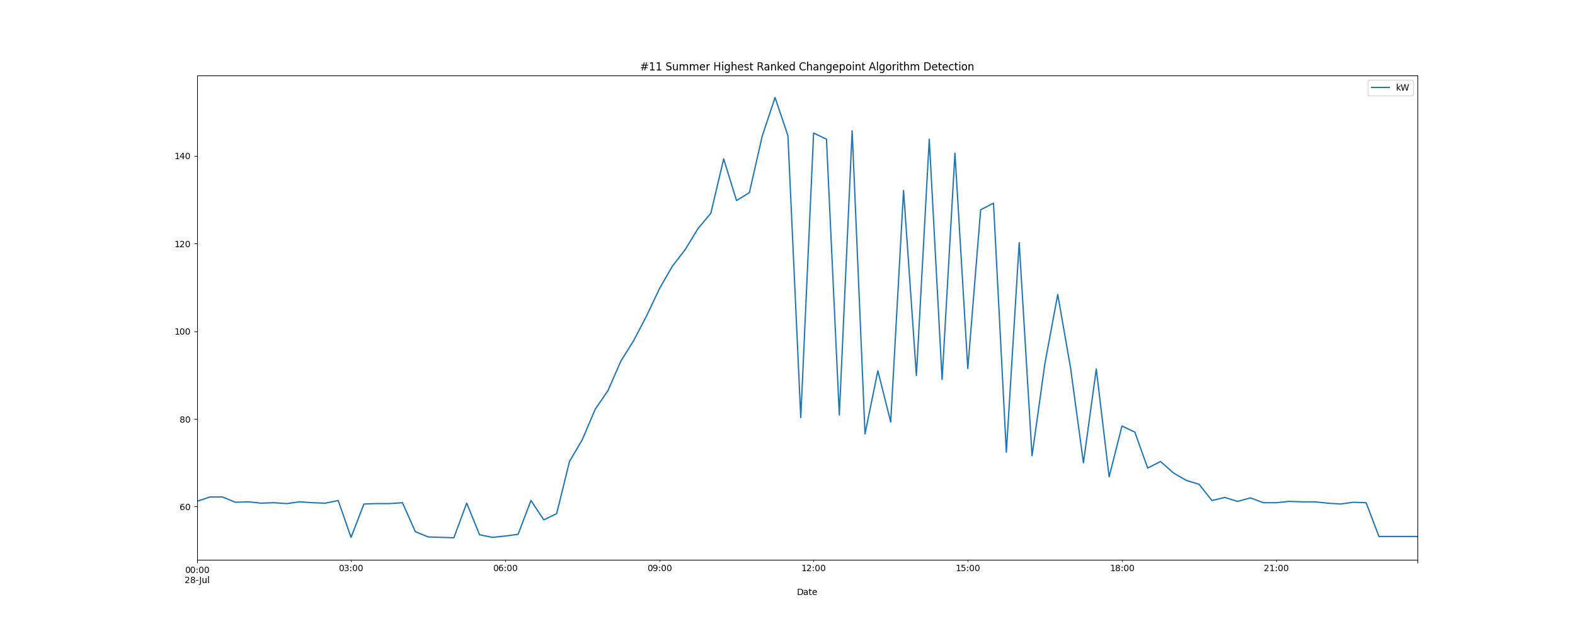

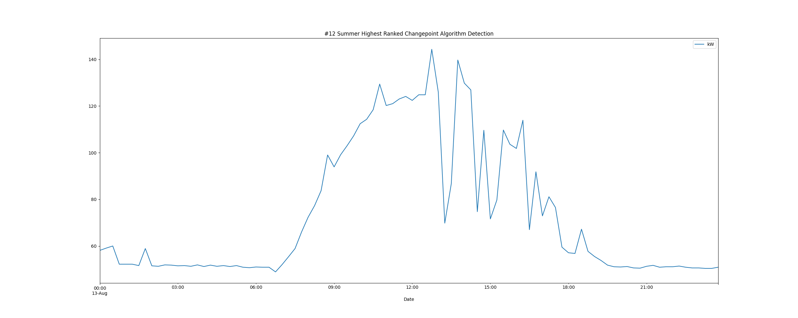

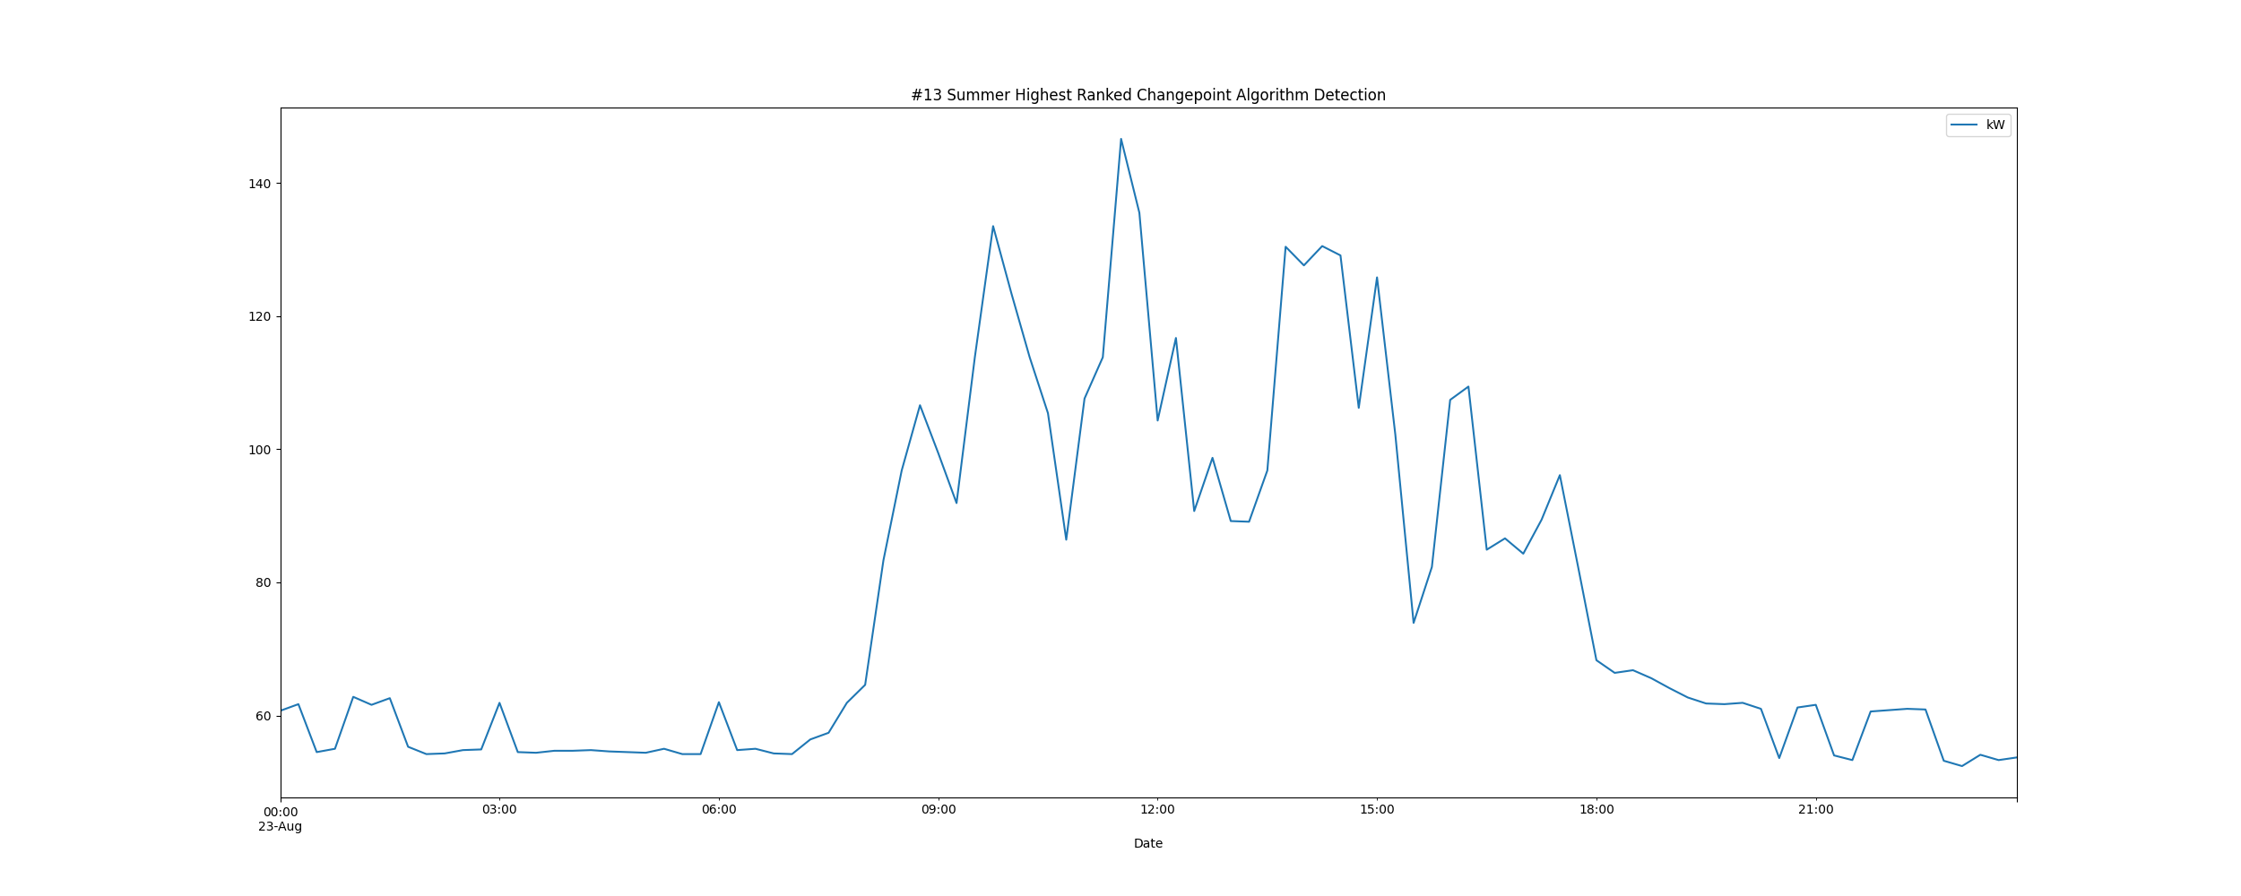

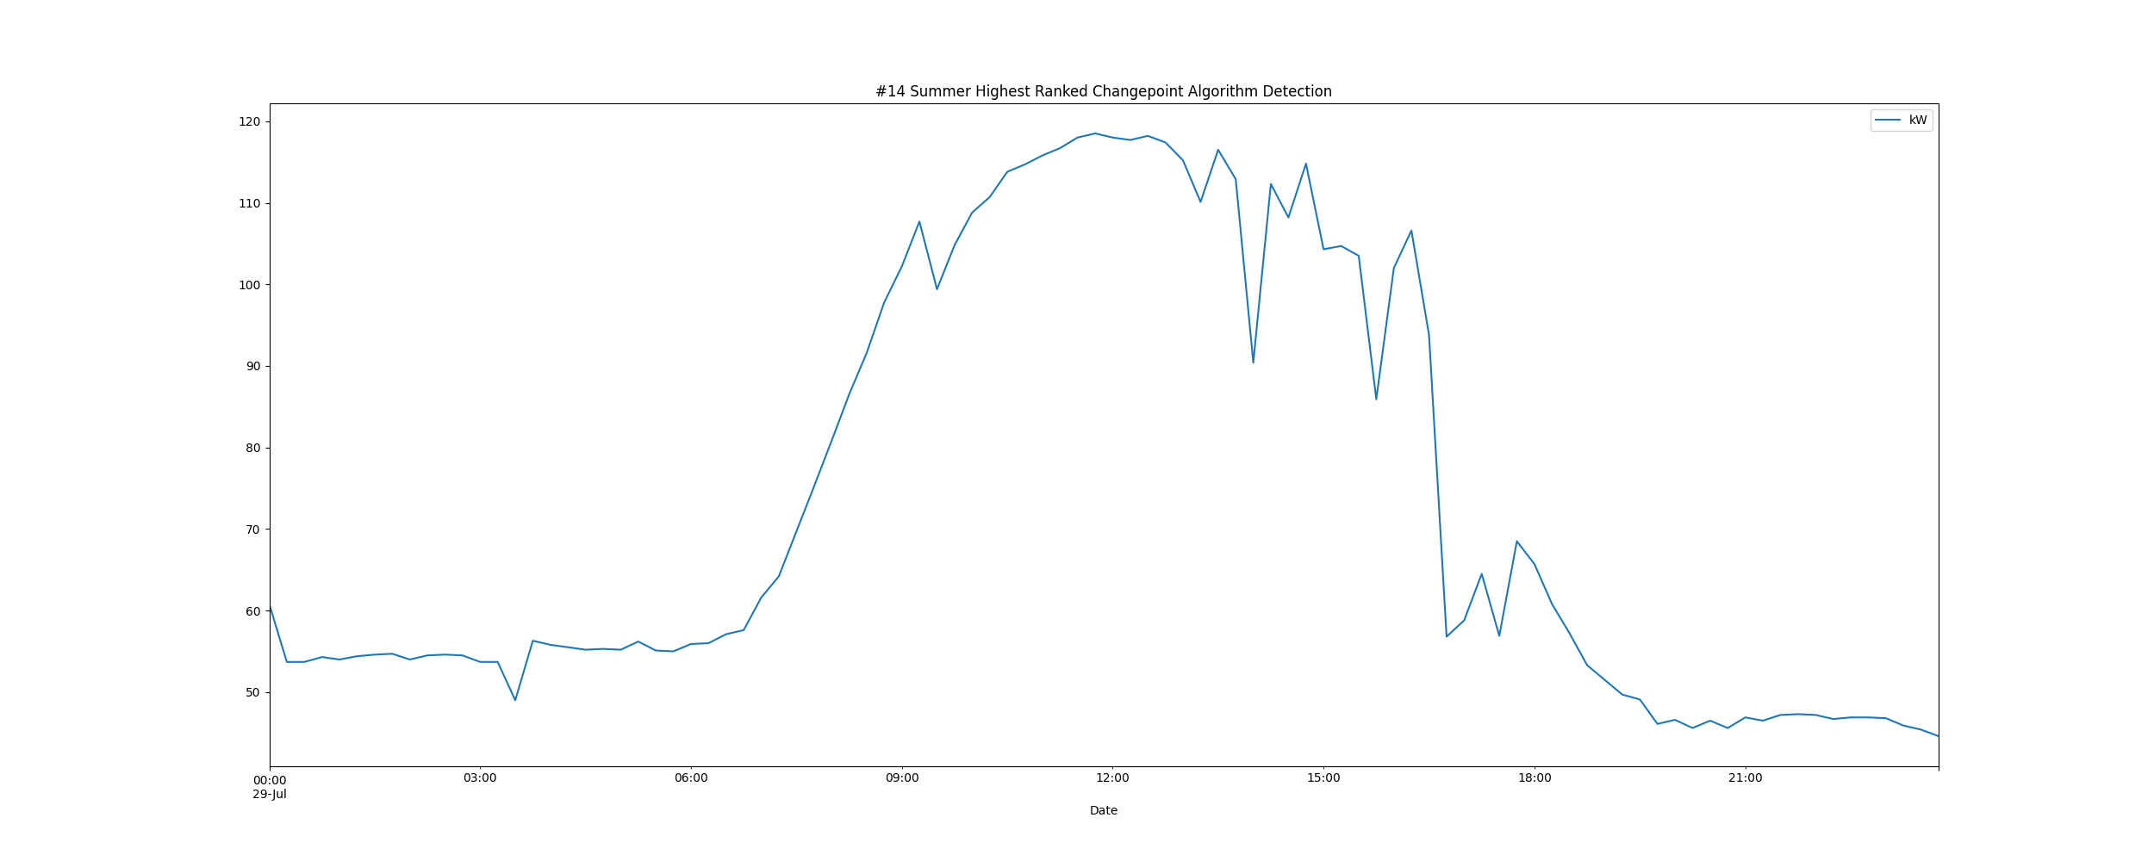

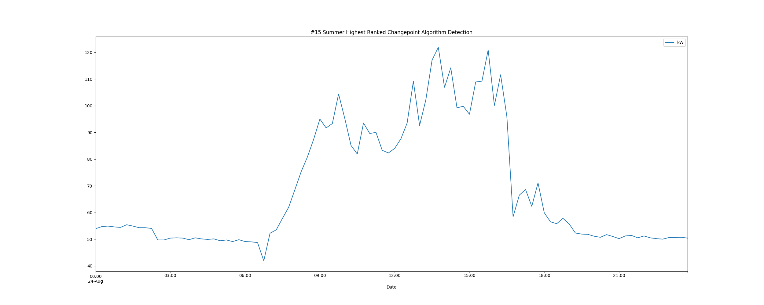

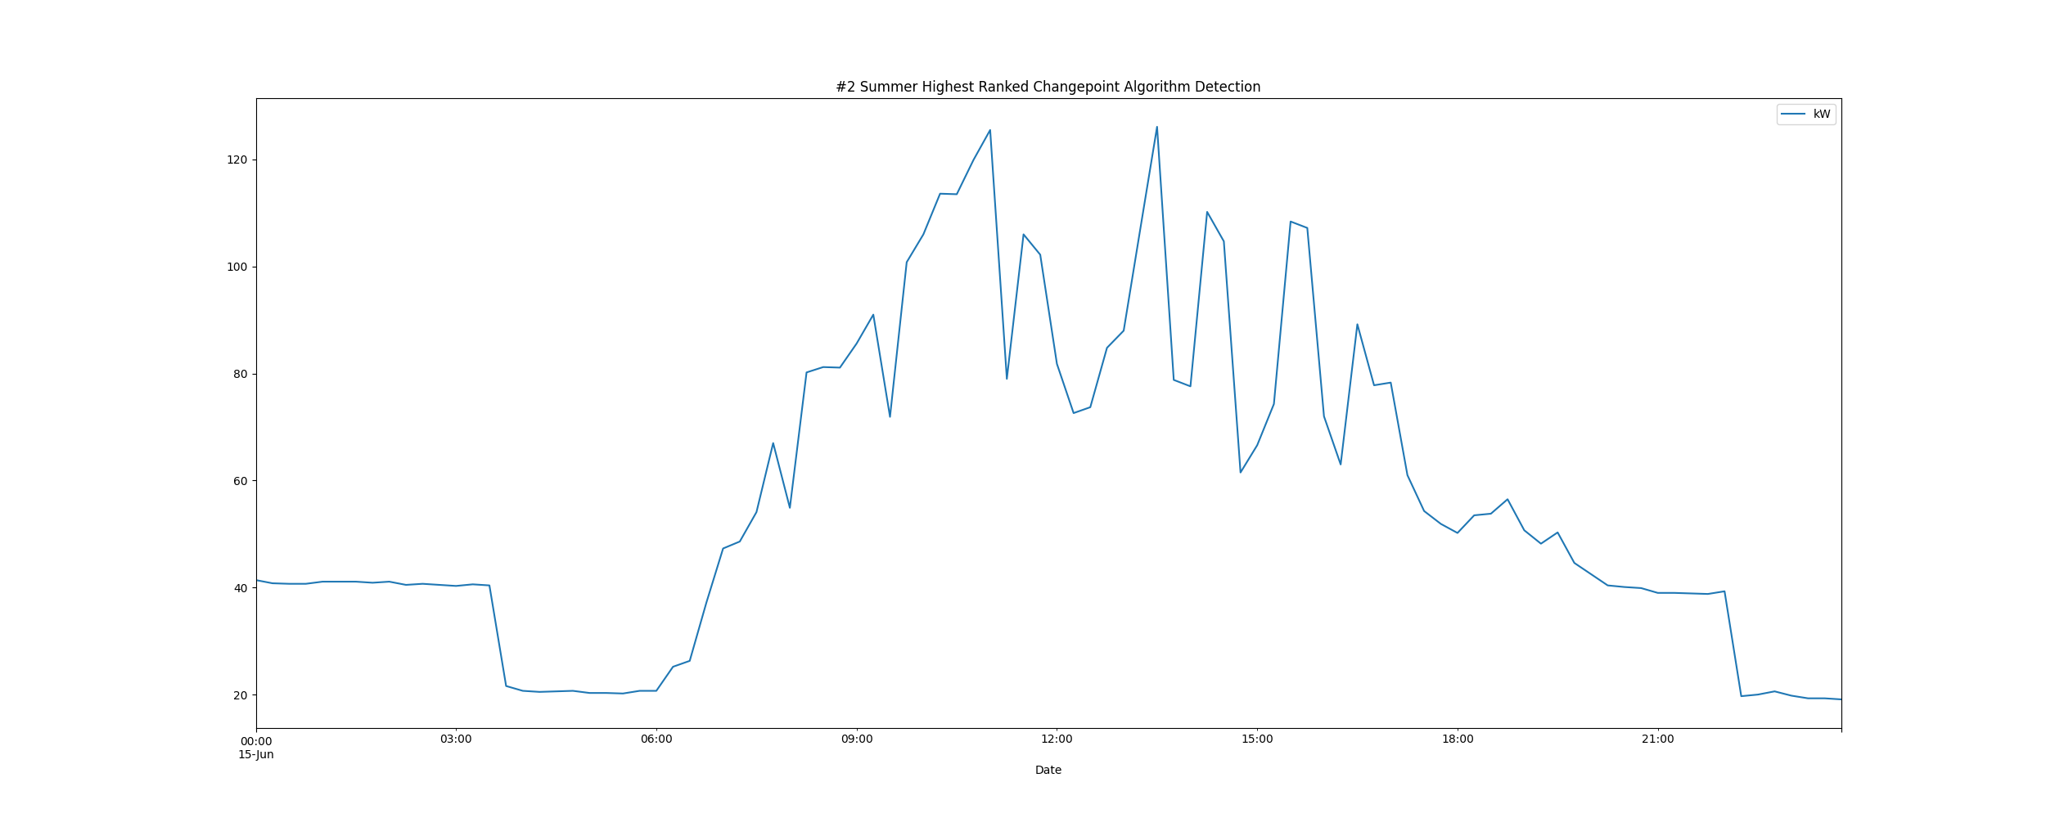

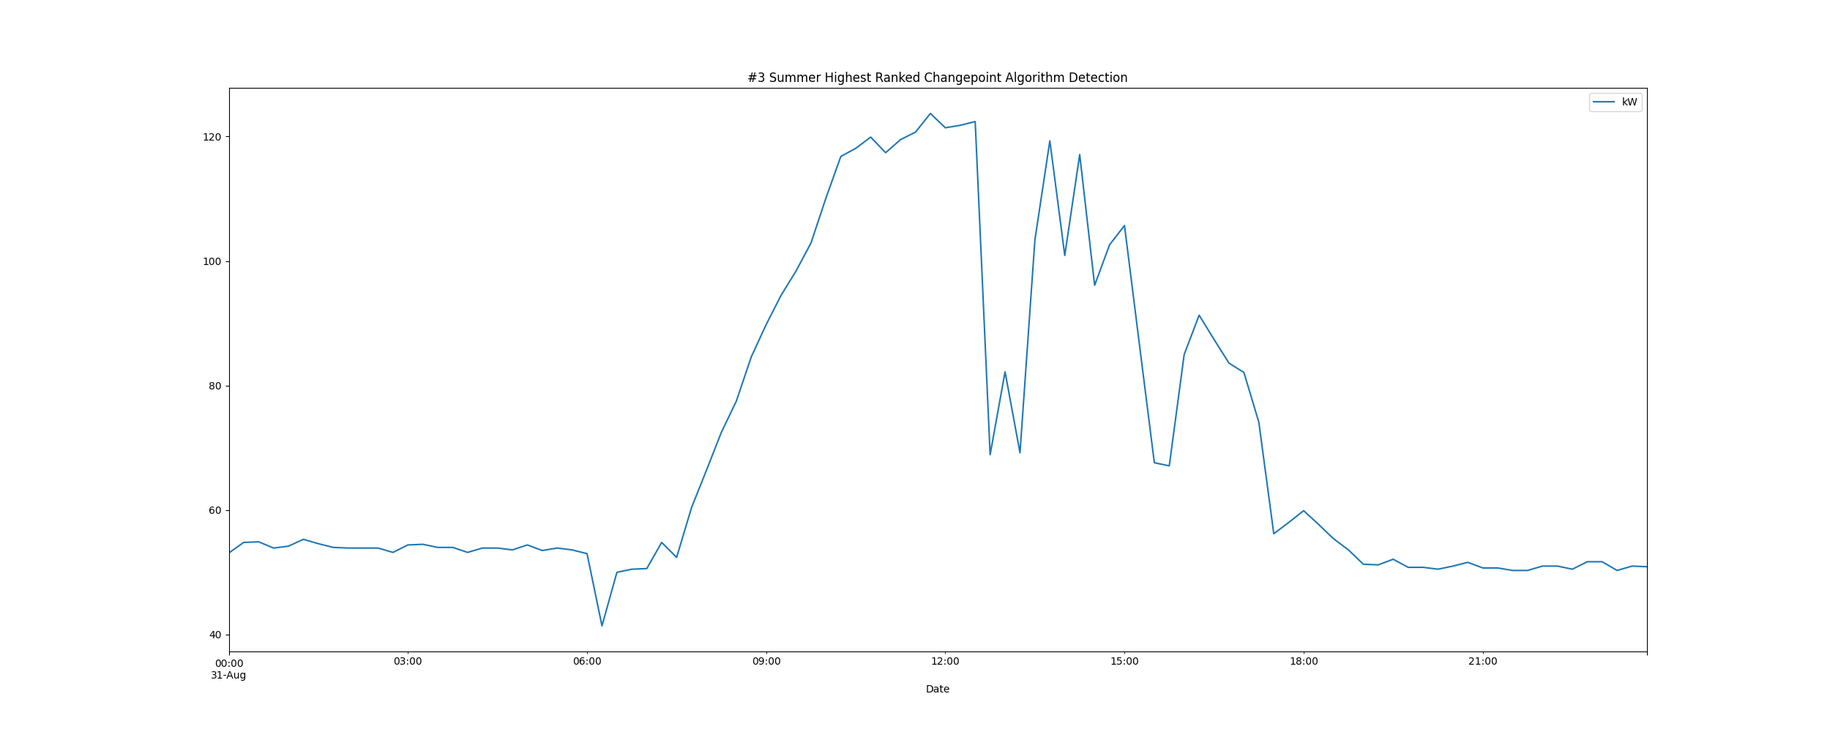

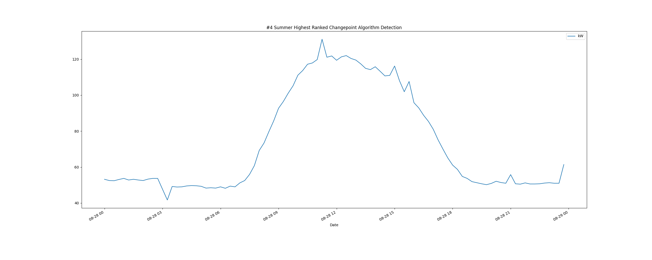

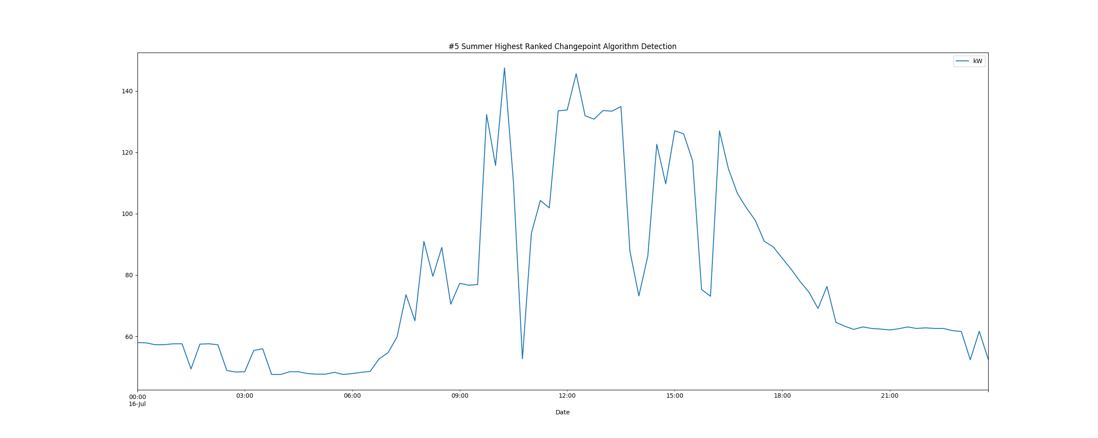

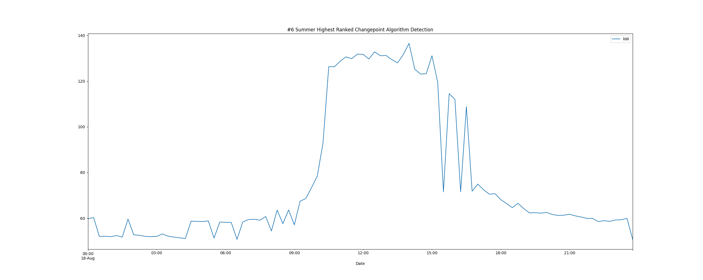

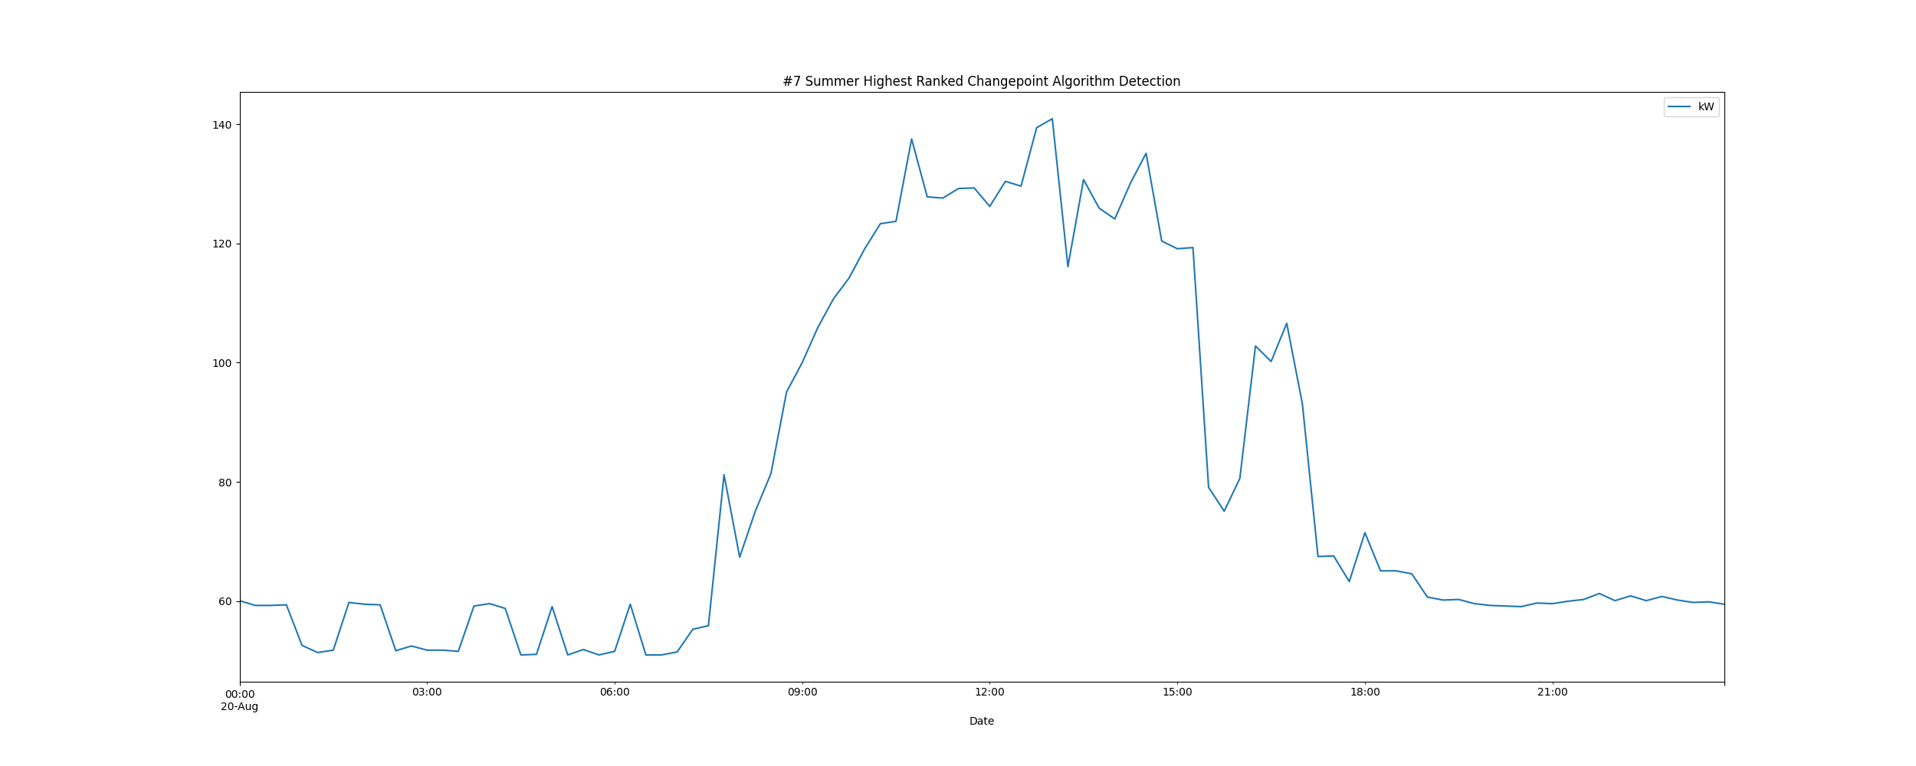

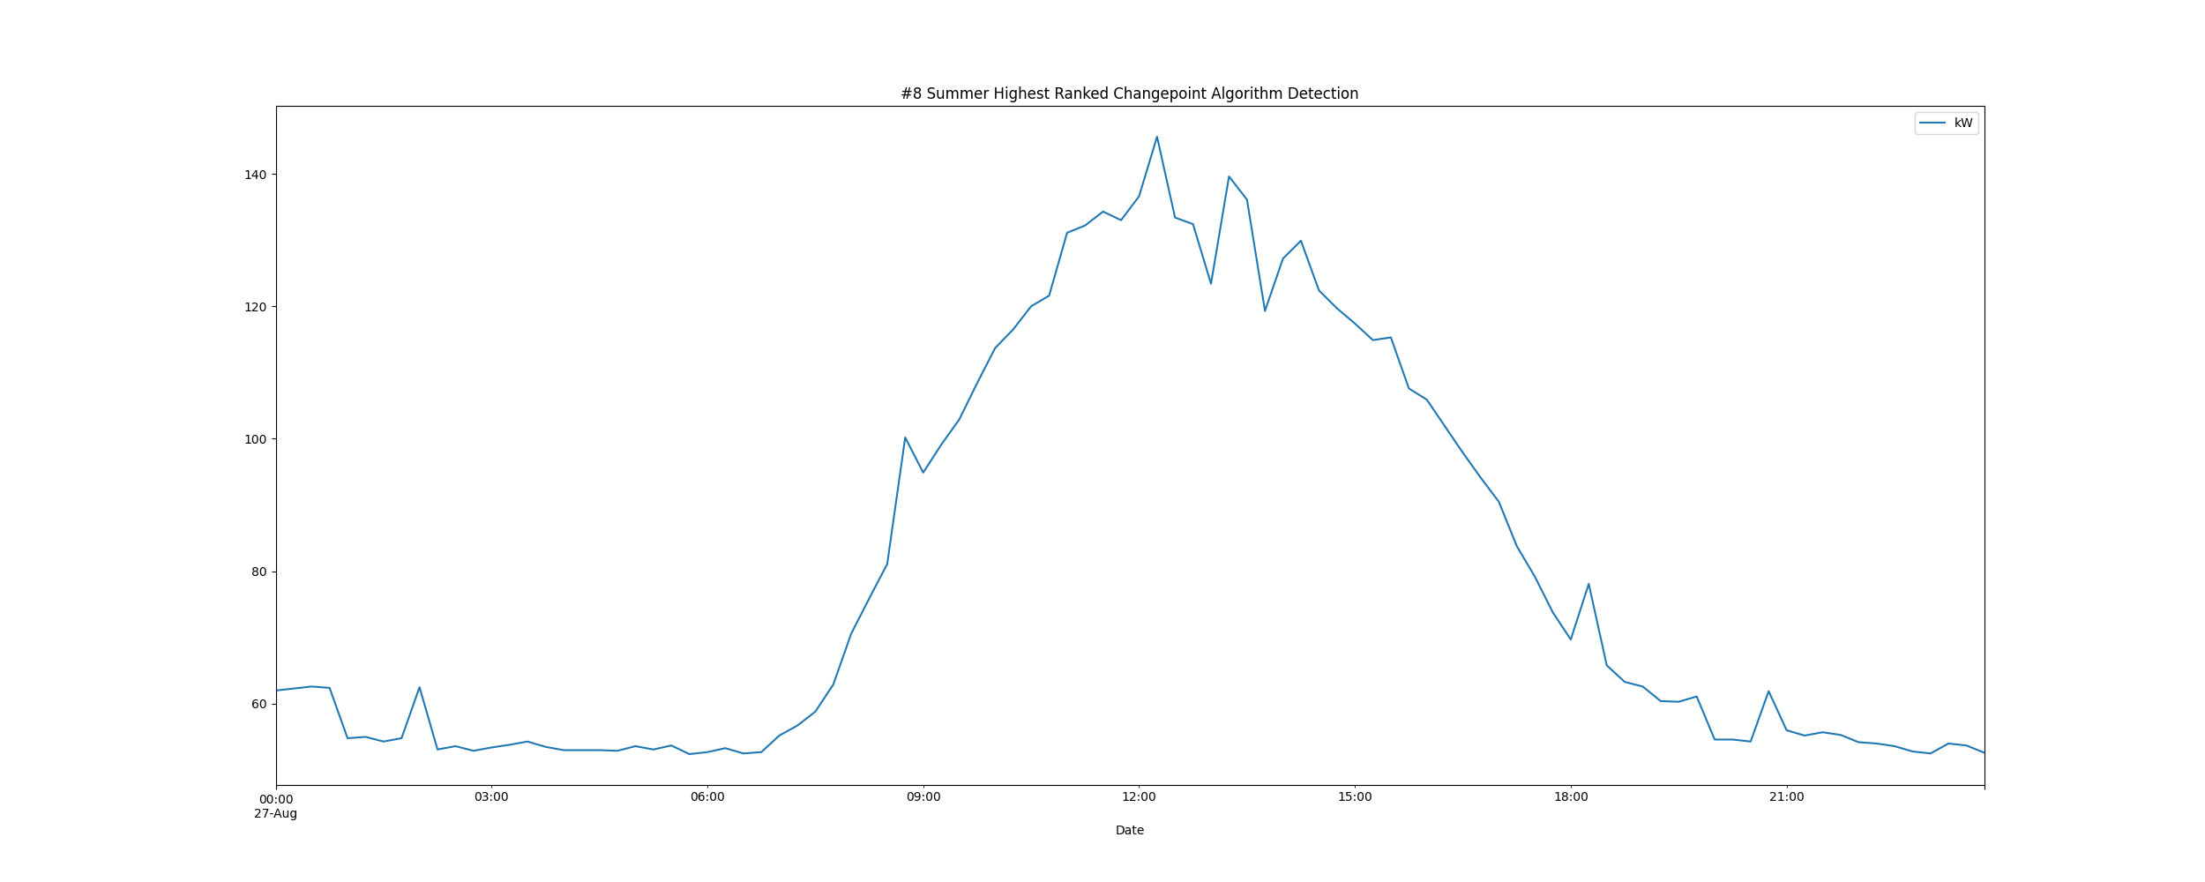

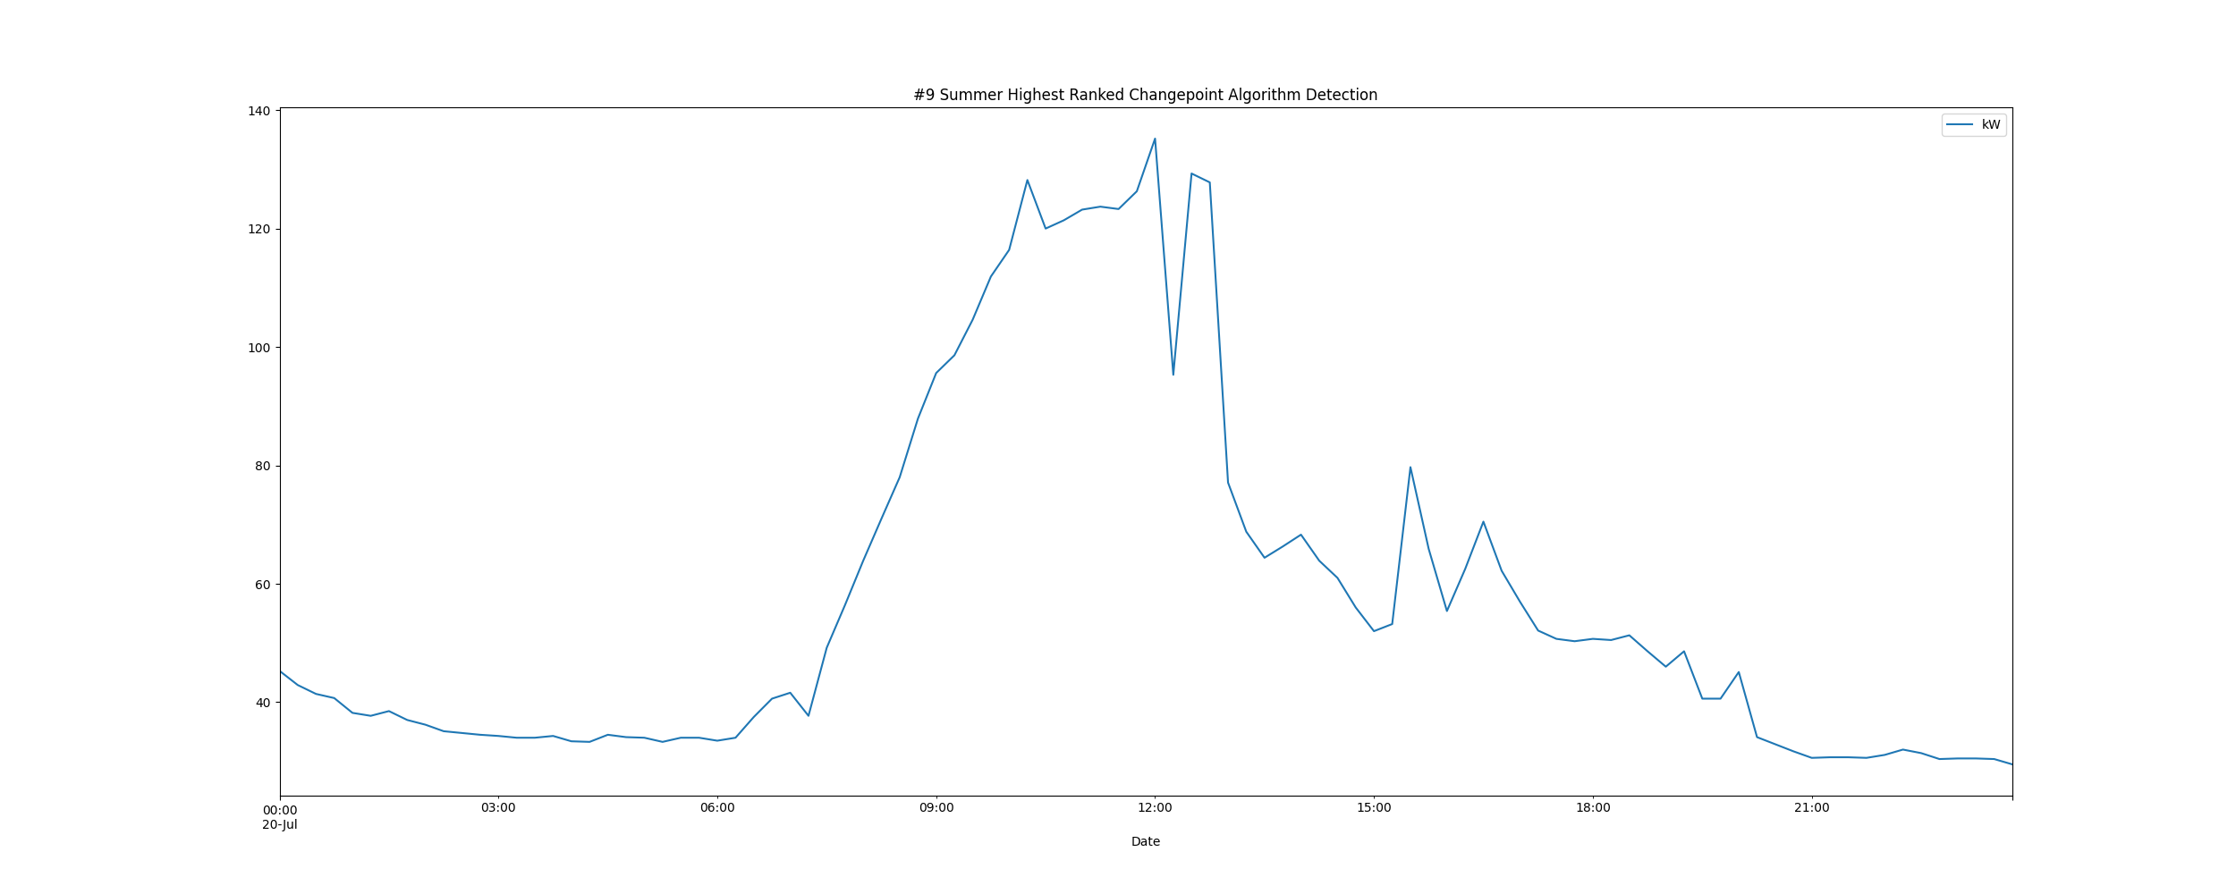

# Daily High and Low Load kW Values

highLowLoadsPlot.png

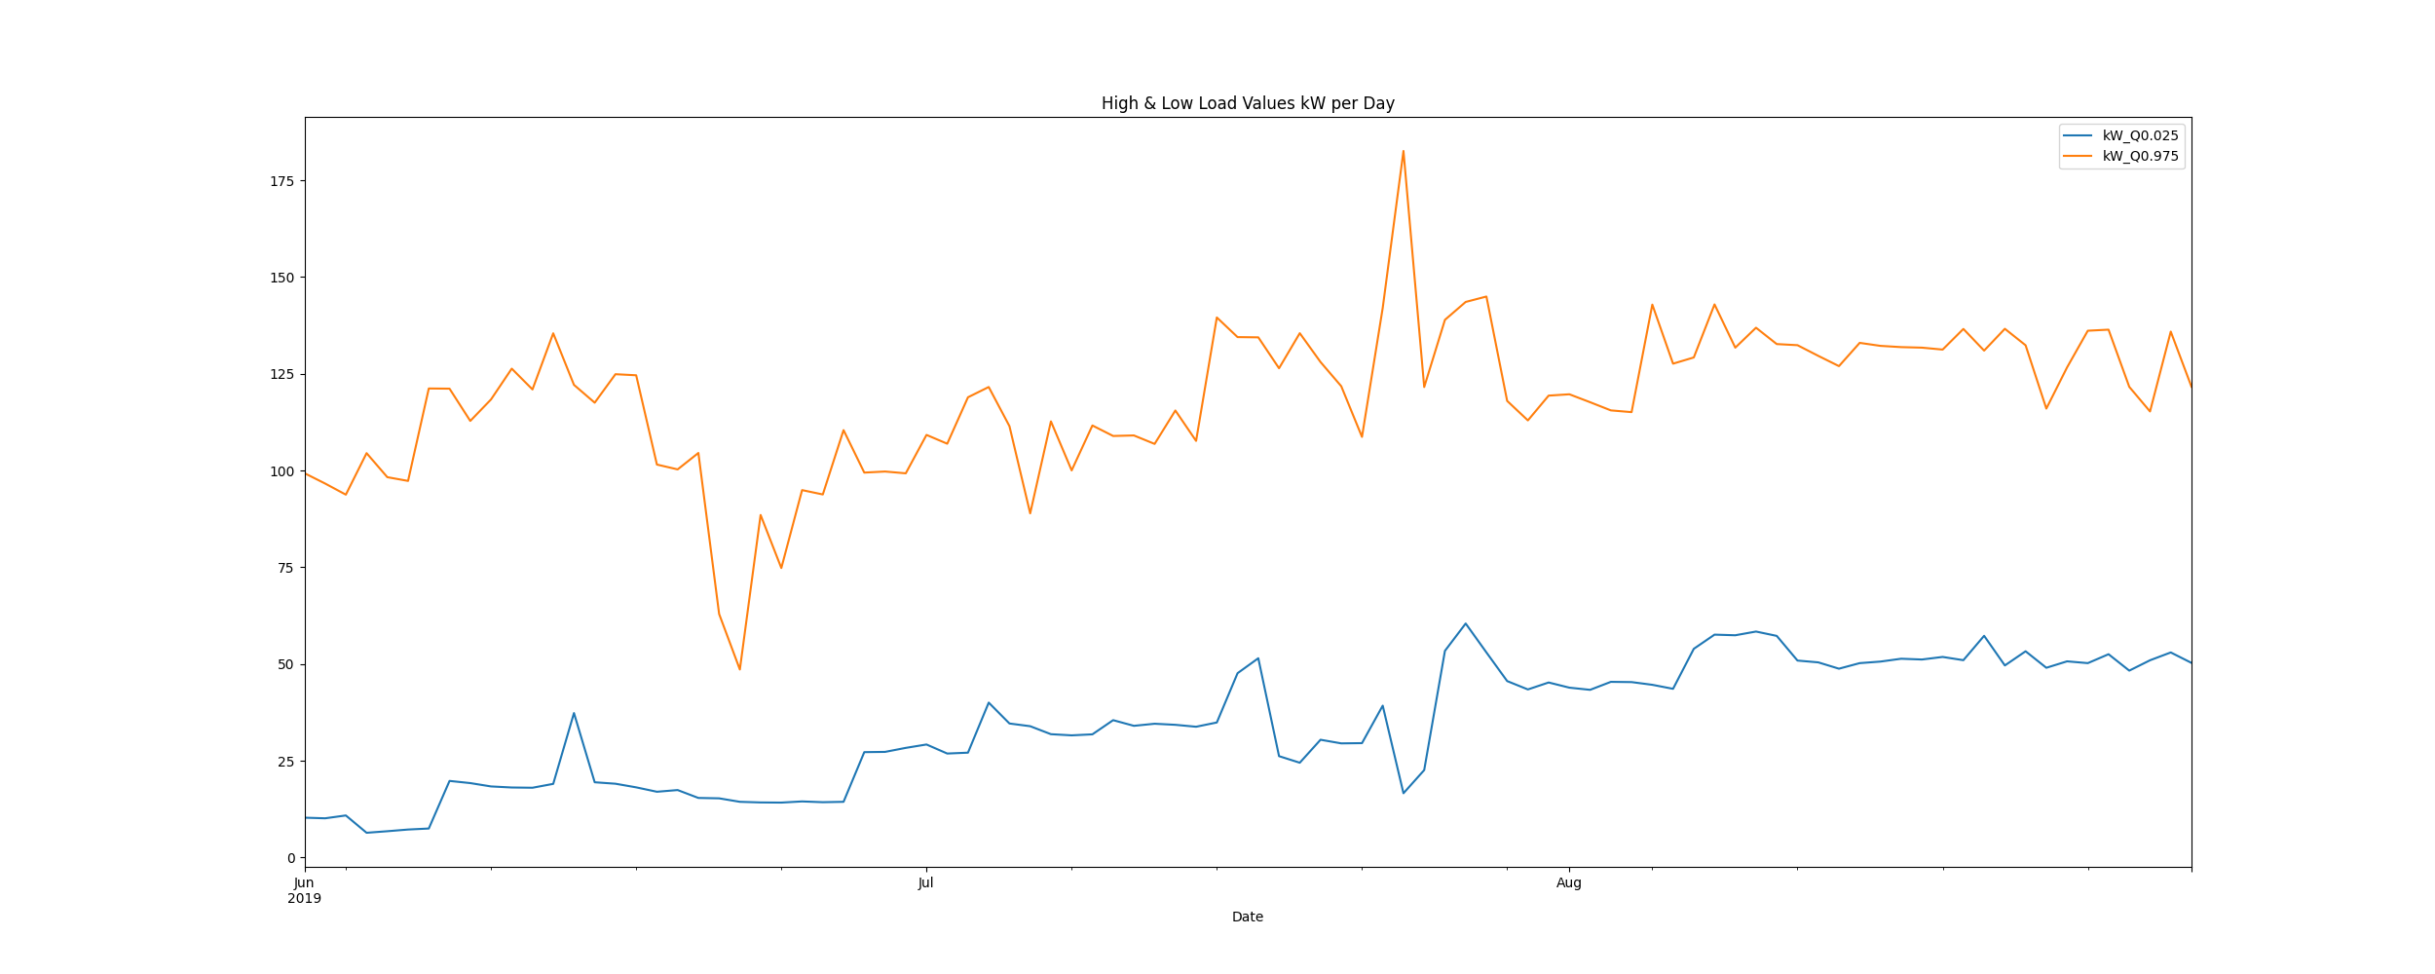

# Max Demand and Hour of Day Plot

Max_Demand_and_Max_Hour_of_Day.png

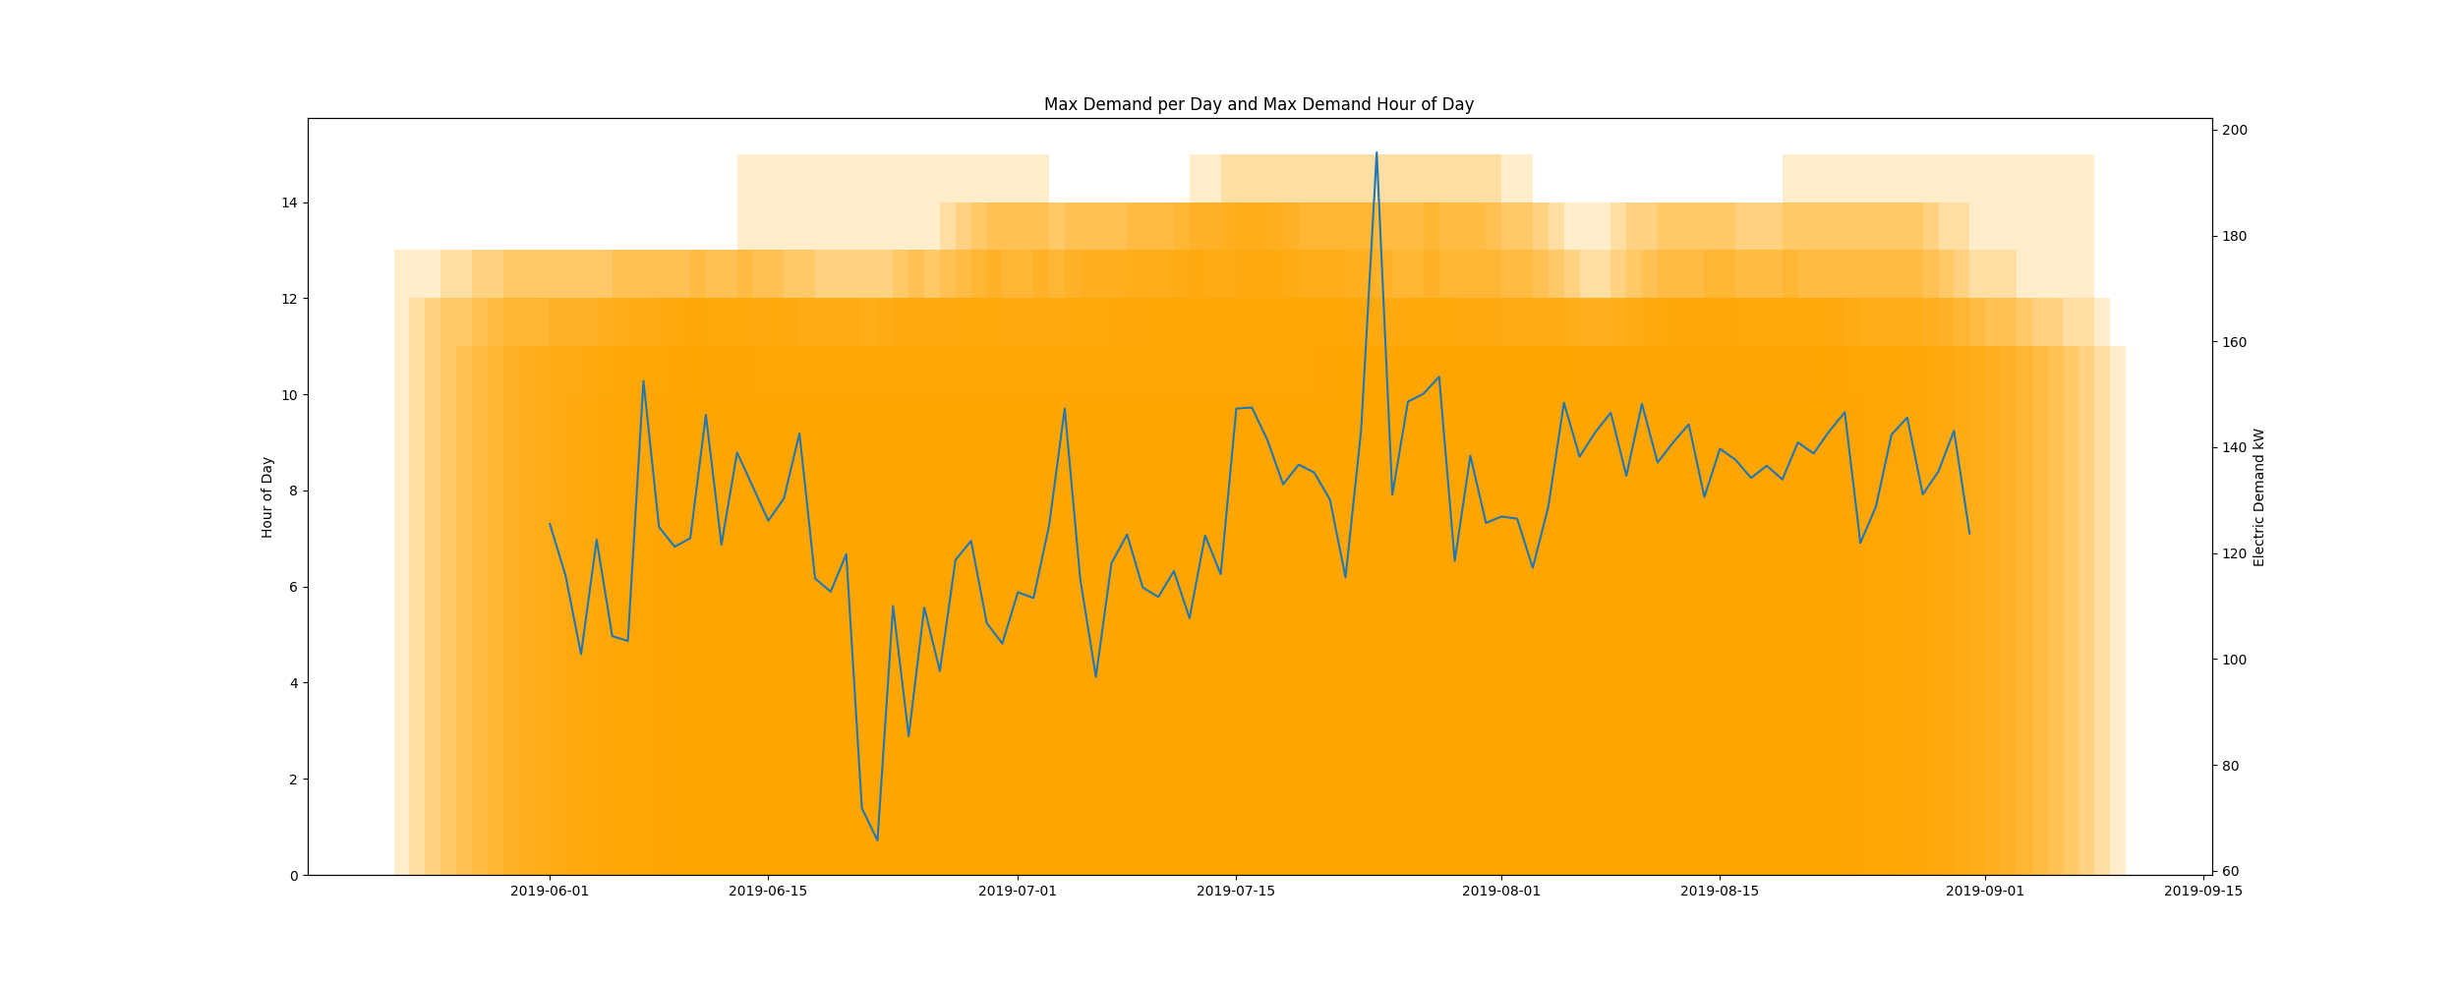

* Resampling the interval dataset to calculate units of energy KWh/day, the first day is 2019-06-01 and the last day is 2019-08-31
* Total days in dataset 91 days
* Total Sum of calculated electrical energy 133050.625 kWh

# kWh Rolling 7 Day Avg

kWhRollingAvg.png

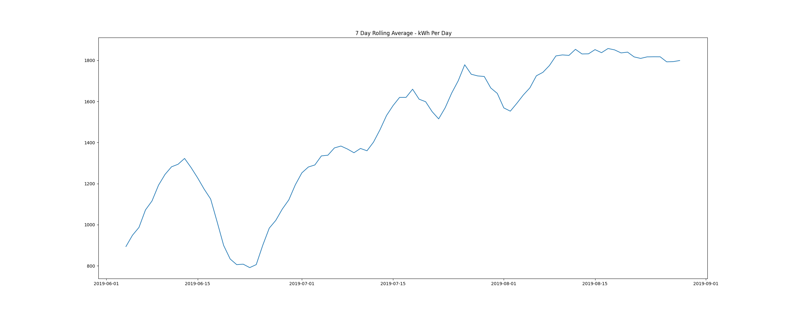

# Demand Plots By Month

report compiled on:

01/01/2021 10:53:07