Fault Condition One Report

Fault condition one of ASHRAE Guideline 36 is related to flagging poor performance of a AHU variable supply fan attempting to control to a duct pressure setpoint. Fault condition equation as defined by ASHRAE:

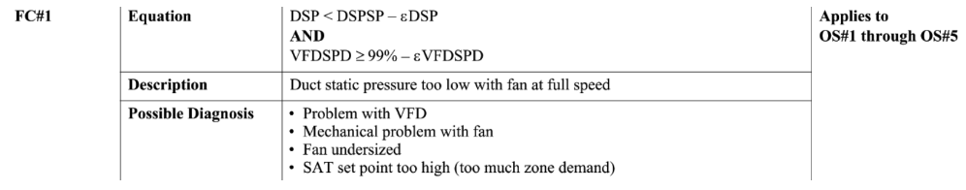

## Dataset Plot

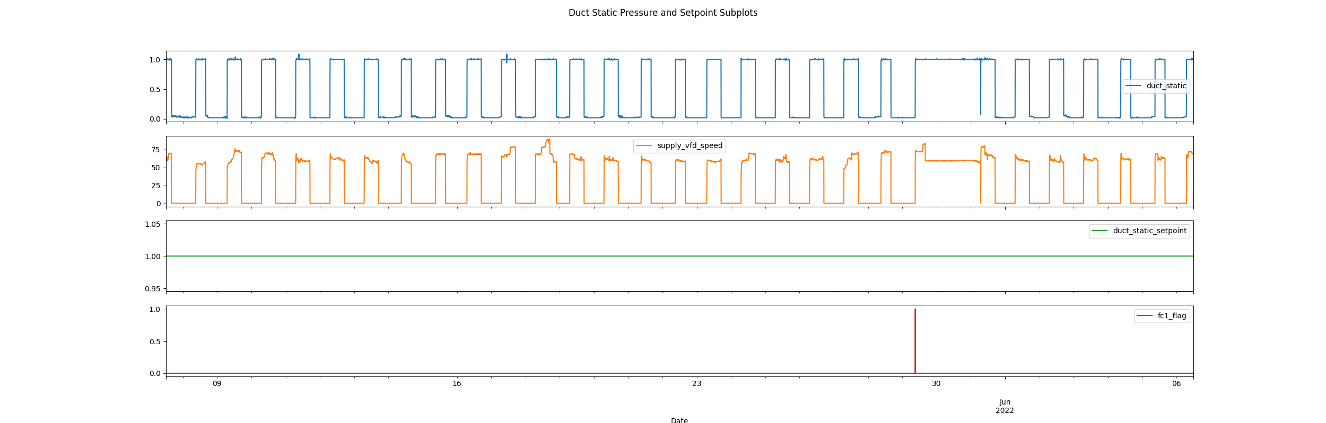

## Dataset Statistics

* Total time calculated in dataset: 29 days 23:55:00
* Total time in hours calculated in dataset: 719
* Total time for when FDD flag is True: 0 days 00:05:00
* Percent of time in the dataset when the Fault FLAG is True: 0.01%
* Percent of time in the dataset when FLAG is False: 99.0%
* Average duct system pressure for when in fault condition (fan VFD speed > 95%): 0.88"WC

## VFD Speed Statistics

* count 8638.000000  
  mean 26.895624  
  std 31.559100  
  min 0.000000  
  25% 0.000000  
  50% 0.000000  
  75% 60.300000  
  max 89.700000  
  Name: supply_vfd_speed, dtype: float64

## Duct Pressure Statistics

* count 8640.000000  
  mean 0.438253  
  std 0.482618  
  min 0.010000  
  25% 0.020000  
  50% 0.030000  
  75% 1.000000  
  max 1.090000  
  Name: duct_static, dtype: float64

## Duct Pressure Setpoints Statistics

* count 8640.0  
  mean 1.0  
  std 0.0  
  min 1.0  
  25% 1.0  
  50% 1.0  
  75% 1.0  
  max 1.0  
  Name: duct_static_setpoint, dtype: float64

## Suggestions based on data analysis

* The percent True of time in the dataset for when the variable fan is running at maximum speed and generating very little duct pressure is very low. This fan system appears to operate well from a perspective that the fan adiquelty meets a duct pressure setpoint.
* The control programming doesnt appear to have a duct pressure reset strategy implemented as the standard deviation of the duct pressure setpoint data equals zero. It would be recommended to hire a consulting engineer to properly design, oversee, and validate a duct pressure reset strategy implemented by a controls contractor. A duct pressure reset can potentially save fan electrical energy consumption.

Report generated: Tue Nov 29 10:29:46 2022